Problem
Analysis and Solution
Development

Module Name: Analysing and Solving Problems
Module Code: ACCA 4019
Student Name: Sadaf Yusufzai
Student ID: 2513631
Group:4
Lecturer’s Name: Amitave Banik

Table of Contents
Table of Contents 1
1. Introduction 2
2. Deconstruct the Problem 3
2.1 MoSCoW Technique Requirements 4
2.2 Variables Identification 5
3. Proposed Solution 6
3.1 Flowchart 7
3.2 Flowchart Explanation 8
4. Reflection and Justification 9
4.1 Abstract thinking 9
4.2 Sub-dividing 9
4.3 Justification of solution 9
4.4 Limitations 10
4.5 Assumptions 10
5. Conclusion 11
References 11

Introduction
In this assignment, I will analyse the problem of organising suitable meeting times for students completing a group computing project. The main purpose is to develop a structured solution that considers the different timetables, part-time jobs and personal commitments of group members while ensuring that meetings take place before weekly project deadlines.

I will begin by deconstructing the problem into smaller components so that the main requirements, constraints and relevant variables can be identified clearly. The MoSCoW prioritisation technique will be used to categorise the requirements according to their importance and distinguish between essential and less critical features of the proposed solution. I will also apply abstract thinking to focus on the information that directly affects meeting scheduling rather than unnecessary individual details.

Following the problem deconstruction, I will propose a logical solution for selecting suitable meeting times and present the process through a flowchart. I will explain each stage of the solution, including its inputs, processes, decision points and expected outcomes. Attention will be given to how the proposed approach identifies common availability, reduces timetable conflicts and ensures meetings are arranged before the required deadlines.

Finally, I will reflect on and justify the problem-solving techniques used throughout the assignment, including decomposition and abstract thinking. I will consider why these techniques are appropriate for the given scenario while also discussing the assumptions and limitations of the proposed solution. Relevant academic and professional literature will be used throughout the report to support the methods, concepts and decisions discussed.

Deconstruct the Problem
Before developing a solution, I need to break the group meeting scheduling problem into smaller and more manageable parts. The main issue is that each group member may have different college timetables, working hours and personal commitments. This makes it difficult to identify a meeting time when everyone is available. The problem becomes more significant when the group has a weekly project deadline because delays in arranging meetings may reduce the time available to discuss progress, distribute tasks and complete outstanding work.

I have divided the problem into three main areas: student availability, scheduling conflicts and project deadlines. Student availability determines when each member is able to attend a meeting, while scheduling conflicts represent periods when attendance is not possible because of another commitment. The deadline creates a time restriction because a suitable meeting must be arranged before the group's work is due. Breaking the scenario into these individual components allows the requirements and variables to be identified more clearly.

MoSCoW Technique Requirements
The MoSCoW technique prioritises requirements as Must Have, Should Have, Could Have and Won't Have [1].

MoSCow Category | Requirement | Reason
Must Have | Collect all members' availability, find a suitable time when everyone can attend, allow enough time for the meeting, and ensure the meeting takes place before the weekly project deadline. | These requirements are essential for arranging successful meetings and completing project work on time.
Should Have | Minimise clashes with college timetables, part-time jobs and personal commitments, and provide alternative meeting times where possible. | This reduces scheduling difficulties and gives the group more flexibility.
Could Have | Consider preferred meeting times, rank suitable options and provide meeting reminders. | These extra features could make the scheduling process easier and more convenient for the group.
Won’t Have | Change students' college timetables, working hours or personal commitments, or schedule meetings during unavailable periods. | These commitments are outside the control of the scheduling solution and are treated as fixed constraints.

Variables Identification
After looking at the main requirements, I identified the variables that will be needed for the scheduling solution. These variables hold the information needed to compare each student's availability, check for clashes and choose a suitable meeting time before the weekly deadline.
Variable | Type | Purpose | Example
groupMembers | List | Stores the students who are part of the group. | Student A, B, C, D
availableTimes | List | Stores the days and times when each student is free. | Monday, 2:00–4:00 pm
busyTimes | List | Stores times when students have college, work or personal commitments. | Tuesday, 9:00 am–1:00 pm
meetingLength | Integer | Stores how much time is needed for the meeting. | 60 minutes
weeklyDeadline | Date/Time | Stores when the weekly project work is due. | Friday, 5:00 pm
commonTimes | List | Stores the time slots when all group members are available. | Wednesday, 3:00–5:00 pm
conflictCount | Integer | Keeps track of any clashes linked to a possible meeting time. | 0
chosenTime | Date/Time | Stores the final meeting time agreed for the group. | Wednesday, 3:00 pm

I chose these variables because they each have a specific purpose when organising the meeting. For example, availableTimes shows when students are free, while busyTimes shows when they already have other plans or commitments. Keeping these separate makes it easier to rule out times that are not suitable.
The meetingLength and weeklyDeadline variables are also important. Even if everyone is free at a certain time, there still needs to be enough time to complete the meeting, and it must take place before the weekly deadline. After comparing everyone's availability, the times that suit the whole group can be saved in commonTimes. If there are several suitable times, conflictCount can be used to find the option with the fewest problems. The best time can then be saved as chosenTime.
Using variables also makes the solution easier to use with different groups. The same process can be followed by simply changing the information stored in the variables, rather than creating a completely new solution each time.

Proposed Solution
For this problem, I have created a simple scheduling process that can help students find a suitable time for their group project meetings. The solution considers when each student is free, when they already have other commitments, how long the meeting needs to be and when the weekly project deadline is.
The main aim is to find a time that works for everyone without creating unnecessary conflicts. Instead of students repeatedly suggesting different days and times, the process compares their schedules and removes options that are not suitable. The variables identified in the previous section, such as availableTimes, busyTimes, meetingLength, weeklyDeadline, commonTimes and chosenTime, are used throughout the process. Considering different constraints can also help when comparing possible choices in a scheduling problem [2].

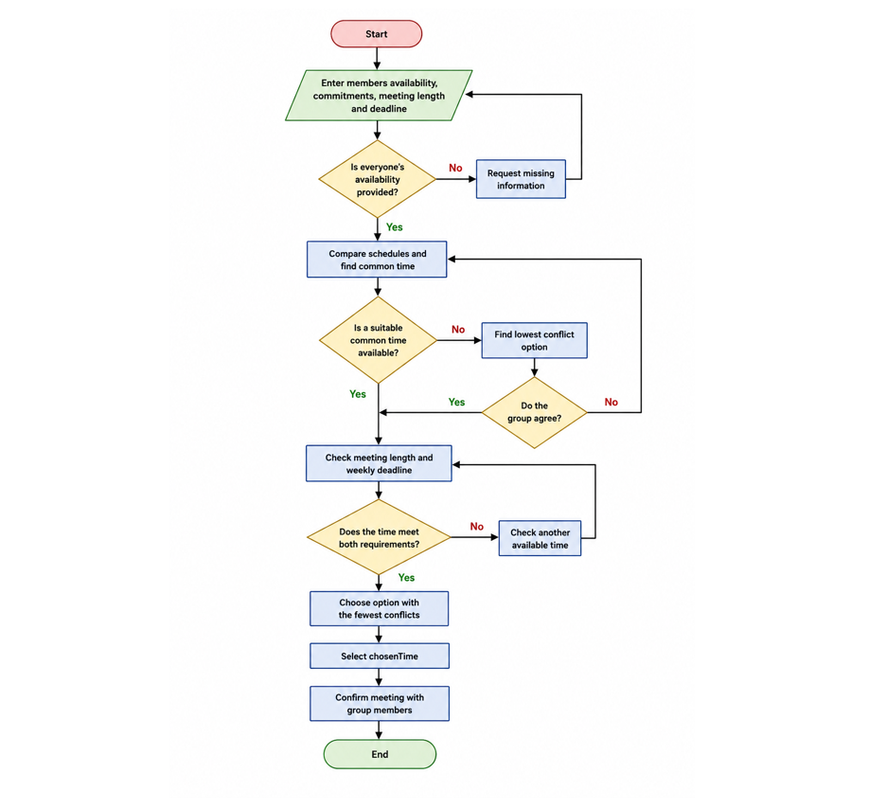
Flowchart
Figure 1: Flowchart for the Group Meeting Scheduling Process.

Flowchart Explanation

The flowchart shows how the group can work through different meeting options in a clear order rather than trying to arrange a time through repeated messages. It starts by collecting the members' availability, commitments, required meeting length and weekly deadline. These details are needed because the meeting cannot be arranged properly without knowing when each person is free and how much time is available before the project work is due.
The first decision checks whether everyone has provided their availability. If the answer is No, the missing information is requested, and the process returns to the previous stage. If the answer is Yes, the schedules are compared to find a common time. I included this check because leaving out one person's schedule could result in choosing a meeting that they cannot attend.
The next decision asks whether there is a suitable common time available. When the answer is Yes, the process moves forward to check the meeting length and weekly deadline. If there is no common time, the solution looks for the option with the lowest conflict. This gives the group another possibility rather than ending the process immediately. The alternative is then presented to the members. If they agree, it can continue through the remaining checks. If they do not agree, another option needs to be considered.
The meeting length and deadline are checked together because both conditions must be met for a time to be useful. A meeting slot may suit everyone's timetable but still be too short. In the same way, a time may be convenient but would not help the group if it takes place after the weekly deadline. If an option does not meet these requirements, another available time is checked.
When a time passes these checks, the remaining options are compared and the one with the fewest conflicts is given priority [3]. This helps reduce disruption caused by lessons, part-time work and personal commitments. The final option is stored as chosenTime, and the meeting is confirmed with the group members.
Overall, the flowchart provides a structured way of moving from several different student schedules to one suitable meeting time. Each decision removes unsuitable choices or sends the process back to consider another option. This makes the process more organised while keeping the weekly project deadline as an important part of the final decision.

Reflection and Justification
In this section, I will reflect on the problem-solving techniques I used to develop the group meeting scheduling solution. I will consider how abstract thinking and sub-dividing helped me break down and simplify the problem. I will also justify why I chose this approach and discuss some of the limitations and assumptions that may affect how well the solution works in a real situation.

Abstract thinking
I used abstract thinking to focus on the information that was most important when arranging a group meeting [4]. Students may be unavailable for different reasons, such as college lessons, part-time work or personal commitments. Instead of creating a separate rule for each situation, I grouped them as busy or unavailable times. This helped me simplify the problem and made it easier to focus on the information that was needed to find a suitable meeting time.

I represented the main information using variables such as availableTimes, busyTimes, meetingLength and weeklyDeadline. This helped me organise the information clearly and avoid including details that were not needed in the scheduling process. I found abstract thinking useful because the same solution can be applied to different project groups, even when students have different schedules and commitments.

Sub-dividing
I also used sub-dividing to break the main problem into smaller tasks [4]. Trying to find a suitable meeting time in one step would be difficult because several conditions need to be considered. I divided the process into collecting availability, comparing schedules, finding common times, checking the meeting length, checking the deadline and choosing the option with the fewest conflicts. Breaking the problem down in this way made it easier to understand what needed to happen at each stage. It also helped when creating the flowchart because each part of the problem could be represented as a process or decision.

Justification of solution
I chose this solution because it directly addresses the main problems faced by the students. Rather than relying on group members to repeatedly suggest different times, their availability can be compared in a structured way. A time when everyone is available is considered first, which supports equal participation within the group.

The solution also checks the required meeting length and weekly deadline before confirming a time.

Another reason for using this approach is that it can deal with more than one possible outcome. If several suitable times are available, the option with the fewest conflicts can be selected. If there is no common time, the group can consider a lower-conflict alternative instead. This makes the solution flexible while still giving priority to a time that works for everyone. This approach is useful because scheduling may involve balancing different requirements when choosing the most suitable option [5].

Limitations
There are some limitations to the proposed solution. It depends on students providing accurate and up to date availability. A meeting could become unsuitable if somebody forgets to enter a commitment or their schedule changes at short notice. There may also be situations where no time can be found that allows every member to attend. Although the process can suggest an alternative with fewer conflicts, this does not guarantee that the affected students will be able to change their plans.

The solution also focuses mainly on scheduling and does not consider other issues such as the location of the meeting, room availability or whether students prefer to meet online.

Assumptions
The solution assumes that all members provide their availability before the meeting is arranged and that the information they provide is correct. I also assume that the weekly deadline and required meeting length are known in advance. College lessons, working hours and personal commitments are treated as fixed unless a student says that they can change them.

Finally, I assume that all members are expected to attend whenever possible and are willing to consider an alternative when no completely suitable time is available. These assumptions allow the scheduling process to remain simple while still addressing the main problem described in the scenario.

Conclusion
In conclusion, this assignment explored the difficulties students may face when arranging group project meetings because of different timetables, part-time work and personal commitments. I broke the problem into smaller parts and used the MoSCoW technique to identify the main requirements and priorities. I also identified the variables needed to support the scheduling process.

The proposed flowchart provides a clear way of comparing students' availability, checking possible meeting times and reducing timetable conflicts. It also checks the meeting length and weekly deadline before a final time is selected. Abstract thinking and sub-dividing helped me simplify the problem and organise the solution into manageable steps.

Overall, the proposed approach provides a practical way for groups to organise their meetings more efficiently. Although the solution depends on students providing accurate availability, it can be adapted to different groups and changing schedules while keeping project deadlines in mind.

References
[1] Agile Business Consortium, “What is MoSCoW Prioritization?,” 28 May 2026. [Online]. Available: https://www.agilebusiness.org/resource/what-is-moscow-prioritization/. [Accessed: 12 August 2026].
[2] T. Ye, A. Jovine, W. van Osselaer, Q. Zhu and D. Shmoys, “Cornell University Uses Integer Programming to Optimize Final Exam Scheduling,” INFORMS Journal on Applied Analytics, vol. 56, no. 2, pp. 159–177, 2026.
[3] M. Elhüseyni, “Course timetabling under conflict and lecturer preferences using bi-objective optimization model,” arXiv:2607.03901, 2026.
[4] J. M. Wing, “Computational thinking,” Communications of the ACM, vol. 49, no. 3, pp. 33–35, 2006.
[5] F. Meier, T. Stidsen, C. Thielen and A. Wiese, “A Multi-Objective Approach to Curriculum-Based Course Timetabling with Continuity Across Semesters,” arXiv:2606.21176, 2026.

