Socket Programming & Concurrency Report
Assignment 1
270696 (Ed Smith)
2021
Contents
Projects Purpose 2
Target Audience 2
Personas 2
Persona Student: 2
Persona Teacher: 3
Scenarios 3
Scenario Student-Student: 3
Scenario Teacher-Student: 3
Intended Functionality 4
Choice of Technologies and Frameworks 4
Sockets 4
WebSockets 4
Java 5
Laravel/Vue.js 5
Node.js 5
Application Logic Planning 6
Server/Client Processes 6
Concurrency Issue Considerations 6
Multithreading 6
Mutexes and Semaphores 7
Synchronous and Asynchronous 7
Socket/Transport Layer language 7
Client Screen Flow Diagram 8
Wireframes 9
Client Username Interface: 9
Chatroom Interface: 9
Testing 10
Unit testing 10
Test Plan 10
User Acceptance Testing 18
Stress testing 21
Test Plan 21
Bibliography 22

Projects Purpose

The purpose of this project is to design and develop a chatroom application that allows students and or lecturers to communicate with one another. With the current learning environment being remote, the development of this application aims to make communication easy and simple. For the application to achieve this, client and server-side technologies will be utilised that will entwine with each other to allow communication between users.

Target Audience

The target audience for this chat application will be students and lecturers who seek a way of communicating amongst the class of the course they are on. Below are some personas of the users expected to use the application.

Personas

Persona Student:
Persona: | Student
Photo:
Fictional name: | Ben Johnson
Job title/major responsibilities: | Computer Science Student
Demographics: | - Male  - 22 years old  - Single  - Swansea, GB  - Unemployed
Goals and tasks: | A focused student, who is goal oriented. One of his concerns is not performing to the best of his ability in his studies.  Spends his time:  - Completing assignments  - Using social media  - Playing sports
Environment: | He can use a computer to an advance level and understands a range of different computing related topics. He uses a laptop/computer to conduct his studies.

Persona Teacher:
Persona: | Lecturer
Photo:
Fictional name: | Justin Peters
Job title/major responsibilities: | Higher Education Lecturer
Demographics: | - Male  - 58 years old  - Married  - Neath, GB  - Employed
Goals and tasks: | Focused on inspiring and educating young people to achieve their potential.  Spends his time:  - Marking assignments  - Teaching computer science students  - Drinking at the local pub
Environment: | He can use a computer to a basic level and uses a computer for all teacher purposes where applicable.

Scenarios

Scenario Student-Student:

Ben, 22, a computer science student, needs to constantly conduct further studies after each lecture, to improve his knowledge and understanding of certain topics. This helps him in completing assignments at a higher level. If Ben does not understand or needs to discuss findings with other students, he must message each student individual and wait for a response. He wastes time in having to wait for responses and would like an alternative method that allows him to message online students. Ben would like a messaging application that allows group communication. He highlights the need to see what users are available to chat and for everyone to converse in a single conversation.

Scenario Teacher-Student:

Justin, 58, a higher education lecturer, currently provides students with tasks and assignments on his course. Justin constantly needs to check emails to see if students have issues or questions related to his course. He finds students asking the same questions and would like an alternative way to respond to students collectively. Justin wants a messaging app, where he can communicate with students during a specific time. Justin would like the ability to see the connected students’ names.

Intended Functionality

From the scenarios, the main functionality for the chatroom will be for students and or lecturers to communicate with each other. To achieve this the chatroom will have the ability to allow more than two concurrent users. Another functionality is for users to be able to join a chatroom with a unique username entered by themselves. The chatroom will also display the connected users and will notify users when someone joins or leaves the chat. Finally, the chatroom will not allow duplicate usernames.

Choice of Technologies and Frameworks

Sockets

The first choice of technology to consider was the type of socket to use. A socket according to IBM ‘is a communications connection point (endpoint) that you can name and address in a network’ (1). They are used to establish links of communication between processes both remote and local. A regular socket application involves the communication between a client and server. To achieve this the client will contact the IP address and its port number of the server. After the connection is made, data can be transferred between the client and server.

This type of socket programming is good as it uses short data transmission times, providing high performance. This is supported by a study conducted by Stephen Kemmerling, who showed it takes a regular TCP socket ‘0.002 milliseconds’ (2) for a response to arrive from a server in comparison to a WebSocket that shows ‘0.02 milliseconds’(2). This suggests this type of application is suitable for real-time applications such as a chatroom. However, using this type of socket programming can ‘increase the development level requirements for developers’ (3).

WebSockets

Another consideration was WebSockets. WebSockets are an ‘advanced technology that makes it possible to open a two-way interactive communication session between the user’s browser and a server’ (4.) The connection made is persistent, providing a ‘bidirectional, full duplex communications channel’ (5) over a TCP/IP connection. WebSockets are considered ‘great for services that require continuous data exchange’ (6), making it a suitable choice for a chatroom application.

Using WebSockets solves some underlying issues of HTTP (web services). As previously mentioned, WebSockets act as a bi-directional protocol whilst HTTP acts as a ‘uni-directional protocol’ (7). This allows either the client or server to send a message to the other. WebSockets also only takes 2 bytes of overhead whereas HTTP takes 2000 bytes, allowing data transfer to be much faster.

Both types of socket achieve similar things; however, they are different. This is because WebSockets run from browser to server, whilst regular sockets run over TCP/IP and are not restricted to browsers or HTTP protocols. From the tests conducted by Kemmerling, as previously mentioned, it is concluded with the statement that it is ‘not a good idea to use WebSockets instead of direct TCP’ (2). Kemmerling supports this statement with his research showing that using TCP will provide 10 times ‘higher message throughout with the latter’ (2). This helped inform the decision of using regular sockets to act as the communication between client and server.

Java

The application will be written in Java. The java.net package will allow both ‘socket and Server Socket’ (8) classes to be used. Using these classes will allow both client side and server-side connections, respectively. The socket class will allow the chatroom application to ‘communicate over the network in a platform-independent fashion’ (9). The server socket class will allow the servers to ‘listen for and accept connections to clients’ (9). With the use of this package, the development process time will be reduced significantly. Java Swing framework will be used to design the GUI interface for the chatroom application.

Laravel/Vue.js

The use of Laravel was an alternative consideration made for the design and develop the chatroom application. ‘Laravel is an open-source PHP framework’ (10). Laravel uses WebSockets which, as previous stated, are not as efficient and reliable as regular sockets, therefore making it not the best choice for the development of the chatroom application. However, Laravel works in tandem with the vue.js framework. This framework would allow Laravel to build a front end without the need to reload web pages. This makes it a good alternative to the current choice of technologies.

Node.js

Node.js was a technology also considered. The Node.js platform is used ‘for easily building fast and scalable network applications’ (11). However, after further research, Node.js is ‘asynchronous and event driven’ (11), this means it is non-blocking. This would not be beneficial to the chatroom application as the system requires the return of data before it can process the next. Node.js also is single threaded platform, meaning a process cannot be concurrently accessed. Again, this would mean users would have to wait to join the chatroom and send messages.

Application Logic Planning

Server/Client Processes
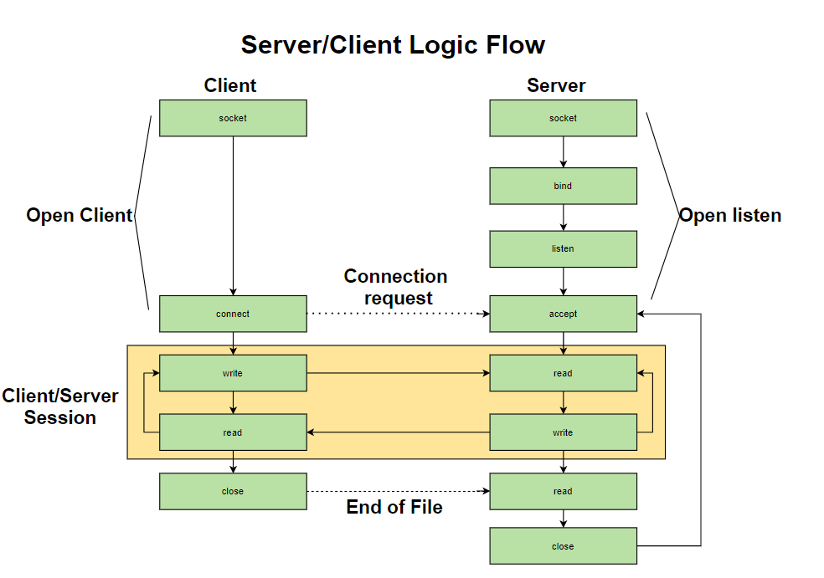

The client binds to a socket to connect to the server. The server binds to a socket then listens for communications. The client sends a connection request using the IP/Port of the server, which is then either rejected or accepted by the server. If connected, the client writes to the server with the server reading the request. The server then writes a response that is then read by the client. This process is looped until either the client or server closes the session, in which case the then the server waits for a new connection request and the process repeats.

Concurrency Issue Considerations

Multithreading

The next choice of technology for the chatroom application was the java.util.concurrent library. Multithreading can be defined as ‘the inclusion of more than one unit of execution in a single process’ (12). The library will allow the use of multiple users concurrently using the chatroom application. The utilisation of a fixed thread pool will allow the application to define how many threads will be active to process tasks. This will allow the application to manage how many messages can be sent, as ‘too many threads will consume to many resources’ (13) ultimately affecting performance. However, to use this process additional time and research will be needed as the ‘creation management and coordination’ (13) for the threads are difficult to grasp.

Mutexes and Semaphores

The consideration of using locks arose from the use of multithreading to handle concurrency for the chatroom application. I decided not to use semaphores as there was no need for ‘mutual exclusivity to multiple threads’ (14). However, this was considered in the event I wanted to allocate the chat room to a limited number of users. Mutexes is as ‘mutual exclusion object that synchronizes access to a resource’ (15). It is a locking mechanism that only allows one thread access to the critical section at a time. I have achieved mutex by using the print writers that ensures each thread accesses critical sections asynchronously, achieving mutually exclusive access to critical I/O sections. This ensures that the chat application is not prone to bugs from race conditions.

Race conditions occur ‘when two threads operate on the same object without proper synchronization’ (16). An example of this can be given by a pair of threads that increment and read a given value, respectively. Ideally, we would want the reading thread to read after each increment of the variable, however, when mutex is not ensured, these threads can be a subject to a race condition. In the described situation, this could result in the reading thread accessing the critical section before the increment thread is able to update the variable, meaning printing a different value than expected.

Synchronous and Asynchronous

To prevent race conditions critical sections must be accessed by threads synchronously. For the application, input of screen names must be synchronised to prevent duplication of screen names. To achieve this, the synchronised key word will be used before the ‘names’ variable can be accessed. This is because the hast set used does not have any built-in thread safety features. The application will use synchronous call-back with messages sent by users as ‘the tasks must be executed in sequence’ (17). As well as this, asynchronous call-back will be used when users create messages as the ‘tasks are not dependent on each other’ (17).

Socket/Transport Layer language

Stream Sockets

Due to the use of Java as the programming language, I had the choice between stream sockets and datagram sockets. Stream sockets ‘allow processes to communicate using TCP’ (18). I decided to use this type of socket as, according to IBM, stream sockets have no boundaries in the data. This would allow ‘multiple concurrent read or write socket calls’ (19), making it beneficial to the application because of the expected concurrent users. Further to this, stream sockets ‘guarantee to deliver data in the order sent and without duplication’ (19), this formatting is necessary for a chat application. Stream sockets are a common choice in socket programming as TCP/IP handles the ‘burden of transferring the data reliably, rather than by the application’ (20).

Client Screen Flow Diagram

Below shows the screen flow of a client using the chatroom application, they must first connect to the server. Once connected, the client form will show, allowing the user to enter a screen name. When completed it will allow the user to communicate with other users in the chatroom. After the user is done chatting, they will end the communication between themselves and the server.
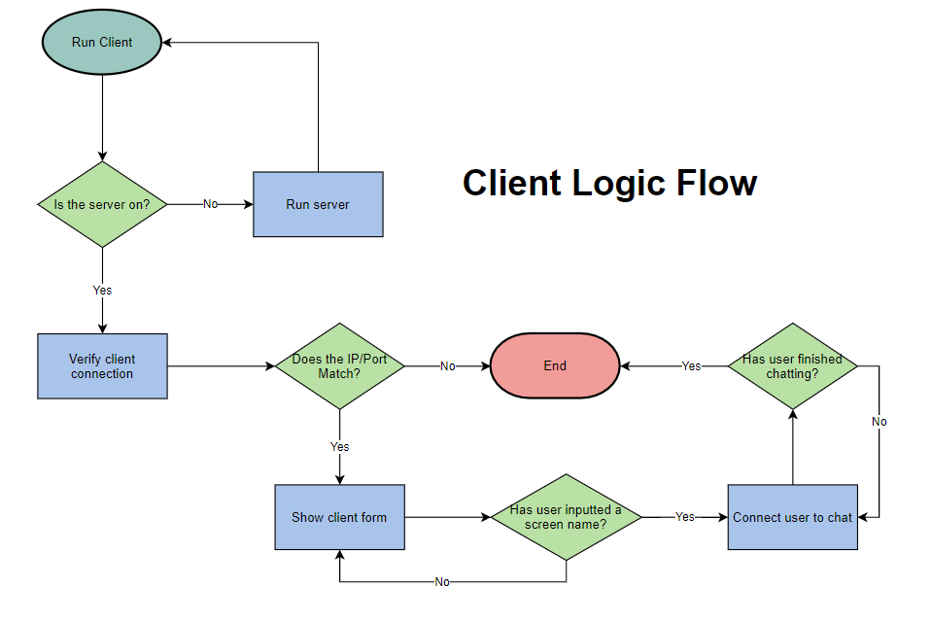

Wireframes

Below are the only two wireframes associated with the user interface for the chatroom application.

Client Username Interface:
As you can see the client will enter their screen name in the message box. Once completed they will press ‘Ok’. This will then allow for them to access the chatroom.
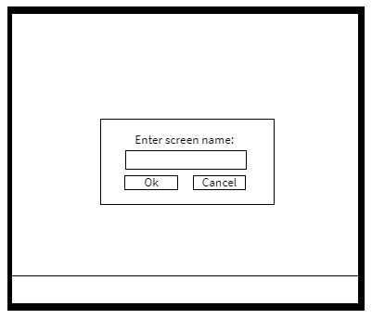

Chatroom Interface:
As you can see in this wireframe, the user will send messages in the chatroom using the bottom text box. The information will then be displayed for all users to see in the message box above.

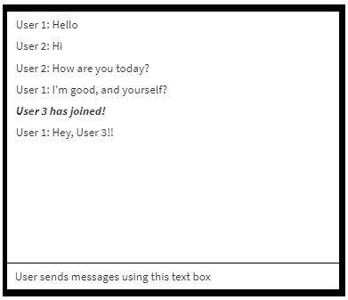

Testing

Unit testing

The first approach to testing the chatroom application will be unit testing. Unit testing breaks down ‘the functionality of your program into discrete testable behaviours that you can test as individual units’ (21). These individual units are tested to determine if there are any issues made by myself (the developer). Issues can be analysed and fixed effectively using this method of testing. This type of testing improves the design of the chatroom application and reduces bugs for when the application goes live.

Test Plan

Category | Test Case | Description
Server Side | 1.1 | Unique name
 | 1.2 | Hash set names adds
 | 1.2.1 | Hast set names removes
 | 1.3 | Scanner reads client input
 | 1.4 | Multithreading
 | 1.5 | Server Socket 59001
Client side | 2.1 | Localhost
 | 2.2 | Server Socket 59001
 | 2.3 | Enter screen name
 | 2.4 | Frame title
 | 2.5 | Message input
 | 2.6 | Message output format
 | 2.7 | Connected Users

Test Case | 1.1 – Unique Names
Test Description | No duplicate screen names should be allowed to enter the chatroom.
Testing Method | Run the system using two clients both trying to enter their screen name as ‘Edward’.
Expected Results | The application prevents any duplicate names from joining the output stream. When the while loop is commented out, duplicate names are accepted.
Actual Results | 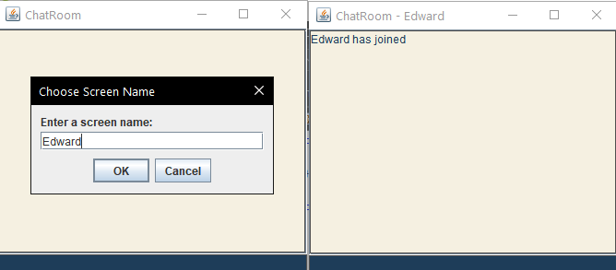  The actual results are that it will not allow for me to join the application using the screen name ‘Edward’ as it is already in use.
Action Needed | No further action required.
Retested Results | N/A

Test Case | 1.2 - Hash set names adds
Test Description | After a new client joins the hash set gets updated.
Testing Method | Enter the chatroom using multiple clients, use the system to output the names of all current chatroom users using system.out.println method.
Expected Results | After entering the chat room, the system prints the names of the current users within the hash set. (Currently connected users).
Actual Results | 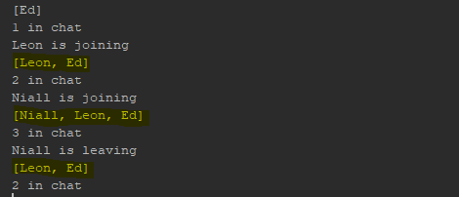  Above you can see highlighted evidence that shows after entering the chat room, the system prints the names of the users within the hash set. (Currently connected users).
Action Needed | No further action required.
Retested Results | N/A

Test Cases

Test Case | 1.2 - Hash set names remove
Test Description | After a client leaves the hash set it gets updated.
Testing Method | Enter the chatroom using multiple clients, use the system to output the names of all current chatroom users using system.out.println method. Leave with a user to show it updating.
Expected Results | After leaving the chat room, the system prints the names of the current users within the hash set. (Currently connected users).
Actual Results | As you can see highlighted, after leaving the chat room the system prints the names of the users within the hash set. (Currently connected users).
Action Needed | No further action required.
Retested Results | N/A

Test Case | 1.3 - Scanner reads client input
Test Description | When a message is entered by a client it gets broadcasted.
Testing Method | Client sends message in chatroom; message will be displayed in the system console to show input is being scanned.
Expected Results | When client sends a message, the scanner reads the user input.
Actual Results | 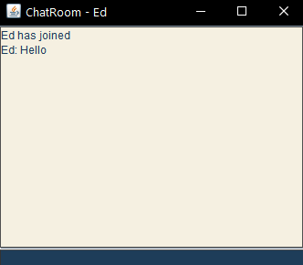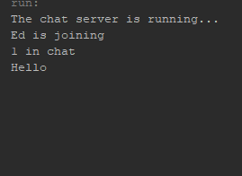  The test clearly shows the message sent by Ed being scanned by the scanner.
Action Needed | No further action required.
Retested Results | N/A

Test Case | 1.4 - Multithreading
Test Description | To check to see if the application supports multithreading.
Testing Method | Open multiple chats client and at once using the chatroom.
Expected Results | That I can make multiple chat clients without any errors from occurring.
Actual Results | 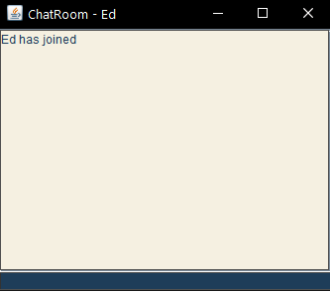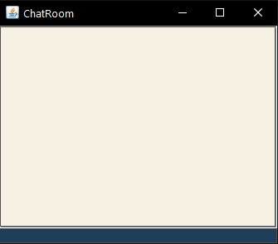  Application did not allow for me to make more than one chat client.
Action Needed | Update thread pool, to allow more than one thread to access the chat client.
Retested Results | Thread pool updated to 50, allowing multiple threads to be used.  Below shows more than one chat client open.  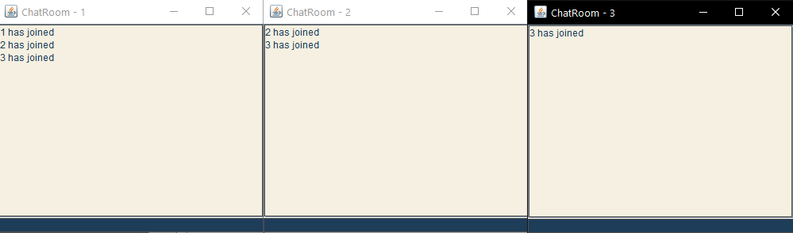

Test Case | 1.5 – Server Socket
Test Description | Test that the server can connect to a port.
Testing Method | Set the server socket port to 59001 as we are using TCP exclusively.
Expected Results | That the server can connect to the port using the server socket method.
Actual Results | The server is successfull in making a new serversocket on port 50991. The image illustrates the server socket running as required.  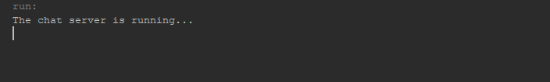
Action Needed | No further action required.
Retested Results | N/A

Test Case | 2.1 - Localhost
Test Description | To test if the chat client is connecting to the IP address of the localhost :”127.0.0.1”.
Testing Method | The chat client will only appear if the new chat client is connected to the IP set.
Expected Results | That the chat client opens as its connected to the localhost.
Actual Results | The chat client userinterface opened upon successfully connecting to the local host IP.
Action Needed | No further action required.
Retested Results | N/A

Test Case | 2.2 - Server Socket 59001
Test Description | Testing to see if the client is connected to the server socket of 59001.
Testing Method | I will change the server socket to 59002 and nothing should happen. I will then change it back the 59001 and the chat client should work as expected.
Expected Results | When using the socket port 59002 on the chat client an error occurs. When changing it to match the chat server socket, the application runs as expected.
Actual Results | 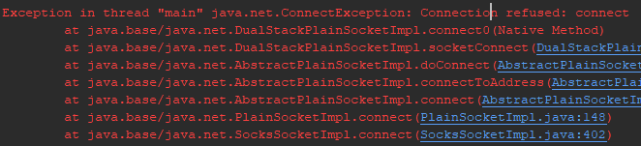  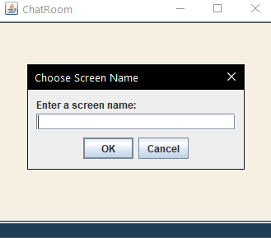  When using the socket port 59002 on the chat client an error showed and when changing it to match the chat server socket, the application runs as expected.
Action Needed | No further action required.
Retested Results | N/A

Test Case | 2.3 - Enter screen name
Test Description | When entering a screen name, it is then used as your chatroom username.
Testing Method | After entering a username if it accepted it gets used as my username for the chatroom.
Expected Results | After entering screen name (Edward) the chatroom will open, allowing for me to send messages under the Edward alias.
Actual Results | 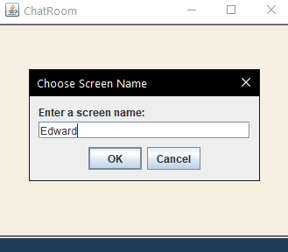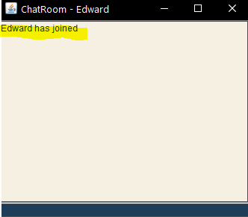  As you can see highlighted that the username was accepted and my chatroom alias is now set to Edward.
Action Needed | No further action required.
Retested Results | N/A

Test Case | 2.4 - Frame title
Test Description | Whether the screen name entered changes the frame title based of entry.
Testing Method | Entering a screen name (Edward) to access the chatroom, frame title will update in accordance with screen name text.
Expected Results | After entering screen name (Edward) the chatroom will open, allowing me to send messages under the Edward alias.
Actual Results | 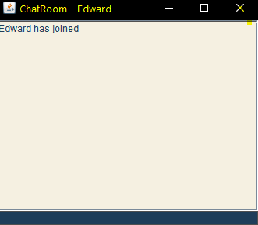  As you can see after entering a the screen name Edward it set the chatroom title to “Chatroom – Edward”.
Action Needed | No further action required.
Retested Results | N/A

Test Case | 2.5 - Message Input
Test Description | The textbox is editable, allowing chatroom users to enter and send messages using the text box and the see messages using the message area.
Testing Method | Opening of a client, to see the text box is editable for input and messages get sent to message area.
Expected Results | The textbox allows messages to be sent, that are then displayed in the message area.
Actual Results | The textbox allows messages to be sent, that are then displayed in the message area. This is evidenced in the screenshots below.  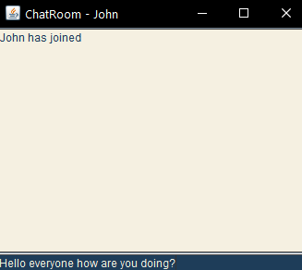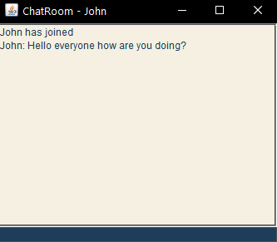
Action Needed | No further action required.
Retested Results | N/A

Test Case | 2.6 - Message Output Format
Test Description | This test was to assess if the message area will display messages in sent order and on a new line for each message.
Testing Method | I will send messages at different times to see how they are outputted and displayed for the user.
Expected Results | Messages will display in output order, and each message sent will start on a new line.
Actual Results | 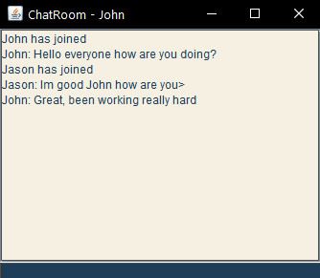  The actual results show that the messages are displayed in output order, and each message sent will start on a new line.
Action Needed | No further action required.
Retested Results | N/A

Test Case | 2.7- Connect Users
Test Description | To test the chatroom users can see who is in the chat after a user leaves.
Testing Method | Join the chatroom with multiple users and leave the chatroom.
Expected Results | When I user leaves the chatroom, a notification appears saying who the current users of the chatroom are.
Actual Results | There was no notification that showed when the user left the chatroom saying who the current users of the chatroom are.  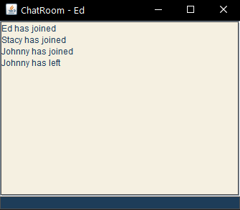
Action Needed | Add the notification to show users in the chatroom.
Retested Results | As you can see the application now shows the connected users after someone leaves the chatroom application.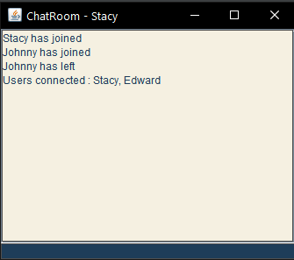

User Acceptance Testing

As the chatroom application was designed to help students and lecturers communicate with each other easily, the application can be considered a service. ‘Every information system brought into service in every type of organisation requires user acceptance testing’ (22). There are many benefits of using user acceptance testing, such as making sure the user is satisfied with the system and that bugs are recognised which the developer may have missed. As mentioned, students and lecturers were the established users for the system. I decided to conduct a questionnaire with 10 respondents, with the purpose to evaluate and test the chatroom application. As the client/server application was created using my PC, I let users test the application via parsec. The responses from the user acceptance testing would form a success criterion for the application.
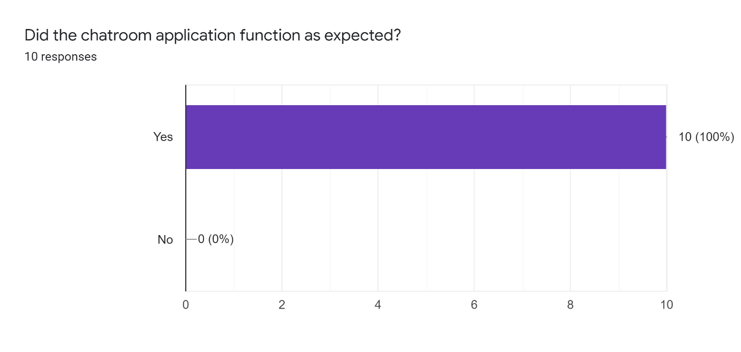
The first question was to assess if the chatroom application functioned as expected. 100% of users of the chatroom answered that the application was fit for purpose. They highlighted its simple UI and navigation features that allowed the chatroom application to be relatively easy to use.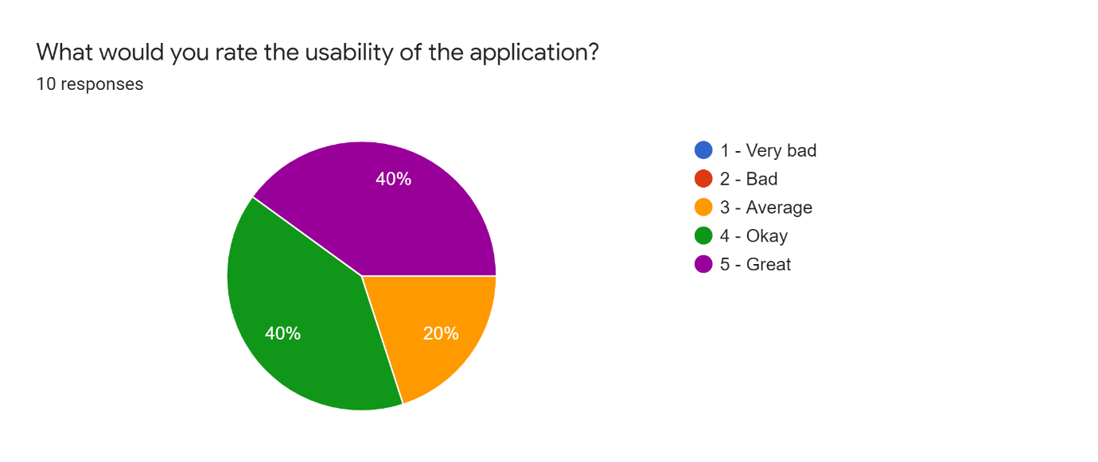
The next question was to assess if the users were satisfied with the applications usability features. The responses indicate that overall, the usability of the chatroom was satisfactory, however there is room for improvement. For future development I will need to look at the different ways of making Java applications more usable. The interface was developed using Swing, which I had little knowledge of how to use effectively.
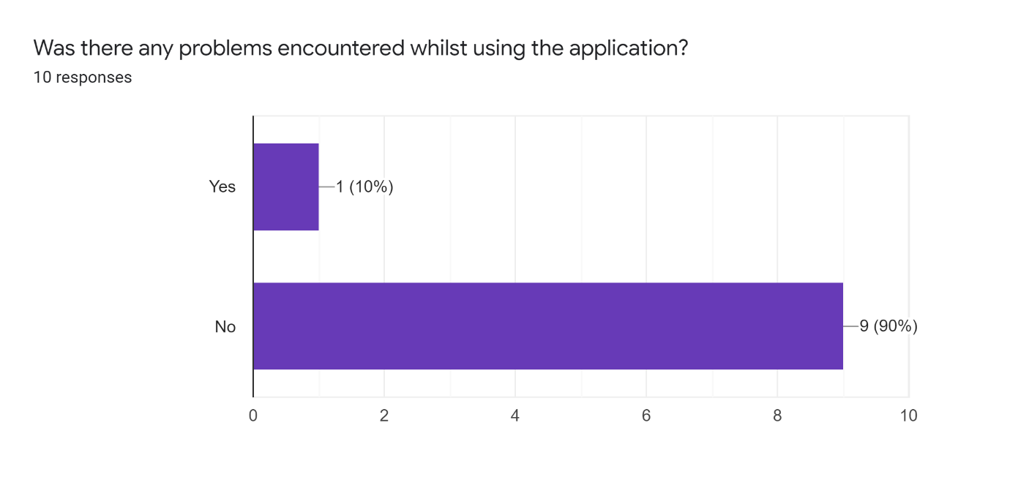
The next question was to see if the users encountered any problems using the chatroom application. Most users did not have any problem using the chat application. The one person who did have issues did not elaborate so corrections could not be made. However, it seemed overall the application ran smoothly for the nine other users.

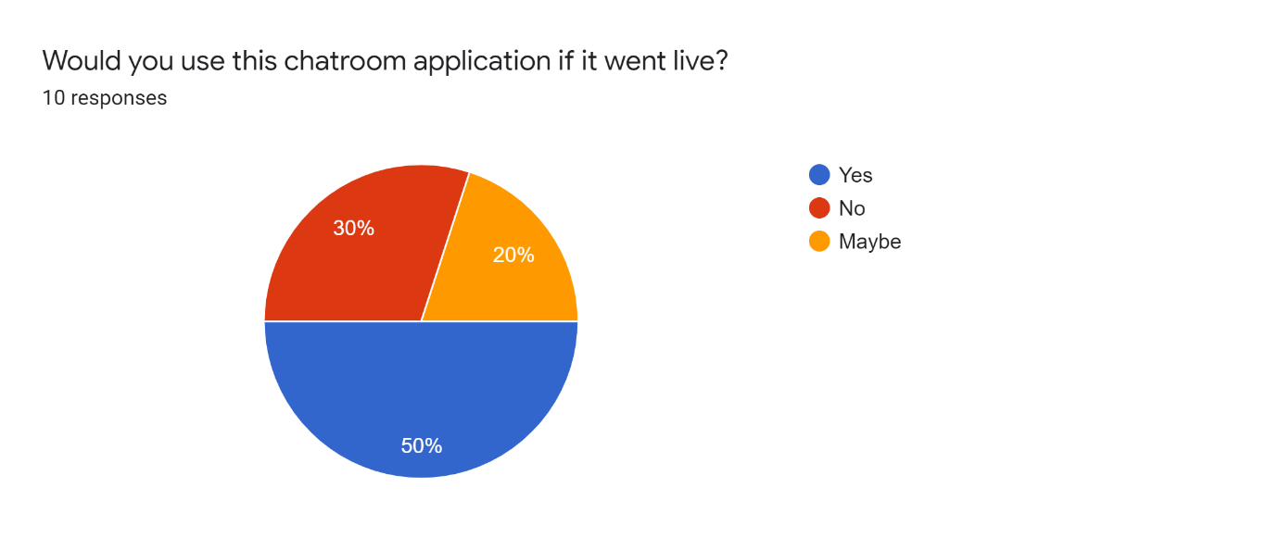
The fourth question was to assess that if the application went live, would it be used by its target audience. The question got mixed responses, but most indicated towards yes, they would use the application if it went live. However, 30% of users said they would not, with all elaborating saying they would ‘stick to their current communication methods’.
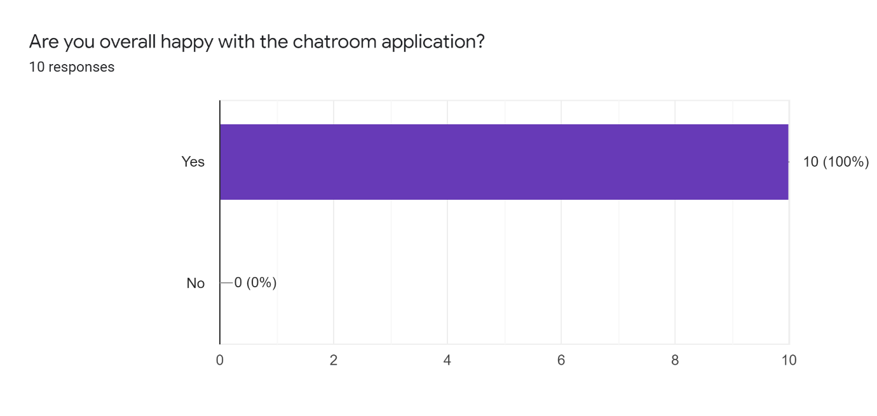
The final question was to see if the users were happy with the chatroom application overall. The results indicate that all 10 users were happy with the chatroom application. An assessment can be drawn that the application is suitable for its purpose, as all 10 users were happy with the applications outcome. Although some users said they would not use it, the majority indicated that they would.

Stress testing

Stress testing is a technique that is most commonly ‘performed as part of a performance testing’ (23). After conducting a stress test, the system is monitored to ensure it can sustain the stress. Using the stress test will allow for me to assess how the application will hold up during unfavourable conditions. For this application I only need to stress test the number of concurrent users the system can handle.

Test Plan
Category | Test Case | Description
System | 1.1 | Concurrent Users

Test Case | 1.1 Concurrent Users
Test Description | To test if the system can hold many concurrent users.
Testing Method | 50 chat clients will be open to stress test the chat application.
Expected Results | No change in performance issues.
Actual Results | As you can the application can handle 50 concurrent users at a time, and performance issues are not effected. A user could send and receive information with other users without any noticable differences.  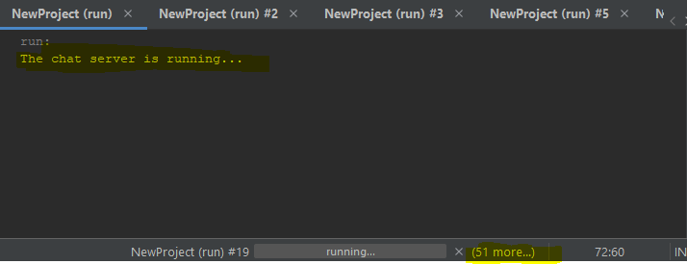
Action Needed | No further action required.
Retested Results | N/A

Bibliography

1.IBM Docs [Internet]. Ibm.com. 2021 [cited 30 April 2021]. Available from: https://www.ibm.com/docs/en/i/7.3?topic=communications-socket-programming

2. WebSockets vs. Regular Sockets [Internet]. Medium. 2021 [cited 30 April 2021]. Available from: https://medium.com/kifi-engineering/websockets-vs-regular-sockets-b3b8e7ea0708

3. Introduction and advantages and disadvantages of socket - Programmer Sought [Internet]. Programmersought.com. 2021 [cited 30 April 2021]. Available from: https://www.programmersought.com/article/53064351990/

4. The WebSocket API (WebSockets) - Web APIs | MDN [Internet]. Developer.mozilla.org. 2021 [cited 30 April 2021]. Available from: https://developer.mozilla.org/en-US/docs/Web/API/WebSockets_API

5. Sookocheff K. How Do Websockets Work? [Internet]. Kevin Sookocheff. 2021 [cited 30 April 2021]. Available from: https://sookocheff.com/post/networking/how-do-websockets-work/

6. WebSocket [Internet]. Javascript.info. 2021 [cited 30 April 2021]. Available from: https://javascript.info/websocket

7. HTTP and Websockets: Understanding the capabilities of today’s web communication technologies [Internet]. Medium. 2021 [cited 30 April 2021]. Available from: https://medium.com/platform-engineer/web-api-design-35df8167460

8. Lesson: All About Sockets (The Java™ Tutorials > Custom Networking) [Internet]. Docs.oracle.com. 2021 [cited 30 April 2021]. Available from: https://docs.oracle.com/javase/tutorial/networking/sockets/index.html

9. What Is a Socket? (The Java™ Tutorials > Custom Networking > All About Sockets) [Internet]. Docs.oracle.com. 2021 [cited 30 April 2021]. Available from: https://docs.oracle.com/javase/tutorial/networking/sockets/definition.html

10. [Internet]. 2021 [cited 30 April 2021]. Available from: https://dev.to/creativetim_official/what-is-laravel-explain-it-like-i-m-five-19eb https://www.tutorialspoint.com/nodejs/nodejs_introduction.htm

11. Node.js - Introduction - Tutorialspoint [Internet]. Tutorialspoint.com. 2021 [cited 30 April 2021]. Available from: https://www.tutorialspoint.com/nodejs/nodejs_introduction.htm

12. What Are Multithreading and Multicontexting [Internet]. Docs.oracle.com. 2021 [cited 30 April 2021]. Available from: https://docs.oracle.com/cd/E13203_01/tuxedo/tux71/html/pgthr4.htm

13. [Internet]. Cs.bham.ac.uk. 2021 [cited 30 April 2021]. Available from: https://www.cs.bham.ac.uk/~szh/teaching/ssc/lecturenotes/Concurrency/Lecture3_ThreadPool.pdf

14. Java Threads — Semaphores & Mutex [Internet]. Medium. 2021 [cited 30 April 2021]. Available from: https://medium.com/@waqas.memon/java-threads-semaphores-44b4597453ee

15. Mutex vs Semaphore [Internet]. Tutorialspoint.com. 2021 [cited 30 April 2021]. Available from: https://www.tutorialspoint.com/mutex-vs-semaphore

16.What is Race Condition in multithreading – 2 Examples in Java [Internet]. Javarevisited.blogspot.com. 2021 [cited 30 April 2021]. Available from: https://javarevisited.blogspot.com/2012/02/what-is-race-condition-in.html#axzz6tSRB9J19

17. Asynchronous and Synchronous Callbacks in Java - GeeksforGeeks [Internet]. GeeksforGeeks. 2021 [cited 30 April 2021]. Available from: https://www.geeksforgeeks.org/asynchronous-synchronous-callbacks-java/

18. Socket Types (Network Interface Guide) [Internet]. Docs.oracle.com. 2021 [cited 30 April 2021]. Available from: https://docs.oracle.com/cd/E19455-01/806-1017/sockets-4/index.html

19. IBM Docs [Internet]. Ibm.com. 2021 [cited 30 April 2021]. Available from: https://www.ibm.com/docs/en/zos/2.3.0?topic=concepts-introducing-tcpip-selecting-sockets

20. IBM Docs [Internet]. Ibm.com. 2021 [cited 30 April 2021]. Available from: https://www.ibm.com/docs/en/zos/2.2.0?topic=concepts-introducing-tcpip-selecting-sockets

21. Unit testing fundamentals - Visual Studio [Internet]. Docs.microsoft.com. 2021 [cited 30 April 2021]. Available from: https://docs.microsoft.com/en-us/visualstudio/test/unit-test-basics?view=vs-2019

22. CERN Library Catalogue [Internet]. Catalogue.library.cern. 2021 [cited 30 April 2021]. Available from: https://catalogue.library.cern/literature/qewe1-sbm95

23. Stress Testing - Tutorialspoint [Internet]. Tutorialspoint.com. 2021 [cited 30 April 2021]. Available from: https://www.tutorialspoint.com/software_testing_dictionary/stress_testing.htm

