

Master of Business Administration
International Marketing: Principles and Practices
LCMB7026
Mercedes in India and Germany
Student Name: Abdulsamad Sajidhusen Malek
Student ID: 2432626

Table of Contents
1.0 Introduction 3
2.0 Brand and Country Overview 4
3.0 Comparison of the Socio-Cultural Context of India and Germany using PESTEL 5
4.0 Comparison of the STP strategies in India and Germany 9
4.1 Segmentation Strategy (India vs Germany) 9
4.2 Targeting Strategy (India vs Germany) 10
4.3 Positioning Strategy (India vs Germany) 11
5.0 Comparison of the Marketing Mix (7Ps) strategies in India and Germany 13
6.0 Comparative Analysis of Marketing Mix Adaptation Considering Environmental, Economic, and Cultural Factors (India vs Germany) 17
7.0 Directional Development Strategy of Mercedes-Benz in India 18
8.0 Evaluation of Marketing Ethics Practice 19
9.0 Conclusion and Recommendations 20
10.0 Reflective Account 21
References 24

1.0 Introduction
This is the global marketing research of Mercedes-Benz, but with more focus on the comparative analysis between India and Germany. As a worldwide established brand of luxurious automobiles, Mercedes-Benz possesses different economic and socio-cultural backgrounds where its marketing practices are integrated, which is why it can be taken as an appropriate example of marketing approach modifications in developed and emerging markets. The purpose of the analysis will be to understand the impact of macro-environmental factors, as well as market-specific aspects, on the strategic choices of the company in these two opposite situations.
To compare the socio-cultural environment, political environment, economic environment, technological environment, environmental environment and legal environment of India and Germany, the report first compares them using the PESTEL approach. This offers a basis through which the market and consumer behaviour are influenced by external factors can be understood. It then analyses the Segmentation, Targeting, and Positioning (STP) of a Mercedes-Benz, whereby it has varying customer profiling, market focus and brand perception. Furthermore, the report will consider the marketing mix (7Ps) to find out how each company modifies its product, pricing, distribution and promotional strategy in the two markets.
This report will discuss only secondary data, which will include government publications, academic literature and company reports. It does not imply primary research. The report, generally, attempts to demonstrate how Mercedes-Benz can manage global standardisation and an adaptation locally so as to maintain a competitive advantage in both a mature market, like Germany and a fast-growing market, like India.

2.0 Brand and Country Overview
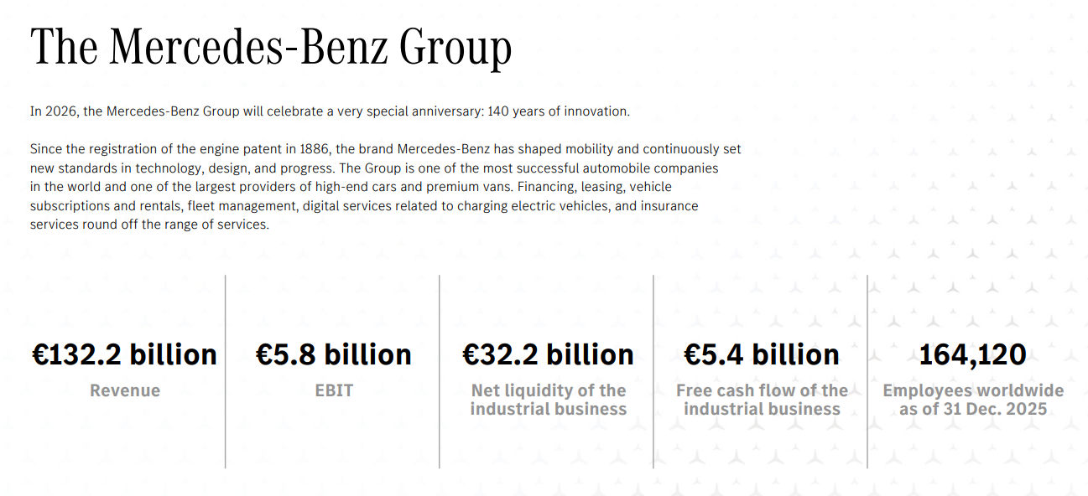
Figure 1: Mercedes-Benz performance
(Source: Mercedes-Benz, 2025)
Mercedes-Benz is a German multinational automotive company founded in 1886 and recognised as one of the pioneers of the modern automobile industry. It deals in luxury passenger vehicles, high-end vans, and mobility services and is a conventional multinational firm as opposed to being a born-global company. The company has developed its local production into foreign expansion in the form of manufacturing, sales subsidiaries, and strategic alliances. Mercedes-Benz has a solid financial standing globally due to the reported revenue and EBIT of €132.2 billion and €5.8 billion in 2025, respectively (Mercedes-Benz, 2025). It has some major rivals, such as BMW and Audi, especially in the luxury market.
Germany is the mother country, where Mercedes-Benz enjoys the advantage of an advanced infrastructure, good R&D and an established luxury car market. On the other hand, India is a host country, which is marked by a developing luxury market and an increasing population with high-net-worth individuals. Mercedes-Benz entered India in 1994 as a joint venture and subsequently formed local production, which is characteristic of a gradual internationalisation strategy under the Uppsala model whereby firms expand slowly into a new market.

3.0 Comparison of the Socio-Cultural Context of India and Germany using PESTEL
Political Factors
Germany has strict EU policies, such as Euro 6 emissions and the Fit for 55 plan and aims to achieve 55% of emission reduction by 2030 and zero-emission cars by 2035 (European Parliament, 2022). Conversely, India is also a stable political environment that actively supports manufacturing, such as through its program known as Make in India, but has a more complicated and protectionist regulatory system (Kapoor and Cyriac, 2024). Another important distinction is import policy, where India has high tariffs of up to 70-110% on imported luxury cars, whereas Germany has a comparatively liberal trade policy (Rao, 2026).
Innovation and sustainability are positive effects of the regulatory power of Germany, and market development in India is positive, but barriers to entry are limited. In the case of Mercedes-Benz, it implies that the production is standardised in Germany but has to be assembled locally in India to avoid tariffs directly affecting the pricing, localisation, and investment strategies.
Economic Factors
Economic disparities between Germany and India are quite large and directly affect the demand for luxury cars. GDP per capita in Germany is about $65,000 versus about $2,800 in India, which means that the purchasing power and disposable income are much greater in Germany (Worldometer, 2026). This renders the market in Germany a mature luxury car market, and India is an emerging market with high growth potential. The Indian economy is growing very fast, and it is expected to expand the luxury car market significantly as incomes grow (Doval, 2026).
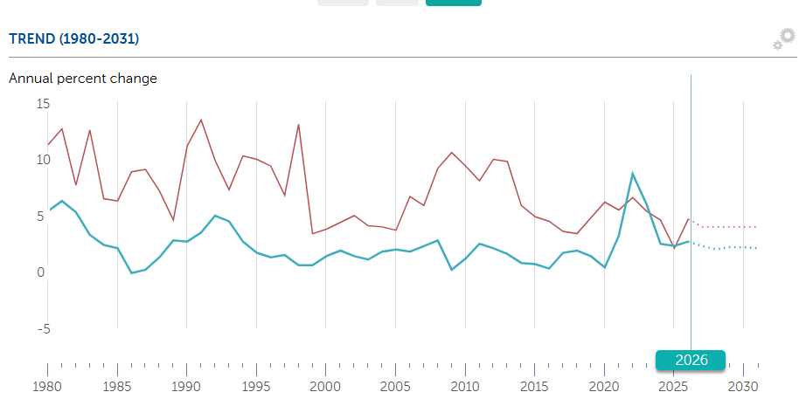
Figure 2: Inflation rate Comparison between India and Germany
(Source: IMF, 2026)
Also, there is inflation that shows relevant economic disparities. Germany has a fairly stable inflation of 2.7%, which contributes to stable purchasing power, and India has a volatile inflation of 4.7%, which impacts affordability, which makes Gremany tommore suitable for the luxury car market (IMF, 2026). On the other hand, inflation in India reduces the short-term purchasing power but enhances market growth in the long-term. In the example of Mercedes-Benz, it includes premium positioning in Germany and flexible pricing and localisation in India to increase the market penetration.
Social Factors
The social factors affecting the consumption of luxury cars in Germany and India have different impacts because of the differences in market maturity and cultural values. Performance, engineering quality, and technological innovation are the main buying factors in Germany, with advanced features and safety systems being among the primary purchase criteria in a developed automotive market (Dakić, Stupavský and Todorović, 2024). Despite the presence of status, status is considered by only 54% of younger consumers in Germany, which means that car value is an equal combination of practical and symbolic value (Continental AG, 2024).
Indian consumers, on the other hand, exhibit a stronger aspirational behaviour in which luxury cars are directly associated with social status, prestige and personal achievement as opposed to sheer functionality (Gaur and Verma, 2025). It is supported by the rapid urbanisation and the increase in high-net-worth individuals, and the luxury car market is steadily growing and is expected to continue to grow (Imarc, 2026).
Technological Factors
There are immense differences in the technological capabilities between Germany and India, which determine innovation and competitive advantage. Germany is the automotive R&D leader, heavily investing in electric vehicles and innovative technologies and is generating more than 1.67 million EVs in 2025, becoming a worldwide innovation centre (Reuters Staff, 2026). It possesses an excess of 120,000 publicly charged stations, as well, endorsing the extensive use of EVs (EVBoosters, 2024). By contrast, the EV ecosystem in India remains immature, as infrastructure issues and a lack of charging infrastructure remain, yet the sector has an investment potential of approximately $200 billion, meaning that the sector will grow quickly in the future (NITI Aayog, 2025).
Germany is at an advantage in terms of technological superiority, in terms of innovation and infrastructure, and India is at a stage of growth, as more people are utilising digital technologies. In the case of Mercedes-Benz, it translates to capitalising on superior technologies and EV dominance in Germany and concentrating on localisation, infrastructure collaboration, and digital offerings to enrich customer experience in India.
Environmental Factors
The environmental regulations in Germany and India vary greatly, and the levels of sustainability maturity can be observed. Germany has stringent EU emission policies like Euro 6, which have low pollutant targets and are backed by wider climate policies to cut carbon emissions and encourage electric cars (European Parliament, 2022). By comparison, since 2020, India has been enforcing BS6 norms, which are mostly equivalent to Euro 6 but were implemented later due to the acute air pollution issues (Vats et al., 2022).
Despite a high level of infrastructure development and improved enforcement of environmental legislation, Germany has a mismatch in infrastructure, whereas India faces the lack of infrastructure discrepancies despite the rising interest in sustainability and EV adoption. Therefore, Germany offers a more favourable response to sustainable innovation, and India needs to be adjusted to it slowly. This would introduce compliance costs in Germany, but localisation and incremental EV plans in India, in the case of Mercedes-Benz.
Legal Factors
The complexity and enforcement of legal frameworks in Germany and India are different and affect the challenges of operations. Germany follows a highly harmonised EU regulatory framework, wherein vehicle type-approval regulations demand adherence to more than 150 regulations and various directives before market entry, which guarantees the high safety, environmental and technical standards (European Union, 2018). This brings a sense of regulatory transparency, at the expense of compliance.
Conversely, the law system of India is under the Motor Vehicles Act 1988 and Automotive Industry Standards, in which the law is conformable to global standards, yet the enforcement is not consistent across states (Singh, Dharme and Bisht, 2026). More fragmentation of the approval processes can occur, and this complicates the administrative process. Germany has a higher level of law stability, and India has difficulties in the process. In the example of Mercedes-Benz, it implies that obedience is anticipated yet tough in Germany, whereas in India, it is complex and makes things time-consuming.
Comparison based on cultural factors
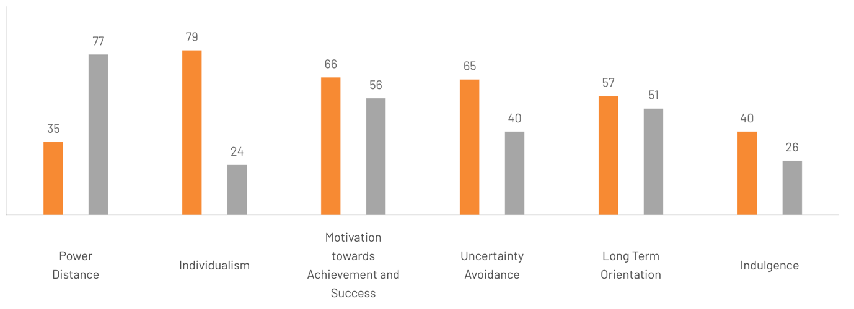
Figure 3: Culture Factor of India and Germany
(Source: The Culture Factor, 2020)
Based on the cultural factors compared in the above diagram, India has a higher power distance than Germany. India is higher only in Power Distance. On the other hand, Germany is higher in Individualism, motivation towards achievement and success, uncertainty avoidance, indulgence and long-term orientation. The factors can affect consumer autonomy in both countries.
In-Depth Comparison of Social Factors
In Germany and India, social factors influence Mercedes-Benz in quite different ways, as the cultural connotation of a high-end car does not coincide in the two markets. In Germany, the culture of purchasing a car is deep-rooted in a culture of mature ownership where the consumers highly value the engineering quality, safety, technology and long-term functionality. Even though cars continue to have symbolic value, the status is not as much pronounced as in the new luxury markets. It is noteworthy that 54% of Germans aged below 34 continue to see cars as a symbol of status, which indicates that prestige is still present and is balanced with the expectations in terms of performance and innovation (Continental AG, 2024).
In India, on the other hand, the demand for luxury cars is more socially visible and aspirational. Studies of Indian luxury consumption have revealed that customers who purchase luxury cars not only associate them with mobility but also with prestige and social status. This is supported by a younger, luxurious consumer base, with Mercedes-Benz India showing that the average age of buyers is approximately 38 years, which means that young professionals are getting into the segment earlier (Mukherjee, 2023). This translates into culturally competing with Mercedes-Benz by engineering credibility and sustainability in Germany. The brand should integrate the elements of technical excellence with prestige signalling, ownership experience and high aspirational positioning in India.

4.0 Comparison of the STP strategies in India and Germany

Figure 4: STP Framework
(Source: Self Developed)

4.1 Segmentation Strategy (India vs Germany)
Demographic segmentation
Demographic segmentation indicates that the market of luxury cars in India is very concentrated with wealthy urban consumers. The Indian luxury car market is estimated to be approximately USD 1.52 billion in 2026 and it is relatively small in comparison with developed markets and shows limited purchasing power among the citizens (Mordor Intelligence, 2026). In 2025, Mercedes-Benz sold approximately 19,000 vehicles in India, which suggests that the segment is focused on the niche market segment of high-income consumers, not the mass market (Shah, 2026). Conversely, Germany is a much bigger and developed market in the automotive sector, with approximately 2.86 million passenger cars registered in 2025, enabling premium brands to cater to a broader demographic base, such as upper-middle-income households and corporate buyers (Bekker, 2026).
Geographic segmentation
The two markets are further separated by the geographic segmentation. The demand of luxury cars in India is highly focused in large metropolitan areas like Delhi, Mumbai, and Bengaluru due to the high purchasing power and infrastructure in such areas to support high end cars. In contrast, the demand of premium cars in Germany is geographically decentralized in economically advanced areas of Bavaria, Rhine Valley, and the Ruhr industrial sector due to a higher national income inequality and transport infrastructure.
Psychographic segmentation
The psychographic segmentation is also quite different. Indian luxury car buyers tend to buy high-end cars to signal status and aspirational value of lifestyle, whereas German luxury consumers tend to focus more on the quality of their engineering, reliability, and technological performance when buying premium cars (Muller, 2023).
Benefit segmentation
The benefit segmentation shows the way consumers pursue various products benefits in both countries. Prestige and exclusivity are the perceived advantages in India, and that is why there is a high demand in high-end models of Mercedes which cost more than 1.5 crore in India (Thakkar, 2025). In Germany, it is important to note that most of the luxury car consumers are more focused on functionality and performance about 60% of the European premium buyers between the age of 35 and 55 years are more focused on buying SUVs with practical functions like versatility and all-weather in Germany (Market Data Forecast., 2025).

4.2 Targeting Strategy (India vs Germany)
The targeting by Mercedes-Benz in India and Germany is different because of the difference in market maturity, income distribution and purchasing behaviour. In India, the brand employs a high targeting approach and targets mostly the wealthy urban professionals, entrepreneurs and high-net-worth individuals with the ability to purchase high-quality vehicles. In 2025, the firm sold approximately 19,007 vehicles in India, indicating that luxury market is still relatively low and dominated by the luxury customers (Rivan RS, 2026).
The most sought-after models are the high-end luxury ones, as well as AMG performance cars, and sales of high-end cars are rising and entry-level luxury models are declining, meaning that Mercedes-Benz is appealing to more wealthy customers who are interested in prestige and exclusivity (Motilal Oswal, 2026). Also, the increasing number of young, affluent and aspirational consumers in India contributes to the growth of the luxury market, supporting the company in targeting premium lifestyle buyers, instead of the mass-market customers (Mukherjee, 2026).
The targeting strategy in Germany is more diversified and expanded since the domestic market is mature and more economical. The German luxury car market is much bigger and is projected to rise consistently to approximately USD 80.2 billion by 2033, enabling luxury brands to focus on various market segments such as individual customers, company fleets, and mobility services (Grand View Research, Inc., 2025). Corporate and leasing customers are another valuable target market in Germany, with the aid of high manufacturer-based financing and leasing programs applied by luxury cars (Ambekar and Wadhwani, 2024).

4.3 Positioning Strategy (India vs Germany)
Mercedes-Benz has a uniform luxury brand identity globally, and its positioning focus in India and Germany varies according to the expectations of the consumers and market maturity. Mercedes-Benz in India is an aspirational status/prestige brand, which is concerned with exclusivity, experience in owning luxury and social value. The company also focuses on high-end cars such as the S-Class and the Mercedes-Maybach line to assist in getting the high-end image of lifestyle among the high-income consumers. In India, the luxury car sales have gone to around 51,000 units in 2024, which implies that the market is an elite and status-based but not a mass-premium market (Thakkar, 2025).
The brand positioning in Germany is more geared towards engineering excellence, technological innovation, and sustainable mobility, especially with the EQ electric vehicle line and the latest safety technologies. In 2025, Germany recorded a figure of 2.86 million passenger cars, which has proven a mature market where performance, reliability and technology can determine consumer perceptions (Bekker, 2026).
Positioning statements
India
“Mercedes-Benz delivers prestigious luxury vehicles that symbolise success, exclusivity, and premium lifestyle for India’s affluent consumers.”
Germany
“Mercedes-Benz provides technologically advanced, high-performance premium vehicles that combine luxury with engineering innovation and sustainability.”
Positioning Map
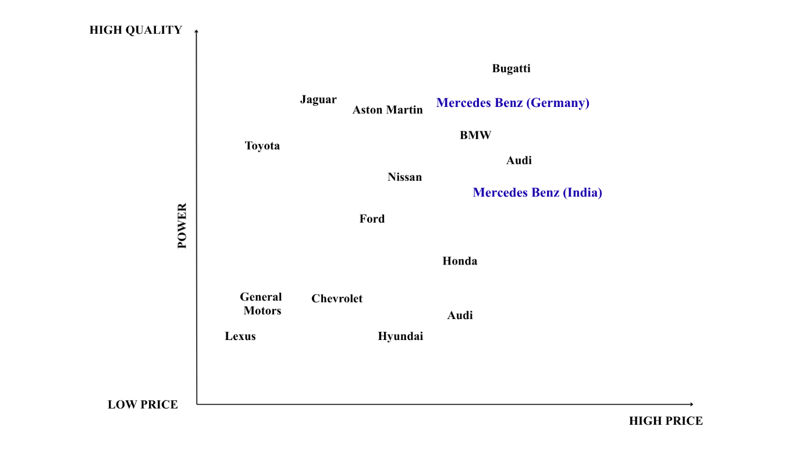
Figure 5: Positioning Map
(Source: Self Developed)
The price quality positioning map depicts the position of the Mercedes-Benz vis-a-vis the competitors in terms of quality and price. The price (low to high) is plotted on the horizontal axis and quality (low to high) on the vertical axis. High-price and high-quality segment is filled with luxury brands like Mercedes-Benz, BMW, Audi, Aston Martin and Bugatti. Mercedes-Benz in India and Germany can be found in this premium quadrant as it has a good image of quality engineering, innovation, and prestige. In the meantime, other brands such as Toyota and Honda have been in the middle price range, but not in the luxury range as these two brands have been more about reliability and value than luxurious brands.

5.0 Comparison of the Marketing Mix (7Ps) strategies in India and Germany

Figure 6: 7Ps of Marketing
(Source: Self-developed)
1. Product
India vs Germany
Mercedes-Benz India Pvt. Ltd. has a portfolio of selectively curated but high-end offerings, such as sedans, SUVs, AMG, EQ electric vehicles, and Maybach in India. The company clearly markets its product as not just a vehicle with the inclusion of products like Wishbox customisation and MB. CHARGE, and thus providing a luxury mobility system. This is indicative of the fact that the company realizes that the Indian consumer is a status, aspiration, and experience of ownership.
In contrast, Mercedes-Benz AG delivers a broader and more standardised product architecture, including compact cars, estates, vans, and advanced electric vehicles like the EQS in Germany. In this area, the company has been strategically oriented to engineering excellence, electrification, and innovation, which adapt to its sustainable mobility vision internationally (Mercedes-Benz AG, 2026). The two markets continue to have a premium offering whereby Mercedes-Benz has adjusted its focus to experiential luxury in India and technological leadership in Germany, as the balance between symbolic and functional value creation.
2. Price
India vs Germany
In India, Mercedes-Benz uses a pricing strategy of prestige and prices, such as GLA ₹51.8 lakh, EQS above ₹1.3 crore, can be indicative and change according to customisation. This is in line with the company's perception about the luxury pricing, which strengthens exclusivity and brand prestige, especially in the emerging markets with high levels of symbolic consumption (Mercedes-Benz, 2026).
In Germany, the company applies a more transparent and structured pricing model, supported by digital configurators and extensive leasing/financing options. Prices are well communicated (e.g., entry models with prices starting around €34,000), as part of a strategy to position Mercedes-Benz as a premium brand and accessible to a mature market (Padeanu, 2025). Mercedes-Benz licenses its pricing strategy with fluctuating, prestige/driven pricing in India and open, finance-backed pricing in Germany, consistent with consumer purchasing power and financial sophistication disparities.
3. Place (Distribution)
India vs Germany
In India, the company is dependent on a dealer-based omnichannel approach, backed by more than 100 dealerships and digital solutions like configurators and test-drive bookings (ET Auto, 2025). Local production of Mercedes-Benz in Pune is also another indication of its approach to improving its responsiveness in the market and cost-effectiveness (Khan, 2026).
In Germany, distribution is digitally interconnected and more direct, with online sales channels, verified used-car platforms, and brand experiences, like driving events (Sigal, 2022). This is indicative of the focus of the company on digital transformation and direct customer interactions in its domestic market.
The differences in infrastructure and consumer preparedness are evident in the relationship-based, dealer-focused strategy of Mercedes-Benz in India and the digitally developed, direct-to-consumer strategy in Germany.
4. Promotion
India vs Germany
The promotional strategies in India are emotional and are based on the aspirational messages that focus on the lifestyle, prestige and personal success. Campaigns like the one called in the title Drive your Mercedes-Benz, your way, are based on the knowledge of the status-oriented consumption tendencies in the company.
Germany is more rational and product-oriented in its promotion, focusing on innovation, electric (EQ range) and engineering quality (Reuters Staff, 2026). This is in line with the global communication strategy by Mercedes-Benz that focuses on technology leadership and sustainability. The business compares emotional promotion in India to identity-related promotion, versus functional technology promotion in Germany, where the business is relevant to the local consumer motivations.
5. People
India vs Germany
Customer experience in India is much affected by dealing with dealers, sales consultants and personalised service. Mercedes-Benz understands the need to build trust and relationships during high-involvement purchases (Pires et al., 2024).
In Germany, the company adopts a more organised and standardised service experience that is backed up by qualified personnel, online technologies, and systematised customer services (Mercedes-Benz, 2025). In India, Mercedes-Benz is more oriented towards relationship engagement, whilst in Germany, it is more oriented to efficiency, consistency and professional service delivery, which is the difference in service expectations.
6. Process
India vs Germany
India is a hybrid market, using digital instruments with offline dealer support. Ordering and financing, as well as configuration, take the form of guided interaction among customers, which is indicative of the adaptive approach of the company in an emerging market (Doval, 2021).
Germany has highly digitalised and smooth processes, which include configurators, direct purchases, leasing and after-sales services. This is part of a larger goal of Mercedes-Benz to provide a frictionless digital customer experience (Mercedes-Benz, 2025). India needs to have a more flexible and human-centred process, whereas Germany is more efficient and fully digitalised, showing different degrees of digital maturity.
7. Physical Evidence
India vs Germany
Physical evidence in India is centred on luxury showrooms, quality interiors and experience cues of ownership that promote the positioning of the brand as prestigious. Online products such as MB. CHARGE also increases the exclusivity perception (Thakkar, 2024).
Germany is more technologically oriented in terms of physical evidence, with new technologies like MBUX digital displays, infotainment, and sustainability displayed in the design (Priestner, 2018). Mercedes-Benz focuses on visual luxury and experience in India, and in Germany, it focuses on innovation, accuracy and technological prowess.

6.0 Comparative Analysis of Marketing Mix Adaptation Considering Environmental, Economic, and Cultural Factors (India vs Germany)
Product Strategy Adaptation
Socio-cultural and environmental factors have a great impact on product strategy. Stringent EU laws in Germany, like Euro 6 and more expansive climate policies, are encouraging low-emission and electric cars, forcing Mercedes-Benz to focus on innovation, electrification (EQ models), and sustainable engineering. This strategy is further fortified by German consumers, who appreciate performance, safety, and technology. Consequently, the company has a wide and technologically mature product line to meet environmental standards and practical requirements.
On the other hand, India has partially adopted BS6 norms, but a high level of infrastructure and slower EV uptake necessitate a more gradual approach to transition. Mercedes-Benz, in turn, is oriented on a carefully selected collection, which will incorporate a balance of internal combustion engine (ICE) cars and the new EVs. The Indian consumers have a social link with luxury cars and their status and aspiration, which prompted the company to beef up the product offerings through experience-based services like customisation and premium ownership programmes. Germany is an innovation-based, sustainability-oriented product development, and India needs a moderate mix of aspirational luxury and slow technological progress.
Price Strategy Adaptation
Pricing is a crucial aspect of economic factors. Germany is a high-income and mature market that favours a transparent pricing structure with solid financing and leasing terms. Customers demand value, flexibility and clarity, and Mercedes-Benz has embraced systematic and transparent premium pricing.
In India, there is less income inequality and a reduced luxury segment, thus making it strategic to price using prestige. Customisation tends to make prices flexible and affected by the customisation, which enhances exclusivity and perceptions of status. This is in line with the socio-cultural behaviour that increases brand desirability due to high prices. In Germany, Mercedes-Benz uses accessible pricing with support provided by finance schemes, whereas in India, the company uses premium and status-based pricing, as the purchasing power and consumer psychology are different.
Place (Distribution) Strategy Adaptation
Infrastructure and economic development have an impact on distribution strategies. The developed digital environment in Germany enables the use of a direct-to-consumer and digitally integrated distribution model by Mercedes-Benz, such as online sales and automated services. This is facilitated by high consumer confidence in digital systems.
Physical dealerships are crucial in the establishment of trust and provision of personalised experiences, particularly in high-value purchases in India. Cost-effectiveness and responsiveness are further supported through local manufacturing. Germany has a digitally mature, direct distribution setup, and India has a relationship-based, dealership-based distribution setup, which is influenced by infrastructure and trust relationship dynamics.
Promotion Strategy Adaptation
The influence of socio-cultural differences is most pronounced in promotions. Consumers in Germany are more focused on functionality, innovation, and sustainability, which means that Mercedes-Benz is forced to use more rational and product-oriented communication with special emphasis on engineering excellence and environmental performance.
In India, the culture of promotion is aspirational and emotional as it depicts a society where luxury represents social status and personal achievement. Lifestyle, status and identity are also other aspects of the campaigns aimed at attracting new high-income consumers. Mercedes-Benz compares functional, technology-based promotion in Germany with emotional, status-based communication in India, which corresponds to the dissimilar cultural motives.

7.0 Directional Development Strategy of Mercedes-Benz in India
The directional development strategy adopted by Mercedes-Benz in India indicates a market development strategy and premium growth strategy in a new luxury market. India is a high-growth market, with a growing number of high-net-worth individuals and the growth of aspirational consumption. In 2025, the company managed to sell some 19,007 vehicles, which nevertheless allowed it to remain the leading luxury car brand, despite the slight drop in volume (Shah, 2026). Notably, Mercedes-Benz has a 36% market share in the Indian luxury market, which reflects good brand dominance (Mohile, 2026).
Strategically, Mercedes-Benz aims at premiumisation and not increased volumes. It is reported that car models costing over 1 crore drive the growth in revenue, and high-end models constitute almost 25% of total sales, which has been a move towards high-margin segments (Shah, 2026). This is in line with the shifting consumer behaviour, which sees consumers giving more consideration to exclusivity and brand prestige. Also, the company has increased its retail and service network, and is focusing on younger affluent consumers, whose average age is approximately 38 years, signifying changing market demographics (Mukherjee, 2023).
Local production and product portfolio expansion are also priorities of the company, where it is planned to launch new models and reinforce the electric vehicle portfolio. Local production of flagship EVs in India is one of the few markets beyond Germany which shows strategic interest in long-term expansion (Kaur and Kumar, 2026).
It is gaining more competition, particularly with BMW and Jaguar Land Rover, which are quickly coming up with their premium products. Nevertheless, Mercedes-Benz continues to enjoy a good brand awareness and customer loyalty because of its quality, innovation and luxury. Overall, the Mercedes-Benz approach in India is a combination of market expansion, premium positioning and localisation, which enables the company to sustain leadership and to seize growth in the long run in a developing luxury automotive market.

8.0 Evaluation of Marketing Ethics Practice
The cultural relativism and perspective of justice can help to assess the marketing ethics of Mercedes-Benz. According to cultural relativism, it is possible that companies can adjust their marketing strategies to the cultural expectations of the local market, and the justice approach implies impartiality, transparency, and preservation of the interests of stakeholders. The high pricing, prestige-oriented positioning and the premium segmentation of Mercedes-Benz are relatively acceptable in both India and Germany since luxury markets inherently are run on exclusivity and differentiation. Nevertheless, ethical issues can occur when aspirational marketing messages overstate the status benefits or develop impractical expectations in consumers.
Moreover, there are other ethical issues associated with sustainability communication. Some of the instances of the so-called greenwashing on certain markets show that when making claims about the environment, one should provide clear evidence to not confuse customers. Ethical marketing thus entails a sense of transparency in sustainability communication and accountable operation in all markets. Mercedes-Benz ought to enhance the third-party environmental checks, report quantifiable sustainability results, and implement similar ethical practices in India and Germany. This would boost corporate credibility, keep consumers trusting and at the same time, global marketing adaptation would be socially responsible.

9.0 Conclusion and Recommendations
According to the analysis, Mercedes-Benz exhibits a powerful and balanced international marketing approach, which is not effective in all parts of India and Germany. The emphasis on engineering excellence, sustainability, and technological innovation in Germany is very successful, since it matches consumer expectations in a mature and performance-driven market. Nevertheless, there are strict rules and high competition, which necessitate constant innovation, especially in electric cars and electronic services.
Premium positioning and aspirational branding are strategies that are efficient in India in its target of high-net-worth individuals, with a 36% market share and sales of more than 19,000 vehicles in 2025. Nonetheless, the dependence on the premium segments restricts the penetration of the market. Therefore, Mercedes-Benz should expand its entry-level luxury and EV portfolio, supported by flexible financing options to attract emerging affluent consumers.
The company should also enhance localisation, including digital retail and customer experience, to enhance accessibility. A middle way between innovation in Germany and selective expansion in India will guarantee long-term competitiveness and sustainable growth.

10.0 Reflective Account
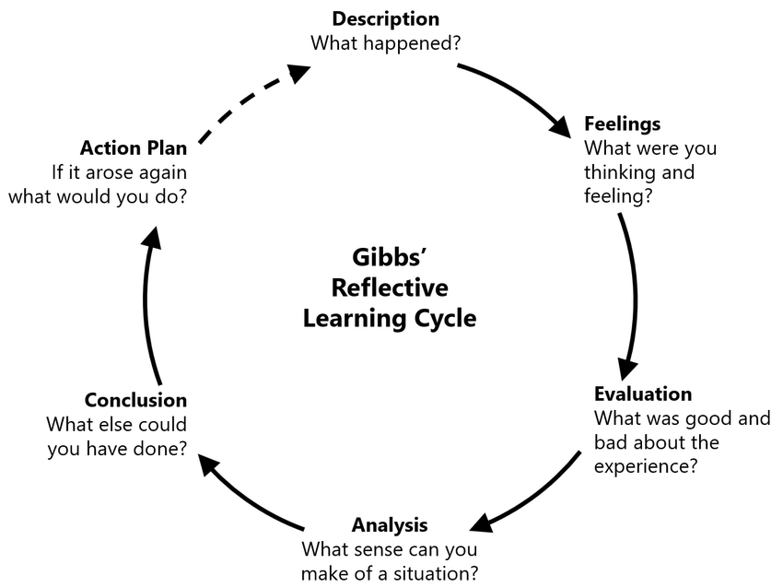
Figure 7: Gibbs Reflective Cycle
(Source: Harithuddin, 2021)
Description
The research, analysis, and preparation of the earlier stages of this assessment were done in a systematic and organised manner. First, I read the assignment brief to know about the requirements of PESTEL analysis, STP strategy and marketing mix comparison between India and Germany, with Mercedes-Benz as the centre of interest company (Nurlatifah, Purnawarman and Sukyadi, 2023). Thereafter, I sourced out information in a variety of reliable sources, such as government websites, company reports, and scholarly journals. In the case of the socio-cultural and legal aspects, official government resources were used to justify them, whereas company strategies were obtained based on the official websites of Mercedes-Benz and annual reports. The collected data were then structured within the contexts of the international marketing theory through the formulation of data into other frameworks like PESTEL and STP (Ahmadpour, Shariati and Moghadam, 2025). The last step was to synthesise the information into a logical report, together with a flow of logic and citing academic works.
Feelings
I had a few doubts at the onset of the process, especially in finding suitable and valid sources that could stand up to academic requirements, especially government-based legal sources. The amount of information presented also posed a problem in sifting through the relevant information (Ocampo et al., 2025). However, as I progressed, my confidence improved as I became more familiar with the databases and sources. Using frameworks such as PESTEL and STP made me feel more organised and in control of analysis. At the conclusion of the assignment, I was content with the fact that I was able to combine theory and real-life business practice (Galli and New, 2022).
Evaluation
The application of credible and current sources was one of the main advantages of my approach, as government publications and company reports were used, which contributed to the reliability of the analysis. Furthermore, the implementation of the commonly used frameworks, like PESTEL and STP, helped to compare India and Germany clearly. The analytical depth was also enhanced with the integration of both the academic theory and practical examples of Mercedes-Benz (Ezezika and Johnston, 2023).
However, there were some weaknesses in the process. It was time-consuming to handle the vast data, and sometimes I struggled to be concise and at the same time be able to have depth of analysis. Moreover, coordinating various parts, including the socio-cultural analysis and marketing strategies, demanded a thorough organisation, which at first presented a problem.
Analysis
This brought out the significance of the systematic research process and critical thinking when writing academic papers. The use of the analytical tools of the PESTEL and STP frameworks simplified working with the complex information and allowed comparing the countries in a systematised manner. It also highlighted the role of credibility of the source, particularly where law and politics are concerned, whereby government sources are required in order to be precise.
The process also proved the applicability of the international marketing theory in practice. In one case, the idea of standardisation versus adaptation was apparent in the approach of Mercedes-Benz in India and Germany, where they use various strategies. This is in line with the theories of global marketing, which highlight that there must be localisation in the various markets.
Conclusion
The experience of doing this assessment sharpened my research, analytical and academic writing skills. I gained improved knowledge of how to implement theoretical material in practical business situations and how to employ authoritative sources. Though information management and organisation of the analysis had some difficulties, it was solved with time planning and repetition. The experience has made me more confident to do independent research and to present structured academic work.
Action Plan
In the future, I will also strive to be more effective in my research by using more advanced search techniques and academic databases. The other area that I will endeavour to improve upon is time management, where I will take a specific time on data collection/analysis and writing. In addition, I would like to develop critical analysis skills by reading and analysing academic texts and studying different opinions. It will also focus on the clarity and conciseness of writing. Finally, I will also keep in mind applying such reflective practices as Gibbs cycle to evaluate my learning process and help me to continue my academic development.

References
Ahmadpour, N., Shariati, A. and Moghadam, M.P. (2025). Effect of narrative writing based on Gibbs’ reflective model on the empathy and communication skills of nursing students. BMC Medical Education, 25(1), p.10. https://link.springer.com/content/pdf/10.1186/s12909-024-06593-7.pdf
Ambekar, A. and Wadhwani, P. (2024). Europe Car Leasing Market Size - By Vehicle, By Lease-Type, By Propulsion, By Application, Forecast, 2024 - 2032. [online] Global Market Insights Inc. Available at: https://www.gminsights.com/industry-analysis/europe-car-leasing-market. [Accessed 16 Apr. 2026].
Bekker, H. (2026). Germany New Car Market Overview and Analysis – Full Year 2025. [online] Best-selling-cars.com. Available at: https://www.best-selling-cars.com/germany/2025-full-year-germany-car-market-overview-and-analysis/ [Accessed 16 Apr. 2026].
Continental AG (2024). Continental Mobility Study 2024 | Cars Are a Status Symbol for Many Young People. [online] Continental AG. Available at: https://www.continental.com/en/press/press-releases/cars-are-a-status-symbol-for-many-young-people/ [Accessed 16 Apr. 2026].
Dakić, P., Stupavský, I. and Todorović, V. (2024). The effects of global market changes on automotive manufacturing and embedded software. Sustainability, 16(12), p.4926. https://www.mdpi.com/2071-1050/16/12/4926
Doval, P. (2021). Now buy cars directly from Mercedes-Benz; dealers only for customer experience, deliveries and service. [online] The Times of India. Available at: https://timesofindia.indiatimes.com/business/india-business/now-buy-cars-directly-from-mercedes-benz-dealers-only-for-customer-experience-deliveries-and-service/articleshow/83180832.cms [Accessed 16 Apr. 2026].
Doval, P. (2026). ‘Luxury car prices will go up, not down’: Mercedes-Benz India MD on FTA, forex and 11 new launches. [online] The Times of India. Available at: https://timesofindia.indiatimes.com/auto/luxury-car-prices-will-go-up-not-down-mercedes-benz-india-md-on-fta-forex-and-11-new-launches/articleshow/128962509.cms [Accessed 16 Apr. 2026].
ET Auto (2025). Mercedes-Benz India, Zoho unveil ‘SKYLine’ dealer management system to elevate customer experience. [online] ETAuto.com. Available at: https://auto.economictimes.indiatimes.com/news/passenger-vehicle/mercedes-benz-india-and-zoho-launch-skyline-dealer-management-system-to-transform-customer-experience/124871148 [Accessed 16 Apr. 2026].
European Parliament (2022). EU ban on sale of new petrol and diesel cars from 2035 explained | Topics | European Parliament. [online] European Parliament. Available at: https://www.europarl.europa.eu/topics/en/article/20221019STO44572/eu-ban-on-sale-of-new-petrol-and-diesel-cars-from-2035-explained [Accessed 16 Apr. 2026].
European Union (2018). New EU type-approval rules for safer and cleaner cars: Frequently Asked Questions. [online] European Commission - European Commission. Available at: https://ec.europa.eu/commission/presscorner/detail/it/memo_18_3652 \ [Accessed 16 Apr. 2026].
EVBoosters (2024). The rapid expansion of the EU’s Electric Vehicle charging infrastructure. [online] EVBoosters. Available at: https://evboosters.com/ev-charging-news/the-rapid-expansion-of-eus-electric-vehicle-charging-infrastructure/ [Accessed 16 Apr. 2026].
Ezezika, O. and Johnston, N. (2023). Development and implementation of a reflective writing assignment for undergraduate students in a large public health biology course. Pedagogy in Health Promotion, 9(2), pp.101-115. https://journals.sagepub.com/doi/pdf/10.1177/23733799211069993
Galli, F. and New, K.J. (2022). Gibbs’ cycle review. Emotions as a part of the cycle. E Motion: Revista de Educación, Motricidad e Investigación, (19), pp.92-101. https://www.uhu.es/publicaciones/ojs/index.php/emotion/article/download/7224/6523
Gaur, S. and Verma, M. (2025). Luxury Consumption in India: Consumer Behavior, Market Trends, and Future Prospects. Stallion Journal for Multidisciplinary Associated Research Studies, pp.87–91. doi: https://doi.org/10.55544/sjmars.icmri.15.
Grand View Research, Inc. (2025). Germany Luxury Car Market Size & Outlook, 2030. [online] Grandviewresearch.com. Available at: https://www.grandviewresearch.com/horizon/outlook/luxury-car-market/germany [Accessed 16 Apr. 2026].
Imarc (2026). India Luxury Car Market Share, Size, Trends, Report 2023-2028. [online] www.imarcgroup.com. Available at: https://www.imarcgroup.com/india-luxury-car-market [Accessed 16 Apr. 2026].
IMF (2026). Inflation rate, average consumer prices. [online] Imf.org. Available at: https://www.imf.org/external/datamapper/PCPIPCH@WEO/IND/DEU [Accessed 16 Apr. 2026].
Kapoor, R. and Cyriac, G. (2024). Recent Political Developments and Investment Trends in India. [online] Morganlewis.com. Available at: https://www.morganlewis.com/pubs/2024/07/recent-political-developments-and-investment-trends-in-india [Accessed 16 Apr. 2026].
Kaur, S. and Kumar, A. (2026). Electric vehicles as a pathway to India’s sustainable development goals. Discover Sustainability. https://link.springer.com/content/pdf/10.1007/s43621-026-02643-w_reference.pdf
Khan, A. (2026). Mercedes to start local production of Maybach GLS model in Pune plant; posts sales of 19,007 luxury cars in 2025. [online] The New Indian Express. Available at: https://www.newindianexpress.com/business/2026/Jan/14/mercedes-to-start-local-production-of-maybach-gls-model-in-pune-plant-posts-sales-of-19007-luxury-cars-in-2025 [Accessed 16 Apr. 2026].
Market Data Forecast. (2025). Europe Luxury Car Market Report. [online] Market Data Forecast. Available at: https://www.marketdataforecast.com/market-reports/europe-luxury-car-market [Accessed 16 Apr. 2026].
Mercedes-Benz (2025). Annual Report 2025. [online] Available at: https://group.mercedes-benz.com/documents/investors/reports/annual report/mercedes-benz/mercedes-benz-annual-report-2025-incl-combined management-report-mbg-ag.pdf [Accessed 15 Apr. 2026].
Mercedes-Benz (2025). Hyper-personalised customer experience through AR and MR. [online] Mercedes-Benz Group. Available at: https://group.mercedes-benz.com/technology/innovation/research/hyper-personalised-customer-experience.html [Accessed 16 Apr. 2026].
Mercedes-Benz (2026). Configurator & Prices | Mercedes-Benz. [online] Mercedes-Benz. Available at: https://www.mercedes-benz.co.in/passengercars/configurator.html [Accessed 16 Apr. 2026].
Mercedes-Benz (2026). Mercedes-Benz | India - Official website. [online] Mercedes-Benz. Available at: https://www.mercedes-benz.co.in/ [Accessed 16 Apr. 2026].
Mercedes-Benz (2026). The all-electric EQS. [online] Mercedes-benz.com. Available at: https://www.mercedes-benz.com/en/vehicles/eqs/ [Accessed 16 Apr. 2026].
Mohile, S. (2026). Mercedes-Benz India posts first sales decline in five years. [online] The Economic Times. Available at: https://economictimes.indiatimes.com/industry/auto/cars-uvs/mercedes-benz-india-sales-fall-1st-time-in-5-years/articleshow/126532484.cms [Accessed 16 Apr. 2026].
Mordor Intelligence. (2026). Mordor intelligence. [online] Mordorintelligence.com. Available at: https://www.mordorintelligence.com/industry-reports/india-luxury-car-market [Accessed 16 Apr. 2026].
Motilal Oswal, (2026). Mercedes India sets new revenue record on luxury car sales | Motilal Oswal. [online] Motilal Oswal. Available at: https://www.motilaloswal.com/news/economy-_-outlook/124622 [Accessed 16 Apr. 2026].
Mukherjee, S. (2023). New buyer age: Young and restless driving change at motown’s luxury street. [online] The Economic Times. Available at: https://economictimes.indiatimes.com/industry/auto/auto-news/new-buyer-age-young-and-restless-driving-change-at-motowns-luxury-street/articleshow/104955314.cms [Accessed 16 Apr. 2026].
Mukherjee, S. (2026). Luxury car sales in India set to double by 2030, says BMW. [online] The Economic Times. Available at: https://economictimes.indiatimes.com/industry/auto/cars-uvs/luxury-car-sales-in-india-set-to-double-by-2030-says-bmw/articleshow/130261081.cms [Accessed 16 Apr. 2026].
Müller, P. (2023). Who really drives luxury cars in Germany - DRIVAR. [online] Drivar.de. Available at: https://en.drivar.de/the-demographics-of-luxury-car-ownership-in-germany-who-really-drives-the-dream/ [Accessed 16 Apr. 2026].
NITI Aayog (2025). NITI Aayog Launches the Report on ‘Unlocking a $200 Billion opportunity: Electric Vehicles in India’. [online] Pib.gov.in. Available at: https://www.pib.gov.in/PressReleasePage.aspx?PRID=2152240&reg=3&lang=2 [Accessed 16 Apr. 2026].
Nurlatifah, L., Purnawarman, P. and Sukyadi, D. (2023, December). The implementation of reflective assessment using Gibbs’ reflective cycle in assessing students’ writing skill. In AIP Conference Proceedings (Vol. 2621, No. 1, p. 070006). AIP Publishing LLC. https://pubs.aip.org/aip/acp/article-pdf/doi/10.1063/5.0143375/18237937/070006_1_5.0143375.pdf
Ocampo, F.A., McIntyre, B.G., Massey, D. and Saunders, R. (2025). Nursing student reflections on a research internship: A reflective discussion following the Gibbs&#39; reflective cycle. Nurse education today, 145, p.106481. https://www.sciencedirect.com/science/article/pii/S0260691724003915
Padeanu, A. (2025). Mercedes Plans New Entry-Level Car Because Volume Matters. [online] Motor1.com. Available at: https://www.motor1.com/news/773226/mercedes-new-entry-level-car/ [Accessed 16 Apr. 2026].
Pires, P.B., Prisco, M., Delgado, C. and Santos, J.D. (2024). A conceptual approach to understanding the customer experience in e-commerce: An empirical study. Journal of theoretical and applied electronic commerce research, 19(3), pp.1943-1983. https://www.mdpi.com/0718-1876/19/3/96
Priestner, M. (2018). MBUX – Mercedes-Benz user experience: revolution in the cockpit | Automotive World. [online] Automotive World. Available at: https://www.automotiveworld.com/news-releases/mbux-mercedes-benz-user-experience-revolution-cockpit/ [Accessed 16 Apr. 2026].
Rao, A. (2026). India–EU FTA Luxury Auto Impact: Tariff Cuts, Quotas & Market Access. [online] India Briefing News. Available at: https://www.india-briefing.com/news/india-eu-fta-luxury-cars-tariffs-market-access-42127.html/ [Accessed 16 Apr. 2026].
Reuters Staff (2026). Germany ranks second worldwide for EV production in 2025, VDA says. Reuters. [online] 4 Feb. Available at: https://www.reuters.com/business/germany-ranks-second-worldwide-ev-production-2025-vda-says-2026-02-04/ [Accessed 16 Apr. 2026].
Rivan RS, (2026). Mercedes India sales drop by nearly 3 percent in 2025. [online] Autocar. Available at: https://www.autocarindia.com/car-news/mercedes-india-sales-drop-by-nearly-3-percent-in-438805 [Accessed 16 Apr. 2026].
Shah, A. (2026). Mercedes India’s revenue hits fresh record on strong top-end luxury sales. Reuters. [online] 15 Jan. Available at: https://www.reuters.com/world/india/mercedes-indias-revenue-hits-fresh-record-strong-top-end-luxury-sales-2026-01-15/ [Accessed 16 Apr. 2026].
Sigal, P. (2022). Mercedes to cut dealerships, move to direct sales in distribution overhaul. [online] Autonews.com. Available at: https://www.autonews.com/retail/mercedes-cut-dealerships-move-direct-sales-distribution-overhaul/ [Accessed 16 Apr. 2026].
Singh, A.R., Dharme, A. and Bisht, J.S. (2026). Enhancing Road Safety through Vehicle Modifications: A Critical Study of the Indian Legal Framework. AIJFR-Advanced International Journal for Research, 7(2). https://www.aijfr.com/research-paper.php?id=4305
Thakkar, K. (2024). Mercedes-Benz Rolls Out MB.Charge in India. [online] Autocar Professional. Available at: https://www.autocarpro.in/news/mercedes-benz-rolls-out-mbcharge-in-india-to-simplify-ev-charging-experience-130585 [Accessed 16 Apr. 2026].
Thakkar, K. (2025). Indian luxury car market grows 6% to 51,200 units in 2024. [online] www.autocarpro.in. Available at: https://www.autocarpro.in/news/indian-luxury-car-market-grows-6-to-51200-units-in-2024-124314 [Accessed 16 Apr. 2026].
The Culture Factor. (2020) Country comparison tool. [Online]. Available at: https://www.theculturefactor.com/country-comparison-tool?countries=germany%2Cindia [Accessed 16 Apr. 2026].
Vats, I., Singhal, D., Tripathy, S. and Jena, S.K. (2022). The transition from BS4 to BS6 compliant vehicles for eco-friendly mobility in India: An empirical study on switching intention. Research in Transportation Economics, 91, p.101131. https://www.sciencedirect.com/science/article/pii/S0739885921001037
Worldometer (2026). GDP per Capita. [online] worldometers.info. Available at: https://www.worldometers.info/gdp/gdp-per-capita/ [Accessed 16 Apr. 2026].

