Fieldwork portfolio
Sophie price
2213749

Section 1
Table of contents

Section 1
Table of contents

Section 2
Acknowledgements

Section 3
Professional development plan
Professional development plan. By student after consultation with the learning mentor and fieldwork supervisor at the outset of the placement
Reflections from supervision

Section 4
Learning mentors final report
Supervisors final report
Placement contract
Practice supervision contract

Section 5
The Journal-
An observation of work placement identifying good youth work practice
A community profile
A summary of your own learning and development, linked to your professional development plan.

Section 6
Reference list

Section 7
Appendix
Photos of tasks with young people
Supervision reading formats
Log of placement hours
Activity I planned for the young people using the method NAOME
- Baking heart shapes cookies
- Making Valentine’s Day cards
- Painting Valentine’s Day rocks
Evaluation sheets for my NAOME activity
Reflections of my practice
Photos of activities I ran with the young people.
Risk assessment

Section 2
Acknowledgements
I would personally like to thank, Rachel Jenkins who has been my supervision and Steve Lewis who has been my learning mentor and all the support they have gave me. I would also like to thank all the young people that took part in all my activities.

Section 3
Personal development plan
PROFESSIONAL DEVELOPMENT PLAN

 | 1. Work in accordance with the 5 pillars of Principles and Purposes of Youth Work in Wales (YWWRG, 2018) (Educative, Expressive, Participative, Inclusive, Empowering). | 2. Facilitate the personal, social and educational development of young people | 3. Promote inclusion, equality and young people’s interests and wellbeing | 4. Work with young people and others  Develop youth work strategies and practice | 5. Develop read and manage myself and others
What do you need to learn? | Educative- what does education in youth work look like?  Expressive- how can we help young people express their emotions and hobbies? | What is social education?  What is development in youth work? | How do I get a fully understanding of the young people I work with enjoy? | What I need/ want from my placement  Improving my practice through feedback | Planning activities inside and outside of youth work.  Check my practice/ concerns and reflect with my colleagues
Activities you will learn from (how will you learn, what will you learn from) | Educative- reading and making notes so I can incorporate it in my practice  Expressive- look at what everyone enjoys doing and make my own activities | Reading about social skills  What skills do young people need to have to progress in their life  Discuss with my colleges | Observe the young people  Speaking to the young people  Do research of what struggles the young people are dealing with. | Have a discussion with my colleagues  Reflection after may activity or session  Ask questions to my colleagues | Promptly respond to any emails.  Making sure everyone knows the key dates.  Asking questions if unsure or uncertain

Student | Sophie price
Supervisor | 
Date | 6th November 2022

Professional development plan. By student after consultation with the learning mentor and fieldwork supervisor at the outset of the placement

PROFESSIONAL DEVELOPMENT PLAN
For completion by the student after consultation with the Learning Mentor and Fieldwork Supervisor at the outset of the Placement
Student | Sophie Price
Learning Mentor | Steve lewis
Placement | Milford haven youth centre.
Date | 31st October 2022

Students will be expected to consider their placement experience to demonstrate competence in the key aspects of youth work outlined in the table below based on the National Occupational Standards for Youth Work (CLD Standards Council Scotland, 2019) and the Youth Work in Wales: Principles and Purposes Document (YWWRG, 2018).
Learning Mentor’s/mentor’s opening comments about the placement – exactly what type of work will the placement involve?
Sophie’s placement will be working within the Community Youth Team which is part of Pembrokeshire County Councils Youth Service.
Sophie will be based at Milford Haven Youth Centre, which is purpose built Youth Centre in the heart of the community. Sophie’s setting will be centre-based work. Sophie’s placement will be three evenings a week – Monday, Wednesday and Thursday, 6:00-8:00pm. Sophie will work with the age range 11-25, however the membership is predominately 11-18 years old. Sophie will have opportunities to reflect on practice with colleagues after each youth club session.
The delivery methods will be curriculum specialities like arts and culture, sport, citizenship, health etc. Sophie will support project work and group work with young people. Sophie will work alongside a full-time Community Youth Worker and part-time Youth Support Workers. Sophie will have the opportunity to work additional placement hors by supporting after school clubs, trips, youth forums and extra hours in other youth clubs.
The work will be based on the voluntary engagement of young people. Sophie will promote and actively encourage opportunities for all young people in order that they may fulfill their potential as empowered individuals and members of communities. Sophie will offer opportunities for learning that are educative, expressive, participative, inclusive and empowering. (Youth Work in Wales: Principles and Purposes Document 2022.)

Student initial comments about the Placement.
I will be working in Milford haven youth club, 3 nights a week on an Monday, Wednesday and Thursday from 6-8pm, this will help me develop my understanding of youth work, and will help me develop on my personal development plan. I will be staying 15 minutes before these sessions and 15 minutes after to talk with my work colleges and discuss the evening and give me time to reflect on my work.

Section 4

LEARNING MENTORS FINAL REPORT
The University would like to remind the Learning Mentor of the importance of their role in the assessment of the student. This role is fundamental in ensuring standards of practice of those working with young people in communities, and cannot be taken lightly.
To ensure the desired results are achieved, all those involved in the placement are required to understand and remain committed to the process of supervised practice. Issues of competence which might jeopardise a student’s ability to complete workplace/work based practice successfully should be identified and communicated to the visiting tutor or fieldwork coordinator as soon as possible.
After the student’s induction to the placement, the student will have drawn up a professional development plan balancing the needs of the student and the requirements of the programme. As Learning Mentor you will have carried out managerial supervision and an interim review of the placement. This document is the final report, and will include your final assessment of the standards achieved by the student on placement and an assessment of an observed piece of youth work practice.
Key areas of competence
When considering the level of competence of a student please refer to the marking criteria outlined below:
Grade | Description | Equivalent % marks towards HE qualification
A | An exceptional trainee Youth worker who is a reflective practitioner; shows initiative and an ability to work independently for a sustained period; demonstrates thoroughness and commitment to all aspects of professional practice. | 70%+
B | An effective trainee youth worker who displays a degree of independence and commitment to further professional development. | 60-69%
C | A satisfactory trainee youth worker who has met the requirements appropriate for a professionally qualified Youth Worker and with further experience should develop into an effective youth worker. | 50-59%
D | A rather weak trainee youth worker with a basic level of knowledge or skill. May be very poorly organised with very limited understanding of important concepts. | 40-49%
E/Fail | A weak trainee youth worker who has been unable or unwilling to meet the required standard, may demonstrate inappropriate values or lack understanding or attention to detail. | Below 40%

LEARNING MENTOR’S FINAL REPORT (continued)
Work in accordance with the pillars of Youth Work in Wales: Principles and Purposes
A-Exceptional  70%+ | B-Effective  60-69% | C-Satisfactory  50-59% | D-Rather weak  40-49% | E-Weak  0-39%
Sophie has shown respect for young people during her placement. Sophie is aware of the importance of inclusion and equal opportunities. Sophie is aware of the importance of offering young people opportunities through a voluntary relationship. Sophie has supported a range of projects and activities during Youth Club sessions and holiday programmes that are in accordance with the pillars of Youth Work in Wales: Principles and Purposes. In particular, Sophie supported a banner-making project at The Edge Youth Centre that looked at what is important to young people. Sophie empowered young people to recognise their rights and the importance of being involved in decision-making structures that affect their lives. Sophie has led on educative projects, particularly cooking at Youth Club.

Facilitate the personal, social and educational development of young people
A-Exceptional  70%+ | B-Effective  60-69% | C-Satisfactory  50-59% | D-Rather weak  40-49% | E-Weak  0-39%
Sophie has the ability to form good relationships with young people. Sophie is aware of the importance of building trusting relationships with young people in order provide advice and support to young people. Sophie has worked across a number of youth club settings supporting Youth Club Team Leaders and Community Youth Workers with the facilitation of a youth club curriculum development plan. Sophie has helped facilitate open-access youth club sessions which allow young people to participate in positive leisure activities and learn new skills in a safe environment.

Promote inclusion, equality and young people’s interests and wellbeing
A-Exceptional  70%+ | B-Effective  60-69% | C-Satisfactory  50-59% | D-Rather weak  40-49% | E-Weak  0-39%
During placement, Sophie has worked with a number of young people who all have different interests and ability levels. Sophie has adapted very well to each situation. Sophie has supported a ‘Quiet Hour’ session at the Edge Youth Centre that provides a quiet time for young people with ASD or ALN. Sophie showed a very compassionate side and was very good at building a rapport with young people who attended this session. Sophie should where possible consult with young people on how we can best provide a provision that meets the needs of young people. Equally as important is evaluation – whether this is done verbally or through a written approach. Sophie should continue to seek feedback to continue to improve and reflect on her practice.

Work with young people and others
A-Exceptional  70%+ | B-Effective  60-69% | C-Satisfactory  50-59% | D-Rather weak  40-49% | E-Weak  0-39%
Sophie is a well-liked member of the staff team and is supportive of her colleagues. At the beginning of her placement, Sophie did not appear confident enough to ask her colleagues for support or guidance. However, more recently we have seen Sophie seek support and feedback on her practice.
When working with young people Sophie is a natural in a youth club environment. It is evident that Sophie’s own experience of being a beneficiary of youth service means she has a good understanding Youth Clubs. Towards the end of the Sophie’s placement, she has seeked out opportunities that have taken her away from her comfort zone. For example, alongside Youth Club she has supported Quiet Hour (session for young people with ALN,) an art project in partnership with SPAN Arts and a warm space session for young people age 16-24.

LEARNING MENTOR’S FINAL REPORT (continued)
How has the student developed during the placement?
Sophie has developed over the six months with the Community Youth Team. She has gained the confidence to lead on activities and seek feedback from both young people and her colleagues. Sophie is able to build strong relationships with young people and is very relatable for a number of young people attending Youth Club. Sophie understands the importance of observing her colleagues and using this to reflect on her own practice in order to make improvements. More recently, Sophie has looked for opportunities to work outside the normal youth club environment. This has given Sophie a more rounded experience and enabled Sophie to understand the importance of developing a service that takes into account young people requirements and interests.
What are your suggestions for further development? What would be your recommendations for the Student’s development during the Level 5 placement?
Sophie should take any opportunity to shadow experienced Youth Workers to develop her understanding of Youth Work. I feel it would beneficial for Sophie to participate in a multi-agency/partnership project, which allows her to observe the benefits and sometimes frustration of partnership working.
In order to develop Sophie should speak to her colleagues if she has any questions or is not sure on how to approach a situation. By being open to constructive criticism and conversations about practice, it will enable Sophie to reflect on situations and develop her confidence.
What is your feedback on observing the student’s planned piece of practice?
I observed Sophie deliver a Valentines Baking Cooking session. Sophie put together a clear plan using the NAOMIE planning tool and evaluated using paper feedback forms. The young people who participated clearly enjoyed the activity despite the baking not going to plan! Sophie explained her instructions well and there was an element of educative youth practice. Sophie planned to extend this piece of work by doing Valentine Cards and Rock painting on the other youth club nights. Sophie reflected well on her session and felt her evaluation session could have been more interactive using flip chart/post-it notes etc. The Youth Club was very busy on this evening, which meant it was not always easy for the young people to concentrate but Sophie engaged with them well with her enthusiasm for the activity. Sophie’s session met all health and safety standards.
Has the student passed the placement? Please take into account your view of the student’s performance in each of the Key Aspects of Youth Work (Please circle clearly).
Yes, Pass | No, Fail
Provisional Grade: C
Further Comments
Thank you for you dedication during your placement Sophie. You have developed over the last six months, which is a testament to your commitment and motivation to work with young people. Keep reflecting, utilizing supervision and observing your colleagues. Thanks, Steve.

Signed Learning Mentor | S. Lewis
Signed Student | S. Price
Date | 20th March 2023

Supervisor final report

FIELDWORK SUPERVISOR’S FINAL REPORT
This section of the report should be completed by the fieldwork supervisor. To complete the report we would like you to use the headings below giving specific examples to support your observations.
How did the student use supervision and respond to feedback?
Sophie has worked really hard during the past couple of months and I have seen a big change in her regarding her practice during her placement.
Sophie has been completing her placement hours mostly in Milford Haven youth club, with the odd few supporting sessions at Haverfordwest youth center. Sophie has taken time during her placement to meet and work with new young people at Milford Haven youth Centre. This has enabled her to develop new relationships and has built her confidence when doing so.
Sophie took full advantage of these supervision sessions by planning what she would like to discuss and taking charge on when and where she would like her supervisions. Sophie has shown willingness to learn and grow as a youth worker. During our sessions Sophie engaged in informal conversations with myself regarding her placement and youth work in general.
To what extent did the student seek challenging situations, and how were these worked with?
Within practice Sophie was provided a wide range of opportunities to further develop her youth work knowledge and experienced difficult situations within her placement. With some of these situations Sophie has been effective when dealing with problems and has always had her focus on the young people. During Sophie’s supervision session she has learnt to further reflect and evaluate her own approaches to situations and understood what steps she can take to improve her own practice.

To what extent did the student show enthusiasm and commitment?
Sophie has always been prepared during her supervision and planned what she would like to discuss and do. She has utilized the knowledge of staff that she has been working with to plan, deliver and evaluate her sessions. Sophie is a valued staff member and is relied upon to engage with young people and support the team leader in delivering activities during the sessions. Sophie was presented with opportunities to further her development and gain more hours for her placement however on some occasions she chose not to take on the extra sessions/trips. I would encourage Sophie to jump at any opportunity she is presented with as it will help her expand her knowledge on the different places that youth work happens.

How well was the student able to relate theory to practice and reflect on their own practice and that of others?
Sophie has shown that she can effectively link theories to her own practice. This has proven to be a valuable tool for Sophie as it has provided her with structure and methodology during her reflections. She has shown that she is reading and using the correct youth work theories and mythologies such as CWYVS Youth work in wales and NOS. to reflect back into her practice. When progressing to level 5 I would encourage Sophie to look at different theories and draw upon them when doing her next placement.
How did the student articulate their own beliefs and values and relate them to the work?
Sophie has taken her learning into her own hands and has proven that this is the field of work that she would like to progress in. Sophie has been empowered to take ownership of her own learning and has learn to express her views in a professional manner, whether it be in supervision or to her team leader. Sophie has progressed from where she started by building relationships with young people whilst maintaining a professional boundary with them.

How pro-active was the student in demonstrating anti oppressive beliefs, language, and behaviour?
Sophie has been in situations where she has had to challenge behavior that isn’t acceptable in youth clubs and she has been able to do this confidently as she has grown confidence in her practice and understands the team dynamic amongst the staff members. As mentioned previously, Sophie has communicated effectively with both young people and staff.

In your professional opinion has the student achieved the necessary standards to progress to Level 5?
Yes

Student’s Provisional Grade (Please refer to the grading criteria above)
B

Signed Supervisor
Signed Student | S. Price
Date | 23/03/23

Placement contract
FIELDWORK PLACEMENT CONTRACT
Where possible please complete this information electronically, the text boxes will expand to contain the necessary information.
STUDENT INFORMATION
Student Name | Sophie price
Student Address | 28 glenfields road,  Haverfordwest,  Sa611eb
Student University e mail | 2213749@uwtsd.ac.uk
Student DBS Status and date | 31/10/2022- completed
Additional requirements | None
Name of fieldwork supervisor | Steve Lewis
Fieldwork supervisor Tel. | 07825365150
Fieldwork supervisor e mail | Steve.lewis@pembrokeshire.gov.uk

HOST ORGANISATION INFORMATION

Name of Organisation |  |  | Pembrokeshire youth service
Tel. |  |  | 07825365150
Email |  |  | Steve.lewis@pembrokeshire.gov.uk
Aims/ Purpose of the Organisation |  |  | To provide young people aged 11 – 25 with universal access to opportunities, activities and youth clubs within the community, based on a voluntary relationship
Duration of placement |  |  | Level 4 Placement: 200 hours (100 or more face to face Youth Work).
Please outline the activities expected of the student  (Use more space if necessary) |  |  | Support the Youth Club Team Leader with the delivery of programmes and activities relating to the curriculum development plan.
Facilities/equipment available to student |  |  | Sophie will complete her placement in Milford Haven Youth Centre. Resources will be available to facilitate youth club activities.
Please confirm that your organisation has in place the following procedures/policies and where the student can have access to them:
a. Equal Opportunities Policy and procedures |  |  | Available on the Pembrokeshire County Council Intranet. Sophie has been e-mailed the policy.
b. Safeguarding policy and procedures including a designated child protection officer |  |  | Available on the Pembrokeshire County Council Intranet. Sophie has been e-mailed the policy.
c. Disability Policy (please state how you will meet any special requirements noted by the student) |  |  | Available on the Pembrokeshire County Council Intranet. Sophie has been e-mailed the policy.
d. Health and Safety Policy and procedures |  |  | Available on the Pembrokeshire County Council Intranet. Sophie has been e-mailed the policy.
e. Risk assessments including significant risks identified? An example to be provided to the University. |  |  | Available on the Pembrokeshire County Council Intranet. Sophie has been e-mailed the policy.
f. Appropriate measures, informed by up to date legal requirements and public health guidance to  minimise health risks associated with COVID-19 |  |  | Available on the Pembrokeshire County Council Intranet. Sophie has been e-mailed the policy.
During induction the student will be made aware of the organisation's rules of conduct (including boundary management), practices and policies, including Safeguarding and Health and Safety (e.g. accident reporting), First Aid contact details and materials and fire procedures.

During induction the student will be made aware of the welfare facilities available during placement.
The student will be covered by your employer's liability insurance whilst on your premises and undertaking any assigned tasks.

Yes No
During the placement, the student will be responsible to:

Name of Learning Mentor |  | Steve Lewis
Position |  | Senior community support worker
Telephone No. |  | 07825365150
Email |  | Steve.Lewis@pembrokeshire.gov.uk
UNIVERSITY INFORMATION

Name of visiting tutor | Frances Chester
Telephone Number | 01267 676929
Email address | F.chester@uwtsd.ac.uk

Student, Learning Mentor, and Visiting Tutor to sign below:

I hereby agree to the terms and conditions outlined above

Signed (student)………………S.Price………………………………. Date: 03/11/22
Signed(LearningMentor)…………… …………… Date : 03/11/22

Signed (visiting tutor) FChester Date: 03/11/2022

FIELDWORK PRACTICE SUPERVISION CONTRACT
Practicalities | Sophie will be required to take a lead on supervision and will need to contact me to arrange times and places to meet. Sophie had suggested meeting once a month before her deadline and the supervisions will be held in the The Edge Youth Centre as it is convenient for her
For example - timing, frequency, place, what are reasonable interruptions.
Boundaries | During supervision sessions, Sophie can discuss anything she is struggling with, situations she feels she may not have handled correctly.  The purpose of supervision is to provide a safe, supportive environment for Sophie to engage in critical reflection in order to raise issues, explore problems and discover new ways of handling difficult situations and aiding her personal development during her time at university.  The supervision sessions will be confidential, unless as Sophie supervisor a situation needs to be escalated accordingly.
What can be discussed, what cannot, confidentiality, how will gossip be dealt with.
Working together | At the start of these session Sophie and I will discuss our shared expectations and what we intend to achieve in our sessions. The focus of our relationship will be to help support Sophie’s professional development and to provide a space for her to voice any concerns.  Sophie mentioned that she is nervous about finding a different placement next year however she is excited to develop her knowledge and skills.
Sharing expectations, what the focus of the relationship will be, hopes and fears, the ethos of the supervision.
Session Format | During each of the supervision sessions, I will try to make Sophie feel comfortable and hopefully create a safe space for Sophie to open up about her placement.  Sophie will be expected to have prepared an agenda of what she would like to discuss with me. The time spent in each session will depend upon the topics/issues to be discussed and the amount of time required.
What will each session be like? Will all the time be spent on one incident; are supervisees expected to bring written recordings or verbatim accounts?
Organisational & Professional context | Sophie is expected to follow Pembrokeshire Youth’s policies and procedures.  Sophie will take lead on these sessions and write an agenda for the session so she knows exactly what she would like to discuss. It is Important for me as her supervisor I give Sophie my full attention and support during each session and throughout her placement.  Sophie will also record the sessions using a supervision recording format given to her by the university.
Expectations, fitness to practice, responsibilities on supervisor and supervisee, professional and ethical boundary discussions.

Signed (supervisee) Sophie Price Date: 07/11/22
Signed (supervisor) Rachael Jenkins Date : 07/11/2022

Section 5-
The journal
In this journal , I will be showing my observations of my work placement, this includes the aim and structures of my work placement. I have also presented a community profile. The community profile is where I done my work placement, I also ran some activities with the young people to get a good understanding of what they feel about their home area. I also put in my community profile, what jobs people have within Milford haven, what education people have, what kinds of housing there are within Milford haven, and what Milford haven has to offer for the young people. I have also discussed my personal development plan, that I made before I started my placement and how through my placement I have developed my learning, within my professional development plan whilst being on my placement in Milford haven youth club.

I will be showing my observations of the work placement I took part in for my level four placement. I will be showing my understanding of what the aim of the organisation is, what was good about my placement. Also what was not so good, and how they could improve. I will show my understanding of the building, if it is suitable and well structured.

For my level four placement, I chose youth club based youth work. I was in Milford haven youth club. The aim of the organisation is ‘to provide young people aged 11-25 with universal access to opportunities, activities and youth clubs within the community, based on voluntary relationships’ (Pembrokeshire youth, unknown date, pg.1). I feel the youth club achieved that aim whilst I was on placement there. I worked with young people ages 11-25 to provide many different opportunities, some young people with additional learning needs. I built professional relationships with the young people. Milford haven youth club is one of the only centred based just for youth work in Pembrokeshire. The good thing about being on placement in Milford haven youth club is I was given the opportunity to build relationships and also have the ability to conduct activities that I had planned and also have the time to reflect on these activities. The thing I would improve about my placement is for them to do more within the community, for example doing a community litter picking session. Another thing my placement could improve on is for the youth club to get more organisations to come in and talk to the young people to educate them on different topics, for example the job centre, or careers wales. In Milford haven youth centre it had 3 rooms, a computer room, a room the young people can watch television, and a room for all the arts and crafts. There is also a hall where there is a sporting activity going on every session. There is also a kitchen where we bake most sessions, and the young people get to choose what we bake. There is also one female toilet, one male toilet, and also one disabled toilet. The building is also accessible for any young people with disabilities, there are no steps or stairs in the building that young people with disabilities can not access. Milford haven youth centre is situated ’17 minutes’ (google maps, unknown date) from the train station and ’17 minutes’ (google maps, unknown date) from the bus station. This means the transport is not far for the young people. Milford haven youth centre is there just for youth work, but some days other organisations sometimes rent it out for activities. Whilst I have been on placement there has been three members of staff to run the youth club sessions. However due to the increase of the young people coming to youth club, they have had to employ another member of staff, so there are now four members of staff. In regards to volunteers Milford haven youth club are there to provide the young people with ‘volunteering opportunities’ (Pembrokeshire youth, unknown date, pg.2) The volunteers take part in activities and have the opportunities to lead an activity. They will also run the tuck shop for the night, this will provide the young people with a lot of new skills, for example, money handling and their maths skills. The youth club ‘provide non-formal and informal educational opportunities and experiences to enhance the personal, social and political development of young people’ (Pembrokeshire youth, unknown date, pg.1) I feel Milford haven youth club is well structured , it is open Monday, Wednesday and Thursdays, from 6pm-8pm, so it gives the young people enough time to go home, have there dinner, and get to youth club. Milford haven youth centre also do a session for any young people open on Monday 1pm-3pm, they have called this session a warm space, the session is for any young people that wants a warm meal, and they have full access to the washing machines and tumble driers. The young people also come to the session as it gives them a safe space and someone to talk to. I feel this time is not suitable for everyone’s needs as it is within school hours and most of the young people are in school and can not attend the session. Due to this there are only young people that are no longer in school and have not attended further education whether that is sixth form or college or the young people that do not have a job.

To conclude, from my research I have shown my understanding of my placement in Milford haven youth centre. I have also shown my understanding of what the youth club offers the young people, and if it is accessible for every young persons needs. I have shown what is good, not so good and what they could do to improve.
Google maps. (Unknown). Milford Haven Youth Centre, Priory Rd, Milford Haven SA73 2EB To Milford Haven SA73 2BP. [Online]. Google maps. Last Updated: Unknown. Available at: https://www.google.com/maps/dir/Milford+haven+youth+centre/Milford+Haven+SA73+2BP/@51.7130668,-5.042 [Accessed 19 March 2023].

Google maps. (Unknown). Milford Haven Youth Centre, Priory Rd, Milford Haven SA73 2EB To Tesco, Milford Haven SA73 3AU. [Online]. Google maps. Last Updated: Unknown. Available at: https://www.google.com/maps/dir/Milford+haven+youth+centre/Tesco,+Milford+Haven+SA73+3AU/@51.7160383 [Accessed 19 March 2023].

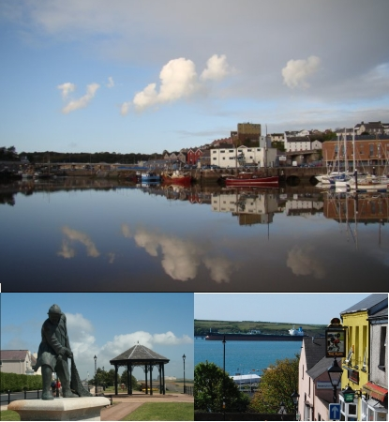
A community profile

Milford Haven,
Pembrokeshire

Sophie price
2213749

Introduction
I will be providing a community profile of a small part of Pembrokeshire called Milford haven. Also thinking about that statistical information and their views and aspiration of the youth people. In my community profile I will be discussing the population of Milford haven, What kind of housing people live in, I will also include what the young people think of their home town of Milford haven, what qualifications people hold. I will also put statistics of peoples jobs and what jobs people are in.

In this section it will include the populations within Milford haven, discussing how many people live in Milford Haven, types of housing people live in, the young peoples thoughts of their home town and peoples qualifications. I will also be including the status of peoples relationships. I have found in my search that census have not had an up to date population check since 2011, so for that reason I will have to go on the 2011 information.
I will be basing my population on 2011, in 2011 there was ‘13,582’ (understanding welsh places, 2020) people living in the whole of Milford haven and there was ‘6,144’ (understanding welsh places, 2020) households within Milford haven.

Whist working with the young people in my placement I came up with an activity to see how they felt about there community, I wrote on paper what makes your proud of Milford haven? what you like about Milford haven? And what would you like to improve within Milford haven? The young people said what they would like to improve, we took all their thoughts and feelings into account, and we are going to put these forward to Pembrokeshire county council to see if we can do something to make Milford haven more fun for the young people.

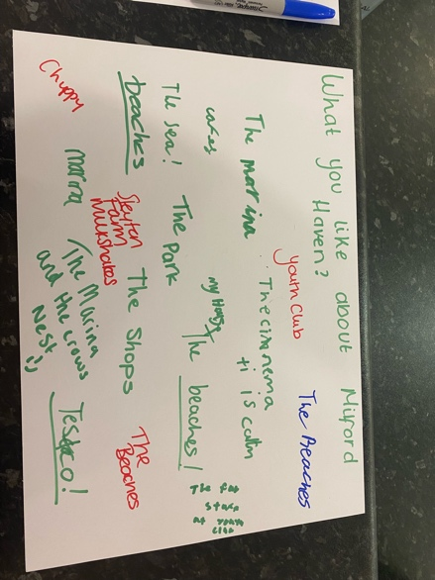
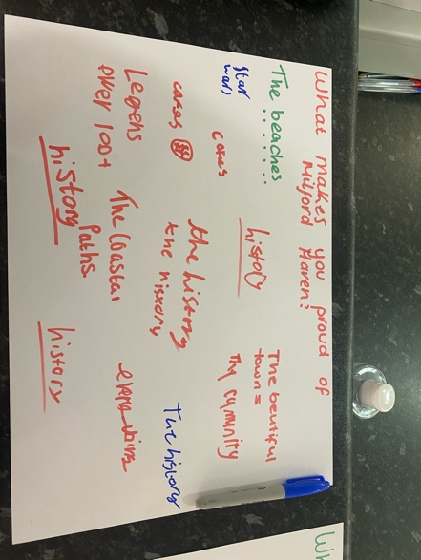

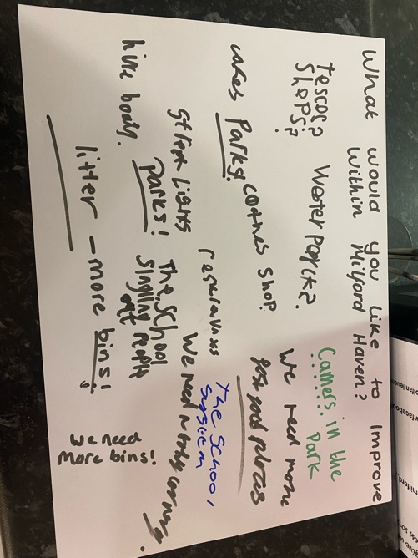

With regards to qualifications, here is a diagram below that I found on (understanding welsh places, 2020) the red line represents wales and the blue line represents Milford haven
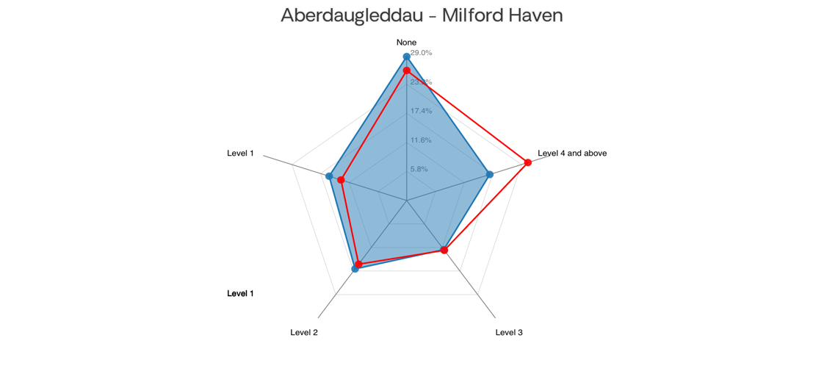
‘ Percentage of usual resident population aged 16+ (from Census 2011). Level 1: qualifications up to 1-4 O Levels/CSE/GCSEs any grades or equivalent. Level 2: qualifications up to 5 or more O Levels/CSE/GCSEs grades A*-C or equivalent. Level 3: qualifications up to 2+ A Levels or equivalent. Level 4 and above: qualifications up to and above degree level or equivalent.’ (Understanding welsh places, 2020)
In the diagram the red line represents all over wales and the red line just represents Milford haven, from census 2011 this diagram shows the amount of parents that are married with and without children, are student households and single etc. From this diagram we can see in Milford haven about 33% of people are single. This then also has a representation of their wage as there its only a single person wage.
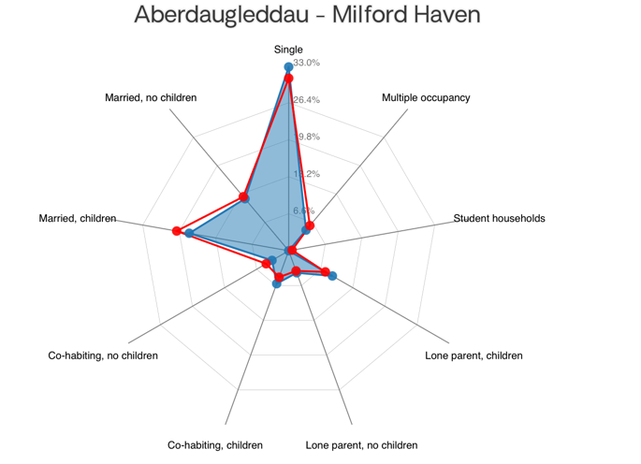

In this section I will discuss what people do for work, the most popular jobs there are for people to be employed in within Milford haven and about house hole incomes within Milford Haven.
Within Milford Haven there are a total of ‘3,420 jobs, 7% people working from home, 30% of people travelling up to 5km, 20% of the people travelling 5 to 10km, 21% of the people travelling between 10 to 30km and 6% of people travelling 30km and over’ (Understanding welsh places, 2020). The jobs include many different things ‘with a massive one being the waterway and the port, there are also a lot of retail jobs, care homes, and delivery driving’. (Stay hired, 2022)

In this diagram below it shows a better understanding of what type of jobs people have within Milford Haven and where the most people are employed to. The majority of people are in wholesale and retail. I feel there is more people in whole sale and retail is because there are more shops and wholesales in Milford Haven than any other occupations, for example ‘ there are 80 shops with 184 people per shop, and 29 charities and 509 people per charity in Milford Haven’ (understanding welsh places, 2020) where as there are only ‘3 primary schools within Milford Haven and 1 secondary school’ (understanding welsh places, 2020). So it’s clear there is going to be more shop keepers as there are more shops than schools within Milford Haven.
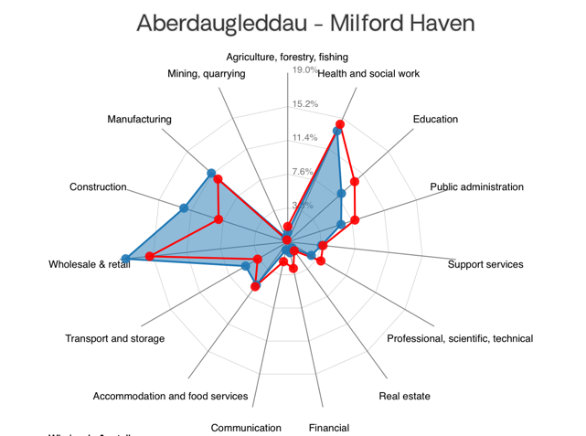
In the diagram the red line represents all over wales and the red line just represents Milford Haven. In this diagram here it shows the amount of people that private rent, social rent and are home owners, we can see here that the majority of the people living in Milford Haven own their house, and there is more that socially rent than privately rent. This may be because ‘Social housing is likely to be cheaper than privately rented housing and can also offer greater security from eviction. It may be a good option if you need an accessible or adapted property’ (ageuk, 2022)

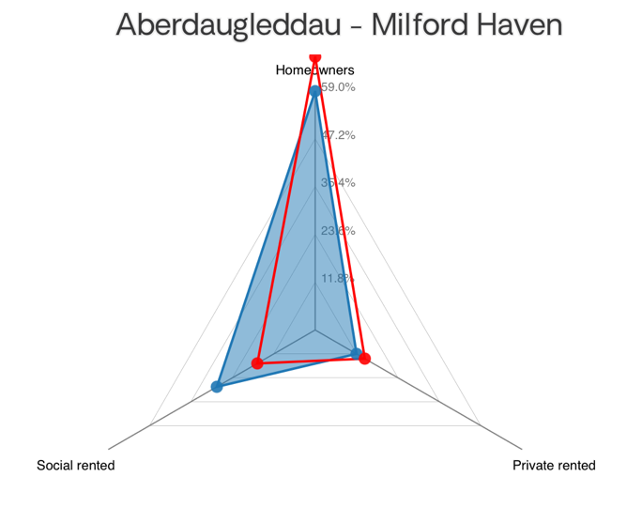

Within Milford haven there is a lot that they have to offer for the young people they offer ‘DJ workshops, break dancing, street art activities and a skate park are some of the fantastic activities on offer to teenagers at Milford Waterfront on Friday evenings during the summer.’ (Port of Milford Haven, unknown date) Another project within Milford haven is ‘Under the Bridge delivered by Milford Youth Matters and the Port of Milford Haven’ (Port of Milford Haven, unknown date) this project was provided to reduce the risk of anti- social behaviour, it took place under the bridge where the young people normally participate in anti social behaviour. Whilst I was on placement the youth centre were taking clothing donations for anyone in the community, for the young people to take for free if they need them.

Conclusion
To conclude by doing this community profile it gave me a good understanding of Milford Haven, and what kind of people that live in Milford Haven, I could see clearly how many people live in Milford haven and what qualification they have, I can also see how many people were single, married and who had children. I could also see what jobs there are to offer within Milford Haven, and what how many people are in what kind of industries of work, it gave me a clear understanding of what housing people live in whether their houses are rented or home owned. In my piece of work I could also see what the young people thought of their community and what kind of things they like and dislike about their community. I have used the same website for all my information as all the information was taken from census and I know that is a reliable site.
Stay hired. (2022). Best jobs in Milford haven. [Online]. Stay hired. Last Updated: 2022. Available at: https://www.simplyhired.co.uk/search?l=milford+haven [Accessed 8 November 2022].
Understand welsh places. (2020). Milford haven. [Online]. Understanding welsh places. Last Updated: December 2020. Available at: http://www.understandingwelshplaces.wales/en/compare/W37000225/ [Accessed 7 February 2023].
Age uk. (2022). Renting and social housing. [Online]. Age uk. Last Updated: 20 December 2022. Available at: https://www.ageuk.org.uk/information-advice/care/housing-options/renting-social-housing/ [Accessed 7 February 2023].

Port of Milford haven. (Unknown). Supporting the Community. [Online]. Port of Milford haven. Last Updated: Unknown. Available at: https://www.mhpa.co.uk/supporting-the-community/ [Accessed 19 March 2023].

This summary of my own learning had been drawn from my personal development plan and my six reflective account highlighting my placement journey.

Working in accordance with the 5 pillars.
At the start of my placement I really wanted to learn the educative point of the 5 pillars (Youth work in wales review group, 2022, pg.08-09) which was what does education look like within youth work? Also I wanted to learn the expressive part of the 5 pillars (Youth work in wales review group, 2022, pg.08-09) which was, how can we help the young people express their emotions and hobbies? In regards to the what does education look like I have realised there are so many ways to educate young people in a non formal and an informal way. I done so many activities with the young people that was educating them. For example, I have done a cooking activity and one of the young people that participated in this activity said that he really enjoys cooking but he comes from a travelling background and his mum and dad do not allow him bake at home because they believe that ‘it is a woman’s job to cook this made it very unfair for the young person. I overcame this situation by getting him involved in more cooking activities. I also spoke to my manager about the situation to try and see if there are any activities within school for him to be more involved in or if there are any cooking clubs near by where he lives. This also leads on to the expressive pillar and with this particular young person not being able to bake at home it gave the young person a safe space to express his feeling and emotions through baking if he was not taking part in this baking activity it would have been highly unluckily he would have said he was not a loud to bake at home.

Facilitating the personal, social and educational needs of the young people.
In this section I wanted to learn about what is social education within youth work? According to infer.org (2019) I found out social education is generally used to refer to the personal development of the individual, particularly in relation to others. I also wanted to learn about what development is in youth work? From my practice I have discovered that the young people will develop their knowledge and educate themselves in so many different ways. For example I ran an activity using the method NAOME with a group of young people to bake heart shaped cookies and prior to the activity made some evaluation sheets for them to fill out at the end, all of them learnt a new skill, some didn’t know how to weigh ingredients before the activity and some did not know how to use an electric whisk.

Promoting inclusion equality and young peoples interest and well being.
At the start of my placement I did not know how to get a full understanding of what the young people I work with enjoy, throughout my time in placement I have built the relationship with the young people to know what they enjoy doing, I done this by getting some flip chart paper and I had 4 sheets. One saying ‘cooking’. They could say what they enjoyed cooking and what they could cook in the future. One saying ‘projects and new skills’. They could say what projects and new skills they would like to learn. Another saying ‘arts and craft’ for this they could say what arts and craft projects they would like to do within this year. Another saying ‘health and well being activities’. They could them say what activities they would like to do to promote good health and well being or what projects they would like to do to help their own well being. In the projects and cooking we discussed they would like to do a new country every week. They would do quizzes around the country, games of what they do in that county also cooking the food they have in that country.

Working with young people and others.
To develop my learning in my placement I needed it to be clear of what my manager and colleagues would like from me. I discussed this with them and they explained what they would like to see me doing within my placement. They wanted me to create an activity using the method NAOME. I ran my activity over 3 nights, one night doing baking heart shaped cookies, one night doing Valentine’s Day cards, and one night painting Valentine’s Day stones. I then evaluated each session and discussed this with my manager and colleagues. Throughout my placement I also wanted to improve my practice through feedback, I completed this by after doing my activities getting the young people to evaluate what they learnt and also what I could have done to make the activity more successful.
Develop, read and to manage myself and others
At the start of my placement I wanted to learn about planning activities inside and outside of youth work. I completed this by when planning activities outside of youth work I would use the model NAOME to help with the planning and to make the activity as successful as I can. I would also work out how my activity would help to develop the young people. Also when I was planning activities inside of my placement I would ask the young people what they wanted to cook for the following session, or I would ask the young people what sporting activities they would like to do in that session and sometimes I would just have to adapt to the young people and if I could see the activity was getting boring or they were not enjoying it do something else. Also in my placement I wanted to be able to check my practice, concerns and reflect with my colleagues. Now I have finished my placement I felt I was able to do this by being there 15 minutes before and 15 minutes after it helped to reflect any concerns I had with my colleagues, and think how we could all over come any concerns. For example whilst I was doing a baking activity a young people said to me they love cooking but can not do it at home because his family are travellers and they do not agree boys should cook, I reflected this back with my colleagues and we was able to see what cooking activities are around him to help with the hobby of his.

Infed.org. (April 2001). Developing youth work: Chapter 5 – Beyond social education. [Online]. Infed.org. Last Updated: July 5, 2019. Available at: https://infed.org/mobi/developing-youth-work-chapter-5-beyond-social-education/ [Accessed 1 March 2023].

(CWVYS, PYOG, EWC. September 2022. Youth work in wales: principles and purposes. Unknown: Youth work in wales review group. pg.08-09.)

Section 6

Reference list

Age uk. (2022). Renting and social housing. [Online]. Age uk. Last Updated: 20 December 2022. Available at: https://www.ageuk.org.uk/information-advice/care/housing-options/renting-social-housing/ [Accessed 7 February 2023].

(CWVYS, PYOG, EWC. September 2022. Youth work in wales: principles and purposes. Unknown: Youth work in wales review group. pg.08-09.)

Google maps. (Unknown). Milford Haven Youth Centre, Priory Rd, Milford Haven SA73 2EB To Milford Haven SA73 2BP. [Online]. Google maps. Last Updated: Unknown. Available at: https://www.google.com/maps/dir/Milford+haven+youth+centre/Milford+Haven+SA73+2BP/@51.7130668,-5.042 [Accessed 19 March 2023].

Google maps. (Unknown). Milford Haven Youth Centre, Priory Rd, Milford Haven SA73 2EB To Tesco, Milford Haven SA73 3AU. [Online]. Google maps. Last Updated: Unknown. Available at: https://www.google.com/maps/dir/Milford+haven+youth+centre/Tesco,+Milford+Haven+SA73+3AU/@51.7160383 [Accessed 19 March 2023].

Infed.org. (April 2001). Developing youth work: Chapter 5 – Beyond social education. [Online]. Infed.org. Last Updated: July 5, 2019. Available at: https://infed.org/mobi/developing-youth-work-chapter-5-beyond-social-education/ [Accessed 1 March 2023].

Port of Milford haven. (Unknown). Supporting the Community. [Online]. Port of Milford haven. Last Updated: Unknown. Available at: https://www.mhpa.co.uk/supporting-the-community/ [Accessed 19 March 2023].
Stay hired. (2022). Best jobs in Milford haven. [Online]. Stay hired. Last Updated: 2022. Available at: https://www.simplyhired.co.uk/search?l=milford+haven [Accessed 8 November 2022].
Understand welsh places. (2020). Milford haven. [Online]. Understanding welsh places. Last Updated: December 2020. Available at: http://www.understandingwelshplaces.wales/en/compare/W37000225/ [Accessed 7 February 2023].
WVYS, PYOG & EWC Youth Work Review Group. (2022). Youth work in wales: principles and purposes. Youth work in wales review group. p.06
WVYS, PYOG & EWC Youth Work Review Group. (2022). Youth work in wales: principles and purposes. Youth work in wales review group. p.07.
WVYS, PYOG & EWC Youth Work Review Group. (2022). Youth work in wales: principles and purposes. Youth work in wales review group. p.08.

Section 7
Appendix
Photos of tasks with young people

Supervision reading formats
Supervision Recording Format
Supervision Recording Format
SUPERVISION RECORDING
DATE:4/11/22
TIME:10:30am
PEOPLE PRESENT: Rachael Jenkins
DURATION OF THE MEETING:
AGENDA/ DISCUSSION POINTS
- Risk assessment

- Plan future supervisions

- Fieldwork practice supervision contact

NOTES/ ACTION OF EACH ITEM
- Racheal send me a practice risk assessment for me to look at to have a go

- Completed

- Completed

6.

PROBLEMS ENCOUNTERED
REFLECTION ANALYSIS AND LEARNING Links between theory and practice can be made here and referenced in the usual way. Also reflection on effectiveness of supervision.
This supervision was at the Picton Centre, I felt because there was only me and Rachel there we I felt safe if I needed to disclose anything about me or a young person, we planned all future supervisions, and signed the contact.

QUESTIONS ARISING
Me and Racheal talked and I will be bringing a reflection to my next supervisor

DATE OF NEXT MEETING: 22/11/22
SIGNED:
STUDENT: Sophie Price
SUPERVISOR: Rachael Jenkins

SUPERVISION RECORDING
DATE:22/11/22
TIME:11am
PEOPLE PRESENT: Racheal Jenkins
DURATION OF THE MEETING: 2 hours
AGENDA/ DISCUSSION POINTS
- Go though my reflections

2.

3.

4.

5.

6.

NOTES/ ACTION OF EACH ITEM
- Went through my reflection with a few questions accounted

2.

3.

4.

5.

6.

PROBLEMS ENCOUNTERED
I didn’t know what to write for the bad points as it was a good experience reflection

REFLECTION ANALYSIS AND LEARNING Links between theory and practice can be made here and referenced in the usual way. Also reflection on effectiveness of supervision.
(Youth work in wales principles and purposes, p.7)
Encourage young people to gain and develop knowledge, understanding, attitudes and values and to make constructive use of their skills, resources and time;

QUESTIONS ARISING
What’s the bad experience of the situation
What’s the sense of the situation

DATE OF NEXT MEETING:15/12/22
SIGNED:
STUDENT: Sophie price.
SUPERVISOR: Rachael Jenkins

SUPERVISION RECORDING
DATE: 15/12/22
TIME:11am
PEOPLE PRESENT: Racheal Jenkins
DURATION OF THE MEETING: 2 hours
AGENDA/ DISCUSSION POINTS
- Reflection- uno

- Professional development plan

NOTES/ ACTION OF EACH ITEM
- Me and Racheal went through of me playing uno with the young people and one young person not quite understanding the game, read through and Racheal said it was amazing

- Me and Rachael read through my personal development plan and I explained how I wanted to achieve these goals and activities I will run alongside these goals.

3.

4.

5.

6.

PROBLEMS ENCOUNTERED
REFLECTION ANALYSIS AND LEARNING Links between theory and practice can be made here and referenced in the usual way. Also reflection on effectiveness of supervision.
This supervision was in costa coffee, I felt this wasn’t a very private space for a supervision, as I was surrounded by a lot of people and if I needed to disclose something about a young person it wouldn’t be confidential.

QUESTIONS ARISING
DATE OF NEXT MEETING: 31/01/23
SIGNED:
STUDENT: Sophie price
SUPERVISOR: Rachael Jenkins

SUPERVISION RECORDING
DATE:31/01/23
TIME:10:30am
PEOPLE PRESENT: Racheal Jenkins
DURATION OF THE MEETING:
AGENDA/ DISCUSSION POINTS
- Discuss what I could do for my NAOME activity in my placement

- Show my reflection I wrote on Jamie and his traditions

NOTES/ ACTION OF EACH ITEM
- Me and Rachael spoke about different activities, and I decided I wanted to do it over a the theme of Valentine’s Day, I based my activity over 3 nights with 3 separate activities.

- We discussed about my relation to do with Jamie’s family traveller traditions

4.

PROBLEMS ENCOUNTERED
I was a little confused on how to make sense out of the situation so Rachael showed me how to, so now I have a good understanding on how to do it

REFLECTION ANALYSIS AND LEARNING Links between theory and practice can be made here and referenced in the usual way. Also reflection on effectiveness of supervision.
This supervision was at the Picton centre. There was only me and Rachael there and I felt this was a private place if I needed to disclose anything about me or a young person. We discussed a reflection of a young person coming from a traveller background, and what else I could do which was interesting.

QUESTIONS ARISING
Me and Racheal talked and I will be brining another reflection to my next supervisor

DATE OF NEXT MEETING: 14/02/2023
SIGNED:
STUDENT: Sophie price
SUPERVISOR: Rachael Jenkins

SUPERVISION RECORDING
DATE:14/02/23
TIME:10:30am
PEOPLE PRESENT: Racheal Jenkins
DURATION OF THE MEETING:
AGENDA/ DISCUSSION POINTS
- Reflection on my baking valentine day cookies

- Reflection on my making cards activity

- Reflection on my painting Valentine’s Day stones activity

- Community profile

NOTES/ ACTION OF EACH ITEM
Say more about problem solving- how they seen a problem and how they over come
Add in photos of my reflections
Change future cooking sticks to- life skills they can take with them in the future, that weighing and measuring can help them in the future

- For good and bad points- football boys not wanting to do it- doing another activity alongside it for example a quiz or a word search, the people that were arts and crafts- adapting the activity too everyone’s needs
Building professional relationship- by doing this activity it helped me build the relationships in a professional manner.

- By doing this activity it helped Build these relationships for the young people talk to me about these kinds of things- rip rock
Get rocks and make positive quotes on them and place them around Milford haven, gets them out in the community, gets them involved physically
Quote more of youth work in wales- page 7- promoting opportunity’s

- Write more about the young people and what there is to offer them, youth clubs and youth matters. Free clothes, opening times, fortunate to have a purpose made building for youth work, eg letterston having a village hall.

6.

PROBLEMS ENCOUNTERED
REFLECTION ANALYSIS AND LEARNING Links between theory and practice can be made here and referenced in the usual way. Also reflection on effectiveness of supervision.
I found my supervision was really helpful with Rachael, she answered anything that I was unsure about, and gave me good ways to improve my reflections. We done this supervision in the Picton Centre and no one was there so it was private and confidential.

QUESTIONS ARISING
DATE OF NEXT MEETING: 13/03/23
SIGNED:
STUDENT: Sophie Price
SUPERVISOR: Rachael Jenkins

SUPERVISION RECORDING
DATE:13/03/23
TIME:10:30am
PEOPLE PRESENT: Racheal Jenkins
DURATION OF THE MEETING:
AGENDA/ DISCUSSION POINTS
- Sign off hours

- Look at how I’ve improved on my pdp

NOTES/ ACTION OF EACH ITEM
- Emailed to Racheal

- Read through, all correct

6.

PROBLEMS ENCOUNTERED
REFLECTION ANALYSIS AND LEARNING Links between theory and practice can be made here and referenced in the usual way. Also reflection on effectiveness of supervision.
This was mine and Rachaels last supervision it was held in the Picton centre in her office, at first there was a member of staff in there, so wasn’t very private but them once they left it was just me and Rachael so if I needed to disclose anything I could and talked about all my time in my placement and what the next steps of my placement for next year.

QUESTIONS ARISING
Racheal asked what I wanted to do next year for supervision

DATE OF NEXT MEETING: N/A
SIGNED:
STUDENT: Sophie Price
SUPERVISOR: Rachael Jenkins

Log of placement hours
Log of hours

Date | Face-to-face | Non face-to-face | Brief outline on session | Signed
31/10/22 |  | 30 mins | Fieldwork mentor contracted- completed
02/11/22 |  | 4 hours | Research for community profile
04/11/22 |  | 2 hours | First meeting with supervisor and learning mentor
04/11/22 |  | 2 hours | Supervision with Racheal
07/11/22 | 2 hours |  | Placement in Milford Haven Youth club
07/11/22 |  | 30 mins | Reflecting after session
07/11/22 |  | 2 hours | Research
08/11/22 |  | 1 hour | Research for community profile
09/11/22 | 2 hours |  | Placement in Milford Haven Youth club
09/11/22 |  | 30 mins | Reflecting after session
14/11/22 | 2 hours |  | Placement in Milford Haven Youth club
14/11/22 |  | 30 mins | Reflecting after session
15/11/22 |  | 5 hours | Research
16/11/22 | 2 hours |  | Placement in Milford Haven Youth club
16/11/22 |  | 30 mins | Reflecting after session
17/11/22 | 2 hours |  | Placement in Milford Haven Youth club
17/11/22 |  | 30 mins | Reflecting after session
18/11/22 |  | 5 hours | Research
20/11/22 |  | 1 hour | Writing reflections and researching for portfolio
21/11/22 | 2 hours |  | Placement in Milford Haven Youth club
21/11/22 |  | 30 mins | Reflecting after session
22/11/22 | 2 hours |  | Placement in Haverfordwest Youth club
22/11/22 |  | 30 mins | Reflecting after session
22/11/22 |  | 2 hours | Supervision with Racheal
23/22/22 |  | 4 hours | Research
24/11/22 | 2 hours |  | Placement in Milford Haven Youth club
24/11/22 |  | 30 mins | Reflecting after session
25/11/22 |  | 6 hours | Research
27/11/22 |  | 3 hours | Research
28/11/22 | 2 hours |  | Placement in Milford Haven Youth club
28/11/22 |  | 30 mins | Reflecting after session
30/11/22 | 2 hours |  | Placement in Milford Haven Youth club
30/11/22 |  | 30 mins | Reflecting after session
01/12/22 | 2 hours |  | Placement in Milford Haven Youth club
01/12/22 |  | 30 mins | Reflecting after session
03/12/22 |  | 5 hours | Research
04/12/22 |  | 3 hours | Research
05/12/22 | 2 hours |  | Placement in Milford Haven Youth club
05/12/22 |  | 30 mins | Reflecting after session
07/12/22 | 2 hours |  | Placement in Milford Haven Youth club
07/12/22 |  | 30 mins | Reflecting after session
08/12/22 | 2 hours |  | Placement in Milford Haven Youth club
08/12/22 |  | 30 mins | Reflecting after session
15/12/22 |  | 2 hours | Supervision with Racheal
09/01/23 | 2 hours |  | Placement in Milford Haven Youth club
09/01/23 |  | 30 mins | Reflecting after session
10/01/23 |  | 3 hours | Research
11/01/23 | 2 hours |  | Placement in Milford Haven Youth club
11/01/23 |  | 30 mins | Reflecting after session
12/01/23 | 2 hours |  | Placement in Milford Haven Youth club
12/01/23 |  | 30 mins | Reflecting after session
14/01/23 |  | 3 hours | Research
15/01/23 |  | 4 hours | Research
16/01/23 | 2 hours |  | Placement in Milford Haven Youth club
16/01/23 |  | 30 mins | Reflecting after session
18/01/23 | 2 hours |  | Placement in Milford Haven Youth club
18/01/23 |  | 30 mins | Reflecting after session
19/01/23 | 2 hours |  | Placement in Milford Haven Youth club
19/01/23 |  | 30 mins | Reflecting after session
20/01/23 |  | 4 hours | Research
22/01/23 |  | 6 hours | Research
23/01/23 | 2 hours |  | Placement in Milford Haven Youth club
23/01/23 |  | 30 mins | Reflecting after session
25/01/23 | 2 hours |  | Placement in Milford Haven Youth club
25/01/23 |  | 30 mins | Reflecting after session
26/01/23 | 2 hours |  | Placement in Milford Haven Youth club
26/01/23 |  | 30 mins | Reflecting after session
30/01/23 | 2 hours |  | Placement in Milford Haven Youth club
30/01/23 |  | 30 mins | Reflecting after session
31/01/22 |  | 2 hours | Supervision with Racheal
01/02/23 | 2 hours |  | Placement in Milford Haven Youth club
01/02/23 |  | 30 mins | Reflecting after session
02/02/23 | 2 hours |  | Placement in Milford Haven Youth club
02/02/23 |  | 30 mins | Reflecting after session
04/02/23 |  | 5 hours | Research
06/02/23 | 2 hours |  | Placement in Milford Haven Youth club
06/02/23 |  | 30 mins | Reflecting after session
07/02/23 |  | 7 hours | Community profile and getting all my documents together
08/02/23 | 2 hours |  | Placement in Milford Haven Youth club
08/02/23 |  | 30 mins | Reflecting after session
09/02/23 | 2 hours |  | Placement in Milford Haven Youth club
09/02/23 |  | 30 mins | Reflecting after session
13/02/23 | 2 hours |  | Placement in Milford Haven Youth club
13/02/23 |  | 30 mins | Reflecting after session
14/02/23 |  | 2 hours | Supervision with Racheal
15/02/23 | 2 hours |  | Placement in Milford Haven Youth club
15/02/23 |  | 30 mins | Reflecting after session
16/02/23 | 2 hours |  | Placement in Milford Haven Youth club
16/02/23 |  | 30 mins | Reflecting after session
20/02/23 | 5 hours |  | Art project- half term
20/02/23 |  | 30 mins | Reflection of art project
22/02/23 |  | 4 hours | Research
24/02/23 |  | 1 hours | Research
26/02/23 |  | 3 hours | Research
27/02/23 | 2 hours |  | Placement in Milford Haven Youth club
27/02/23 |  | 30 mins | Reflecting after session
01/03/23 | 1 hour |  | Quiet hour for young people with additional learning needs
01/03/23 | 2 hours |  | Placement in Milford Haven Youth club
01/03/23 |  | 30 mins | Reflecting after session
02/03/23 | 2 hours |  | Placement in Milford Haven Youth club
02/03/23 |  | 30 mins | Reflecting after session
04/03/23 |  | 4 hours | Research
06/03/23 | 2 hours |  | Placement in Milford Haven Youth club
06/03/23 |  | 30 mins | Reflecting after session
08/03/23 | 1 hour |  | Quiet hour for young people with additional learning needs
08/03/23 | 2 hours |  | Placement in Milford Haven Youth club
08/03/23 |  | 30 mins | Reflecting after session
09/03/23 | 2 hours |  | Placement in Milford Haven Youth club
09/03/23 |  | 30 mins | Reflecting after session
11/03/23 |  | 4 hours | Research
13/03/23 |  | 2 hours | Supervision with Racheal
13/03/23 | 2 hours |  | Warm Space session for 16-25 year olds at Milford Haven Youth Centre
13/03/23 | 2 hours |  | Placement in Milford Haven Youth club
13/03/23 |  | 30 mins | Reflecting after session
15/03/23 | 1 hour |  | Quiet hour for young people with additional learning needs
15/03/23 | 2 hours |  | Placement in Milford Haven Youth club
15/03/23 |  | 30 mins | Reflecting after session
16/03/23 | 2 hours |  | Placement in Milford Haven Youth club
16/03/23 |  | 30 mins | Reflecting after session
20/03/23 | 2 hours |  | Warm Space session for 16-25 year olds at Milford Haven Youth Centre
20/03/23 | 2 hours |  | Placement in Milford Haven Youth club
20/03/23 |  | 30 mins | Reflecting after session
21/03/23 |  | 3 hours | Research
22/03/23 | 2 hours |  | Placement in Milford Haven Youth club
22/03/23 |  | 30 mins | Reflecting after session
23/03/22 | 2 hours |  | Placement in Milford Haven Youth club
23/03/22 |  | 30 mins | Reflecting after session

Activity I planned for the young people using the method NAOME
The activity’s I’ve chosen to plan are around the celebration of Valentine’s Day, I will do three different activities over 3 different days, Monday Wednesday and Thursday. On Monday I will be helping the young people bake love heart shapes cookies. Wednesday I will help the young people make valentines day cards and on the Thursday I will be helping the young people Paint stones associated around valentines day.

Baking heart shapes cookies

Needs
I will be giving them a list of instructions to follow which will require their reading skills. It will help them develop their planning skills by them getting all the ingredients together of what they need to make cookies. It will help their further develop in their time management skills by them having an idea of how long it will take to prepare the cookies, how long it will take to bake the cookies and how long it will take to decorate the cookies and sell them by the time youth club ends.

Aim
The aim of the project is to help them develop in their cooking life skills for the future. Helping them in the future with their time management skills and to be strict with time and how important it is to be on time. It also helps them with different skills that they may not realise for example maths, doubling the mixture, will teach them how to double numbers. The ‘young people should be empowered partners in the processes and opportunities that youth organisations provide’ (Youth work in wales: principles and purposes, 2022, pg.06)

Objective
The objective is to get them involved in a cooking activity that will improves them in many different ways. For the young people to learn a range of different cooking techniques kneading the dough and baking the cookies. It’s an opportunities for the young people to cooperate and interact with the other young people. It’s a chance for the young people to work together as a group to make a successful outcome. It will also help the young people to develop their maths skills in a non formal way.

Methods
The method I will follow to make this activity as successful as I can is to give the young people a set of instructions to follow. Getting them to get the correct measured ingredients mixed together, making them into cookies and baking them making sure they don’t burn. Then getting the young people to get people to buy them and whoever buys them can get involved by decorating their own.

Evaluation

I have created some evaluation sheets for the young people to reflect on their work. I will also evaluate the activity after I have completed the activity.

Making Valentine’s Day cards

Needs
The needs of this activity is to help the young peoples with their writing skills and drawing skills. It will also help them to express their creativity skills. It will also show them to be patient and if they want to make a nice looking card it will take time to create it. It will also show the young people their planning and organisation skills, they will need to plan how to make the cards and organise all the equipment they need to make the cards. It also allows the young people show pride in what they’ve done and be proud of the card they’ve made, and then take them home to their family.

Aim
The aim is for the young people to express themselves through their art skills. It will also help them with their self achievement for them to feel a success from the piece of work they have created. It will also help them to boost their confidence by them doing amazing cards and youth workers and their family tell them how well they’ve done.

Objective
The objectives for the young people to make Valentine’s Day cards are for the young people to have pride in what they have done. It will also help them improve their creativity skills and their self- esteem within their future. It will also help them help them with their self achievement and their confidence by expressing their feelings over card making.

Methods
The method I will be following to make this activity as successful as possible is to get all the equipment ready for them to use, get them to plan out what they are going to be drawing on their cards and to get all the equipment they need to make their cards and then for them to create their cards and to take them home and to show their family and friends.

Evaluation
I have created some evaluation sheets for the young people to reflect on their work. I will also evaluate the activity after I have completed the activity.

Painting Valentine’s Day stones.

Needs
The needs for this activity is for the young people to get creative. It will also help them express their love over Valentine’s Day by painting for their loved ones. They will also be creating aesthetically pleasing work to be proud of. They will need to have patience throughout the activity and be able to see if something goes wrong how to overcome it. They will need to be using their planning and organisations skills to see what they are doing and to have a vision on the out come.

Aim
The aim is to get the young people to practice their painting skills and for me to promote being creative to them. It will also help their problem solving they will need to think if they have made a mistake like painting the wrong colour or it going over the lines they need it to then they will have to think what they need to do next. They will also be sharing ideas with the other young people of what they are doing. It is also an activity to promote them physically by painting. Socially by talking to other young people and also their personal development. We are ‘encouraging and enabling young people to express their understanding and knowledge and their ideas, opinions, emotions and aspirations through a broad range of creative and often challenging opportunities’ (Youth work in wales: principles and purposes, 2022, pg.08)

Objective
The objectives to this activity is for the young people to show pride in their work and what they have done. In the activity the young people will connect with the youth workers and the other young people to share ideas. It will also help to improve their confidence by expressing their feelings over painting and communicating with the other young people.

Method
The method I will be following to make this activity as successful as I possible can is to get all the young people choose a rock that they like plan out on a piece of paper what what they are going to draw on the rock and then they will draw an outline on the rock then start carefully painting it. They will then take it home for their loved ones.

Evaluation
I have created some evaluation sheets for the young people to reflect on their work. I will also evaluate the activity after I have completed the activity.

Youth Work in Wales Review Group. (2018) Youth Work in Wales: Principles and Purposes, Cardiff: Youth Work in Wales Review Group. Pg06
Youth Work in Wales Review Group. (2018) Youth Work in Wales: Principles and Purposes, Cardiff: Youth Work in Wales Review Group. Pg08

These are the Evaluation sheets that I asked the young people to fill in after the activity

Evaluation sheet

During the activity of baking cookies I learnt?

We worked by a team by …?

I was really pleased with…?

What problems did I have?

How did I resolve the problems?

Next time what would I do different?

Reflection 1

Whist I was attending a placement session there was a group of young people there that wanted to play a card game called uno. So I got uno out to play and started going through the instructions. There was one young person in particular called Lucy. Lucy wasn’t quite coming to terms with the card game. So I went through the instructions for a second time but this time kept it quite short and simple to see if she would have a better understanding I just gave 2 instructions and said ‘if the card in your hand is the same colour or number that’s on the table you can put it on top’ then followed it with an example by saying ‘if the card on the table is red and has the number 4 on it. You can either put down a red with any number on it, or a 4 with any colour on it’. So then we started to play the game. There was a blue card with the number five on it so I asked Lucy what colour can she put on top and she said a blue card or a card with the number 5. But after that she still carried on putting the wrong cards down. I had to keep telling her that she should put certain cards down. After about twenty minutes of playing the game I could see she was getting frustrated and stressed out with herself. So I could see it was time to pack the cards away and stop playing otherwise she would have got more and more frustrated. But reassured her that after a couple of sessions she would understand the game and feel confident playing, I felt it would be beneficial playing it short period so she would have more and more understanding every time. So the following week we got the game out again and I got her to explain the instructions to me to see her level of understanding, after that I could see that she had a fully understanding of the game. We played a few games of it with me giving her very little help and her making very little mistakes. We then started to play a few games every week. Then we started playing by everytime she placed a card down she would tell me why she put that specific car down and her replies would be ‘because it’s the same colour’ or ‘because it’s the same number’. I am now happy that she has a fully understanding of the game and she now comes into youth club really exciting and happy to play the game.
While at the fist session of playing uno with Lucy it may have seemed very frustrating to keep gluing over the sale rules all time. I kept very patience throughout the whole learning process. It did then feel very rewarding at the end when she felt exited and proud of herself, she nips gets very excited to come to youth club to play uno.
The good experience about it was she may now go to her friends and play now she feel confident to play. It is important ‘encouraging and supporting young people to partners in and share responsibility for, the opportunities, learning processes and decision-making structures which affect their own and other peoples lives and environments’ (youth work in wales; principles and proposes, 2022)
The only bad experience that came from the game was it took a very long time to build up goer knowledge and it felt like I pet repeating myself. I then had to understand myself that it does sometimes take a while for young peoples to learn new things.
The sense I made from the situation was that I understood when she started playing the game that she was getting frustrated annoyed and angry at herself and I had to put the game away before she just gave up and never wanted to try to play the game again.
Now that I know she’s confident in playing I have decided that the next session im going to see if she would if I got a small group of young people together to all play uno and she could then teach them how to play, and she will have an understanding if people don’t know how to play because she was in that position.
If this situation ever rose again I would be consistent and give her the instructions again and challenge her again on how to play and what she can remember form this time around and what she can remember leaning.

WVYS, PYOG & EWC Youth Work Review Group. (2022). Youth work in wales: principles and purposes. Youth work in wales review group. p.08.

Reflection 2

Whilst I was in Milford haven youth club on placement there was a young person in there called poppy that wanted a little extra attention and didn’t feel very confident. These feelings could have been to do with a variety of different things for example not getting the attention she wanted at home or at school and she seen as a youth club we was very supportive and would give the young people the extra positive attention in youth club. So I have been spending that little extra time with her to give her that little bit of extra support. A big thing I saw was to do with numeracy. She didn’t feel confident at all in adding and subtracting. Every time she would go to the tuck shop she would ask me to count her money to see how much she had, and how much things cost and how much change she would get. So I would go through with her and ask her what value each coin was worth, and she would tell me each value of the coin, after a few sessions she was then confident enough to tell me how much she had, we then went onto if she bought something how much change would she have. After a few sessions she was really confident with money handling.
I was feeling very positive and very helpful throughout the whole of the experience, but I did also feel a little frustrated at times as I kept going over and over the values and she would add if up correctly but then say a whole new number. Also her knowing how to add it all up but still continued to ask. But them I just kept reminding myself that these things do take time and I need to keep consistent.
There was a few good things about the experience, a young unconfident girl is now feeling confident with money handling. The skills she has learned she can use them else where. She can also use the skills she’s learnt to help her friends that may also be struggling with money handling. I was glad that where she was struggling I could stand in and give her help and have an understanding.
The sense out of the situation is that I was able to understand that she is developing and her brain is also developing but now that I’ve used a couple of sessions to help her I can challenge the situation, and instead of her coming to me just to ask ill tell her to reflect on what she’s learnt and to try and do it on her own, and come to me if she is still stuck.
For the next few sessions I will keep helping her build and develop her knowledge and the understanding of money handling, by getting her to help on the tuck shop and get her to take peoples orders and money and her to work it out, and slowly develop session by session, but also not getting her to do it for ages at once’s and to build up her knowledge otherwise it may overstimulate her and completely scare her off.
I would try my hardest to not let this problem arise again by keeping on top of it. But if the problem did arise again I would just have a recap with her of what we’ve gone over, and what’s she’s already learned and get her to remember what we’ve done. I will also speak to my team leader to see if she’s ever had problems in school, and see if the school can provide any extra help.

Reflection 3
Whilst being on placement there was a boy called Jamie. Jamie was a very kind and caring young person that will take part in any activity he can and loves getting stuck into anything that varies from board games, football, cooking and art and crafts. Whist Jamie was taking part in a baking activity Jamie made a comment saying ‘I’m not aloud to cook at home.’ Jamie is from a traveller background where in his house they feel men are not aloud to cook and clean and only the women are aloud to. I feel this is unfair on Jamie as cooking is one of Jamie’s hobbies and he is getting restricted due to his families culture.
I felt very sorry for Jamie as it was something he really enjoyed but got stopped from doing it at home because his parents wouldn’t allow him to. In youth club he takes part in any opportunity he can to cook. I also felt it was very unfair on him as he doesn’t agree with the way his parents are at home but has to go along with out.
The bad out of the situation was that he could widen his experience of his hobbies at home because of his parents beliefs, the positive out of it is as a youth worker we are able to offer the opportunity of cooking.
The sense we can make out of the situation is that we can provide him with the safe space he needs to explore what’s he enjoys to do and the activities he enjoys doing.
I could now get in contact with other clubs that involve cooking and see what there is to offer him for example in the school, to see if they do any cooking clubs, do some cooking with him in sessions. I could also see in his area what there is to offer him.
If this situation arose again I would see what opportunities there are to offer him within the school or his area. I think this situation will always be there as his family will never change their beliefs its just about how we as youth workers can help his do what he enjoys. We as youth workers are ‘encouraging and enabling young people to express their understanding and knowledge and their ideas, opinions, emotions and aspirations through a broad range of creative and often challenging opportunities’ (youth work in wales; principles and proposes, 2022, pg.08)

WVYS, PYOG & EWC Youth Work Review Group. (2022). Youth work in wales: principles and purposes. Youth work in wales review group. p.08.

Reflection 4
Whilst being on placement they asked me to plan an activity to conduct to the young people using they method NAOME. The activity I chose was based around the celebration of Valentine’s Day. On Monday I got the young people to bake heart shaped cookies. I gave them a list of instructions to abide by and follow it to successfully make the cookies. This will help their development in so many different ways. It will help them with their time management, communication, planning, and life skills, they can take this experience with them into the future, for example weighed and measuring. It was also to help them with their maths skills in a non-formal setting. It was an activity that i personally felt was very well planned and went really well. I got the ingredients out and the young people read through the instructions list to make sure we had all the correct ingredients. They all got a bowl out of the cupboards for themselves. Then they all worked in a team to take it in turns to measure out the ingredients into their bowls, after they done that they all took it in turns to use the electric whisk and mix all the ingredients together. The young people then all greased a tray with butter then put their mixed ingredients on the trays to be cooked. Unfortunately the mixture when cooked all combined to one but we fixed the problem by cutting them up. This also helped develop their problem solving skills, they had to work around the problem and how they could over come it. After they figured out the cut the cookies they tasted them and they tasted delicious. I also gave all the young people an evaluation sheet after the task, so it gave me some feedback also gave them a bit of reflection time.

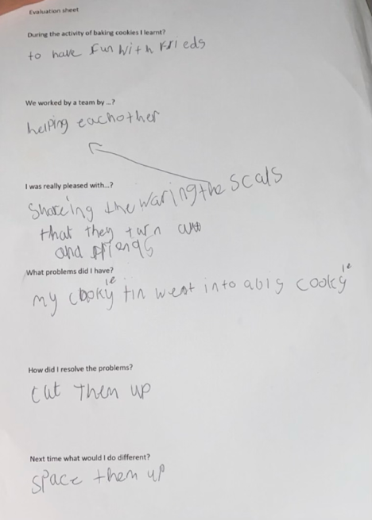
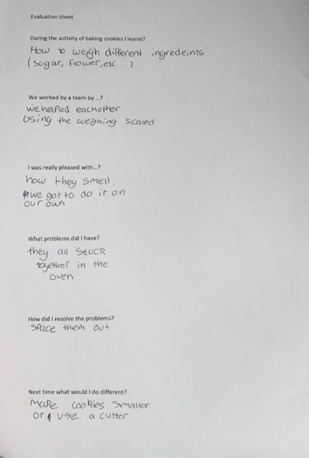
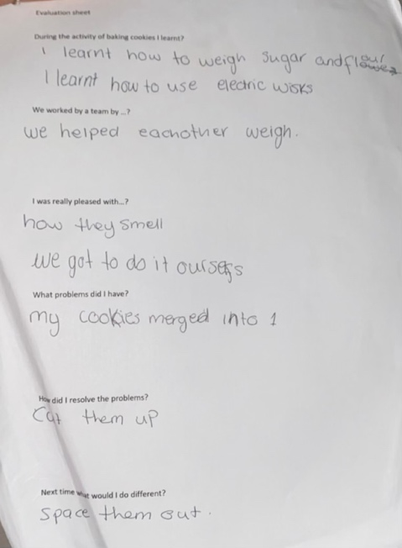

I felt the young people showed really good determination to get the cookies made the best they could. They also really enjoyed the activity and working as a team, also making new friends. The young people were a little upset that their cookies merged to one but then they realised it was kind and they could fix it by cutting them up.
I feel this experience was a good experience that the young people thoroughly enjoyed they learned a lot of new things and they really enjoyed themselves. They didn’t realise whilst they was really enjoying themselves and having fun they was also learning new skills and educating themselves. There was a little but of a bad experience when the young people realised their cookies had merged by shortly after they realised that it was fixable.
The sense I made out of the situation was that the young people really enjoyed themselves within their safe spaces. The young people stated on their evaluation sheets that they learned how to use an electric whisk and weigh out different ingredients, which was a big positive. They stated that they worked well as a team and enjoyed making new friends. They really enjoyed taking lead of the activity and me just observing them. Then when I asked what problems did they have they said the cookie mixture all merged to make one big cookie but then I said how did you resolve the problem they all said ‘we can just cut them up’. Then I asked what could we do next time and they said we can just space them out more.
I think overall the activity went really well and the young people really enjoyed working together to get it done the best they could. They worked really well to share everything that we only had one of, for example the measuring scale and the electric whisk.
If this activity arose again I would use the same method as I used this time, just making sure the cookies have enough room beside them to get bigger.

Reflection 5
In my placement I was asked to conduct an activity using the method NAOME I chose a multiple of different activities throughout the week based around Valentine’s Day. On Wednesday I got the young people to make Valentine’s Day cards. I got plain white card, red card and green card to give the young people a choice. I also got different coloured felt pens. I also printed and cut out different pictures of Valentine’s Day images, for example hearts and penguins holding hearts. The young people really enjoyed the activity, but at first they had no interest because they said ’I don’t have a boyfriend or a girlfriend’ but once I explained it doesn’t need to be for a boyfriend or girlfriend and that Valentine’s Day is for all your loved ones. Mainly all of the young people made cards for their mums, dads, brothers and sisters. It was really nice to see the new group of young people getting stuck into new activities. It helps the young people develop in a numerous amount of ways. One of them was their creativity skills, they got really creative with the felt pens and sticking images to their cards. But it was also gave the young people a chance to talk to someone whilst doing an activity. One of the young people spoke to me about how she doesn’t see her dad and it gave her the safe space to talk to someone.
I was feel very happy and positive that the activity was successful and everyone really enjoyed. The young people seemed extremely happy with the activity. This activity helped me build relationships in a professional manner. They really enjoyed creating valentines dat cards for their boyfriends, girlfriends and their family.
I think overall it was really good and a well planned activity the young people enjoyed making a variety of cards for different people, sticking different images on the cards and drawing and writing with different colours. The young people seemed to have a really enjoyable experience. But the boys that love to play football didn’t really want to get involved in the activity so next time I could do another activity alongside this one, for example a quiz. This will help to make it more inclusive to everyone’s needs.
The sense I can make out of the situation is the young people done an activity that they really enjoyed doing, but whilst doing the activity they were also in a safe space where they know they can take to someone, for example one of the young people was making a card for her step dad and she started talking to me about why she doesn’t talk or see her real dad.
Next time I could get some more equipment, for example I could get stamps and I could also get the paint out for them to paint the cards. I could also do it over a couple of sessions to get more variety of the young people. As there are different young people that come on different nights of the week.
If this activity arose again I would do everything the same. I could also add some more equipment. I would also do it over a variety of different nights to get more of the young people involved.

Reflection 6
In my placement I was asked to conduct an activity using NAOME. I chose to base my activities around the celebration of Valentine’s Day. I done 3 different activities I’ve the course of 3 nights on Thursday I ran an activity for the young people to paint Valentine’s Day rocks. I brought rocks into my placement, got a variety of different colour paints. We all discussed what what they were going to be painting. They all planned it out then they started painting. This activity helped develop the young people in a numerous amount of ways for example their planning and organising skills, I encouraged this by getting the young people to plan out what they would be painting before they painted. It also helped the young people by them being creative, they were also experimenting with mixing colours together to see what colour it would create. It also helped them with their problem solving skills as a few of the young people painted over the lines, so they took a moment to see how they would fix it, they ended up getting some paper towels and wiping the paint but it encouraged them to use their problem solving skills. It was really good that all the young people took part and all mixed together and helped each other, all the older ones were communicating with the younger people and they were all making new friends. One of the young people that was painting the rocks is quite a shy young person and she was engaging with everyone which was definitely a positive whilst painting rocks one of the young people said ‘my gran is my valentine but she’s passed away’ so we spoke about what he could do. He decided to paint a rock to go on his nans grave, this helped me and the young person build that professional relationship for the young people to talk to me about these types of things. Their was also some of the young people out of the older ones swearing so straight away I have it establish the ground rules as swearing isn’t aloud within the youth club.
I was feeling very happy and positive with how well the activity went. Also all the young people engaging in everyone’s conversations and all getting on really well and all mixing together well to all engage well. It was also nice to see everyone getting involved with the activity. The activity was a very good experience for everyone the young people showed great determination to get the activity done and was very good at communication with each other and sharing ideas. The only bad experience was the young people swearing but when ground rules were established they all listened and didn’t continuing to swear. Overall the young people had a good time and really enjoyed the activity.
The sense that can be made out of the situation is that the activity gave the young people someone to talk to whether that was me or the young people around them in a safe space. They really enjoyed and it brought them all out of their comfort zone and made them all feel confident within themselves, and expressing their thoughts and feelings through art and painting.
I could have also carried on the activity over a few sessions to get more young people involved as there is normally a variety different young people over different nights. I could also get example images for the young people to draw onto the rocks to give them a variety of different things to draw and paint. But it was nice to see the young people drawing things that they love for their loved ones.
If this activity arose again I would get a variety of different images for the young people to get more of an Idea of what they want to draw. I would conduct the activity over a few different nights to give more young people a chance to take part. Next time I could also take the young people with me to choose what rocks they want so there is more of a variety. Also next time I could get the young people to paint rocks with positive quotes, and we can go for a walk around Milford haven to place them in areas, this also gets them physically active and gets them out in the community. This will help them to ‘promote and actively encourage opportunities for all the young people in order that they may fulfil their potential as empowered individuals and as members of groups and communities’ (youth work in wales; principles and proposes, 2022.pg.07)

WVYS, PYOG & EWC Youth Work Review Group. (2022). Youth work in wales: principles and purposes. Youth work in wales review group. p.07.

Photos of activities I ran with the young people

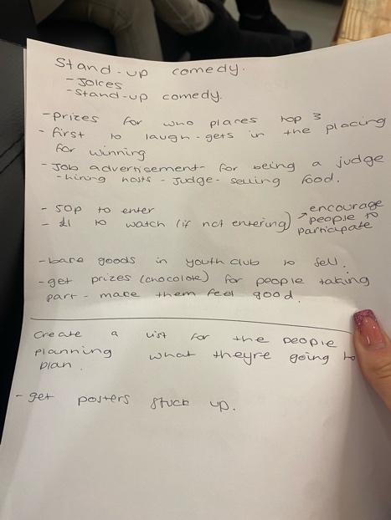
When me and the young people were planning to do a stand up comedy night.
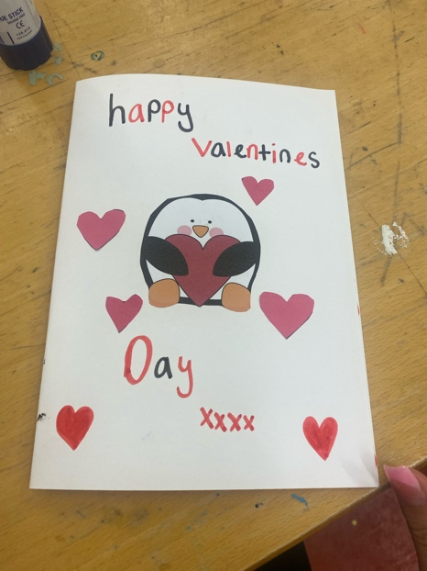
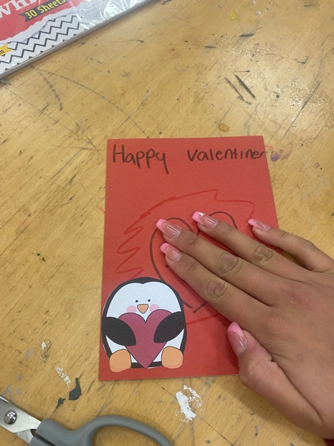
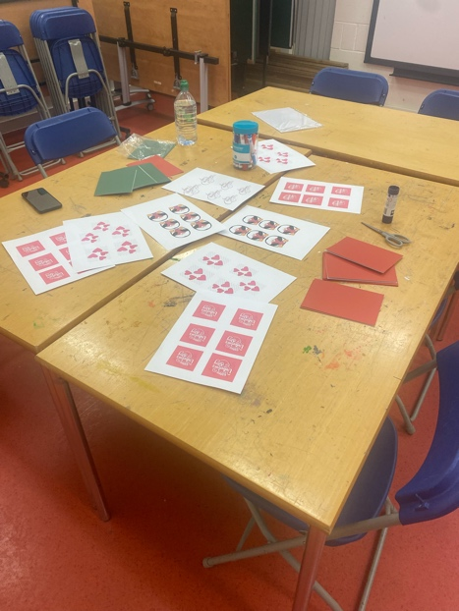

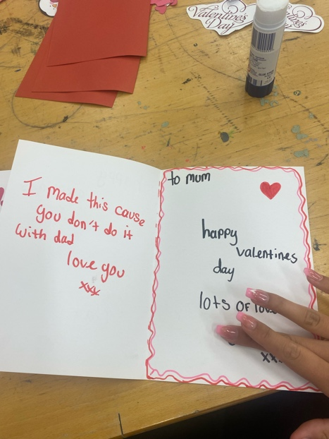
This was the activity I ran with the youth people using the writing model NAOME, and ran the activities around Valentine’s Day. This is my card making activity.

This was the activity I ran with the youth people using the writing model NAOME, and ran the activities around Valentine’s Day. This is my rock painting activity.
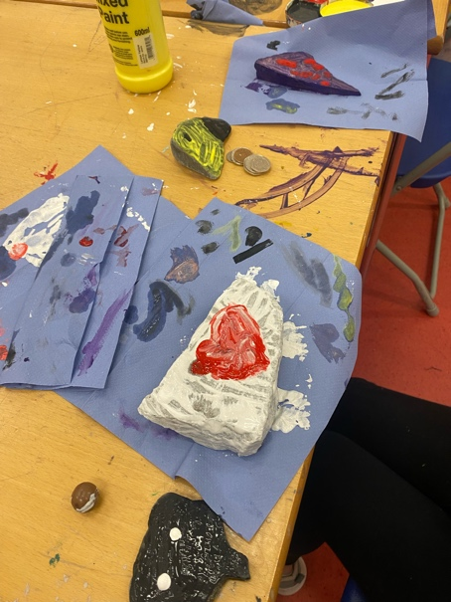
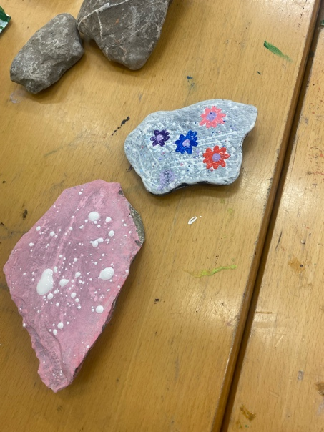
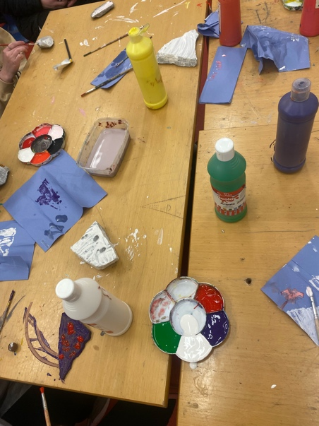
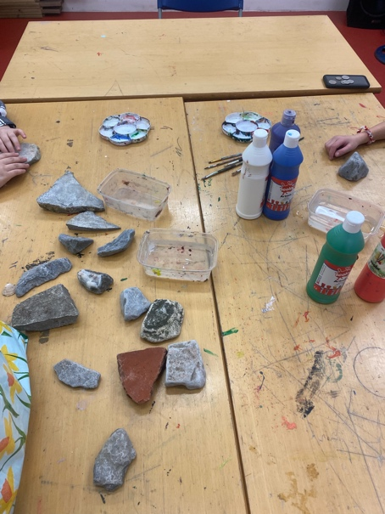
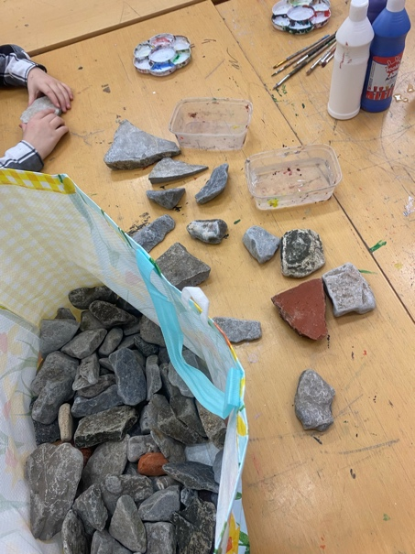

Risk assessment

HEALTH AND SAFETY RISK ASSESSMENT:

SERVICE – COMMUNITY YOUTH WORK TEAM
Person responsible:  Julie Bevington | Place: Milford Haven Youth Centre | Assessed on: 22nd October 2021  Date: 22nd October 2021
Manager:  Liz Griffiths | Task, Activity or Situation:  Generic Risk Assessment for Premises | Re-assessment date:  October 2022

Risk = severity x likelihood | Severity of harm
Likelihood of occurrence | (1) Slight  (All other injuries and illnesses) | (2) Serious  (Over 3 day injury or serious illness) | (3) Major  (Death or major injury)
(1) Low  (Harm will seldom occur) | Low (1) | Low (2) | Medium (3)
(2) Medium  (Harm likely to occur) | Low (2) | Medium (4) | High (6)
(3) High  (Harm certain to occur) | Medium (3) | High (6) | High (9)

HAZARD | WHO MIGHT BE  HARMED AND HOW? | EXISTING CONTROL MEASURES | RISK  (severity x likelihood) | WHAT MORE NEEDS TO BE DONE TO CONTROL THE RISK? | BY WHOM?  BY  WHEN?
Slips, trips and falls | Young people and staff may suffer injuries such as fractures or bruising if they slip, eg on spillages or trip over objects | Spacing equipment out to ensure plenty of room.  Equipment stored away safely and securely when not in use.  First Aid Kit on site. All accidents / incidents reported to CYW/LG | Low (2) | Consider layout of room.  Keep equipment tidy during sessions.  Staff have access to mobile phones in the event of emergencies. | CYW / All Staff  Ongoing
Obstructed fire exit | Staff and young people | Ensure no equipment is set up near the fire exits.  Equipment stored away safely and securely when not in use. | Low (1) | Remind staff and young people not to obstruct the fire exits | CYW / All Staff  Ongoing
Manual Handling/ Lifting and carrying  when setting up and  clearing away | Young people and staff may suffer back pain if they try to lift objects that are too heavy or awkward | Young people to be supervised by staff if they help to set up and/or clear away.  Two people to lift if required. | Low (1) | Continue practice of two people lifting equipment | All Staff  Ongoing
Personal injury due to doors swinging  quickly and one-way only. | All Centre Users | Keep doors open unless there is a  need for them to be closed | Low (1) | All doors fitted with hinge guards | All staff
General use of the building | Staff and young people | Keep all floors and corridors clear for ther fire exits  All floors and particularly corridors, walkways and fire exits are to be kept free from obstructions; any spillage is to be mopped up immediately.  Make sure all windows and doors are closed before leaving the building.  Staff asked to report any hazards or damage to CYW.  CYW to carry out and complete ‘Risk Assessment for Youth Club Premises’ annually. | Low(1) | Ensure that staff are aware of the need to check the general state of the building and youth club space regularly. | CYW  Ongoing  All Staff  CYW  CYW
Uneven surface near garden area which could result in tripping and personal injury | All visitors, staff and young people may suffer injuries such as fractures or bruising if they slip or fall | Lighting will be sufficient to aid vision.  Staff have access to First Aid Kit  and phone access for 999 if need | Low(1) |  | CYW  All staff
Youth Club staffing and security | Staff and young people | Staffing levels are appropriate with suitably qualified staff in place.  Cash and all valuable equipment (e.g. iPads) are to be kept secure at all times. Cash will be banked regularly.  Youth workers are not to undertake lone working. | Low (1) | Staff are aware of other users of the premises or members of the public present in the building.  Behaviour is managed effectively.  Staff have access to mobile phones in the event of emergencies. | CYW  All staff  All staff
General use of kitchen | Young people and staff could suffer from cuts, burns, scalds | Staff to ensure good housekeeping – work areas kept tidy, goods stored suitably.  Staff clean up spillages immediately using suitable methods to keep the floor dry.  Staff trained (Level 2 Food Safety in Catering) on how to use knifes. Knifes locked away when not in use.  Staff trained in all risks such as hot pans/ hot waters | Low (2) | Continue to adhere to the safe working practices which are in place.  Keep equipment tidy during sessions.  Behaviour is managed effectively.  Staff and Young People to wash and dry hands at all times to avoid cross-contamination of foods. Correct chopping boards and knifes to be used. | All staff
Traffic outside building & in public car park adjacent to youth centre | Staff and young people, other users of Milford Haven Youth Centre could suffer serious injury if struck by cars entering/leaving car park or on road. | Young people and staff aware that they must be vigilant of traffic in the car park and on the road.  Local residents, leisure centre users and car park users aware that youth club runs from the building adjacent to the car park. | Medium (3) | Staff to supervise young people who are hanging around outside Milford Haven Youth Centre.  Staff will report any incidents of dangerous driving to police. | All staff

