Safiya Nanton (2114630)
29 April, 2022
Assignment 1 ACBA4000: Digital Estimating and Measurement in Construction
tendering Procedure

Table of Contents
What is Tendering? 2
Difference between Tendering and Procurement 2
Different Types of Tendering Procedures 3
Tendering Process and its Documents 5
Role of a Quantity Surveying when Preparing a Tender 8
References 9

What is Tendering?

Tendering is an important part of the majority of construction companies' business development strategies. If you want to complete a project or a portion of one, you'll need a contract that specifies how much money, time, and other criteria you'll need to do so. You may acquire new contracts with buyers you weren't previously aware of or even have access to via tendering (Hudson, 2020).

Difference between Tendering and Procurement

In the construction industry, the difference between tendering and procurement is sometimes misinterpreted. Some people use these expressions interchangeably without understanding the full meaning.

To manage a construction firm or carry out a project, procurement is the purchase of materials, equipment, and services. In other words, the materials and labour required to build a building are referred to as "raw materials." Procurement must be aggressively addressed if construction companies are to maximise their productivity on each project.
A construction company's procurement strategy must be rigorous to get the necessary supplies for the lowest feasible price. The procurement strategy must consider several variables, such as budget, timeliness, and the overall quality of the project (constructionplacements, 2020).

On the other hand, Tendering refers to the act of requesting bids or accepting formal offers, such as the acceptance of a takeover bid, for a project. Tendering is a method used by government organisations to get quotes for large-scale projects with strict deadlines.
Tendering is also the process of soliciting bids from contractors for a building project from a client. Contractors' bids are based on the customer's tender documents.
As a "contractor," the successful tenderer is also a "party" to a "client" contract. Signing the tender documents makes them legally binding to all parties involved. The contract documents comprise the completed bidding paperwork (constructionplacements, 2020).

Different Types of Tendering Procedures

There are 3 main types of Tendering Procedures.
- Single stage Tendering
It's the most common kind of bidding method, in which a client makes one offer for the whole project, including all relevant information. According to (RICS, n.d.), to win the job, the contractor may opt to quote aggressively to guarantee that the customer obtains a competitive price. Before picking a single contractor, they are analysed for cost and quality. In order to finish the task, they enter into a construction contract with the client.

It's possible to find a contractor this way. Due to this, it is important to make sure that all crucial aspects of a project's specifications are included in the contract. If they aren't, contract revisions may have to be made later and the final bill may be drastically different as additional expenses are accrued. Increased pressure on contractors may lead them to look for ways to minimise costs, even at the sacrifice of quality. As a result, clients will not be able to reap the benefits of early contractor engagement under this approach. One stage contracts are becoming less popular amongst contractors owing to their perceived risk and the time commitment involved (Simons, 2021).

- Two-Stage Tendering
Recently, tendering has undergone a major transformation. It's common practise to employ two-stage tendering when time is at a premium since it permits both design and tendering to take place simultaneously. Contractors are often called upon to aid with design in later phases, as well. Contractors can get started on a project promptly with this approach.
Because the project is still in the design phase, no contractors are being requested to submit bids for the whole scope. Instead, the preferred contractor is picked based on the quality of their offer, the quality of their team, and their preliminary pricing, overhead, and profit allowances for the project. The preferred contractor then joins the design team on a consulting basis through a pre-construction services agreement, which is how they work together (PCSA). Following that, the recommended contractor collaborates with the design team to execute the project (RICS, n.d.).
The two-stage tendering procedure, on the other hand, may take more time, and companies on a tight development schedule may find this unappealing. An increase in cost may occur because a two-stage tendering procedure may not be competitive enough for the favoured contractor (Rutherford, 2020).

- Negotiating Tendering
A negotiated tender is a one-stage tender in which only one contractor provides an initial price. They next consult their client's professional staff, such as a quantity surveyor or project manager (PM).
The advantage of this technique is the quickness with which a price for the job may be received. However, the competitive advantage of a formal bidding procedure is jeopardised. Many public corporations and government agencies will not allow negotiated bids unless under exceptional circumstances, since establishing value for money in today's market is difficult (RICS, n.d.).

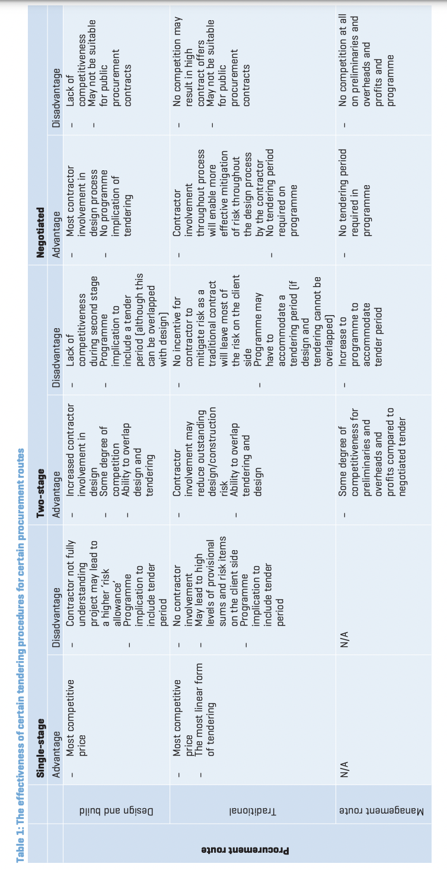
Figure 1: Table showing the Advantages and Disadvantages of Each Procedure described above

Tendering Process and its Documents

To complete a Tender, Bidding parties need to provide documents at the relevant stages during the Tendering process. According to the (RICS, n.d.), the Tendering process occurs by:
- The selection of tendering contractors is a critical step in the tendering process since the quality of tender returns is only as good as the quality of the tenderers. Its included in the pre-stages of the Tendering Process which are as follows:
- There are three main ways to select a contractor:
- Anybody who wishes to tender may do so via the process known as "open tendering." When there is a new tender, it is frequently announced in periodicals or on the internet. Procurement is referred to as "OJEU tendering" or "OJEU procurement." This is an example of open bidding (albeit with some caveats as to suitable contractors). A shortlist may be produced by the project or client team, or it may be drawn from a pre-approved framework/approved suppliers list.
- Selective tendering: The main difference between open tendering and selective tendering is that the project team determines the list of possible bidders for selective bidding. Everyone on the design and client teams should come up with a lengthy list of when a project is likely to happen.

- Choosing a single contractor is a good strategy for negotiating a task. Negotiations begin when a contractor is selected. A single individual has made the cut, so to speak.

- Assessing a suitable tender period: Tender inquiries should be sent to contractors in a reasonable amount of time. The length of this time depends on the specifics of each project.
- Producing or Compiling The tender documents: It is important to start the tender compilation process by making a list of what is needed, depending on the procurement route and the type of contract. Contracts for design and construction are distinguished from conventional contracts by the fact that the documents are consolidated into a single document referred to as the "employer's requirements," to which the contractor responds with their proposal for the task. A bill of quantities may be necessary depending on the contract type selected.

- Invitation to Tender: The opportunity might be advertised in a variety of ways. This letter or document says that the contractor has been asked to bid on the project. It also explains the project, confirms the return date and provides contact information for any questions that arise.
- Contract conditions may contain a commentary on the proposed contract terms, which may be dictated by parties other than the client. Additionally, this is the obvious location for any suggested contract changes.
- Instructions to tenderers documents: Most tenders contain an instruction to tenderers document (sometimes referred to as tender conditions) that details what the contractor is expected to return and by what date. Additionally, it contains the proposed scoring method, any relevant questionnaires, information on how to schedule site visits, and information on how to submit tender inquiries.
- Project information (preliminaries/works information/employer’s requirements): This document is referred to differently in different contracts, but it is essentially where the project is detailed and the contractor's contractual obligations are established. It will also address the number of design tasks required for design and build (or standard CDP contracts) projects.
- Pricing document: The price document is determined by the contract type and the procurement channel used. A complete bill of quantities is a standard price document for a conventional project. A traditional contract, on the other hand, may be offered based on specifications and drawings, with the contractor being responsible for producing the quantities.
- Evaluation of the tender submissions: instructions to tenderers should make it clear how bids are to be sent out and received. Bids should be filed at a certain time, date, and location. Additionally, it should provide the name of the individual who shall receive tender returns. The evaluation and analysis of submitted bids must be systematic and comprehensive in order to maintain equality for all tenderers and to ensure that tender returns are compared on a like-for-like basis. All tender returns should be checked for errors before further investigation may begin. The tender return price and the rest of the tender are subject to comprehensive arithmetic and logic verification.
Hazards and risk distribution, as well as environmental concerns, will be examined in these evaluations. If risks are difficult to estimate, employers should be wary of contractors who, despite their inadequate competence, offer lower prices because they haven't considered all the potential pitfalls. However, if these dangers materialise, the contractor may be unable to deal with the repercussions, putting the employer in a difficult position (IADC, n.d.).
- Post-tender interviews: should be undertaken only after the initial inquiries and equalisation procedures have been completed and these analyses have been utilised to guide the interview process. Before the interview, the framework and broad questions should be agreed upon for all invited tenderers; nevertheless, it is anticipated that specific questions will be unique to individual tenderers.
- Award of contract: The consumer may call a tender settlement meeting after he or she has selected one or more offers. During these meetings, the client and their chosen supplier may work out the details of the contract. The documents for the tender may be revised or a new tender can be submitted. The decision should be notified to all bidders after the tender report has been created and authorised by the client.
It is to be hoped that risk assessment and allocation are taken into consideration when a tender is granted to a certain contractor. Hopefully, the prize will also give preference to the most affordable option. This kind of contract may cost more upfront, but it will pay off in the long run (IADC, n.d.).

Role of a Quantity Surveying when Preparing a Tender

A QS has a vital role to play when preparing a tender. During the tendering process, the quantity surveyor is expected to do several things. A professional Quantity Surveyor prepares and monitors the tender to ensure the customer gets the most value for money. A quantity surveyor must examine each tender to determine price disparities (Whiteandlloyd.com, 2016).
They receive a brief from the employer to determine what they require in a proposal and collaborate with the project team to develop a credible bidding strategy. They must also deal with tender questions and respond immediately. Tender returns, design team inquiries, and a tender report with preferred contractor status recommendations agreed upon by the whole project team.
This assures the contractor is pleased with their proposal and will complete the task at the agreed price. It provides the buyer with a list of costs for units that aren't too pricey. The consumer may also compare quotations "as is." Having a QS indicates to the customer the contractor is dedicated (Whiteandlloyd.com, 2016).

References

constructionplacements (2020). What is Procurement and Tendering in Construction? [online] ConstructionPlacements. Available at: https://www.constructionplacements.com/what-is-procurement-and-tendering-in-construction/.
Hudson, J. (2020). What is Tendering in Construction? | Why Tender for Work? [online] Construction Tenders. Available at: https://www.construction-tenders.co.uk/what-is-tendering-in-construction/.
IADC (n.d.). Tenders and Bidding - Tenders are usually conducted in four stages:... [online] IADC Dredging. Available at: https://www.iadc-dredging.com/subject/procurement-dredging-projects/tenders-bidding/.
RICS (n.d.). Tendering strategies. [online] RICS. RICS guidance note, UK. Available at: https://www.rics.org/globalassets/rics-website/media/upholding-professional-standards/sector-standards/construction/black-book/tendering-strategies-1st-edition-rics.pdf.
Rutherford, H. (2020). StackPath. [online] brodies.com. Available at: https://brodies.com/insights/construction-and-engineering/two-stage-tenders-a-means-of-managing-risk-for-contractors/.
Simons, J. (2021). Single-stage vs two-stage tendering - procurement process. [online] Scape. Available at: https://www.scape.co.uk/news/2021/single-stage-vs-two-stage-tendering.
Whiteandlloyd.com. (2016). Tendering in construction. Why and how? - Surrey, Weybridge, Fulham, Chelsea. [online] Available at: http://www.whiteandlloyd.com/quantity%20surveying/2016/09/20/tendering-in-construction-why-and-how.html#:~:text=Part%20of%20the%20Quantity%20Surveyors.
Word Count: 1922

