Content
Entry 1: Positionality and Individuality 2
Appendix 1: References 4
Appendix 2: Useful Links 6
Appendix 3: Definitions 7
Appendix 4: Development Activities 9
Entry 2: Reading and evaluating literature and information sources 10
Appendix 1: References 12
Appendix 2: Useful links 13
Appendix 3: Definitions, figures and frameworks 14
Appendix 4: Self-development activity 20
Entry 3: The Contribution of Research to Knowledge and Organisational Development 21
Appendix 1：References 24
Appendix 2：Useful websites and links 26
Appendix 3：Tables 26
Appendix 4：Self-development activity 30
Entry 4: Defining the research question 31
Appendix 1: References 33
Appendix 2: Useful links 34
Appendix 3: Figures and Tables 35
Appendix 4: Self-development activity 37
Entry 5: Philosophical frameworks for research 38
Appendix 1: References 40
Appendix 2: Useful links 42
Appendix 3: Frameworks and tables 43
Appendix 4: Self-development activities 47
Entry 6: Types of research and research design 48
Appendix 1: References 51
Appendix 2: Useful link 52
Appendix 3: Definitions and figures 53
Appendix 4: Self-development activity 56
Entry 7: Research ethics and integrity 57
Appendix 1: References 59
Appendix 2: Useful links 61
Appendix 3: Figures 62
Appendix 4: Self-development activity 63

Entry 1: Positionality and Individuality
Word count: 512
Positionality
“There’s no enunciation without positionality. You have to position yourself somewhere in order to say anything at all” (Hall, 1990, p. 18). Positionality is a combination of objectivism and subjectivism. The two are a dialectical relationship (Freire, 2000, p. 50). We can never get rid of our subjectivity and pursue pure objectivity. But we should strive to be objective in our pursuit process and always pay attention to our subjectivity. This is known as positionality. We admit that we are independent individuals, that we are part of a group, we are constantly on the move (Bourke,2014). The theory of positional opposition to the fixed, static, essentialist view. It is more inclined to look at one aspect of a person’s experience, such as gender and related power situations (Alcoff, 1988; Collins, 1993). The external environment determines the relative position of people. Positionality theory illuminates the multiple overlapping identities of people. People define them in terms of their social class, their professional identity (Longino, 1993; Kezar, 2002).

The significance of positionality
According to Bourke (2014), positionality has a potential impact on the whole research process, participants and researchers. The results of the study were mediated not only by my positionality, but also by the participation of the responders. As people develop knowledge, positionality performance is a better explanation of how diversity appears in other environments (Collins, 1993). In qualitative research, the essence is the researcher’s tool for data collection. The researcher’s gender, race, educational background, class, socioeconomic status and other cultural background, political stand and belief are all important variables that affect the research process. The experiences of both researchers and participants are shaped in a sociocultural context. We need to be aware of the fact that my own biases affect the participants, and that their reactions, researcher’s observations and interpretations also affect a study (Bourke,2014). When you do research, a lot of times you have to make an assumption, and it involves the concept of an inside person and an outside person. Positionality is determined by the relationship between people and others (Merriam, et al. 2001).

Individuality in Research
In the conduct of scientific research, the outstanding individuality plays the highest value. It plays an extremely important role in the development of the world and contributes to the well-being of mankind. Especially for young researchers, they need foresight and awareness to make decisions in complex environments. They need to choose between being inspired more or developing ideas that already exist. Science is international. Each country should solve part of the common problem in its own way, allowing its people to express themselves fully and freely on an individual level (Carmichael,1919).

Positionality and Individuality
It is essential to pay attention to the inherent positionality, individuality, knowledge generation, reflexivity and power relations in the research process (Sultana, 2007). The development of knowledge and the progress of society are inseparable from the deep personality of researchers. While pursuing the maximization of objectivity, researchers should minimize subjectivity and prejudice. Thus, they can contribute to knowledge and society. The position taken by a researcher affects every stage of the research process. There is a hidden contradiction between personality and position.

Appendix 1: References
Alcoff, L. (1988). Cultural Feminism Versus Post-Structuralism: The identity crisis in feminist theory. Signs, 13(3):405-436.
Bourke, B. (2014). ‘The Qualitative Report Positionality: Reflecting on the Research Process’. The Qualitative Report, 19(33), pp.1–9.
Carmichael, R. D. (1919). ‘Individuality in Research’. The Scientific Monthly, 9(6), pp. 514-525.
Collins, P. (1993). ‘Learning from the Outsider within: The Sociological Significance of Black Feminist Thought.’ In Women in Higher Education: A Feminist Perspective, edited by Judith Glazer, Estela Bensimon & Barbara Townsend, 45-65. Needham Heights, MA: Ginn.
Corlett, S. and Mavin, S. (2017) ‘Reflexivity and researcher positionality’. The SAGE handbook of qualitative business and management research methods: pp.377-399.
England, K.（1994）. Getting personal: reflexivity, positionality, and feminist
research. Professional Geographer 46（1） 80-89.
Freire, P. (2000). Pedagogy of the oppressed (30th anniversary ed.). New York, NY: Continuum.
Hall, S. (1990). Cultural identity and diaspora. In J. Rutherford (Ed.), Identity: ommunity, culture, difference (pp., 2-27). London, England: Lawrence & Wishart. Kezar, A. (2002). Reconstructing static images of leadership: An application of positionality theory. Journal of Leadership Studies, 8(3), 94-109.
Longino, H. (1993). Feminist Standpoint Theory And The Problems Of Knowledge. Signs, 19(11): 201-212.
Merriam, S., J. Johnson‐Bailey, Y. Lee My Lee, G. Ntseane and M. Muhamad (2001). "Power and Positionality: Negotiating Insider/Outsider Status Within and Across Cultures." International Journal of Lifelong Education 20(5): pp. 405‐416.
Sultana, F. (2007). Reflexivity, positionality and participatory ethics: Negotiating fieldwork dilemmas in international research. ACME: An international E-journal for Critical Geographies, 6(3), 374-385.

Appendix 2: Useful Links
1. What is Your Researcher Positionality?
https://decolonizingresearch.wordpress.com/2016/02/25/what-is-your-researcher-positionality/
2. WHAT DOES POSITIONALITY MEAN?
https://www.dictionary.com/e/gender-sexuality/positionality/
3. What is Positionality
https://www.igi-global.com/dictionary/queering-the-marianist-charism/23040
4. positionality
https://www.lexico.com/definition/positionality
5. Thinking about Positionality
https://prezi.com/mwkdn3ob1kxh/thinking-about-positionality/

Appendix 3: Definitions
Figure 1. Situated dissertation researcher positionality (Throne, Bourke et al., 2018).
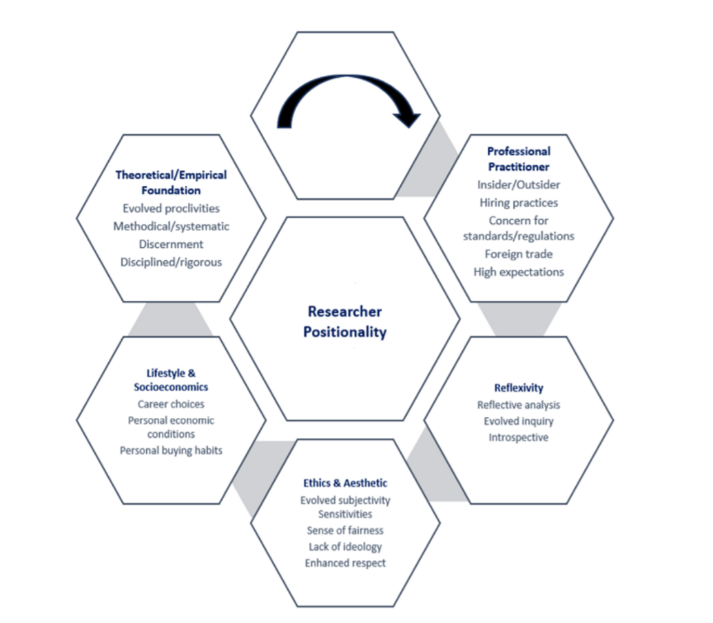

Figure 2. intersectionality
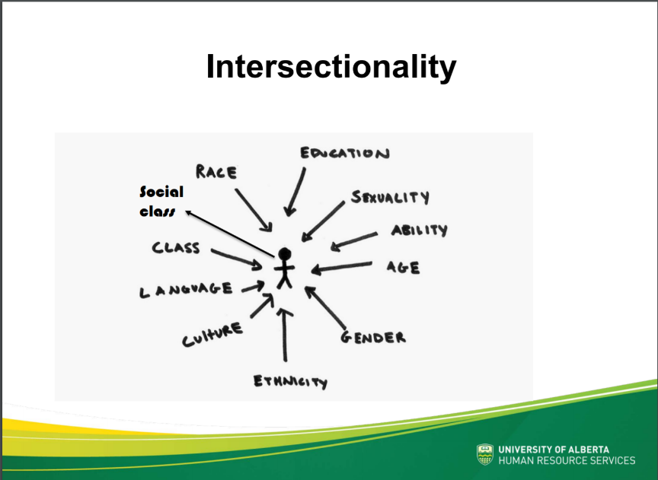
(Source:https://cloudfront.ualberta.ca/-/media/gradstudies/professional-development/gtl-program/gtl-week-august-2018/2018-08-28-social-location-and-unconscious-bias-in-the-classroom.pdf)

Appendix 4: Development Activities
In class, Caroline gave us a quiz to test our attitudes on age, race, occupation, etc. If an accident happens to a ship, we can only save five people on board. Caroline give us the papers with figure’s information about their age, race, and occupation. There was a thirty years old black nurse, a sixty-years-old white doctor, a sixteen-years-old pregnant woman, a policeman, a lawyer, a thirty years male manager, a housewife and so on. When we finish the test, we found that everyone had different attitudes about their occupation, age, race, etc. Opinions differ as to who should be saved. This is also a reflection of each person’s position will affect his view. Since I went back to China, I didn’t bring the specific material of the characters I practiced in class with me, so I'm sorry that I can’t put photos here.

Entry 2: Reading and evaluating literature and information sources
Read & think critically
Reading plays an important role in the whole research process. It helps us to understand the relevant field, understand the research results and the latest development in this field, and it can also provide some theoretical views and methodologies for reference. We can also seek support for our views by reading related resources and using them in our own research. In the process of reading, we will explore various points of view, and we need to evaluate them. Critical reading is very important and necessary for researchers. Read actively, critically, and in conjunction with what you already know, assessing the robustness of the author’s research and the strength of researcher’s arguments (Ridley, 2012).
Reading skills and effective methods are especially important when dealing with large amounts of reading. In the early days, we are more exploratory, hoping to find more relevant information. Later, as our research topic became more specific, we took a focused approach to reading for more support. The front is relatively free, the back is relatively purposeful. Because then you will gradually be able to identify valid information and filter it.
One recommended effective reading program is SQ3R (Survey, Question, Read, Recall, Review). We read to get the main points what the author is trying to convey. But we still need to take its question and analysis. For example, do you think the author has enough evidence? What is the author's background to this article? Is the author’s hypothesis reasonable? After reading, we also need to classify and group the appropriate literature collected. It is also a process of analysis and synthesis (Cronin; Ryan and Coughlan, 2008). In the systematic and critical review of the content, the PCQS structure proposed by Cohen can be adopted. Specifically, preview, question, reading, summary system (Cohen ,1990). Taking notes is a good way. Use different color pens or computer software to take notes and include your own comments and thoughts.

Evaluate literature and information sources
When we do academic research, we need to collect a lot of relevant information resources and materials. Common sources include books, journal articles, published literature reviews of a field, 'Grey literature', Web sites. All sources of information should be carefully evaluated as they may be used in your academic writing. We should pay special attention to the various network resources. The web is a vast collection of unfiltered information sources. Anyone can put anything on it and edit it, and the material doesn’t have to be peer-reviewed or quality-tested. So, when we're using information on the web, it’s important to evaluate it (Ridley, 2012). An effective strategy is analysis the URL {Uniform Resource Locator) address to assess the site’s credibility.
Many scholars and research institutions have studied the criteria for evaluating literature and sources. From the website of City university of Hong Kong accuracy, authority, objectivity, currency and coverage are the five basic criteria for evaluating information from any sources. According to Hek and Langton (2000), they proposed to focus on quality, reliability and accuracy when evaluating articles. Specifically including the peer review of the journal, the status and background of the author. Many scholars have also suggested that the last stage of assessment should be to write a short summary of your own. It includes the central idea of the article, the rationality of the design, the substitution of the method, the limitation and so on. It is actually a good process of self-reflective, and it will deepen your understanding of the article. Moreover, it also lays a solid foundation for later literature review. This will make it easier to find the relevant information and literature you need for future literature reviews.

Appendix 1: References
Cohen G (1990) Memory. In: Roth I, ed. The Open University’s Introduction to Psychology. Volume 2. Milton Keynes, Lawrence Eribaum: 570–620
Cottrell, S. (2017). Critical thinking skills: Effective analysis, argument and reflection. Macmillan International Higher Education. Red Globe Press
(3rd Edition)
Cronin, P., Ryan, F. and Coughlan, M., (2008). Undertaking a literature review: a stepby-step approach. British journal of nursing, 17(1), pp.38-43.
Graham, V. F. (2011) The literature review: a step-by-step guide for students, Evaluation & Research in Education, 24(3), pp.224-225.
Hek, G., Langton, H. (2000) Systematically searching and reviewing literature. Nurse Res 7(3): 40–57
Saunders, M. N., & Lewis, P. (2012). Doing research in business & management: An essential guide to planning your project. Pearson.
Saunders, M.，Lewis, P. and Thornhill A. (2016). Research Methods for Business Students (7th edn). Essex:Pearson. Saunders, M.N.K. (2011) ‘The management researcher as practitioner’, in B. Lee and C. Cassell (eds) Challenges and Controversies in Management Research. New York: Routledge, pp. 243–57.
Templier, M., and Paré, G. (2015). A framework for guiding and evaluating literature reviews. Communications of the Association for Information Systems, 37(6), pp.112 – 137.
Ridley, D. (2012). The literature review: A step-by-step guide for students. Sage.
2nd Edition

Appendix 2: Useful links
1.Literature Review - Finding the Resources
https://libguides.library.cityu.edu.hk/litreview/evaluating-sources
2. Evaluate Your Sources
https://guides.library.uoit.ca/literaturereview/evaluate-sources
3. Writing a Literature Review in Social Sciences
https://guides.lib.fsu.edu/c.php?g=353387&p=2382272
4. Tips to Evaluate Sources
https://libguides.asu.edu/c.php?g=264095&p=1763442#s-lg-box-5389254
5. Literature Review - what is a Literature Review, why it is important and how it is done
https://lit.libguides.com/c.php?g=664499&p=4701470

Appendix 3: Definitions, figures and frameworks
1. Evaluation Criteria
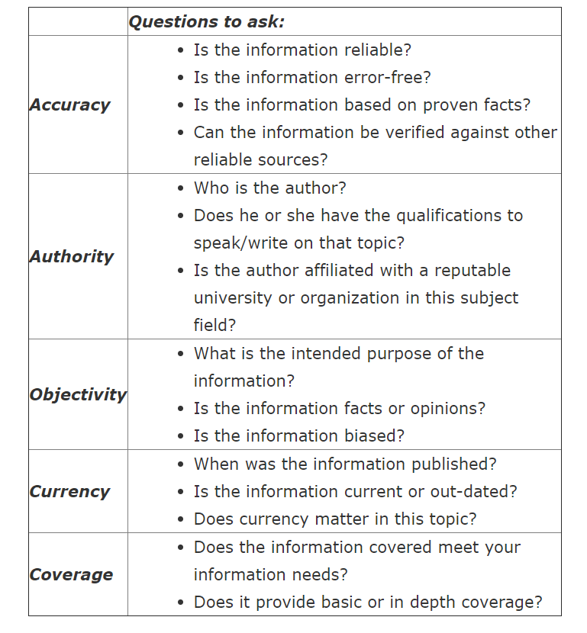
(Source: https://libguides.library.cityu.edu.hk/litreview/evaluating-sources)

2. Tips to Evaluate Sources
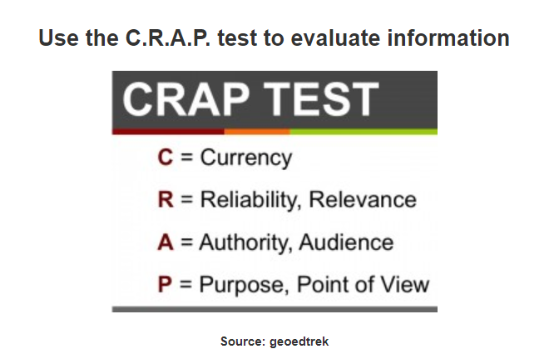
(Source: https://libguides.asu.edu/c.php?g=264095&p=1763442)
3.how to read academic texts
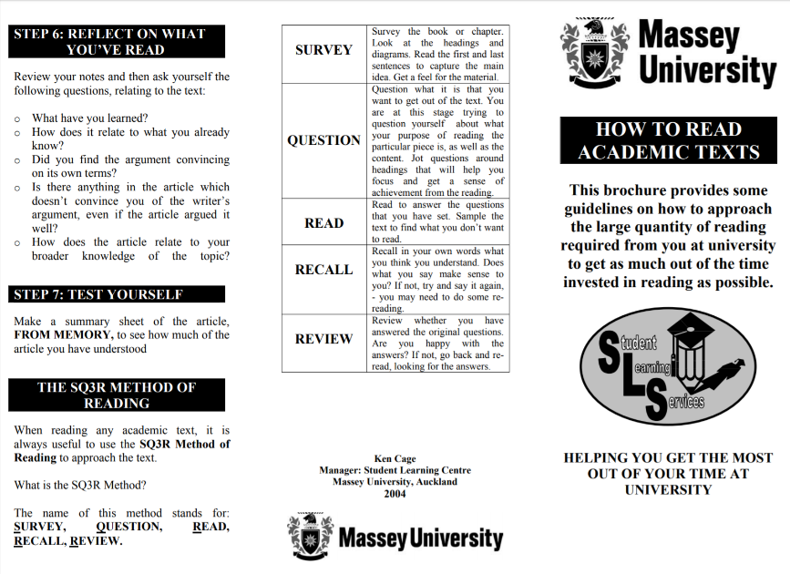
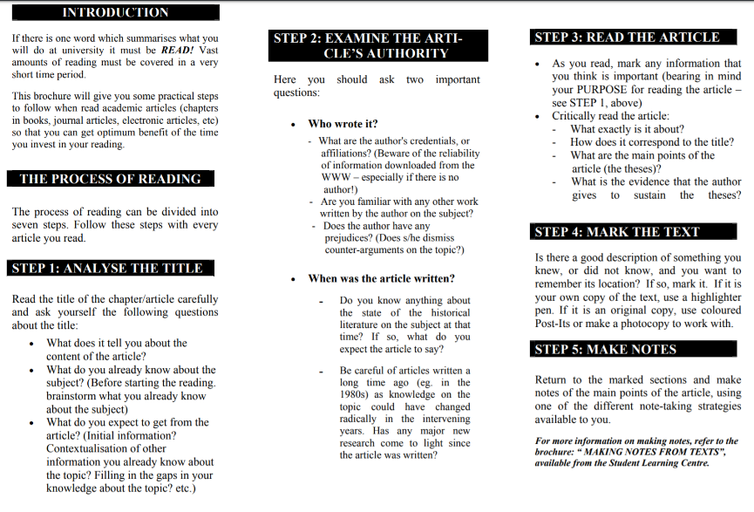
(Source: https://www.massey.ac.nz/massey/fms/Student%20services/Student%20Learning%20Development%20Service/Documents/Albany/Brochures/Study%20skills/Reading%20academic%20texts.pdf)

4. Pattern notes- Linear notes
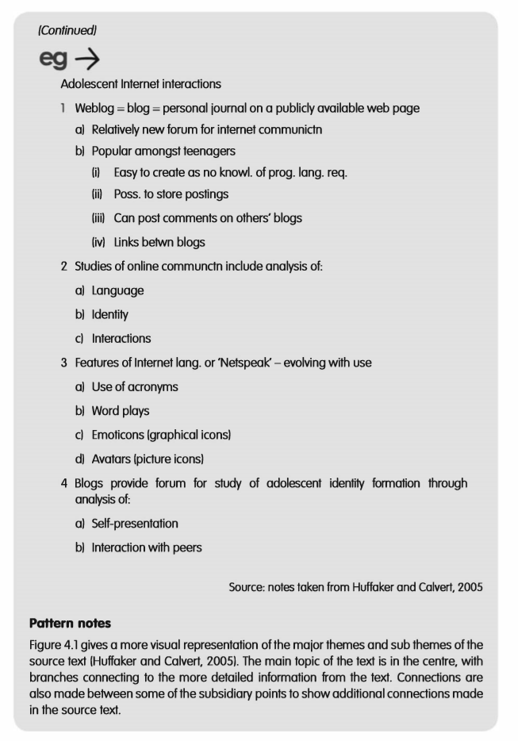
(Source: notes taken from Huffaker and Calvert, 2005).

5. Pattern notes- A global summary
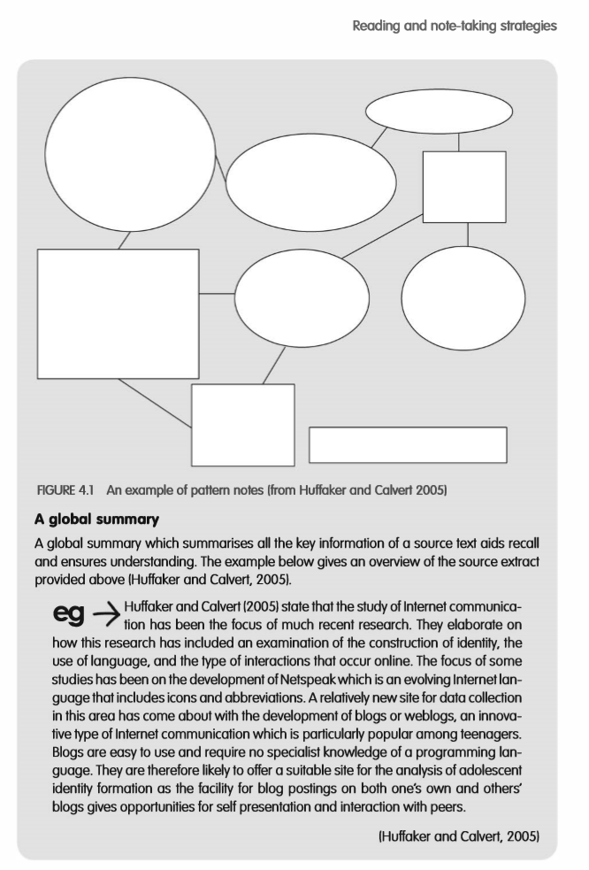
(Source: notes taken from Huffaker and Calvert, 2005).

6. Reflex Interaction, Reflective Analysis, and Critically Reflexive Questioning
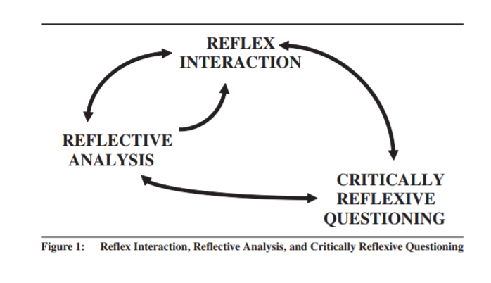
(Source: On Becoming a Critically Reflexive Practitioner, Cunliffe,2004).
7.The evaluation process vs traditional research
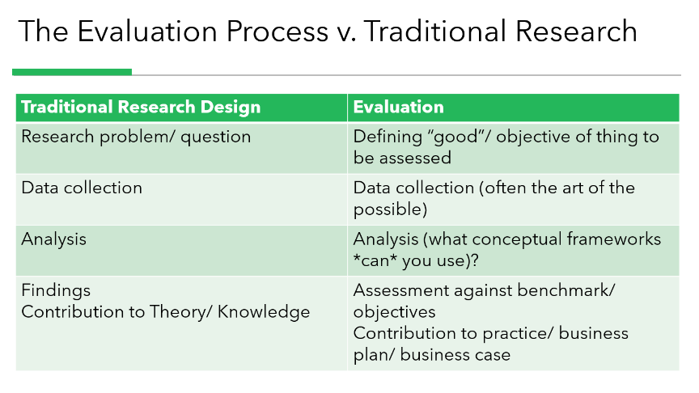
(Source: class PPT, Caroline,2019).

Appendix 4: Self-development activity
In class, David showed us an academic article from Harvard Review. We were asked to critically evaluate the article, and later we learned that the Harvard Review had no peer reviewed. It also makes us understand that peer review is an important indicator of academic standards. Then we were shown another article and asked to critically analyze it. Let us understand from the author's background to analysis is also a good measure. Gareth showed us two articles and a news report and asked us to guess how many stars they were. We can tell whether the author’s attitude is objective from the words in the headlines of news reports, because the author uses a very subjective judgment. The title of the article uses encouraging, but that’s not the actual situation.
All the relevant training in the class makes us understand the importance of critical reading and critical analysis of sources. Through the teachers’ courses, I understand that some strategies can be adopted to improve the efficiency of reading and critical thinking. For example, we can summarize the main information of the literature by making small summaries or tables.

Entry 3: The Contribution of Research to Knowledge and Organisational Development
Understanding of Management and business research
Business and management research is actually to find out the business and management related matters through systematic research (Saunders,2016).
There is still a debate about whether management research leads to the development of academic theory, or whether it leads to the solution of practical problems. This is really a debate between pure research and applied research. Combining the insights and expertise of researchers and managers, the research offers the possibility of joint production of knowledge. (Easterby-Smith, Thorpe and Jackson, 2012). Management research also provides access and support for managers and employees, and even many funding agencies are looking for potential economic benefits. Research enables these practices and practitioners to participate (Alvesson and Deetz, 2000).
The goal of management research is to develop knowledge about organizational management (Alvesson and Deetz, 2000). One striking feature is the use of general or sociological methodologies to study the phenomena of management and organization. Some researchers think research should develop some knowledge. For managers, they can better improve the performance of the organization (Alvesson and Deetz, 2000). Develop knowledge and practical understanding of business management to enable change and provide skills to guide new ways of doing business. This is the embodiment of a pragmatic management view (Alvesson and Deetz, 2000). According to Tranfield and Starkey (1998), business and management research should complete a virtuous circle of theory and practice. This requires a combination of theory and practice.
In short, business and management research needs not only to promote the discovery of knowledge and understanding, but also to provide solutions to practical business management problems (Saunders,2016).

Knowledge production in the field of business and management
Gibbons et al. (1994) proposed two paradigms of knowledge production. Mode1, characterized by leadership in theoretical or experimental science. It is mainly carried out within the academic community, with an emphasis on analysis and basic knowledge and a preference for a single discipline. A new knowledge production paradigm is mode2, which is application-oriented and generated in the context of the application (Nowotny et al. ,2003). It is characterized by interdisciplinary work, with a focus on solutions (Van Aken, 2001). Nowotny et al. (2003) add the characteristics of mode2 are much greater diversity, highly reflective and novel forms of quality control. Mode 2 is characterized by a constant flow back and forth between foundation and application of theory and practice (Gibbons et al., 1994). It overcomes the limited external correlation of mode1(Van Aken, 2001). Next, huff found mode3 of knowledge production, which focuses on understanding the human condition and future. Its purpose is to ensure the common good of all social strata (Huff and Huff 2001).

The relevance gap and the research-practice gap
The relevance gap caused by the separation of knowledge producer and knowledge user has been a controversial topic (Tranfield and Denyer, 2004).
Some scholars believe that managers often do not take the direct results of academic research when making strategic decisions (Abrahamson,1996; Mowday,1997). In addition, in the process of research, researchers often fail to integrate the views of practitioners (Rynes, Bartunek and Daft, 2001). There is a real gap between management research and practice (Carter, 2008) that fails to establish management based on best evidence (Saunders, et al. 2016).
Only when academic members of universities, business schools, relevant academic institutions, managers and companies are closely connected Murphy and Saal，1990；Rynes et al.，2001）can the creation of management knowledge and the implementation of practical strategies be promoted (Álvarez & Mazza, 2000).

Appendix 1：References
Alvesson, M., & Deetz, S. (2000). Doing critical management research. Sage.
Álvarez, J. L., & Mazza, C. (2000). The Consumption of Management Publications. I ESE Research Papers D/420, IESE Business School. Retrieved March 30, 2019, from https://media.iese.edu/research/pdfs/DI-0420-E. pdf
Robson, C. (2002). Real world research: A resource for social scientists and practitioner-researchers (Vol. 2). Oxford: Blackwell.
Carter, C. R. (2008). Knowledge production and knowledge transfer: closing the research-practice gap. Journal of Supply Chain Management, 44(2), 78-83.
Easterby-Smith, M., Thorpe, R. and Jackson, P (2012) 4th ed，Management Research, London: Sage.
Gibbons, M. (Ed.). (1994). The new production of knowledge: The dynamics of science and research in contemporary societies. Sage.
Hodgkinson, G. P., & Rousseau, D. M. (2009). Bridging the rigour–relevance gap in management research: It's already happening!. Journal of Management Studies, 46(3), 534-546.
Huff, A.S. and Huff, J.O. (2001) ‘Re-focusing the business school agenda’, British Journal of Management, Vol. 12, Special Issue, pp. 49–54.
Nowotny, H., Scott, P., & Gibbons, M. (2003). Introduction: 'Mode 2'revisited: The new production of knowledge. Minerva, 41(3), 179-194.
Pritchard, D. (2014) What is this thing called knowledge? Routledge.
Saunders, M. N., & Lewis, P. (2012). Doing research in business & management: An essential guide to planning your project. Pearson.
Saunders, M.，Lewis, P. and Thornhill A. (2016). Research Methods for Business Students (7th edn). Essex:Pearson. Saunders, M.N.K. (2011) ‘The management researcher as practitioner’, in B. Lee and C. Cassell (eds) Challenges and Controversies in Management Research. New York: Routledge, pp. 243–57.
Van Aken, J. E. (2001). Mode 2 knowledge production in the field of management. Eindhoven Centre for Innovation Studies, Working Paper, 1.

Appendix 2：Useful websites and links
1. WHAT EXACTLY IS A ‘CONTRIBUTION TO KNOWLEDGE’?
https://phdinahundredsteps.com/2014/02/03/what-exactly-is-a-contribution-to-knowledge/
2. How to make an original contribution to knowledge
https://www.universityaffairs.ca/career-advice/career-advice-article/how-to-make-an-original-contribution-to-knowledge/
3. PhD Proposal Writing | Contributing to knowledge
https://www.ukessays.com/essays/education/an-original-contribution-to-knowledge-education-essay.php
4. Basic vs Applied Research
https://www.linkedin.com/pulse/basic-vs-applied-research-kiki-ahmadi

Appendix 3：Tables
1.Table of Contributions and Outcomes of Research
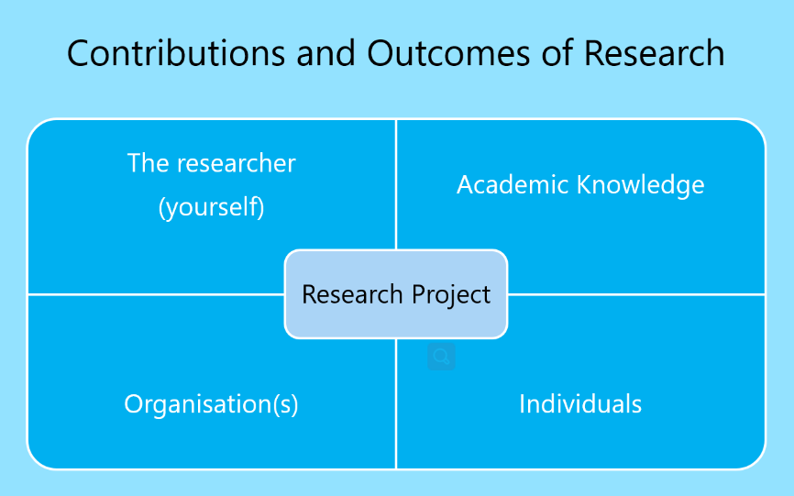
(Source: class PPT, Jill Venus,2019).
2.Epistemological conceptions of knowledge
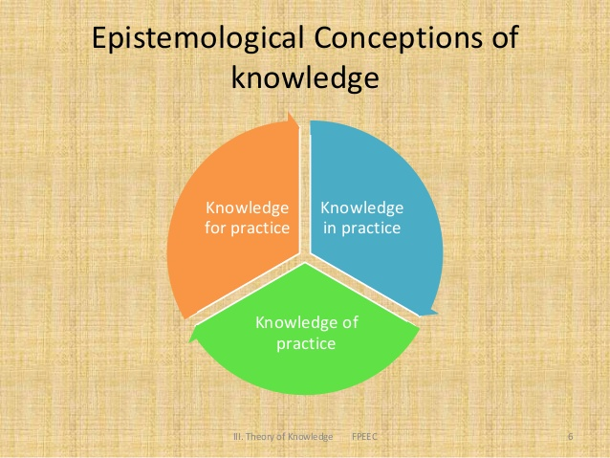
(Source: class PPT, Caroline,2019).
3.Forms of knowledge
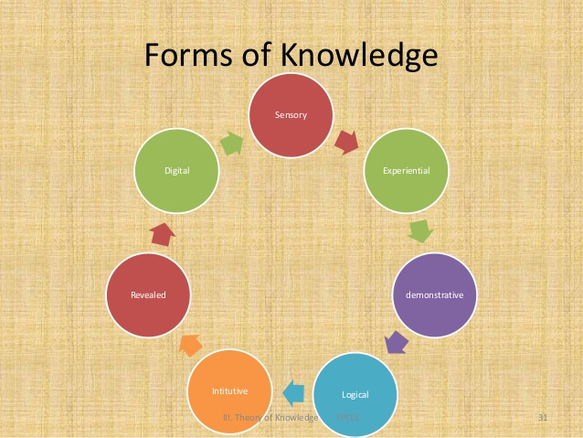
(Source: class PPT, Caroline,2019).
4. Basic vs. Applied Research
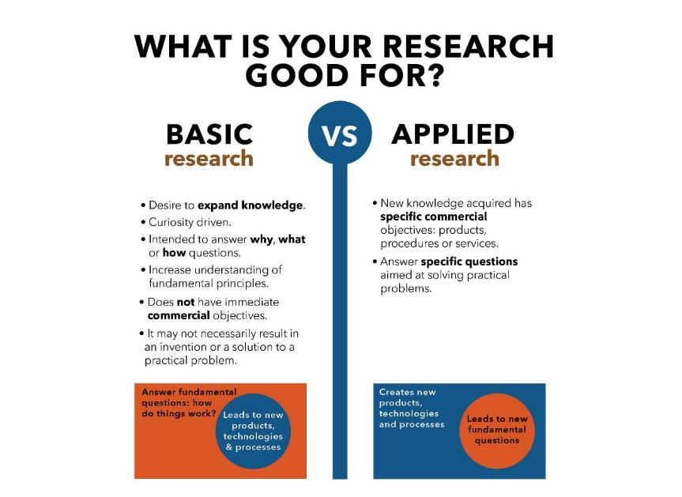
(Source: https://www.utep.edu/couri/about-ug-research/basic-vs-applied-research.html)

5. Major characteristics of basic, applied and action research (Burns, 2005, p. 61)
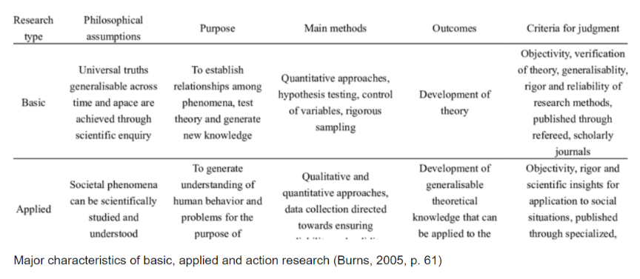

6. Differences between basic and applied researches (Rajasekar et al., 2013)
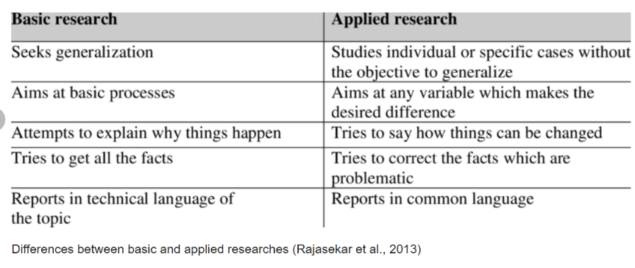

Appendix 4：Self-development activity
Activity: consider the types of contribution that my research topic could make.
My topic: B&B accommodation entrepreneurs: a critical analysis of motivations for choosing rural B&B accommodation business in China.

Researcher:
contribute to a better understanding of entrepreneurial theory by providing further evidence about the primary motivations, and the challenges faced by the B&B accommodation entrepreneurs.
Academic Knowledge:
developing the theory on B&B accommodation businesses.
identification of motivational factors which provides a clearer account of what actually motivates entrepreneurs to ventures into home-stay accommodation businesses – an under researched area.
Individuals:
providing further evidence about what entrepreneurs believe they need for business start-up, and the challenges faced by the home-stay accommodation entrepreneurs.
can provide reference for investors who want to invest in home stay industry in future.
Organizations:
the findings of this research will have relevance for policy making and supportive measures at the government levels to create an environment that will stimulate the competitiveness of SMEs in B&B accommodation businesses in their attempts for business growth and key strategy for economic improvement.

Entry 4: Defining the research question
What is a research question?
Research questions are questions that we will solve in the process of research. This is often a prelude to research objectives (Saunders and Lewis, 2012). Problems arise because you need to know something you don't know, resolve conflicts, validate previous research (Portney, 2020).
Why are research questions important?
Research question plays an important role in the process of social research (Bryman, 2004). Research question is an early indicator that provides direction and can guide research design and methodology (Bryman, 2007). A research project is carried out on the basis of research questions (Blaikie, 2000). At the beginning of any research work, you need to identify specific question to be studied, even if sometimes you will continue to refine your research issues later (Saunders et al, 2016). This is the most important and difficult part, and it provides guidance for later research planning and analysis (Portney, 2020). The key to the success of our research is the clarity of the research questions we ask. Research questions will affect your subsequent literature selection, study design, sampling, data collection, analysis, and so on (Saunders et al, 2016).
The criteria for judging appropriate research questions
However, defining the research question is not an easy thing. We need to consider what is an appropriate research question. We want to avoid both difficult and descriptive questions. This requires that you have links to relevant literature and that you will have new insights into the subject (Saunders and Lewis, 2012). Many scholars have studied the criteria for judging appropriate research questions. It was Clough and Nutbrown (2008) who came up with the "Goldilocks test’", which can be used to determine whether a problem is too big, too small, too hot or just right. Too big involves things that might require a lot of money, too small involves simple descriptive questions, and too hot involves sensitive topics, like how some women discriminate. Clough and Nutbrown’s (2008) use a very graphic analogy - the Russian doll principle - to illustrate how to clarify research issues. Like the Russian dolls, gradually peel off the layers of complexity until the core issues emerge. There are four universal criteria by which research questions are important, answerable, ethical, and doable (Portney and Watkins,2015).
Steps to defining a research question
In general, researchers identify a topic of interest and the journey begins. Once the topic is identified, begin to determine what we know and need to find out based on experience and observation, theory and practice, and relevant references (Portney and Watkins,2015). Portney and Watkins（2015) presents four basic building blocks of PICO for a research question, namely population or Problem、Intervention、Comparison or Control、Outcomes. The next step is to transform research ideas into clearly defined research questions. It should be noted here that it is dangerous to define too deep a research question. We can avoid the trap of asking questions that are too easy, too difficult, or have already been answered by consulting our tutors for help. Sometimes you can brainstorm or use Delphi techniques with your peers (Saunders et al, 2016). Development research question is a process of continuous reflection (Agee,2009).

Appendix 1: References
Agee, J. Developing qualitative research questions: a reflective process. Int J Qual Studies Educ 2009;22(4):431-447.
Andrews, R. (2003). Research questions. Springer Tracts in Advanced Robotics (Vol. 126). London: Continuum.
Bryman, A. (2007). The research question in social research: what is its role?. International Journal of Social Research Methodology, 10(1), 5-20.
Clough, P. and Nutbrown, C. (2008) A Student’s Guide to Methodology, 2nd edn, London: Sage.
Edmondson, A. C., & McManus, S. E. (2007). Methodological fit in management field research. Academy of management review, 32(4), 1246-1264.
Portney, L. G. and Watkins, M.P. (2015). Foundations of Clinical Research: Applications to Evidence-Based Practice (3th edn). FA Davis.
Portney, L. G. (2020). Foundations of Clinical Research: Applications to Evidence-Based Practice (4th edn). FA Davis.
Saunders, M. N., & Lewis, P. (2012). Doing research in business & management: An essential guide to planning your project. Pearson.
Saunders, M.，Lewis, P. and Thornhill A. (2016). Research Methods for Business Students (7th edn). Essex: Pearson
Thabane, L., Thomas, T., Ye, C., & Paul, J. (2009). Posing the research question: not so simple. Canadian Journal of Anesthesia/Journal canadien d'anesthésie, 56(1), 71.

Appendix 2: Useful links
1. How to Write a Research Question
https://writingcenter.gmu.edu/guides/how-to-write-a-research-question
2. Research question definition of wikipedia
https://en.wikipedia.org/wiki/Research_question
3. How to define your research question
https://www.qualtrics.com/blog/research-problem/
4. What Makes a Good Research Question?
https://sites.duke.edu/urgws/files/2014/02/Research-Questions_WS-handout.pdf
5. Narrowing a Topic and Developing a Research Question
https://libraries.indiana.edu/sites/default/files/Develop_a_Research_Question.pdf
6. How to Identify a Meaningful Research Question
https://www.enago.com/academy/things-need-know-writing-good-research-question/

Appendix 3: Figures and Tables
1. Figure 1-Five-step process for developing a research question. Portions of these steps may vary, depending on the type of research question being proposed.
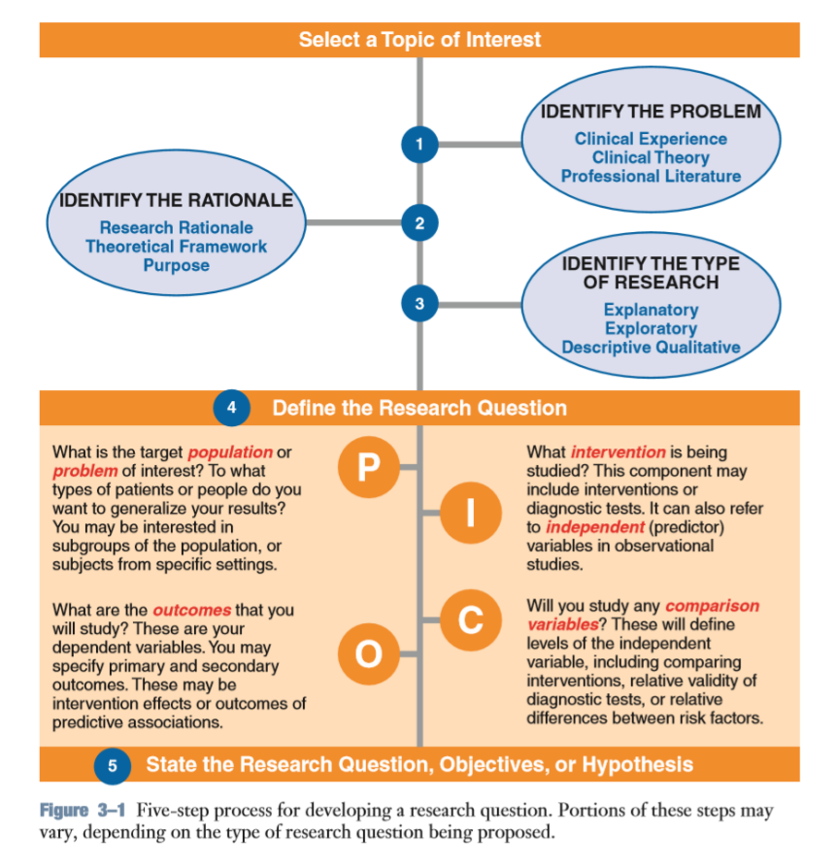
(Source: Portney, L. G. ,2020)

2. Figure 2-Development of a research question for an explanatory study of intervention for pressure ulcers.
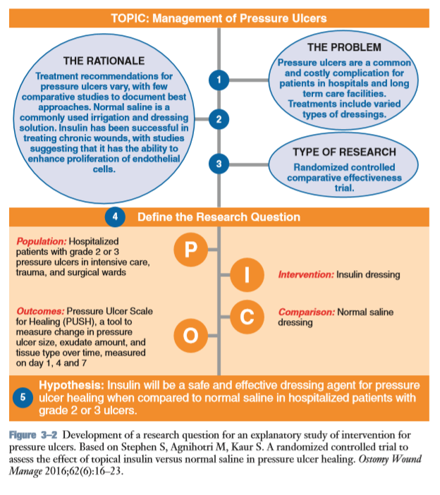
(Source: Portney, L. G. ,2020)

Appendix 4: Self-development activity
As a teacher of landscape architecture, I am also a designer in my spare time. I have done a lot of rural landscape planning and design, and the natural landscape of the countryside has left a deep impression on me. At the beginning, I wanted to apply for the DBA because I found that the operation success of a project not only depends on the design, but also on the operation and management. I deeply understand the importance of management. Interestingly, we’ve seen a lot of designers, architects and florists have invested in home-stay accommodation in rural area of China. Besides, some of my friends and classmates have started their own home stay accommodation business in recent years. Through the help from Caroline and Gill and the reflective activities triggered by them, as well as the discussion and study with classmates after class, I gradually clarified the following three research questions. The three questions aroused my interest to study.
Research Question 1: What are the primary motivational factors that motivate the entrepreneurs to become involved in rural B&B accommodation tourism businesses in China?
Research Question 2: What are the underlying motivation factors for B&B entrepreneurs, especially for some technical professionals?
Research Question 3: What are the challenges entrepreneurs’ or rural B&B accommodation operators encounters in this unique industry?

Entry 5: Philosophical frameworks for research
The term “philosophy” is a Greek derivative meaning “the love of wisdom” (Cavalier, 1990). According to traditional philosophy, philosophy is a field of thought and reflection about life and all that is in it (Ruona and Lynham,2004). Philosophy is a critical analysis of the basic assumptions or beliefs we hold (Saunders and Lewis, 2012).
The importance of research philosophy
The research philosophy we adopt includes important assumptions about the way we look at the world around us. These assumptions will support our research strategies, research methods, data collection methods. For example, some people think that the purpose of research is to describe some phenomena that we experience, something that we can observe and measure. Some people think that beliefs, values are important areas worth studying. We should always keep our philosophical position in mind, because it will affect the way we study (Saunders and Lewis, 2012).
Thinking about the philosophical framework of research helps us to examine the basic ideas of research. It’s possible that we haven't thought about these ideas at all (Saunders and Lewis,2012). According to Burrell and Morgan (1979), whatever set of philosophical assumptions we adopt will influence our choice of later modes of engagement and how we will defend their legitimacy.
Only by thinking of philosophy as a system of thought and action can we better understand its potential utility (Bohm 1994). As an activity or process of inquiry, philosophy involves the way we think about problems, explain things, and think about possible reasons and arguments for and against them.
Core components of philosophy
Philosophy generally involves three aspect issues: being (ontology), knowing (epistemology) and acting (axiology) (Denzin and Lincoln 2000). Ontology involves basic assumptions about the nature of reality (Gioia and Pitre,1990). Kuhn (1970) believes that ontology is the common understanding, belief and hypothesis of how a person views the world and how he perceives the essence of reality and phenomena. Ontological hypothesis will shape the choice of research content and the way of observing research objects (Saunders, et al. ,2016). Epistemology involves assumptions about the nature of phenomenal knowledge (Gioia and Pitre,1990). One view is that: knowledge=true, justiﬁed belief (Pojman 1995). Namely what is acceptable, valid and legal knowledge, and how we communicate that knowledge with people. Epistemological relevance is more obvious than ontological. The multiplicity of epistemological assumptions will govern what you think is legitimate about your research. The influence of different epistemological assumptions on the choice of research methods and the advantages and disadvantages of the following research results are very important (Saunders, et al. ,2016). Axiology is related to actions and refers to the role of values and ethics in the research process. Method and methodology are two important parts of axiology (Ruona and Lynham,2004). Personal values are the guiding factors of all human actions, and the choice of philosophy is the embodiment of personal values. Researchers need to deal with their own values and those of study participants (Saunders, et al. ,2016).

Five major philosophies in business and management
There are five major philosophies in business and management, namely positivism, critical realism, interpretivism, postmodernism and pragmatism (Saunders, et al. ,2016). Each researcher should choose a paradigm that reflects his personal beliefs and stick to it. Research is a mixture of strategies and methods, influenced by philosophical issues (May and Williams,2002). There is no single “best” philosophy research, and each philosophy is a unique way of seeing and perceiving the world.

Appendix 1: References
Antwi, S. K., & Hamza, K. (2015). Qualitative and quantitative research paradigms in business research: A philosophical reflection. European journal of business and management, 7(3), 217-225.
Burrell, W.G. and Morgan G. (1979). Sociological paradigms and organizational analysis . London: Heinemann.
Cavalier, R. (1990) Plato for Beginners, New York: Writers & Readers.
Hammersley, M. (ed), (1993) Social Research: Philosophy, Politics and Practice. London: Sage.
Cavana, R., Delahaye, B., & Sekeran, U. (2001). Applied business research: Qualitative and quantitative methods. John Wiley & Sons.
Denzin, N. K. and Lincoln, Y. S. (2000) Handbook of Qualitative Research, 2nd edn, Thousand Oaks, CA: Sage.
May, T., & Williams, M. (2002). An introduction to the philosophy of social research. Routledge.
Quinlan, C., Babin, B., Carr, J., & Griffin, M. (2019). Business research methods. South Western Cengage.
Ruona, W. E. A., & Lynham, S. A. (2004). A philosophical framework for thought and practice in human resource development. Human Resource Development International, 7(2), 151–164.
Savin-Baden, M., & Howell-Major, C. (2013). QUALITITATIVE RESEARCH: THE ESSENTIAL GUIDE TO THEORY AND PRACTICE. Qualitative Research: The Essential Guide to Theory and Practice. Routledge.
Saunders, M., Lewis, P., & Thornhill, A. (2009). Understanding research philosophies and approaches. Research methods for business students, 4(106-135).
Saunders, M. N., & Lewis, P. (2012). Doing research in business & management: An essential guide to planning your project. Pearson.
Saunders, M.，Lewis, P. and Thornhill A. (2016). Research Methods for Business Students (7th edn). Essex: Pearson.
Sekaran, U., & Bougie, R. (2016). Research methods for business: A skill building approach. John Wiley & Sons.

Appendix 2: Useful links
1. Philosophical Assumptions for Qualitative Research
https://www.carnaghan.com/philosophical-assumptions-for-qualitative-research/
2. Call for mixed analysis: A philosophical framework for combining qualitative and quantitative approaches
https://www.tandfonline.com/doi/abs/10.5172/mra.3.2.114?journalCode=rmra20
3. Philosophical Assumptions and Interpretive Frameworks
https://pdfs.semanticscholar.org/164f/6e6ff0fd6621d04ab96cee2caf429aac1458.pdf
4. Philosophy and theoretical frameworks
https://www.essaytown.com/subjects/paper/philosophy-theoretical-frameworks-fit/8739809

Appendix 3: Frameworks and tables
Figure 1: The research onion
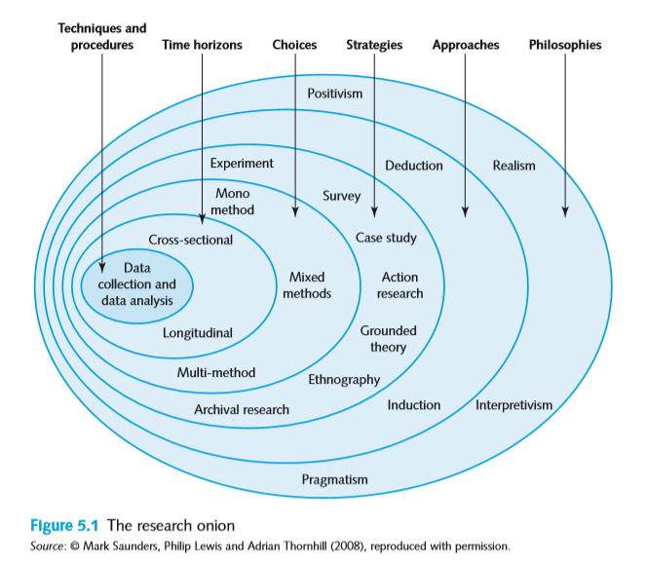

Figure 2: Critical realist stratified ontology
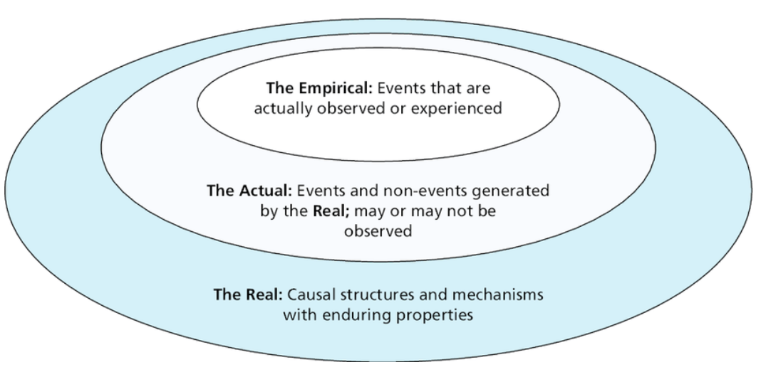
(Source: Developed from Bhaskar,1978)

Figure 3: Philosophical assumptions as a multidimensional set of continua
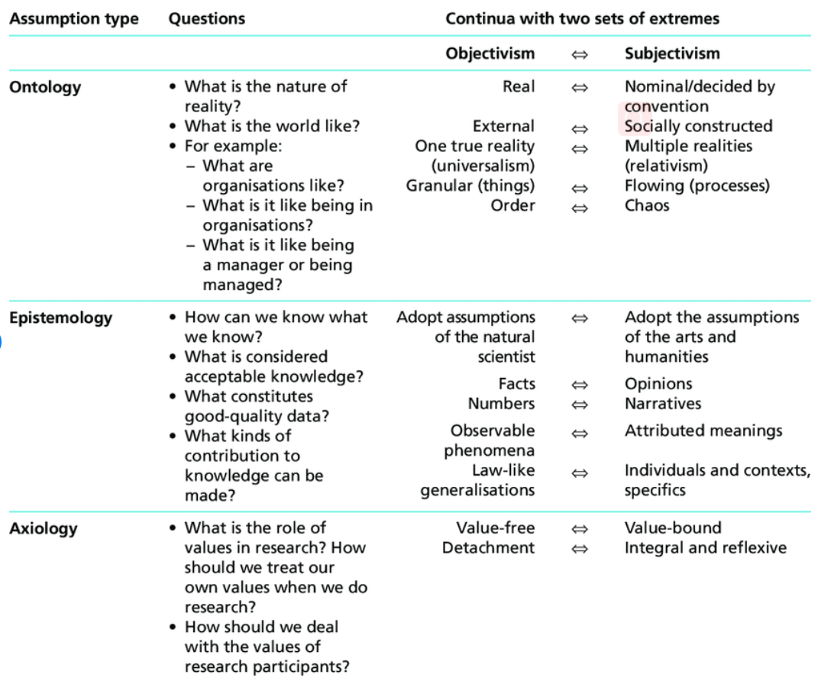
(Source: Saunders et al., 2016)

Figure 4: Comparison of research philosophies in business and management research
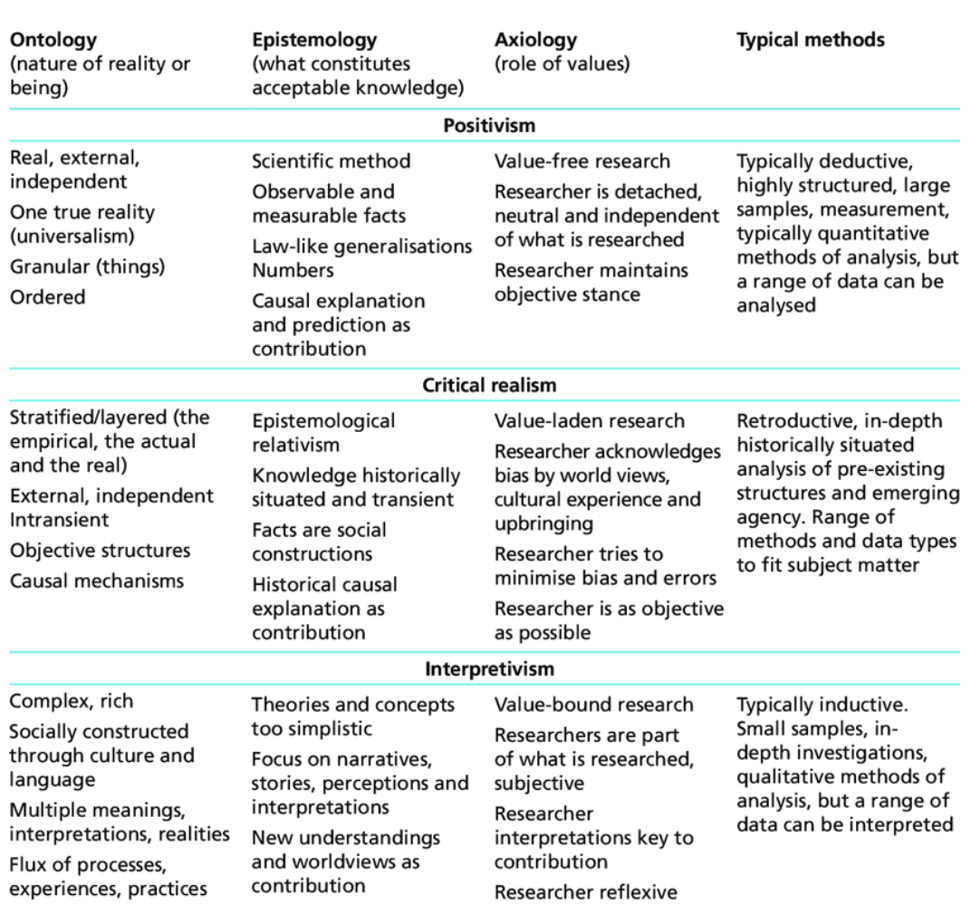
(Source: Mark Saunders, Philip Lewis and Adrian Thornhill,2008)

Figure 6: Positioning Research Paradigm (Sexton, 2003)
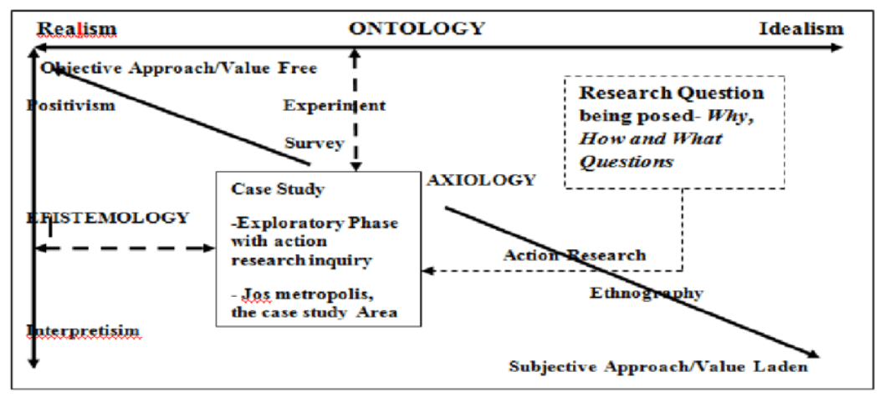
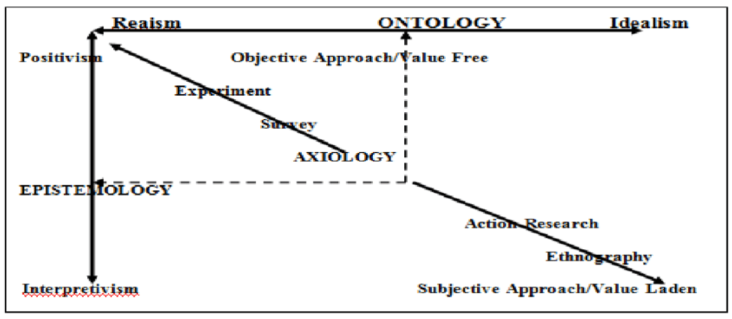
Figure 7：Ontology, Axiology and Epistemology
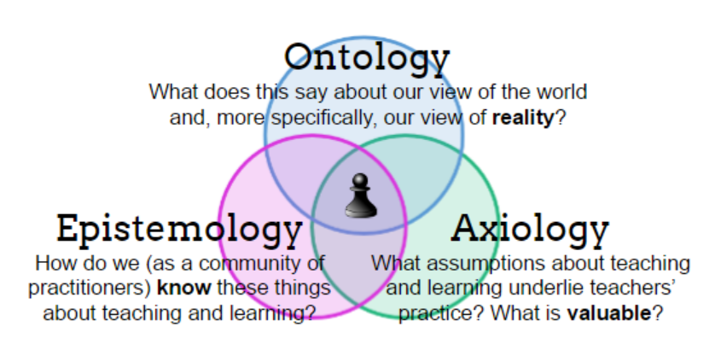
(Source: http://pamsmindlab.blogspot.com/2017/01/day-1-notes.html)

Appendix 4: Self-development activities
Caroline gave us an assignment to find two essays and analyze their philosophical framework. Through the guidance of the teacher in class, I gradually deepened the philosophical framework of my research topic.
Axiology- This study will contribute to a better understanding of entrepreneurial theory by providing further evidence about the primary motivations, and the challenges faced by the B&B accommodation entrepreneurs.
Ontology
- There is a single, objective fact about the primary motivations of B&B entrepreneurs that can be observed through science.
- There are multiple, subjective facts about the underlying motivation factors of B&B entrepreneurs especially for some technical professionals, which are affected by the social positionality between individuals.
Epistemology
- The motivation factors of B&B entrepreneurs can be obtained through the questionnaire analysis of quantitative research.
- The challenges encountered by B&B entrepreneurs can be obtained through questionnaire analysis of quantitative research.
- The push and pull motivation factors of B&B entrepreneurs of some technical professionals are subjective. It can be obtained through in-depth interviews of qualitative research due to the differences between individuals.

Entry 6: Types of research and research design
Rigorous and careful design plays a key role in ensuring the reliability of any research. Insufficiently conceived research leads to insufficient execution and findings that do not bear scrutiny (Bradshaw and Stratford, 2010). This is a central concern of our researchers.

Differing types of studies
Depending on the purpose of our research design, research can be classified as exploratory, descriptive, explanatory, evaluative, or a combination of these (Saunders et al, 2016). That’s what we have to come up with when we approach research questions. Exploratory research is particularly beneficial to new phenomena, aiming at finding new insights, asking new questions, and evaluating them from a new perspective. Exploratory research is very suitable for qualitative research methods, which can be conducted by interviewing experts in the field or searching literature (Saunders and Lewis, 2012). The aim of descriptive research is to obtain accurate descriptions of people, events, or situations. The usual descriptive questions such as who, what, how, etc. For instance, what is the age and occupation characteristic of guest of home stay? Who are the main groups of home stay entrepreneurs? Descriptive research can be a further extension of exploratory questions or a forerunner of explanatory research. We can obtain primary data through both secondary data analysis and questionnaires, sampling and interviews (Saunders et al, 2016). Explanatory research is usually done by establishing causal relationships between key variables. It is usually shown as a research question beginning with "why" and "how" to seek explanatory answers to specific questions or situations (Saunders and Lewis, 2012). For example, why do young people prefer B&B to traditional hotels? Why are so many professionals investing in B&B in China? The aim of evaluative research is to assess how something works. In combination with the business and management fields, it may involve the strategies, policies, marketing activities, cost strategies and so on of the organization and business (Saunders et al, 2016). For example, how are these B&B invested by technical professionals working now? Are there advantages compared with other B&B? How attractive are these B&B compared to other B&B? Combined research is a combination of research with multiple purposes. A variety of hybrid approaches can be used in research design to facilitate the collection of a variety of data.

Having identified the purpose and type of research, the next step is to think about what data needs to be collected to solve the problem. Such as the type of data and how it can be collected (Creswell & Creswell, 2017). Then choose the appropriate research method, whether it is quantitative research method, qualitative research method, or mixed research method. Qualitative research is exploratory, and it is characterized by the immaturity of relevant concepts due to the inadequacy and lack of theories, so it needs to be explored and developed (Morse,1991). In quantitative research, we need to know which variables or factors affect the results. When researchers need both a quantitative understanding of the relationship between variables in a situation and a further qualitative discussion of the problem, a mixed method is needed (Creswell & Creswell, 2017).

Quantitative research attempts to collect data through questionnaires or structured interviews in order to summarize the samples into a whole（Fowler，2008）. Creswell and Poth (2018) summarized the various types of qualitative research and the complete procedures of specific qualitative investigation methods. Clandinin and Connelly (2000) constructed a picture by narrative researchers. Moussakas (1994) discusses the philosophical principles and processes of phenomenological methods; Charmaz (2006), Corbin and Strauss (2007; 2015) and Strauss and Corbin (1990,1998) determine the process of grounded theory. Fetterman (2010) and Wolcott (2008) summarized many aspects and research strategies of Ethnology procedure and ethnology, and stack (1995) and Yin (2009, 2012, 2014) proposed the process involved in case study.

Appendix 1: References
Bailey, K. (2008). Methods of social research. Simon and Schuster.
Bradshaw, MB and Stratford, E. (2010). Qualitative research design and rigour, In:Qualitative Research Methods in Human Geography, Oxford University Press, Hay, Iain (ed), Ontario, Canada, pp. 69-80.
Burrell, G. and Morgan, G. (1979) Sociological Paradigms and Organizational Analysis, London : Heineman, Chapters 1 and 2.
Creswell, J. W., & Poth, C. N. (2016). Qualitative inquiry and research design: Choosing among five approaches. Sage publications.
Creswell, J. W., & Creswell, J. D. (2017). Research design: Qualitative, quantitative, and mixed methods approaches. Sage publications.
Cassell, C. and Symon G. (2004) Essential Guide to Qualitative Methods in Organisational Research, London: Sage.
Denzin, N., Lincoln, Y., (2000) Handbook of Qualitative Research, Thousand Oaks: Sage
De Vaus, D. (2001). Research design in social research. Sage.
Marczyk, G., & DeMatteo, D. (2005). Essentials of research design and methodology. John Wiley & Sons.
Maxwell, J. A. (2012). Qualitative research design: An interactive approach (Vol. 41). Sage publications.
Gray, D. E. (2019). Doing research in the business world. Sage Publications Limited.
Saunders, M. N., & Lewis, P. (2012). Doing research in business & management: An essential guide to planning your project. Pearson.
Morgan G. and Smircich, L. (1980) The Case for Qualitative Research, Academy of Management Review, 5(4): 491-500.
Hassard, J. (1991) Multiple paradigms and organizational analysis: a case study, Organization Studies, 12(2), 275-299.
Donaldson, L. (2003) “A Critique of Postmodernism in Organization Studies. Postmodernism and management: Pros, cons and the alternative”, Research in the Sociology of Organizations, 21: 169-202.
Forrester, J. (1983) Critical Theory and Organizational Analysis, in G.Morgan (ed), Beyond Method, London: Sage, pp. 234-46.
Hardy, C. and Clegg, S. (1997) Relativity without relativism: Reflexivity in Post-Paradigm Organization Studies, British Journal of Management, 8 (special issue) : S5-19. CIFx2
Guba, E. and Lincoln, Y.S. (1994) “Competing Paradigms in Qualitative Research”, in N.K. Denzin and Y.S. Lincoln (eds) Handbook of Qualitative Research, Newbury Park: Sage.Cassell, C.M., Buehring, A., Symon, G., Johnson, P. and Bishop, V. (2005) Qualitative Management Research: A Thematic Analysis of Interviews with Stakeholders in the Field, Report for the ESRC.
Potter, W. (1996) An analysis of thinking and researching about qualitative methods, Mahwah:Erlbaum Associates
Taylor, S.J. and Bogdan, R. (1984) Introduction to Qualitative Research Methods: The Search for Meanings (2nd edn). New York:Wiley.

Appendix 2: Useful link
1. Research design
https://en.wikipedia.org/wiki/Research_design
2. Research Design – Types of Research Design
https://scholarshipfellow.com/research-design-types-research-design/
3.

Appendix 3: Definitions and figures
Figure 1: Stages in the experimental design process
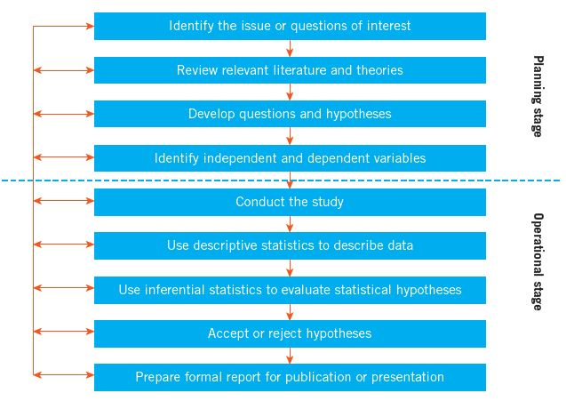
(Source: Keppel et al., 1992)
Figure 2: Multiple case study method
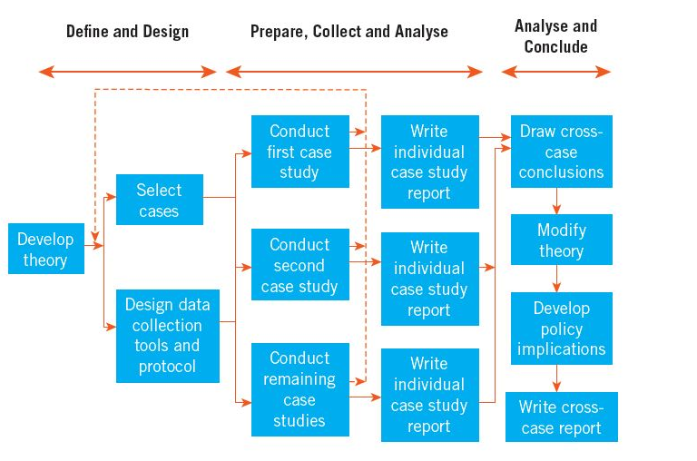
(Source: Yin, 2009)
Figure 3: Differences between Quantitative and Qualitative Research Approaches
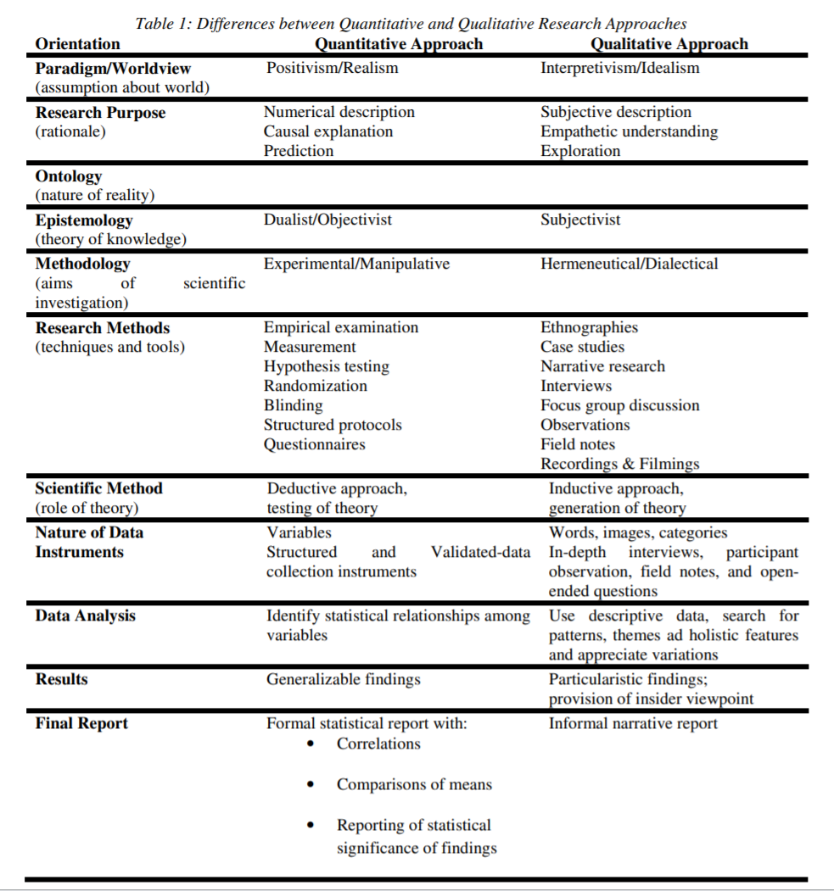
(Source: Antwi and Hamza,2015)

Figure 4: Alternative research designs
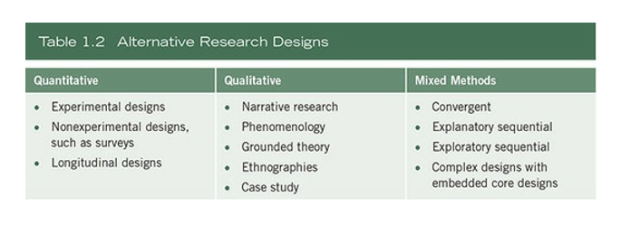
(Source: Creswell & Creswell, 2017).

Figure 5: Quantitative, mixed and qualitative methods
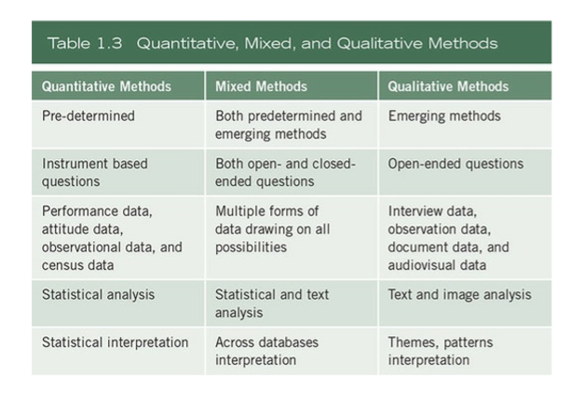
(Source: Creswell & Creswell, 2017).

Appendix 4: Self-development activity
Through this week's study, we learned about research design. We need to consider many factors and master the general procedures of research design. The first is to determine the appropriate topic as the research object and research question, determine the required data, then choose the appropriate research method, and then to think about the specific questionnaire design or interview questions. One is that when we were in a quantitative research class, we had a brainstorming process that led to a research problem.
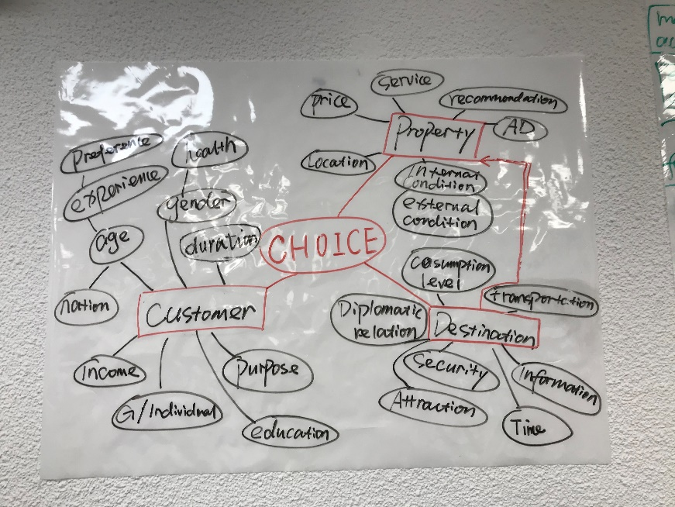
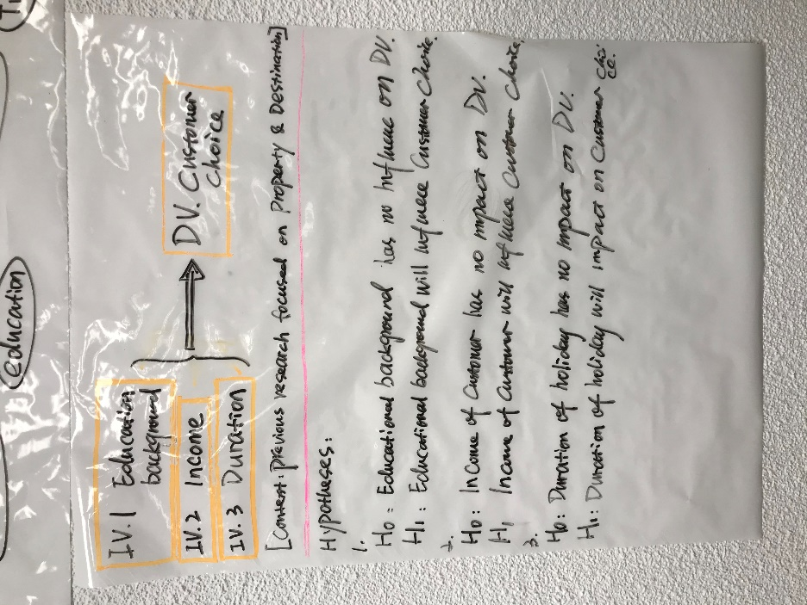

Entry 7: Research ethics and integrity
The management research community tends to rely on the ethics developed by social researchers in related fields to guide the practical research activities of researchers (Bell and Bryman,2007).
Thomas (1996) Outlines a useful typology, specifically for deontological and consequentialist positions（Capurro and Pingel，2002）, which can help to illustrate the ethical responses of researchers. The deontological position is essentially based on the formal designation of guidelines that reflect compliance with the rules (Nozick，1978). Just as many schools, academic boards, and academic research institutions have established codes of conduct that guide the conduct of researchers. Consequentialists, on the other hand, believe that the purpose of an action is to produce the greatest social benefit or the least social harm( Capurro and Pingel，2002). The first controversy about research ethics -- Small Town in Mass Society -- was about the identification of research findings even when they were reported anonymously（Allen,1998）. Other researchers have used deception in interviewing subjects, notably the Milgram experiment (1963). These controversies led to the publication of a series of ethical Research specifications, such as the Belmont Report for the Protection of Human Subjects of Biomedical and Behavioural Research in 1979 (Walther, 2002). All of these provide a warning to practical researchers about the importance of ethical justice and ethical considerations in the research process. As Reid (1996) says, it is irresponsible and immoral to deny ethical traps.

With the characteristics of accessibility, persistence and diversity, the Internet provides a new social life form for researchers(Castells，2000). Nowadays, it is quite common to conduct research survey through the Internet, which can save time and money on the one hand. It can eliminate the boundaries of time and distance, but it also brings a series of problems. Such as informed consent and subjects’ privacy, because sometimes the boundary between public and private space is not very clear (Eysenbach and Till, 2001). We need to take into account the risks of internet-based research and the technical complexities involved.

Through these established ethical principles and standards, researchers have an ethical basis for predicting problems and risks in the research process and making decisions to avoid conflicts and harm (Saunders, 2011). We DBA students should be guided by the university's ethical code or code of ethics to prevent misconduct. Be careful to incorporate ethical principles and standards into your research. Ethical issues are important throughout the research process.

Appendix 1: References
Allen, C. (1998), “Spies like us: when sociologists deceive their subjects”, available at: http://csf.colorado.edu/gimenez/ papers/lies.html (accessed February 1, 2003).
Bell, E. and Bryman, A. (2007) ‘The ethics of management research: An exploratory content analysis’, British Journal of Management, Vol. 18, No. 1, pp. 63–77.
Berry, D. (2004) ‘Internet research: Privacy, ethics and alienation: An open source approach’, Internet Research, Vol. 14, No. 4, pp. 323–32.
Birnbaum, M.H. (2004) ‘Human research and data collection via the Internet’, Annual Review of Psychology, Vol. 55, pp. 803–32.
Capurro, R. and Pingel, C. (2002), “Ethical issues of online communication research”, available at: www.nyu.edu/projects/nissenbaum/projects_ethics.html (accessed February 1, 2003).
Castells, M. (2000a),The Information Society: The Power of Identity , Vol. 2, Blackwell, Oxford.
Eysenbach, G. and Till, J.E. (2001) ‘Ethical issues in qualitative research on internet communities’, British Medical Journal, Vol. 323, pp. 1103–5.
Israel, M., & Hay, I. (2006). Research ethics for social scientists. Sage.
McAreavey, R. and Muir, J. (2011) ‘Research ethics committees: Values and power in higher education’, International Journal of Social Research Methodology, Vol. 14, No. 5, pp. 391–405.
Nozick, R. (1978), Anarchy, State, and Utopia , Blackwell, Oxford.
Reid, E. (1996), “Informed consent in the study of online communities: a reﬂection on the effects of computermediatedsocialresearch”, TheInformationSociety ,Vol.12 No. 2, pp. 169-74.
Saunders, M. N. (2011). Research methods for business students, 5/e. Pearson Education India.
Walther, J.B. (2002), “Research ethics in Internet-enabled research: human subjects issues and methodological myopia”, available at: www.nyu.edu/projects/ nissenbaum/projects_ethics.html (accessed March 2, 2003).
Thomas, J. (1996) ‘Introduction: A debate about the ethics of fair practices for collecting social science data in cyberspace’, The Information Society, Vol. 12, No. 2, pp. 107–17.

Appendix 2: Useful links
1. University of Cambridge Research Ethics
https://www.research-integrity.admin.cam.ac.uk/research-ethics
2. Research Integrity & Ethics
https://www.uwtsd.ac.uk/research/research-ethics/
3. UWTSD Research Ethics & Integrity Code of Practice
https://www.uwtsd.ac.uk/media/uwtsd-website/content-assets/documents/research/research-ethics-integrity-code-practice.pdf
4. Research Integrity
https://ori.hhs.gov/education/products/ucla/chapter1/page02.htm
5. Research Ethics and Integrity
https://www.ed.ac.uk/files/atoms/files/research_ethics_and_integrity_awareness.pdf
6. Research Ethics and Integrity
http://www.perform-research.eu/wp-content/uploads/2018/09/19005_PERFORM_A4-document_01.9_BW_Research-Ethics-and-Integrity.pdf
7. RESEARCH ETHICS AND INTEGRITY
http://www.bbk.ac.uk/research/bgrs/research-ethics-and-integrity

Appendix 3: Figures
Figure 1: Ethical issues at different stages of research
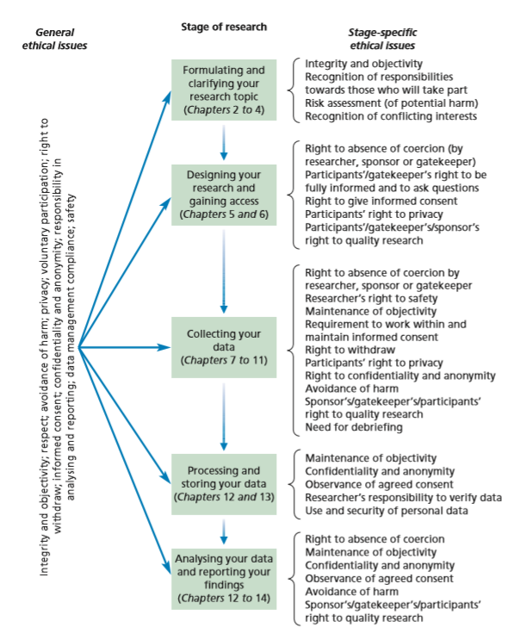
(Source: Saunders，Lewis and Thornhill ,2016).
Figure 2: Social research ethics codes
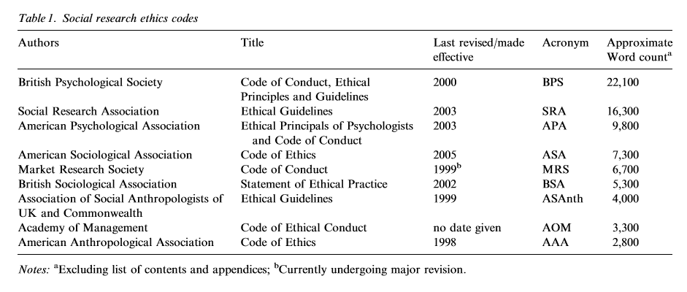
(Source: Bell, E. and Bryman, A. ,2007)

Appendix 4: Self-development activity
As for my research topic, I have raised the following ethically related concerns:
- Validity
the data collection was limited to one industry and one country, thus it suggests comparative work in similar context in different sectors and countries.
it would be interesting to explore the socio-economic impact of this home-stay accommodation businesses from the perception of operator’s which is ignored in this study.
it must be stress that the study is a snapshot in time. The home-stay accommodation businesses are fast changing business and industry demand and expectations can alter quickly. Thus, the motivators in the push–pull model for the home-stay entrepreneurs are liable to change over time.
- Representativeness
Homestay industry is different from other industries and has its own particularity
- Low response rate
Many B&B entrepreneurs are not willing to participate in your questionnaire. Sometimes they don’t run B&B themselves.
- Bias
Whether the sample is representative of the target population.
- Positionality
Due to the influence of different entrepreneur's age, race, educational background, social culture, professional identity, experience and other factors, the cognition of the problem is different. This is also a positional issue of the study.

