Title: An individual reflective response to the Professional Teaching Experience
While on placement I discovered that reflection is a crucial part of teaching and the learning process, teachers must constantly monitor and assess the classroom to see what is going well and what needs improvement. They have to reflect on their own teaching and monitor children’s behavior and understanding to adjust their teaching techniques.
For the first three weeks of my teaching experience, I was placed in Year 1 with 23 students where I was able to engage with the pupils learning. One of my main targets at the start of placement was to build a positive relationship with the children this links directly to the QTS standards S1.2 and S3.3.1, I think it is important to have a caring and supportive attitude towards the pupils as you want them to feel comfortable around you and for them to be confident to come to you which helps create a positive learning environment to help learners achieve the best they can (Education Wales, 2009). Another target was to be able to communicate with the children effectively by supporting pupils and being confident giving verbal feedback, I think this is important because children need to reflect on their own learning to know how they are doing and where they need to improve, it is also important to see the children’s understanding of a task and to practice different techniques to keep their attention .
I spent the first week observing the children and leading group work, I began to focus my attention on the children’s behavior in the shared continual provision areas (see appendix 1) as this is where the children got to choose which tasks they wanted to complete. These continual provision areas gave children the option to lead their own learning, there were seven different areas of learning in the classroom for each area of learning and experience in the foundation phase, this layout gave children the opportunity to learn in a cross curricular environment, this technique can be linked to discovery learning. Discovery learning is a constructivist based theory developed by Bruner who believes children learn best through inquiry based activities. This type of learning is believed to develop children’s creativity, motivation and problem-solving skills (Bruner,1961). During my observation in these areas I noted that the children would often go off task and this would lead to arguments and the children being noisy and distracted. I spent my time trying to keep these shared areas under control and keep children focused on their task with their challenges, this links to Bruner’s scaffolding theory where adults assist children solving problems, I demonstrated this theory on placement by gradually fading my support with a child’s task (Bruner, 1976). This is also helped me learn how to gain authority and respect in the classroom whilst also trying to learn the children’s routine and what attention-grabbing techniques worked for them.
In addition to this, I could see the positive impact the continual provision areas had on the children’s learning, they were being given opportunities to be independent learners and work together collaboratively to complete tasks however, the children often got distracted in these areas and needed lots of reminding to keep on task. This first observational week was a key part of my reflection process because I was able to see what was going well in the classroom and what I would adjust. I also had time to think of different techniques I could use, I realized that children learn best through interacting with their environment and being more hands on, this supports Dewey’s pragmatist learning by doing theory. It is believed that children who are given the opportunity to learn through a more hands on approach in their environment are able to adapt and learn more (Dewey, 1938). This child centered approach allows children to collaborate and communicate while problem solving in a cross- curricular environment, the progressive education approach also supports the new Donaldson curriculum where Graham Donaldson (2015) describes giving learning context and a purpose. This helped me prepare and plan for my lessons carefully thinking of classroom management which links directly to the QTS standard S2.7 and helped me see how I would adjust the continual provision areas so that they could be more of a purposeful and effective learning environment (Education Wales, 2009).
Following my lessons, I completed assisted reflective conclusions (ARC’s) to reflect on my experience to collect my feelings and to reflect on what went well and what I was disappointed with, I evaluated and analysed my lessons to decide what I would keep the same and what I would change to ensure effective teaching. The ARC model is made up from different reflective theories. One is Kolb’s reflective cycle, it has four main parts; concrete experience, reflective observation, abstract conceptualization and active experimentation (Kolb, 1984). I think this reflective cycle is very effective because it allows the teacher to reflect on their experience, think about what they have learnt and then plan what they will try for next time. Blooms taxonomy model is used in the central part of the ARC it is a hierarchy which helps to classify thinking through six cognitive levels (Bloom,1956), remember and understand, evaluate and analyse are key elements of the reflection process in the ARC model. Another reflective model used is Rolfe et Al’s reflective cycle which focuses on three key question; What?, So what?, and What now? (Rolfe, 2001) I like this model because the key questions are simple and effective in getting the teacher to think about how to move forward and improve. Also Gibb’s model of reflection is part of the ARC, it has six stages and helps people focus on where they need to improve (Gibbs,1988), I think that this is a good model to follow because it helps you focus on all phases of an activity or experience and helps you think of your next steps by using an action plan.
My mentor and I reflected on my teaching through an end of week review (see appendix 2), we discussed my strong points and where I needed to improve. I showed good subject knowledge and differentiated my activities according to ability well this can be directly linked to S3.1.2 catering to learners’ varying needs and making sure they have the right support (Education Wales, 2009). I was also good at praising the children by using simple techniques such as; “whoosh whoosh pat on the back” and rewarding the children who showed a good work ethic with stickers, this links to S1.3 of the QTS standards by motivating and inspiring learners (Education Wales, 2009) this stems from the concept of positive reinforcement and Skinners’ operant conditioning theory. Operant conditioning is the theory that good behavior that is rewarded is most likely to be repeated and bad behavior that is given consequences is less likely to be repeated (Skinner, 1948). I put this teaching theory to practice by focusing on the cause of the children’s bad behavior and by disciplining the children by giving them a warning then if they continued, I moved their name into the unhappy area which meant they lost golden time on a Friday. I positively reinforced good behavior by rewarding children with pine cones and giving out house points. I reflected on my use of this teaching theory technique and found operant conditioning to be a very effective away of controlling behavior management in the classroom.
Another important part of reflection in the classroom is monitoring and assessment which links to the QTS standard S3.2 (Education Wales, 2009), pupils progress must be assessed so that they are given the right support for where they are on their learning journey. It was important for me to reflect on the children’s progress to see how I could move them forward and plan my next steps. One way teacher’s reflect on children’s learning is through the use of observation sheets, while on placement I used observation sheets when leading group work but also when teaching the whole class to monitor children’s understanding of the lesson and its objectives. Another way teacher’s monitor children’s progress of a topic is by using tracking records which is a systematic approach to tracking and reviewing pupils work over a period of time. I found tracking records incredibly useful on placement and found them the easiest to use out of all the monitoring sheets. Tracking records allow teachers to see clearly what the learning objective is and what the success criteria the children are trying to achieve is, they allow teachers to grade children clearly; red, amber and green the teachers then make next steps for pupils as individuals but also as groups. Tracking records are useful when planning next sessions because teachers can see where children need to improve with their learning and see which children understood, this reflective technique to monitor children’s progress can be linked to the QTS standard S3.2.6 (Education Wales, 2009), to help review learners progress and to inform planning.
Following my discussion with my class mentor I created an action plan focusing on my targets and how I would achieve them in my next lessons. I was advised to focus on S3.3.13 and S3.2.2 for my targets. To achieve S3.3.13 I will plan and communicate effectively with TA’s and check how they are finding the activity and check the children’s understanding by using different formative assessment techniques such as; learning lagoons and thumbs up thumbs down to see if the children understand. I will use Vygotsky’s approach of the more knowledgeable other to help children develop cognitively with having a focus on social interaction in the classroom (Vygotsky,1934) by the children working in pairs or groups or working with a teaching assistant when completing tasks however, I will monitor behavior and make sure children stay on task for this approach to work effectively.
To address my second target, I will use tracking sheets to score how the children are doing and see progress whilst also continuing to use observation sheets. The approach that I would consider best to address my target would be giving children feedback as they go, I will try using ‘pen pit-stops’ in the middle of lessons to mark children’s work as they go so that they have feedback to improve. My next steps would be to continue building on classroom management and transition so that everything is running as smoothly as possible in the classroom, I could achieve this by monitoring behaviour in all areas of the classroom not just focus task groups, I will make an effort to walk around the classroom and check how everyone is doing and also check in with specialist teachers and other colleagues to check that the group they are with is working well.
In conclusion, I have discovered the importance of reflection in teaching and have learnt there are many different reflective techniques. To move forward in my teaching practice I will conduct research, experiment and try difference reflection structures to see which one works best for me. I will focus on classroom management and giving immediate and constructive feedback to learners to improve.

Reference List

Bruner, J. S. (1961). The act of discovery. Harvard educational review.
David L. (2014). Bloom's Taxonomy (Bloom). Available: https://www.learning-theories.com/blooms-taxonomy-bloom.html. Last accessed 19/03/19.
David L. (2017). Discovery Learning (Bruner). Available: https://www.learning-theories.com/discovery-learning-bruner.html. Last accessed 20/03/19.
Dewey Articles. (2002). A Brief Overview of Progressive Education. Available: http://www.uvm.edu/~dewey/articles/proged.html. Last accessed 20/03/19.
Education Wales. (2009) Qualified Teacher Status Standards Wales 2009. Cardiff: Welsh Government.
Graham Donaldson. (February 2015). Successful Futures. Available: https://gweddill.gov.wales/docs/dcells/publications/150225-successful-futures-en.pdf. Last accessed 20/03/19.
Graham Gibbs. (1988). Reflective Cycle. Available: https://thoughtsmostlyaboutlearning.files.wordpress.com/2015/12/learning-by-doing-graham-gibbs.pdf. Last accessed 20/03/19.
Saul McLeod. (2018). Lev Vygotsky. Available: https://www.simplypsychology.org/vygotsky.html. Last accessed 19/03/19.
Saul McLeod. (2018). Skinner - Operant Conditioning. Available: https://www.simplypsychology.org/operant-conditioning.html. Last accessed 20/03/19.
Steve Wheeler. (2017). Learning Theories: Jerome Bruner on the Scaffolding of Learning. Available: https://teachthought.com/learning/learning-theories-jerome-bruner-scaffolding-learning/. Last accessed 21/03/19.
University of Cumbria. (2016). Rolfe et al.'s (2001) Reflective Model. Available: https://my.cumbria.ac.uk/media/MyCumbria/Documents/ReflectiveModelRolfe.pdf. Last accessed 20/03/19.

Appendix

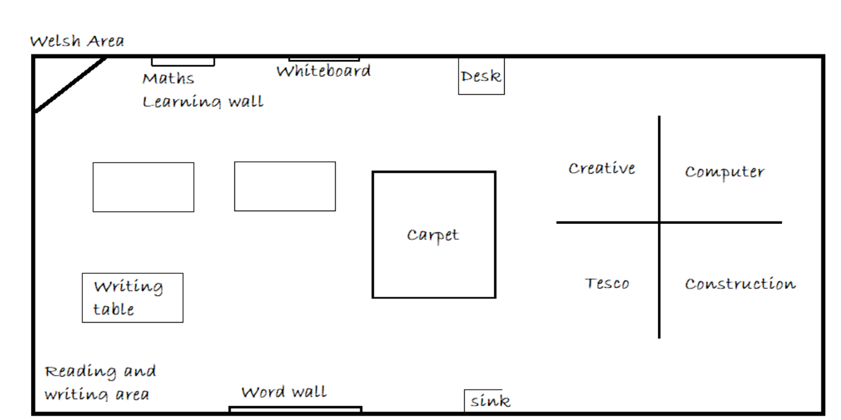
Appendix 1: this image shows the classroom layout and the different continual provision areas

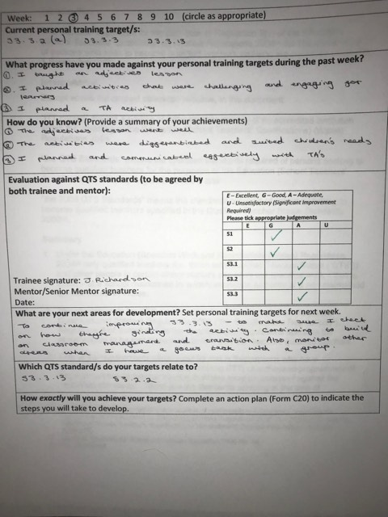
Appendix 2: End of Week Review

