Open ended play opportunities within the Education for Sustainable Development Global Citizenship (ESDGC)
By Amy Clark.

What is the ESDGC?
The Education for Sustainable Development and Global Citizenship or as it is most commonly referred to the ESDGC is a Welsh document which enables learners around wales to gage a greater understanding on the world around them and allow them to have a clear understanding on the importance of what their actions can do which will affect the world at a future date. (Welsh Government, 2017).

T2 Knowledge bank (no date) state that there is 7 key themes within the ESDGC. An example of an activity that links to some of the ESDGCs key themes is something similar to mud play. Mud Play would link closely to the natural environment, consumption and waste and Climate Change.
Future Generations Act and linking to the ESDGC
The Welsh Government highlighted the importance of sustainable through using the Future Generations Act. The Future Generations Act is an act which allows people within public bodies to look at the long term and look at how they can work better with both people communities, and each other to prevent problems and to create a more joined up approach (Welsh Government, 2016). With using both the ESDGC and the Future Generations Act it allows practitioners to emphasise and the importance of the rights and the sustainability to be able to have a healthy and successful within Wales. It also highlights the importance of it to young children's education within wales. (Tiney and Hirst,2017). The future generations act also establishes Public Services Boards (PSB) for every authority throughout Wales. These PSB’s encourage others to improve on their social, economical, cultural and environmental well being to be able to achieve their well being goals. (Welsh Government, 2016).

Open ended play and ESDGC
It is important to look at the foundation phase when also linking it to the ESDGC as the 7 key areas of learning will all link into a specific area of development. This means that for practitioners within Wales they can ensure that they are looking at all of the important areas to ensure that they are supporting children’s development in the correct way. Welsh Government created a document in 2015 which every practitioner should be following with each individual child to ensure that they are developing at the right level for their age (Welsh Government,2015). Welsh Government (2015) states that within the foundation phases there are 7 areas of learning. There are many of them which link to Open Ended Play and the importance of children being able to experience open ended play on a daily basis to allow them to develop. One of the key areas that encourages Open ended Play is Personal and Social Development, Wellbeing and Cultural diversity. Within this section, the Welsh Government (2015) states that children should be given the opportunity to develop on a range of skills and values through being allowed to experience ‘different types of play and a range of planned activities which includes those that are child initiated’ (Welsh Government, 2015). The importance of ensuring that children experience different types of play is key as it is important for children to use their imagination. This also links to the Creative development section of the Foundation Phase as they say that every child should have the chance to be able to use imaginative play and should be able to access resources throughout the day to encourage children’s imaginative development which in turn will encourage them to play without having a practitioner giving them instructions. Although Wales do encourage children to do open play a lot of the time even when they are provided with opportunities the practitioners have given thought about what a range of activities could be set up to allow the children to think and discuss.

In Wales, Children are given time throughout the day in which practitioners encourage them to play without practitioners support. This is normally when practitioners may sit back and look at the child to see how they are developing and which section of the Foundation Phase they are focused on and supports practitioners to plan activities around the children which will further children’s development. In Wales it is vital that to encourage children’s development that they look at both the ESDGC and the Foundation Phase. The image below shows how the ESDGC and the Foundation Phase link together and shows how practitioners can use each area of learning from the ESDGC and from that also look at the areas of the Foundation Phase and look at how they can put open ended play into a child’s day.
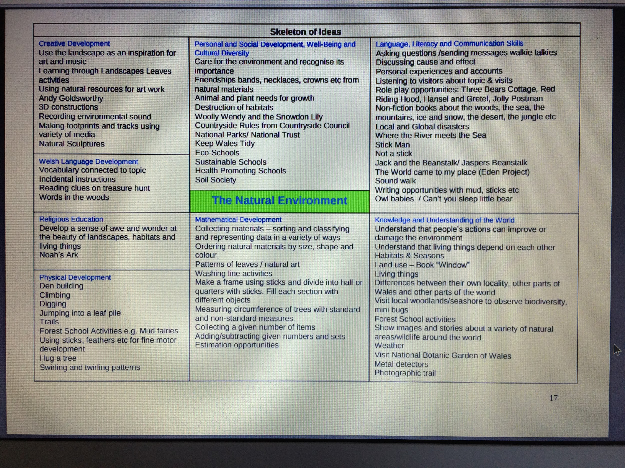
(Carmarthen Council, no date).
International perspectives and Open Ended Play
In Sweden Play is ‘accorded the same importance as formal learning in Sweden, and is now regarded as necessary for making sense of the surrounding world.’ (Knight, 2013). Sweden were inspired to create an education system in which allowed children to play openly and freely all day. One theorist who they took some ideas from was Frobel. Froebel believed about the importance of Outdoor education. He also believed that when children were outdoors that they should be able to use a wide range of play materials that were free to be used for the children at any time of the day. (Nutbrown,Clough and Selbie, 2008) and (Robertson, 2012). The swedish education system also focus on working from the inspiration system for Reggio Emilia. The Reggio Emilia Approach is an innovative and allows children to be the leader of their own learning and it encourages children to make their own decisions and to also look at the world around them and to create different ways that they can play. Within the approach the adult will be encouraged to not instruct the child in what to do but to be there as a help and support if the child was to need help within the setting. (Kate Gribble, 2017). Sweden follow the learning of a holistic child development. This means that when assessing a child they are not only looking at what the child is able to do academically but is able to look at the other components that make the child who they are (Taguma, Litjens and Makowiecki 2013). Sweden describe their particular curriculum as being accessible, high quality and able to shape children as a comfortable and confident learner and individual that is able to thrive in whichever area they feel most confident in.

Sweden has a very different education system to ours in Wales. In Sweden Children do not start compulsory school until the age of 6 which further more allows them more time to develop on their social skills. However in Wales we start school aged 4 or 5. Which can mean that children start to become more anxious from starting schools at an earlier age, Wales also encourage children to meet expected requirements and be matching up to the correct areas of development based on the Foundation Phase and practitioners are planning activities to encourage their areas of development. However in Sweden they allow the children to pick their own activities and allow them to grow and develop in the child’s own time. (Lewis, no date). NCCA (2007) states that in the last 50 years there has been a massive decline in children spending time outside and that most of children’s free play is now done inside and if it is done outside then it is done separately to other children and other adults. For example children are less likely to be able to be let into a woodland sheltered area without being given specific boundaries in which they are not allowed to cross. Although they have the same aspect in Sweden there area in which the children are allowed to explore is on a much bigger scale than what it is here in Wales. In sweden they also have a range of activities which can challenge all ages within the setting they also allow all children of all ages to mix together as they feel that it will allow children to learn from one another. (Robertson, 2012).

In Sweden they have many pedagogues which enables both staff and children to have equal opportunities. In sweden they ensure that children’s voices are heard and that they have equal opportunities as the adults. During lunch times, the swedish approach means that both staff and children will sit down together and eat similar to a family meal time. Pedagogues believe that by creating a family meal time. The children are more calmer and generally feel more comfortable in being able to share problems and issues as this set up is more familiar to them and allows them to be open with their feelings (Lewis, no date). Bennett (2001) cited in Lewis (no date) states that children are capable learners but should be treated fairly and listened to as any adult is. This will then encourage children to accept help and support to support their learning. Pedagogues encourage children to also use the same places to put their coat and wellies after they have finished as this can help and support children’s independence. Pedagogues within the swedish curriculum are also encouraged to not interupt children during their play but to sit back and watch the children or get involved with their learning. This means that there is not a lot of routine for these children which can be seen as both a good and negative factor to the swedish approach (Lewis, no date). It is important for pedagogues to recognise the important times within the day which is appropriate to encourage children’s learning and development rather than forcing a child to learn and develop when as the child they may not feel ready.

When comparing the statistics to the amount of children that attend an early years setting in both Wales and Sweden. Nillson (2015) states that 95% of children aged 3-5 in Sweden attend a early years setting. However Gov.uk (2017) states that only 67% of children in wales attend an early years setting. This shows how different the curriculums are and shows that within the swedish curriculum that the children have a lot more freedom which allows children to explore their every area of their development.

Why are we not embedding the ESDGC in everyday life
CCBC Education (no date) states that it is important that the community think about the impact that many things will have on everyday life both individually, within the community and globally.

CCBC Education (no date) have also said that as practitioners if we do not encourage children to think about the specific implications it will mean that there will be implications for many years and going beyond current generations. CCBC (no date) explained that if we did not encourage children to make changes such as

- Shopping either with local businesses or fairtrade products
- Use less waste and look at using more natural resources.
- Supporting more countries that are living in poverty rather than buying from other consumer countries
- Use less fossil fuels which will help to decline the amount of carbon dioxide within the air.
It is important for children to realise that by being a sustainable citizen it does not mean that they have to be planning big projects but in fact they can become a sustainable citizen but in fact they can make small changes to their life which will impact on the environment and will mean that are helping to support the environmental effects that will be able to support them within their everyday.

Why are we not embedding the ESDGC in open ended play
It is also important that ESDGC is embedded open ended play as it allows children to gage a further understanding of different concepts of the further world which will encourage children to look at the world holistically which will allow them to ensure that they will look at different aspects within their environment. T2 Group (2014) states that to embed ESDGC within open ended play they need to ensure that they have high quality resources. This could mean that they are not meeting the specific areas of the ESDGC as within the ESDGC they encourage children and adults to look at recycled materials which will help to support the environment around them.

Opportunities that arise from Open Ended Play
There are many reasons why open ended play is important to ensure children’s development progresses. One reason why open ended play is important to include within a child’s life is that it allows the child to grow and to allow them to explore different ideas and concepts to allow them to encourage their learning and development. (NCCA,no date). Open ended play also encourages children’s independence, help them to think tactically this will furthermore encourage their learning and to develop their skills in all areas of their development. (Mclure 2013). By encountering open ended play you are allowing children to enable their play to become more complex and richer learning. (NCCA, no date). As the practitioner it is important to ensure that the role of practitioner is clear and concise. Practitioners should ensure that they create an environment that is welcoming and inviting which will encourage children to come and explore the materials to allow them to start to grow and develop. Mainly practitioners are there to observe the children and occasionally suggest ideas for children to do with the wide variety of different resources. It is also important for practitioners to understand that any open ended material is able to be used by any age child but should be changed accordingly to support the children’s level of development.
Criticisms that arise from Open Ended Play
Although there are some critisms to open ended play. Within the welsh curriculum sometimes it is important for practitioners to get involved with the children and to encourage them to learn basic life skills. Without children seeing the way in which as a society we behave the children will not understand the way that we believe that they should behave. (Play and Playground Encyclopedia, 2017). Another negative to open ended activities is that there is no end or limit to where a child can go this can be seen as both a positive and a negative but from a practitioners view it is hard to view when is the best time for them to be able to stop the children to be able to encourage different parts of learning throughout the settings day. A final critism to open ended play is that it can mean there is no routine within the day, which some children may find difficult to comprehend. The importance of a routine in a child’s life allows the child to understand the importance of what will be happening at what part of the day and help them to understand when and where they will be, this will help to reduce the anxiety within childhood. (Education.com, 2017). Also children with ALN may find open ended play difficult as there is no plan of what will happen this can cause the child to feel upset and often anxious. So it is important for practitioners to be able to voice the options on what each child can do.

Theorists
Vygotsky
Nutbrown,Clough and Selbie (2008) suggests that Vygotsky’s view is that children learn better through interacting with both other children and adults. The Zone of Proximal development is a key aspect within his theory which led him to create an understanding on the role of the adult.
Vygotsky and open ended play
Child Development Media (no date) suggests that Vygotsky has a strong view on open ended play. He also believed that children are more independent and keen learners when they are using play.

Criticisms to Vygotsky's Theory
However when looking at Vygotsky’s zone of proximal development we can see that although Vygotsky does encourage children’s independence and does encourage child to do open ended play. Vygotsky also suggests that practitioners play a key role in supporting children. As we can see from the image below the zone of proximal development is set out in three main circles. The inner circle consists of what the child can do independently without any support. The middle circle is what i can do with help?. This is where the zone of proximal development comes in and practitioners look at what they can do to help support the child within their learning. The final circle is what i can’t do. This is where practitioners look and see if they can set up a range of different activities that will help and support the child in enabling them to be able to achieve these points. (Research Gate, 2011). 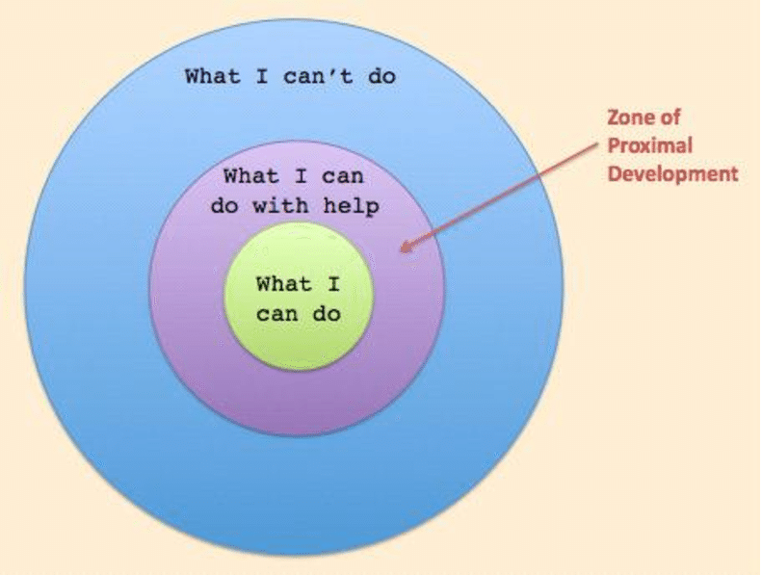
Piaget
Piaget was a theorist who believed in cognitive development and believed that there was four main stages of cognitive development. These stages consisted of sensorimeter, cognitive, pre- operational and formal operational stages. These stages all linked in to the main times of a child’s life when they are growing a progressing. He believed that all children were born with a schema which gave you the basis on what you can achieve in life. It also focused on how the child behaves and how clever the child is.

Unlike Vygotsky, Piaget believed that there was no reason for children to learn within stages. Piaget believed that as children they learn best with an adult teaching a child what to do with clear and consise instructions. Piaget also believed that there were many aspects within education that were not important and that children should spend more time focused on what he thought was the important aspects of education such as english and maths.

Piaget and the ESDGC do not have a wide link as piaget did not believe that natural environment and caring for the world were important aspects for a child to learn. As a child he believed that children need to be able to count and read to be able to continue and have a good life and he disagreed with theorists who spoke about the outdoors being an important factor.

Reference List.
Alyson Lewis (no date) Making sense of Swedish practice: is it that different from practice in Wales? http://www.tactyc.org.uk/pdfs/Reflection-Lewis.pdf accessed 01.12.17

Bland (2016) ‘ what does open ended play actually mean’ https://www.teachwire.net/news/qa-what-does-open-ended-play-actually-mean accessed 29.11.17.

Carmarthenshire Council (no date) A Support Pack for the Integration of Education for Sustainable Development & Global Citizenship through the Foundation Phase accessed 01.12.17.

Child development media (no date) ‘play the work of lev vygotsky’ http://www.childdevelopmentmedia.com/articles/play-the-work-of-lev-vygotsky/ accessed 30.11.17

Education.com (2017) Routines: why they matter and how to get started https://www.education.com/magazine/article/importance-routines-preschool-children/ accessed 02.12.17

Gov.uk (2017) Childcare and early years providers survey 2016 https://www.gov.uk/government/collections/statistics-childcare-and-early-years accessed 02.12.17

Kate Gribble. (2017) ‘What is the Reggio Emilia Approach’ An Every Day Story. Blog [on-line]. http://www.aneverydaystory.com/beginners-guide-to-reggio-emilia/main-principles/ accessed 01.12.17.

NCCA (2007) ‘play as a context for early learning and development’ http://www.ncca.ie/en/Curriculum_and_Assessment/Early_Childhood_and_Primary_Education/Early_Childhood_Education/How_Aistear_was_developed/Research_Papers/Play_paper.pdf accessed 01.12.17

Nillson (2015) Why Swedish early learning is so much better than Australia’s http://theconversation.com/why-swedish-early-learning-is-so-much-better-than-australias-35033 accessed 02.12.17

Nutbrown, C., Clough, P. and Selbie P. (2017) Early Childhood Education- History, Philsophy and Experience. London: SAGE, p.57.

Play and Playground Encyclopedia (2017)n ‘Open ended play’ https://www.pgpedia.com/o/open-ended-play accessed 02.12.17
Research gate (2011) ‘zone of proximal development’ https://www.researchgate.net/figure/308918140_fig6_Figure-1-Zone-of-Proximal-Development-ZPD-Source-Culatts-2011 accessed 30.11.17

Robertson,. J (2012) ‘A Swedish Förskola’ http://creativestarlearning.co.uk/early-years-outdoors/a-swedish-forskola/ accessed 01.12.17

T2 Knowledge Bank (no date) ‘The seven key themes of the ESDGC’ http://www.t2group.co.uk/download/brochure/The%20Seven%20Key%20 Themes%20of%20ESDGC.pdf accessed 29.11.17

Taguma, M., Litjens I,. and Makowiecki, K,. (2013) Quality Matters in Early Childhood Education and Care Sweden. OECD.

Tinney, G., and Hirst, N. (2018) Understanding sustainability in early childhood education within Wales : Case studies and approaches across the UK. Fulton. Pp 104-138.

T2 (2014) ESDGC policy. http://www.t2group.co.uk/welsh/download/ESDGC%20Policy.pdf accessed 02.12.17

Welsh Government,. (2015) ‘Curriculum for Wales: Foundation Phase Framework (Revised 2015) http://learning.gov.wales/docs/learningwales/publications/150803-fp-framework-en.pdf accessed 01.12.17.

Welsh Government,. (2016) ‘Well-being of Future Generations (Wales) Act 2015’ http://gov.wales/topics/people-and-communities/people/future-generations-act/?lang=en accessed 30.11.17

Welsh Government. (2017) ‘Education for Sustainable Development and Global Citizenship’ http://gov.wales/topics/educationandskills/allsectorpolicies/europeanandinternational/sustainabledevelop/?lang=en accessed 30.11.17

