Samantha MacLaren (2011977)
Word Count: 2446
A consideration of how Roman was Roman Britain? Using a case study of your choice. Chosen site: Eboracum.
The beautiful City of York is a place which has a diverse and interesting history and remains a popular tourist attraction that receives over eight million visitors per year. This essay will examine its earliest origins as the Roman garrison, Eboracum, founded in 71 AD, briefly charting its development into the capital of Britannia Inferior, examining its multi-cultural diversity in the later Roman period, and determining to what extent the area could be considered truly Roman. It will also briefly examine the etymology of the name of the site and its possible meanings, and finally it will identify the legacy of Eboracum in the modern-day period and whether the Roman history still influences the City of York.
The history of the garrison of Eboracum may be traced to the arrival of the Roman army in the north of England and is linked to the activities of the powerful Brigantes tribe and their queen, Cartimandua. When Julius Caesar made his initial military expedition to Britain (55 – 54 BC), the impact on the area that was to become Eboracum was minimal, as the campaign was never intended to reach further than the areas in the south-east of the island. 43 AD however, saw the arrival of more than 20,000 Roman soldiers to British soil, whose goal was to expand the Roman Empire into Britain at the behest of Emperor Claudius. It took a quarter of a century before the Roman military reached the site, when the Ninth Legion marched from Lincoln to set up camp in 71 AD. Their move was due to revolt amongst the powerful Brigantes tribe, who objected to their fate as a client kingdom of Rome, and who deposed and imprisoned their Queen, Cartimandua. The exact nature of Cartimandua’s early alliance with Rome is not clearly understood, but a typical Roman strategy was to keep client rulers, ensuring that these rulers would maintain control of their own client kingdoms whilst allowing the Empire to reap the benefits of trade and negating the need for direct occupation. In return, the client ruler could expect to benefit from military aid, wealth, and trade from Rome. Cartimandua had effectively sealed her alliance with the Empire after handing over the British war lord Caratacus of the Catuvellauni to Rome around 51 AD, when he fled to Brigantes territory for protection. As a reward, she was bestowed with great wealth, but her actions sowed the seeds of revolt within her own tribe. This unrest escalated in 57 AD, when Cartimandua divorced her husband Venutius, and married his armour-bearer Vellocatus. Venutius staged a rebellion against the Queen, which by association meant a rebellion against Rome. This was quickly suppressed by the Ninth Legion, but Venutius rebelled again in 69 AD, taking Cartimandua prisoner, leading her to seek assistance from her Roman defenders. She was evacuated by Rome and disappeared from historical record. Venutius however, continued his revolt, and the political upheaval caused by this and Cartimandua’s departure was such that it became necessary to establish a garrison in the area that was to become known as Eboracum. In 71 AD, the Governor of Britain, Petilius Cerialis, led his Ninth Legion northwards from Lincoln, and invaded Brigantes territory. Tacitus tells us that Cerialis:
instilled terror by invading the realms of the Brigantes, claimed as the largest tribe of the whole province: many battles were fought, some with great bloodshed; and by forays and extensive victories he annexed a large section of the tribe.
Thus, the Brigantes uprising was permanently suppressed and as a result, the need for a permanent military garrison was identified.
Prior to the arrival of the Romans in 71 AD, the area that was to become Eboracum seems to have had little importance in the Iron Age, apart from marking the boundary zone between the Brigantes and their tribal neighbours the Parisi, who inhabited the Wolds area of modern east Yorkshire. Archaeologically, the site has offered little in the way of Iron Age material in the immediate location of the fortress, with the nearest pottery remains being located 2.5 miles to the north-west. There does, however, appear to be evidence of a pre-Legionary presence, with fragments of Lyon pottery being found, dated to the Claudian-Neronian period, suggestive of an earlier auxiliary fort:
This suspected fort – if it does exist – may date to the administration of governor Vettius Bolanus in 69 or 70, though may conceivably belong to either of his immediate predecessors.
The chosen site for the garrison was the confluence point of the Rivers Foss and Ouse, allowing access to the east coast via the Humber estuary, and thus access to Europe, the Mediterranean and the farthest reaches of the Empire. The site was also situated 30 miles south-east of Aldborough, the likely tribal centre of the Brigantes, and close to Parisi territory, and was therefore an ideal position to oversee the entire region. Its location in a flat vale meant that the garrison would have had an extensive view of marauders from any direction.
The naming of the site has several possible origins. The names Eboracum and Eburacum are accepted as a Latinization of the Celtic *Eburaco. Margaret Gelling states that:
The meaning is probably ‘yew grove’, the name being formed by the addition of the adjectival suffix -āco- to the British word for a yew tree. It is possible that the suffix was added to a personal name *Eburos.
In Britain, the suffix āco meant ‘place of’, however, in Gaul, Eburos was a personal name, with āco meaning ‘property of’, giving us either ‘the place of the yew trees’ or ‘the property of Eburos’. If there was a British landowner of that name however, no trace of his field or farmstead currently exists in the archaeological record. Another possible etymological origin connects with pig farming. The basis for this theory rests on the linguistic progression of the place-name from the Brythonic into Anglo-Saxon. The Anglo-Saxon Eoforwic recorded c. 1060 can be translated as ‘boar farm’, and Gelling suggests this is an adaptation of the earlier Evorōg (still extant in the modern Welsh Efrog), which she states: ‘would be the form of the British place-name Eburaco known to Germanic mercenaries at the end of the Roman period.’
Regardless of etymological origin, Eboracum was to become an important location in Romano-British history. The original purpose of the site was as a garrison to house Roman soldiers. Only two Legions were ever garrisoned there in its 400-year history: the 9th Hispanic Legion who initially constructed the fortress in 71 AD, and the 6th Victorious Legion which replaced the 9th around 122 AD. It is around 237 AD that the civilian settlement which housed the legionaries and their families south of the River Ouse, was established as a colonia, the highest grade of civilian town. Eboracum was perhaps most famous however, for becoming the capital city of Britannia Inferior in 197 AD. Emperor Lucius Septimius Severus divided the country in two, with the old Brigantian territories north of the Mersey and Humber becoming Britannia Inferior (Lower Britain), and the southern provinces becoming Britannia Superior (Upper Britain). This arrangement may have been for administration purposes, but ‘also to avoid the concentration of British legionary power into the hands of a single governor.’
In becoming the northern capital, Eboracum gained increased status when Emperor Severus took up residence in 208 AD. He replaced the original turf and timber defensive structures with a solid stone construction, thus creating a permanent, and well-fortified settlement. Severus was of Libyan origin and his wife, Julia Domna, a Syrian. It is perhaps thanks to Severus and his wife that Eboracum became so culturally and ethnically diverse. The colonia became a thriving centre for trade and commerce, attracting a wide variety of settlers from all over the Empire. Inscriptions from the area document the presence of Gauls, Italians, and north Africans. Severus brought his religion to the colonia, adding to the existing melting-pot of beliefs, by ordering a temple to the Egyptian god Serapis to be built. A stone dedication from the temple is still extant in the Yorkshire Museum in York. It reads: ‘Deo sancto / Serapi / templum a so- / lo fecit Cl(audius) / Heirony- / mianus leg(atus) / Leg(ionis) VI Vic(tricis)’, which translates to: ‘To the holy god Serapis, Claudius Hieronymanius, legate of the Sixth Legion, built this temple from the ground.’ It is interesting to note, in an article by Dr. Caitlin Green, that the study of oxygen isotope evidence drawn from human teeth in the British Roman period suggests that over 45% of the fifteen sites studied (including York) indicated individuals of north African origin. It seems however, that the site of Eboracum may have been multi-ethnic from the outset due to cultures being subsumed by the Empire as they conquered them, and local inhabitants joining the legions.
The burials in the Roman graveyards around the site bear testimony to the diverse demographic of the area, and the existence of high-status north Africans in the colonia. One such burial is the famous ‘Ivory Bangle Lady’ discovered in 1901 in a stone coffin in what is now Sycamore Terrace, Bootham. The grave goods suggested a woman of high status and included: ‘jet and elephant ivory bracelets, earrings, pendants and beads. Also found were a blue glass jug, likely to have contained cosmetics or perfumes, and a glass mirror.’ Analysis of the skeletal remains determined that the woman was of mixed-race origin, with the cranium sharing both ‘black’ and ‘white’ characteristics. It is certainly evident that Eboracum became a diverse multi-cultural settlement, particularly in the later Roman period.
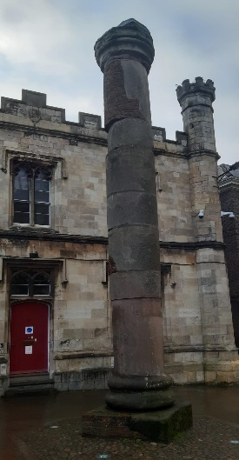
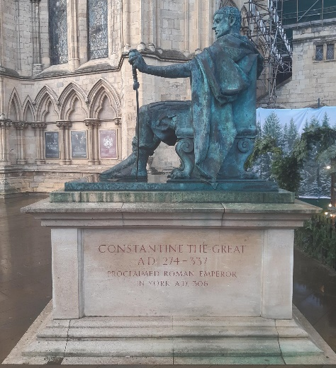
The echoes of Eboracum can still be heard and felt in the city of York. The statue of Constantine The Great sits outside York Minster, with the re-erected basilica column standing opposite him, marking the general entry location of the cathedral-like structure, the remains of which were unearthed below the Minster between 1966 and 1973 (See fig. 1 and 2):
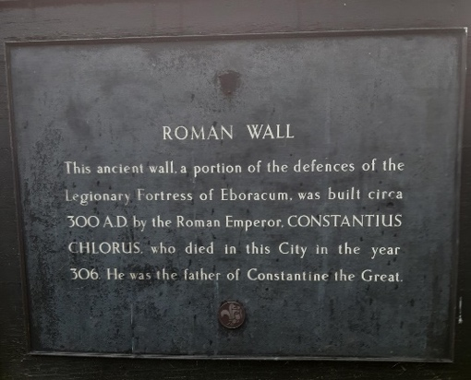
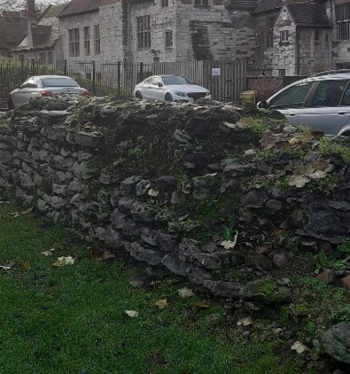
Fig. 1 Fig. 2
Remains of the original defensive wall of the fortress erected by Severus are limited, but in some areas have been preserved, as can be seen here at St. Leonard’s Place (fig 3 and 4): Fig. 3 Fig. 4
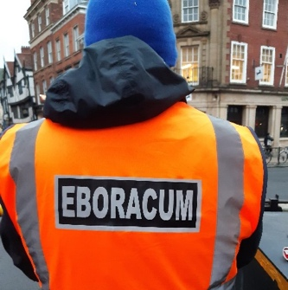
The people of York attend the yearly ‘Ebor Races’ in August, or may join the ‘Ebor Cycling Club’, or even hire heavy machinery from ‘Ebor Plant Hire’. At Christmas, the local Street Security Officers, who protect the city from potential terror threat, wear high visibility jackets which display the name ‘EBORACUM’ on the back (fig 5):
Fig. 5
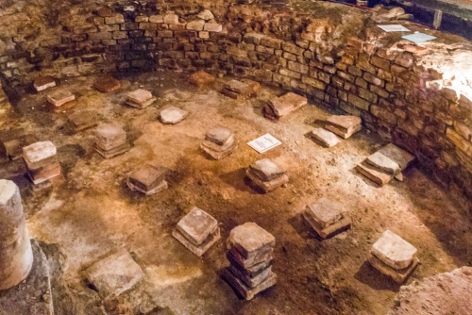
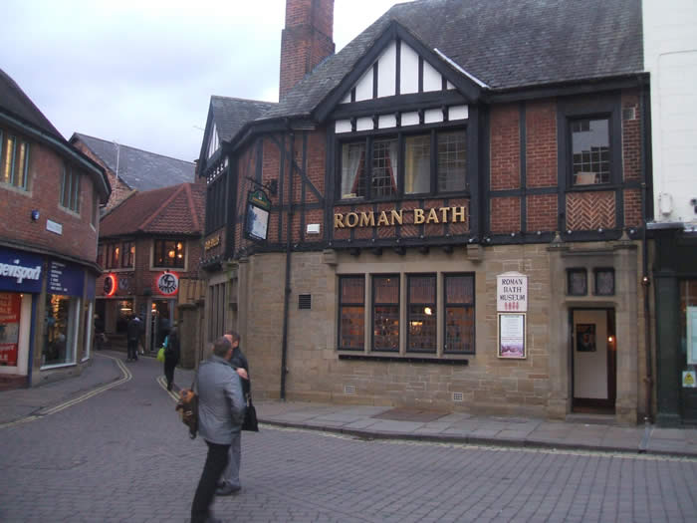
Locals enjoy a drink in ‘The Roman Bath’ public house, which sits on top of the remains of a fully excavated military Roman bath house, built by the Ninth Legion between 71 and 122 AD (fig 6 and 7):
Fig. 6 Fig. 7
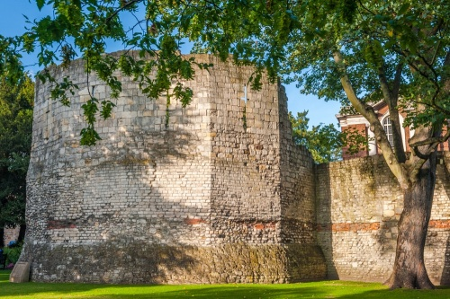
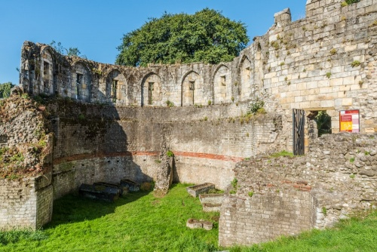
Beneath the streets, exists a network of Roman sewers quite big enough for one to stand up in. A Roman road was discovered under the Treasurer’s House in 1953, and under the Minster in 2012. The stunning Multiangular Tower in the Museum Gardens is without doubt the finest example of standing Roman remains in the city (see fig 8 and 9):
Fig. 8 Fig. 9
The tower stood at the west corner of the legionary fortress and dates from the early third century and was almost certainly the work of Severus. These are but a few examples of the extant evidence of Eboracum. The echoes of the Roman settlement can, therefore, still be seen and felt daily in this ancient city, and the memory of it is affectionately held in the naming of local events and businesses, and the officers who patrol and protect the city against terrorism. The people of York are proud of their Roman connection.
In conclusion, to what extent can Eboracum be considered Roman? Prior to the Roman arrival, the area was certainly Brigantes territory, but it seems that the site was little used by the Iron Age native population. The building of the garrison in 71 AD established a strong Roman presence in the area, and because it was built and populated by members of the Roman Imperial army, it can be said to have been entirely Roman. However, the archaeological evidence suggests that a diverse range of ethnicities were present in the settlement from its earliest origins as, over time, soldiers and their families settled there, along with traders and merchants. This multi-ethnic community was enhanced by the arrival and settling of the north African native, Emperor Lucius Septimius Severus to Eboracum in 208 AD. His establishment of a temple to the Egyptian deity Serapis indicates the diversity of pagan worship, and the acceptance of a north African leadership. The grave-goods of the ‘Ivory Bangle Lady’ reveal a woman of mixed-race appearance with British and north African origins, and a woman of high status, again indicative of the diversity of the population and an absolute acceptance of other cultures within the Empire. So, how Roman was Eboracum? The answer to this, based on the evidence, is that it was very Roman indeed, since the site was identified, built, established, and developed by Roman culture. There is a caveat however, in that one must remember that in identifying Roman culture, we find a broad range of ethnicities which form that culture; a broad range of people who were not of Roman (ie: from Rome) origin, but who were subsumed by the conquest of their own countries by the Empire, or whose presence in Eboracum evolved from trade relationships.

Bibliography:
Bevan-Jones, Robert, The Ancient Yew: A History Of Taxus Baccata, (Macclesfield: Windgather Press, 2017)
Clarkson, Tim, The Men Of The North: The Britons Of Southern Scotland, (Edinburgh: Birlinn Ltd., 2018)
Cunliffe, Barry, Britain Begins, (Oxford: Oxford University Press, 2013)
English Heritage, Cartimandua, Queen Of The Brigantes (2022)
https://www.english-heritage.org.uk [accessed 09 November 2022]
Gelling, Margaret, Signposts To The Past: Place-Names And The History Of England, (Oving: Phillimore & Co. Ltd., 2010)
Green, Caitlin, A Note On The Evidence For African Migrants In Britain From The Bronze Age To The Medieval Period (2016) https://www.caitlingreen.org [accessed 05 December 2022]
Hall, Richard, York, (London: B.T. Batsford Ltd., 1996)
Leach, S, and H. Echardt, C. Chenery, G. Müldner, M.Lewis, ‘A Lady Of York: Migration, Ethnicity And Identity In Roman Britain’, Antiquity, 84.323 (2010), 131 - 145
Mann, J.C., ‘The Division Of Britain In AD 197’, Zeitschrift Für Papyrologie Und Epigraphik, 119 (1997), pp. 251 - 254
Parker, Adam, The Archaeology Of Roman York, (Stroud: Amberley Publishing, 2019)
Rivet A.L.F. And Colin Smith, The Place-Names Of Roman Britain, (Cambridge: Cambridge University Press, 1981)
Roman-Britain, York (Eburacum) Roman Settlement (2022) https://www.romanbritain.co.uk [accessed 30 November 2022]
Roman Inscriptions Of Britain, RIB 658. Dedication To Serapis (2022) https://www.romaninscriptionsofbritain.org [accessed 05 December 2022]
Ross, David, (photographer), ‘The Multiangular Tower’, ‘The Rear Of The Tower’ and ‘The Caldarium’. https://www.britainexpress.com [accessed 05 December 2022]
Tacitus, Agricola 17 https://www.poetryintranslation.com [accessed 09 November 2022]
Tacitus, Publius, Tacitus On Britain And Germany: A New Translation By H. Mattingly, (Bungay: Richard Clay And Company Ltd., 1954)
The Roman Bath Museum, (photographer), untitled. https://www.york-wiki.co.uk [accessed 05 December 2022].
Tomlin, RSO, Britannia Romana: Roman Inscriptions And Roman Britain, (Oxford: Oxbow Books, 2018)
Webster, Graham, The Roman Invasion Of Britain, (London: Taylor and Francis, 2003)

Tacitus, Agricola 17, (2022) https://www.poetryintranslation.com [accessed 09 November 2022].
Roman-Britain, York (Eburacum) Roman Settlement (2022) https://www.roman-britain.co.uk [accessed 30 November 2022].
Margaret Gelling, Signposts To The Past: Place-Names And The History Of England, (Oving: Phillimore & Co. Ltd., 2010), p. 42.
A.L.F. Rivet And Colin Smith, The Place-Names Of Roman Britain, (Cambridge: Cambridge University Press, 1981), p. 357.
Richard Hall, York, (London: B. T. Batsford Ltd., 1996), p. 27.
Gelling, p.60.
Roman-Britain, 2022.
Roman Inscriptions Of Britain, RIB 658. Dedication To Serapis (2022) https://www.romaninscriptionsofbritain.org [accessed 05 December 2022].
Caitlin Green, A Note On The Evidence For African Migrants In Britain From The Bronze Age To The Medieval Period (2016) https://www.caitlingreen.org [accessed 05 December 2022].
S.Leach, H. Eckardt, C. Chenery, G Müldner and M. Lewis, ‘A Lady Of York: Migration, Ethnicity And Identity In Roman Britain’, Antiquity, 84.323 (2010), 131 – 145 (p. 134).
Ibid.
The Roman Bath Museum (photographer), untitled. https://york-wiki.co.uk [accessed 05 December 2022], and David Ross, (photographer), ‘The Caldarium’, https://www.britainexpress.com [accessed 05 December 2022].
David Ross, (photographer), ‘The Multiangular Tower’ and ‘The Rear Of The Tower’. https://www.britainexpress.com [accessed 05 December 2022].
Fig. 1 to 5 are my personal photographs.

