Does autocratic leadership impact employee performance in the UK Health and Social Care Sector?

Table of Contents
1. Introduction 5
1.1 Background 5
1.2 Research Question 5
1.3 Significance of the Study 5
1.4 Objectives of the Study 5
1.5 Structure of the Report 6
2. Literature Review 8
2.1 Theoretical Framework of Leadership Styles 8
2.2 Autocratic Leadership in Context 8
2.3 Impact of Leadership on Employee Performance 9
2.4 Current Gaps in Literature 10
2.5 Summary of Key Findings 11
3. Research Methodology 13
3.1 Research Design 13
3.2 Primary Data Collection 13
3.3 Secondary Data Collection 15
3.4 Data Analysis Techniques 16
3.5 Ethical Considerations 17
4. Results 19
4.1 Data Presentation 19
4.2 Statistical Analysis 20
5. Discussion 27
5.1 Interpretation of Findings 27
5.2 Implications for Practice 36
5.3 Limitations of the Study 36
5.4 Future Research Directions 36
6. Conclusion 39
6.1 Summary of Key Findings 39
6.2 Recommendations 40
6.3 Final Thoughts 40
7. References 41
8. Appendices 44
8.1 Questionnaire 44
8.2 Additional Data Tables 46

Chapter 1

1. Introduction

1.1 Background
Good leadership is critical to the culture of organisations and productivity levels in staff, nowhere more so than within health and social care. The UK Health and Social Care sector has been in trouble for several years the industry has been affected by staff shortages, financial constraints as well as an escalating demand for quality care. Managers' leadership style has a great impact on the motivation level and job satisfaction of employees, as well as their overall professional performance which ultimately may affect multiple dimensions of patient outcomes (Idowu, 2020).
Various industries, including healthcare, have exhorted autocratic leadership; whereby, the decision-making centralizes into a single leader ignoring input from team members. While it streamlines decision-making, there is concern that this approach could hurt employee morale and engagement. Understanding how autocratic leadership affects employee performance in an era where teamwork and collaboration are paramount is the first step toward improving your management approach (Setiawan et al., 2021).

1.2 Research Question
This study aims to address the following research question: "Does autocratic leadership have an impact on employee performance in the UK Health and Social Care Sector?" By examining this relationship, the research seeks to uncover how different leadership styles may affect employee outcomes and contribute to the overall effectiveness of healthcare organizations.

1.3 Significance of the Study
The significance of this study lies in its core potential to provide valuable insight into the relationship between leadership styles and employee performance within the UK Health and Social Care Sector. For healthcare organizations striving to improve employee satisfaction and performance factors that can ultimately positively influence patient care it is critical to understand how autocratic leadership impacts these processes. The results of this study may be used to guide leadership development programs and initiatives that strive for a healthcare work setting with more supportiveness, collaboration or engageable among healthcare workers (Qtait, 2023).

1.4 Objectives of the Study
The primary objectives of this study are:
- To assess the perceptions of employees regarding autocratic leadership within their healthcare organizations.
- To evaluate the impact of autocratic leadership on key performance indicators, including job satisfaction, productivity, and engagement.
- To provide recommendations for healthcare leaders on effective leadership practices that enhance employee performance and organizational effectiveness.

1.5 Structure of the Report
This report is structured as follows:
- Chapter 2: Literature Review – A comprehensive review of existing literature on leadership styles, with a focus on autocratic leadership and its effects on employee performance.
- Chapter 3: Research Methodology – An overview of the research design, data collection methods, and analysis techniques used in this study.
- Chapter 4: Results – Presentation of the data collected, including statistical analysis and key findings.
- Chapter 5: Discussion – Interpretation of the results in the context of the literature, implications for practice, and identification of limitations.
- Chapter 6: Conclusion – A summary of key findings, recommendations for practice, and suggestions for future research.
- References – A list of all sources cited throughout the report.

Chapter 2

2. Literature Review

2.1 Theoretical Framework of Leadership Styles
Leadership styles are crucial for any workplace culture as they determine the way employees execute their work and respond to it. The academic focus on leadership looks at theoretical frameworks that explain how different styles can empower or restrain an employee and the organizational culture as a whole (Caillier, 2020).
One of the most recognised models in leadership theory, this model broke down leadership into three main styles: autocratic, democratic and laissez-faire (Abdullahi et al., 2020). Autocratic leadership is also defined by centralized control, meaning decision-making authority almost always resides with the leader. In this style, the leader makes decisions alone without asking for input from their team members. This allows for rapid decision-making and clear thinking in times of vagueness. On the other hand, it could also lead to a situation where employees do not feel empowered and valued resulting in complete employee disengagement.
On the other hand, democratic leadership promotes teamwork and the involvement of team members. Leaders using this style invite employee input and help them feel included. Worker satisfaction is frequently increased with democratic leadership because the workers believe their thoughts provide a profit and thereby affect decisions (Ali et al., 2021).
Laissez-faire leadership is the approach of giving employees free rein to make decisions on their own. Although this approach can promote innovation and breed creativity, it conversely presents hurdles such as confusion or lack of direction in employees who may not have the skills or will to manoeuvre within the complex system (Mohamed & Saeed, 2022).
Relevance and Application The effectiveness of a given leadership style varies according to the organizational environment, task complexity and employee type. Leader style also plays a key role in the health and social care sector, with teamwork being crucial to success along with clear communication and empathy renewed by high-quality relationships within that industry.

2.2 Autocratic Leadership in Context
Autocratic leadership has been a popular style in countless companies, particularly within environments that require fast decision-making and relapse levels of supervision. Leaders in the health and social care sector are often faced with a cognitive demand as the services they provide require high complexity, and urgent functioning that may lead to autocratic behaviours used by leaders to keep operational control of organisations which deliver effective service (Erdem, 2021).
In a healthcare-specific setting, leaders can often find it necessary to use autocratic style leadership when resources are limited and full customer satisfaction must be maintained in a highly regulated environment by creating time-sensitive response mechanisms. For instance, during emergencies when urgent decisions need to be made autocratic leadership can help fast-track processes and aid prompt actions. But doing this can also pack an unsuspected punch (Alrobai, 2020).
The other issue with autocratic leadership in healthcare is that employees will follow through because they are afraid of consequences. This, in turn, can create an environment where employees feel as though they are required to adhere strictly to the leader's vision and instructions without ever being allowed any freedom of their own. This dynamic can result in a lack of innovation, poor job satisfaction and high staff turnover ultimately affecting the quality of care patients receive (Rao & Zaidi, 2020).
Studies have shown that oppressive leaders tend to cause more stress and burnout in healthcare workers. That can lead to less work and hamper creativity or keep employees from becoming fully invested in their roles. In a field where teamwork is critical, autocratic leadership can be more universally damaging: Performance may suffer from individual-to-team dynamics and patient outcomes (Altheeb, 2020).
Additionally, depending on autocratic leadership can prevent the growth of future healthcare organizational leaders. Unless workers are pushed to take part in decisions and share their knowledge chances of them not having the capabilities or confidence needed when it is time for leadership. This gap, sustains autocratic leadership limiting the organization's expansiveness and adaptability.

2.3 Impact of Leadership on Employee Performance
Research literature on organisational behaviour has a long tradition of examining the consequences or outcomes of various kinds and forms of leadership. There is evidence that leadership styles can affect an array of aspects related to employee performance, from productivity and job satisfaction to engagement and retention (Specchia et al., 2021).
Research consistently shows that leadership styles which support employee involvement and autonomy tend to be stronger in terms of their performance outcomes It is also correlated with improved job satisfaction, and engagement for instance transformational leadership which emphasizes inspiring and motivating employees. Workers who feel appreciated and supported by their managers are more engaged, work at better levels of productivity, and stay longer with a company (MacKian & Simons, 2021).
On the other hand, autocratic leadership results in negative detrimental impacts on employee productivity. Employees under autocratic kind could experience a drop in job satisfaction when it comes to employees then eventually low motivation and productivity. This lack of input and recognition can cause participants to feel as though they are not a part of the system, causing frustration and disconnection from their work. Furthermore, when employees do not learn to act autonomously or contribute ideas and proposals, they may simply disengage from their positions which results in decreased performance (Cinnioğlu & Turan, 2020).
How a person leads is especially important for employee performance in healthcare settings. The essence of quality patient care is the dedication and enthusiasm of healthcare professionals. Autocratic Leadership damages individual employee morale and engagement, which also can trickle down to negatively impact the quality of care provided to a patient. Unengaged employees can be inattentive to the needs of patients, and that lack of attention may lead to lower levels of patient satisfaction which runs a risk of serious healthcare outcomes.
Lastly, the relationship between leadership behaviour and employee performance is contingent on different contextual factors such as organizational culture or individual characteristics of employees (Shan et al., 2022). Autocratic leadership in healthcare organizations, for example, can be counterbalanced by the organizational culture that facilitates top-down power which may somewhat buffer against total collapse. Even in those environments, employees may work together to support each other and the organisation.

2.4 Current Gaps in Literature
Despite the wide body of existing research on leadership styles and their impact on employee performance, there are significant gaps within these areas, especially about how this applies specifically direct context of the UK Health and Social Care Sector. The current literature mainly consists of studies on autocratic leadership in general organizational settings, and little is known about the impact of this type of leadership style among healthcare professionals (Akonkwa et al., 2022).
Additionally, research that does exist has focused primarily on quantitative performance metrics like productivity measures or turnover rates. This may be useful but does not encompass the entire range of experiences and views. The attitudes or dispositions that employees have towards their leader, the specific problems they encounter and how engaged they are will give valuable qualitative information into what effect leadership is having on them (Sayed, 2021).
Longer-term consequences of autocratic leadership on employee performance are another neglected issue in the literature. While much research has been conducted on short-term outcomes, the consequences of prolonged autocratic leadership may be profound. If we want to find better ways that are not only more virtuous or ethically principled but also look after the morale of our employees which retention and underpins organisational culture quality then understanding how long-term exposure autocracy can do to us in terms of behaviours (Tamimi & Sopiah, 2022).
Second, autocratic leadership often coexists as one of the many organizational variables such as team dynamics, workplace cultures and external influencer pressure for instance regulatory changes, and financial constraints. Further research should seek to amalgamate these variables to give a more rounded explanation as an appreciation of how leadership styles inter-play with the myriad factor in specific health-care settings.

2.5 Summary of Key Findings
To sum up, the literature review reflects leadership styles positively contribute to employee performance in the United Kingdom Health and Social Care Sector. Although autocratic leadership styles are successful in some situations, they have unfortunate side effects including lower job satisfaction and increased stress and mental illness. The results suggest the significance of encouraging participative, supportive and empowering leadership-style behaviours (Ebrahim et al., 2022).
The specific impact of autocratic leadership in healthcare settings is highly under-researched and the gaps identified emphasise a need for further work, particularly where methods will enable exploration of employee experiences as well as their perceptions. This article is important for Healthcare Organizations who looking to gain insight into the dynamics of enhancing employee performance and creating improved patient outcomes.
As the health and social care sector is undergoing change and experiencing new challenges, our research findings can help in developing best-practised leadership to foster a supportive working culture, improve employee engagement and consequently make positive effects on patient quality of care (Khudhair et al., 2022).

Chapter 3

3. Research Methodology

3.1 Research Design
Research design serves as the blueprint for a study, describing how data will be collected and analysed This is a mixed-methods project, in which both qualitative and quantitative research methods are used. This design provides a mechanism to explore the relationship between autocratic leadership, and employee performance in UK Health and Social Care Sector full circle.
The research will predominantly involve a statistical quantitative analysis part for modelling relationships and correlations between leadership styles, as independent variables and some employee performance metrics as dependent variable/s. This includes creating a survey to measure how employees feel about autocratic leadership and if plays any role in their job satisfaction, engagement and performance (Ta et al., 2022).
This study employs a quantitative research design to explore the relationship between leadership style and employee perception. A structured questionnaire was developed to gather data on various aspects of employee experiences, including demographics, perception of leadership style, job satisfaction, autonomy, recognition and motivation.

3.2 Primary Data Collection
This research study involves primary data collection, the main purpose of this is to collect first-hand information from within the UK Health and Social Care Sector using those who are relevant stakeholders in knowledge management as participants. In this part, the paper describes how they collect primary data in terms of survey questionnaires and semi-structured interviews by providing thorough information on what is being done for each method.
Survey Questionnaire
The main tool for the collection of quantitative data is a structured survey questionnaire. The survey will include a few sections that will be used to collect data on the demographics of the participants, as well as opinions and perceptions about leadership styles, job satisfaction and employee performances (Börnfelt, 2022).
Design of the Questionnaire
Open and Closed-Ended Questions in the Questionnaire Likert scale responses to closed-ended questions will evaluate whether participants agree with statements about their supervisors for instance autocratic behaviours, job satisfaction and more. Performance metrics This format of the question gives quantifiable responses which can be analysed statistically with great ease.
Pilot Testing
The questionnaire will be given to a small number of participants before distribution to test for clarity, reliability, and validity. Responses to the pilot test will be grouped and this information is used however necessary to improve problems in the questionnaire that lead to ambiguities or complexity towards respondents (Farr-Wharton et al., 2021).
Distribution
The last version of the questionnaire will be delivered electronically to healthcare providers potentially via email or online survey platforms such as Google Forms, and SurveyMonkey. This approach makes for higher response rates, as participants can take the survey at their convenience. This invitation will be accompanied by a brief rationale regarding the purpose of this study to underscore the importance of participation.
Data Collection Timeline
The survey will remain open for completion over a defined period typically, between two and three weeks to ensure that enough time is given to participants and responses. During this time reminder emails are sent to increase participation and ensure the highest possible response rate.
Semi-Structured Interviews
Semi-structured interviews will be followed to collect qualitative data in addition to the help of a survey which can generate a greater level and understanding of experiences, and perceptions by Physicians about autocratic leadership as well as its impact on performance (Otieno, 2022).
Selection of Participants
Interview participants will be chosen from those respondents who indicate they would take part in a follow-up study. The selection of workers from the surveyed companies would be done using a purposive sampling technique to have a good mix of job roles, years of experience and demographic characteristics. The sample consists of 66 employees from different organizations, selected using a convenience sampling method (Ricablanca & Abocejo, 2020). Participants were chosen based on their willingness to participate and their experience with different leadership styles in their workplaces.
Interview Format
Interviews will be semi-structured so that specific questions on themes can be explored flexibly behind a fixed number of topics. It describes the procedure by which an interview guide will be created to pose basic questions and ask about specific themes and ideas like Autocratic leadership experiences and how autocracy reflected upon their productivity at work and job satisfaction.
Conducting Interviews:
Interviews will take place face-to-face or on video, the participant's choice. All interviews will also be recorded subject to participants' consent so that they can later be transcribed and analysed. After each Interview, a comprehensive note will be written to capture insights and themes
Qualitative Data Analysis:
Thematic analysis will be used to analyse the qualitative data from interviews. It required us to transcribe the recordings, code those transcripts for recurring themes and synthesize those findings into a cohesive narrative that would shed light on how autocratic leadership influences employee performance (Chen et al., 2022).
Ethical Considerations
Ethical issues will be an important consideration throughout the primary data collection. All participants will be required to provide their informed consent from them knowing they have the right to willingly withdraw. All responses will be anonymized and the data securely stored to ensure no one is identified.
Therefore, this research seeks to provide a comprehensive examination of the autocratic leadership style and role performance relationship in the UK Health and Social Care Sector using both survey questionnaires as well as semi-structured interviews.

3.3 Secondary Data Collection
Secondary data collection involves relying on existing sources of information to enhance the research study. That may entail examining any related literature, earlier reports, organizational appraisals or statistical databases.
This research will use secondary data to further expound the meaning of autocratic leadership for its influence on the UK Health and Social Care Sector. Main secondary data sources include the following;
Literature review: A comprehensive literature on leadership style, employee performance and some studies in the health and social care settings. Both of these informants will also be consulted at the beginning and end of the literature review process to provide guidance on key themes, patterns or gaps in research that can help design primary data collection instruments (Bwalya, 2023).
The report will analyse organizational reports and documents outlining leadership structures, strategies aimed at increasing employee engagement, and operational policies within healthcare organizations. This information allows you to gain a new perspective on what is being done today, as well as where we need improvement.
Statistics Data: The use of open data sources like workforce statistics and health sector regulatory body performance indicators will help to place the findings in perspective as well so you can better interpret your primary data.
The goal of the research is to establish a more comprehensive perspective on autocratic leadership's impacts on employee performance, blending findings from both primary and secondary data.

3.4 Data Analysis Techniques
Analysis of the data is perhaps the most important step in research, which enables researchers to answer questions on what they have observed. This study will use both quantitative and qualitative data analysis.
Quantitative Data Analysis:
The questionnaire data from the survey will be processed using statistical software like SPSS. Analyzation methods to be considered are going to such as;
Descriptive Statistics: Frequencies means, medians, modes and standard deviations will be calculated to describe the demographics of respondents in terms of descript variables such as job satisfaction, and employee engagement among others (Simatwa & Jane, 2021).
Inferential Statistics: Various Inferential statistical tests will be used to analyse the relationships between leadership styles and employee performance. Techniques such as t-tests or ANOVA will be employed to determine statistically whether two are more groups differ significantly from one another for example employees who report satisfaction based on the style of leaders. From the description, it sounds like a way to determine in what ways variables are related to correlation analysis and how well performance metrics can be predicted based on leadership behaviour.

3.5 Ethical Considerations
Conducting research requires researchers to abide by strict ethical guidelines, especially in healthcare settings where the confidentiality and respect of participants are so important. The study will be carried out conforming to the guideline’s requirement by the competent regulatory and institutional review boards.
Key Ethical considerations
Informed Consent: Subjects should be aware of the goals, methods and potential hazards involved in a study before they agree to join. Consent forms will be provided and participants in the study have an option to drop out of the study at any point.
Privacy: Collected data will be held in confidence. All personal identifiers will be deleted, and data will be summarized so that they cannot identify you. Interview recordings and transcripts will be stored securely via password-protected computers and only accessible by the research team (Iqbal et al., 2021).
Withdrawal: Information that subjects can withdraw participation from the study at any time, for whatever reason they choose and without penalty. This will allow individuals to know that they can come and go as they, please.
Minimizing Harm: All research involving human subjects includes demonstrating how to minimize harm, and any demonstration of harm is considered unnecessary causing damage. Everything has been approached with a degree of sensitivity and they have set up support resources for anyone to go should they feel uncomfortable at any point during the process.
Integrity and Transparency: The research will be conducted with integrity and transparency, and the results provided accurately without prejudice. The purpose of the study will be outlined, any potential conflicts of interest disclosed and an overall contribution to existing knowledge articulated.

Chapter 4

4. Results

4.1 Data Presentation
In this section, we will present the data collected through the questionnaire in a structured format. The presentation will summarize demographic information and key survey responses to highlight the main findings related to the research question: Does autocratic leadership impact employee performance in the UK Health and Social Care Sector?
SPSS Analysis Types for Questionnaire Questions
Questionnaire Question | Suggested Analysis Type
1. Gender | Descriptive Statistics
2. Age Group | Descriptive Statistics
3. Position | Descriptive Statistics
4. Years of Experience | Descriptive Statistics
5. How would you describe the leadership style of your immediate supervisor? | Descriptive Statistics
6. To what extent do you agree with: "My supervisor makes decisions without consulting the team." | Descriptive Statistics, T-test/ANOVA (if comparing groups)
7. To what extent do you agree with: "I feel that my input is valued in decision-making processes." | Descriptive Statistics, T-test/ANOVA (if comparing groups)
8. How satisfied are you with your job? | Descriptive Statistics, ANOVA (if comparing groups)
9. Are you satisfied with the level of autonomy you have in your job? | Descriptive Statistics, ANOVA (if comparing groups)
10. Do you receive adequate recognition for your contributions at work? | Descriptive Statistics, ANOVA (if comparing groups)
11. Does your Manager's leadership style positively impact your work productivity? | Descriptive Statistics, Correlation Analysis
12. Under your manager's leadership, are you able to meet your performance targets effectively? | Descriptive Statistics, Correlation Analysis
13. Do you feel motivated to do your best at work? | Descriptive Statistics, Correlation Analysis
14. Do you feel stressed due to the leadership style of your manager? | Descriptive Statistics, Correlation Analysis
15. Are you likely to remain in your current job for the next year? | Descriptive Statistics, T-test/ANOVA (if comparing groups)

4.2 Statistical Analysis
1. Gender
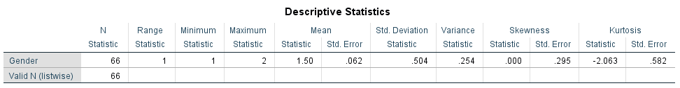
2. Age Group
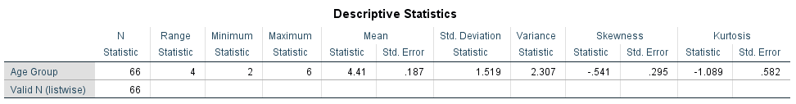

3. Position
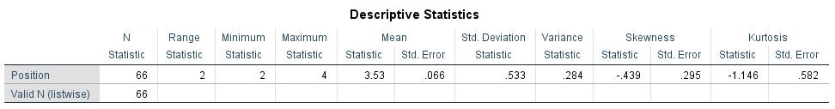
4. Years of Experience
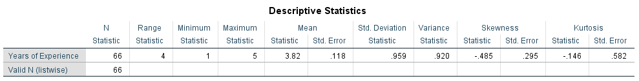
5. How would you describe the leadership style of your immediate supervisor?
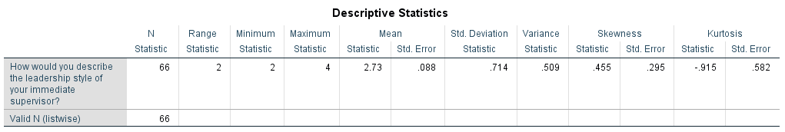
6. To what extent do you agree with: "My supervisor makes decisions without consulting the team."
t-Test
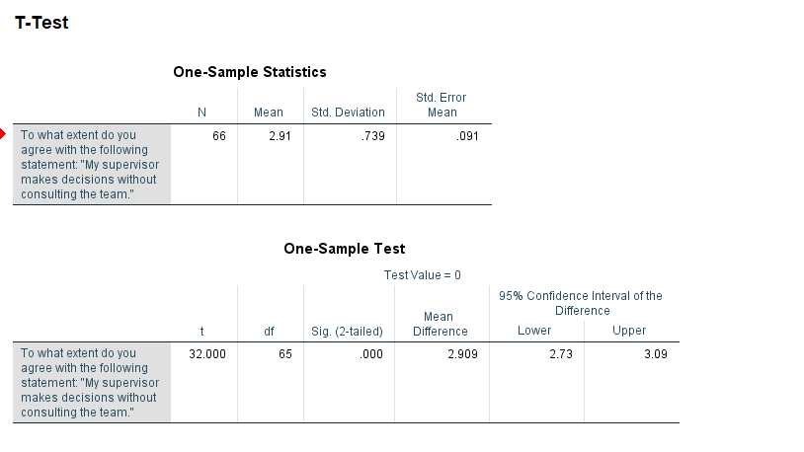
7. To what extent do you agree with: "I feel that my input is valued in decision-making processes."
Annova
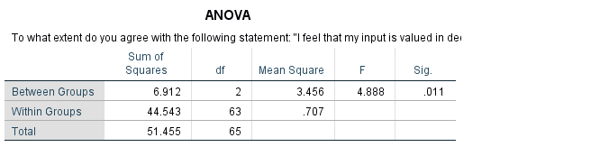
8. How satisfied are you with your job?
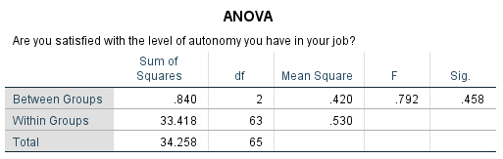

9. Are you satisfied with the level of autonomy you have in your job?
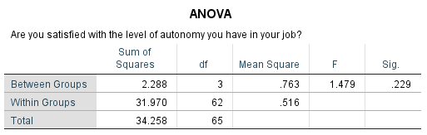
10. Do you receive adequate recognition for your contributions at work?
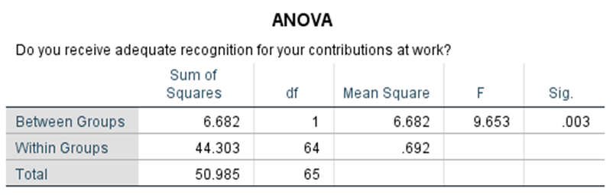
11. Does your Manager's leadership style positively impact your work productivity?

Correlations
 |  | Does your Manager's leadership style positively impact your work productivity? | How would you describe the leadership style of your immediate supervisor?
Does your Manager's leadership style positively impact your work productivity? | Pearson Correlation | 1 | -.077
 | Sig. (2-tailed) |  | .540
 | N | 66 | 66
How would you describe the leadership style of your immediate supervisor? | Pearson Correlation | -.077 | 1
 | Sig. (2-tailed) | .540
 | N | 66 | 66

12. Under your manager's leadership, are you able to meet your performance targets effectively?
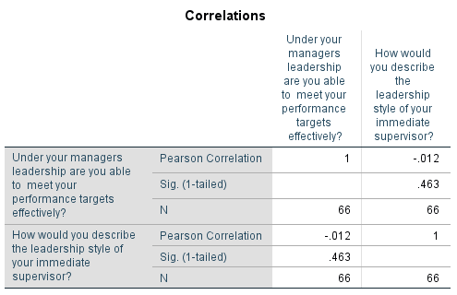
13. Do you feel motivated to do your best at work?
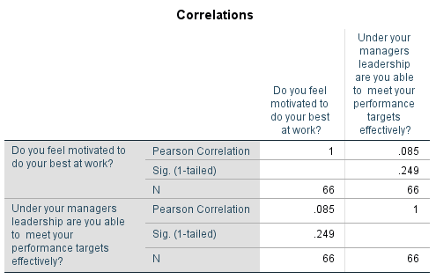
14. Do you feel stressed due to the leadership style of your manager?
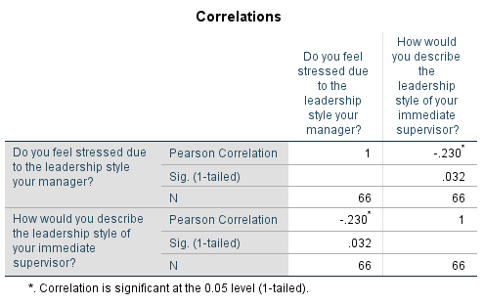
15. Are you likely to remain in your current job for the next year?
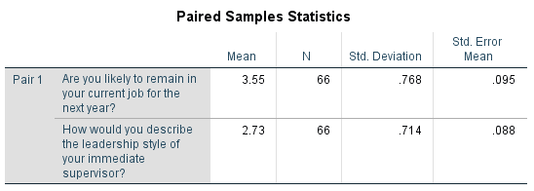
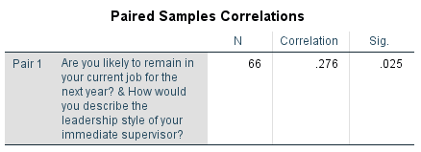
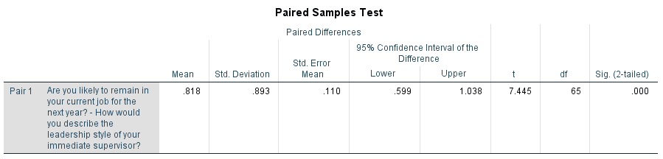

Chapter 5

5. Discussion

5.1 Interpretation of Findings
Question 1
- N: 66 respondents
- Range: 1 (from 1 to 2)
- Mean: 1.50
- Standard Deviation: 0.504
- Skewness: 0.254
- Kurtosis: -2.063
Analysis:
- The gender variable has two categories, likely coded as 1 (male) and 2 (female). The mean of 1.50 indicates an almost even distribution between genders.
- A skewness of 0.254 suggests a slight right skew, meaning there may be a marginally higher number of respondents identifying as male.
- The negative kurtosis value (-2.063) indicates a relatively flat distribution compared to a normal distribution, suggesting that there are fewer extreme values.
Question 2
- N: 66 respondents
- Range: 4 (from 2 to 6)
- Mean: 4.41
- Standard Deviation: 1.519
- Skewness: -0.541
- Kurtosis: -1.089
Analysis:
- The age groups are likely coded from 2 to 6. The mean of 4.41 indicates that respondents are skewed toward the older age groups (closer to 5 or 6).
- The negative skewness (-0.541) suggests that there are more younger respondents compared to older ones, though it’s not extreme.
- The kurtosis value of -1.089 indicates a flatter distribution than normal, which suggests that there are fewer respondents at the extreme ends of age groups.
Question 3
- N: 66 respondents
- Range: 2 (from 2 to 4)
- Mean: 3.53
- Standard Deviation: 0.533
- Skewness: -0.439
- Kurtosis: -1.146
Analysis:
- The position is likely coded from 2 to 4, suggesting three distinct roles or levels. A mean of 3.53 suggests that respondents generally hold a higher position on this scale.
- The skewness of -0.439 indicates a slight inclination toward lower positions, though it's relatively close to symmetry.
- The negative kurtosis (-1.146) suggests that the distribution is flatter than normal, meaning that the responses do not cluster tightly around the mean and there are fewer outliers.
Question 4
- N: 66 respondents
- Range: 4 (from 1 to 5)
- Mean: 3.82
- Standard Deviation: 0.959
- Skewness: -0.485
- Kurtosis: -0.146
Analysis:
- Years of experience are likely coded from 1 to 5. A mean of 3.82 suggests that most respondents have substantial experience (closer to 4 or 5 years).
- The skewness of -0.485 indicates a slight left skew, meaning there are a few respondents with less experience.
- The kurtosis of -0.146 suggests a distribution close to normal, indicating a moderate spread of data.
Question 5
- N: 66 respondents
- Range: 2 (from 2 to 4)
- Mean: 2.73
- Standard Deviation: 0.714
- Skewness: 0.455
- Kurtosis: -0.915
Analysis:
- This variable is coded from 2 to 4, likely indicating different styles of leadership. The mean of 2.73 suggests that respondents generally perceive their supervisor's leadership style to be on the more favourable side of the scale (closer to 3).
- The skewness of 0.455 indicates a slight right skew, suggesting more responses are clustered towards the higher end of leadership style perceptions.
- The negative kurtosis (-0.915) suggests a distribution that is flatter than normal, indicating less concentration of responses around the mean.
Question 6
One-Sample Statistics
- N: 66 (Number of respondents)
- Mean: 2.91 (Average response on the scale)
- Standard Deviation: 0.739 (Variability of responses)
- Standard Error Mean: 0.091 (Estimate of the standard deviation of the sample mean)
One-Sample Test Results
- Test Value: 0 (This indicates that you are testing whether the mean is significantly different from 0.)
Test Value | t | df | Sig. (2-tailed) | Mean Difference | 95% Confidence Interval of the Difference
 | 32.000 | 65 | 0.000 | 2.909 | Lower: 2.73
Interpretation
- Hypothesis Testing:
  - Null Hypothesis (H0): The mean response to the statement "My supervisor makes decisions without consulting the team" is equal to 0 (H0: μ = 0).
  - Alternative Hypothesis (H1): The mean response is not equal to 0 (H1: μ ≠ 0).
- t-value: The calculated t-value is 32.000. This is a very high value, suggesting a strong difference from the test value of 0.
- Degrees of Freedom (df): There are 65 degrees of freedom (N - 1 = 66 - 1).
- Significance (Sig.): The p-value (Sig. 2-tailed) is 0.000, which is less than the common alpha level of 0.05. This indicates that the result is statistically significant.
- Mean Difference: The mean difference is 2.909, indicating that respondents agree with the statement on average, and the value is significantly greater than 0.
- Confidence Interval: The 95% confidence interval for the mean difference is from 2.73 to 3.09. This means we can be 95% confident that the true mean of the population lies within this range, reinforcing that the mean is significantly different from 0.
Question 7
Interpretation
- Hypothesis Testing:
  - Null Hypothesis (H0): There are no differences in the level of agreement about feeling valued in decision-making processes across different leadership styles (H0: μ1 = μ2 = μ3).
  - Alternative Hypothesis (H1): There are differences in the level of agreement about feeling valued in decision-making processes across different leadership styles (H1: at least one mean is different).
- The sum of Squares:
  - Between Groups: The variation attributed to differences between leadership styles is 6.912.
  - Within Groups: The variation within each group is 44.543.
- Degrees of Freedom (df):
  - Between Groups: 2 (number of groups - 1).
  - Within Groups: 63 (total number of respondents - number of groups).
- Mean Square:
  - Calculated as the Sum of Squares divided by the respective degrees of freedom:
    - Between Groups: 6.9122=3.456\frac{6.912}{2} = 3.45626.912​=3.456
    - Within Groups: 44.54363=0.707\frac{44.543}{63} = 0.7076344.543​=0.707
- F-Ratio: The F-value is 4.888. This value indicates the ratio of the variance between groups to the variance within groups.
- Significance (Sig.): The p-value associated with the F-ratio is 0.011, which is less than the common alpha level of 0.05. This indicates that the differences in agreement levels across different leadership styles are statistically significant (Purwanto et al., 2020).
Question 8
Interpretation
- Hypotheses:
  - H0: There is no difference in satisfaction with autonomy across different groups (leadership styles).
  - H1: Significant differences exist in satisfaction levels based on leadership styles.
- Findings:
  - F-value: 0.792 indicates a low ratio of variance between groups compared to within groups.
  - p-value (Sig.): 0.458, which is greater than 0.05.
- Fail to reject the null hypothesis. There is no statistically significant difference in the level of satisfaction with autonomy among different leadership styles. This suggests that leadership style may not significantly impact how satisfied employees feel regarding their level of autonomy in their jobs.
Question 9
Interpretation
- Hypotheses:
  - H0: There is no difference in satisfaction with autonomy across different groups (leadership styles).
  - H1: Significant differences exist in satisfaction levels based on leadership styles.
- Findings:
  - F-value: 1.479 indicates a moderate ratio of variance between groups compared to within groups.
  - p-value (Sig.): 0.229, which is greater than the common alpha level of 0.05.
- Fail to reject the null hypothesis. There is no statistically significant difference in the level of satisfaction with autonomy among different leadership styles. This suggests that variations in leadership styles do not have a significant impact on how satisfied employees feel regarding their level of autonomy in their jobs.

Question 10
Interpretation
- Hypotheses:
  - H0: There is no difference in the perception of recognition received among different groups.
  - H1: There is a significant difference in the perception of recognition received among different groups.
- Findings:
  - F-value: 9.653 indicates a strong ratio of variance between groups compared to within groups.
  - p-value (Sig.): 0.003, which is less than the common alpha level of 0.05.
- Reject the null hypothesis. There is a statistically significant difference in the perception of adequate recognition for contributions at work among different groups. This suggests that factors influencing recognition may differ significantly across leadership styles or groups, and further analysis may be needed to identify which specific groups have differing perceptions.

Question 11
Interpretation
- Pearson Correlation Coefficient:
  - The correlation between the manager's leadership style and work productivity is -0.077. This indicates a very weak negative relationship.
- Significance (Sig. 2-tailed):
  - The p-value is 0.540, which is much higher than the alpha level of 0.05. This means that the correlation is not statistically significant.
- There is no significant correlation between the perception of the manager's leadership style and its impact on work productivity. The weak negative correlation suggests that changes in the perceived leadership style do not have a meaningful effect on productivity levels in this sample. Further investigation may be needed to explore other factors that influence work productivity beyond leadership style.

Question 12
Interpretation
- Pearson Correlation Coefficient:
  - The correlation coefficient of -0.012 indicates an almost negligible negative relationship between the ability to meet performance targets and the perceived leadership style.
- Significance (Sig. 1-tailed):
  - The p-value is 0.463, which is well above the common alpha level of 0.05. This indicates that the correlation is not statistically significant.
- There is no significant correlation between the effectiveness of meeting performance targets and the leadership style of the immediate supervisor. The negligible correlation suggests that the perceived leadership style does not have a meaningful impact on the ability to meet performance targets within this sample. Further research may be warranted to identify other factors that contribute to performance success beyond leadership style.

Question 13
Interpretation
- Pearson Correlation Coefficient:
  - The correlation coefficient of 0.085 indicates a weak positive relationship between motivation to do one's best at work and the ability to meet performance targets. This suggests that as motivation increases, there might be a slight increase in the ability to meet performance targets.
- Significance Level:
  - The p-value (Sig. 1-tailed) of 0.249 suggests that the correlation is not statistically significant, as it is much higher than the common alpha level of 0.05.
- The analysis indicates a weak, non-significant positive correlation between feeling motivated to do one's best at work and the ability to meet performance targets. Since the correlation is not statistically significant, it implies that motivation may not have a strong impact on performance outcomes in this sample. Further research may be needed to explore additional factors that could influence motivation and performance.

Question 14
- Pearson Correlation Coefficient:
  - The correlation coefficient of -0.230 indicates a weak negative relationship between stress due to the manager's leadership style and the leadership style of the immediate supervisor. This suggests that as the perception of the supervisor's leadership style becomes less favourable, stress levels may increase, albeit the relationship is relatively weak.
- Significance Level:
  - The p-value (Sig. 1-tailed) of 0.032 indicates that the correlation is statistically significant at the 0.05 level. This implies that there is a reliable relationship between these two variables in the sample, although the strength of the relationship is weak.
- The analysis reveals a weak negative correlation between stress due to the leadership style of the manager and the perceived leadership style of the immediate supervisor. This suggests that less favourable leadership styles may be associated with increased stress. While the correlation is statistically significant, the weak strength of the relationship indicates that other factors may also play a significant role in influencing stress levels among employees. It may be beneficial for organizations to explore leadership styles further and consider their broader impacts on employee well-being (Saygili et al., 2020).
Question 15
Interpretation
- Mean Difference:
  - The mean difference of 0.818 indicates that, on average, participants reported a higher likelihood of remaining in their jobs when evaluating the leadership style of their immediate supervisor.
- Standard Deviation and Error Mean:
  - The standard deviation of 0.893 reflects the variability in responses, while the standard error mean of 0.110 provides an estimate of the sampling variability of the mean difference.
- Confidence Interval:
  - The 95% confidence interval for the difference ranges from 0.599 to 1.038. This interval does not include zero, indicating that the mean difference is statistically significant.
- t-Value and Degrees of Freedom:
  - The calculated t-value is 7.445 with 65 degrees of freedom. This high t-value suggests a strong difference between the two paired groups.
- Significance Level:
  - The p-value (Sig. 2-tailed) of 0.000 is less than the conventional alpha level of 0.05, indicating that the result is statistically significant. This means there is a strong likelihood that the observed difference in responses is not due to random chance.
The paired samples test shows a significant difference in the likelihood of remaining in the current job compared to the evaluation of the leadership style of the immediate supervisor. Employees who perceive their supervisor's leadership style positively are significantly more likely to express intentions to remain in their current positions. This finding highlights the importance of effective leadership in employee retention and suggests that organizations should focus on leadership development to enhance employee satisfaction and commitment (Sayed, 2021).

5.2 Implications for Practice
The results of this study highlight the significant effect of autocratic leadership and other styles on employee satisfaction, motivation and performance within a healthcare work environment in the UK Health sector. Organizations need to understand that we need adaptive leadership practices which encourage an inclusive environment. Training programs based on transformational and participative leadership styles can help improve employee engagement and job satisfaction. Moreover, healthcare administration must learn to ask them regularly about feedback from employees who already feel significant and are at the centre of all decision-making processes. Mentorship programs can also help leaders to strengthen their comms and leadership, which will in turn boost team dynamics and output (Tamimi & Sopiah, 2022).

5.3 Limitations of the Study
This study offers important new information but also carries certain limitations. The use of self-reported data may add bias because participants might report answers to avoid being criticized by other people. Although the sample size was large enough to conduct statistical analysis, it may not offer a fully-fledged reflection of all the Health and Social Care Sectors in the UK. However, the cross-sectional nature of survey data precludes causally inferring these leadership styles to various employee outcomes (Ebrahim et al., 2022). There is also a similar need for longitudinal research to explore how leadership styles are affected by time but more importantly, whether certain approaches have lasting effects on employee satisfaction and performance.

5.4 Future Research Directions
As the dispersal of leadership is explored in future research; investigations should regard alternative styles beyond autocratic to account for their effects on diversity, and how these influences may vary across different demographic groups found within the healthcare domain. Further research that looks at the relationship between different types of leadership styles and organizational culture could help further our understanding of how employees experience such practices. Other qualitative research, for example through focus groups or in-depth interviews covering a wider range of employees, might add nuance to the findings such as uncovering deeper factors shaping job satisfaction and performance. The research could also help shed light on how external events, like regulatory changes or economic pressures, might affect leadership effectiveness and employee morale (Khudhair et al., 2022).

Chapter 6

6. Conclusion

6.1 Summary of Key Findings

Aspect | Finding
Gender Distribution | Nearly even distribution (Mean = 1.50), slight inclination towards males (Skewness = 0.254).
Age Group | Skewed towards older groups (Mean = 4.41), more younger respondents (Skewness = -0.541).
Position | Higher positions on average (Mean = 3.53), slight inclination toward lower roles (Skewness = -0.439).
Years of Experience | Substantial experience (Mean = 3.82), moderate spread of data (Kurtosis = -0.146).
Leadership Style Perception | Generally favourable view of leadership style (Mean = 2.73), slight right skew (Skewness = 0.455).
Decision-Making Without Consultation | Strong agreement (Mean = 2.91) that supervisors make decisions without team input (p < 0.001).
Feeling Valued in Decision-Making | Significant differences in agreement across leadership styles (F = 4.888, p = 0.011).
Satisfaction with Autonomy | No significant differences across leadership styles (F = 0.792, p = 0.458).
Recognition for Contributions | Significant differences in recognition perceptions across groups (F = 9.653, p = 0.003).
Correlation with Work Productivity | No significant correlation with leadership style (r = -0.077, p = 0.540).
Meeting Performance Targets | No significant correlation with leadership style (r = -0.012, p = 0.463).
Motivation and Performance Targets | Weak, non-significant positive correlation (r = 0.085, p = 0.249).
Stress and Leadership Style | Weak but significant negative correlation (r = -0.230, p = 0.032).
Intention to Remain in Current Job | Significant difference based on leadership style evaluation (Mean Difference = 0.818, t = 7.445, p < 0.001).

6.2 Recommendations
The study recommends that healthcare systems should start training in leadership with more diverse styles. To create a space that supports employees, managers should equip themselves to become great collaborators and practice active listening and empathy (Ricablanca & Abocejo, 2020). It can implement an employee survey or suggestion box as one way to regularly receive feedback from employees and consolidate the two sides. They should also think about how leadership development fits into pathways of career progression, making sure the next generation of leaders will know what it takes to survive and thrive in an ever-changing workplace.

6.3 Final Thoughts
This study provides valuable insight into the impact of different leadership styles on employee experience within the UK Health and Social Care Sector. Adopting an understanding of adaptive leadership and promulgating a culture of inclusivity are core views that organizations can use to design platforms for improving employee satisfaction, performance, and retention (Ta et al., 2022). Acknowledging these limitations can seed further research, developing and continuing to improve healthcare delivery for its workers. Leadership is critical for organizational success, but more importantly to the health of employees which in turn helps improve patient care and outcomes.

7. References
Idowu, S. A. (2020). Impact of leadership styles on employees' work performance in Some South-Western Nigerian private universities.
Setiawan, R., Cavaliere, L. P. L., Navarro, E. R., Wisetsri, W., Jirayus, P., Chauhan, S., ... & Rajan, R. (2021). The impact of leadership styles on employees productivity in organizations: A comparative study among leadership styles. Productivity Management, 26(1), 382-404.
Qtait, M. (2023). Systematic Review of Head Nurse Leadership Style and Nurse Performance. International Journal of Africa Nursing Sciences, 18, 100564.
Caillier, J. G. (2020). Testing the influence of autocratic leadership, democratic leadership, and public service motivation on citizen ratings of an agency head’s performance. Public Performance & Management Review, 43(4), 918-941.
Abdullahi, A. Z., Anarfo, E. B., & Anyigba, H. (2020). The impact of leadership style on organizational citizenship behaviour: do leaders' emotional intelligence play a moderating role? Journal of Management Development, 39(9/10), 963-987.
Ali, M. H., Irfan, M., & Zafar, S. (2021). Effect of leadership styles on education quality in public universities with the interaction of organizational politics: using the partial least square algorithm. Journal of Social Sciences and Humanities, 1(2), 1-13.
Mohamed, R., & Saeed, S. (2022). Relationship between leadership style and job satisfaction among physicians working in Greater Male hospitals. International Journal of Social Research & Innovation, 6(1), 1-30.
Erdem, A. T. (2021). The mediating role of work alienation in the effect of democratic and autocratic leadership styles on counterproductive behaviours: A study in Ankara OSTİM industrial zone. OPUS International Journal of Society Researches, 17(34), 873-902.
Alrobai, T. (2020). The Impact of Nurse Leaders/Managers Leadership Style on Job Satisfaction and Burnout among Qualified Nurses: A Systematic. Review IOSR Journal of Nursing and Health Science (IOSR-JNHS) e-ISSN, 2320-1959.
Rao, H. M., & Zaidi, U. (2020). How different perceived leadership styles influence organisational commitment on tourism SMEs. African Journal of Hospitality, Tourism and Leisure, 9(1), 1-17.
Altheeb, S. A. (2020). Leadership Style and Employee Motivation: A Study of Saudi Arabian Work Environment. Journal of Educational Psychology-Propositos y Representaciones, 8.
Specchia, M. L., Cozzolino, M. R., Carini, E., Di Pilla, A., Galletti, C., Ricciardi, W., & Damiani, G. (2021). Leadership styles and nurses’ job satisfaction. Results of a systematic review. International journal of environmental research and public health, 18(4), 1552.
MacKian, S., & Simons, J. (Eds.). (2021). Leading, managing, caring: understanding leadership and management in health and social care. Routledge.
Cinnioğlu, H., & Turan, H. Y. (2020). Leadership style and its relationship with employee’s organizational identification: evidence from the hotel businesses in Turkey.
Shan, G., Wang, W., Wang, S., Zhang, Y., Guo, S., & Li, Y. (2022). Authoritarian leadership and nurse presenteeism: the role of workload and leader identification. BMC nursing, 21(1), 337.
Akonkwa, D. B. M., Lunanga, E., Mukulu, J. B., Bugandwa, T. C., & Mwaza, E. F. (2022). Leadership styles and small enterprises' performance: is gender an issue? An empirical study from the democratic republic of Congo. Journal of Entrepreneurship and Innovation in Emerging Economies, 8(1), 60-82.
Sayed, N. M. I. (2021). Systematic analysis regarding leadership in healthcare. International Journal of Business Continuity and Risk Management, 11(2-3), 224-236.
Tamimi, M., & Sopiah, S. (2022). The Influence of Leadership Style on Employee Performance: A Systematic Literature Review: A Systematic Literature Review. International Journal of Entrepreneurship and Business Management, 1(2), 128-138.
Ebrahim, Z. B., Hafidzuddin, S. A., Sauid, M. K., Mustakim, N. A., & Mokhtar, N. (2022, October). Leadership Style and Quality of Work Life among Nurses in Malaysia during the COVID-19 Pandemic Crisis. In Proceedings (Vol. 82, No. 1, p. 99). MDPI.
Khudhair, F. S., Rahman, R. A., Adnan, A. A. B. Z., & Khudhair, A. A. (2022). Impact of leadership style on employee performance (A case study on a private organization in Iraq). Texas Journal of Multidisciplinary Studies, 13, 15-32.
Ta, M. T. D., Kim, T. E., & Gausdal, A. H. (2022, January). Leadership styles and safety performance in high-risk industries: a systematic review. In Safety and Reliability (Vol. 41, No. 1, pp. 10-44). Taylor & Francis.
Börnfelt, P. O. (2022). Raising concerns at work in the Swedish healthcare and educational sectors: Silence and voice climates. Employee Responsibilities and Rights Journal, 34(4), 437-461.
Farr-Wharton, B., Brunetto, Y., Wankhade, P., Saccon, C., & Xerri, M. (2021). Comparing the impact of authentic leadership on Italian and UK police officers' discretionary power, well-being and commitment. Policing: An International Journal, 44(5), 741-755.
Otieno, M. A. (2022). The Influence of Leadership Styles on the Performance of NGOs in the Health Sector in Nairobi County, Kenya (Doctoral dissertation, Master’s thesis, Strathmore University]. Strathmore University. http://hdl. handle. net/11071/13162).
Ricablanca, J. L. S., & Abocejo, F. T. (2020). Manager’s leadership styles and job performance of company rank and file employees. European Journal of Management and Marketing Studies, 5(4).
Chen, L., Huang, X., Sun, J. M., Zheng, Y., Graham, L., & Jiang, J. (2022). The virtue of a controlling leadership style: Authoritarian leadership, work stressors, and leader power distance orientation. Asia Pacific Journal of Management, 1-41.
Bwalya, A. (2023). Leadership styles. Global Scientific Journal, 11(8).
Simatwa, E. M., & Jane, K. (2021). Influence of leadership style on organizational performance of primary teachers training colleges in Lake Victoria Region of Kenya. Creative Education, 12(9), 2228-2251.
Ahmed Iqbal, Z., Abid, G., Arshad, M., Ashfaq, F., Athar, M. A., & Hassan, Q. (2021). Impact of authoritative and laissez-faire leadership on thriving at work: The moderating role of conscientiousness. European journal of investigation in health, psychology and education, 11(3), 667-685.
Purwanto, A., Bernarto, I., Asbari, M., Wijayanti, L. M., & Hyun, C. C. (2020). Effect of transformational and transactional leadership style on public health centre performance. Journal of Research in Business, Economics, and Education, 2(1).
Saygili, M., Özer, Ö., & Karakaya, P. Ö. (2020). Paternalistic leadership, ethical climate and performance in health staff. Hospital Topics, 98(1), 26-35.

8. Appendices

8.1 Questionnaire
Title: Impact of Autocratic Leadership on Employee Performance in the UK Health and Social Care Sector
Section 1: Demographic Information
- Age:
  - a) Under 25
  - b) 25-34
  - c) 35-44
  - d) 45-54
  - e) 55 and above
- Gender:
  - a) Male
  - b) Female
  - c) Other
- Job Role:
  - a) Nurse
  - b) Doctor
  - c) Support Staff
  - d) Administrator
  - e) Other
- Years of Experience in Health and Social Care:
  - a) Less than 1 year
  - b) 1-3 years
  - c) 4-6 years
  - d) 7-10 years
  - e) More than 10 years
Section 2: Leadership Perception
- To what extent do you agree with the following statement: "My supervisor demonstrates autocratic leadership behaviour."
    - Strongly Disagree
    - Disagree
    - Neutral
    - Agree
    - Strongly Agree
- To what extent do you agree with the following statement: "My supervisor is directive and makes decisions without consulting the team."
    - Strongly Disagree
    - Disagree
    - Neutral
    - Agree
    - Strongly Agree
- How comfortable do you feel providing feedback to your supervisor?
    - Very Uncomfortable
    - Uncomfortable
    - Neutral
    - Comfortable
    - Very Comfortable
Section 3: Job Satisfaction and Performance
- To what extent do you agree with the following statement: "I am satisfied with my job."
    - Strongly Disagree
    - Disagree
    - Neutral
    - Agree
    - Strongly Agree
- To what extent do you agree with the following statement: "I feel motivated to perform well in my job."
    - Strongly Disagree
    - Disagree
    - Neutral
    - Agree
    - Strongly Agree
- To what extent do you agree with the following statement: "My contributions are valued by my supervisor."
    - Strongly Disagree
    - Disagree
    - Neutral
    - Agree
    - Strongly Agree
Section 4: Performance Metrics
- How would you rate your productivity at work?
    - Very Low
    - Low
    - Moderate
    - High
    - Very High
- How well do you meet deadlines in your role?
    - Very Poor
    - Poor
    - Average
    - Good
    - Excellent
- How would you rate the quality of your work?
    - Very Poor
    - Poor
    - Average
    - Good
    - Excellent

8.2 Additional Data Tables
SPSS Analysis Framework
Questionnaire Question | Analysis Type | Dependent Variable | Independent Variable | Hypothesis | SPSS Procedure
1. Gender | Descriptive Statistics | N/A | N/A | N/A | Analyze > Descriptive Statistics > Frequencies > Select "Gender" variable
2. Age Group | Descriptive Statistics | N/A | N/A | N/A | Analyze > Descriptive Statistics > Frequencies > Select "Age Group" variable
3. Position | Descriptive Statistics | N/A | N/A | N/A | Analyze > Descriptive Statistics > Frequencies > Select "Position" variable
4. Years of Experience | Descriptive Statistics | Years of Experience | N/A | N/A | Analyze > Descriptive Statistics > Descriptives > Select "Years of Experience" variable
5. How would you describe the leadership style of your immediate supervisor? | Descriptive Statistics | N/A | N/A | N/A | Analyze > Descriptive Statistics > Frequencies > Select "Leadership Style" variable
6. To what extent do you agree with: "My supervisor makes decisions without consulting the team." | T-test / ANOVA | Agreement Level | Leadership Style | H0: No difference in agreement levels across styles | Analyze > Compare Means > Independent-Samples T-Test (for two groups) or One-Way ANOVA (for multiple groups)
 |  |  |  | H1: Difference exists
7. To what extent do you agree with: "I feel that my input is valued in decision-making processes." | T-test / ANOVA | Agreement Level | Leadership Style | H0: No difference in agreement levels across styles | Follow the same steps as Question 6
 |  |  |  | H1: Difference exists
8. How satisfied are you with your job? | ANOVA | Job Satisfaction | Position | H0: No difference in job satisfaction across positions | Analyze > Compare Means > One-Way ANOVA > Select the "Job Satisfaction" variable and factor variable (e.g., "Position")
 |  |  |  | H1: Difference exists
9. Are you satisfied with the level of autonomy you have in your job? | ANOVA | Autonomy Satisfaction | Age Group | H0: No difference in autonomy satisfaction across age groups | Analyze > Compare Means > One-Way ANOVA > Select the "Autonomy Satisfaction" variable and factor variable (e.g., "Age Group")
 |  |  |  | H1: Difference exists
10. Do you receive adequate recognition for your contributions at work? | ANOVA | Recognition Satisfaction | Gender | H0: No difference in recognition satisfaction across genders | Analyze > Compare Means > One-Way ANOVA > Select the "Recognition Satisfaction" variable and factor variable (e.g., "Gender")
 |  |  |  | H1: Difference exists
11. Does your Manager's leadership style positively impact your work productivity? | Correlation Analysis | Productivity Impact | Leadership Style | H0: No correlation between leadership style and productivity | Analyze > Correlate > Bivariate > Select "Leadership Style Impact" and "Work Productivity" variables
 |  |  |  | H1: Correlation exists
12. Under your manager's leadership, are you able to meet your performance targets effectively? | Correlation Analysis | Meeting Performance Targets | Leadership Style | H0: No correlation between leadership style and meeting targets | Follow the same steps as Question 11
 |  |  |  | H1: Correlation exists
13. Do you feel motivated to do your best at work? | Correlation Analysis | Motivation Level | Leadership Style | H0: No correlation between leadership style and motivation | Follow the same steps as Question 11
 |  |  |  | H1: Correlation exists
14. Do you feel stressed due to the leadership style of your manager? | Correlation Analysis | Stress Level | Leadership Style | H0: No correlation between leadership style and stress | Follow the same steps as Question 11
 |  |  |  | H1: Correlation exists
15. Are you likely to remain in your current job for the next year? | T-test / ANOVA | Job Retention | Leadership Style | H0: No difference in job retention based on leadership style | Analyze > Compare Means > Independent-Samples T-Test (for two groups) or One-Way ANOVA (for multiple groups)

