6/25/2020
Gavin Clarkson (1809104)
BEng mechanical and maunfacturing engineering
Motion Simulation
M5X02064
CAE and Stress Analysis

Table of Contents
Table of Contents 1
Introduction 2
Research 3
Finite Element Analysis 3
Motors 4
Degrees of Freedom 4
My Assembly 6
Link For Solidworks Files 8
Conclusions 9
References 10

Introduction
Solidworks in a 3D modelling platform with the ability to produce 2D drawings. Drawings are created by drawing on a 2D surface and using features such as extrude, revolve, extrude cut, revolve cut, fillet and many more. With these models, assemblies can be created by importing the parts and from the assemblies studies such as motion analysis and Finite Element Analysis (FEA) (Anon, 2012) (Stimmel, 2020) (Zhang, et al., 2009) (Lombard, 2013).
It was created in 1993 with founder Jon Hirschtick and currently being owned by Dassault Systèmes S.A. who are based in Paris. It currently serves more than 3 million designers and engineers in over 240,000 businesses. (Oanes, 2019) (Solidworks, 2020) (Solidworks, 2011)

Research
Solidworks is used in a variety of industries, these include aerospace, automotive, construction, electronics, manufacturing, medical, oil and gas plus many more. It is used by companies such as Ford Motor Company, SpaceX, General Atomics and even a company called Brunswick Bowling Company who use it to design a variety of cores and to map the dynamics of the bowling ball (InnovaSystems, 2020) (Solidworks, 2020) (HG Insights, 2020).

Finite Element Analysis
FEA uses a model to simulate real world behaviours. It can predict how a component reacts to fluid flow, heat and vibration as well as looking at physical effects such as fatigue, motion, heat transfer, mechanical stress and vibration. FEA does this by breaking down a component into small pieces, often called mesh, and examining how each part reacts. This then predicts how the component itself will react (Stimmel, 2020) (Autodesk, 2020) (Iancu, 2017) (Korka & Gillich, 2017). An example of the process is shown below (figure 1) and example of mesh applied to gears can be seen in figure 2.
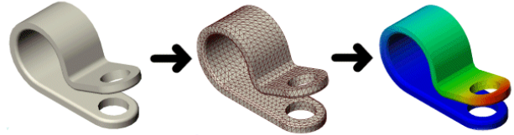

Figure 1 - Iancu (2017)

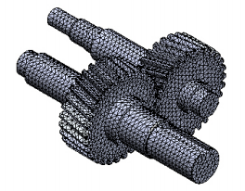
Figure 2 - Korka & Gillich, (2017)

The motion feature within solidworks is split in three categories:
- Animation – basic movements without taking mass or gravity into account.
- Basic motion – more complex than animation and takes mass, gravity, springs and impact detection into account.
- Motion study – the top tier, offers an accurate simulation and analysis of motion and observes a wider range of physical interactions, such as momentum, impact effects and damping.
Analysis can be used to accurately analyse effects of motion elements, including forces, friction, springs and dampers, and to simulate motion. It uses kinematic solvers and takes into account material properties, mass and inertia (Iancu, 2018) (Keane, 2018) (Solidworks, 2020) (Glodová, et al., 2014) (Mojarad, 2018) (Planchard, 2019).
Motion analysis and thermal analysis can be used in conjunction with each other to test reliabilities of components with regards to material chosen. As shown below (Glodová, et al., 2014) analysed a clutch made of different materials.
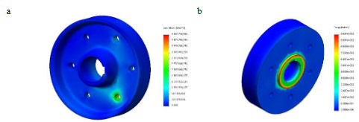
Figure 3 - Glodova, et al (2014)

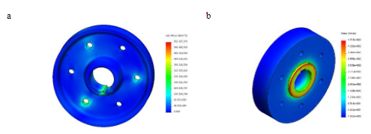
Figure 4 - Glodova, et al (2014)

Figure 2 shows the motion analysis (a) and thermal analysis (b) of the clutch made of cast carbon steel. Figure 3 shows the same analysis but with the material being a composite of aluminium matrix and ceramic particles. The cast carbon steel has a critical value of 4007736.500 N/m2 (a) and 9.634e+002K (b). Were as the composite material having critical values of 552437.375 N/m2 (a) and 4.714e+002K (b).

Motors
To get an assembly to move in a determined way in motion analysis a motor needs to be used. These motors can either be a rotary, linear or a path mate motor. Both the rotary and linear motor can be used to simulate movement of an object around the assembly. The path mate motor can be used to move a component around a pre-defined path in the assembly. These motors are not forces and only move components in a determined direction. They can be set to move by constant speed, distance, oscillating, and others (Raoufi, 2019) (Planchard, 2019).

Degrees of Freedom
Degrees of freedom (DoF) represents the number of parameters that are needed to be specified in order to determine the position, velocity and acceleration of a rigid body (Chang, 2020) (Raoufi, 2019). A rigid body has six DoF, three which are along its X, Y and Z axis and another three which are rotation around each of these axis (Solidworks Help, 2020) (Chang, 2020) (Mojarad, 2018) as shown in figure 5.

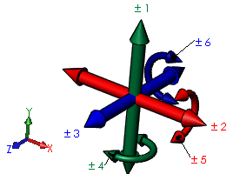
Figure 5 - Solidworks Help, (2020)

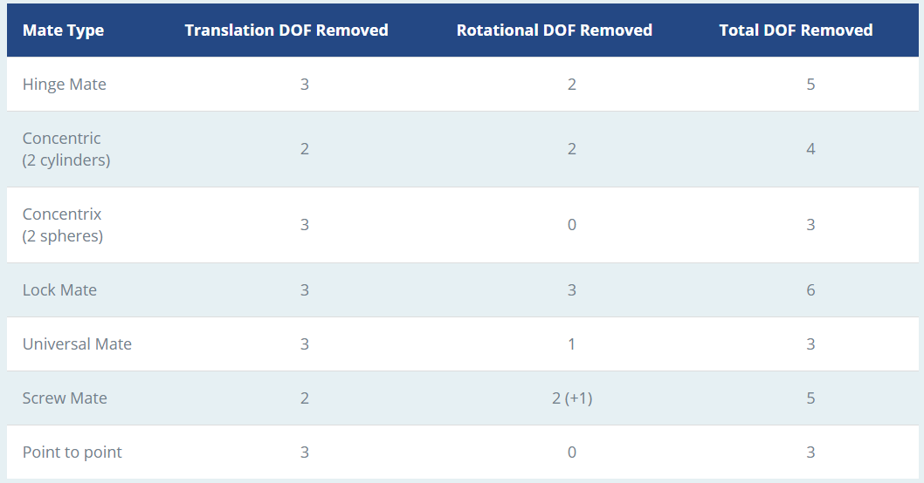
By adding a mate, or a constraint, into the assembly reduces the DoF. Table 1 below illustrates DoF that gets removed when a mate is added. By using these mates, you are able to constrain motion (Solidworks Help, 2020) (Mojarad, 2018).
Table 1 - Mojarad, (2018)

By adding to many mates into an assembly you can over constrain the model. This mean that several mates remove the same DoF and can fight to control it. These are known as mate redundancies. The motion solver can detect/ignore one of these redundant mates, this can still ensure that the motion is correct but may result in wrong dynamic results (Chang, 2020) (Mojarad, 2018) (Raoufi, 2019).

My Assembly
When first constructing the gearbox assembly I used standard mates including concentric and coincidence. This gave me a lot of redundant mates while using motion analysis. The reason being is the number of DoF removed while using this type of mate. The coincidence mate removes three DoF and the concentric mate removes four DoF (Solidworks, 2012) (Mojarad, 2018). This removes a total of seven DoF which means there are two redundant mates on the rotation around two different axes. To eliminate this, a hinge mate could be used. A hinge mate combines both a coincident and concentric mate and limits the movement to one rotational DoF (Solidworks, 2020) (Mojarad, 2018) (Solidworks, 2012). Using this mate then reduces the redundant mates.
While locating the first input gear I used a hinge mate as described above. On the second input gear I used a concentric and a distance mate. The distance mate set the gear ‘x’ distance from the side of the primary end bearing. This distance mate gave me two mate redundancies. By adding a point into the center of each and mating these two points using a distant mate, I reduced my mate redundancies by two. This is because the point mate still allows movement around all axis.
To remove more redundant mates from the assembly, I fixed all the bearings. These bearings do not need to move in the assembly as they would be held in position by the gearbox housing. By fixing these I removed several mate redundancies from the motion analysis.
There were several mate redundancies around my output shaft and gears. A rigid group was added to all three of these which eliminated them. A rigid group can group together components that all move together within the motion and the mate relating to these parts are then ignored within the motion study (Martin, 2010).
When aligning/setting the gears for first and second gear, I first used a gear mate to get these to move. A gear mate enables two components to rotate relative to each other about their selected axis (Solidworks Help, 2020) (Chang, 2020). This did not add any redundant mates and the motion looked correct with a good graph showing the output shaft speed (figure 6). However, unless the gears are in the correct position before adding the mate, they will not be aligned with each other. By using solid body contact instead of gear mates, this will eliminate this problem as when the drive gear turns the driven gear will follow when it comes in to contact. A solid body contact can be used to determine how a part would react when it comes into contact with another and it will prevent components from penetrating each other (TriMech, 2018) (Chang, 2020).
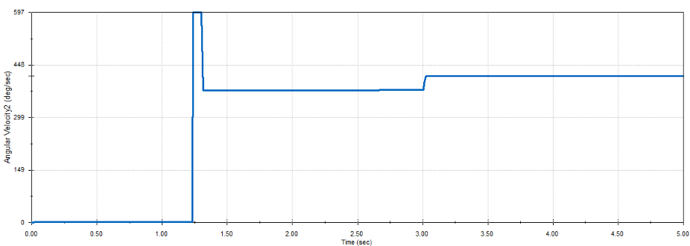
Figure 6 - Gear Mate Used

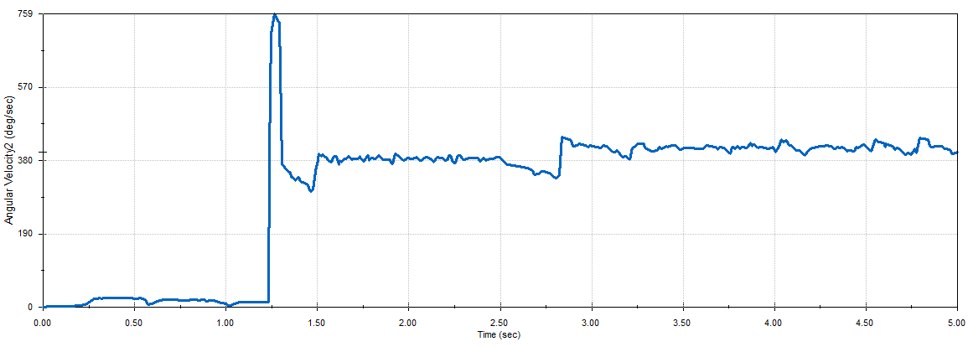
By using a solidbody contact between both first and second gears, the graph for output speed was similar but showed a lot more noise in the readings (figure 7). This was motion was solved using 25 frames per second.
Figure 7 - Solidbody Contact Using 25 Frames per Second
The frames per second is within the settings tap on motion analysis, it “specifies the frequency of captured data in a motion study” (Raoufi, 2019). This is defaulted to 25 frames per second. By increasing this number, it can result in smoother result plots and motion.
In my assembly I increased the frames per second to 50 and then to 75 (figure 8 and figure 9). This resulted in a smoother plot with less noise while in motion.
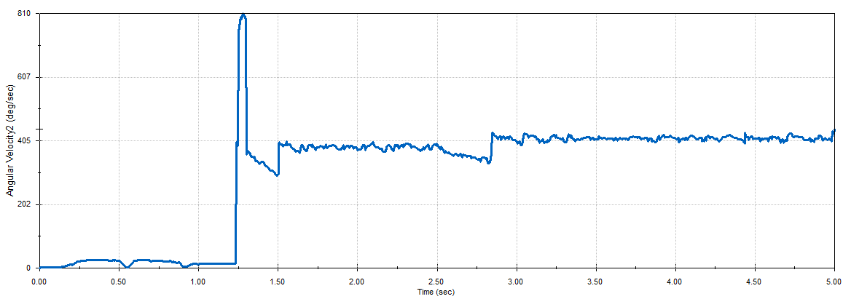
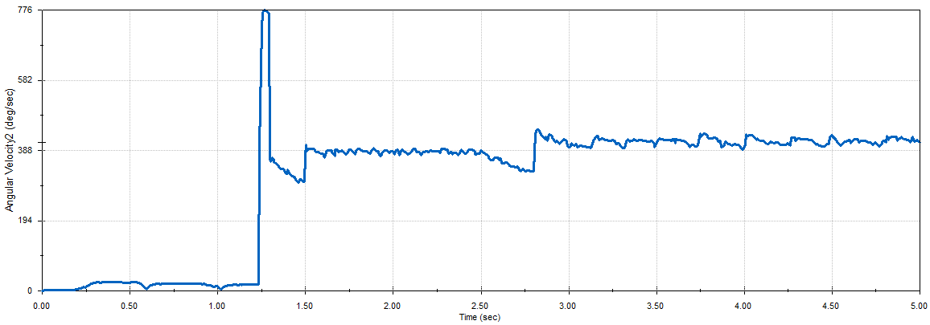
Figure 8 - Solidbody Contact using 50 Frames per Second
Figure 9 - Solidbody Contact using 75 Frames per Second
By using solidbody contact, it added a small amount of motion to the output shaft before the primary combined 1st 2nd gear had engaged. This could be because the gears are not quite aligned when motion analysis is started.
When making the housing to go around the gear box, I first created a sketch within the assembly to model the bottom. By doing this I ensured that the bearing lined up with housing. The top was then sketched against the bottom to ensure the location. Both halves of the housing were created so they are both halfway through the assembly to clamp the bearings and gear shifter rod, this also allows for easy access to replace or remove them. There is also extrudes on the outside of the housing with a lip on which will help to keep the bearing in place. Where required this lip is also on the inside. The gearbox housing could have been made by using equations to ensure that the bearing cut outs are in the correct place on both top and bottom even if the shaft were to be moved along the Z axis. Equations can be used to “create mathematical relationships between the dimensions” inside a model (Planchard, 2019).

Link for Solidworks Files

https://uowtsd-my.sharepoint.com/:f:/g/personal/1809104_student_uwtsd_ac_uk/EoE4byGX6u9FgMHxTXch_8oBKNB95k17ID1ar2IQJL1OjQ?e=zan9TU

Conclusions
In conclusion, solidworks is a platform that has a varied and practical use that is used by hundreds of thousands of companies worldwide (Solidworks, 2020). By using motion analysis, solidworks is able to identify real world problems before any sort of trial is done, as shown in the works of (Glodová, et al., 2014).
The degrees of freedom within an assembly play an important part when modelling motion or forces. By removing to many degrees of freedom and creating redundant mates could affect the dynamic results (Chang, 2020) (Mojarad, 2018) (Raoufi, 2019). The mate that seems very useful at removing redundant mates is the hinge mate. This acts as a coincident and concentric mate in one and removes five degrees of freedom in total allowing the component to move in one direction only. Another way of reducing redundant mates is to fix components that are not required to move, this automatically removes. Creating rigid body groups within motion analysis also removes redundant mates by grouping together components that move together.

References
Anon, 2012. EC: Solidworks 2013. Control Engineering.
Autodesk, 2020. Finite Element Analysis Software. [Online]
Available at: https://www.autodesk.co.uk/solutions/finite-element-analysis
[Accessed 07 06 2020].
Chang, K.-H., 2020. Motion Simulation and Mechanism Design. Mission: SDC Publications.
Glodová, I., Liptak, T. & Bocko, J., 2014. Usage of Finite Element Method for Motion and Thermal Analysis of a Specific Object in SolidWorks Environment. Procedia Engineering, Volume 96, pp. 131 - 135.
H. I., 2020. Dassault Solidworks. [Online]
Available at: https://discovery.hgdata.com/product/dassault-solidworks
[Accessed 24 06 2020].
Iancu, C., 2017. About Features of Simulation Module in Solidworks. Fiabilitate şi Durabilitate, 1(19), pp. 191 - 198.
Iancu, C., 2018. About Animation in Motion Studies in Solidworks. Fiabilitate şi Durabilitate, 1(21), pp. 228 - 231.
InnovaSystems, 2020. Solidworks is the software of choice for many industries. [Online]
Available at: https://www.innova-systems.co.uk/solidworks-industries/
[Accessed 24 06 2020].
Keane, P., 2018. Motion Studies (and How to Do Them). [Online]
Available at: https://www.engineersrule.com/motion-studies-and-how-to-do-them/
[Accessed 08 06 2020].
Korka, Z.-I. & Gillich, N., 2017. Modal Analysis of Helical Gear Pairs with Various Ratios and Helix Angles. Romanian Journal of Acoustics and Vibration, 14(2), pp. 91 - 96.
Lombard, M., 2013. Solidworks 2013 Bible. indianapolis: John Wiley & Sons, Inc.
Martin, R., 2010. Day 4: SolidWorks Simulation & SolidWorks Motion. [Online]
Available at: http://www.javelin-tech.com/newsletter/tech_old/2010/january/video_day4.htm
[Accessed 23 06 2020].
Mojarad, S., 2018. Motion Simulation in SOLIDWORKS. [Online]
Available at: https://www.javelin-tech.com/blog/2018/02/solidworks-motion-simulation/
[Accessed 16 06 2020].
Mojarad, S., 2018. Redundancies in SOLIDWORKS Motion Analysis. [Online]
Available at: https://www.javelin-tech.com/blog/2018/07/solidworks-motion-analysis-redundancies/
[Accessed 16 06 2020].
Oanes, S., 2019. The History of Solidworks. [Online]
Available at: https://blog.alignex.com/the-history-of-solidworks
[Accessed 24 06 2020].
Planchard, D. C., 2019. Solidworks 2019 Reference Guide. Mission: SDC Publications.
Raoufi, C., 2019. Design of Mechanisms with SolidWorks Motion Analysis and MATLAB/Simscape. Burnaby: s.n.
S. H., 2020. Degrees of Freedom. [Online]
Available at: http://help.solidworks.com/2016/English/SolidWorks/MotionStudies/c_degrees_freedom_motion.htm#:~:text=An%20unconstrained%20rigid%20body%20in,of%20freedom%20between%20the%20bodies.
[Accessed 22 06 2020].
S. H., 2020. Gear Mates. [Online]
Available at: http://help.solidworks.com/2016/english/solidworks/sldworks/t_gear_mates_swassy.htm
[Accessed 16 06 2020].
Solidworks, 2011. SolidWorks 1995 to 2012 - The Evolution of a 3D CAD System. [Online]
Available at: https://www.youtube.com/watch?time_continue=136&v=4vbY5arqxZA&feature=emb_logo
[Accessed 24 06 2020].
Solidworks, 2012. SAE Car Suspension With SolidWorks Motion: Part 1 Eliminating Redundancies. [Online]
Available at: https://www.youtube.com/watch?v=V78w-ja7f_w
[Accessed 16 06 2020].
Solidworks, 2020. Company Information. [Online]
Available at: https://www.solidworks.com/sw/183_ENU_HTML.htm
[Accessed 24 06 2020].
Solidworks, 2020. Company Stories. [Online]
Available at: https://www.solidworks.com/customer-stories?wocset=6
[Accessed 24 06 2020].
Solidworks, 2020. Hinge Mates. [Online]
Available at: http://help.solidworks.com/2016/english/solidworks/motionstudies/t_hinge_mates.htm
[Accessed 06 16 2020].
Solidworks, 2020. Introduction to Motion Studies. [Online]
Available at: http://help.solidworks.com/2020/English/SolidWorks/motionstudies/c_introduction_to_motion_studies.htm
[Accessed 08 06 2020].
Stimmel, J., 2020. 3D CAD. [Online]
Available at: https://www.solidworks.com/
[Accessed 08 06 2020].
TriMech, 2018. Video Tech Tip: Using Solid Body Contact in SOLIDWORKS Motion Simulation. [Online]
Available at: https://www.youtube.com/watch?v=Mg-E26Nfejo
[Accessed 16 06 2020].
Zhang, H.-Y., Li, T.-C. & Li, Z.-K., 2009. Modeling in SolidWorks and Analysis of Temperature and Thermal Stress During Construction of Intake Tower. Water Science and Engineering, pp. 95 - 102.

