Animation production design written assignment

By S.Fenwick

"In a hole in the ground there lived a Hobbit. Not a nasty, dirty, wet hole, filled with the ends of worms and an oozy smell, nor yet a dry, bare, sandy hole with nothing in it to sit down on or to eat: it was a Hobbit-hole, and that means comfort."

To start, we were given the task of creating a presentation based on the work of any production designer of our choosing, this would then determine the theme of the piece of text which we would work from.
I decided to create my presentation based on the work of Dante Ferratti, a famous Italian production designer. I focussed on his work from the films, Sweeny Todd: The Demon Barber of Fleet Street and Hugo.
The reason I chose these two films is that I loved the way each film looked, Sweeny Todd had a very dark/ horror aesthetic whereas Hugo was entirely steampunk themed.

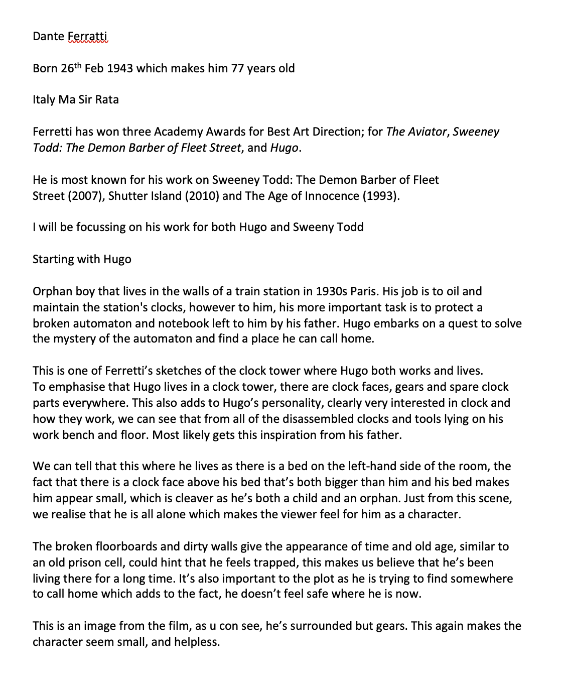
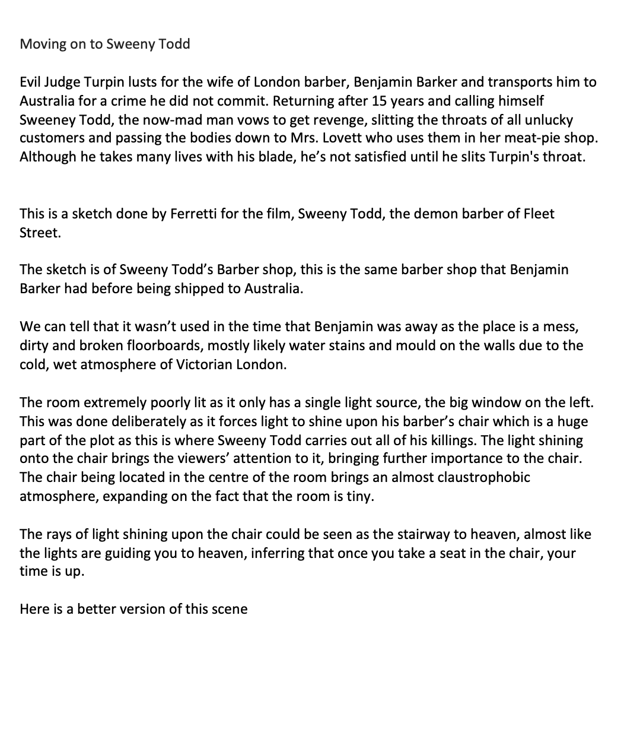
Here is my analysis and written notes from my presentation:

After the presentation, we had to choose a piece of writing to base our room model/ design off. I chose to look for a steampunk themed piece of text as I thought it would be both good fun and a challenge to model, however. After a lot of reading and research, I was stuck, I couldn’t find a suitable steampunk room description anywhere. This gave me the idea of using a room description from a different themed book and re-imagining it in my own steampunk style.
I looked at many pieces of writing from many different books such as, the chocolate room from Charlie and the Chocolate Factory by Roald Dahl And The shop from Maida’s Little Shop. In the end, I decided on the description of Bilbo Baggin’s house, from the Hobbit.

"In a hole in the ground there lived a Hobbit. Not a nasty, dirty, wet hole, filled with the ends of worms and an oozy smell, nor yet a dry, bare, sandy hole with nothing in it to sit down on or to eat: it was a Hobbit-hole, and that means comfort."

Once I was happy with the piece of writing, I started doing some research about Hobbit houses, steampunk interiors and other buildings such as cottages. I researched cottages because in the piece of writing it says, “that means comfort”, to me, nothing is more comforting than a cottage, so this was the best place to start. All of the cottage research I did showed that most cottage interiors are quite small and packed with furniture. This fit well with the hobbit theme because hobbits are known to be small and have cottage- like homes.

I also researched steampunk interiors, I found that every single steampunk room that I looked at had pipes, cogs, wood and lots of bronze and copper. This gave me my colour pallet for the room already. I chose to use different shade and types of wood, as well as bronze and copper.

I now had the foundations set for my steampunk hobbit hole. A small cottage- like room with lots of pipes, cogs and other metal objects.

Whilst doing my research about hobbit holes, I came across a bird’s eye view of ‘bag end’. This seemed to be a floor plan of Bilbo’s house, so I took it into maya, set it as an image plane and used it as a guide to create my house design.
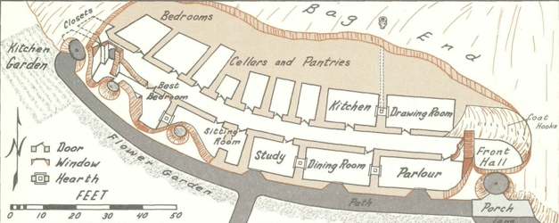
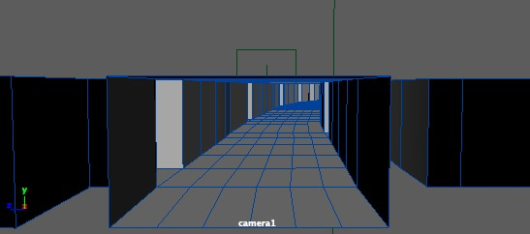
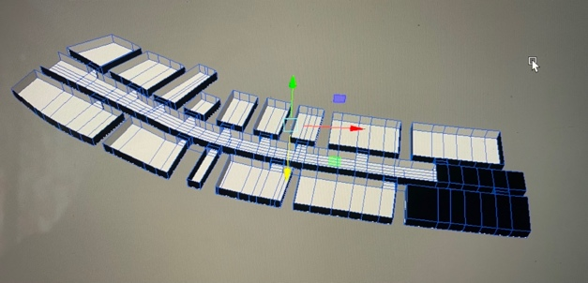
Although this took me a while, I was not happy with it at all. I had completely abandoned my original idea and had a huge empty shell of a house. It felt like I had cheated, by using an already existing floorplan. Not only did it feel like I had cheated, but the house was also 10x bigger than I intended to make it, which would have taken 10x longer too. Eventually, I scrapped this idea and returned to my original idea of a small steampunk cottage hobbit house.

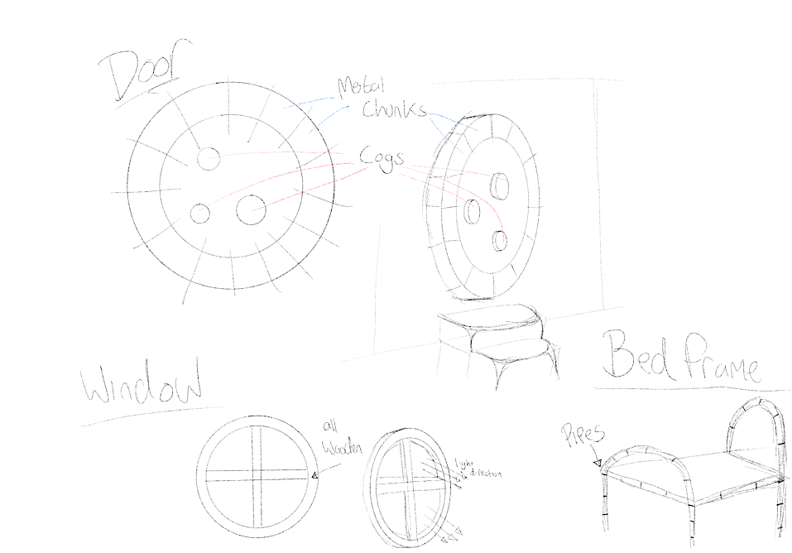
Now that I was back on track with my original plan, I started doing some sketches of potential furniture for the house. A huge circular door was a must, in both the book and films, hobbit houses always have big circular doors. Round windows are also a must have, they will come in clutch when trying to show that the house is a hobbit hole and not just a steampunk cottage.

Video, double click above image

At first, I couldn’t decide whether or not I wanted to make the room a bedroom or a living room, as in all of the films, Bilbo’s house is rather big with lots of tunnels. However, going off the piece of writing, “that means comfort” I decided to go with a one room bedroom as after conducting more cottage research, I realised that quite a lot of cottages are only one room. So, I decided to go with the bedroom approach.
Now that I had decided to go with a single room approach, I started modelling basic room structures. I created many different variants of the room with varying amounts of curvature to the walls and ceiling, however. In the end, I chose to create a simple box shaped room and focus my time on the interior, rather than the shape of the ceiling which you most likely wouldn’t have been able to see anyway. Here are a few examples of test room shapes. A very important part of modelling the room was reversing the box and then using ‘backface culling’, this allowed me to have the interior textured but still be able to see inside of the room from whichever direction I look at it from.
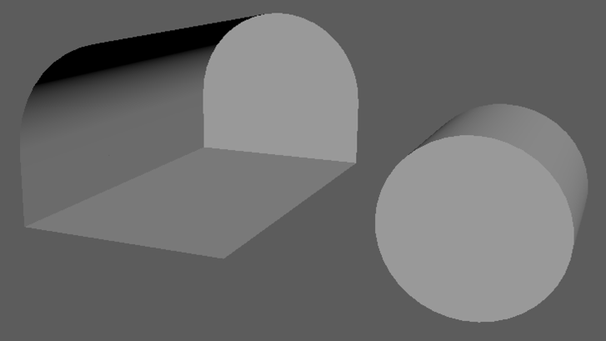
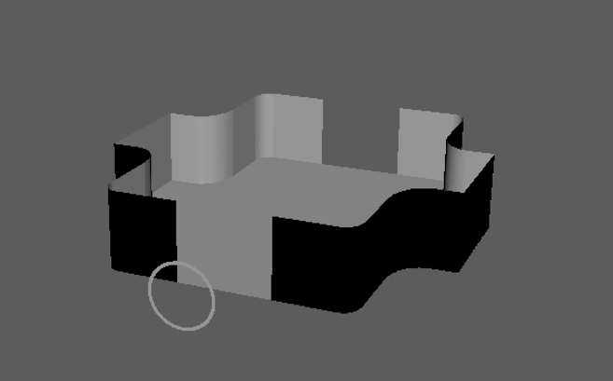

The first piece of furniture that I started modelling was the door as I believe that it’s the most important thing in the entire room, the door is what will determine whether or not the room looks like a hobbit hole.
I used lots of inspiration from the film, I made note that the doors in the film all had big even pieces of stone surrounding them, not only did this bring your attention to the door but also give the door some definition. If the stone wasn’t there, it would be a green door in a grass green hill. I decided to use the stone to my advantage, although I was modelling the inside of the door, I still wanted to have the eye-catching effect that the door in the film has. I chose to create big equal chunks of metal to surround the door, this would be one of the only things in the room that wasn’t wood coloured, brass or copper. I went with a hard steel material with a highly reflective surface to really make it pop. To emphasize the steampunk theme, I created gears to add to the front of the door. I gave the door a wooden base with copper and bronze for the gears. Although the gears were made out of metal, I decided not to make them too reflective.
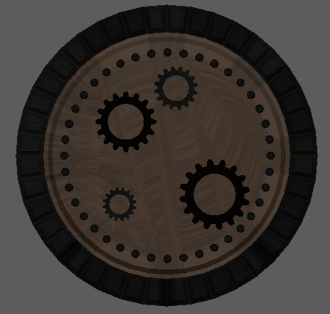
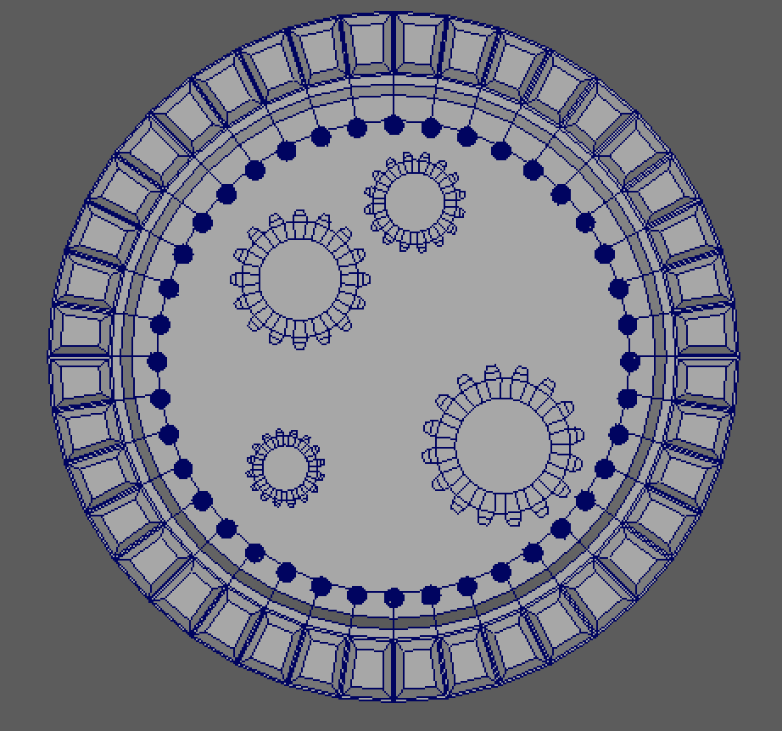

The windows were the next thing I worked on, I only needed to make a single window as I could just duplicate it. I started with a cylinder and used the extrude tool to create the shapes I wanted. The windows were very easy to make however, the only problem I had was removing the back face of the window to allow light to pass through. To fix this, I removed the entire back side of the window and used the fill hole tool to fill the areas that needed fixing, leaving the hole for light to pass through. I chose a lighter shade of wood for the windows as I didn’t want then to blend in with the stone wall. I then duplicated the window and decreased the size of the window so that I had 2 perfect hobbit styled windows.

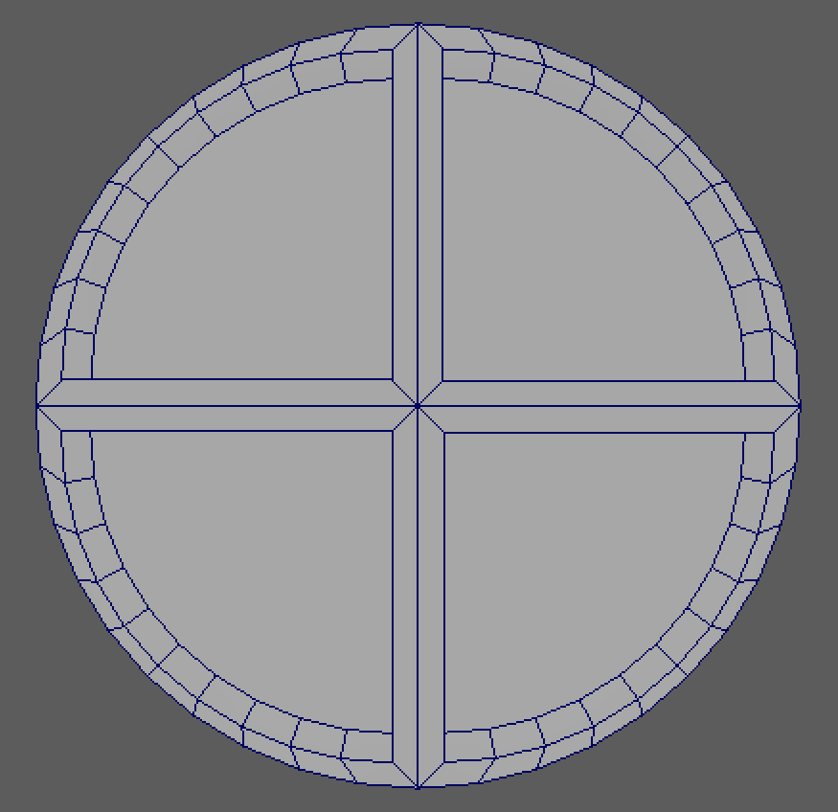
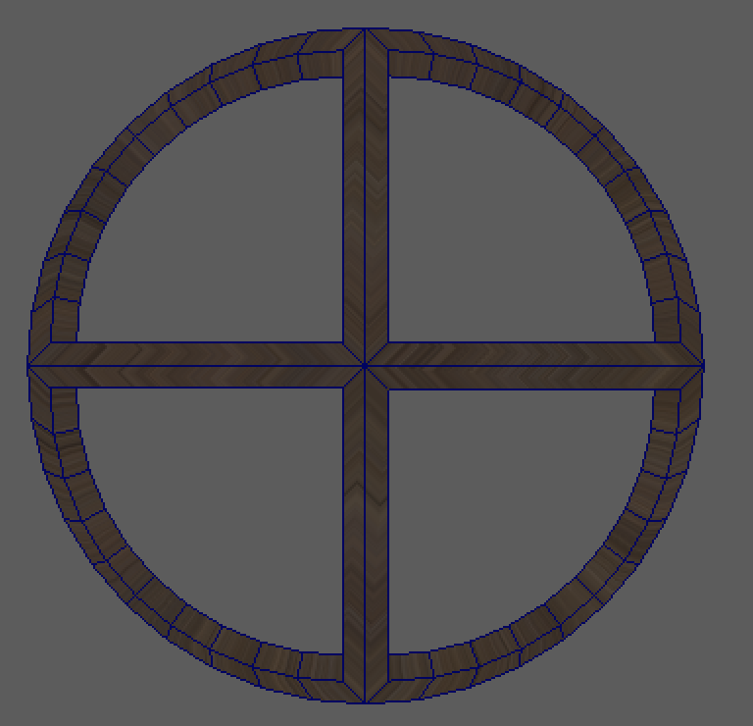

Next was the bed, also a very important part of the room design. I spent a long time modelling a bed made out of pipes and sheet metal however, after a long time modelling it, I decided to restart. There were two main reasons I restarted with the bed modelling. Reason 1 was because I knew that there was going to be a large number of copper/ bronze cogs and pipes all over the room. I felt as if having a bed made out of pipes would just be too much copper for one room, so I decided to go with a wooden bedframe instead. Reason 2 was because, I’m modelling this room for a hobbit. They aren’t the tallest creatures so creating a bed that is very high off the ground just seemed like a silly idea. I thought that having a bed that’s close to the ground would suit the aesthetics of the room much more and be much more realistic. I chose to make a double bed so that I could make multiple pillows to really show off my skills. I used Ncloth to create the pillows, I then froze transformations and deleted history so that they’d stay exactly how I wanted them to.
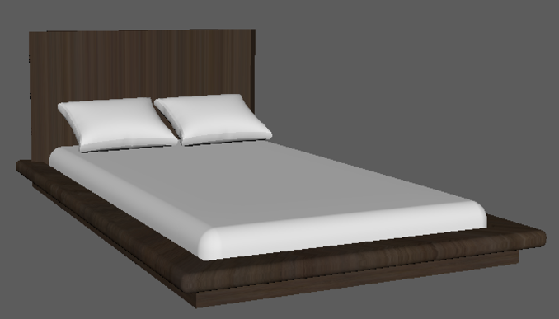
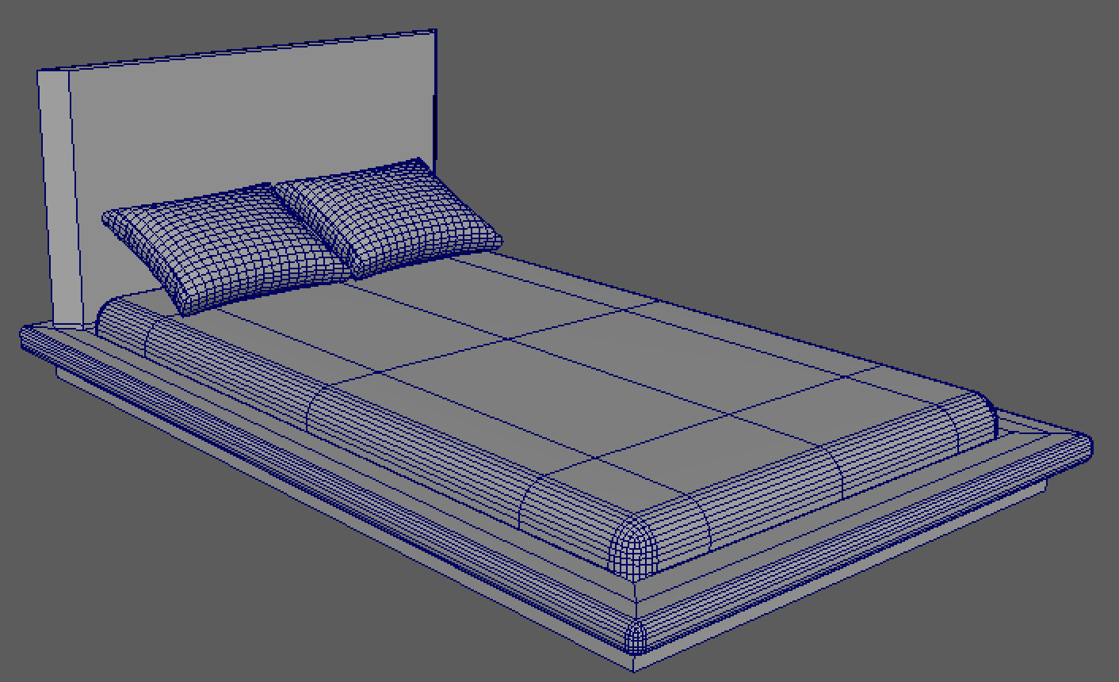

Since I had chosen to model a bedroom, I decided to would be a good idea to include some form of clothing storage. A set of drawers was what I had in mind. I started off with just a simple cube and began extruding different faces until I had the base shape. I went with a box shaped drawer with bevelled front edges. I made the decision to have one of the drawers open so that it’d look more natural, as if someone actually lived there. Now that I had finished modelling the drawers, it was time to texture it. At first, I was concerned that the drawers looked too modern for the steampunk style I was going for but, after texturing the model, I was a lot less worried. I chose to give the base of the drawers a dark oak wooden texture with bronze edges, I also added bronze pipe handles to the outside.

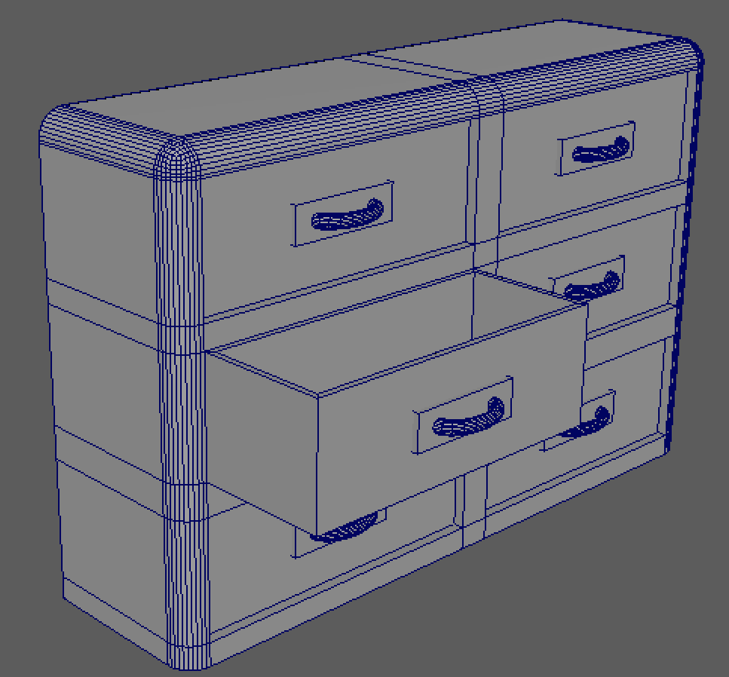
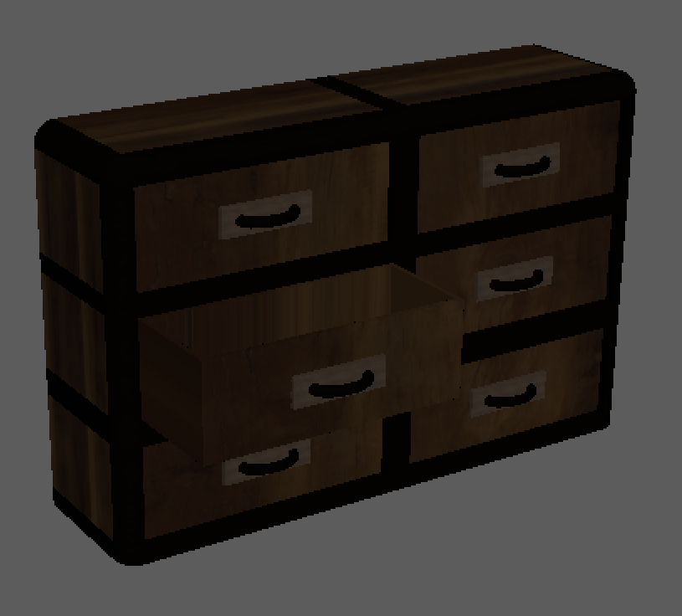

There were only a few other pieces of furniture left to model, a standard unit for storage, a chair and a mirror. Starting with the unit, I followed the same method that I used to model the drawers. Once I had the basic shape of the unit finished, I duplicated it so that I could make two separate, slightly different units. Unit one was designed as a half unit, half desk. I wanted there to be somewhere that Bilbo could work without adding a separate desk to the room. Unit 2 was just a standard unit, designed to hold whatever the house owner chooses to put in it. Both were wooden with bronze piping around the edges, similar to the drawers. The mirror was one of the hardest things to model, I wanted to create a gear shaped exterior with a reflective surface on the inside. The biggest challenge I faced here was creating two separate faces within one face. If I was to extrude the face of the gear, I’d end up with a smaller gear shape in the middle, this was not what I wanted. I wanted a circle shaped mirror on the inside to give a variation in shape. Once the mirror was modelled, I began texturing. I chose the bronze texture for the gear and a blinn material with a high amount of reflectivity. I also modelled a chair, once again, I stated with a box and extruded all the faced I need to until I was happy. I then used to smooth tool to make the chair look much nicer. A bronze texture was applied to add to the steampunk theme.

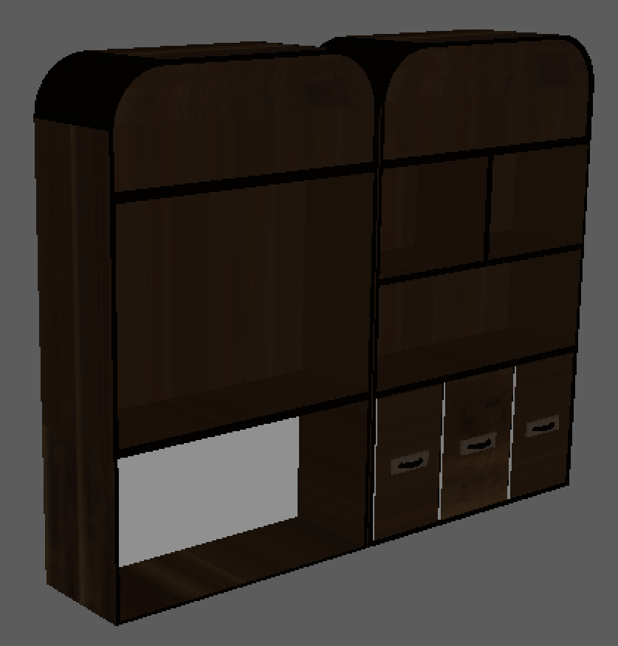
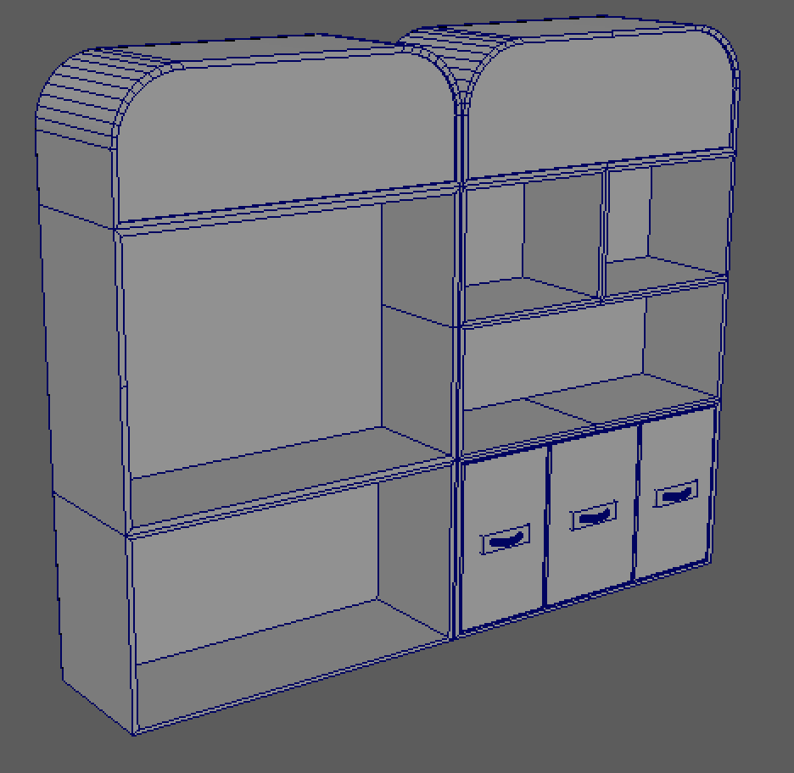
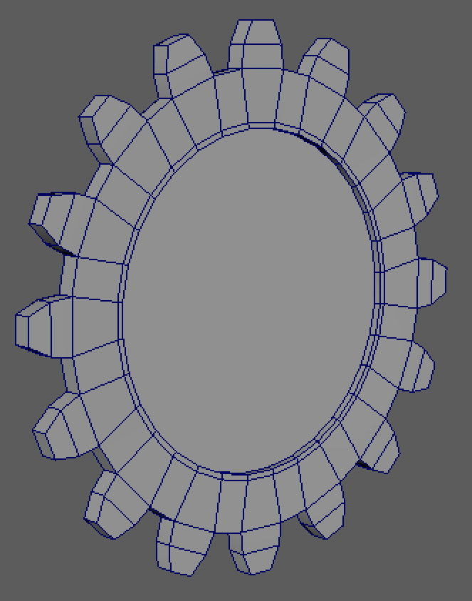

The Only other things that I needed to model were all the extras, such as pipes and spare gears. All of these were extremely simple to make and didn’t take much time at all. A few textures were added, mainly bronze and copper however, I did play around with silver to add a variation. A big challenge I faced towards the end of the design was working out how to create a hole in the wall without messing up the textures. I tried extruding and the ‘make hole’ tool however, this drastically changed the textures which I wasn’t happy with. In the end I went with the Boolean tool, I created a new sphere and used it to cut two holes in the wall for light to pass through, without screwing with my textures.
Now that I had everything modelled, it was time to placed everything in the room. I had already sketched out a few potential floor plans as you can see below. I chose floorplan 3 because I thought it was the best use of space out of the 3.
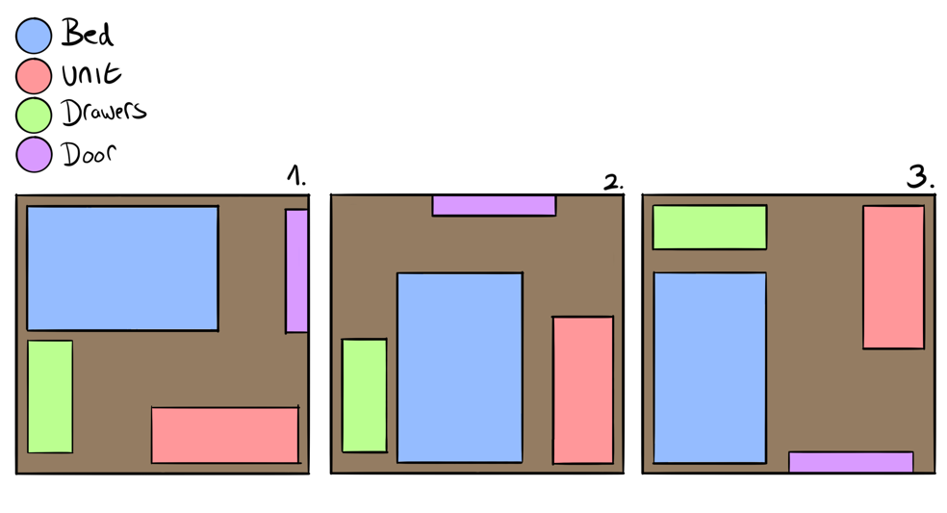

Now that everything was rendered and in place, it was time to work on lighting and cameras. I used and area light and a skydome light. The area light was used just to set a base light level, whereas the skydome was used as the sun in the sky, allowing light to shine through the windows. Lastly, I created a camera and set the FOV to 100, this allowed me to fit more in the frame without it looking distorted. I made the camera pan around the room, showing off all of the effort and detail which I put into the room. Below are screenshots I took while testing out the Arnold rendered, here is also the final rendered version of my model. Double tap to play video.
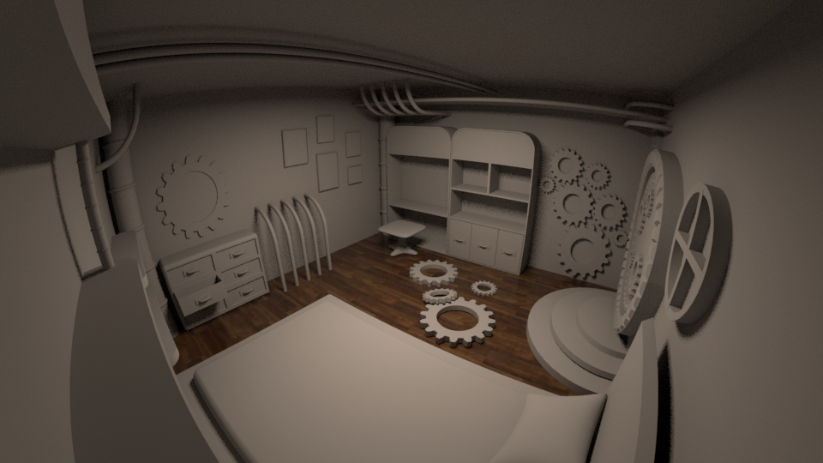

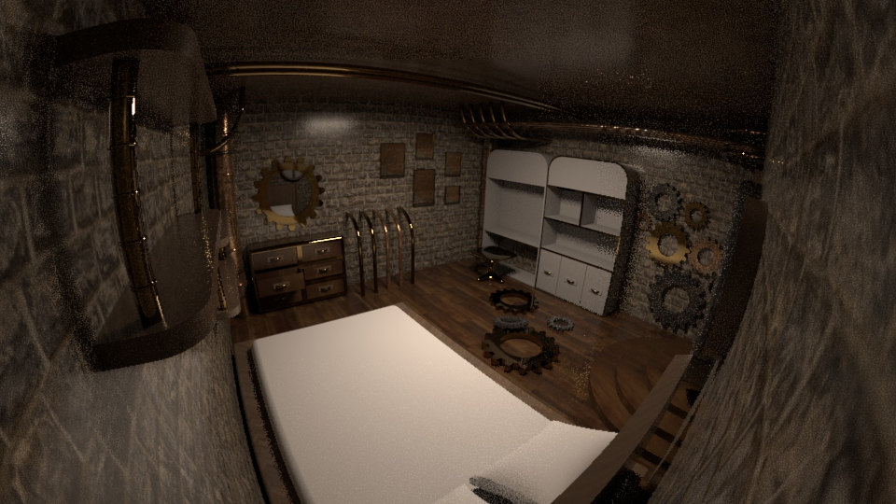

Video is below
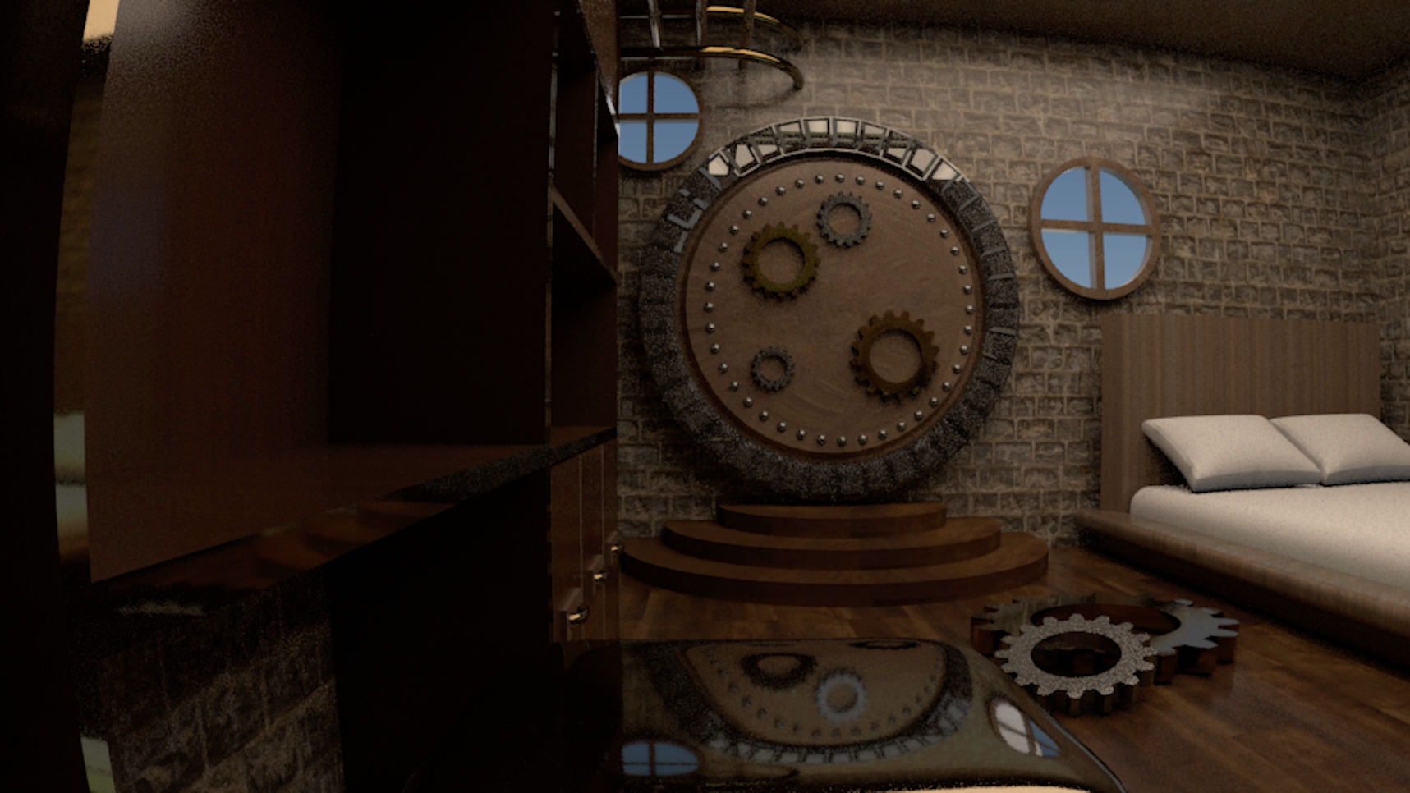
Double tap above

