Learning in the Digital Era (Computing & Electronics)
Assignment 1: E-Portfolio
Jacob Smelt (2215291) – Beng2-PT embedded electronics systems

Contents
E-Portfolio 2
Link 2
Home Page 2
Written summary (Task 1) 2
Academic Poster (Task 2) 3
Link 3
Poster 3
Automatic referencing tool (Task 3) 4
E-portfolio 5

E-Portfolio

Link
https://sites.google.com/view/assessment-1js/home

Home Page
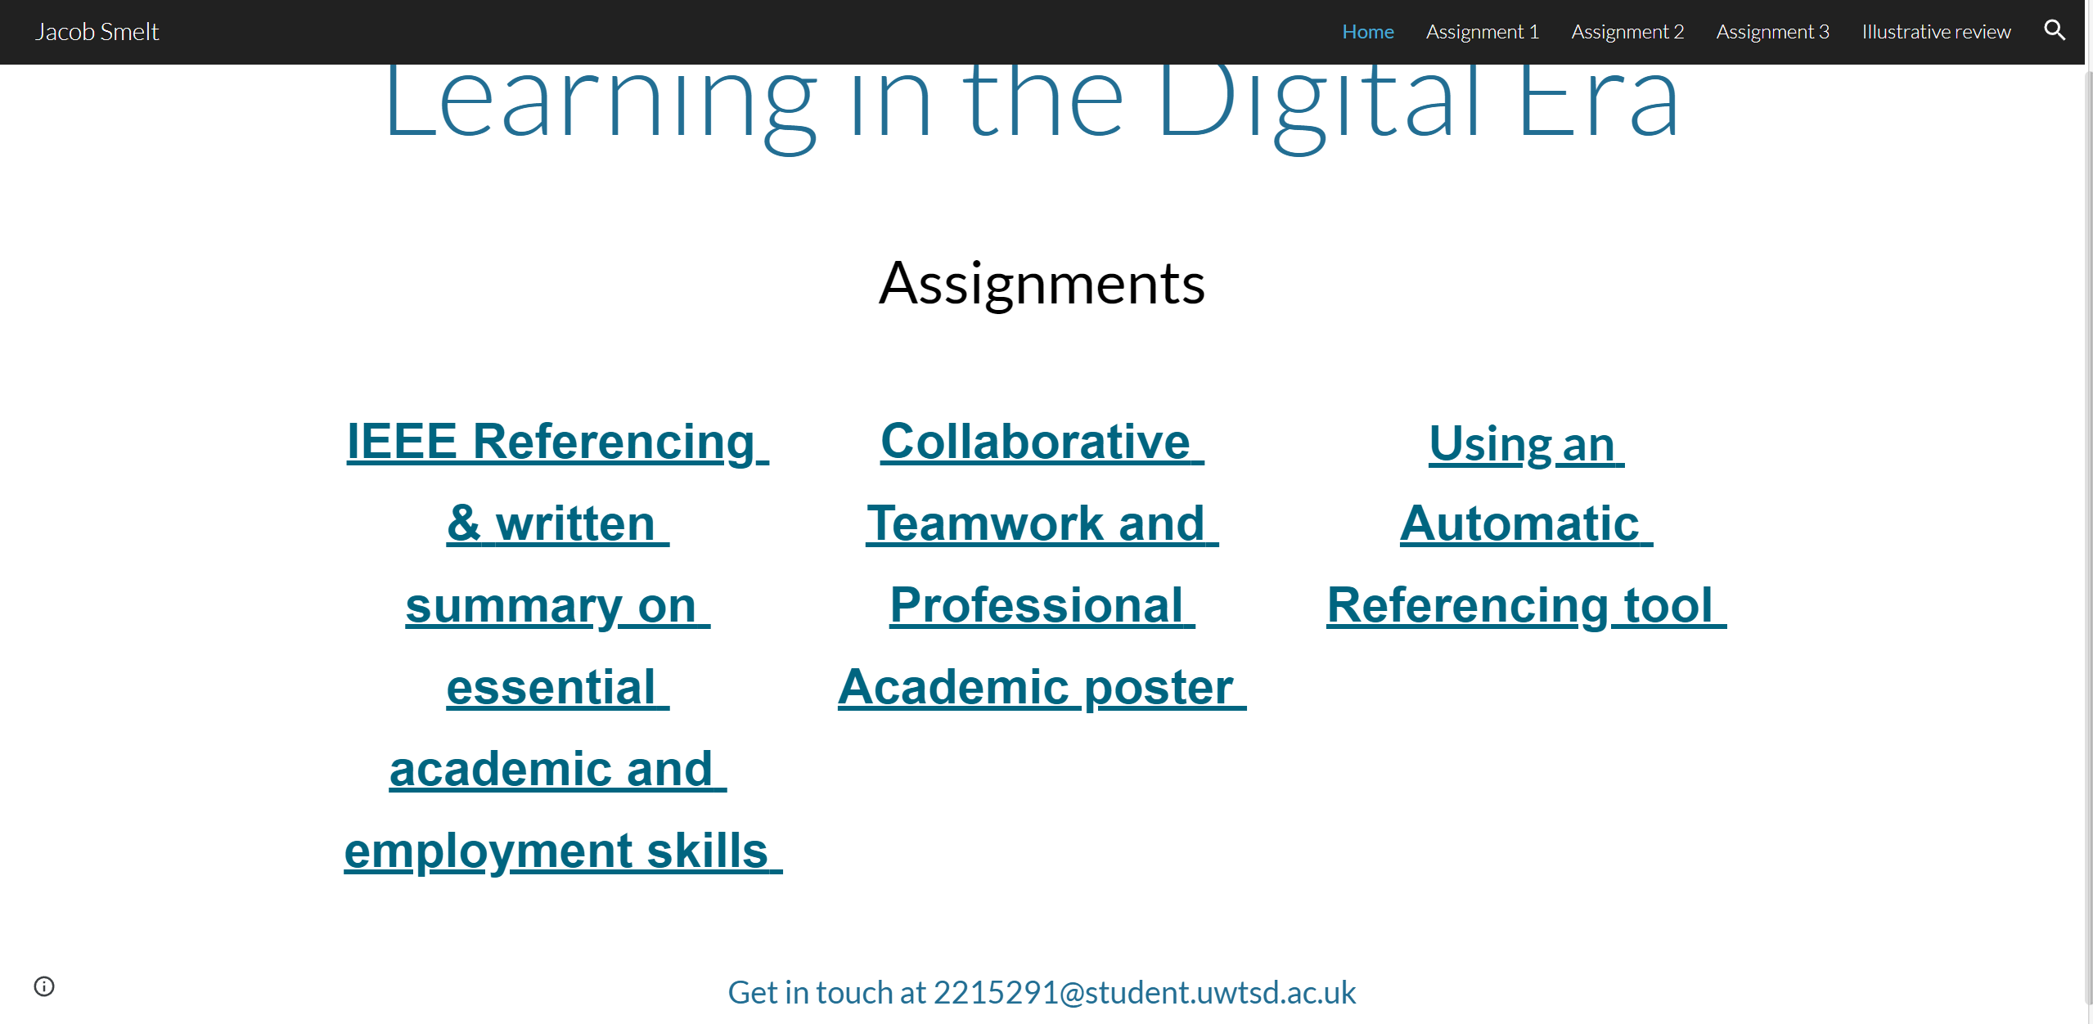

Written summary (Task 1)

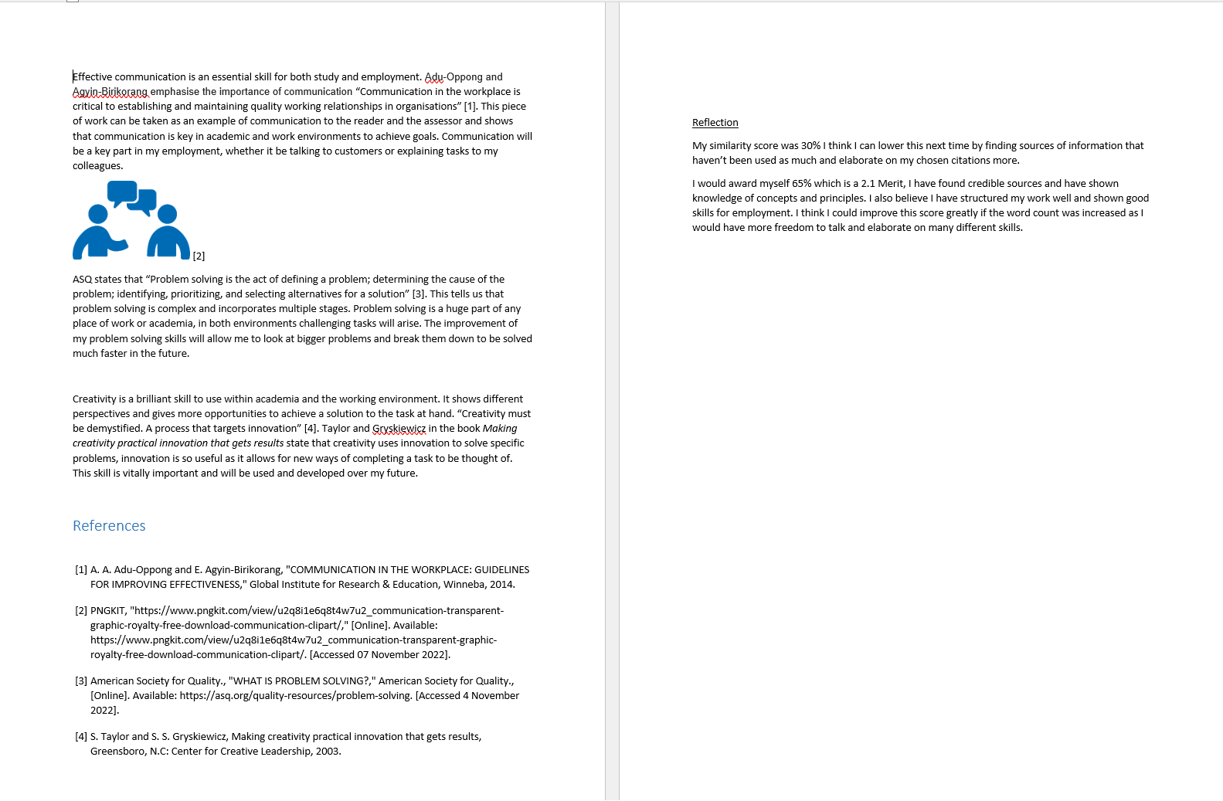

Academic Poster (Task 2)

Link
https://docs.google.com/presentation/d/1qmn2DlKP81ptDULDK967tUjY2RfuyTnE/edit?usp=sharing&ouid=105918704369033434835&rtpof=true&sd=true

Poster
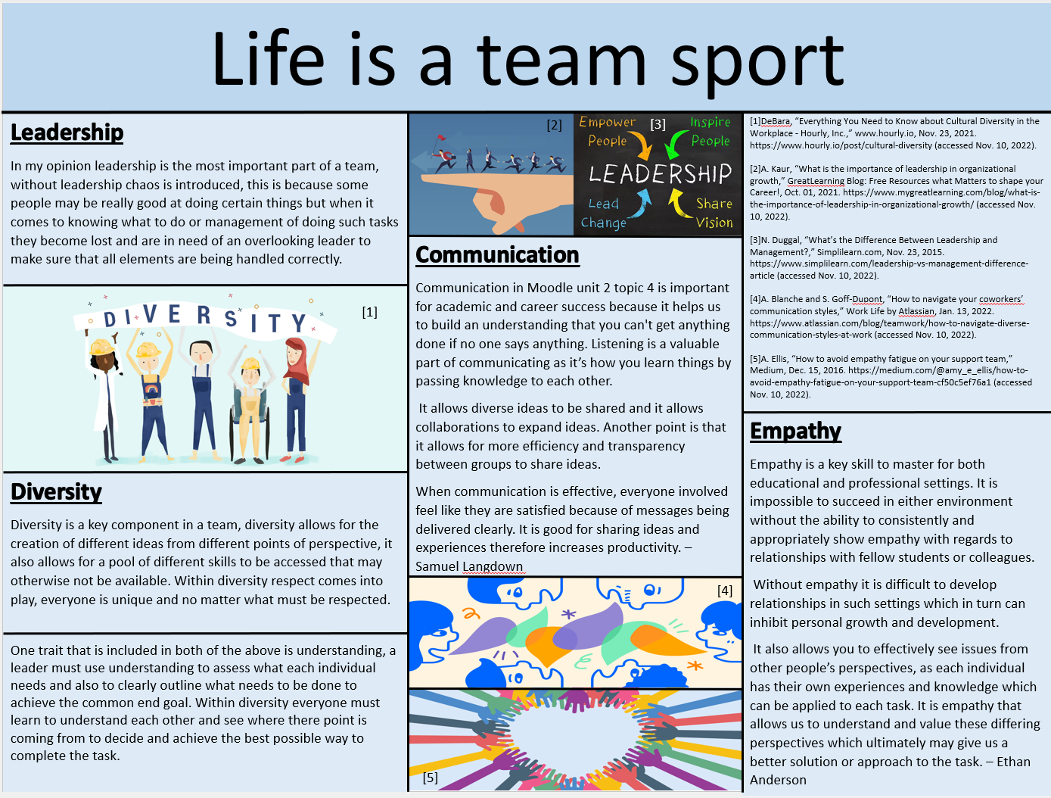

Automatic referencing tool (Task 3)
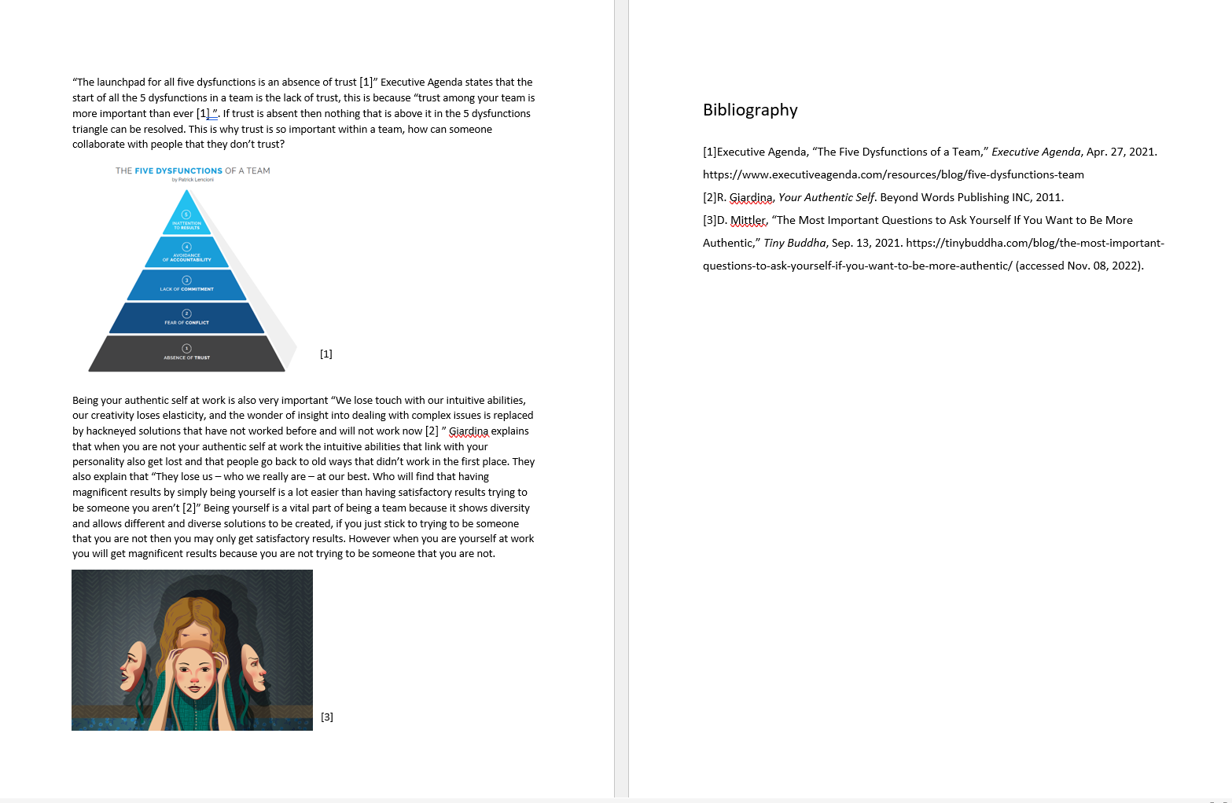

E-portfolio


