Quantification of bones.

To put it simply, we count so we know how many of something we have. This is the same for bones in archaeozoology; we count everything, whole bones and fragments all count. This is called the NISP (number of individual specimens present), and is a common method used. NISP gives the maximum number of animals we are dealing with (O’Connor, 2004. P. 54). This is the first step of arranging an assemblage. The NISP is important but does not provide any more information other than how many bones or fragments we are working with; it is for observational purposes (Lyman, 1994. P. 38). At this stage species, age or lefts or rights is less important, for example if we have three scapulae, two humeri, four tibias and four whole femora and six bone fragments our NISP is nineteen. It does not matter if we have three identical scapulae, a humerus from a large animal and another from a small animal, or six bone fragments that fit together perfectly, the NISP is nineteen.
Once the total amount of bones present is established, we then start being more specific by sorting them into species, age, lefts and rights and how many of each bone we have to determine the minimum number of individuals (MNI). This process is important as it tells us the minimum number of animals identified in the assemblage (Lyman, 1994. P. 38). For example, if we have one small whole left scapula, one large whole right scapula both the NISP and MNI would be two as they could not possibly belong to the same animal. If we had one large left whole humerus and one right whole humerus the same size, we could assume they came from the same animal (unless something else tells us it does not), therefore the NISP would be two, but the MNI would be one.
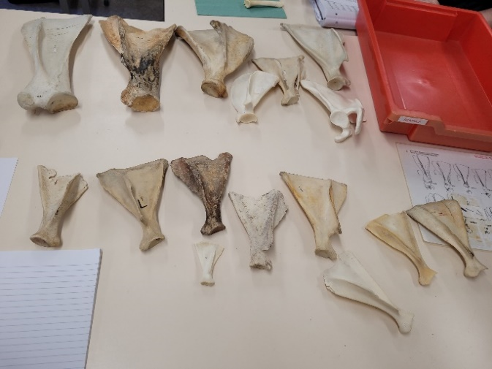
This picture shows a selection of scapulae. The NISP is the total number which is sixteen. It is clear some of them belong to different species and some belong to the same species just by looking at the various sizes and shapes of them.
To work out the MNI we need to separate them into species, lefts and rights, juveniles and adults.
Figure 1 Collection of scapulae.

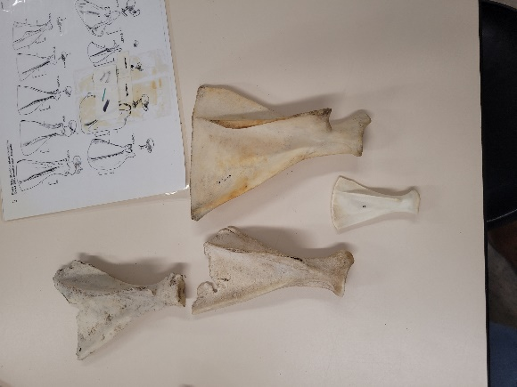
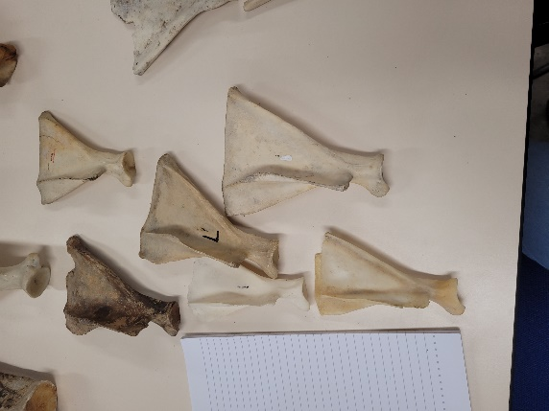
After sorting out the different species and lefts and rights, we are left with ten ovis scapulae as shown in the pictures on the left and right. The NISP for ovis scapulae is ten. We need to establish the MNI. As we have six left scapulae, the new MNI would be six as each ovis only as one left scapula, we must be dealing with at least six individual ovis. Just from looking at the right scapulae, one is clearly a lot smaller than the rest, therefore making the new MNI seven.
Figure 3 Collection of left scapulae.
Figure 2 Collection of right scapulae.

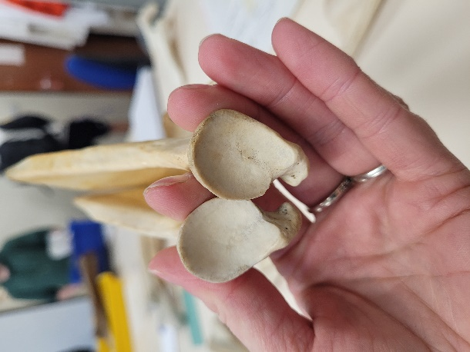
By taking a closer look at the bones, we were able to match two lefts and two rights together. This makes the new and final MNI eight as we had two matched lefts and rights, four unmatched lefts and two unmatched rights.

Figure 4 a left and right scapula.

References:
Lyman, R.L. (1994) ‘Quantitative Units and Terminology in Zooarchaeology’, American antiquity, 59(1), pp. 36–71. Available at: https://doi.org/10.2307/3085500.
O’Connor, T. (2004) The archaeology of animal bones. Pbk. ed. Stroud: Sutton.

Images:
Authors own, taken at UWTSD Lampeter 17/02/2023.

