Impact of virtual learning environment (VLE): Moodle on students’ learning experience at the University of Wales Trinity Saint David London Campus

Masum Billah (2028988)
Module code and title: Digital Skills and Research Methods BMSW4003
Lecturer’s name: Toyin Adisa,
Assignment Title: DSR Assessment 2 Individual Report

Table of Contents
Introduction 3
Research method 3
Primary research 3
Secondary research 9
Conclusion 11
Reference List 13

Introduction
Virtual learning has become one of the popular modes of learning in the new covid affected global educational environment. The shift of the educational system from traditional to virtual has changed the whole way of learning and its outcome. Online education for students has become beneficial to engage them in individual and creative learning in times of global pandemic. Virtual learning has both beneficial and adverse effects in terms of the academic engagements of the students. Here in this article, the impact of virtual learning has been discussed based on the data and learning outcome collected and analysed from online classes to prepare a survey on the said topic.

Research method
The method of research for virtual learning is based on two research methods; the primary research method consists of surveys involving students of University of Wales Trinity Saint David London Campus who are appearing for virtual learning. In addition to this, the secondary research is focused on research data analysis for the effect of the virtual learning environment. Primary research data has been collected with an extensive survey and discussion of the students to understand the advantages and disadvantages they are facing. Many students belonging to the lower socio-economic background have faced difficulties in online learning due to the unavailability of electronic devices (Torres et al. 2021). Contrarily many students could focus on their career, or other professional activities because of online education. This research data show that working professionals can get back to academic learning for the digitalisation of the mode of education (Korcz et al. 2021).

Primary research
Q1. Please specify your age.
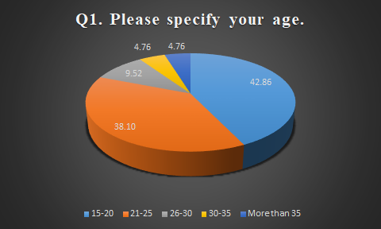
Figure 1: Age
(Source: Excel)
As shown in the above chart, 42.86% of the respondents belong to the 15-20 age group, 38.10% of them belong to the 21-25 years age group. Moreover, 9.52% of the respondents belong to the 26-30 years age group, 4.76% of respondents belong to the 30-35 years age group, and another 4.76%. Therefore, most of the respondents belong to the age group 15-20 and 21-25 who are majorly involved in the learning process.
Q2. Please specify your gender.
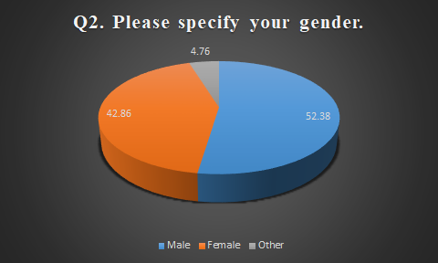
Figure 2: Gender
(Source: Excel)
There are 42.86% female, 52.38% male, and 4.76% non-specified gendered students who have taken part in the survey. The above chart shows the representation of gender specification appearing for the virtual learning process.
Q3. How effective do you think the courses of remote learning are?
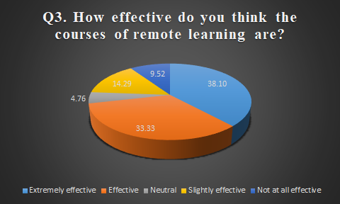
Figure 3: Effectiveness of courses in remote learning
(Source: Excel)
The above chart shows that 38.10% of the students find the mode of learning highly effective. Where 33.33% of the students find it effective, the rest 14.29% find it slightly effective, 4.76% are neutral about the virtual learning process, and the remaining 9.52% find it not effective at all. Therefore, the new way of learning adapted by educational institutes is found effective to conduct in the covid affected circumstances (Bahasoan et al. 2020).
Q4. How far do you agree that virtual learning has a direct impact on students’ engagement in terms of the COVID-19 pandemic?
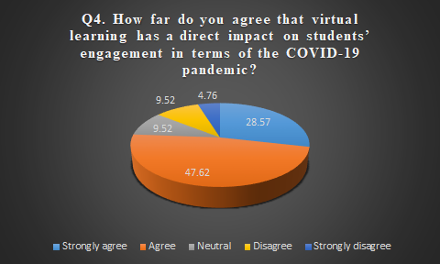
Figure 4: Direct impact of virtual learning on students’ engagement
(Source: Excel)
The survey shows that 28.57% of the virtual learners strongly agree to the fact that virtual learning has created a direct impact on students' engagement, where 47.62% of students agreed to the outcome. However, 9.52% of the students disagreed and 4.76% students strongly disagreed that virtual learning has any direct impact on students' engagement in terms of the COVID-19 pandemic. 9.52% of the students however chose to stay neutral about it. The virtual learning environment created by universities has a direct impact in terms of students' engagement and the engagement level of students has been enhanced (Ryan and Poole, 2019).
Q5. Do you agree that collaboration and inquiry-based learning increase the engagement of students in a virtual learning environment?
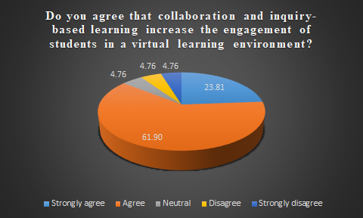
Figure 5: Increase of engagement via collaboration and inquiry-based learning
(Source: Excel)

Here in this chart shows that 23.81% of the students who appeared for the survey strongly agree that collaboration and inquiry-based learning increase the engagement of students in VLE, and 61.90% of the students agreed to it, 4.76% of students strongly disagreed. The same percentage of students disagreed with the outcome, and 4.76% of students stayed neutral. Collaborative and inquiry-based learning provided by universities has increased students' engagement creating a more productive platform for students' knowledge sharing (Della tola et al. 2020)

Q6. How far do you agree that students incorporate intrinsic motivation in online learning?
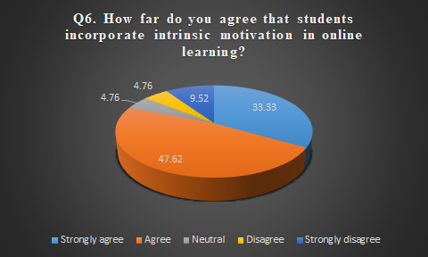
Figure 6: Students incorporate intrinsic motivation in online learning
(Source: Excel)
The above-mentioned figure shows that 33.33 percent of the students strongly agree and 47.62% of students agree that students incorporate intrinsic motivation in online learning. 9.52% of the students however strongly disagreed with the learning outcome, 4.76% of the students disagreed with it, and the same ratio of the survey students stayed neutral. Therefore, universities that are providing effective online education motivates students in intrinsic and individual learning (Rheinberg and Engeser, 2018)
Q7. Do you agree that socioeconomic status can influence students’ engagement on virtual learning portals?
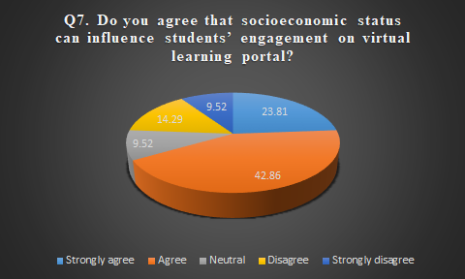
Figure 7: Influence of Socioeconomic Status on students' engagement
(Source: Excel)
The above-mentioned chart shows that 23.81% and 42.86% of the students strongly agreed and agreed to the fact that socioeconomic status can influence students' engagement on virtual learning portals respectively. From the remaining 9.52% of the students stayed neutral, and 14.29% of students disagreed 9.52% strongly disagreed with it. Therefore, the virtual learning methods applied by educational organisations are facing challenges in educating financially affected students where universities need to close the gap in educating students from all socio-economic backgrounds. Students from higher socioeconomic backgrounds are being beneficial with technologies. As they have access to digital tools like laptops, mobile phones, internet access, paid software is creating a great challenge for universities in closing the gap of education among students (Leo et al. 2021).

Secondary research
Engagement of the Students with UWTSDLC through VLE
The UWTSD London campus engages the professional students through various virtual learning methods Recruitment, Selection, and Students’ Eligibility, Social and Extracurricular Activities, Peer monitoring, Teaching, Learning, and Assessment are the most followed VEL techniques used by the University. Due to covid 19 pandemic e-learning method has acquired types of knowledge such as tacit knowledge and explicit knowledge. The detailed knowledge emphasised mental models, personal experience. On the other hand, tacit knowledge focused on organisational productivity and competitive growth. Before the pandemic, there was a debate on acquiring knowledge through codifying, transferring. In this digital generation, Information and communication information has been used to develop tacit and explicit knowledge. Nowadays, a vast number of people use e-learning platforms to do official work.
Through the e-learning communities and management systems, students engaged with the study in the UWTSD London campus. Students adopted online learning on campus and distance mode of learning. This new system is used in all the sectors of different types of subjects. Teachers and students used various technical tools such as gaming tools, 3d worlds, media tools, and other education-related tools to simplify online systems (Djiffouet,2019). The University has adopted a staff Development and CPD Program for developing the learning environment. Students gathered the tacit knowledge through observation and learning with the help of doing, learning with benefit of using, chatting, online meeting. Through the Moodle platform, virtual learning took an important place in the whole world learning system. The online learning platform is developed through the sharable content object model. The video calling lectures became suitable for both on-campus and distance medium students. This process is a perfect solution for boosting up the knowledge of distance mode students. Virtual learning enhances the vital concept of literature through the different types of web-based tools by interaction. The main aim of this learning system is to make durable, reusable, and interoperable the University's education system.
Impact of VLE on the students of the UWTSDLC
Including Distance learners
UWTSD London campus introduced a virtual learning environment to the whole UK rather than the entire world. This has been useful for distance learners to be a part of their learning system. It has also been beneficial for the students to acquire explicit and tacit knowledge through this system. In addition, an innovative approach has been helpful for distance learners to be part of their desired course to grow in their career (Uwtsdlondon.ac.uk, 2020).
Lack of interconnection between peers and students
Having a Virtual learning method has been helpful to many on-campus students. However, there is a lack of attention in the studies that have been seen within students. Students got detached from their education because face-to-face interaction is hampered due to this covid pandemic. Students avoid it due to the lack of innovative or experiential learning (Djiffouet, 2019).
Easy access to VLE resources
This VLE system is easily accessed by students all over the world with students from different backgrounds. Students can experience additional knowledge through online learning tools and platforms.
Slow improvement of academic performance
Lack of performance improvement is a well-known issue that the academy is facing right now. Students are less interested in experimenting with their subjects. For that, the academic performance becomes slow by the student. They cannot acquire the proper explicit and tacit knowledge.
Strategies have been applied by the UK Universities for developing a virtual learning experience.
The UWTSD London campus has implemented different strategies such as facilitating students to access the syllabus, course reading and bibliography services to enhance the virtual learning experience of the students. At present, the University has become significantly conscious of the potential of online technologies and develops institutional strategies to improve the virtual learning experience of the students. In order to promote online learning, the University has taken initiatives to provide the funding for motivating teaching staff to use the online resources in virtual learning sessions. In addition, the University has implemented significant infrastructure to enhance teacher-student communication in the virtual learning sessions. Student engagement is one of the most critical factors to enhance the virtual learning experience in the University.

Effective Planning
The University has developed effective planning to set up the infrastructure of introducing virtual learning for the students. The University has observed that Virtual learning is one of the significant ways to forward the learning experience of educators. The UWTSD London campus has provided funding and proper training to motivate the teaching staff for using the online resources and enhance the e-learning experience in this pandemic situation (Dishman, 2018.). Virtual learning links have been designed to explore the innovative way of learning in the present case. Virtual Field Trips and Virtual Science Labs are used to enhance the interactions between the students and teachers.

Implication of technologies
In order to develop the virtual learning experience, the University has implemented different technologies such as 5G technologies, 3D printing and automation technologies that help enhance the knowledge about the learning topics. Social networking tools, Virtual Learning Environments, including mobile applications, help increase the aspects of virtual learning. VLE can engage the students by providing the learning materials to improve the teaching sessions (Singh et al. 2019). Online applications such as Blends cape and Facebook are easier to access than using VLE.

Increasing the communication
Maintaining the relationship between teacher and student is significantly important that helps enhance the students' learning experience. Communication is considered one of the significant factors that improve engagement in virtual learning. Media such as audio and video can be more engaging than text messages. Implementing these factors can increase the communication between the teacher and students.

Conclusion
The report aims to investigate the impact of Virtual learning on the students of the UWTSDLC. In order to mitigate the aim, a primary survey has been conducted in order to gather knowledge on the research ground. Secondary data analysis has been done in the subjective area with the bottom of the selected topic area. After evaluating the research area, it can be concluded that VLE has been very useful for continuing the learning process in the recent pandemic. However, it has been seen that several issues have been arising in this phase. From the analysis conducted here, it can be said that the VLE has been surrounded with several problems, however it has been the best platform for the learning process in UWTSDLC.

Reference List
Bahasoan, A.N., Ayuandiani, W., Mukhram, M. and Rahmat, A., 2020. Effectiveness of online learning in pandemic COVID-19. International journal of science, technology & management, 1(2), pp.100-106.
Dellatola, E., Daradoumis, T. and Dimitriadis, Y., 2020. Exploring students’ engagement within a collaborative inquiry-based language learning activity in a blended environment. In Emerging Technologies and Pedagogies in the Curriculum (pp. 355-375). Springer, Singapore.
Dishman, L., 2018. Practices of effective online faculty: How to enhance e-learning experience of health administration students. The Journal of Health Administration Education, 35(1), p.95.
Djiffouet, A.L.K., 2019. An Investigation into the Acquisition of Tacit Knowledge in e-Learning Environments: An Experimental Study. University of Wales Trinity Saint David (United Kingdom),p15
Korcz, N., Janeczko, E., Bielinis, E., Urban, D., Koba, J., Szabat, P. and Małecki, M., 2021. Influence of Informal Education in the Forest Stand Redevelopment Area on the Psychological Restoration of Working Adults. Forests 2021, 12, 993.
Leo, S., Alsharari, N.M., Abbas, J. and Alshurideh, M.T., 2021. From Offline to Online Learning: A Qualitative Study of Challenges and Opportunities as a Response to the COVID-19 Pandemic in the UAE Higher Education Context. The Effect of Coronavirus Disease (COVID-19) on Business Intelligence, 334, p.203.
Rheinberg, F. and Engeser, S., 2018. Intrinsic motivation and flow. In Motivation and action (pp. 579-622). Springer, Cham.
Ryan, E. and Poole, C., 2019. Impact of virtual learning environment on students’ satisfaction, engagement, recall, and retention. Journal of medical imaging and radiation sciences, 50(3), pp.408-415.
Singh, R., Gehlot, A., Akram, S.V., Gupta, L.R., Jena, M.K., Prakash, C., Singh, S. and Kumar, R., 2021. Cloud Manufacturing, Internet of Things-Assisted Manufacturing and 3D Printing Technology: Reliable Tools for Sustainable Construction. Sustainability, 13(13), p.7327.
Torres Martín, C., Acal, C., El Honrani, M. and Mingorance Estrada, Á.C., 2021. Impact on the virtual learning environment due to COVID-19. Sustainability, 13(2), p.582.
Uwtsdlondon.ac.uk, (2020) , Transforming Education; Transforming Lives in the Heart of London, Available at: https://www.uwtsdlondon.ac.uk/ [Accessed on 12/8/21]

