Contents page

Page 1 – Contents page

Page 2 – AI Guidance

Page 3 & 4 – PDP

Page 5-10 – Briefing paper

Page 11-16 – Written piece

AI Guidance

I confirm that I have not presented any AI generated text as my own work. I confirm I have copies of my drafts, notes, and other resources I used before, and after the use of AI tools which I may be asked to provide in evidence.

PDP

What do I know already: I have already completed a level 2 safeguarding course as part of my role within the provision
I have taught a small group of children how to communicate the song ‘Little Donkey’ for a Christmas performance. I am keen to develop my ability to communicate with every individual whichever way I can. I use a non-maintained setting curriculum and have areas set up as suggested in the ‘Foundation Phase’ programme but also have the knowledge of the ‘new curriculum for Wales’ and the Four Purposes.
What have I learnt so far: I have learnt how important safeguarding is when working in an Early Years provision. Being able to communicate and develop your communication methods to be inclusive of all children is imperative when working with children. Providing a safe, holistic, engaging environment enhances a child’s experience and helps develop their learning. Also, as cited in the PLEYE review (2017), practitioners should engage in PDP to improve the quality of pedagogical interactions and enhance their knowledge which can significantly benefit children’s learning and experiences (Roger, S et al, 2017).
What do I want to develop: To extend my knowledge and the possibility of enhancing my role within the setting. Develop my ability to communicate via Makaton, this will provide opportunities to communicate with all children in the setting. Enhance my CPD and review it regularly to ensure I provide an excellent Early Years provisions, which will benefit staff and learners.
Objective | Actions (How will I achieve this objective/ what needs to be done?) | Resources (What support and resources are needed to achieve this objective?) | Target Date for achieving objective | Success criteria (How will I know I have achieved this goal; how will I review this?)
Complete level three in safeguarding. | Book and attend a Level 3 (Category C) Safeguarding course. | Use a device to access the internet and complete an online booking form at  https://www.earlyyears.wales/en/event/safeguarding-category-c-online  Ensure a quiet area with paper and pen to take notes. | January 2025 | I will receive a certificate identifying the level I have completed and will review every 3 years.
Develop the ability to communicate through Makaton. | Book onto an online Makaton course and attend each session. | Use a device to access the internet and complete the online booking form at  https://makaton.org/TMC/TMC/Learn_Makaton/Online_workshops.aspx  Ensure access to a device for each session. | September 2025 | I will receive a certificate can further develop onto higher levels.
Learn about what my Early Years setting should look like. | Attend seminars in relation to Early Years. For example, Top tips for setting up an Early Years provision and The Power of Play. I will be required to book onto the required seminars via The National Education Show website. | Use of a technical device and access to the internet in order to book via https://nationaleducationshow.com/cardiff-show-information-booklet-2024/.  The seminars will held in person, so I will need to attend on the required date  The seminars will be part of the National Education Show held in Utilia Arena, Cardiff. There will be many exhibitors’ stalls to access so further knowledge may be gained.  Ask the exhibitors and seminar speakers relevant questions to gain more knowledge on Early Years.  Make notes and collect as much information as possible to enhance the provision. | October 2024 | I will bring any knowledge and experience from the day to develop the provision. I will then review the situation by reflecting on the changes I would need to make.

Reference List:
https://www.earlyyears.wales/en/event/safeguarding-category-c-online

https://makaton.org/TMC/TMC/Learn_Makaton/Online_workshops.aspx

https://nationaleducationshow.com/cardiff-show-information-booklet-2024/

Rogers, S; Brown, C and Poblete, X (2017) A Systematic review of evidence base for Professional Learning in Early Years education (The PLEYE Review) Available at scholar.google.co.uk/scholar_url?url=https://discovery.ucl.ac.uk/id/eprint/10053553/1/Rogers_PLEYE_A%2520SYSTEMATIC%2520REVIEW%2520OF%2520THE%2520EVIDENCE_Nuffiels.pdf: 30/10/2024

Briefing Paper
What is reflection?  Reflection is a process that helps professionals develop and insight into the way they work and a way forward. By thinking analytically professionals can apply their reflection as lessons learned and develop a way of maintaining good practice. According to Barbara Bassot, The Reflective Journal, (Bassot, 2024, p.8) whether a practitioner focuses on problematic experiences or positive ones, reflecting on them will provide them with opportunities for growth and development.  What is reflective practise?  According to Schön ‘reflective practise is the ability to reflect on one’s actions so as to engage in a process of continuous learning.’ However, another view of reflective practise is the development in the way in which professional’s work from real life experiences. (https://libguides.cam.ac.uk) Brookfield 2015, cited in Hallet, 2012, identifies that reflection and reflective practices can help practitioners make informed decisions on whether their own practice and the practice of others is effective or not. | Why is reflective practise important to EY practise?  Critical thought and reflection founded a philosophical debate by Greek Philosophers Aristotle, Plato and Socrates. Two core values of Early Years professional training are reflection and reflective practice. According to Brock, 2015, purposeful reflection needs to be meaningful and relate to a professional work to be most effective.  The importance of using reflective practice in Early Years is to develop and use professional knowledge and skills by interpreting policies that have been developed by bodies, for example, Local Authority or Government, to subsequently modify, enhance and improve a provision for the children and family members. Whilst, also developing the individual’s practice as an Early Years Practitioner.  Gunning (2022).    www.bing.com/reflect
The theory of reflective practise:

John Dewey (1933) is thought to be the founder of reflective practise.
He believed that to reflect on learning you are required to recall an event, ask questions to explore what happened and why. When you have the answers to your questions Dewey suggested you consider possible actions that could give a different outcome from the event.
From his theory of Reflective Practise, Dewey identified two types of action: ‘routine action’ and reflective action’.
Routine Action comes from habit or the reasoning of ‘it’s always been done that way!’. From this practice the actions are less likely to be able to change and a practitioner may be ‘stuck in their ways’ of doing tasks. This could lead to recurring behaviours and outcomes.
However, Reflective Action allows more flexibility of working. Practitioners are more likely to be concerned with understanding why sometime is occurring or recurring and will be willing to make changes depending on the outcome.

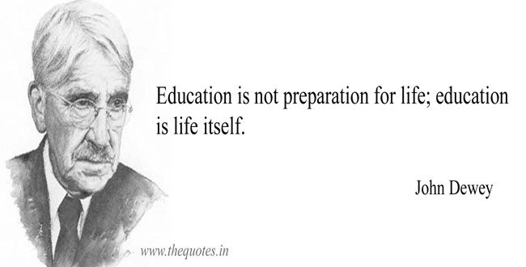
This Photo by Unknown Author is licensed under CC BY-SA-NC
www.bing.com/johndewey
Donald Schön (2007) like John Dewey also had two processes of Reflective Practise. His theory suggests a practitioner should use ‘reflection in practice’ and reflection on practice’
Reflection in practice requires practitioners to be flexible as they would be reflecting on the work or activity they are currently participating in and make changes as required. This is very similar to Dewey’s Reflective action.
However, the similarity in practices ends there as Schön’s reflection on action requires a practitioner to reflect after they have completed the task or activity and make changes of improvement.
Both theorists have carried out many investigations on their theory and have developed their processes. Some may say for the better however, others may not always agree with those statements.
As cited in The Reflective Early Years Practitioner, 2012, Moon (2006) suggests that ‘being a reflective practitioner is a characteristic of a person’s behaviour rather than an intellectual activity’.

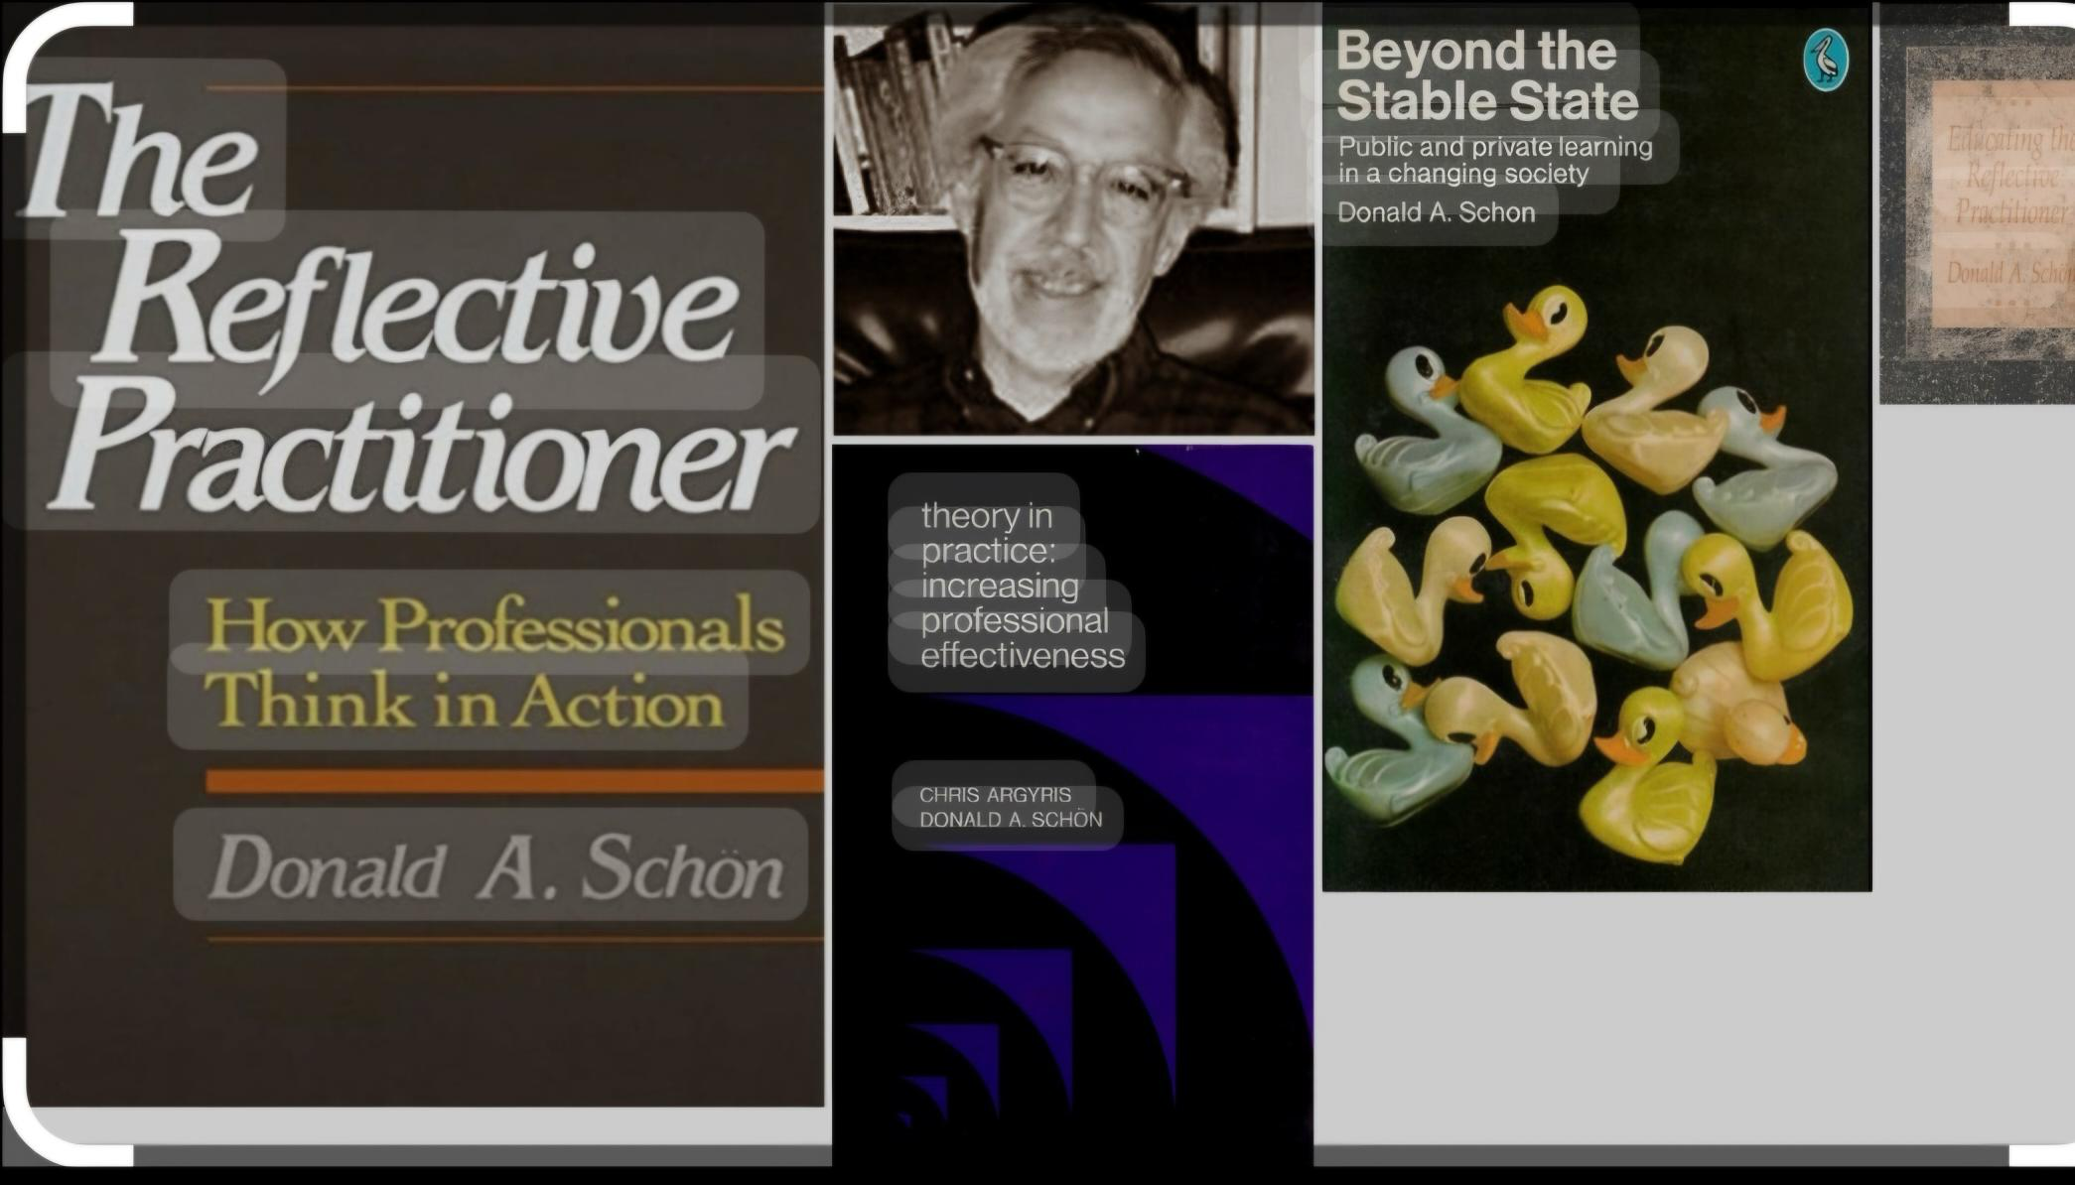
www.googleimages.com/donaldschön
ERA cycle  Experience  ç  ç  Reflection  Action | Driscoll’s model of reflection  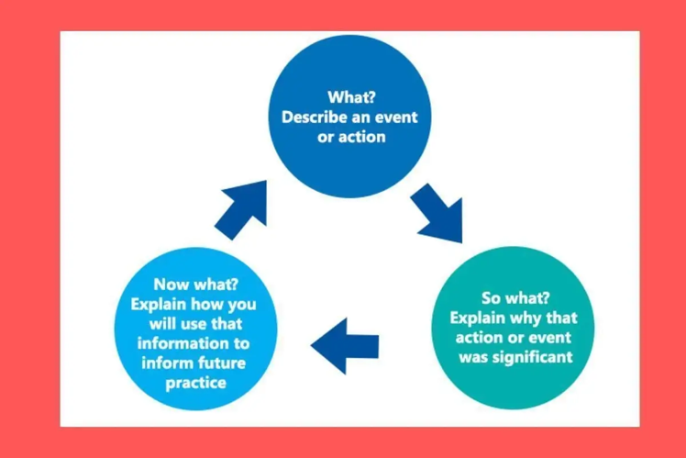  www.googleimages.co.uk/driscoll’smodelofreflection
Analysis of models
As seen in the images above ERA cycle (Jasper, 2013) and Driscoll’s model of reflection look similar. One noticeable similarity is that they both have three stages.
Although the wording on each model is different, it could be argued that they both mean the same. ERA cycle’s wording is brief whilst Driscoll provides a short explanation to develop on what is happening. Driscoll’s stages were developed in the mid 1990’s and based on the 3 What’s questions of Terry Borton in the 1970’s.
Both end with an ‘action’ stage. The ‘action’ stage of ERA’s cycle will depend on the practitioner’s experience and results in another experience and the cycle will continue. Driscoll’s ‘Now What?’ stage asks the practitioner to explain if there is anything they would change for their future practice.
There are many advantages and disadvantages of using a model when reflecting on your practice.
As a practitioner is may be beneficial to use a model, it offers a structure and a starting point when considering your practice. However, some of your experiences as a practitioner may not require the model to reflect as they do not always apply to every situation.
When reflecting on certain situations using a model allows you to assess all levels and when you have identified an ‘action’ you are more aware that the process is complete. However, when reflecting your practice in Early Years, this should be a continuous process. When an action is identified the process would start again as you reflect on the next situation. Also, a disadvantage of the models of reflection is having to follow the stages in a defined way. When using a model of reflection, a practitioner should consider which model best suits their practice.
https://libguides.cam.ac.uk
Conclusion
As an Early Years practitioner reflecting on one’s practice is an important tool to self-improve and develop. A practitioner can enhance their provision by learning from their reflections and the pedagogy can be gained and built upon.
Reflective practice is a skill an Early Years practitioner should develop by identifying models of reflection that best suits their needs. There is a possibility that practitioners unintentionally reflect on their practice using a model, however, are unaware that they are following a model as they are working to their best practice. Practitioners can enhance their own continuous professional development by identifying skills or knowledge they require. Opportunities to reflect on one’s practice will lead to active learning which will enable effective practice to any Early Years provision.
https://www.teachearlyyears.com/cpdview/reflective_practice_part_2

Reference List:

Bassot, B. (2024) The Reflective Journal. 4th Edition. London: Bloomsbury

Brock, A. (2014) The Early Years Reflective Practice Handbook. London: Routledge

Gunning, C. (2022) Reflective Practice. https://www.earlyeducation.com (accessed: 30/10/2024)

Hallet, E. (2012) The Early Years Practitioner. London: Sage Publications

https://www.cambridge-community.org.uk/professional-development
accessed on 29/10/2024

https://libguides.cam.ac.uk/reflectivepracticetoolkit
accessed on 29/10/2024

https://libguides.hull.ac.uk/rteflectivewriting/reflection1a
accessed on 29/10/2024

https://www.teachearlyyears.com/cpdview/reflective_practice_part_2

Rogers, S; Brown, C and Poblete, X. (2017) A systematic review of evidence base for professional learning in Early Years education (the PLEYE review)
Available at: scholar.google.co.uk (accessed: 30/10/24)

Schön, Donald A (2016) The Reflective Practitioner: How professionals think in action. London: Routledge
Available at: https:// doi.org/10.4324/9781315237473 (accessed: 29/10/24)

Virmani, Elita Amini; Hatton-Bowers, Holly; Lombardi, Caitlin Mcpherran; Decker, Kalli B; King, Elizabeth K; Plata-Potter, Sandra I; Vallotton, Claire D. (2020) Early Education and Development. London: Routledge
Available at: doi 10.1080/10409289.2020.1798718 (accessed: 29/10/2024)

www.bing.com/johndewey

www.bing.com/reflect

www.googleimages.com/donaldschön

www.googleimages.co.uk/driscoll’smodelofreflection

Written Piece

Introduction.
Professionalism and professional practise have been debated for many years. Perez (2019) recognises professionalism as ‘attitude based’ on one’s social and behavioural characteristics. Perez suggests becoming a professional is the responsibility of the individual to develop their ‘professional self-image’. (Perez, 2019). In early years it is believed that professionalism is underpinned by values that lead to skills, knowledge and the ethics required to work within a setting. However, McGillivray (2008) emphasises that ‘professional identity’ is contributed to by traditional beliefs, ideology, training, qualifications and assessment. (McGillivray, 2008). When working within early years, as mentioned in Article 3 of the United Convention on the Rights of the Child (UNCRC), having the best interest and welfare of the child is paramount. This is regardless of a practitioner’s experience or qualifications.
Early Years Practitioners (EYP) should identify values to work with children. Values are qualities that govern a person’s behaviour. They help to develop professional identity, help professionals know and develop the whole child through their individual needs, develop an understanding of working collaboratively with families and multi-agencies and contribute to recognising how to safeguard the children and families’ practitioners work with. Many values of EYP have been identified and debated. An example of some values identified by Powell (2010) are ‘a genuine liking for and interest in children and their development, good communication skills, confidence, a helpful, caring and understanding nature and a commitment to undertake training’. According to Brock (2012), principles are based on a person’s values and identified as knowledge, skills, qualifications, training and professional development. They discuss 7 interrelated dimensions of professionalism, identified above are 3 of the 7. These were based on a study in England that examined 12 years educators’ personal reflection of their professionalism. ‘Their perceptions of children’s needs were at the heart of their professionalism, and they interpreted policy and curriculum in ways that they believed met those needs.’ (Brock, 2012). When working within Early Years is it important to ensure a child is at the centre of everything you do. Bronfenbrenner’s model (1979) places the universal child at the centre of concentric circles of influence and demonstrates the significance of policies and events that impact children and their families. (Brock, 2015, pg. 83).
Early childhood has been impacted by politics for several decades. There has been discussions and policies produced that shape children’s and their families daily and future lives. This has evolved by research and awareness of the significance of the first five years of life for intellectual, social and emotional development. Developing policies is continually undergoing revision and change – due to knowledge developed from research and practice; also, due to economic and political ideologies. An economic recession has previously resulted in a reduction in funding for early years services. This affected many social, political and cultural influences on how professionals work and how they develop their professional development. Access to funding resulted in less training and development of practitioners’ values and ethics. This policy change had a significant impact on children and their families. Another influence that has been debated by those who working within early years, is communication. Effective communication in early years is vital to develop relationships. A child’s ability to share experiences that support personal, social and emotional development as well as early literacy skills. This could lead to successful learning in all areas. As an EYP developing one’s skills with theoretical knowledge and an understanding of a child’s qualities ‘produce the optimum professional, dedicated to best practice.’ (Gasper,2015) Developing listening skills; repetitive language and asking questions are a few ways to develop communication. (Department of Education, 2024). As cited on Nursery World, The Effective Provision of Pre-School education (EPPE) research found that a consequence of a child’s poor communication skills leads from a poor home learning environment. This had ‘twice as much influence as the early years setting on academic outcomes at age 11. However, it was found that where a child had a poor home learning environment, but attended a high-quality setting, can make a difference.’ (Nursery World, 2011). As a result of continued ineffective communication skills, could lead to the inability to communicate as an adult, which can affect how a person processes and understands information. There could be a diagnosis of a disorder or an undiagnosed disorder that may require further treatment for a person to communicate effectively in their own way. (Healthline, 2021).
In Wales, all children have contact from birth with a range of health professionals – midwife, general practitioner, health visitor and dentist. There may be occasions when children may require specialist intervention from paediatricians, dieticians, or speech and language therapists. Many children will experience care with childminders, EYP in community settings in Parent and Toddler groups and nursery nurses in day care settings. Most children access the education system in a Nursery Class within a Primary School. Some may be educated in the independent sector or be home educated. There are occasions when children may have interventions with further multi-agency workers from social services and may experience social workers, outreach workers, police officers and lawyers (Brock, 2011). In some areas of Wales, there are projects such as Flying start. This programme is interagency working to meet needs of children under three years of age and their families. It provides early years practice and integration of family support services to improve outcomes for children and give them a ‘Flying Start’ in readiness to commence school. However, this programme is not available to all children in Wales. According to Bridgend.gov.uk, to check your child’s eligibility, you must provide your postcode within your Council’s website.
As an EYP, an important part of the role is to observe children whilst they play. Observations may be carried out for various reasons, it should always be considered, ‘why?’. Observations allow a practitioner to gain pertinent information. Depending on the reason ‘why?’ will allow a practitioner to choose the best observational technique to gain the information they require. For example, a ‘Magic Moment’ observation is a brief observation where you observe a child’s first step unaided or a child’s interest in linking toys together. This observation type could be recorded on post it notes. However, if a practitioner required information on where a child plays or who they play with, they may choose to use the ‘time sample’ observation. This can be brief periods of observation but require the practitioner to observe a child every five minutes over a set period, possibly an hour or more. Choosing a technique to use will depend on the time you have available and the reason for the observation. It is essential to use a range of observational methods to gain a breadth and depth of knowledge about children. Similarly, practitioners will observe through their own lens of experiences and may record differently to others depending on their knowledge base. Observations are vital in identifying whether children are developing and progressing appropriately or whether there are any developmental delays or children require any additional support. Likewise, observations play a crucial role in the safeguarding process and identifying changes in behaviour or appearance that may require further assistance to raise a concern.
‘Effective observation enables us to analyse what we see and hear, and to respond in ways that will help children make progress. We should use these observations to inform current and future planning in our setting. Our observations may be planned and specific; they may be timed over a period or be spontaneous occurrences when something new or significant is noticed. Using a range of observation techniques will ensure that we obtain detailed understanding of each child’ (Welsh Government, 2008).
‘In 1989 the United Nations Convention on the Rights of the Child (UNCRC) afforded all children the same range of civil, political, economic, social and cultural rights and was adopted worldwide by governments.’ (Brock, 2014) The UNCRC is an international treaty that outline’s children’s rights under three main characteristics:
The right to provision (health and education services)
The right to protection (right for protection from violence)
The right to participation (being part of decisions made that affect the child).
The UNCRC came into force in the UK in 1992 and it provides details of what every child requires to have a ‘safe, happy and fulfilled childhood, respecting the dignity and worth of each individual, regardless of race, gender, language, religion, opinions, wealth or ability.’ (Brock, 2014). Young children are linked to a family unit. The UNCRC recognises and supports parents and families and their crucial role and responsibilities for protecting and caring for children to ensure good values and standards (articles 5 and 18). When providing a safe and secure service to children and their families, ‘we need to keep in mind three aspects; the child as an individual, their environment, and the socioeconomic culture which surrounds the child and family’ (Siraj-Blatchford et al, 2012, cited at childreninwales.org.uk).

Conclusion.
Professionalism reflects the attitude of a professional who is willing to participate in training. In early years there is an understanding of the importance for individuals to demonstrate in practice their skills and knowledge, with or without formal qualifications. Many curriculums or National Minimum Standards (NMS) highlight the importance of EYP in supporting the holistic development and education of young children, as the first five years of a child’s life are a critical time of learning and development. In Wales settings are required to follow the NMS to gain registration to provide a quality provision. Practitioners working with children should be observing them every day as part of regular practice. The UNCRC has 54 articles that cover all aspects of a child’s life and set out the rights that all children are entitled to. As an EYP you should be aware of how adults and governments must work together to make sure all children can access all their rights.

Reference List:

Brock, A. (2012) Building a model of early years professionalism from practitioners’ perspectives. Journal of Early Childhood Research 11(1) 27–44 Building a model of early years professionalism from practitioners’ perspectives (sagepub.com)

Brock, Avril. (2014) The Early Years Reflective Practice Handbook, Taylor & Francis Group. ProQuest Ebook Central, https://ebookcentral.proquest.com/lib/trinity/detail.action?docID=1744144.

Department of Education (2024) Interactions. Available at: https://help-for-early-years-providers.education.gov.uk/communication-and-language/interactions (accessed on 1/11/24)

https://www.bridgend.gov.uk/flyingstart (accessed on 1/11/24)

https://www.childreninwales.org.uk/professionals/our-work/early-years/ (accessed on 1/11/24)

https://www.healthline.com/communicationskillsanddisorders (accessed on 1/11/24)

https://www.nurseryworld.co.uk/content/features/learning-development-communication-part-2-friendly-places/ (accessed on 1/11/24)

https://www.teachearlyyears.com/nurserymanagement (accessed 1/11/24)

McGillivray, G. (2008) ‘Nannies, nursery nurses and early years professionals: constructions of professional identity in the early years workforce in England’, European Early Childhood Education Research Journal. 16 (2) pp 242-254.

Perez, R. (2019) ‘What Does It Mean to Be a Professional?,’ Professional Case Management. 24 (4) pp 212.

Powell, S. (2010). Hide And Seek: Values In Early Childhood Education And Care. British Journal of Educational Studies, 58(2), 213–229. https://doi.org/10.1080/00071001003752195 (accessed on 1/11/24)

Welsh Government (2008) Early Years Framework: Observing Children https://gov.wales/files (accessed on 1/11/24)

