Reflective Review Of Leaning Journey

Shahidur Rrahman 1805959

Professional Career Development
BMSK4005

Contents
1
Introduction 3
FINDINGS: 4
SWOT ANALYSIS 4
Personal SWOT Analysis 5
GO MAD 11
Personal GO MAD 12
Personal Development Plan (PDP) 13
Conclusion 14
Bibliography 14

Introduction

Professional development is a vital part of my career success as this will make me competent in any profession. Help to enhance and extend ability, skills & construct realistic career and personal plans.
Various skills are required to work effectively within a profession. Skills such as: time management, critical thinking, research, quantitative skills, analytical skills, group working, self-awareness, independency, communication skills, presentation skills & I.T skills are transferable skills which will make me employment ready. (Confederation of British Industry/Universities UK, 2009). They are also skills for lifelong learning, in order to meet the market demand
Within this report I will reflect and re-evaluate my learning journey of professional career development, demonstrating & explaining learning styles. Apply a personal SWOT analysis & Johari Window from which I’ll set SMART objectives completing a GO MAD framework & how to achieve a personal development plan.

FINDINGS:

SWOT ANALYSIS

Sarby (2016, p.3) suggested ‘SWOT is a popular 4-box strategy analysis & strategy development framework’.
SWOT has been around for decades & is the most widely used strategy in modern times.
The acronym SWOT is derived from: Strengths, Weaknesses, Opportunities & Treats.

Strengths:
Strengths are internal & supportive in respect of SWOT objectives. Strengths are factors that support an Opportunity or overcome a Treat.
Weakness:
Weaknesses are internal & damaging in respect of the SWOT objective. Weaknesses are factors that result in being unable to take advantages of an Opportunity & vulnerable to Treat.
Opportunities:
Opportunities are external & supportive factors over which we have no control but could be helpful. Opportunities arise from many sources.
Treats:
Treats are external and damaging factors over which we have no control. Treats are also tangible or intangible.

Personal SWOT Analysis

STRENGTHS  - Independent  - Multi-tasking  - Teamwork  - Confidence  - People motivated  - Communication skills  - Networking (catering industry)  - Ability to learn  - Completed the Duke of Edinburgh | WEEKNESSES  - Need inspiration  - Patience  - Un-organised  - Time management  - Lack stress management  - I.T skills  - Essay / Academic writing
OPPORTUNITY  - Alternative Job requiring less commitment  - Study skills & tutorial support is available  - Reading a book on how to organise myself  - Regularly talking with positive people for inspiration  - Student loans & financial grants are available  - Studying academic & employability will enhance time management  - Professional career development can help me with assignment management  Peer & family support | TREATS  - Current Job requires to many hours & commitment  - Stress relating to time management  - Struggle with assignments need additional support on essay/ report writing  - Financial stress can demotivate me

Knowing what my positive & negative is extremely important, this will help me reflect upon skills to develop, rather than do the things as I always have.

JOHARI WINDOW

The Johari Window is a method which helps individuals to explore themselves & acknowledge what understanding others have about us. This formula was created by J Luft & H Ingham. (Luft & Ingham, 1955).
I have used the Johari Window on myself to identify & understand areas that are blind, unknown to establish areas of self-awareness & professional development.

Personal Johari Window
 | Known By Self | Unknown By Self
Known By Others | Open Area  - Able  - Kind  - Accepting  - Friendly  - Helpful  - Brave  - Confident | Blind Area  - Intelligent  - Observant  - Clever  - Cheerful  - Energetic  - Amusing  - Dependable
Unknown By Others | Hidden Area  - Spontaneous  - Sentimental  - Trustworthy  - Dignified  - Leadership | Unknown Area  - Logical  - Religious  - Proud  - Resourceful

Having completed the Johari Window I’ve identified various areas which were hidden & unknown to me, now I can pick up & reflect on areas which I wasn’t aware of using a leaning cycle that I have been taught on my current course.

HONEY & MUMFORD LEARNING STYLES
Honey & Mumford (1992) developed a structure of learning that divided people into four distinct learning styles or preferences Activist, Theorist; Pragmatist & Reflector. This was based upon the work of Kolb.
The characteristic of the four learning styles are summarised below:
ACTIVIST:
Those people, who learn by doing, work in flexible & spontaneous ways. Take an open minded approach to learning, involving themselves fully without bias in new experiences.
THEORIST:
These learners like to understand the theory behind the actions; they grasp attitude of a perfectionist & like concrete information to think logically, prefer to analyse & synthesise before drawing a logical theory.

PRAGMATIST:
Learn by ‘trying things out’ to see if they work, they like to be practical & realistic, they prefer just getting on with things. Totally energetic & love to experiment new ideas.

REFECLTORS:
Prefer to observe & reflect, they like to stand back & view everything from different angles. They consider all methods & alternatives before making any decisions.

Learning Styles developed by Honey & Mumford (1992)
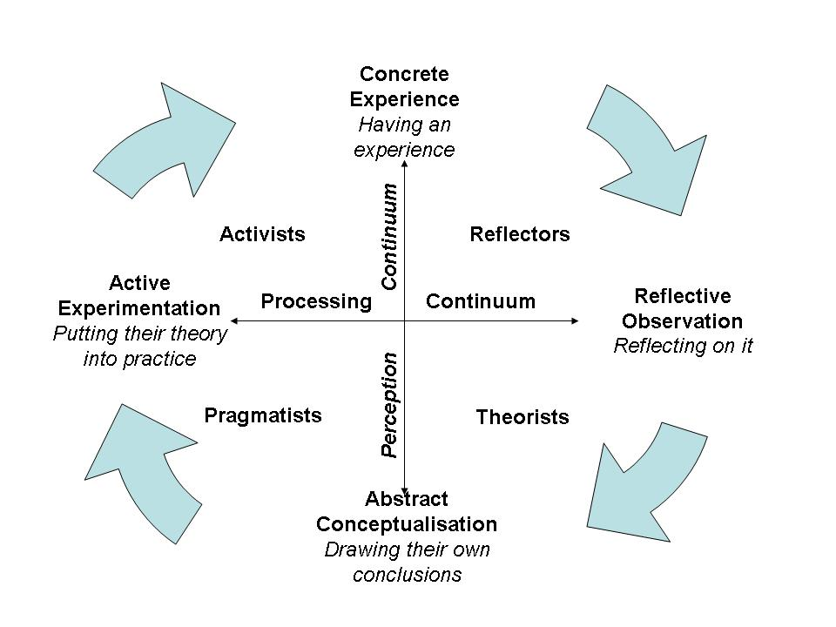
I have completed the learning styles questionnaire. With help from scoring & interpreting the learning questionnaire, my strong learning preference matches Activist & Pragmatist. Having considering the results & evaluating myself, these are the best learning styles to reach my full potential.
Personal Scoring Results

Activist summary of strengths:
- Accepting & variable
- Content to experiment
- Content to raise to new situations
- Confident to undertake new things & styles
- Comfortable with alteration

Activist summary of weaknesses:

- Habit of acting instantaneous without thinking
- Often take unnecessary possibility’s
- Charge into action without preparation
- Like attention s therefore tend to put too much pressure on myself
Pragmatist summary of strengths:
- Keen to sample things in practice
- Pragmatic & realistic
- Professional getting straight to the point
- Procedure orientated
- Comfortable with change
Pragmatist summary of weaknesses:
- Enthusiastic to decline without obvious application
- Not keen on conjecture or basic concepts
- Tend to apply the first solution, rather than rethink
- Anxious
- Regret unnecessary requirements

Analysing the strengths & weaknesses the preferred methods of learning according Honey & Mumford (1992)
- Brainstorming
- Problem solving
- Group discussions
- Role-play
- Case studies
- Time to think about how to apply learning in reality
Kumar, R & Pande, N (2018) Assessing learning styles preferences of working professional cohorts in India: an empirical study using Honey & Mumford learning styles questionnaire.

VARK
Fleming & mills (1992). Developed the VARK questionnaire, a small design to determine which learning style best helps an individual learn information efficiently. The theory was there are four ways to learn: Visual, Aural, read/write & kinesthetic.
The VARK questionnaire pin points which of those four I use the most when learning new things, so that I can utilise it to the fullest potential.
Van Blerkom,D.L (2009) Empathised on a strategy called mapping, creating visual diagrams or representations of written & oral information from a concept map by seeing it, Kinesthetically be able to remember the information on how it felt or how I created it, will also benefit from experiments & recalling self tests.
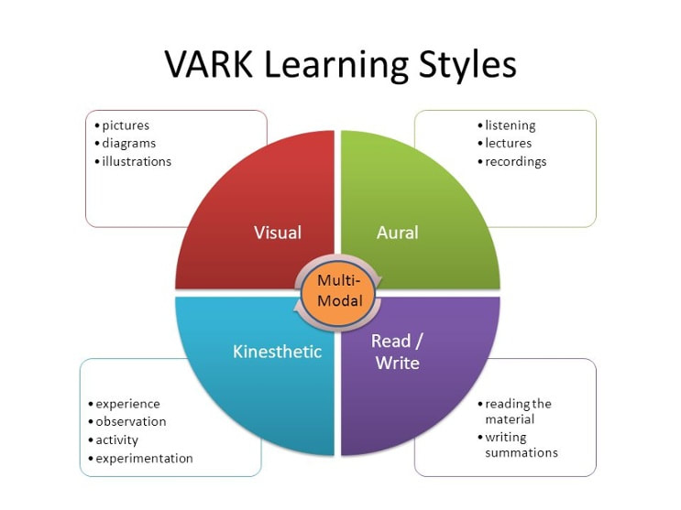

Visual:
Learners prefer to the use of images, maps & graphs to understand new information.
Auditory:
Learner’s best understand new contents by listening & speaking during lectures & group discussions. Aural learners use repetition as a study technique.
Read & Write:
Students with a strong reading writhing preference learn best through words. These students are able to take notes effectively holding ability to translate abstract concepts in to words & essays.
Kinesthetic:
Learner’s best acknowledge information through representation of information & by practical experiences.
Flemimg,N & Baume,D (2006) stated VARK is not just a learning style questionnaire, but a form of communication questionnaire which allows one to discover the best way of learning as a student, the ways you learn & the ways your thought during lectures.
By applying the following techniques I’d maximise learning information visually:
- Use pictures, videos & sides
- Flow chats
- Text books with diagrams & pictures
- Graphs
- Underlining words with highlighters
By applying following techniques I’d maximise learning information aurally:
- Attend lectures
- Discuss topics with peers
- Discuss topics with study skills support
- Explain the overheads, information & other visuals to someone
- Leave space in lecture notes, later recalling & adapting.
Having completed the VARK questionnaire my strengths of learning lay between visually & aurally.
Personal VARK questionnaire

Vince,R. (1988) ‘ Discusses Kolb’s learning cycle, the author considers the importance’s of the cycle with mainstream education & development & then takes a critical view, looking both behind & beyond the learning cycle at issues that can be developed’.
David Kolb’s experiential model of learning (Kolb,1984) from which he developed his learning cycle & allows individuals to reflect & understand individual needs.
Applying Kolb’s learning cycle on the two questionnaires I have completed helps me identify & reflect on my strengths & weaknesses.

GO MAD
Andy Gilbert & Ian Chakrvoty developed the GO MAD thinking model system which helps businesses & individuals improve & transform them self by using their leadership thinking skills.
To create an accurate & précised GO MAD frame work I will implement SMART objectives to define my & set my goals.

SMART
- S – Specific
- M – Measurable
- A – Achievable
- R – Relevant
- T – Time-bond

Personal GO MAD
Take Action & Measure Results (7)
- Achieve certificate in higher education
- Complete by august 2019
- Start BA Hon’s in businesses management September 2019

Self Belief (4)  - Ability to learn  - Independent  - Academic reflection  - Self-awareness  - Confident  - Communication skills  - Willingness | Personal Responsibility (5)  - Use learning styles to maximise potential  - Complete additional learning/reading  - Time management | Involve Others (6)  - Study skills  - Fellow peers  - Lectures  - Influential people  - Family
Reasons Why (1)  - Gain qualifications  - Self-management  - Advance study skills  - Enhance job prospective  - Professional career  - development | Define Goals (2)  - Complete professional career development course  - Expand personal & professional Portfolio  - To complete BA Hon’s in business management | Plans &Priorities (3)  - Attend all lectures & tutorials  - Reduce work hours to maximise learning  - Control of financial balance  - Family plans expecting new edition to family April 20019

Personal Development Plan (PDP)
After taking a PDP rate yourself quiz on study skills & only scoring 46 out of a maximum 75 I’m aware there is plenty room for improvement. Few areas which I would specifically like to improve are:
- Essay writing
- Time management
- Report writing
- Critical thinking skills
- Reading skills
Skills/Behaviour | Actions Needed | Resources Needed | Dates For Action | Date For Review | Asprirational Goal (SMART)
Report Writing | Practice academic writing, paraphrasing & referencing.  Practice previous or mock assignments. | Study skills.  Attend tutorials.  Online resources.  Books on essay writing/referencing. | Practice writing every Sunday.  Every Tuesday choose a case case study to paraphrase & reference. | 10th December complete mock assignment & get feedback. | I want a 50% pass mark on my second assignment.  I’ll use feedback from mock assignment to achieve this.
Reading Skills | Read at least 10 pages of info three nights a week.  To understand & gain more knowledge. | Books.  Online resources.  Hand outs.  Library.  Study skills. | Three nights a week.  Starting 10/11/2018.  Monday/Wednesday & Friday. | 08/12/2018  08/01/2019 | Every night read some information or text.  I’ll explain to family members or fellow peers to evaluate my understand.

Conclusion
After 6 weeks of learning & try complete this report on professional career development has been very difficult for me, as I’ve been out of academic learning for over 20 years. However the learning styles & reflective methods are excellent & will allow me to pick up on strengths & weakness best suited to my personal learning styles. Being able to use SWOT analysis, SMART objectives & using GO MAD will help recover my very best inner self.

Bibliography
Bayne, R. (1997) The Myer-Briggs The Indicator: A Critical Review & Practical Guide, Cheltenham: Nelson Thornes Ltd.
Cotterell, S. (2015) Skills for Success Personal Development& Employability (3rd Ed). London: Palgrave.
Gilbert, A. & Chackrovaity, I. (2001) ‘Go Mad About Coaching’ Bath: Bathpress.
Honey,P. & Mumford, A. (1992) The Manual of Learning Styles (3rd Ed). Maidenhead: Peter Honey.
Kurmar, R. & Pande, N. (2018) ‘Inderscience online’, International Journal of Indian Culture & Business Management, vol 16 (3), (2, March), [online].Available at: http://www.inderscience.com (accessed: 30 October 2018).
Maund, A. Schriek, M. & Tinkler, P. K. (2017) Certificate in Higher Education: Skill for the Workplace Student Year Book. London: Sage Publications.
Peter, M. (2017) Business Student’s Guide to Study & Employability. London: Sage Publications Ltd.
Pears, P. (2016) Cite Them Right (10th Ed). London: Palgrave.
Sarby,A. (2016) Swot Analysis. England: Spectaris Ltd.
Stella, C. (2015) Skills for Success. London: Palgrave.
Van Blerkom, D.L. (2009) Orientation to college Learning.6th Ed. Wandsworth: Cengage Leaning.
Vince,R. (1998) ‘Behind & Beyond Kolb’s Learning Cycle’, Journal of Management Education, 22 (1 June) pp.304-319, [online]. Available at: http://www.reseacrchgate.net (accessed: 7 November 2018)

