Lidl’s Competitive strategy

Introduction
In this report, I will be looking to identify what strategy Lidl has been implementing in order to gain a competitive advantage. I will analyse some of the companies actions in attaining this strategy and assess what impact it has had on the company itself. I will also be critically analysing the strategy and model used and looking to provide recommendations in Lidl’s future activities and whether this particular strategy is benefitting them.

Lidl is a German food retailer whose origins date back to the 1930s though its first store officially opened in 1973 in Ludwigshafen, Germany ("Grocery Store | Low Prices | Lidl US", 2019). Expanding outside Germany in the 1990s they now operate in 32 countries and employ over 280,000 people. The company is a grocery store that mainly sells its own private label products. Lidl explain in their own website that their mission is to provide high quality at low prices ("Grocery Store | Low Prices | Lidl US", 2019). They state that as well as food they aim to offer a diversified product assortment that change on a fortnightly basis. In 2018 Lidl made a turnover of 474.5 million pounds in the UK alone ("Turnover of Lidl supermarket 2012-2018 Statistic | Statista", 2019).

Before looking at the strategy Lidl has employed its necessary to define some key concepts. Strategy in business terms can be described as actions and decisions a business employs to reach its goals. Another concept we need to define is competitive advantage, this is what Wen-Cheng describes as when a firm delivers the same benefits as competitors but at a lower cost (Wen-Cheng, Chien-Hung & Ying-Chien, 2011).
The model that I will be looking at is the Cost leadership model in Porters Generic strategies.
When we look at Lidl’s success in their industry it is appropriate to identify what kind of strategy they have been employing to achieve this. By analysing their activities over the years we can see that their strategy identifies with what Porter describes as “cost leadership”. In a model that has come to be known as Porter’s generic strategies, Michael Porter outlines four competitive strategies, Cost leadership, Differentiation, Cost Focus and Differentiation Focus (Porter 1985). Ritika Tanwar details that Porter’s model looked to benefit from firms with either a high market share or low market share in order to gain a competitive advantage, by pursuing supply side strategy of low costs or through product differentiation (Tanwar, 2013).

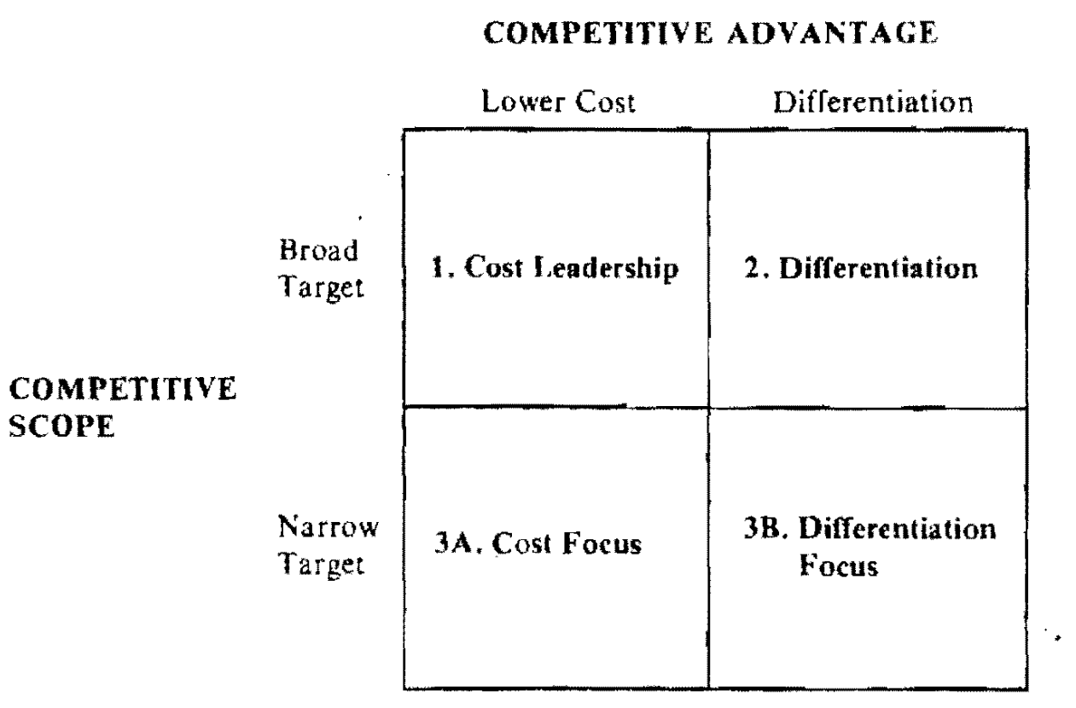
Figure 1.1: Porters Generic strategies (Porter, 1985)
The above diagram taken from Porter’s book shows the four strategies that Porter identifies (Porter 1985). The strategy that Lidl seem to have adopted is “Cost Leadership”, utilising lower costs and targeting a broad market.
Main Body
Porter details that the fundamental idea behind the cost leadership strategy is to produce at lower prices than rivals and translate the cost advantage into higher returns.

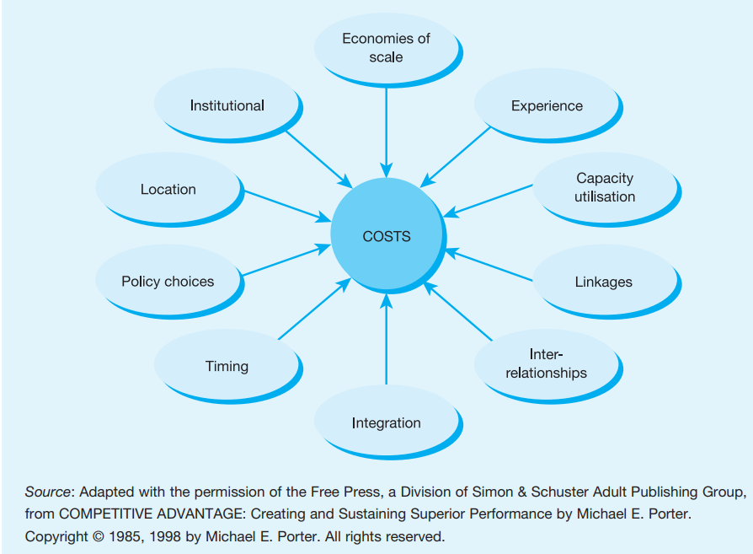
Figure 1.2: Cost driver (Hooley et al., 2008)
The above diagram is taken from a Pearson textbook (Hooley et al., 2008), it shows us what Porter termed as “cost drivers” (Porter 1985), factors that effect a firms costs. The foundation for attaining the necessary competitive advantage is achieved through economies of scale, increasing efficiency through experience, capacity utilisation amongst other drivers. The aim of this approach is ultimately to minimise the unit cost of production. Once a low unit cost is achieved, the firm will aim to sell this product in a market with similar products but at a much lower price. This will effectively be a form of differentiation for the product in a market which consists of typically similar products.

Implementation of the strategy

Lidl themselves detail on their website that their focus is to have a less complicated process that enables low prices by focussing on their own brand products Germany ("Grocery Store | Low Prices | Lidl US", 2019). They explain that they keep their overheads at a minimum to eliminate costs. In comparison other supermarkets offer products from a range of different brands to provide customers with choice. However this means that they have less control over the overheads of that product and as a result aren’t able to offer the lower prices that Lidl does with its private brand products.
In a survey of 12,000 shoppers, Lidl and similar competitor Aldi came above the UKs big four supermarkets in terms of popularity ("Asda has come bottom in a new supermarket satisfaction league table", 2019). This shows the success that Lidl has had implementing this strategy.
Crititque of the strategy
Duica describe that one of the main advantages of a cost leadership strategy is that it protects the firm against rival companies, strong clients and providers (DUICĂ and DUICĂ, 2014). When rival companies exhaust their resources, the company can still achieve profits due to low costs. Strong clients can not force their hand unless they find a lower price elsewhere, and strong providers will have less power in negotiations with a market leading company.
Tanwar states that firms pursuing a low cost strategy tend to struggle to maintain a competitive advantage and end up in price wars (Tanwar, 2013). He says that instead firms look to adopt a best cost strategy where they aim to provide the best value for a comparatively low price.
One of the most common criticisms of Porters cost leadership stategy is that there is not necessarily a trade off between differentiation and cost leadership. Datta explains that product differentiation through higher quality and uniqueness can also lead to a firm attaining market share leadership and is a more profitable advantage, and as a result can put them in a position to be able to keep their costs the lowest (Datta, 2010). He also criticises the model being built on two dimensions; differentiation and scope, when differentiation can be achieved through different strategies including controlling price.

Conclusion
In conclusion we can see that the cost leadership strategy has certainly been successful for Lidl as their popularity and market share seem to continue growing. However we can not ignore the fact that Lidl compete vigorously with their rivals Aldi which stops them from being able to be a true market leader

For Lidl to grow further it would be wise of them to employ further marketing techniques to build their popularity and overcome their rivals which would also in turn allow them to keep overhead costs of their products the same .

References

Grocery Store | Low Prices | Lidl US. (2019). Retrieved 3 December 2019, from https://www.lidl.com/about-us

Grocery Store | Low Prices | Lidl US. (2019). Retrieved 3 December 2019, from https://www.lidl.com/about-us#principles-and-values

Turnover of Lidl supermarket 2012-2018 Statistic | Statista. (2019). Retrieved 3 December 2019, from https://www.statista.com/statistics/919806/lidl-turnover-in-the-united-kingdom/

Wen-Cheng, W., Chien-Hung, L., & Ying-Chien, C. (2011). Types of Competitive Advantage and Analysis. International Journal Of Business And Management, 6(5). doi: 10.5539/ijbm.v6n5p100
Porter, M. (1985). Competitive advantage. London [New York]: Free Press.

Hooley, G., Piercy, N., Nicolaud, B. and Saunders, J. (2008). Marketing strategy and competitive positioning (4a. ed.). Harlow: Pearson Educación.

Tanwar, R. (2013). Porter’s Generic Competitive Strategies. IOSR Journal of Business and Management, 15(1), pp.11-17.

Asda has come bottom in a new supermarket satisfaction league table. (2019). Retrieved 3 December 2019, from https://inews.co.uk/news/aldi-lidl-asda-sainsburys-tesco-morrisons-which-supermarket-survey-102858

