Data Centre Technologies
Moij Gugarman(1704972)
University of Wales trinity saint david

Module Name: Data centre Technology

Abstract
The contribution of HE in transforming the society and world economy through collaboration between different universities, students and researchers is duly acknowledged by several scholars. The given case relates to the issue of centralising the IT operation of UWTSDpost-merger of TSD and SMU. In this regard the study has considered building data centres where the institute can efficiently manage its ICT infrastructure to perform day-to-day operations.The proposed design of the CC model is based on the adoption of HC architecture which will ensure maximum security and flexibility among the privately hosted and publicly hosted cloud of UWTSD. The private cloud will be hosted by the academics and institutes under UWTSD, while the public CSP comprises of Amazon, Microsoft and Google. The study has further identified the possible cloud users and controllers in the different CS layer of SaaS, PaaS and IaaS. The scalability of the overall architecture has been taken into account with SDN combined with DNN approach. This will not only ensure collecting the data from OpenFlow method, but also implementing an intelligent IDS through detecting availability of each class discriminating attack and normal packets, thereby identifying an instance of malicious attack from beforehand. The security issues will be addressed with techniques ranging from AES and CASB. The proposed FT approach relates to prevention of crash faults via monitoring method, restart method and replication method. Additionally, DCLCA will ensure efficient fault detection and job migration. The main approach for performance enhancement is considered with LSSF and SRTF techniques. The sustainability approach will rely on adopting TAS for reducing the average energy consumption in the physical components and VMs.

Table of Contents
Introduction 3
Design 4
Scalability 8
Security 10
Fault Tolerance 12
Performance 15
Power consumption 18
Conclusion 19
Reference List 21

Introduction
In the recent times, the institutions conducting “higher education (HE)” are seen to be facing additional demand pertaining to technology services, but meeting these needs is not always an easy task [2]. The advent of “cloud computing (CC)” has been considered as a promising solution for the institutions suffering from budget constraints and suffice the needs on-demand ICT infrastructure, software over the network and other services [5]. The implementation of CC to fulfil the needs of a public institution for HE, such as UWTSD will allow it to attain the learning requests of the students without the need to put all the data centres (servers) and other IT infrastructure in a single premise [9]. For instance, the popularity of Dropbox, Sky Drive, G-Drive, Google apps and Microsoft cloud service has enabled easy integration of CC into educational setting [8].
The “cloud-based services (CBS)” used for hosting the information stored in the data centres ensures reliability and resolve availability issues concerning both users and service providers [11]. The benefit of adopting CC in a HE environment is mainly categorised into two dimensions namely education and financial. In terms of educational aspect, CC allows the students to access web-based self-services, module assignments and personal portfolios. It further permits the instructors to efficiently manage large data and getting access to a teaching system which is flexible in nature [33]. Moreover, CC services enable both the instructors and the students to avail the desired data, anywhere and anytime through a centralised data warehouse which enhances the entire learning experience [4]. Secondly, in terms of financial perspective, the proposed CC deployment model will enable UWTSD considerably reduce the cost by adopting “pay-as-you-go model (PAYGM)”[6].
The proposed CC model for UWTSD will consider developing an architecture which is flexible in his design, thereby, offering scalability, tolerance to fault, performance and power management and consumption. The main focus for building the overall architecture will focus on how the Institute is able to open its ICT infrastructure to “cloud service providers (CSP)” for research advancements. In addition to this, the overall deployment of the CC model will ensure efficient management of massive workloads and projects. Cloud computing is also conducive to reduce carbon footprint through better power management [7]. The robust CC model will ensure that when the students enter the workforce in a global scenario, they will have a better understanding of users and the value of new technologies.

Design
The cloud deployment of the proposed CC model for UWTSD relates to “hybrid cloud (HC)”architecture for education.A HC environment is a mix of at least one private cloud and one 3P CSP with orchestration between both the platforms. The HC architecture will allow the institute to integrate information from internal and external cloud [21].The overall users of the cloud can be depicted in Figure 1 shown below as follows:

Users of CC
Admin Dept
Admissions
Exam controller
Exam controller
Classrooms of UWTSD
Trainer, lecturer and other faculty
Students
Figure 1: Possible cloud users of CCofUWTSD
Source: Adapted from [30]
The choice of HC infrastructure will be conducive to centralise the ICT infrastructure of TSD and SMU and such infrastructure can be used by all the institutes and academies of UWTSD. The proposed HC architecture will allow the access of information by the Confucius Institute, WISA, WIAV, Academy for health and physical literacy and Institute of Management and health.
The cloud deployment of UWTSD will comprise of combination of hosting a private cloud (PC UWTSD) which would use local network to process user request of faculties, researchers and students. On the other hand, the educational cloud (EC UWTSD) will rely on public CSPs which will consider processing the requests of various academies of UWTSD. The illustration of HC architecture is shown below as follows:

EC UWTSD
Institute B
Institute C

Infrastructure (VM)
Storage or Software (VM)
Processors (VM)
Institute A

PC UWTSD

Students
Faculty
Exam controller
Infrastructure (Physical Components)

Storage or Software (Physical Components)

Processors (Physical Components)
Researchers
Figure 2: Proposed HC design of UWTSD
Source: As created by the author
It is important to note that the processing of requests in the PC UWTSD will be done with the use of a public network, whereas EC UWTSD would use the local physical network componentsto process the requests. The deployment of the HC architecture across the three models of “cloud service (CS)” has been illustrated below as follows:
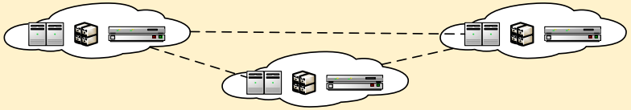
Data Centre

Hardware Infrastructure (Virtual Machines and Physical Components)
Student, Developer, Researcher
Staff,Researcher
IaaS
(Storing various institutes content and Study material)

PC UWTSD

PaaS
(Development of Web-based application)

PC UWTSD

Student
Staff, Database developer

SaaS
(Online Attendance and online quiz)

PC UWTSD

Student, Faculty
Cloud User
Data Input/Admin/Controller
Admin department, Examination department
Figure 3: Cloud users of UWTSD for different CS model
Source: Adapted from [17]

In order to focus on the current situation of the CC deployment model and future possibilities, we have adopted a five-step migration process to the proposed architecture.
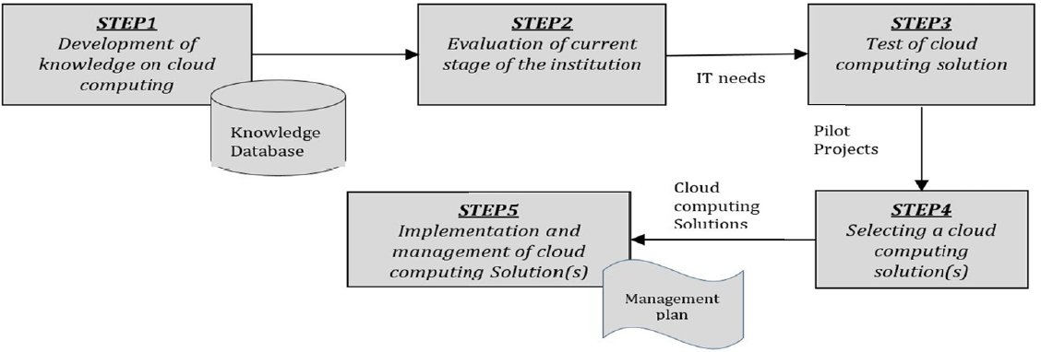
Figure 4: Migration strategy for the cloud model
Source: Adapted from [20]
The adoption of HC architecture along with using all the layers of the CS model would be appropriate when there is a high amount of demand for processing requests along with the need of expanding storage capacity. The adoption of such an architecture will comply with “Quality of service (QoS)” when there is an increased need for conducting online classes and accessing project related study materials.
The informationin the private cloud i.e. PC UWTSD will be hosted by the institutes under UWTSD such as by the Confucius Institute, WISA, WIAV, Academy for health and physical literacy and Institute of Management and health. Similarly, the EC UWTSD will be hosted by the following CS providers for education.
Service Model | CS provider for education | Description of services
SaaS | Google Apps | - Providing web browser access  - Allows the institutes under EC UWTSD to retain their existing domain names  - Web-based file storage and applications  - Google survey, Google spreadsheet and presentations  - Gmail, calendar and G Talk
SaaS | MicrosoftLive@edu | - Office live workspace, shared view beta, sky Drive and live alert  - Free registration for universities and colleges  - Enables services based on hosted collaboration
SaaS | “Amazon Web Services (AWS)” | - Provision for free credentials and ICT infrastructure used for academic researchers, educators and student  - Provides web-based services in the field of workforce, software, content delivery,
PaaS | Microsoft Azure | - Tools for software development and testing  - Quick deployment of applications
IaaS | AWS | - Provides basic database deployment and storage  - Rack space, servers and other computing resources

As per the above to build we can see the appropriate areas of implementing the EC UWTSD. This tells us that for IaaS CBS Google Apps, MicrosoftLive@edu and AWS are most appropriate. On the other hand, Microsoft Azure and AWS are apt for PaaS and IaaS [3].

Scalability
Scalability refers to the intelligent management of the system by providing additional resources to fulfil the changing demands of users in a cloud workspace [34].Scalability is one of the key components of the CC which provides additional benefits of hosting information in a cloud environment rather than local terminals. The scalability in CC plays a pivotal role in offering on demand resource provisioning with negligible time to downgrade or upgrade requirement. This ensures that the scalable CC platform is appropriate for educational institutions for researchers, students and faculties.
The scalability approach for the CC architecture will be associated to “software defined network (SDN)” management, which enables efficient network configuration and dynamic optimisation to improve the overall performance monitoring of the model. The SDN approach has recently proved to be a promising solution for deploying future cloud-based services. The centralised network control in the SDN will be able to ensure a cost-efficient architecture, thereby providing greater network visibility for achieving better resource utilisation and performance. However, the traditional model of network architecture suffers from certain drawbacks when it comes to scalability and elasticity. In order to curb such drawbacks, we will implement “Deep Neural Network (DNN)” as an “intrusion detection system (IDS)” and training the model with existing data collected from the native OpenFlow method. This will be essential to detect flow-based anomaly in the SDN environment.
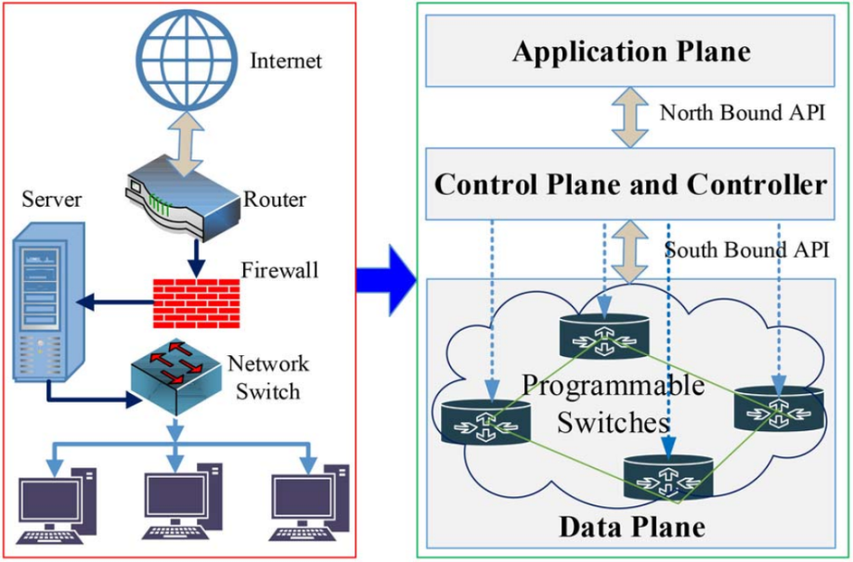
Figure 5: Comparison of traditional network architecture and SDN for scalability
Source: Adapted from [31]
The scalability feature in the CC will be a deciding factor for UWTSD to effectively monitor computing power requirement and energy consumption when group exercises are being solved by the students. This will also allow downgrading the computing power as and when required during vacations [27].The implementation of the DNN SDN will be the responsibility of the system administrator, software developer and IT team at UWTSD. The data centres are the main places where storage of information takes place. The adoption of the SDN approach in the data centres enables dynamic expansion are shrinking of storage size as and when required. The global view feature in the SDN can be used for efficient management of network traffic, which allows better resource utilisation and reduce energy consumption of the network [36].

Security
The biggest challenge in the flexible and dynamic adoption of CC model is seen with lack of resources, compliance and security. Despite of strong security measures taken by the data centres, there still remains a considerable challenge for the security of the cloud. The three main types of security for the proposed cloud model of UWTSD will include legal issues, loss of control over data and compliance. Some of the other top security threats can be seen with trusting the security model of vendor, losing physical control, potential for massive outages, abuse of cloud services by malicious insiders and the reliability of the CBS providers.
Security in the CC is a highly important and sensitive factor as cloud data centres stores various confidential information. It is one of the prime responsibilities of CSPs to ensure strong security protocols and policies are put in place for protecting the data of its clients and customers. This is particularly important as the users of cloud service needs the transparency and confidence in terms of security and performance [37].
The CC model of UWTSD will mitigate the data security threats by taking measures such as cryptography, reducing redundancy and disposal. The issues related to network security will be mitigated by process of security configuration, transfer security and fire walling. Some of the main measures associated to governance will be taken care of by locking method, security control and data control. The data security measure of cryptography will be based on encryption techniques to ensure that the cloud services are accessed securely by the hosts of cloud providers. UWTSD will use “Advanced Encryption Standard (AES)” for making sure that the security protocols comply with symmetric key algorithm for encryption. Each of the ciphers will have key sizes of 128, 192 and 256 bits, respectively [12].
The approach of fire walling for resolving network security issues will be considered by the Isoflat mechanism of firewall for public cloud service providers. The Isoflat type of network provider will put certain limitations in creating multiple flat providers in single network interfaces. This has a minimum effect on TCP traffic, thereby significantly improving the overall throughput of information in the data centres [38].
The locking method approach relates to implement appropriate locking strategies for accessibility of data in a cloud environment. The CC architecture for UWTSD will include a two-phase locking protocol, which will comprise of expanding phase and shrinking phase. In the expanding phase the locks will be acquired and not released and the system will only be able to increase the number of locks. On the contrary, during the shrinking phase the locks will be released and not acquired [19].
The security measures should be tightened by the system administrator and IT team in any instance when there exists a loss of data or denial of access of data without any intervention from the developers. Additionally, the selection of cloud vendor as a crucial role in ensuring overall security. Furthermore, the security in IaaS service model is to be ensured by implementing the virtual web application firewalls to safeguard the system against malware attack. In the SaaS layer, the user security should be ensured by putting logging restrictions, API gateways and IP restrictions. Similarly, in PaaS layer, UWTSD has the scope of implementing “Cloud Access Security Broker (CASB)”. Such a security protocol would be most appropriate for both locally hosted information in the PC UWTSD and publicly accessed information in the EC UWTSD. The four pillars of CASB are seen with Visibility, compliance, data security and threat protection. The visibility function permits the cloud admin to gain visibility on the user activity and sanctioning of the cloud applications. The compliance will guarantee the identification of sensitive information and enforcing DLP policies for data residency. The data security measures are taken into account through enforcing of data centric security controls such as data rights, tokenization and encryption. The threat protection feature relates to detection of malicious insider threats [13].

Fault Tolerance
“Fault tolerance (FT)” refers to the system’s ability to function even in the occurrence of failures.FT approach depends on the failure of a task which may result from either hardware redundancy or time (re-execution of failed task post anomaly detection). A failure in the cloud may also happen due to an error in any of the CC layers, thereby causing the system to reach an invalid state [10].
The importance of FT approach lies in clearly understanding and defining system behaviour with correct specifications so that the fault resistant system can be developed.
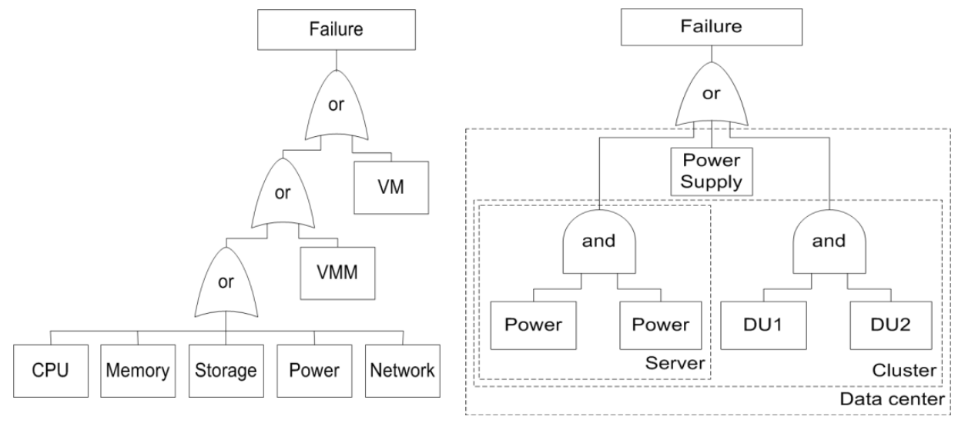
Figure 6: Fault free comprising of server failure (left) and power failure (right)
Source: Adapted from [24]
Some of the common methods for prevention of crash faults due to hard disk failure and power outage will be done by monitoring method, restart method and replication method. In the monitoring method, the runtime of the system will be verified and validated for ensuring correct system specifications are prevailing. In the restart approach, the state of the system will be saved and captured after every 2048 instructions. During the time of failure, the system will be restored to previous non-correct state based on latest checkpoint information. The replication method will be applied by duplication of additional network resources, hardware and software using active and passive formats [22]. The CC architecture of UWTSD will implement twofold model. Firstly, the crash FT model will work on capturing the component failures based on the user’s perspective which relates to understanding the behaviour of users for the application deployed in VM instances in a situation of failure of server components. Secondly, the proposed FT model will depict the correlation between individual components and the parameters leading to each failure [24].
In addition to the suggested methods, the CC model of UWTSD will also implement “dynamic clustering league championship algorithm (DCLCA)” in order to schedule problem associated with FT in CC services. The DCLCA will be suitable for segregating groups of independent tasks with appropriate computational task partition or computational size by prioritising on the partition. Additionally, a heuristic will be applied for categorising the task segments, with existing knowledge of resource states in the cloud environment [32]. The flow of tasks associated to fault detection and job migration through DCLCA approach is enumerated below as follows:
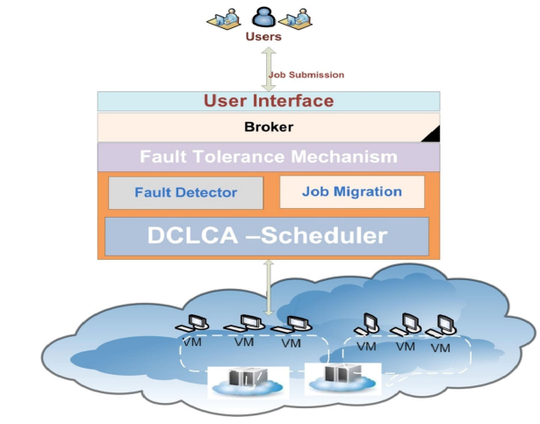
Figure 7: FT approach for scheduling components using DCLCA scheduler
Source: Adapted from [1]
In critical situations the deployment of hardware redundancy is done frequently for sustaining the fixed targets, avoiding delay and ensuring a fault-tolerant system. The DCLCA approach will be most suitable for combining task mapping and clustering into joint allocation of resource and improve computing accessibility pertaining to the resources. The FT approach for crash faults will be most suitable to substantially reducing the number of failures in the physical drives, assuming in situations where there is failure of independent components.The implementation of both crash FT approach and DCLCA FT approach will be done by the IT team of the Institute.DCLCA approach will be conducive to schedule the segregated tasks over limited heterogenous resources in a cloud. However, the prevention mechanisms for crash faults is mostly associated with the virtual and physical servers comprising the data centre. This is often implemented to improve the reliability of hard disks.

Performance
Performance refers to that factor in CC which handles the impact of FT procedure at the end to end QoS both during occurrence of faults and failure free periods [24]. The performance of CC architecture has a decisive role in determining levels of service and satisfaction among the cloud users. Speed is one of the important QoS characteristic of performance in a CC model. The different constraints for performance are determined by lack of resource, limited bandwidth, network connections, low processor speed, memory availability and disk space [37].The features defining the service performance in a cloud is shown below as follows:
Performance parameter | Description | Metrics
Communication | Exchanging data in Cloud between external and internal consumer | - Byte speed/ transfer bit of MPI  - Frequency of packet loss  - Error rate in connection
Time | Completion of project within deadline, thereby maintaining quality | - Communication time  - Computation time
Memory | Rapid use of temporary stored information | - Response time (ms)  - Byte speed  - Rate of updating random memory  - Mean hit times (s)
Computation | Task processing time in Cloud system | - Request process efficiency (% CPU peak)  - OP(FLOP) Rate  - CPU Load(%)

The implemented method for performance enhancement in the CC deployable architecture for UWTSD will comprise of maintaining cloud server clusters for processing virtualised user request from the VM through hypervisor control. We will implement “load balancing (LB)” approach for avoiding an instance of temporary overload by dividing the server into two clusters and enforcing the SLAs mainly comprising of processing time of requests. The LB strategy for the clusters will be performed through job processing via mutual job overflows by events comprising of “Local Server System First (LSSF)” and “Shortest Response Time First (SRTF)”. As per the LSSF strategy, each SS will serve only when the idle server is available. In case all the servers are busy, the arriving requests will be assigned for buffering in the local queue. The buffered jobs will be served through strict FIFO mode [28].
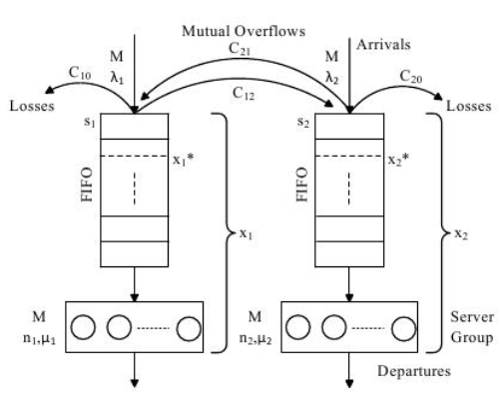
Figure 8: System model for serving requests for two servers under LSSF
Source: Adapted from [26]
In the SRTF approach, the performance improvement will be taken into consideration by several multi-queue server system or single server system which has identical service time. In this case, the arriving job will be assigned to the shortest queue. The main benefit of this strategy is seen with guaranteeing absolutely shortest delay in processing.The IT team of UWTSD needs to adopt a generalised strategy of “Join the Shortest Queue (JSQ)” as an alternative to the previously suggested LSSF approach. The SRTF strategy will be conducive to guarantee the SLA in terms of scheduling the arriving requests to the SS, thereby allowing the categorisation of heterogenous server groups bearing distinct server speed, buffer capacity and number of servers[29].
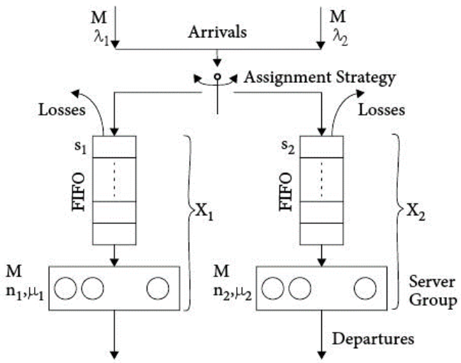
Figure 9: System model for serving requests for two servers under SRTF
Source: Adapted from [26]
In this way, the number of resources for processing requests can be reduced considerably. Additionally, the CC model will save a considerable amount of energy through server consolidation in case the current load does not require configuration of all the activated servers in the local server system or VM.

Power consumption
In general, each of the cloud servers are seen to host the distinct number of homogenous computing machines. The power consumption is referred as the approximate power units consumed by each machine in the cloud server [16].
Based on a study conducted in 2016, it was found that ICT contributed to more than 2% of global anthropogenic GHG emissions in 2006, which is comparable to the emissions of aviation industry in the same year [14]. As data centres are one of the major sinks of electricity in ICT infrastructure, they have a massive contribution to such emissions. Therefore, energy efficiency and power consumption in the cloud servers have a contributory role in reducing this the GHG emissions.
We will adopt “Thermal Aware Scheduling (TAS)” in our CC architecture to control the average energy consumption in the cloud centre by focusing on reducing the high temperature of physical components. The TAS will comprise of allocating the workloads based onthe temperatures of the physical machines. This will not only lead to better energy consumption, but also reduce the cost of cooling for controlling the average temperature for the servers. The scheduling process of workload considers the operating system to decide on which server the workload is to be executed by keeping a record of the historic information on the temperature of the servers [25]. The main goal of TAS would be based on avoiding any instance of hotspots which negatively influences the reliability and performance of a system. UWTSD has a range of options for determining the temperature for the servers over time. We will proceed with this approach through thermal aware profiling and monitoring. The thermal aware monitoring will track the heat dissipated from data centres. Additionally, the thermal profiling will keep a record of dissipation of heat pertaining to computational workload, servers and microchips [15].
The TAS approach will be implemented in three stages, namely the reactive approach, mixed approach and proactive approach. In the reactive approach, the workload scheduling will be conducted after any thermal anomaly has taken place. On the contrary, in the proactive approach, the scheduling is done before any thermal anomaly takes place. The overall strategy of TAS is based on making the best use of thermal profiles and predictions to distribute the workload across different data centres and reduce overall heat. The CC architecture of UWTSD will experience a considerable reduction in power consumption, heat transfer and migration time with the use of proactive approach.Application of such a system is most appropriate when the high temperature causes power leakage and increasing consumption of static power among the servers [35]. The implementation process of TAS would be the responsibility of IT team and system administrator at UWTSD.The application of such a model will be mainly appropriate for the physical components of the data centres in UWTSD [23].

Conclusion
The study suggests how the CC model for UWTSD would be based on the HC architecture for education. PC UWTSD would use local network to process user request of faculties, researchers and students and EC UWTSD will rely on public CSPs which will consider processing the requests of various institutes under UWTSD.The study further suggests the five-stage migration strategy which would involve an evaluation of the present stage of the institution and implementing the CC solutions based on IT needs of the Institute.The main public CSPs pertaining to the EC UWTSD have been identified with Google apps, MicrosoftLive@edu, Microsoft Azure and AWS. The proposed model has adopted SDN combined with DNN for a better intrusion detection system and training the model with existing data collected from the native OpenFlow method.
The preliminary security related issues related to data will be mitigated by techniques such as cryptography, reducing redundancy and disposal. Additionally, the network security threats will be resolved with security configuration, transfer security and fire walling. The advanced security protocols will comprise of AES will enable symmetric key algorithm for encryption which will ensure that each cipher has key sizes between 128, 192 and 256 bits.In order to ensure maximum security in EC UWTSD and PC UWTSD, the institute will consider adopting CASB which will be based on functions associated with visibility, compliance, data security and threat protection.The two-stage FT approach will ensure enhanced performance and resistance to failure comprising of physical components, VM and cloud layers. The crash faults due to power outages will be mitigated through monitoring method, restart method and replication method. This mainly relates to the FT approach for physical component and VMs of the data centre. On the other hand, DCLCA will ensure segregating groups of independent tasks with appropriate computational task partition or computational size by prioritising on the partition. Finally, the sustainability of the model will be confirmed with TAS method.

Reference List
- Abdulhamid, Shafi’I. Muhammad, et al. "Fault tolerance aware scheduling technique for cloud computing environment using dynamic clustering algorithm." Neural Computing & Applications 29.1 (2018).
- Alenezi, Hussain, Ali Tarhini, and Sujeet Kumar Sharma. "Development of quantitative model to investigate the strategic relationship between information quality and e-government benefits." Transforming Government: People, Process and Policy (2015).
- Alharthi, A., et al. "Critical success factors for cloud migration in higher education institutions: a conceptual framework." Int. J. Intell. Comput. Res.(IJICR) 8.1 (2017): 817-825.
- AlKharusi, Mohammed H., and Ali H. Al-Badi. "IT personnel perspective of the slow adoption of cloud computing in public sector: Case study in Oman." 2016 3rd MEC International Conference on Big Data and Smart City (ICBDSC). IEEE, 2016.
- Almajali, Dmaithan Abdelkarim, and Ali Tarhini. "Antecedents of ERP systems implementation success: a study on Jordanian healthcare sector." Journal of Enterprise Information Management (2016).
- Al-Qirim, Nabeel, et al. "Towards a personality understanding of information technology students and their IT learning in UAE university." Education and Information Technologies 23.1 (2018): 29-40.
- AlZadjali, Amira M., Ali H. Al-Badi, and Saqib Ali. "An analysis of the security threats and vulnerabilities of cloud computing in oman." 2015 International Conference on Intelligent Networking and Collaborative Systems. IEEE, 2015.
- Arpaci, Ibrahim. "Antecedents and consequences of cloud computing adoption in education to achieve knowledge management." Computers in Human Behavior 70 (2017): 382-390.
- Batista, Bruno Guazzelli, et al. "A QoS-driven approach for cloud computing addressing attributes of performance and security." Future Generation Computer Systems 68 (2017): 260-274.
- Bilal, Kashif, et al. "Fault tolerance in the cloud." Encyclopedia of Cloud Computing (2016): 291-300.
- Bokhari, Mohammad Ubaidullah, Qahtan Makki Shallal, and Yahya Kord Tamandani. "Cloud computing service models: A comparative study." 2016 3rd International Conference on Computing for Sustainable Global Development (INDIACom). IEEE, 2016.
- Chatterjee, Rishav, Sharmistha Roy, and U. G. Scholar. "Cryptography in cloud computing: a basic approach to ensure security in cloud." International Journal of Engineering Science 11818 (2017).
- "Cloud Computing Security Architecture For Iaas, Saas, And Paas." sdxcentral.com. Apr 20, 2020 [Online]. Available: https://www.sdxcentral.com/cloud/definitions/cloud-computing-security-architecture/
- Dandres, Thomas, et al. "Consideration of marginal electricity in real-time minimization of distributed data centre emissions." Journal of Cleaner Production 143 (2017): 116-124.
- Darya, AMIN-SHAHIDI, Abhishek Dhanda, and Toshiki Hirano. "Thermal aware workload scheduling." U.S. Patent No. 10,528,098. 7 Jan. 2020.
- Deng, Ruilong, et al. "Optimal workload allocation in fog-cloud computing toward balanced delay and power consumption." IEEE internet of things journal 3.6 (2016): 1171-1181.
- Desai, Ms Tanvi, et al. "Cloud computing in education sector." International Journal 2 (2016): 191-194.
- Ganguly, Debashis, et al. "Harvesting Underutilized Resources to Improve Responsiveness and Tolerance to Crash and Silent Faults for Data-intensive Applications." 2017 IEEE 10th International Conference on Cloud Computing (CLOUD). IEEE, 2017.
- Garde, Shri VD, Aarthi Mudaliar, and Bhopal NCHSE. "Concurrency Lock Issues in Relational Cloud Computing. IEEE, 2016"
- Gholami, Mahdi Fahmideh, et al. "Cloud migration process—A survey, evaluation framework, and open challenges." Journal of Systems and Software 120 (2016): 31-69.
- Glazunova, Olena G., and Tetyana Voloshyna. "Hybrid Cloud-Oriented Educational Environment for Training Future IT Specialists." ICTERI. 2016.
- Gudadhe, Manish B., and Avinash J. Agrawal. "Performance analysis survey of data replication strategies in cloud environment." Proceedings of the 2017 International Conference on Big Data Research. 2017.
- Ilager, Shashikant, Kotagiri Ramamohanarao, and Rajkumar Buyya. "ETAS: Energy and thermal‐aware dynamic virtual machine consolidation in cloud data center with proactive hotspot mitigation." Concurrency and Computation: Practice and Experience 31.17 (2019): e5221.
- Jhawar, Ravi, and Vincenzo Piuri. "Fault tolerance and resilience in cloud computing environments." Computer and information security handbook. Morgan Kaufmann, 2017. 165-181.
- Kaur, Amanpreet, V. P. Singh, and Sukhpal Singh Gill. "The future of cloud computing: opportunities, challenges and research trends." 2018 2nd International Conference on I-SMAC (IoT in Social, Mobile, Analytics and Cloud)(I-SMAC) I-SMAC (IoT in Social, Mobile, Analytics and Cloud)(I-SMAC), 2018 2nd International Conference on. IEEE, 2018.
- Kueh, Paul J., and Maggie Ezzat Mashaly. "Load Balancing in Distributed Cloud Data Center Configurations: Performance and Energy-Efficiency." Proceedings of the Eighth International Conference on Future Energy Systems. 2017.
- Kumar, Vikas, and Aashish Bhardwaj. "Role of Cloud Computing in School Education." Handbook of Research on Diverse Teaching Strategies for the Technology-Rich Classroom. IGI Global, 2020. 98-108.
- Mashaly, Maggie, and Paul J. Kuehn. "Evaluation of Scheduling Techniques in Cloud Data Centers: Simulation and Experimentation." 2019 International Conference on Innovative Trends in Computer Engineering (ITCE). IEEE, 2019.
- Mashaly, Maggie. Managing load balancing, energy efficiency and performance of cloud data centers with service level agreement guarantees. Universität Stuttgart, Institut für Kommunikationsnetze und Rechnersysteme, 2017.
- Naranjo, Diana M., et al. "A Visual Dashboard to Track Learning Analytics for Educational Cloud Computing." Sensors 19.13 (2019): 2952.
- Rawat, Danda B., and Swetha R. Reddy. "Software defined networking architecture, security and energy efficiency: A survey." IEEE Communications Surveys & Tutorials 19.1 (2016): 325-346.
- Shafi’i Muhammad Abdulhamid, Muhammad Shafie, et al. "Secure scientific applications scheduling technique for cloud computing environment using global league championship algorithm." PloS one 11.7 (2016).
- Sharma, Sujeet Kumar, et al. "Predicting motivators of cloud computing adoption: A developing country perspective." Computers in Human Behavior 62 (2016): 61-69.
- Siddiqui, Shams Tabrez, et al. "Cloud-Based E-Learning: using cloud computing platform for an effective E-Learning." Smart Innovations in Communication and Computational Sciences. Springer, Singapore, 2019. 335-346.
- Sun, Hongyang, Patricia Stolf, and Jean-Marc Pierson. "Spatio-temporal thermal-aware scheduling for homogeneous high-performance computing datacenters." Future Generation Computer Systems 71 (2017): 157-170.
- Tang, Tuan A., et al. "Deep learning approach for network intrusion detection in software defined networking." 2016 International Conference on Wireless Networks and Mobile Communications (WINCOM). IEEE, 2016.
- Zanoon, Nabeel. "Toward Cloud Computing: Security And Performance." International Journal on Cloud Computing: Services and Architecture 5.5/6 (2015): 17-26.
- Zhang, Ruipeng, Mengjun Xie, and Li Yang. "Isoflat: Flat Provider Network Multiplexing and Firewalling in OpenStack Cloud." ICC 2019-2019 IEEE International Conference on Communications (ICC). IEEE, 2019.

