Programme: MSc Public Health and Social Care in Practice

Module: Population Health and Digital Health Promotion

Module Code: LCHS7009
Assignment Title: Component 1
2 Blogs

Student name: Adil karim
Student ID number: 2426763

Table of Contents
Blog 1: Hypertension and Cardiovascular Risk - SHIP (Self-monitoring and Hypertension Intervention Programme) 3
Introduction 3
Public health problem 3
Chosen NHS Digital Health Intervention and Application of Technology 4
Evaluation of Digital Health Intervention 4
The Use of Digital Technology in Promoting Health 5
Merits and Demerits with solutions 5
Solutions 5
Conclusion 5
Blog 2: Designing a digital intervention “D-LITE” for Health Problem: Type 2 Diabetes and Lifestyle Management 6
Introduction 6
Public health problem 6
Designing of NHS Digital Health Intervention and Use of Technology 7
Evaluation of Digital Health Intervention 7
The Use of Digital Technology in Promoting Health 8
Merits and Demerits with solutions 8
Solutions 8
Conclusion 8
References 9
Blog 1 9
Blog 2 10

Blog 1: Hypertension and Cardiovascular Risk - SHIP (Self-monitoring and Hypertension Intervention Programme)

Introduction
Hypertension is the leading modifiable risk factor for cardiovascular disease (CVD) including comorbidities, such as kidney disease and diabetes. Lifestyle changes, remote monitoring of blood pressure and intake of drugs containing ACE inhibitors can prevent and manage high BP (Burnier and Damianaki, 2023).

Public health problem
Causing factors
Major risk factors for high blood pressure are smoking, eating excess salt, fat, and alcohol, being overweight and lack of physical activity. Untreated hypertension increases the risk of stroke and coronary heart disease (Blood Pressure UK, 2021).
Global statistics
In 2025, 1 out of 3 adults globally has hypertension, and it affects over 1.3 billion people, especially in low- and middle-income countries. It is also responsible for more than 10 million deaths annually due to cardiovascular complications, primarily from stroke and ischemic heart disease (Paho.org, 2025).
UK-based statistics
Around the adult population in the UK, every 1 out of 3 adults are diagnosed with hypertension, and the remaining are undiagnosed, which leads to a higher mortality rate, especially among people over 75 years age group (Campbell et al., 2023).
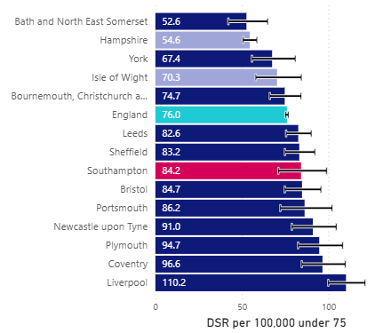
Figure 1: Region-specific death rate of cardiovascular problems in 2021
(Source: Southampton.gov.uk 2025)

Chosen NHS Digital Health Intervention and Application of Technology
NHS introduces an impactful digital intervention for hypertension called the SHIP (Self-monitoring and Hypertension Intervention Programme). The program allows patients to measure their blood pressure at home with the Bluetooth-supported devices linked to a smart phone application or web portal. The information is sent automatically to primary care teams while making it possible to make timely clinical decisions and adjust the medications (Smith et al., 2024).

Evaluation of Digital Health Intervention
According to a study, systolic BP decreases by 5.4 mmHg on average after the use of SHIP in comparison to conventional care. Digital intervention also enhanced patient engagement with over 70 percent of the daily follow-ups within the first 3 months. SHIP also facilitates remote monitoring, which minimises the need to visit in-person, and lower workloads of healthcare professionals (Smith et al., 2024).

The Use of Digital Technology in Promoting Health
Management of hypertension and associated cardiovascular risks becomes easier by integrating digital health tools, which support data-driven care as medical professionals can access real-time dashboards to tailor interventions. Community pharmacies and NHS Health Checks use digital BP monitors and risk stratification tools to help in early detection (NHS England, 2025). Mobile applications, like SHIP and NHS-approved platforms such as Omron Connect, MyGP offer reminders, trend tracking, and lifestyle advice (Omron Healthcare, 2019).

Merits and Demerits with solutions
Merits:
Digital interventions for hypertension are cost-effective, which empower patients through self-monitoring and education, enable early detection; reduce the risk of stroke, and lower clinical burden (Zhang et al., 2024).
Demerits:
It concerns data security and privacy of patient information, includes issues with NHS IT systems, and often deprives older adults without smart phones.

Solutions
In order to optimise the application, training must be provided to elderly people about how to use the technologies with expanded funding for community and remote monitoring schemes. This must integrate with NHS Electronic Health Records (EHRs) seamlessly.

Conclusion
Early detection, personalised care, and improved outcomes prove hypertension management is taking a new form using digital health interventions, such as SHIP. The challenges can be associated with this intervention can be mitigated through strategic planning, policy reform and investments.

Blog 2: Designing a digital intervention “D-LITE” for Health Problem: Type 2 Diabetes and Lifestyle Management

Introduction
Type 2 Diabetes has become the primary issue of health concern in the world, and lifestyle related factors are presenting a challenge to the populace health. The NHS has incorporated digital health interventions in the process of prevention and lifestyle management for this health issue (Altobelli et al., 2020). Aside from those, this blog aims to design a user-friendly digital intervention called D-LITE (Diabetes Lifestyle Intervention for Therapeutic Enhancement).

Public health problem
Cause of concern
Eating high carbohydrate contents, obesity, low exercise, and prolonged stress are major reasons for type 2 diabetes. Positive changes in lifestyle, such as a balanced diet, staying hydrated, regular physical activity, along insulin therapy, can control the blood sugar levels (Mayo Clinic, 2024).
Global statistics
Globally, over 590 million adults are living with diabetes in 2025, with 90% of cases being Type 2 and out of which 40% people are unaware of it. Predictions show that this rate will increase by 465, and 1 in 8 adults, approximately 853 million, will have diabetes by 2050 (International Diabetes Federation, 2025).
UK statistics
In the UK, more than 2.8 million people were diagnosed with Type 2 diabetes in 2020, which includes approximately 10% of health expenditure in England, equating to around £11bn annually to the NHS (NHS England, 2021).
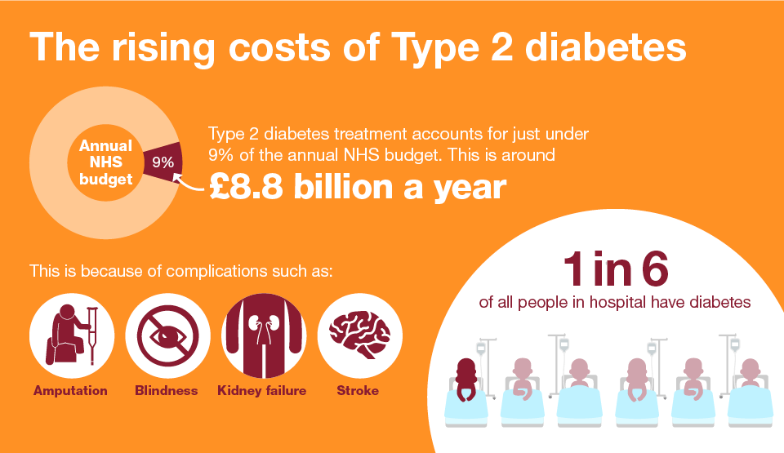
Figure 2: Costs for type 2 diabetes management in 2018
(Source: Public Health England, 2018)

Designing of NHS Digital Health Intervention and Use of Technology
The core objectives of D-LITE will be improving glycaemic control and enhance diet quality of diabetic patients. It will align with NHS’s digital programme called Healthier You: NHS Diabetes Prevention Programme in 2016, to support individuals at high risk of developing Type 2 Diabetes. The proposed intervention will help to monitor physical activities through mobile apps (NHS England, 2025). D-LITE will also supports in secure log in through mobile applications and web portal.

Evaluation of Digital Health Intervention
A study evaluating the effectiveness of this digital intervention for diabetes showed that participants using the digital stream achieved an average weight loss of 3.7 kg, comparable to face-to-face programmes. Engagement rates were higher among younger adults and those in full-time employment, suggesting digital flexibility suits busy lifestyles (Barron et al., 2023). The data-sharing options with healthcare providers and reminders of medication will grow people’s interest in D-LITE.

The Use of Digital Technology in Promoting Health
Digital health tool like D-LITE will transform the management of lifestyle for type-2 diabetes patients by providing real-time monitoring of glucose levels in blood, activity and diet. This technology will provide personalised feedback and encourage individuals to practice healthy habits over geographical barriers. In the NHS context, these also support clinicians to tailor care plans through data-driven insights and reduce burden on primary care services with self-managed approaches (Fundoiano-Hershcovitz et al., 2022).

Merits and Demerits with solutions
Benefits
This newly designed digital intervention will be available anytime and anywhere at a cost-effective way. It will also promote self-management and autonomy through offering individualised and data-driven care (Kyaw et al., 2023).
Disadvantages
This may pose barriers in application for older adults and lower income groups due to lack of digital literacy.

Solutions
Digital literacy training and use of culturally specific content can also be used to support it to enhance patient engagement in various communities. In order to maximise the favorable effects, hybrid models should incorporate digital and face-to-face assistance in inclusivity and integrate with electronic health records (EHRs) in an attempt to ensure ease in care coordination.

Conclusion
The integration of digital stream of the NHS Diabetes Prevention Programme within the D-LITE offerings can work positively in reducing weight, engaging, cost-effective and accessibility as a means of preventing the occurrence of diabetes type 2.

References

Blog 1
Blood Pressure UK (2021). Blood Pressure UK. Available at: https://www.bloodpressureuk.org/your-blood-pressure/causes/(Accessed 15 Oct. 2025).
Burnier, M. and Damianaki, A. (2023). Hypertension as cardiovascular risk factor in chronic kidney disease. Circulation research, 132(8), pp.1050-1063. https://doi.org/10.1161/CIRCRESAHA.122.321762
Campbell, E., Macey, E., Shine, C., Vahé Nafilyan, Clark, N.M., Pawelek, P., Ward, I., Hughes, A.D., Raleigh, V.S., Banerjee, A. and Finning, K. (2023). Sociodemographic and health-related differences in undiagnosed hypertension in the health survey for England 2015–2019: a cross-sectional cohort study. EClinicalMedicine, 65(102275), pp.102275–102275. doi: https://doi.org/10.1016/j.eclinm.2023.102275.
NHS England (2025). NHS England» NHS Community Pharmacy Blood Pressure Check Service. (online). Available at: https://www.england.nhs.uk/primary-care/pharmacy/pharmacy-services/nhs-community-pharmacy-blood-pressure-check-service/ (Accessed 30 Oct. 2025).
Omron Healthcare. (2019). OMRON Apps for Connected Products & Bluetooth Devices - OMRON Healthcare. Available at: https://omronhealthcare.com/omron-connect-app(Accessed 15 Oct. 2025).
Paho.org. (2025). Global report on hypertension 2025: high stakes: turning evidence into action. Available at: https://www.paho.org/en/documents/global-report-hypertension-2025-high-stakes-turning-evidence-action(Accessed 15 Oct. 2025).
Smith, A., Tucker, K.L., Barnes, R.K., Drakesmith, C.W., Agwunobi, A., Bateman, P.A., Forbes, A., de Lusignan, S., Ford, G.A., Fujiwara, T. and Hobbs, F.R. (2024). A service evaluation of the implementation of a novel digital intervention for hypertension self-monitoring and management system in primary care (SHIP): protocol for a mixed methods study. BMC Cardiovascular Disorders, 24(1), p.707. https://doi.org/10.1186/s12872-024-04279-y
Southampton.gov.uk. (2025). Cardiovascular disease (CVD). Available at: https://data.southampton.gov.uk/health/health-conditions/cardiovascular-disease-cvd/(Accessed 15 Oct. 2025).
Zhang, W., Mei, Z., Feng, Z. and Li, B. (2024). Nurse-led digital health program for home blood pressure monitoring in stroke patients: protocol for a pooled analysis of randomized controlled trials. Frontiers in Public Health, 12. doi: https://doi.org/10.3389/fpubh.2024.1378144.

Blog 2
Altobelli, E., Angeletti, P.M., Profeta, V.F. and Petrocelli, R. (2020). Lifestyle Risk Factors for Type 2 Diabetes Mellitus and National Diabetes Care Systems in European Countries. Nutrients, 12(9), p.2806. doi: https://doi.org/10.3390/nu12092806.
Barron, E., Bradley, D., Safazadeh, S., McGough, B., Bakhai, C., Young, B., Khunti, K., Murray, E., Wareham, N., Jebb, S. and Valabhji, J. (2023). Effectiveness of digital and remote provision of the healthier you: NHS Diabetes prevention programme during the COVID‐19 pandemic. Diabetic Medicine, 40(5), p.e15028. https://doi.org/10.1111/dme.15028
Fundoiano-Hershcovitz, Y., Bacher, D., Ritholz, M.D., Horwitz, D.L., Manejwala, O. and Goldstein, P., 2022. Blood pressure monitoring as a digital health tool for improving diabetes clinical outcomes: retrospective real-world study. Journal of Medical Internet Research, 24(2), p.e32923. doi:10.2196/32923
International Diabetes Federation (2025). Diabetes Facts & Figures. Available at: https://idf.org/about-diabetes/diabetes-facts-figures/(Accessed 15 Oct. 2025).
Kyaw, T.L., Ng, N., Theocharaki, M., Wennberg, P. and Sahlen, K.G., 2023. Cost-effectiveness of digital tools for behavior change interventions among people with chronic diseases: systematic review. Interactive Journal of Medical Research, 12(1), p.e42396. doi:10.2196/42396
Mayo Clinic (2024). Diabetes management: How lifestyle, daily routine affect blood sugar. Available at: https://www.mayoclinic.org/diseases-conditions/diabetes/in-depth/diabetes-management/art-20047963(Accessed 15 Oct. 2025).
NHS England (2021).Type 2 Diabetes: Tips for Healthy Living. Pediatric Patient Education. doi:https://doi.org/10.1542/peo_document576
NHS England (2025).NHS England» NHS Diabetes Prevention Programme – digital stream. Available at: https://www.england.nhs.uk/diabetes/digital-innovations-to-support-diabetes-outcomes/nhs-diabetes-prevention-programme-digital-stream/(Accessed 15 Oct. 2025).
Public Health England (2018). Health matters: Preventing Type 2 Diabetes. Available at: https://www.gov.uk/government/publications/health-matters-preventing-type-2-diabetes/health-matters-preventing-type-2-diabetes(Accessed 15 Oct. 2025).

