INTERNATIONAL BUSINESS
Student name: MohammedakibMahammediqbal Shaikh
Student id: 2237233
Module code: LCMB7014
Lecturer: Lan Dang
Internal verifier: Vasilios Tavlaridiss

Executive Summary
The study analysed the history of Toyota to understand its expansion strategy while expanding business globally. This report has compared the differences in the strategic approach alongside company’s choice of a particular strategy in the host country China. In addition to this, a PESTLE analysis has been conducted to display the potential opportunities that Toyota can generate during its operations in China. Based on the understanding, the study has shown the implication of PESTLE in shaping the strategies of the company. It further includes recommendation based on the ways through which Toyota can improve its globalisation strategy further.

Table of Contents
1. Background analysis 4
2. Internationalisation strategies 8
3. Company’s internationalisation approach 11
4. PESTLE analysis 15
5. Integration of contextual factors and internationalisation strategy 18
6. Recommendation 21
References 23
Appendix 1: Important aspects which customers looked at when buying a vehicle in China as of May 2020 30
Appendix 2: Value chain works in Toyota 31

1. Background analysis
Background
Toyota is a leading Japanese company famous for developing and manufacturing automobiles and products related to automobiles. The associated products involve “vehicles, engines, car air-conditioning compressors, car electronics components and devices, and stamping dies” (Toyota-industries.com, 2023). The aim of the company lies in becoming the leading force in the global automobile industry. It insists on leading the “future mobility society” followed by enriching lives with the safest and most responsible ways of moving people (Global.toyota, 2023). Moreover, the commitment of the company encompasses “quality, ceaseless innovation, and respect for the planet”.

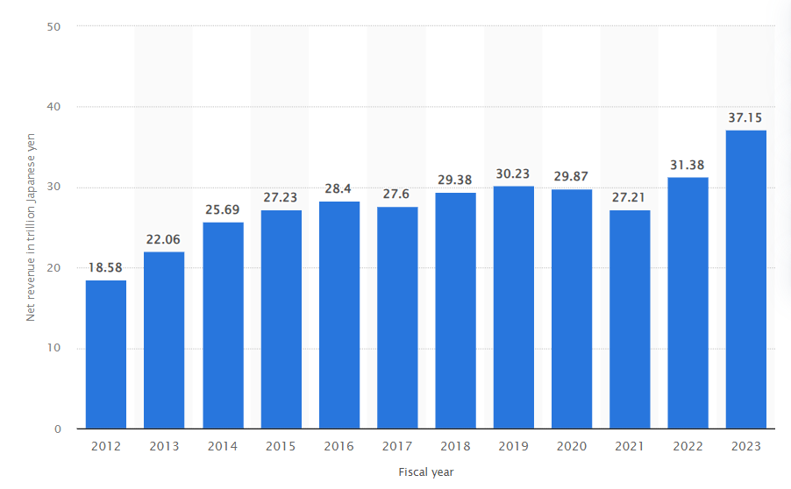
Figure 1: Toyota's net revenue from FY 2012 to FY 2023
(Statista,com, 2023)
The above image depicts the fluctuation in the overall revenue of the company from 2012 to till date. Based on the report of Statista, the company achieved 7.2 trillion Japanese yen in 2023 depicting an overall growth of 18.4% from the previous year (Statista.com, 2023). Overcoming the hurdles of the pandemic shows the sheer resilience of the company that helped in retaining momentum in the market. From the global perspective, Toyota sold around 10.48 million vehicles within the time span of January to December in 2022 (Statista.com, 2023). However, the company’s sales tally decreased by 0.1%, due to the impact of limited availability of semiconductor supply. Amidst high competition and limited resources, the company exhibited a steady performance in the market. All these efforts can be embedded in the idea and principles of the company that has helped Toyota in taking this far.
History
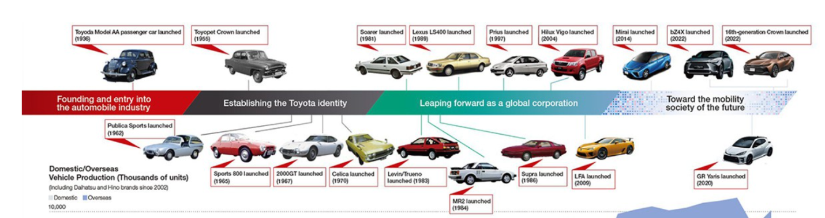
Figure 2: History of Toyota
(Source: Global.toyota, 2023)
The legacy of Toyota started in 1933 under the leadership of founders’ son Kiichiro Toyoda. Earlier, the company used to be a division under “Toyoda Automatic Loom” with their keen interest into the production of cars. Since the beginning, the company always intended to bring prosperity in society by enhancing the movement of people. The first passenger car of Toyota was launched in 1936 followed by Toyota Crown launched in 1955 (Global.toyota, 2023). The time between 1965-1983 helped Toyota to create its identity in the market with the launch of “Sports 800, 2000 GT, Celica, and Levin. Moreover, with the launch of Supra and LFA, the company leaped forward expanding the operations globally (Global.toyota, 2023). The company has recently celebrated 75 years of their journey with their commitment towards providing quality product and services. After the launch of Model G1 Truck in 1935, the company has manufactured around 145 million automobiles in Japan to date (Toyota-global.com, 2023). However, technology has been a key driving force for Toyota to build new cars over the years, which has helped the company immensely in improving customer experience.
Internationalisation journey
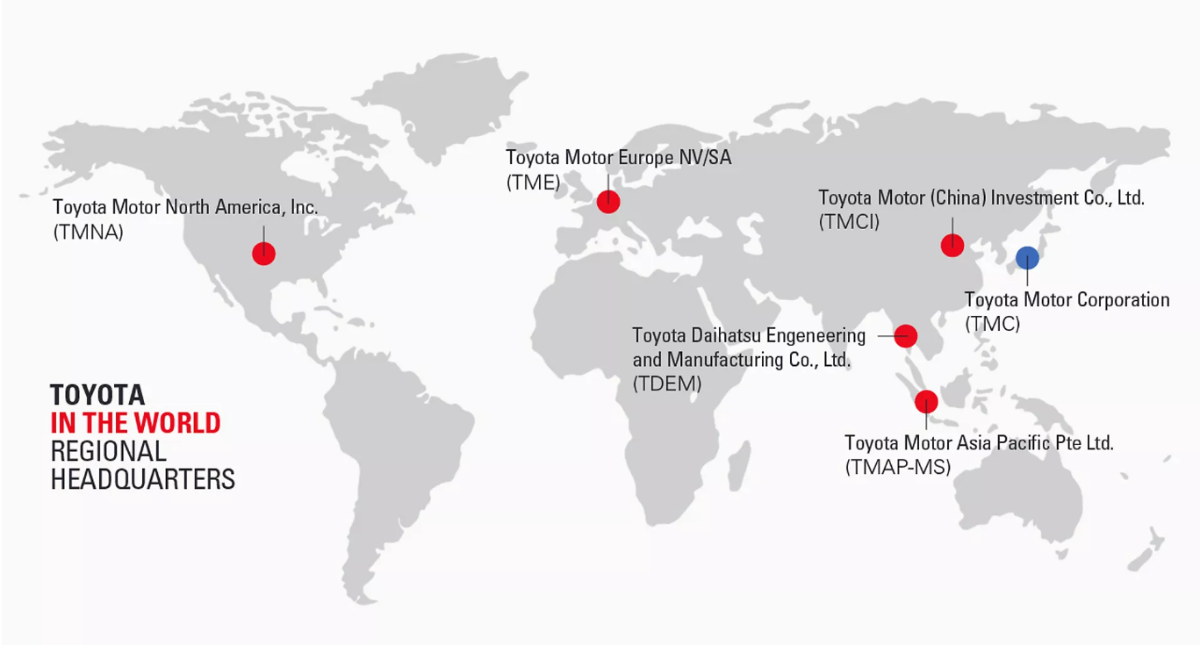
Figure 3: Toyota in the world
(Source: Toyota-europe.com, 2023)
The beginning of the year 1980s is marked with the expansion of Toyota globally. Initially, the business started its expansion in various parts of the world except North America (Toyota-global.com, 2023). However, later it also expanded its business in North America by exhibiting their prowess in the automobile industry. The company set up its business in Taipei in May 1983 and from there, Toyota has started strengthening its operations overseas. Toyota’s “US-made EV”, a new electric 3-row SUV is to bring new opportunities for the company by fortifying its operation in the global market (Electrek.co, 2023). Globally, the company has expanded exponentially in different parts of the world. The company 71 manufacturing companies worldwide with 170 plus sales in countries and regions (Toyota-europe.com, 2023). This company keeps on experimenting with the technology built to bring forth new car models to help the customers.
Operations in home and host country
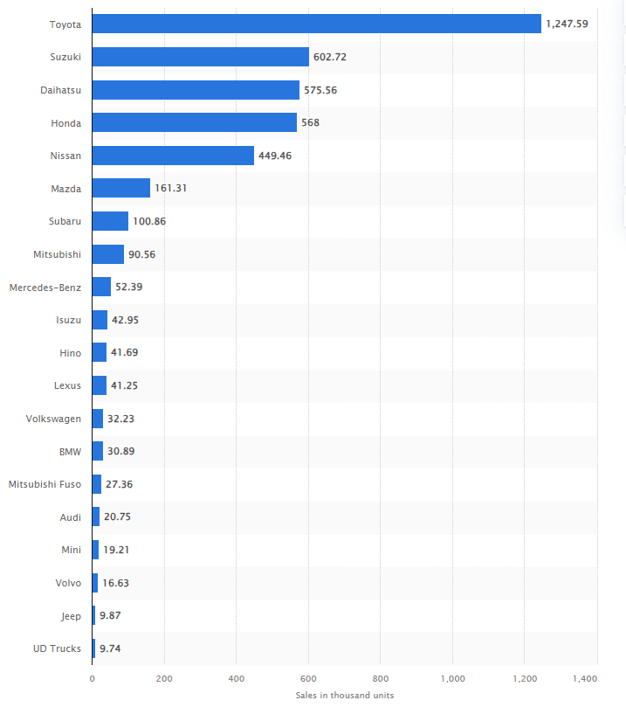
Figure 4: Leading car manufacturers in Japan in 2022, based on sales
(Source: Statista.com, 2023)
Toyota has accelerated its operational scale with the forward looking approach, which has made the company an industry champion. In the financial year 2023, the company recorded 37,154,298 sales revenue depicting an overall 18.4% growth from the previous year (Global.toyota, 2023). This shows the deep conviction in operational ideology coupled with belief in quality and integrity in performance. The cumulative effort of all these factors resulted in building a new dimension for the company. On the other hand, Toyota’s revenue is expected to reach US$43bn in 2023 with an expected annual growth rate of 2.03% (Statista.com, 2023). The company is performing quite well in China where the unit sale of the cars is expected to reach 1,815.0k vehicles by 2027 (Statista.com, 2023). In contrast to this, Toyota remains the leading car manufacturer in Japan “selling around 1.25 million vehicles domestically” (Statista.com, 2023).Part of this can be attributed to its resilience and determination in building a strong operational force. Therefore, it can be stated that the company is performing quite well in both the countries with rising car sales each year.

2. Internationalisation strategies
A detailed analysis of the features and characteristics of ethnocentric, polycentric, and geocentric internationalisation strategies
Ethnocentric internationalisation strategy
Ethnocentric approach is generally applied during the recruitment of international staff that the HR departments generally incorporate to manage momentum in overseas operations. As observed by Zhong et al. (2021), in the ethnocentric internationalisation strategy, the company tends to recruit employees of the same nationality as the parent company overseas. As a result, managing the employees becomes easier and the organisation can easily proceed with the operational process without getting to provide any brief to the employees. In view of Pérez (2022), the most likely challenges that organisations face while internationalisation is to manage multicultural employees. The different views and values remain the crucial point of contention in this case that the organisations encounter during the process of internationalisation.
Polycentric internationalisation strategy
A polycentric international strategy is contradictory to the approach of ethnocentric international strategy. This strategy encourages organisations to limit the recruitment of nationals and rather shift to local people. According to the view of Zhu (2019), most companies shift from ethnocentric to polycentric as it is not convenient for the company to hire nationals in the host country. In this context, the attempt to cut the cost remains the key driving force for the organisations to rapidly shift to the polycentric international strategy. The key feature of this international strategy is that HR recruit employees with technological skills so the void of skill deficiency within operations can be met properly. In most cases, employees are hired from the locals with adequate knowledge in the field to help the organisation in navigating the performance in an orderly manner.
One of the key features of this international strategy is that nationals of the company are posted in a higher position compared to the locals. As observed by Fernando (2021), the primary reason for putting the nationals of the parent company in the higher position of the subsidiary is to ensure that the interest of the parent company can be conveyed properly to the local employees. This allows the organisation to maintain synchronisation with the parent and help in taking uniform decisions.
Geocentric internationalisation strategy
In a geocentric approach, organisations tend to hire the most suitable person with the role who can help in achieving the respective organisational objectives. It is analysed that in this strategic approach, organisations tend to focus less on nationals and seek to explore the wider perspective of the operational cycle. As opined by Eickemeyeret al. (2021), when the organisations are moving towards the maturity level, it becomes more selective towards the choice of the employees. This can be particularly attributed to the aspects of bringing greater focus towards maximising profit and productivity. This strategic approach has helped the company immensely to thrive amidst rising competitiveness by retaining its momentum in the market. Along with this, the relentless effort of achieving quality further made companies adopt this strategy, which can add more impetus to the productivity of the organisation. In addition to this, the strategic management of the companies have been crucial to slowly penetrate in the market and use local skills and knowledge further.
HRM remains the most crucial prospect for the companies in this geocentric internationalisation strategy. It includes recruiting people strictly based on skills and knowledge followed by measuring the job suitability of the individual. Based on the observation of Vermootenet al. (2019), the recruitment of suitable employees for a specific job role implies that individuals can work more proactively. Consequently, this improves the operational productivity and performance due to the familiarity of the individuals regarding the specific job role. The implication of this strategy is quite beneficial as it constantly attempts to retain the performance through talent management within the operation.
Comparison of the approaches
 | Ethnocentric | Polycentric | Geocentric
Feature | The primary feature of this international strategy is that only focuses on hiring nationals. This can be seen in the expansion of Toyota in Taiwan (Toyota-global.com, 2023) | This strategy focuses on recruiting more locals over the nationals as can be seen in the globalisation of Toyota in USA (Toyota.com, 2023) | Increasing skilled and suitable individuals for the job role is mostly preferred in this strategy. This can be observed in the Toyota’s strategy to put more focus on creating a talent pool (Thetoyotaway.org, 2023)
Characteristics | It is generally characterised by following the same principles and policies same as the home country. This is followed by Toyota in all its expansion such as keeping its vision of making innovation to make movement of people easier. | It focuses on maintaining the principles of the home country by appointing nationals in the higher position. This can be followed in any global market by Toyota to retain momentum. | At this stage, the companies are mostly focused on accelerating its performance in the global market, which further requires Toyota to make adjustment in the existing principles and policy of the host country such as including more technological advancements
HRM approach | HRM approach relies heavily on recruiting only nationals to maintain the momentum as followed in the initial globalisation strategy of Toyota | In this strategy, the importance lies on hiring nationals for the top management and recruiting locals in the lower level. This is followed by Toyotawhile expanding to a new market | In this geocentric strategy, the recruitment and selection are solely based on hiring suitable and skilled professionals who can meet the needs of Toyota.
Table 1: Illustration of comparison of the international strategic approaches
(Source: Created by author)
Analysis
The above table clearly illustrates the comparison between the “ethnocentric, geocentric and polycentric” internationalisation strategy. All these strategies distinguish from each other and contribute differently in the global expansion of the companies. As observed by McCann and Soete (2020), in the course of global expansion, it is important to hire local people as their inclusion ensures that local market trends and other important features regarding local market can be understood properly. In this context, the polycentric approach can be relatively effectively helping the company Toyota to boost global expansion further. On the other hand, in the course of the maturity of an organisational operation, it becomes important for the organisations like Toyota to hire experts and professionals who can help Toyota in meeting its strategic objectives. Moreover, hiring the experts always comes with advantages such as executing operations with quality, which further results in maintaining productivity of the operations. The accumulated effort of all these aspects paves the way for further global expansion.

3. Company’s internationalisation approach
Critical evaluation of the internationalisation approach chosen by the company
Internationalisation is a crucial process for every organisation as it brings forth the opportunity for market penetration, acquiring new resources and expanding customer numbers further. In this respect, Toyota’s global vision is intrinsically linked to the developmental process, where providing importance to the customer preference remains the most important operation for the company (Toyota-global.com, 2023). In this context, conveying this philosophy of the organisation remains important to include consistency and synchronisation within the company. Therefore, the company always relies on recruiting local employees in other terms localisation to get further insights into the key market behaviour. Therefore, Toyota chooses a polycentric internationalisation strategy in order to retain momentum during its global expansion.
In this context, it is important to highlight that Toyota’s approach is home-country driven, which implies that the values of the company in the home country lies at the core feature of this international strategy. This also leads the company to choose the polycentric approach, which is reflected in its insistence to carry forward the ideas and philosophy of the parent company further even during the marketing process. However, Toyota remains indifferent towards the ethnocentric internationalisation strategy as it is biased and only encourages the recruitment of nationals. This ethnocentric internationalisation strategy prioritises the belief and values practised in the home country rather than the host country (Cleveland et al. 2022). Therefore, valuing the cultural belief and values of the home country is important, however over indulgence into the recruitment of nationals can bring greater challenges for the company. It is observed by Campbell et al. (2020), employment of local individuals can help in understanding the key marketing dynamism, which can help the company in learning aspects regarding the market trends and customers behavioural intention. Moreover, with the help of the local employees, the company can get further familiarity with the market. As a result, this helped Toyota to design its global strategies accordingly.
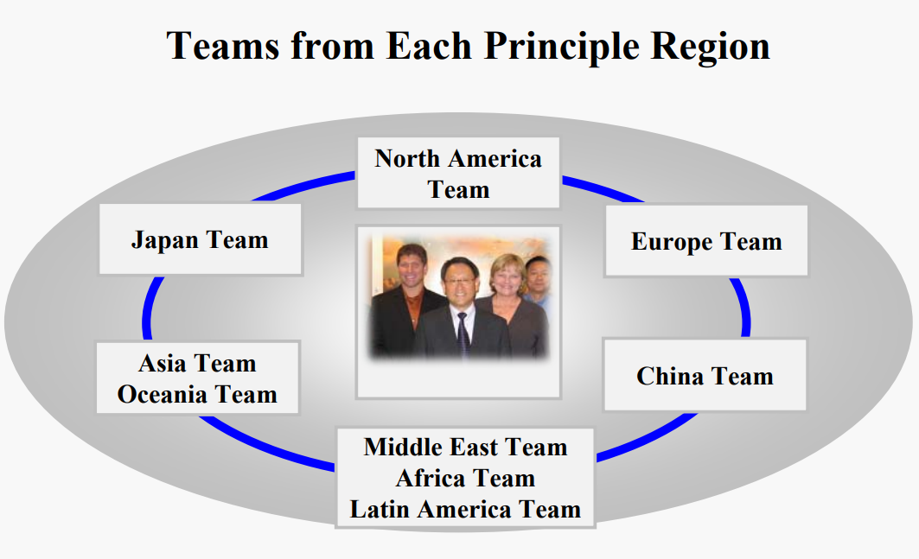
Figure 5: Teams for each principle region
(Source: Toyota-global.com, 2023)
The adoption of developing new teams based on the area and regions have been quite beneficial for the organisation in retaining its resilience while navigating global operations. Moreover, another key characteristic of the polycentric strategy is that it upholds the interest of the headquarter, which again symbolises the fact of following the same belief as the home country overseas. This allows the company to make its employees understand the key vision and consequently, this helps employees to understand the key vision of the company. In this context, Fountaine et al. (2019) have stated that developing a vision is the key tool for an organisation to give expression to its needs. In the course of achieving this strategy, every organisation strives towards designing an effective strategic framework, which can help the company in fulfilling its key needs. Likewise, Toyota formulated a strategy, which is holistic in approach implying that the organisation seeks to create more employment opportunities in the market (Toyota-global.com, 2023). This remains the same in their expansion prospect as well. As a result, the company offers employment opportunities to both the nationals and locals. Part of this reason can be attributed to the inherent need to get more insights into the market nature of the host country, which is China. Therefore, in strengthening operations in China, the company needs to expand its polycentric internationalisation strategic approach.
Exploration of factors affecting the strategic decision-making approach of the company
The characteristic of polycentric strategy is that it does not require any full-fledged international market. On the other hand, the recruitment process in this approach involves four key stages such as “self-selection, creating a candidate pool, technical skills assessment, and making a mutual decision”. This can be termed as the key factors of the strategic framework that Toyota needs to consider further in order to make the right decision during the process of selection. As polycentric strategy focuses more on recruiting locals over nationals, it becomes important for the company to employ an effective strategic design (Vogelsang and Pilz, 2021). This further helps in the implementation of the strategies effectively. In this context, needs of the market and requirement of the strategic approach are the two significant factors that Toyota needs to take into account in streamlining its global expansion in China. In this context, Toyota believes that employees drive inclusion within operations, which further leads the company to emphasise on the multicultural team (Toyota-global.com, 2023). Therefore, the feature of this international strategy is highly effective as it saves the time of the organisation in conveying the interest of the parent company.
Based on the analysis, it can be stated that global expansion depends on different factors such as resources and strategic operational position of the company. In this aspect, choosing the right strategic approach helps in creating opportunities like customer acquisition and leading the way for further market penetration. As the cultural belief of China differs from Japan, Toyota needs to consider aspects like employee management and policy design properly to foster a better culture for the organisation. It is argued by Lake et al. (2021), organisations tend to follow the same principles and philosophy as the parent company while expanding globally. This further affects the decision making process of Toyota in China. The reason can be attributed to the desire of maintaining the same objectives and building synchronisation in the operations.
Moreover, at the mature point of operation, hiring only the nationals of the host nation can be challenging as knowledge and skills become important for the organisation in navigating its key activities effectively. Additionally, in the presence of skilled employees’ organisations are able to bring forth new momentum to the overall operations. As a result, the organisation becomes more productive, which is further reflected in the financial performance.

4. PESTLE analysis
Factors | Description | Overall Impact
Political | - China’s score in “political power” is estimated at -2 out of 40 implying that people in China are not politically free (Freedomhous.org, 2023)  - China’s government reflects authoritarian rule, which believes in restricting the freedom of the people (Freedomhous.org, 2023)  - Leaders of China are not freely elected, which depicts the strict rule of the company that further brings challenges to the organisations | Negative
Economic | - China’s GDP is expected to grow by 5.1% at the end of 2023, which implies the production rate in the country is expected to rise rapidly (Edition.cnn.com, 2023)  - In 2022, China’s inflation rate was estimated around 1.97%, an overall of 0.99% increase from 2021 (Macrotrends.net, 2023)  - Passenger vehicles share around 86.1% share in the Chinese market followed by Commercial Vehicles holding 13.9% share implying that automobile sector is prosperous in the country (Marklines.com, 2023) | Positive
Social | - Chinese society is more ideologically-driven and restricted implying that new things are not accepted easily within the country (Carnegieendowment.org, 2019)  - In 2020, the number of passenger cars registered in China can be estimated at 241.7 million, which is increased by 7.5% from the previous year (Statista.com, 2023)  - The future of Chinese society lies in innovation, where people seek to use new technology in making daily life easier (Hbr.org, 2021) | Positive and negative
Technological | - China’s car companies are turning tech companies with rapid inclusion of technology, which is upscaling the industry further (Technologyreview.com, 2023)  - Navigation of autopilot becomes the new technological approach towards building the future of automobile industry (Technologyreview.com, 2023)  - Recently, Xiaomi won the $10 Billion Investment Pledge that further received approval from China to make electric vehicles with high technological features (Gadgets360.com, 2023) | Positive
Legal | - China’s domestic trade policies are driven by “pushing for indigenous innovation, driving self-sufficiency, enhancing national security, and market reform” (Impact.economist.com, 2021)  - China has developed 21 pilot free trade zones as of February 2022 to streamline trading further (Impact.economist.com, 2021)  - Based on the report of WTO, China's average “applied Most Favoured Nation (MFN)” tariff rate has been progressively lowered from 15.3% in 2001 to 7.5% in 2020 (Research.hktdc.com, 2022) | Negative
Environmental | - China is committed towards becoming carbon neutral before 2060 (Chinadashboard.gist.asiasociety.org, 2021)  - The country has taken the pledge of curbing emission by signing the Paris agreement (Cfr.org, 2021)  - China is installing wind and solar power generator to create a combined capacity of 1.2 billion kilowatts by 2030 (Cfc.org, 2021) | Positive and Negative
Table 2: PESTLE
(Source: Self-created)
Analyse
Based on the PESTLE analysis, it can be stated that Toyota has both opportunities and threats while expanding its operations further in China. The most potential threat is expected to come from the political power of the Chinese government. The repressive and interventionist policy of the Chinese government can affect the free set-up business (Freedomhous.org, 2023). In addition, the businesses are unlikely to get any autonomous opportunity in navigating its business operations properly in the country. As a result, Toyota is expected to witness more challenges compared to opportunities in the course of adding momentum to the internationalisation strategy. On the other hand, it is projected that China’s GDP is expected to grow significantly in the coming years, which can be seen as a positive sign for Toyota to boost its operations along with the acceleration of financial performances in the country (Edition.cnn.com, 2023). In terms of measuring the inflation rate and overall sales of the passenger cars in China, it can be stated that Toyota can take advantage of the growing economy in its benefits to fortify market operations. Overall, the PESTLE analysis shows that these factors can have a both and positive impact on the internationalisation strategy of Toyota. China’s growing GDP is an indication that this company can provide better facilities to employees. A tech-driven nation further paves the way for including different technological dimension to make training more data-driven.
The social factors can be a challenge for the organisation due to following the cultural beliefs rigidly. However, rising acceptance of technology and increasing purchase of passenger cars can be beneficial for Toyota to dominate the market (Statista.com, 2023). In this context, the social factor can have both positive and negative influence on the company. In addition to this, it is analysed that technology-driven culture of China has more things to offer to companies. The well-built IT infrastructure and expansive use of technology in the automobile sector enables the company to experiment with the car models further. Contradictory to this, the robust legal structure of China can be a challenge for Toyota in retaining momentum in the internationalisation strategy. This can further lead to the rapid change in the existing strategic framework. Moreover, this can also cause challenges during the internationalisation process of Toyota due to the rigid legal framework (Impact.economist.com, 2021). Additionally, Toyota needs to oblige the current environmental plan of China ensuring that this can simplify the internationalisation process of the company.

5. Integration of contextual factors and internationalisation strategy
Integration of PESTLE analysis and company’s internationalisation strategy
Environmental analysis is an important tool that allows organisations to design effective internationalisation strategies. In the context of Toyota, this remains the same as it focuses on key external factors like “political, economic, social, technological, legal, and environmental” to frame the internationalisation strategy. Based on the analysis of the political factors, it can be stated that non-compliance can become a challenge for Toyota in streamlining operations during the expansion in China. With regard to this, Toyota always focuses on formulating strategies which are holistic in nature and encompasses the key vision of the company (Toyota-europe.com, 2023). Considering the overbearing pressure of cost depending on value chain that the company faces while internationalisation, it is important to consider an effective cost reduction strategy, which is both cost-effective and competitive. It is argued by Jamjumrus and Sritragool (2019) cost leadership is a strategy that organisations generally adopt with the aim of reducing costs from operations and adding further agility to the production. Considering the inflation rate in China, it can be stated that the cost-leadership strategy of Toyota is expected to bring significance towards the company’s operations (Businesswire.com, 2022). Therefore, formulation of this strategy during the process of internationalisation is likely to produce more positive results in the host country.
Based on the analysis, it can be stated that Toyota’s internationalisation strategy is in line with the external factors. This further allows the company to bring consistency with the operations based on value chain within and also balances changing situations outside the company. As observed by Yang et al. (2019), the failure behind most of the organisations can be attributed to the overarching inconsistency and gap that exists between the company’s internationalisation strategy and changing market scenario. The lack of knowledge regarding the key marketing trends in China Toyota can face a serious setback in its expansion journey. On the other hand, competitive strategy is another key tool in the hands of Toyota in strengthening its marketing position in China. For instance, China is a technology and innovation driven country, which can be reflected in the growing IT infrastructure (Technologyreview.com, 2023). In order to match this growing IT developments, Toyota also adopted a differentiation strategy for its production. Through the “mobility concept” Toyota intends to bring forth new EV technology that can change the direction of manufacturing completely (Global.toyota, 2023). In addition to this, the environmental strategy, which is committed to reducing carbon emissions, is also effective in the face of growing concern regarding global warming.
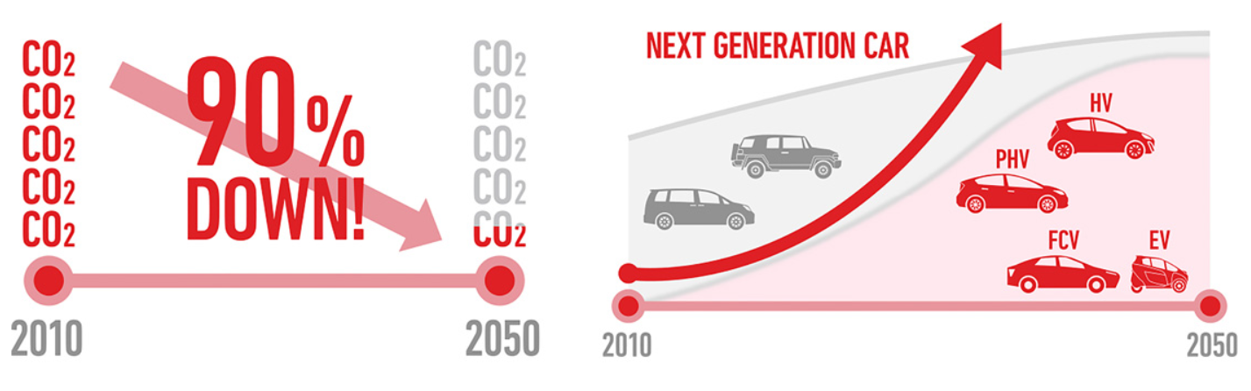
Figure 6: Toyota’s environmental strategy
(Source: Tdem.toyota-asia.com, 2023)
Toyota’s environmental strategy is driven by sustainable governance that seeks to create equilibrium within operations by reducing the negative impact of production and operation on the environment. In 2015, Toyota announced its first ever “Toyota Environmental Challenge 2050 (Challenge 2050)”, which consists of six visionary challenges to make the company a climate champion (Tdem.toyota-asia.com, 2023). It is analysed that this environmental strategy is closely linked with exploring EV, PHV, FCV, and HV cars, which are both environmentally-friendly. The above illustration depicts that the company intends to achieve carbon neutrality in the operations by 2050 (Tdem.toyota-asia.com, 2023). The discussion on the international strategies is significant for the company in realising that external factors have become a major factor for the organisation in terms of designing its internationalisation strategy. Based on the comments of Zhang and Dong (2020), customers are becoming environmentally conscious and this can be further reflected in the choice of purchase. This can further serve as a driving force for the companies like Toyota in reformulating its car models to cater to the interest of the customers.
Importance of contextual factors in shaping the internationalisation strategy
The importance of contextual factors cannot be measured with any yardstick, however, it can be seen in the changing operational situation of the company. The study by Xin-gang and Wei (2020) illustrates that contextual factors serve as a guiding force for companies in terms of bringing momentum change in the operational parameter of an organisation. In this case, the importance of contextual factors is quite evident in helping the company in shaping its strategies. Based on the above image, it can be discerned that safety configuration remains the most preferred choice among the people of China, while purchasing cars (Statista.com, 2023). Following this, around 53% of people responded towards dynamic performance of cars. In light of this preference, Toyota has designed a sturdy safety configuration, which is not only holistic in approach but also provides quality assurance. For instance, “Pre-Collision System with Pedestrian Detection (PCS w/PD)” is designed to help the drivers in detecting vehicles, bicyclist, pedestrians and motorcyclists and provide a warning in terms of audio/visual forward collision warning under certain circumstances (Toyota.com, 2023). This feature immediately makes Toyota famous in front of the customers. In addition to this, it also provides “dynamic radar cruise control”, lane departure alert and lane tracing assistance to provide drivers with safety alert. Moreover, the dynamic car features such as “Adjustable ORVM, Power Windows, Turn Indicators on ORVM, Rear Defogger, One Touch -Down, Rain-sensing Wipers” makes operations of these cars more comforting (Zigwheels.com, 2023). The “one in all approach” adopted by Toyota seems to be quite competitive for the company in terms of optimising its expansion strategy further. As a result, the company has generated 767,207 sales outside Japan implying that the sales have improved impeccably over the years (Global.toyota, 2022). Part of this can be attributed to the contextual factors, which has helped the company immensely in producing positive results for the company globally. Therefore, it is important to state that contextual factors have been important for the organisation in understanding market drivers and this further helped in shaping its internationalisation strategy. This can be further reflected in the differentiation strategy followed in the production of cars and its operation.

6. Recommendation
Developing a multicultural team
Toyota needs to develop a multicultural team, which can help in retaining consistency and add synthesis in the operations of employees. As observed by Brett et al. (2020), in the absence of a multicultural team, a company can face cultural issues, which has become a more frequent challenge in terms of expansion. It is recommended to Toyota to adopt an effective multicultural strategy that can help in creating a productive team followed by reducing the conflicts within the team. This further pave the way for optimising overall productivity. As a result, the company can accelerate its performance in the market as well.
Emphasising on geocentric internationalisation strategy
The geocentric internationalisation strategy can be effective for Toyota in retaining skilled professionals who can constantly keep the scale of productivity within the operation. According to the view of Conrad and Meyer-Ohle (2019), geocentric internationalisation strategy is closely linked to hiring skilled and suitable individuals who can execute the activities handed over to them appropriately. In the course of internationalisation strategy, Toyota needs to include this internationalisation strategy to help the company hire suitable Chinese people that can bring new opportunities for the company in scaling its performance. Henceforth, it can be recommended that geocentric internationalisation strategy can further help in optimising productivity and helping the company in producing quality services for the customers.
Bringing agility to the production
Developing agility in the production needs to be supported with rapid inclusion of technology that can add new dimensions in the production. The study by Mrugalska and Ahmed (2021) depicts that automation has helped the companies in achieving new dimensions and agility. It is further followed by paving the ways for organisations like Toyota to include accuracy and efficiency in its overall production. It can be recommended that encouraging automation in the manufacturing process is highly beneficial for the company in meeting market demands and achieving resilience throughout the operational cycle. Moreover, it is evident that including agility through new technology can be beneficial for the organisation in meeting market demands. Additionally, it is expected to bring more accuracy in terms of determining the future scope and demands of car models. As a result, this can bring more efficiency in terms of building capacity and managing inventory accordingly.
Production of more EV cars
Customers are gaining more awareness about the environment, which can be reflected in the purchase of EVs. As observed by Barkenbus (2020), Electric vehicles are gaining quick momentum in the market due to its less carbon emission prospect. Moreover, several governments have set an ambitious goal of achieving carbon neutrality in the coming decades. In the face of such high commitment, Toyota needs to boost its EV production in order to retain its competitive advantage in the market. Moreover, the trends in the market and customer preference rely heavily on this aspect. Thus, it is recommended for Toyota to boost EV production in order to streamline its internationalisation strategy.

References
Barkenbus, J.N., (2020). Prospects for electric vehicles. Sustainability, 12(14), p.5813.
Brett, J., Behfar, K. and Kern, M., (2020). Managing multicultural teams. In Organizational Collaboration (pp. 155-164). Routledge.
Businesswire.com, (2022). Toyota Motor Corp Case Study including Generic Strategies, Product Range, Growth and Marketing Strategies. Available at: https://www.businesswire.com/news/home/20221017005724/en/Toyota-Motor-Corp-Case-Study-including-Generic-Strategies-Product-Range-Growth-and-Marketing-Strategies---ResearchAndMarkets.com [Accessed on: 8th November 2023]
Campbell, C., Sands, S., Ferraro, C., Tsao, H.Y.J. and Mavrommatis, A., (2020). From data to action: How marketers can leverage AI. Business horizons, 63(2), pp.227-243.
Carnegieendowment.org, (2019). Chinese State-Society Relations: Why Beijing Isn’t Trembling and Containment Won’t Work. Available at: https://carnegieendowment.org/2019/03/14/chinese-state-society-relations-why-beijing-isn-t-trembling-and-containment-won-t-work-pub-78596 [Accessed on: 8th November 2023]
Cfr.org, (2021). China’s Fight Against Climate Change and Environmental Degradation. Available at: https://www.cfr.org/backgrounder/china-climate-change-policies-environmental-degradation [Accessed on: 8th November 2023]
Chinadashboard.gist.asiasociety.org, (2021). Environment. Available at: https://chinadashboard.gist.asiasociety.org/winter-2021/page/environment#:~:text=While%20China%20is%20dropping%20short,these%20goals%20will%20be%20achieved [Accessed on: 8th November 2023]
Cleveland, M., Papadopoulos, N. and Laroche, M., (2022). Global consumer culture and national identity as drivers of materialism: an international study of convergence and divergence. International Marketing Review, 39(2), pp.207-241.
Conrad, H. and Meyer-Ohle, H., (2019). Overcoming the ethnocentric firm?–foreign fresh university graduate employment in Japan as a new international human resource development method. The International Journal of Human Resource Management, 30(17), pp.2525-2543.
Edition.cnn.com, (2023). China’s economy regains momentum. But real estate remains a drag. Available at: https://edition.cnn.com/2023/10/17/economy/china-q3-gdp-intl-hnk/index.html#:~:text=Earlier%20this%20month%2C%20the%20World,weakness%20and%20an%20aging%20population [Accessed on: 8th November 2023]
Eickemeyer, S.C., Busch, J., Liu, C.T. and Lippke, S., (2021). Acting instead of reacting—ensuring employee retention during successful introduction of i4. 0. Applied System Innovation, 4(4), p.97.
Electrek.co, (2023). Here’s where Toyota’s first US-made EV, an electric 3-row SUV, will be built. Available at: https://electrek.co/2023/05/31/toyotas-top-global-plant-to-build-first-us-made-ev-3-row-suv/ [Accessed on: 8th November 2023]
Fernando, D., (2021). Challenging the cross-national transfer of diversity management in MNCs: Exploring the ‘identity effects’ of diversity discourses. human relations, 74(12), pp.2126-2152.
Fountaine, T., McCarthy, B. and Saleh, T., (2019). Building the AI-powered organization. Harvard Business Review, 97(4), pp.62-73.
Freedomhouse.org, (2023). China. Available at: https://freedomhouse.org/country/china/freedom-world/2023 [Accessed on: 8th November 2023]
Gadgets360.com, (2023). Xiaomi, With $10 Billion Investment Pledged, Wins China Approval to Make Electric Vehicles. Available at: https://www.gadgets360.com/auto/news/xiaomi-ev-approval-china-usd-10-billion-investment-automobiles-electric-vehicles-4322778[Accessed on: 8th November 2023]
Global.toyota, (2022). Sales, Production, and Export Results for 2022 (January - December). Available at: https://global.toyota/en/company/profile/production-sales-figures/202212.html [Accessed on: 8th November 2023]
Global.toyota, (2023). FINANCIAL SUMMARY. Available at: https://global.toyota/pages/global_toyota/ir/financial-results/2023_4q_summary_en.pdf [Accessed on: 8th November 2023]
Global.toyota, (2023). History of Toyota. Available at: https://global.toyota/en/company/trajectory-of-toyota/history/ [Accessed on: 8th November 2023]
Global.toyota, (2023). Toyota Global Vision. Available at: https://global.toyota/en/company/vision-and-philosophy/global-vision/#:~:text=Toyota%20will%20lead%20the%20future,be%20rewarded%20with%20a%20smile[Accessed on: 8th November 2023]
Global.toyota, (2023). Toyota Unveils New Technology That Will Change the Future of Cars. Available at: https://global.toyota/en/newsroom/corporate/39288520.html [Accessed on: 8th November 2023]
Hbr.org, (2021). China’s New Innovation Advantage. Available at: https://hbr.org/2021/05/chinas-new-innovation-advantage [Accessed on: 8th November 2023]
Impact.economist.com, (2021). Economic Power Play: Assessing China's Trade Policies. Available at: https://impact.economist.com/perspectives/sites/default/files/economic_power_play_assessing_chinas_trade_policies_0608.pdf [Accessed on: 8th November 2023]
Jamjumrus, T. and Sritragool, N., (2019). Investigating the impact of supply chain agility, government regulations and supply chain efficiency on business performance: mediating role of cost leadership. Int. J. Supply Chain Manag, 8(4), pp.399-407.
Lake, D.A., Martin, L.L. and Risse, T., (2021). Challenges to the liberal order: Reflections on international organization. International organization, 75(2), pp.225-257.
Macrotrends.net, (2023). China Inflation Rate 1987-2023. Available at: https://www.macrotrends.net/countries/CHN/china/inflation-rate-cpi#:~:text=China%20inflation%20rate%20for%202022,a%200.82%25%20increase%20from%202018 [Accessed on: 8th November 2023]
Marklines.com, (2023). Automotive-sales-in-China-by-month. Available at: https://www.marklines.com/en/statistics/flash_sales/automotive-sales-in-china-by-month [Accessed on: 8th November 2023]
McCann, P. and Soete, L., (2020). Place-based innovation for sustainability. Publications Office of the European Union: Luxemburg.
Mrugalska, B. and Ahmed, J., (2021). Organizational agility in industry 4.0: A systematic literature review. Sustainability, 13(15), p.8272.
Pérez, K., (2022). Cultural Diversity as a Competitive Advantage and The Importance of Cross-Cultural Management in the Internationalization Process of a company: The case of smart Europe GmbH.
Research.hktdc.com, (2022). Trade Regulations of China. Available at: https://research.hktdc.com/en/article/MzM0NTEzMzcy [Accessed on: 8th November 2023]
Statista.com, (2023). Amount of passenger cars in China from 2009 to 2020. Available at: https://www.statista.com/statistics/278423/amount-of-passenger-cars-in-china/#:~:text=In%202020%2C%20the%20amount%20of,in%20China%20reached%20302%20million [Accessed on: 8th November 2023]
Statista.com, (2023). Important aspects which customers looked at when buying a vehicle in China as of May 2020. Available at: https://www.statista.com/statistics/1148137/china-factors-for-purchasing-cars/#:~:text=Preferences%20of%20vehicles%20in%20China%202020%2C%20by%20criteria&text=According%20to%20a%20survey%20conducted,making%20purchases%20of%20a%20car [Accessed on: 8th November 2023]
Statista.com, (2023). Leading car manufacturers in Japan in 2022, based on sales. Available at: https://www.statista.com/statistics/348427/car-sales-in-japan-by-brand/
Statista.com, (2023). Toyota (Passenger Cars) – China. Available at: https://www.statista.com/outlook/mmo/passenger-cars/toyota/china#:~:text=Revenue%20for%20Toyota%20is%20projected,1%2C815.0k%20vehicles%20in%202027 [Accessed on: 8th November 2023]
Statista.com, (2023). Toyota's net revenue from FY 2012 to FY 2023. Available at: https://www.statista.com/statistics/262752/total-net-revenues-of-toyota/#:~:text=The%20Toyota%20Motor%20Corporation%27s%20net,to%20279%20billion%20U.S.%20dollars [Accessed on: 8th November 2023]
Statista.com, (2023). Toyota's retail vehicle sales from 2017 to 2022. Available at: https://www.statista.com/statistics/267274/worldwide-vehicle-sales-of-toyota-since-2007/#:~:text=Globally%2C%20Toyota%20sold%20around%2010.48,of%20the%20limited%20semiconductor%20supply [Accessed on: 8th November 2023]
Tdem.toyota-asia.com, (2023). Toyota environmental challenge. Available at: https://www.tdem.toyota-asia.com/sustainability-envi.html [Accessed on: 8th November 2023]
Technologyreview.com, (2023). China’s car companies are turning into tech companies. Available at: https://www.technologyreview.com/2023/08/16/1077942/chinas-car-companies-turn-tech/ [Accessed on: 8th November 2023]
Thetoyotaway.org, (2023). Toyota Talent: Developing Your People the Toyota Way. Available at: https://thetoyotaway.org/product/toyota-talent/ [Accessed on: 16 November 2023]
Toyota.com, (2023). Engaged, Diverse and Inclusive Environments for All. Available at: https://www.toyota.com/usa/sustainability/diversity [Accessed on: 16 November 2023]
Toyota.com, (2023). Safety hub. Available at: https://www.toyota.com/safety-sense/ [Accessed on: 8th November 2023]
Toyota-europe.com, (2023). Toyota in the world. Available at: https://www.toyota-europe.com/about-us/toyota-in-the-world [Accessed on: 8th November 2023]
Toyota-global.com, (2023). Item 1. Taiwan. Available at: https://www.toyota-global.com/company/history_of_toyota/75years/text/leaping_forward_as_a_global_corporation/chapter1/section4/item1.html [Accessed on: 8th November 2023]
Toyota-global.com, (2023). TOYOTA GLOBAL VISION. Available at: https://www.toyota-global.com/pages/contents/company/message_from_president/president110309.pdf [Accessed on: 8th November 2023]
Toyota-global.com, (2023). Vehicle Lineage Chart. Available at: https://www.toyota-global.com/company/history_of_toyota/75years/data/automotive_business/products_technology/vehicle_lineage_chart/vehicle_lineage_chart/index.html [Accessed on: 8th November 2023]
Toyota-industries.com, (2023). Automobile. Available at: https://www.toyota-industries.com/products/automobile/#:~:text=Toyota%20Industries%20develops%20and%20manufactures,and%20devices%2C%20and%20stamping%20die [Accessed on: 8th November 2023]
Vermooten, N., Boonzaier, B. and Kidd, M., (2019). Job crafting, proactive personality and meaningful work: Implications for employee engagement and turnover intention. SA Journal of Industrial Psychology, 45(1), pp.1-13.
Vogelsang, B. and Pilz, M., (2021). Conditional factors for training activities in Chinese, Indian and Mexican subsidiaries of German companies. European Journal of Training and Development, 45(4/5), pp.419-435.
Xin-gang, Z. and Wei, W., (2020). Driving force for China’s photovoltaic industry output growth: Factor-driven or technological innovation-driven?. Journal of Cleaner Production, 274, p.122848.
Yang, E., Bisson, C. and Sanborn, B.E., (2019). Coworking space as a third-fourth place: changing models of a hybrid space in corporate real estate. Journal of Corporate Real Estate, 21(4), pp.324-345.
Zhang, X. and Dong, F., (2020). Why do consumers make green purchase decisions? Insights from a systematic review. International journal of environmental research and public health, 17(18), p.6607.
Zhong, Y., Zhu, J.C. and Zhang, M.M., (2021). Expatriate management of emerging market multinational enterprises: a multiple case study approach. Journal of Risk and Financial Management, 14(6), p.252.
Zhu, J.S., (2019). Chinese multinationals’ approach to international human resource management: A longitudinal study. The International Journal of Human Resource Management, 30(14), pp.2166-2185.
Zigwheels.com, (2023). Key Specification of Fortuner Top Model. Available at: https://www.zigwheels.com/toyota-cars/fortuner/specifications#leadform [Accessed on: 8th November 2023]

Appendix 1: Important aspects which customers looked at when buying a vehicle in China as of May 2020

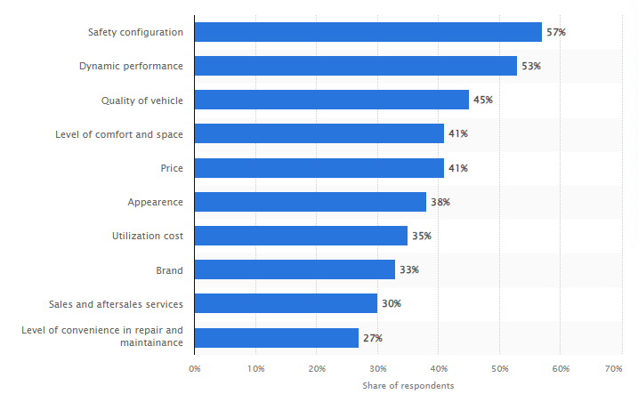
(Source: Statista.com, 2023)

Appendix 2: Value chain works in Toyota


