NON-FACE TO FACE HOURS
Placement provider: Carmarthenshire Youth Support Service (St Clears and Tycroes Youth Clubs)

DATE | LOCATION | TOPIC | HOURS
9/11/2024 | Home | Reading level 4 placement guidelines | 3
28/11/2024 | University | Safeguarding training | 4.75
9/12/2024 | St Clears leisure centre | St Clears Youth Club staff meeting | 0.75
18/01/2025 | Home | Writing reflection 1 | 3
16/1/2025 | Home | Researching youth club activities | 3
1/2/2025 | Home | Reading the Youth Work in Wales policy documents | 4
2/2/2025 | Home | Researching about the Carmarthenshire Youth Support Service | 3
3/2/2025 | Online at home | Level 2 online food safety training | 6.5
4/2/2025 | Costa Coffee Cross Hands | Meeting with Tycroes staff member | 1.75
5/2/2025 | Home | Pancake activity planning and food shopping (for Tycroes youth club) | 2.5
7/2/2025 | Home | Reading the NOS | 5.5
21/2/2025 | Home | Writing reflection 2 | 2.5
27/2/2025 | Home | Researching and reading for community profile | 6
3/3/2025 | Home | Pancake activity planning and food shopping (for St Clears Youth Club) | 2
3/3/2025 | St Clears Starbucks | Supervision meeting 1 | 1
6/3/2025 | Home | Planning for community profile questions (St Clears) | 3
11/3/2025 | Home | Writing reflection 3 | 2.5
13/3/2025 | St Clears Starbucks | Supervision meeting 2 | 1
14/3/2025 | Home | Writing reflection 4 | 3
16/3/2025 | Home | Writing professional development plan | 3.5
17/3/2025 | Home and St Clears youth club room | Planning and writing risk assessment for an activity | 4
17/3/2025 | St Clears Leisure Centre | Supervision meeting 3 | 1
20/3/2025 | Home | Writing reflection 5 | 4
21/03/2025 | Home | Reading Carmarthenshire Youth Support Service’s safeguarding policies and youth club building risk assessments | 4.5
24/03/2025 | St Clears Leisure Centre | Supervision meeting 4 | 1
26/3/2025 | Home | Planning and researching for the Welsh quiz (for Tycroes) | 3
30/3/2025 | Home | Writing reflection 6 | 3
31/3/2025 | St Clears Leisure Centre | Supervision meeting 5 | 1
3/4/2025 | Home | Writing reflection 7 | 2.5
5/4/2025 | Home | Researching and reading about adverse childhood experiences and county lines | 3
7/4/2025 | St Clears Leisure Centre | Supervision meeting 6 | 1
14/4/2025 | St Clears Leisure Centre | St Clears staff meeting | 1
16/4/2025 | Home | Easter Scavenger quiz planning and research (for Tycroes) | 3
23/4/2025 | Home | Playdough activity planning and shopping (for Tycroes youth club) | 3
28/4/2025 | St Clears Leisure Centre | St Clears staff meeting | 1
29/4/2025 | Home | Writing and reading for portfolio | 3.5
30/4/2025 | Home | Writing reflection 8 | 3
 |  |  | Total: 104.75

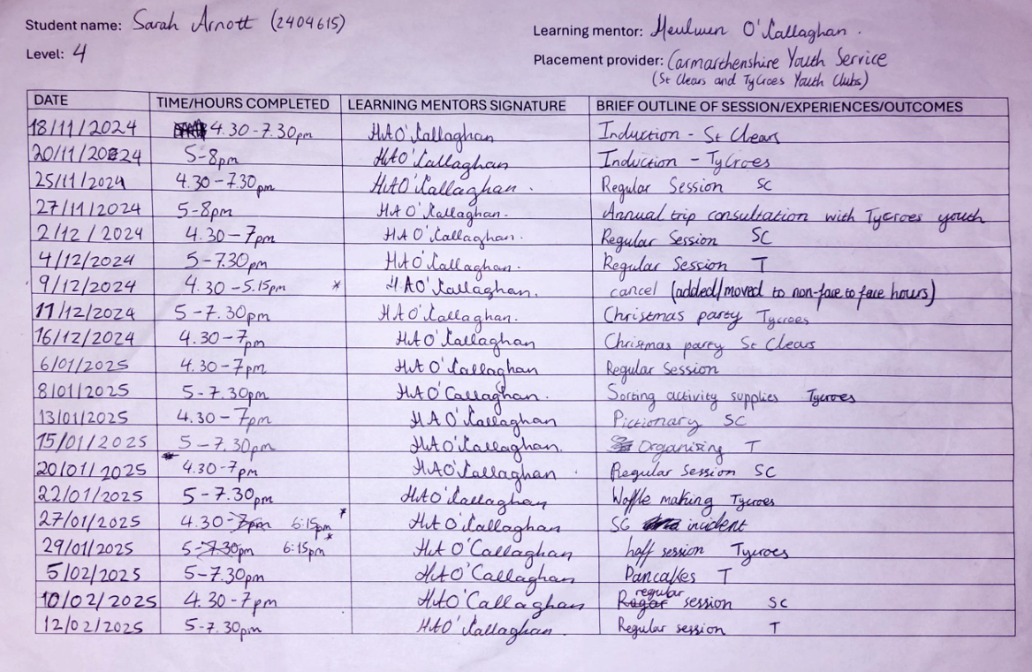
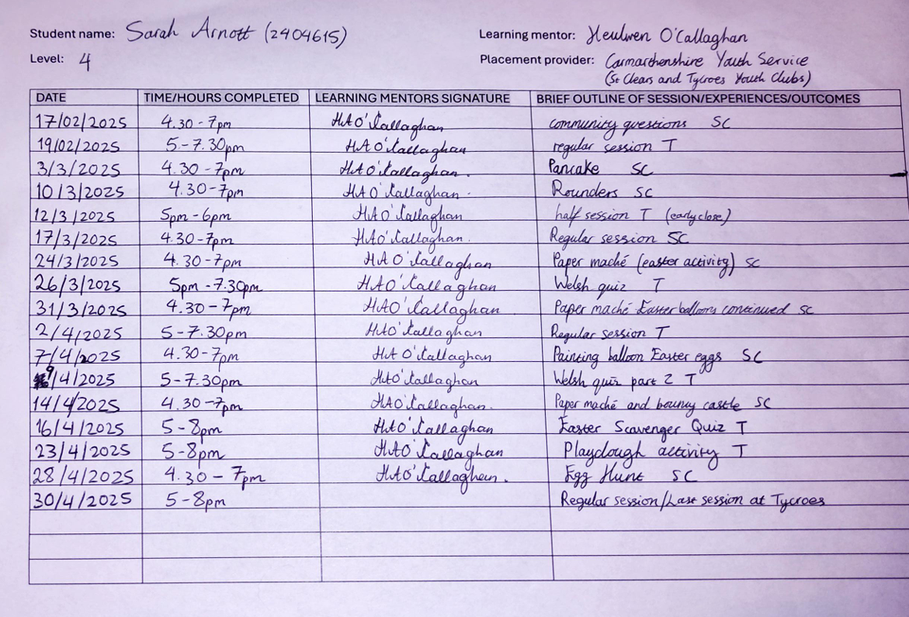
Total hours with young people as of 30/4/25: 90.5 hours Remaining hours will be completed in May

