
Principles and Concepts of Finance
Student name: Kevin Tomko


University OF WALES TRINITY SAINT DAVID

March 12, 2025

Table of Contents
1. Introduction 4
2. Main Findings 5
2.1 Stock Budget 5
Explanation of Stock Budgeting 5
2.2 Cash Budget 6
Explanation of Cash Budgeting 6
2.3 Profit and Loss Account 8
2.4 Key Takeaways 10
3. Problems and Management Actions 10
3.1 Problem Identification 10
3.2 Management Solutions 11
4. Critical Discussion on Budgeting Systems 11
4.1 Conditions for Successful Budgeting and Budgetary Control 11
4.2 People’s Behaviour and Budgeting 12
5. Critical Evaluation of Traditional Budgeting Approaches 12
5.1 Flaws in Traditional Budgeting 12
5.2 Alternative Budgeting Models 13
6.1 Summary of Findings 14
6.2 Final Thoughts 14
7. Bibliography 14

Executive Summary
The UK-based textile company Blue Thread Ltd. has grown somewhat during the past decade. Several areas of financial management have been severely impacted by the company's development, including budgeting, cash flow forecasting, and stock management. This study analyses the company's budgeting procedure and identifies all of its wasteful aspects. Following stock budget analysis, stock purchases have been rising consistently to meet sales demands. The stock price has increased from £120,000 in June to £338,000 as of the last trading day. Even though it ensures enough supplies, overstocking or shortages can occur due to poor stock management. With a consistent surplus of £21,000 to £85,000 in the cash budget, the business will have no trouble paying its payments as they come due. An overdraft of 250,000 GBP is due in November, on top of rising expenses and debt. A review of the profit and loss account reveals a net profit of 294,000 GBP on sales revenue of 1.35 million GBP for the six months. To turn a profit, one must carefully watch their spending. Budgeting, cash flow management, and stock control were all found to be inefficient according to the study. The company should use zero-based budgeting and flexible rolling predictions to keep its finances stable. On top of that, the business needs to cut down on unnecessary expenses and make the most of its stock procurement processes. With the help of these new tactics, Blue Thread Ltd. may expand, improve its resource management, and achieve financial stability.

1. Introduction
Context
The United Kingdom is home to Blue Thread Ltd., a medium-sized textile company. Over the last ten years, the company has experienced constant growth as a result of the high quality of both its goods and its image (Stawasz Grabowska and Wieloch, 2023). But as the group has grown, budgeting and managing money have become more tough. Blue Thread Ltd. needs to get better at planning its finances and allocating its resources if it wants to reach its practical and strategic goals, stay ahead of the competition, and keep growing. Akindele et al. (2024) say that the organization's full planning system, which includes both managing stock and predicting cash flow, is a problem. This is a problem because the current way is not only inconvenient, but it also doesn't give any useful information about how real performance relates to expectations, which means that bad financial choices are made. It is hard for the company to guess how much cash it will have coming in and out. Making business plans, managing working capital, and giving daily guarantees of liquidity are all useless activities (Drury, 2021).
Purpose of the Report
This study analyses the budgeting method utilized by Blue Thread Ltd. to make recommendations for enhancements. We may discover inefficiencies in the organization's financial management strategy if we examine the cash, stock, and profit and loss projections. Such processes are carried out. To improve both decision-making and the organization's financial situation, the organisation needs a budgeting system that is stable and efficient (Schubert and Kirsten, 2021).
Key Areas of Focus
The stock and cash budgets in the report may disclose a lot about the company's financial situation. This strategy involves doing an exhaustive analysis of the organization's financial situation. The purpose of this study is to identify the many financial elements that have the potential to influence the profitability, cash flow, and stock prices of the organisation. In addition to this, the research will evaluate the benefits and drawbacks of the company's budgeting procedures. Additionally, the benefits of rolling predictions for the management of financial resources will be investigated.

2. Main Findings

2.1 Stock Budget

Explanation of Stock Budgeting
As part of its financial planning, Blue Thread Ltd. uses the stock budget to make sure it has adequate inventory to satisfy customer demand without tying up too much cash. There are several important stages to prepare a stock budget. Determine the cost of sales (COS), estimate closing stock levels, determine stock acquisitions, and forecast revenues for the next months. The first step in creating a stock budget is to estimate the cost of goods sold (COS) every month. Typically, a percentage of the projected income for every time frame. Here, share sales expenditure accounts for 60% of Blue Thread Ltd.'s revenue. Owing to this innovation, we can now estimate the direct costs of client orders with more precision. After that, the business projects how much shares it will buy. This determination is based on the initial inventory balance, product sales cost, and planned closing stock (Horner, 2020). There is an initial stock balance at Blue Thread Ltd. every month. The next step is for the company to determine the optimal stock purchase amount by projecting its future demand and closing inventory levels. Last but not least, the anticipated inventory at the end of the month is used to determine the closing stock. Possible causes include changes in the market due to the seasons or the introduction of new products (Jauhar et al., 2024).
Calculated Stock Budget
Below is the stock budget for Blue Thread Ltd for the six months, based on the sales forecasts, the expected cost of stock sold, and stock purchase requirements.
Table 1: Stock Budget for Blue Thread Ltd
Month | June | July | August | September | October | November
Opening Stock (£'000) | 90 | 120 | 156 | 220 | 248 | 278
Stock Purchased (£'000) | 150 | 180 | 190 | 160 | 200 | 210
Cost of Stock Sold (£'000) | (120) | (144) | (126) | (132) | (138) | (150)
Closing Stock (£'000) | 120 | 156 | 220 | 248 | 278 | 338

- In June, the opening stock was £90,000, with £150,000 worth of stock purchased during the month. The cost of stock sold amounted to £120,000, leaving a closing stock value of £120,000.
- In July, the opening stock increased to £120,000, and stock purchased for the month amounted to £180,000. The cost of stock sold was £144,000, which led to a closing stock value of £156,000.
- August saw the opening stock rise to £156,000It costs £190,000 to buy stock and £126,000 to sell it. Stocks hit £220,000 by the end of the month.
- In September, there were £220,000 worth of goods in stock and £160,000 worth of deals. It cost £132,000 to sell shares, so the stock at the end of the day was £248,000.
- The stock opened in October at £248,000, and £200,000 was bought. The shares were sold for £138,000, and the stock was worth £278,000.
- The starting stock hit £278,000 in November. During the month, £210,000 worth of goods were bought, and £150,000 worth were sold. At the end of the month, the stock was worth £338,000.
The start and end stock have slowly gone up over the months, with purchases and sales of stock taking the same amount of time.
2.2 Cash Budget

Explanation of Cash Budgeting
By projecting future cash inflows and outflows, Blue Thread Ltd. can better manage its liquidity. The organization must have sufficient cash on hand to cover its operational expenses, invest as needed, and deal with unforeseen financial needs (Farooq et al., 2024). Create a cash budget by projecting your monthly cash inflows and outflows. Sales revenue (cash and credit sales included) and other forms of monetary input, including payments made by credit card or loan, make up the bulk of a company's cash revenues. Payment in cash is required for a variety of expenses, including rent, utilities, labor, and capital expenditures (such as renovations) and loan interest (Danda, 2024). The monthly difference between the company's cash outflow and cash inflow is known as its net cash flow. For Blue Thread Ltd. to stay afloat, the business needs to figure out if it will have more cash on hand than it needs. You can see here whether the business has more or less money on hand. The net cash flow is then added or subtracted from the starting cash balance to get the ending cash balance (Drury, 2021).
Monthly Breakdown
Below is the cash budget for Blue Thread Ltd, detailing the monthly cash receipts, payments, cash surplus, and closing cash balance.
Table 2: Cash Budget for Blue Thread Ltd
Month | June | July | Aug | Sept | Oct | Nov
Cash Receipts

Sales net | 200 | 240 | 210 | 220 | 230 | 250
Credit Card Payments | 60 | 72 | 63 | 66 | 69 | 75
Total Receipts | 260 | 312 | 273 | 286 | 299 | 325
Cash Payments

Administration | (23) | (24) | (25) | (26) | (27) | (28)
Stock Purchased | (150) | (180) | (190) | (160) | (200) | (210)
Repayments of Loan | (4) | (4) | (4) | (4) | (4) | (4)
Selling Expenses | (5) | (6) | (7) | (8) | (9) | (6)
Taxation Paid | - | - | (15) | - | - | -
Interest Payments | (1) | (1) | (1) | (1) | (1) | (1)
Shop Refurbishment | - | (12) | (10) | (14) | - | -
Total Payments | 183 | 227 | 252 | 213 | 241 | 249
Cash Surplus (Deficit) | 77 | 85 | 21 | 73 | 58 | 76
Opening Balance | - | - | - | - | - | -
Closing Balance | - | - | - | - | - | -

- Cash Receipts: Overall, financial inflows come from net sales and credit card payments. Sales net, which is direct revenue from sales, started at 200 in June and rose to 250 in November due to expanding sales. Credit card payments rose from sixty in June to seventy-five in November, adding revenue. Total receipts for credit card purchase and payments are rising steadily. These revenues range from 260 in June to 325 in November.
- Cash Payments: The firm pays monthly expenses. Administration expenditure rose from £23,000 in June to £28,000 in November while being mostly stable. Cash outflows from stock purchases range from £150,000 to £210,000. The loan's £4,000 monthly payment remains unchanged. Selling costs rise from £5,000 in June to £9,000 in October, then fall to £6,000 in November. In some months, taxes and retail renovations are extra costs. A £15,000 tax payment is paid in August. The store gets £12,000 renovation in July and £10,000 in August. It costs £14,000 in September. Monthly interest is always £1,000. From June to November, rewards vary from 183,000 to 249,000 pounds. The firm enjoys a financial surplus every month, from £21,000 in August to £85,000 in July. Swings notwithstanding.
- Cash Surplus (Deficit): Cash surpluses result from the difference between total receipts and payments and vary monthly. The excess peaks at 85 in July and drops to 21 in August, possibly due to tax and refurbishment costs.
- Closing Balance: Since the table lacks an opening balance, the closing balance cannot be calculated. However, tracking the monthly surplus may help estimate the final balance. This summary highlights a competent corporation that has controlled its expenses and is growing revenues.

2.3 Profit and Loss Account
Overview
A summary of Blue Thread Ltd.’s income, expenditures, and costs for six months is given in the Profit & Loss (P&L) Account, which aids the firm in determining its profitability. Subtracting operational expenditures and cost of goods sold (COGS) from overall sales revenue yields the profit and loss statement. Every month, after deducting operational expenditures, the remaining amount is the net profit, which is the same as the gross profit (Liu et al., 2023).
Figures
Below is the Profit & Loss Account for Blue Thread Ltd for the six months, showing the breakdown of sales income, cost of goods sold, gross profit, operating expenses, and net profit.

Table 3: Budgeted Profit & Loss Account for Blue Thread Ltd
Category | £'000 | Calculation
Sales Income | 1,350 | Total Sales from June to November
Cost of Goods Sold | (810) | 60% of Sales Income
Gross Profit | 540 | Sales Income - Cost of Goods Sold
Selling Expenses | (41) | Based on Monthly Forecast
Admin Expenses | (159) | Total Administrative Costs
Credit Card Charges | (40) | 3% of Sales Income
Operating Profit | 300 | Gross Profit - (Selling + Admin + Credit Card Charges)
Interest Payable | (6) | Fixed Monthly Interest Payments
Profit for the Period | 294 | Operating Profit - Interest Payable

- Sales Income: Blue Thread Ltd. has made a total of £1,350,000 in sales over the past six months, with each month's income going up. From £200,000 in June to £250,000 in November, sales go up, showing that demand is steadily rising.
- Cost of Goods Sold (COS): 60% of sales income, or £810,000 for the time, is used to figure out the cost of goods sold. This is the direct cost of buying stock and getting it ready to sell.
- Gross Profit: Gross profit is £540,000, which is found by subtracting the cost of things sold from the sales income. This number shows how much profit the company can make from its main activities.
- Selling Expenses: Selling expenses amount to £41,000 for the six months, with monthly variations based on projected marketing and promotional costs.
- Administrative Expenses: The total amount of money spent on administrative costs is £159,000. This includes things like rent, bills, and pay. Because of inflation, these prices go up a little every month.
- Credit Card Charges: Credit card charges are estimated at 3% of sales income, amounting to £40,500 over the six months.
- Operating Profit: After deducting selling expenses, administrative costs, and credit card charges, the operating profit for the period is £300,000.
- Interest Payable: Interest payments total £6,000 over six months, reflecting £1,000 per month on existing loans.
- Profit for the Period: The final net profit for the period is £294,000, indicating a strong financial position for Blue Thread Ltd. The company maintains profitability while covering all necessary expenses.
Blue Thread Ltd.'s anticipated six-month Profit and Loss Account shows a rise in revenue, control over costs, and a good net profit of £294,000. The corporation manages costs properly, ensuring growth and financial stability.

2.4 Key Takeaways
- Stock Budgeting: Blue Thread Ltd needs to purchase additional stock each month to meet sales demand, with purchases growing from 150 units in June to 210 units in November.
- Cash Budgeting: Positive net cash flow across all months indicates a surplus of cash, which ensures that the company can meet its financial obligations and make investments.
- Profitability: The company shows increasing profitability, with sales growing and net profit reaching £42 by November.
These financial forecasts will help Blue Thread Ltd plan its operations effectively, manage liquidity, and ensure that it maintains a profitable and sustainable business model.

3. Problems and Management Actions

3.1 Problem Identification
Blue Thread Ltd. is worried about its finances, which could impact on its capacity to stay in business and grow in the future. Cash flow management is challenging since the company needs enough cash on hand to pay for operational expenditures, loan payments, and unforeseen expenses. The cash budget indicates healthy cash flow; but, to stay afloat, the firm needs to carefully control its withdrawals. The company is also required by the bank to settle its overdraft of £25,000 by the end of November. Thoroughly planning and reducing expenses is necessary for this. Problems with either too little or too much inventory are another big obstacle. If the company overestimates its stock needs, it can end up losing money on unsold inventory, even if it has planned stock acquisitions to satisfy sales demand (Ro et al., 2025). On the other hand, shortages caused by incorrect stock procurement forecasts might impact on sales and customer satisfaction. Inadequate management of administrative costs and selling charges can also cut profits.

3.2 Management Solutions
To address these concerns, Blue Thread Ltd. ought to seek to improve both its financial efficiency and its cash flow. It may be possible to save cash and maintain inventory levels by reducing stock purchases, but this will depend on the sales projections. Hoarding may be easier to manage with JIT inventories (Choi et al., 2023). Additionally, to reduce expenses, the company ought to go over its secondary marketing and administrative bills. It is possible that reducing financial stress may be accomplished by negotiating better supplier agreements or deferring renovations (Msawil et al., 2022). Blue Thread Ltd. may need to advertise or discount short-term sales to prevent any overdrafts. It is possible that making payments on time with credit cards may enhance cash flow and minimize borrowing.

4. Critical Discussion on Budgeting Systems

4.1 Conditions for Successful Budgeting and Budgetary Control
A budgeting system can only be useful if it caters to the needs of the company. To ensure that the budgeting process is in line with the organization's strategic goals, it is essential to have clearly stated financial targets. Allocating resources and measuring achievement become more challenging in the absence of well-defined financial objectives. If Blue Thread Ltd. wants its budget to be successful in the long run, it needs to establish targets for revenue, costs, and profitability. Regular checks and evaluations are crucial. When making a budget, it's important to keep track of actual performance and compare it to the numbers you planned for (Biondi and Russo, 2022). When a business uses variance analysis, it may spot outliers and fix their finances before they get out of hand. Keeping an eye on the budget every month helps in forecasting, fixing inefficiencies, and making better decisions. Accurate and trustworthy data is essential for budgeting. Important monetary imbalances might result from inaccurate forecasts. Miscalculations of revenue or expenditure could cause these discrepancies (Bouteska and Mili, 2022). If Blue Thread Ltd. wants more accurate data and more reasonable budgets, it could buy some fancy financial software and analytics tools. A well-functioning system of communication across departments is essential for keeping all financial choices aligned with the company's objectives (Seal et al., 2018).

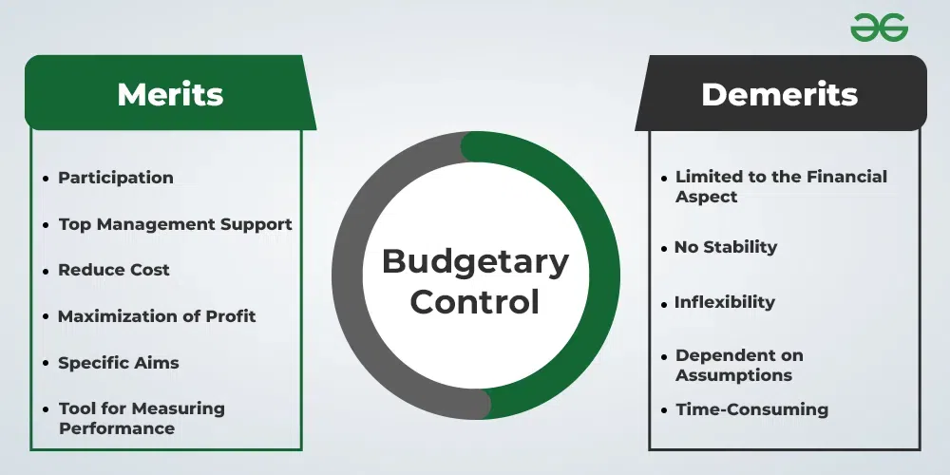
Figure 1: Budgetary Control

4.2 People’s Behavior and Budgeting
The efficiency of the budgeting system is impacted by employee activity. Both the involvement and motivation of workers are important. Employees can oppose budgets if they appear to be too restrictive or wrong. We might not be able to maximize our budget. The workforce should be included in the budgeting process so that management can hold them accountable for achieving budgetary goals. This increases the loyalty of the workforce. Another problem that arises when it comes to budgeting and managing spending is reluctance to change. When there are limits on the budget, employees may rebel if they are afraid of their employment or the financing for their departments. For minimizing resistance, Blue Thread Ltd. should manage change. The creation of a budget, the communication of benefits, and the instruction of workers on new financial habits should all be included in these projects. There are occasions when managers will overestimate expenditure or underestimate earnings to make targets that are more attainable generating financial wiggle room. Using this approach puts you in danger of squandering resources. Performance-based budgeting is a method that Blue Thread Ltd. should implement to eliminate budgetary slack. This method involves aligning financial goals to employee incentives and assuring responsibility at every level. To successfully manage a budget, you need people who are dedicated and processes that are transparent. Both the budget efficiency and the long-term growth of Blue Thread Ltd. are improved by the company's financial discipline and involvement (Cuadrado-Ballesteros and Bisogno, 2022).

5. Critical Evaluation of Traditional Budgeting Approaches

5.1 Flaws in Traditional Budgeting
Traditional budgeting approaches are still widely utilized, but they come with several limitations that can make them useless in a dynamic business setting. Inflexibility is a significant shortcoming. Conventional budgets are fixed at the beginning of each fiscal year and do not change during that time (Bhimani et al., 2024). This makes it challenging for businesses to adjust spending in response to shifts in the market. Blue Thread Ltd. may not be able to make time-sensitive adjustments to its financial goals due to budget constraints. The retail industry is quite sensitive to external variables and seasonality, which Blue Thread Ltd. must contend with. The time it takes to complete a typical budget is another issue. Many forecasts, approvals, and data-gathering sessions are required during the months-long operation. Budgets could become inaccurate and out of date if the company is not efficient enough. Misallocation of funds is possible in the conventional budgeting process because managers often put short-term financial gains ahead of long-term strategic decisions. To evade budget cuts, departments may engage in "use-it-or-lose-it" expenditure, which leads to overspending. Traditional budgeting is not ideal for sectors that change quickly because it is rigid, which brings us to our fourth point (Alrawazqee and Tsatkhlanova, 2021). Adaptable budgeting is a need for Blue Thread Ltd. in an ever-changing industry. This is because there is a continual flux in the economy.

5.2 Alternative Budgeting Models
To get beyond the limitations of traditional planning, companies are turning to alternative budgeting methods that provide more precision and flexibility. Financial estimates are updated using real-time data in rolling projections. Rolling predictions, as opposed to yearly budgets, give businesses the ability to reallocate and spend capital in response to changes in market circumstances (Okeke et al., 2024). Blue Thread Ltd. can provide accurate rolling projections due to the dynamic nature of the retail industry. Instead of using statistics from previous months, ZBB begins each month from where it left off. It is possible to minimize wasteful spending and inefficiency by making everything legitimate instead.
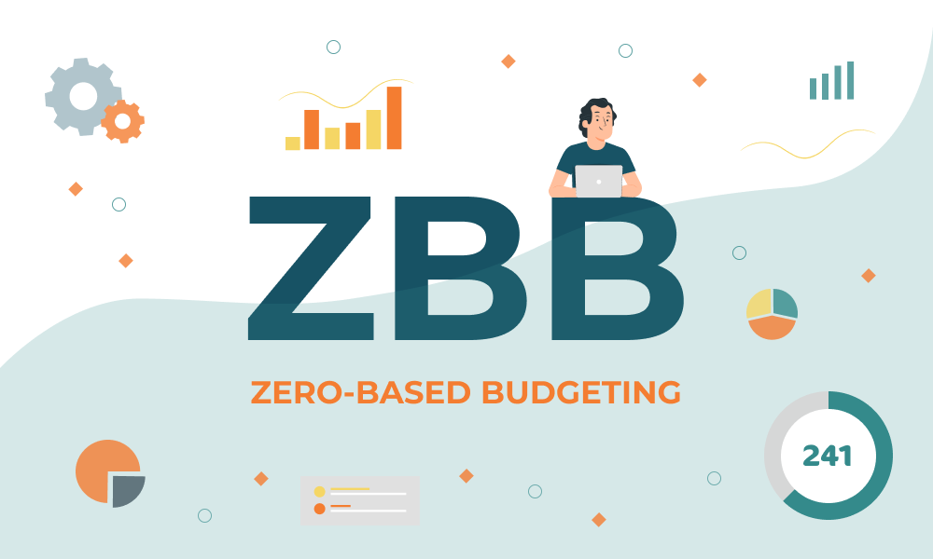
Figure 2: ZBB

ZBB might help Blue Thread Ltd. manage its marketing and operating expenditure, as well as their financial discipline. Rolling projections or zero-based planning might help Blue Thread Ltd. change its finances. Because of this, the firm may develop and maximize its resources despite commercial difficulties (Furr et al., 2021).
6. Conclusion

6.1 Summary of Findings
Blue Thread Ltd.'s budgeting and financials over the past six months are examined in this research. Despite increasing sales and profits, the company is having trouble with cash flow management and stock control, according to the most important data. While cash inflows tend to increase in tandem with sales, rising operational and stock expenses could lead to liquidity problems, as seen in the cash budget analysis. The company cannot keep up with the dynamic retail industry using its conventional budgeting approach, which relies on exacting annual projections. Blue Thread Ltd. consistently turns a profit, both in terms of gross and net, according to their profit and loss statement. Nonetheless, controlling stock costs and operating expenses should be the company's top priorities. In light of the impending overdraft, the cash budget analysis stresses the importance of meticulously monitoring expenditure and income to forestall financial shortages.

6.2 Final Thoughts
To enhance their finances, Blue Thread Ltd. might adopt a strategy that is both flexible and forward-looking. To better respond to changes in the market and distribute resources, the organisation could benefit from using zero-based budgeting and rolling forecasts instead of the traditional, inflexible budgeting methods. Management should maximize stock acquisitions and minimize wasteful spending if the company is to achieve its financial objectives and keep its cash flow positive. Resolving cash flow challenges requires regular monitoring of payments and collections as well as strategic steps, such as minimizing remodeling spending. Blue Thread Ltd. can overcome challenges and grow sustainably with the support of dynamic budgeting techniques and financial management. In the long and near term, this aids the company in reaching its financial objectives.

7. Bibliography
Akindele, J.A., Marsidi, A., Jakpar, S., Adeyemi, A.A. and Yunusa, L. (2024). Working capital investment and firm performance: analysis of financial constraint as moderating role. Afro-Asian Journal of Finance and Accounting, 14(6), pp.792-821.
Alrawazqee, A. and Tsatkhlanova, T. (2021). Improve performance or corruption motivation in beyond budget implementation, survey in public sector organizations. Research Journal of Finance and Accounting, 12(6).
Bhimani, A., Sivabalan, P., Soonawalla, K. and Wakefield, J. (2024). Annual budgets and rolling budgets use in UK and Australian firms. Journal of Management Control, 35(4), pp.509-561. https://doi.org/10.1007/s00187-024-00382-5
Biondi, L. and Russo, S. (2022). Integrating strategic planning and performance management in universities: a multiple case-study analysis. journal of management and governance, 26(2), pp.417-448. https://doi.org/10.1007/s10997-022-09628-7
Bouteska, A. and Mili, M. (2022). Does corporate governance affect financial analysts’ stock recommendations, target prices accuracy and earnings forecast characteristics? An empirical investigation of US companies. Empirical Economics, 63(4), pp.2125-2171. https://doi.org/10.1007/s00181-022-02297-3
Choi, T.Y., Netland, T.H., Sanders, N., Sodhi, M.S. and Wagner, S.M. (2023). Just‐in‐time for supply chains in turbulent times. Production and Operations Management, 32(7), pp.2331-2340. https://doi.org/10.1111/poms.13979
Cuadrado-Ballesteros, B. and Bisogno, M. (2022). Budget transparency and financial sustainability. Journal of Public Budgeting, Accounting & Financial Management, 34(6), pp.210-234. https://doi.org/10.1108/JPBAFM-02-2022-0025
Danda, R.R. (2024). Financial Services in the Capital Goods Sector: Analyzing Financing Solutions for Equipment Acquisition. Library Progress International, 44(3), pp.25066-25075.
Drury, C. (2021) Management and Cost Accounting, (Eleventh Edition), London: Prentice Hall
Farooq, U., Al-Gamrh, B. and Dai, J. (2024). Green drives greenbacks: The impact of sustainable innovation on corporate cash holdings in BRICS nations. Journal of Cleaner Production, 436, p.140533. https://doi.org/10.1016/j.jclepro.2023.140533
Furr, N.R. and Eisenhardt, K.M. (2021). Strategy and uncertainty: Resource-based view, strategy-creation view, and the hybrid between them. Journal of Management, 47(7), pp.1915-1935. https://doi.org/10.1177/01492063211011760
Horner, D. (2020), Accounting for Non Accountants, (Twelfth Edition), London; Kogan Press
Jauhar, S.K., Jani, S.M., Kamble, S.S., Pratap, S., Belhadi, A. and Gupta, S. (2024). How to use no-code artificial intelligence to predict and minimize the inventory distortions for resilient supply chains. International Journal of Production Research, 62(15), pp.5510-5534. https://doi.org/10.1080/00207543.2023.2166139
Liu, J., Li, C., Ouyang, P., Liu, J. and Wu, C. (2023). Interpreting the prediction results of the tree‐based gradient boosting models for financial distress prediction with an explainable machine learning approach. Journal of Forecasting, 42(5), pp.1112-1137.
Msawil, M., Greenwood, D. and Kassem, M. (2022). A Systematic evaluation of blockchain-enabled contract administration in construction projects. Automation in Construction, 143, p.104553. https://doi.org/10.1016/j.autcon.2022.104553
Okeke, N.I., Bakare, O.A. and Achumie, G.O. (2024). Forecasting financial stability in SMEs: A comprehensive analysis of strategic budgeting and revenue management. Open Access Research Journal of Multidisciplinary Studies, 8(1), pp.139-149. https://doi.org/10.53022/oarjms.2024.8.1.0055
Ro, S., Lee, J. and Kim, D. (2025). The Dark Side of Project Financing: Leverage, CEO Overconfidence, and Sustainability Challenges in the Construction Sector. Sustainability, 17(1), p.16. https://doi.org/10.3390/su17010016
Schubert, H. and Kirsten, S.M. (2021). Effect of budgeting control on the financial performance of SMEs in Germany. Journal of Finance and Accounting, 5(2), pp.1-9. https://www.stratfordjournals.com/journals/index.php/journal-of-accounting/article/view/812
Seal, W., Garrison, R.H, and Noreen, E. (2018), Management Accounting, (Sixth Edition), UK: McGraw Hill
Stawasz-Grabowska, E. and Wieloch, J. (2023). The United States–China trade war: timeline, consequences, and prospects for the US economy. An analysis based on the textile industry. Comparative Economic Research. Central and Eastern Europe, 26(1), pp.147-170.

