Data Handling and Business Intelligence

Component 2: Coursework

Student Number: 2227304
Student Module: Data Handling
Module code: LCBB5000
Due Date: 24/08/2024

Part 1:
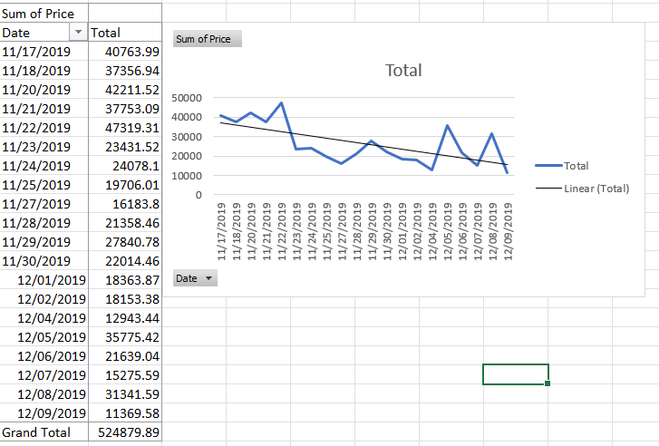
1a. How was the sales trend over the months?
Observations from the sales trend:
The line graph in the image indicates fluctuations in daily sales during the latter part of November and early December 2019. Notably, there are several key observations:
- Fluctuations in Sales: The sales figures show a significant variation from day to day, with peaks and troughs indicating inconsistent purchasing behaviour during this period. For instance, the data reveals a peak on certain days (e.g., 11/21/2019 with sales totalling approximately 47,319.31) followed by a steep decline (e.g., 11/24/2019 with sales dropping to 24,078.1).
- Decline Towards December: As the month transitions from November to December, there is a noticeable downward trend in sales, finishing in one of the lowest recorded days on 12/09/2019, with sales totalling 11,369.58.
One possible explanation for these developments is the influence of seasonal shopping habits. November often features Black Friday, a day that has historically driven large consumer spending, particularly in the e-commerce sector. According to Zhang et al. (2017), consumer behaviour around this period is significantly impacted by discounts and promotional events, which may explain the late-November peaks.
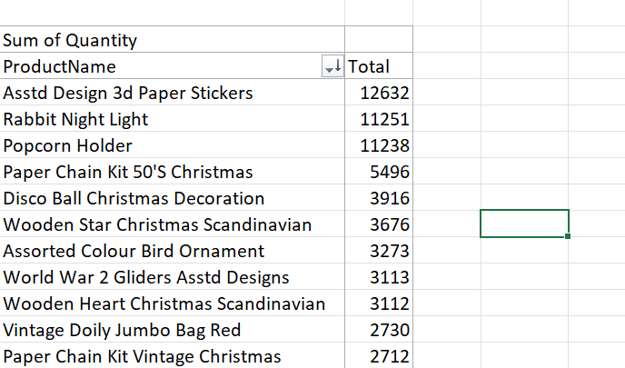
1b. What are the most frequently purchased products?

Here I have created a Pivot table on Excel with the data input of the product name and the sum of quantity. Then I sorted the data in descending Z-A value by the sum of quantity which displayed the most purchased products…
Observations
The dataset offered shows the total quantity sold of various products, providing information on customer preferences and the most popular things in the online retail market. Understanding the most popular products is critical for inventory management, marketing campaigns, and product development.
High Turnover Items: Products like the "Asstd Design 3d Paper Stickers" and "Rabbit Night Light" appear to be high turnover items, meaning they are likely staples in the inventory, consistently driving sales across different periods.
Seasonal Influence: Several of the top products are Christmas-related, which suggests that the data might reflect a period leading up to the holiday season, where demand for such items naturally increases. This aligns with research by Santini et al. (2019), which highlights the significant impact of seasonality on retail sales, especially in categories like home decor and gifts.
Identifying the most frequently purchased products is crucial for efficient inventory management. According to Chopra and Meindl (2016), keeping adequate stock levels for high-demand products allows businesses to meet consumer demand without overstocking, which ties up money in inventory. For example, the high sales volume of "Asstd Design 3d Paper Stickers" suggests that this product should be prioritised for restocking to avoid stockouts, which could result in lost sales and dissatisfied customers.
The popularity of specific products can also inform marketing strategies. As noted by Kotler and Keller (2016), understanding consumer preferences allows businesses to tailor their marketing efforts, promoting products that are likely to resonate with their audience. The data suggests that products like the "Rabbit Night Light" and "Popcorn Holder" could be featured prominently in marketing campaigns, leveraging their established popularity to drive further sales.
Offering a wide range of popular products helps increase client happiness and loyalty. According to Anderson (2006), the "long tail" of e-commerce indicates that businesses can succeed by selling a diverse range of products, including niche ones. The presence of both general and seasonal items on the top-selling list indicates that this company is successfully catering to a wide range of consumer needs, which can help retain a loyal customer base.
However, it is crucial to strike a balance between variety and emphasis. According to Johnson et al. (2007), too much variety might cause consumer decision fatigue, potentially diminishing the possibility of making a purchase.

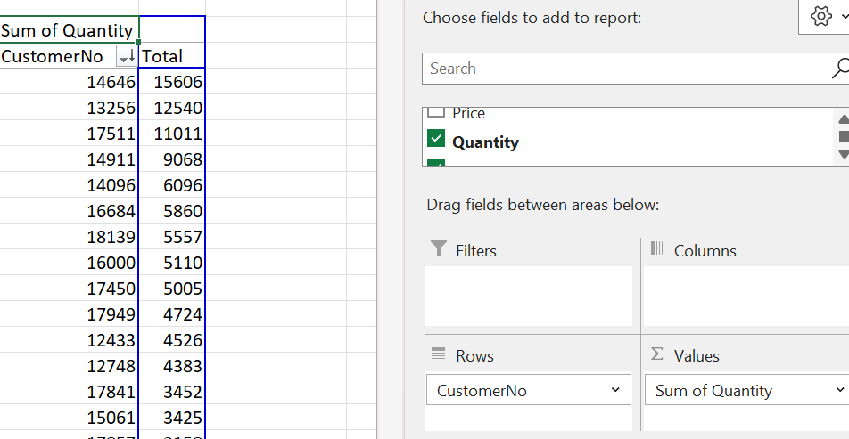
1d. What are the most profitable segment customers?

The dataset provided shows the total quantities purchased by independent customers, as identifiable by their unique customer number. This data is critical for determining which client categories are the most profitable, as it directly represents each customer's purchasing behaviour and overall value to the firm.
Observations
The data shows that the top clients, in terms of total quantity purchased, have contributed significantly to the company's overall sales. The top buyers are as follows: Customer 14646 purchased the most units (15,606), followed by Customer 13256 (12,540) and Customer 17511 (11,011 units). These customers have contributed the most revenue and profitability towards the company so far.
High-Value Customers: The customers with the highest overall purchases are from high-value groups. As Kumar and Reinartz (2018) point out, developing and sustaining connections with these high-value clients is crucial for long-term profitability.
Pareto Principle: The data may reflect the Pareto Principle, which states that a small fraction of customers’ accounts for a significant percentage of sales. This theory is commonly applied in business, where 20% of consumers can earn 80% of income (Reinartz & Kumar, 2002).
Identifying the most profitable client categories is critical when developing CRM strategies. These tactics entail devoting efforts to keeping and upselling to these high-value consumers while also investigating ways to convert lower-value clients into higher-value ones. High-value clients, such as those in the upper bracket, should be targeted with personalised marketing efforts. According to Kotler and Keller (2016), personalised offers and loyalty benefits can improve customer retention and raise lifetime value. Also by segmenting customers based on their purchasing behaviour, businesses can create more effective marketing strategies. Reinartz and Kumar (2002) suggest that understanding the profitability of different segments allows businesses to allocate resources more efficiently, focusing on segments that provide the highest return on investment.

1e. Based on your findings, what strategy could you recommend to the business to gain more profit?
Based on the analysis of the sales trends, the most frequently purchased products, and the most profitable customer segments, several strategic recommendations can be made to enhance the business's profitability. To capitalise on the identified opportunities, these recommendations prioritise optimising marketing efforts, improving inventory management, and boosting customer relationship management (CRM). Some strategies include:
- Utilising targeted marketing help increase sales
The sales trend analysis revealed fluctuations, with peaks most likely linked to promotional times such as Black Friday. This shows that focused marketing during specific periods has a major impact on sales. These insights might help the company optimise its marketing efforts throughout the year. Some recommendations for this would be implementing promotional campaigns. For example, the company can try and capitalise on seasonal trends by launching specific marketing campaigns during peak demand periods, such in the run-up to Christmas or major shopping events like Black Friday. These promos should be tailored to attract high-value customers while also encouraging lower-value customers to spend more. Grewal et al. (2009) argue that well-timed promotions can dramatically increase sales by capitalising on consumer urgency and seasonal demand.

- The expansion of products
The data indicated that certain products, such as the "Asstd Design 3d Paper Stickers" and "Rabbit Night Light," are consistently popular among customers. One way that the company can boost sales is by increasing the marketing and availability of products that have consistently high sales volumes. These products should be prominently featured in marketing campaigns and given priority in inventory management. The company could additionally create similar product lines similar to their most popular ones and generate more profit.

- Data-driven marketing decisions
Use sales data to determine which promotions and goods are most popular with customers. By analysing the performance of previous campaigns, the company may fine-tune its marketing plans to focus on the most effective approaches, increasing the return on marketing spend. Winston (2016) emphasises the significance of data analytics in guiding marketing decisions that drive profitability.
To increase profitability, the company should prioritise leveraging its most profitable customer segments through personalised CRM strategies, optimising inventory management based on sales trends, expanding product offerings to match consumer preferences, and implementing targeted marketing campaigns. By combining these techniques, the company can increase revenue potential, improve customer satisfaction, and maintain a competitive edge in the e-commerce sector.

Part 2: SPSS
2a. How many students are male and female?

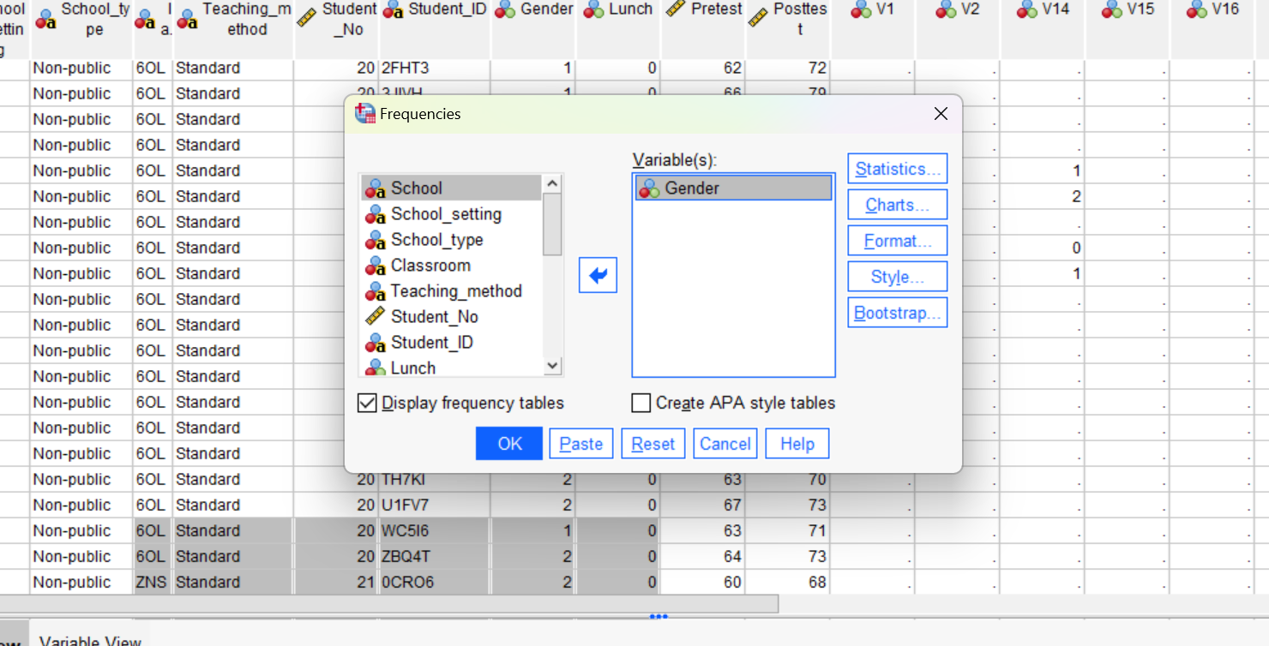

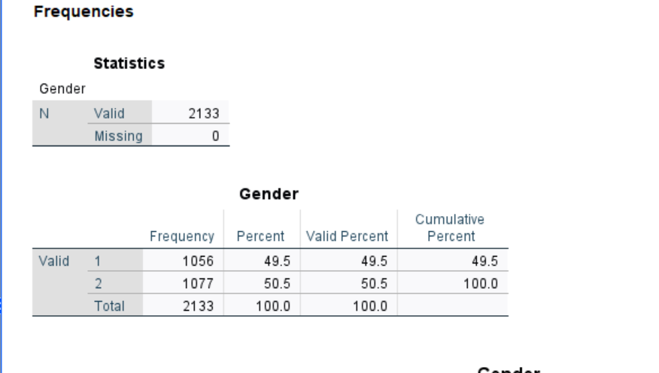

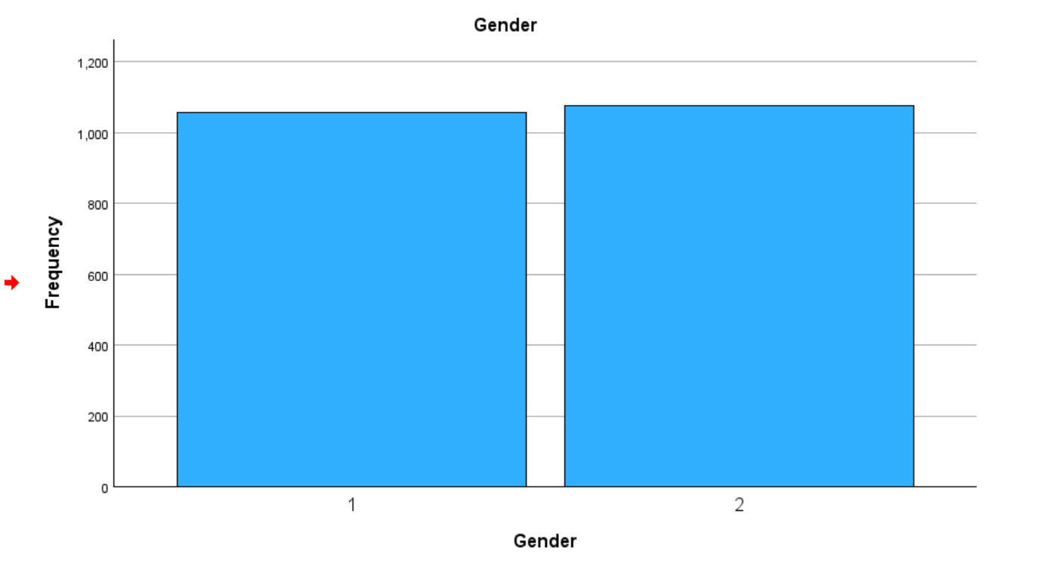
Based on the data presented in the SPSS output screenshot, the gender distribution of the students is as follows:
- Male Students: There are 1,077 male students
- Female Students: There are 1,056 female students
The total number of students is 2,133, the student population is nearly evenly split between males and females, with a slightly higher number of male students. Understanding gender distribution is critical in educational research because it influences how academic outcomes and effectiveness of programs are interpreted (OECD, 2015). For example, if one gender is severely under-represented, the results of any gender-related analysis of academic performance or socioeconomic status may be skewed.
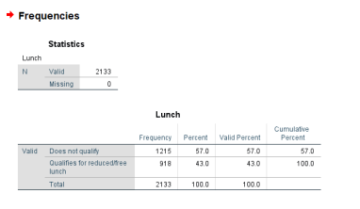
2b. How many students qualifies and does not qualify for reduced/free lunch?
The provided SPSS output presents the frequency distribution of students who qualify and do not qualify for reduced/free lunch.
Students Who Do Not Qualify for Reduced/Free Lunch:
1,215 students
Students Who Qualify for Reduced/Free Lunch:
918 students
Understanding the proportion of kids who are eligible for reduced/free lunch is crucial for various reasons.
- According to the data, a large proportion of the student population originates from low-income homes. This can have an impact on academic achievement, as research regularly reveals that socioeconomic position is strongly related to educational outcomes (Broer, 2019). Schools may need to consider this while developing intervention to support children' academic progress.

- This data could help schools better allocate resources. For example, programs aimed at academic support, nutrition, and after-school activities may need to prioritise kids who qualify for reduced/free lunch to close success gaps.

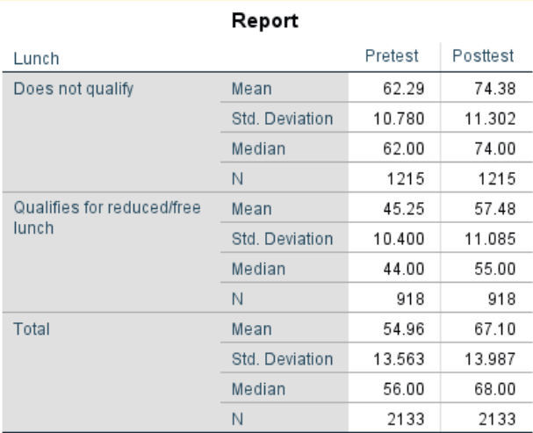
2c. What are the mean and median of students who qualifies and does not qualify for reduced/free lunch?
The data demonstrates a considerable discrepancy in academic achievement between students who qualify for reduced or free lunch and those who do not.
Pretest Scores: Students who do not qualify for reduced/free lunch had a much higher mean pretest score of 62.29 compared to those who do qualify, which is 45.25. The median results show a similar pattern, with non-qualifying students earning 62 against 44 for qualifying students. This shows that pupils from higher socioeconomic backgrounds (those not eligible for reduced/free meals) do better on pretests.
Post-test Scores: The post test results follow a similar trend, witth the student who do not qualify for reduced/free lunch achieving a mean score of 74.38 and those who do scoring 57.48. The median scores are 74 and 55, respectively. This shows that the academic performance discrepancy continues over time, even after the post-test.
The consistent gap between pretest and post-tests scores suggests that while both groups improve over time, the improvement is not sufficient to close the initial performance gap. This underscores the need for ongoing support, particularly for students from lower SES backgrounds.

2d. Using the dataset Student_Score.csv provided in conjunction with SPSS, give a specific example of Clustering (ex. K-Means Clustering). Show your workings with screenshots and clearly explain your results
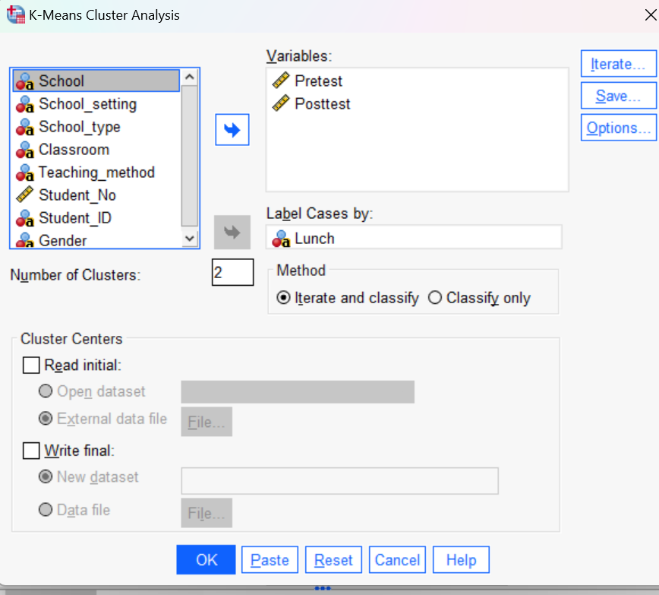
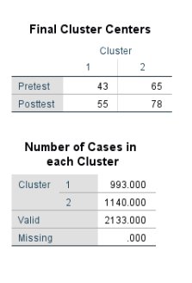
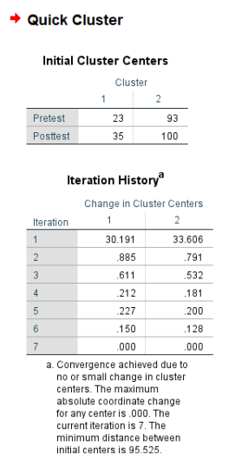
Clustering is a useful technique for grouping data points that are similar to one another. K-Means clustering is a popular clustering method that divides data into discrete groups depending on their features.
The initial cluster centres, as shown in the first image, were set to the following:
- Cluster 1:
- Pretest: 23
- Post-test: 35
- Cluster 2:
- Pretest: 93
- Post-test: 100
These values serve as the starting points for the algorithm. The iteration history demonstrates how the cluster centres shifted throughout multiple cycles. The algorithm ran for seven iterations, as is usual in K-Means clustering, in order to settle on a stable solution in which further iterations do not appreciably alter the cluster centres.
After convergence, the final cluster centres were established as follows:
- Cluster 1:
- Pretest: 43
- Posttest: 55
- Cluster 2:
- Pretest: 65
- Posttest: 78
The results from the K-means clustering are as follows:
Cluster 1 (Lower Performance): This group of students has lower average pretest (43) and post-test scores (55). These student may need further academic support to enhance their performance.
Cluster 2 (Higher achievement): Students in this cluster scored higher on both the pretest (65) and post-test (78), showing improved academic achievement.
Students in Cluster 1 are characterized by lower average scores on both pretest and post-test assessments. This group likely includes students who face academic challenges and may benefit from additional support. Support for this group could include:
Focused Tutoring: Hold one-on-one or small group tutoring sessions that focus on the areas in which students struggle the most. According to Bloom (1984), learning and focused tutoring can greatly increase student progress, especially for those who are falling behind.
Peer-Assisted Learning: Pairing low-performing pupils with high-performing peers can promote collaborative learning. Topping (2007) found that peer tutoring improves both academic achievement and student involvement, particularly when peers are taught to provide structured support.
After-School Programs: Providing extra learning time after school might assist students reinforce ideas that they find difficult. These programs should concentrate on reinforcing fundamental abilities, particularly in core disciplines such as mathematics and reading, which are essential for general academic performance (Rosenbaum, 2001).
Adaptive Learning Technologies: Use technology-driven platforms that adjust to each student's unique learning pace. These technologies can give personalised activities and content that address specific knowledge gaps, allowing students to improve at their own speed (Pane et al., 2015).
Using K-Means clustering to identify unique groups of students based on academic achievement allows educators to provide tailored interventions that address each group's specific requirements. Interventions for Cluster 1 children with lower performance should focus on remediation and fundamental support. Schools can ensure that all students receive the support and resources they need to succeed by implementing these strategies

2e. Discuss the advantages and disadvantage of using SPSS and Excel using relevant practical examples and present your discussions in a table by using different criteria.
Criteria | SPSS | Excel
Cost | Disadvantages: - SPSS's specialised features require a subscription or license, making it costly for small organisations or individual users.  Advantages: - SPSS provides a wide range of statistical capabilities, making it a worthwhile investment for advanced analytics. | Advantages: - Excel is inexpensive and commonly included in Microsoft Office Suite bundles, making it accessible to a wider audience.  Disadvantages: - Excel lacks extensive statistical tools compared to SPSS, despite its low cost.
Beginner friendly? | Disadvantages: - SPSS requires prior knowledge of statistics and data analysis, making it less accessible to beginners. - Users may need to invest time in learning through tutorials or formal education.  Advantages: - Once learnt, SPSS provides a user-friendly interface for difficult statistical tasks, with clear navigation and analysis options. | Advantages: - Excel is extensively taught and used in numerous industries, making it familiar to many users. - The interface is straightforward and easy to use, making it accessible for beginners.  Disadvantages: - Excel's simplicity can limit extensive statistical analysis, necessitating additional plugins or advanced knowledge of Excel operations.
Statistical Analysis | Advantages: - SPSS provides advanced statistical tests such as regression, ANOVA, t-tests, and factor analysis. - It is designed to handle huge datasets and execute sophisticated analysis quickly, making it excellent for academic and professional research.  Disadvantages: - Excessive features may overwhelm consumers who simply require basic statistical operations. | Advantages: - Excel offers fundamental statistical operations such as mean, median, standard deviation, and regression analysis.  - It is ideal for simple analysis and quick calculations, particularly in corporate settings where complex statistics are not required.  Disadvantages: - Excel's statistical capabilities are restricted, necessitating the use of add-ins or additional tools (e.g. Data Analysis Toolpak) for advanced analyses.  - It may not be suitable for handling large datasets or complex statistical models.
Creating of graphs | Advantages: - SPSS produces advanced statistical graphs and charts, including scatter plots and histograms.. - These graphs are easily customisable and designed for statistical analysis, providing more detailed insights into the data.  Disadvantages: - Creating graphs can be hard and time-consuming, particularly for new users. | Advantages: - Excel is user-friendly for creating simple graphs such as bar, line, and pie charts. - It allows for rapid and easy customisation, making it ideal for presentations and reports.  Disadvantages: - Excel has limited graphing tools for advanced statistical visualisation. - Users may struggle to construct complicated or highly customised graphs without substantial customisation.

Practical Examples:
SPSS Example: A university research team analysing survey data may use SPSS to do an analysis of data by using ANOVA or variances. The team can handle the enormous dataset using SPSS's powerful data management features, as well as its advanced statistical algorithms for complex studies. The team may also produce thorough statistical graphics to back up their conclusions in scholarly articles.
Excel Example: A financial analyst may use Excel to run a basic regression study to forecast future sales based on historical performance. Excel's ability to easily build and customise charts makes it excellent for creating graphics to use in business reports.
Conclusion
In conclusion both SPSS and Excel have advantages and disadvantages, and both are great software’s however they good at different things. SPSS is better suited for complicated statistical analysis and huge datasets, making it perfect for academic research and specialised industry applications. Excel is more accessible for day-to-day commercial work, offering adequate tools for basic statistical analysis and data visualisation in a user-friendly interface. It depends what the user is looking for.

References:
Anderson, C. (2006). The Long Tail: Why the Future of Business Is Selling More for Less. New York, Ny Hyperion.
Bloom, B. S. (1984). The 2 Sigma Problem: The Search for Methods of Group Instruction as Effective as One-to-One Tutoring. Educational Researcher, 13(6), 4-16.
Broer, M. (2019). SOCIOECONOMIC INEQUALITY AND EDUCATIONAL OUTCOMES : evidence from twenty years of timss..
Chopra, S. and Meindl, P. (2016). Supply Chain Management : Strategy, Planning, and Operation. 6th ed. Boston: Pearson.
Grewal, D., Levy, M. and Kumar, V. (2009). Customer Experience Management in Retailing: an Organizing Framework. Journal of Retailing, 85(1), pp.1–14.
Johnson, E.J., Häubl, G. and Keinan, A. (2007). Aspects of endowment: A query theory of value construction. Journal of Experimental Psychology: Learning, Memory, and Cognition, 33(3), pp.461–474. doi:https://doi.org/10.1037/0278-7393.33.3.461.
Kotler, P. and Keller, K.L. (2016). Marketing Management. 15th ed. Boston: Pearson.
OCED (2015). The ABC of gender equality in education : aptitude, behaviour, confidence. Paris: Oecd.
Pane, J.F. (2015). Continued Progress.
Reinartz, W. and Kumar, V. (2002). The Mismanagement of Customer Loyalty. [online] Harvard Business Review. Available at: https://hbr.org/2002/07/the-mismanagement-of-customer-loyalty.
Rosenbaum, J.E. (2001). Beyond college for all : career paths for the forgotten half. New York: Russell Sage Foundation.
Santini, F.D.O., Ladeira, W.J., Vieira, V.A., Araujo, C.F. and Sampaio, C.H. (2019). Antecedents and consequences of impulse buying: a meta-analytic study. RAUSP Management Journal, 54(2), pp.178–204. doi:https://doi.org/10.1108/rausp-07-2018-0037.
Topping, K. J. (2007). Trends in Peer Learning. Educational Psychology
Winston, W.L. (2016). Microsoft Excel 2016.
Zhang, Y., Li, X., & Sun, Y. (2017). Online Shopping Promotions and Consumer Purchase Intention: A Study on Black Friday Shopping Festival. Journal of Electronic Commerce Research, 18(2), 87-102.

