 | Student No: | 2316775
 | Module Title: | BUSINESS SKILLS
 | Module Code: | BMIH4007
 | Lecturer: | Daniel Payne

Component One: Reflective Journal 1000 words
As I reflect on my experience of studying at the university between weeks 2 and 6, I am amazed by the growth and development that I have undergone. In this reflective journal, I will explore the knowledge I acquired in the classroom and practice. Using the ERA model, this essay will examine the time spent in class during weeks 2 and 6. I will reflect upon the enhancements in my communication skills, increased confidence levels, improved referencing abilities and refined reading skills. The essay will also focus on week 3 of my study period and reflect on the knowledge gained.
First and foremost, one of the things I have gained from my time at university is a significant improvement in my communication ability. Participating in classroom discussions taught me how to express my thoughts and ideas. Hearing different perspectives from caveats has expanded my knowledge and encouraged me to think critically about various subjects. Additionally, interacting with my lecturer has helped me refine my skills in asking questions and engaging in conversations. Moreover, this time of study has significantly boosted my confidence levels. Initially, I was hesitant about participating in class discussions. With practice and constructive feedback from classmates and my lecturer, I gradually gained more confidence. This newfound self-assurance extends beyond academics; it also impacts areas of my life. Whether voicing opinions during team meetings or taking on leadership roles in activities, I now approach these situations with a sense of assurance I did not have before.
Furthermore, another essential skill that I have developed during this period is referencing proficiency. Paying attention to detail when accurately citing sources using the appropriate referencing styles is crucial in writing. By adhering to these guidelines throughout assignments and essays, I have built a strong foundation in referencing techniques that will undoubtedly be valuable for future academic endeavours. This ability guarantees the trustworthiness of my work. It also showcases my regard for the intellectual rights of others. Additionally, my reading abilities have greatly improved during this period of studying. The university setting requires me to read and understand texts from fields. Over the six weeks, I have easily navigated dense academic literature and extracted crucial information.
While studying hospitality and hotel management at the university, I had the chance to explore the workings of Marriott Hotel and learn about the factors contributing to its success. In week 3 of the business session, the hotel's general manager shared insights regarding the significance of safety, health and hygiene staff training and incident reporting in maintaining the operation of prestigious establishment.
First and foremost, ensuring safety is of importance in any business in the hospitality sector. Duringthe practical sessions at the Marriott Hotel, I discovered that they emphasise guest safety by implementing security protocols. They take measures such as installing surveillance cameras, conducting fire drills, and practising emergency evacuation procedures. It includes flashing lights and strobes to help deaf individuals during emergencies. What makes this system more impressive is its technology that can quickly detect changes in smoke or heat. Once activated, it activates audible alarms to ensure everyone is fully aware of the situation. The introduction of this fire alarm system by the Marriott Hotel showcases its dedication to providing an environment for all guests. Deaf individuals can now know they will receive notifications during emergencies without relying on others for assistance. Therefore, the dedication to safety measures implemented in the Marriot Hotel inspires customer trust. It also fosters a favourable work atmosphere for the staff members.
Furthermore, health and hygiene greatly influence maintaining customer satisfaction and loyalty. In the hotel industry, negative reviews can quickly arise if cleanliness standards are not upheld. I witnessed their commitment to cleanliness during my time at the hotel. Their rooms were impeccably clean. Their dining areas were thoroughly sanitised. The housekeeping staff followed protocols to ensure that all linens and towels were meticulously cleaned before reuse. This level of attention to detail guarantees a stay for guests while minimising the risk of infections or allergies.
In addition to health and hygiene, I gained insights into the importance of staff training. The five-star hotel places an emphasis on a comprehensive staff training program, which equips staff members with the skills and knowledge to excel in their organisational roles. By offering learning opportunities through workshops and seminars focused on customer service and conflict resolution skills development, Marriott ensures that its team is well prepared to handle any situation that may arise. Teamwork commences in the hotel at 10 am every morning, where the hotel manager and staff members gather to share information, set goals, and promote teamwork. The team members come together around the table for insight and updates on how the hotel is running. The manager starts the meeting by acknowledging each team member's presence. This simple gesture creates a sense of belonging and appreciation among the staff, reminding them of their role in contributing to the hotel's success. Next, any announcements or updates regarding hotel policies or procedures are shared. This ensures that everyone is well-informed about changes that might affect their work. It also facilitates communication between management and staff, building transparency and trust. Once administrative matters are addressed, attention shifts to setting daily goals. Each department head shares their targets for customer satisfaction, revenue generation or operational efficiency. This collaborative goal-setting process fosters teamwork as everyone recognises how their efforts contribute to achieving these objectives. This enhances the guest experience and boosts employee morale and job satisfaction.
Lastly, I have learned the importance of incident reports to uphold organisational transparency and accountability. While at the hotel, I was genuinely impressed by their system for reporting incidents. They promptly report any incident, no matter how small it may be. This proactive approach enables management to address issues and implement measures to prevent similar incidents from occurring in the future. Marriott Hotel cultivates a culture of trustworthiness and responsibility by promoting communication and creating an environment where employees feel comfortable reporting incidents without fear of retaliation.
Component Two: Action Plan

The action plan of the essay discusses areas for improvement and highlights existing strengths that can be further enhanced. Specifically, it will focus on two topics: identifying areas where I need to improve my business skills and enhancing my core strengths for practice.
As noted in my journal, one aspect that stands out for improvement is my communication skills. While I can express my thoughts and ideas when speaking, I often need help presenting and organising them in written form (Thomson, 2018). Moreover, enhancing my written communication skills will significantly benefit my practice.
To address this, I seek feedback on business writing from my lecturer and allocate time to practice and refine this skill. By doing so, I aim to convey information clearly and concisely.
Time management is another aspect where I need to make some improvements. Being a university student is quite overwhelming due to the deadlines for assignments and commitments. Sometimes, I procrastinate or rush through tasks right before they are due. To tackle this problem, I plan to adopt strategies like developing a schedule that allocates specific time blocks for each task and dividing larger projects into smaller, more manageable parts with their deadlines. Applying these tactics, I can efficiently handle my time and avoid the anxiety accompanying last-minute tasks. Additionally, by organising my schedule and breaking down projects into manageable tasks, I will meet deadlines and attain improved outcomes in my university studies (Hair et al., 2019).
Furthermore, even though I have a grasp of using technology for tasks like writing documents or conducting research, there are specific sophisticated software applications widely utilised in the corporate realm that I have yet to have the chance to become acquainted with. To accomplish this objective, my plan entails enrolling in courses or tutorials explicitly designed to teach these software programs.
On the other hand, when I reflect on my core strengths, I have good problem-solving skills. I consistently develop innovative solutions to complex challenges using my critical thinking skills and creativity. To further improve this strength, I plan to enrol in courses or participate in workshops on developing problem-solving techniques. Another area where I excel is thinking and effective decision-making. I intend to use real-life case studies and simulations that mimic business situations to enhance this strength. This hands-on approach will sharpen my abilities and expose me to the ever-changing nature of decision-making in the business world. Furthermore, through my experiences in group discussions, I work seamlessly within a team environment. To make the most of this strength in a setting, I will actively participate in activities like business competitions or entrepreneurial projects that involve teamwork dynamics. This practical experience will strengthen my collaboration skills and provide valuable insights into different perspectives and approaches (Mullins, 2019).
In conclusion, through the reflective journal, I have gained valuable insights into areas requiring improvement and growth opportunities and ways to enhance my core strengths for further professional practice.

Reference
Hair Jr, J., Page, M. and Brunsveld, N., (2019). Essentials of business research methods. Routledge.

Mullins, L. J., (2019). Organisational behaviour in the workplace. Harlow: Pearson Education.
Thomson, N., (2018). Effective communication: A guide for the people professions. 3rd Edition. Basingstoke: Palgrave Macmillan.

Component Three: Professional development: build a personal brand and promote a professional identity. (700 words)

Canva Document
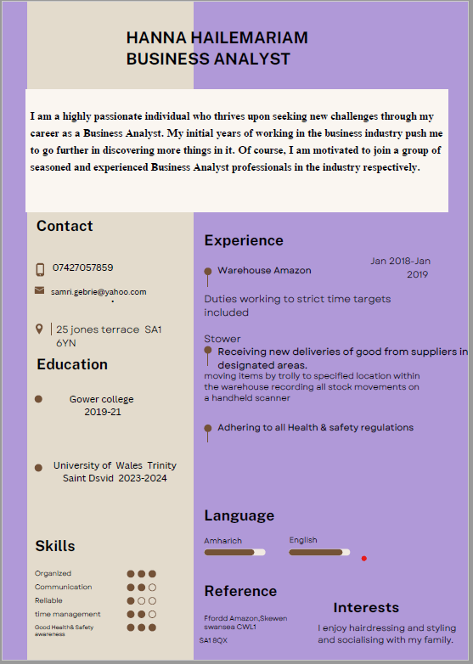

Linkedin Screenshot


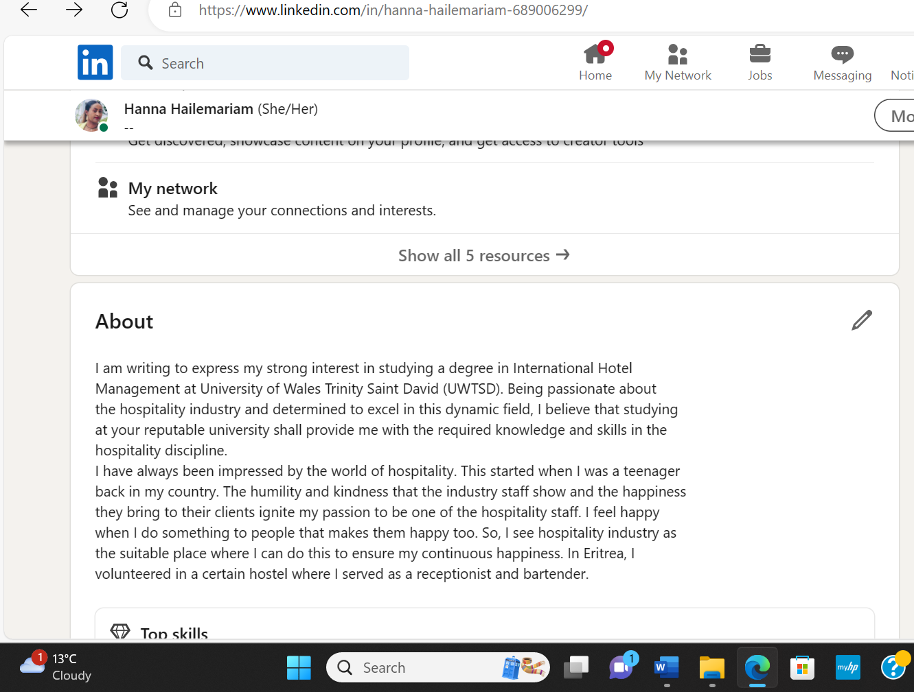
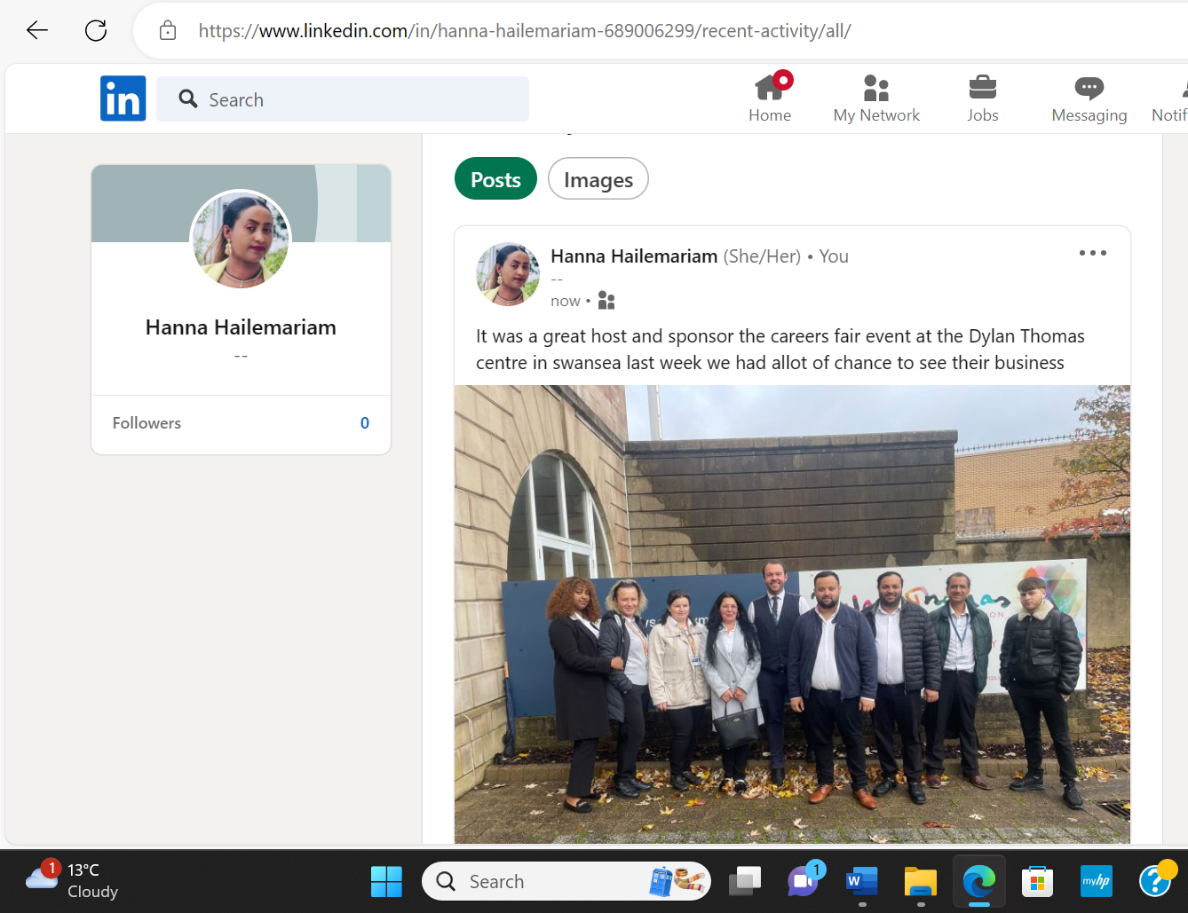

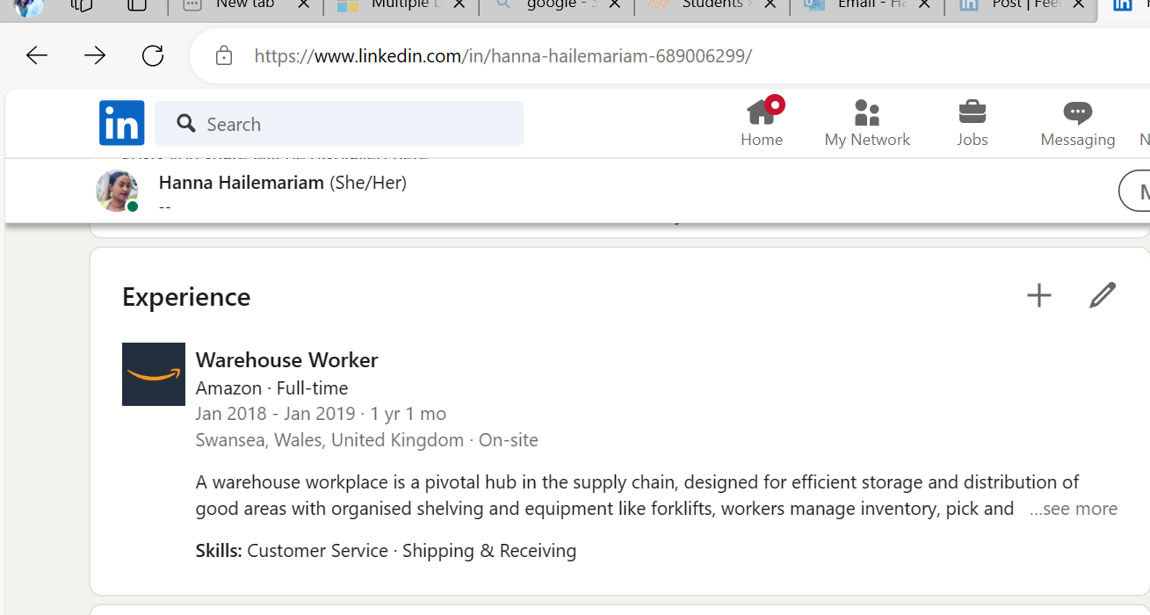
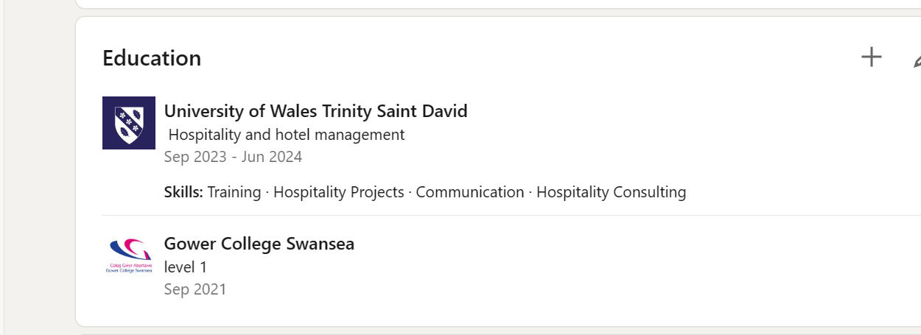

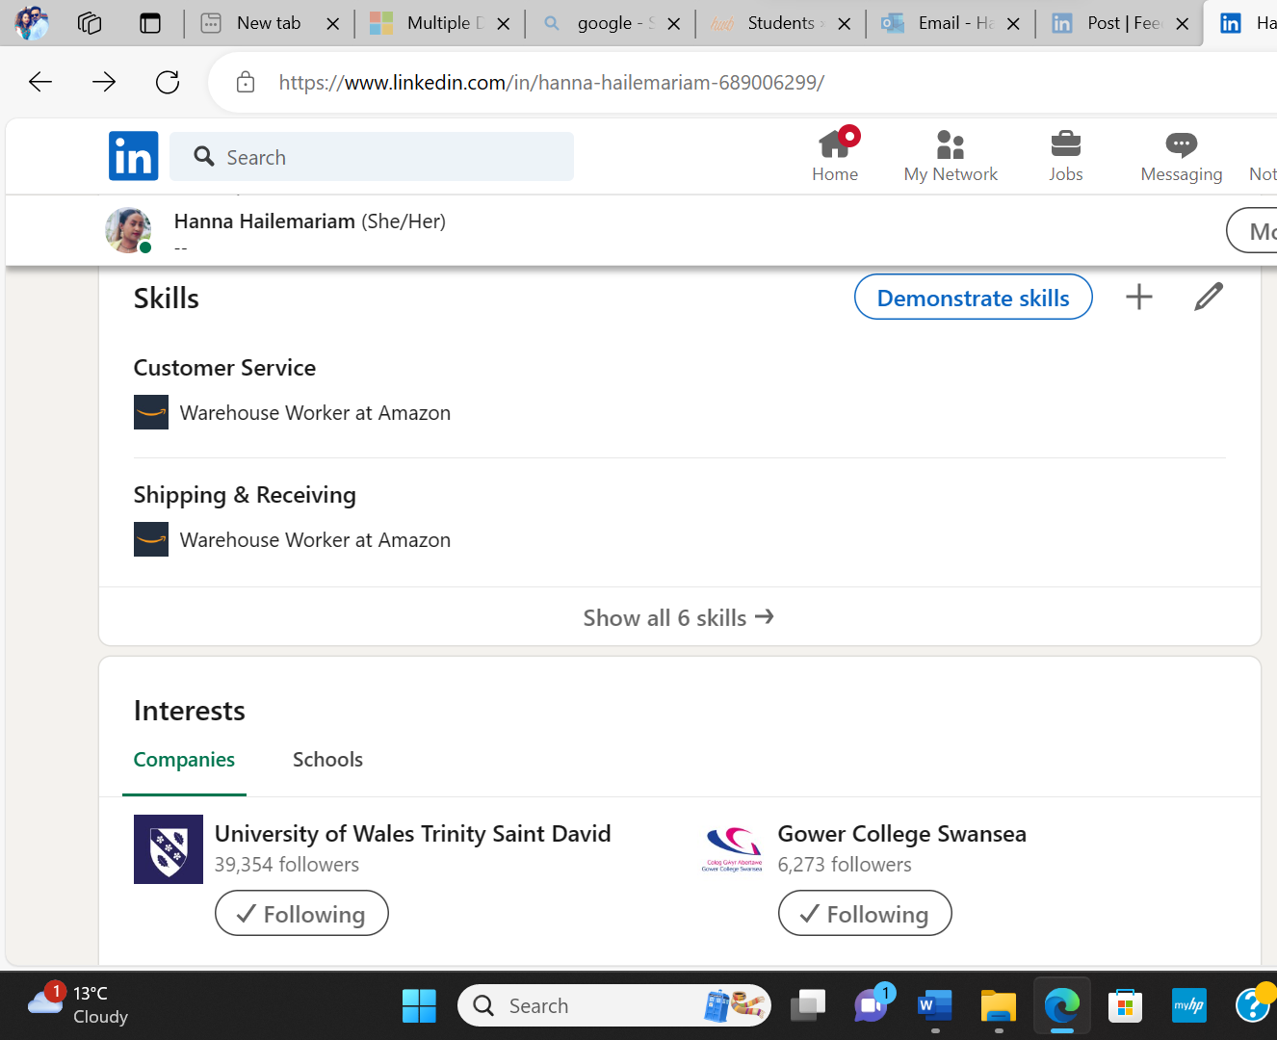

Component Four: Using the information prepared for your CV, present a 5 minute spoken CV

This Presentation will be completed in person on site at Delta by Marriott.
Place your presentation time below.

Timeslot:

