

CULTURAL INFLUENCES ON CHANGE MANAGEMENT: A CASE STUDY OF ENERGY POWER’S ACQUSITION OF UNIVERSEL ELECT PLC

Leading and implementing workplace change
(BMSW6103)

Lecturer name: Masoud Keimasi
Number of words: 5500
Submission date: 22/03/24
Student name: Vasilka Sarandalieva
Student number:2113113

Contents
Introduction 3
Significance of Cultural Factors in Change Management 4
Cultural Influence on Communication and Negotiation 5
Communication: 6
Negotiation Practices 7
Organisational culture 8
Bridging Cultural Differences 9
Feedback practices 9
IHMR Practices 10
Cultural Implications 12
Conflict Resolution Approach 13
Ethnocentric and Polycentric Model in People Management 14
Interview Analysis on the Validity of the Lewis Model 18
Conclusion and Recommendations 21
Appendix 23
References 27

Figure 1 Galbraith Star Model 4
Figure 2 Lewis Model 6
Figure 3 Organizational culture model 8
Figure 4 Interaction between linear and multi-active countries 10
Figure 5 Application of Lewin model in IHRM issue 12
Figure 6 EPRG Model 15

Introduction

This paper delves into the intricate ways in which culture shapes communication, negotiation, and feedback practices between the United Kingdom (UK) and the United Arab Emirates (UAE), drawing upon the insights provided by the Lewis model. By examining the cultural dimensions of these two countries, this study aims to shed light on the challenges and opportunities inherent in cross-cultural interactions, offering valuable implications for organizations engaging in international business ventures. Through a critical analysis of cultural distinctions, communication styles, negotiation strategies, and feedback dynamics, this paper contributes to a deeper understanding of the complexities involved in managing cultural diversity within multinational contexts.
The globalization of business has led to increased interactions between individuals from diverse cultural backgrounds (Sarala et al., 2019). In the context of multinational acquisitions, such as Energy Power's recent takeover of Universal Elect Plc in the UK and UAE, understanding the influence of culture on communication, negotiation, and feedback practices is paramount for achieving organizational success. This paper explores how the Lewis model, which categorizes cultures into linear-active, multi-active, and reactive, can offer insights into the cultural dynamics between the UK and UAE and their implications for cross-cultural management.
Energy Power's acquisition of Universal Elect Plc in the UK and UAE represents a strategic move aimed at enhancing market reach, diversifying product offerings, and leveraging synergies to drive growth and profitability. By incorporating Universal Elect Plc's expertise, resources, and market presence, Energy Power seeks to capitalize on emerging opportunities within the dynamic energy landscape of the UAE while reaffirming its commitment to innovation, sustainability, and customer satisfaction. This strategic approach, based on the Star Model introduced by Jay Galbraith in the 1960s, underscores the importance of considering five key elements for a smoother transition process. Although this report will primarily focus on the human resources aspect, it's acknowledged that other elements also warrant attention.

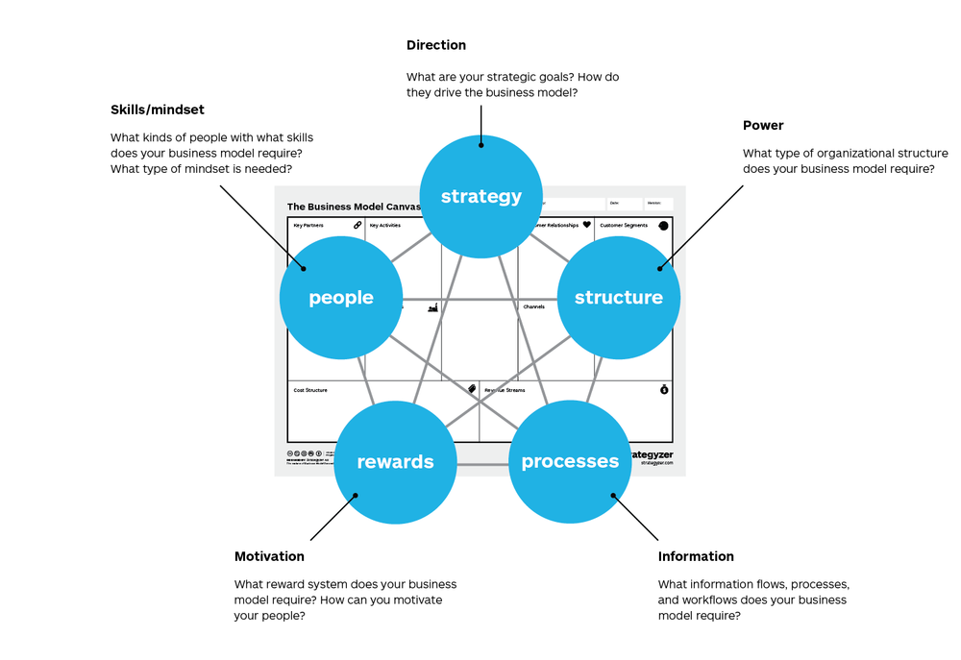
Figure 1 Galbraith Star Model
Source: https://www.strategyzer.com/library/implementing-your-business-model-with-the-galbraith-star-model

Significance of Cultural Factors in Change Management
The successful integration of Universal Elect Plc into Energy Power's operations hinges not only on strategic alignment and operational efficiency but also on effectively managing cultural differences and fostering collaboration across diverse teams. Cultural factors play a crucial role in shaping attitudes, behaviours, and communication styles within organizations, impacting how change initiatives are perceived, accepted, and implemented (Hu et al., 2012).
In the context of this acquisition, understanding and addressing cultural shades between the UK and the UAE are paramount to fostering a smooth transition and maximizing the synergies between the two organizations. Factors such as communication styles, hierarchy, decision-making processes, work ethic, and attitudes towards authority may vary significantly between the two cultures, influencing how employees from both sides perceive and adapt to changes brought about by the acquisition.
Effective change management in a cross-cultural context requires sensitivity, flexibility, and a proactive approach to bridging cultural gaps, fostering mutual understanding, and building trust among team members (Adler & Aycan, 2018). By acknowledging and respecting cultural differences, fostering open dialogue, promoting cultural intelligence, and providing cross-cultural training and support, Energy Power can cultivate a collaborative and inclusive organizational culture that embraces change and drives success in the post-acquisition integration process.
As a pivotal department throughout the acquisition process, International Human Resource Management (IHRM) may encounter challenges in comprehending cultural disparities, organisational culture, communication styles, feedback practices, and leadership and management methodologies, potentially impeding the success of the effort, and negotiations to resolve the conflicts. By recognizing the hints within these areas, the process might become more difficult or even unsuccessful. Equipped with a background in Leadership and Management studies, alongside expertise in cross-cultural change management, I intend to engage with the IHRM department to offer consultation services, thereby facilitating an understanding of these challenges and optimizing strategies for transcultural alignment. In the next sections I will focus on communication, negotiation, feedback and IHRM practices.

Cultural Influence on Communication and Negotiation

Culture plays a pivotal role in shaping communication, negotiation, and feedback practices, particularly in cross-cultural contexts (Guirdham & Guirdham, 2017) such as those between the United Kingdom (UK) and the United Arab Emirates (UAE). Understanding these cultural influences is crucial for effective intercultural communication and successful negotiation outcomes. The Lewis Model, proposed by Richard D. Lewis, offers a valuable framework for analysing cultural differences and their implications on communication styles and business practices (Manville et al., 2018). Figure 1 illustrates and provides a description of the Lewis Model below.
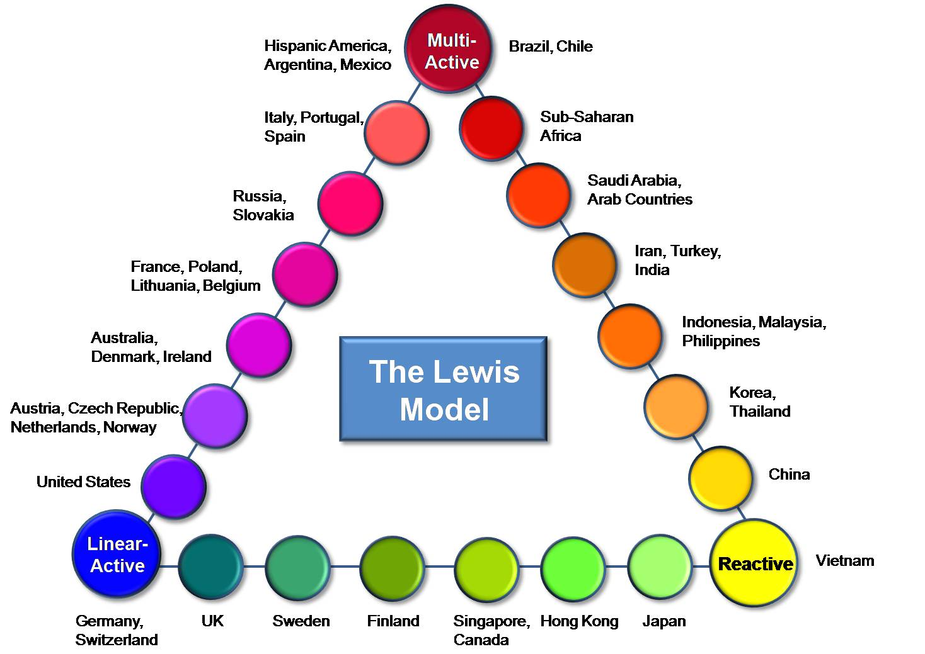
Figure 2 Lewis Model
Source: https://society30.com/lewis-model-understand-every-culture-world/

Communication:
In the context of communication, cultural factors significantly influence the ways in which individuals from the UK and the UAE interact, express ideas, and convey messages. The Lewis Model categorizes cultures into three main categories: Linear-Active, Multi-Active, and Reactive.
In the UK, which typically falls under the Linear-Active category, communication tends to be direct, explicit, and task-oriented. British individuals value clarity, efficiency, and professionalism in their communication style. They prefer to express their thoughts and ideas logically and concisely, often relying on facts and data to support their arguments. Furthermore, the British communication style is characterized by a preference for individualism and autonomy, with individuals often expressing their opinions openly and directly.
Conversely, in the UAE, which is often classified as Multi-Active according to the Lewis Model, communication is more fluid, context-dependent, and relationship-oriented. Emiratis value personal relationships, harmony, and social cohesion in their interactions. Communication tends to be indirect, nuanced, and focused on building rapport and trust. Emiratis may prioritize maintaining harmony and avoiding confrontation, leading to a more diplomatic and indirect communication style. Additionally, Emiratis may rely heavily on non-verbal cues, such as body language and facial expressions, to convey meaning and build rapport.
Understanding the cultural influences that shape communication styles is essential for fostering effective cross-cultural interaction (Bennett, 2017). The contrasting approaches observed in the UK and the UAE highlight the importance of cultural sensitivity and adapting communication strategies to achieve successful communication across diverse cultural contexts.

Negotiation Practices
Negotiation practices are deeply influenced by cultural norms and values, leading to significant variations in approaches between different countries. In the context of negotiations between the United Kingdom (UK) and the United Arab Emirates (UAE), these cultural differences manifest in distinct strategies and priorities.
UK Negotiation Practices:
Negotiation approaches in the UK are often characterized by a competitive and assertive demeanour, with an emphasis on achieving objectives through direct communication and logical argumentation (Fells & Sheer, 2020). British negotiators prioritize efficiency, clarity, and transparency throughout the negotiation process. They typically focus on tangible outcomes and are often willing to take calculated risks and make concessions to secure favourable deals.
In the academic literature, this negotiation style aligns with Fisher and Ury's concept of principled negotiation (Fisher et al., 2011), which emphasizes separating people from the problem, focusing on interests rather than positions, generating a variety of options for mutual gain, and insisting on objective criteria. British negotiators often adhere to these principles, seeking to create value and build durable agreements while maintaining professionalism and integrity.
UAE Negotiation Practices:
Conversely, negotiation practices in the UAE exhibit a more collaborative and relationship-oriented approach (Aroussi et al., 2024). Emirati negotiators prioritize building trust, maintaining harmony, and preserving face in their interactions. Negotiations in the UAE are often preceded by extensive relationship-building activities, such as socializing and hospitality, which serve to establish rapport and mutual understanding before substantive discussions commence.
This negotiating strategy is consistent with the notion of integrative bargaining, in which parties aim to maximise joint advantages by finding common interests, trading concessions, and encouraging collaboration. Emiratis place a high priority on the development of strong interpersonal connections (Goby et al., 2015) and may use intermediaries and third-party validators to assist discussions and generate consensus among stakeholders, demonstrating a comprehensive and inclusive approach to decision-making.

Organisational culture
Organizational culture in the UK tends to prioritize efficiency and individual achievement, while in the UAE, it emphasizes harmony and collective relationships. Navigating these differences is vital for businesses operating between the two countries. Understanding and respecting cultural nuances fosters trust, collaboration, and success in both markets.

Figure 3 Organizational culture model
Source: Created by the author
Base on organisational culture model, given that these companies operate within the energy sector, prioritizing efficiency and productivity over creativity, and facing a relatively stable environment, they tend to share a hierarchical organizational culture. The primary challenge they encounter lies in managing national cultural differences, where the first is characterized by linearity while the second is characterized by multi-activity.

Bridging Cultural Differences
To effectively manage these cultural differences, negotiators should embrace a nuanced and flexible strategy that acknowledges and honours the values and preferences of all parties involved (Moore & Woodrow, 2010). Utilizing cross-cultural negotiation frameworks, such as those outlined in the Lewis Model, can offer valuable insights into the core motivations and communication patterns of each culture. By understanding these dynamics, negotiators can adapt their approach accordingly, fostering mutual understanding and collaboration across cultural boundaries.
Furthermore, cross-cultural training and intercultural competence development can equip negotiators with the necessary skills and strategies to navigate cultural differences sensitively and effectively. By fostering mutual understanding, trust, and respect, negotiators can overcome cultural barriers and forge mutually beneficial agreements that transcend cultural boundaries.
In conclusion, understanding the cultural underpinnings of negotiation practices in the UK and the UAE is essential for successful cross-cultural interactions. By acknowledging and embracing cultural diversity, negotiators can leverage cultural differences as opportunities for collaboration and innovation, ultimately enhancing the quality and durability of negotiated outcomes.

Feedback practices
Feedback practices are deeply entrenched in cultural norms and expectations, shaping communication dynamics and interpersonal relationships. Examining the differences between the United Kingdom (UK) and the United Arab Emirates (UAE) provides insights into how cultural values influence feedback exchanges.
UK Feedback Practices:
In the UK, feedback is characterized by directness, constructiveness, and goal orientation. British individuals prioritize honesty, transparency, and accountability in feedback interactions. Feedback is typically delivered promptly and openly, focusing on specific behaviours or outcomes and providing actionable recommendations for improvement.
Rahim (2002) have described this feedback style as predominantly assertive, where individuals are encouraged to express their thoughts and opinions directly and confidently. This approach aligns with the cultural value of individualism, where personal autonomy and achievement are highly esteemed.
UAE Feedback Practices:
Conversely, feedback practices in the UAE may be more implicit, subtle, and context-dependent. Emiratis often prioritize maintaining harmony and avoiding direct criticism or confrontation in feedback exchanges. Feedback may be conveyed indirectly, utilizing implicit cues or non-verbal communication to convey messages.
In the UAE, the cultural concept of "saving face" is significant, where individuals strive to protect their dignity and social standing. Therefore, feedback is often delivered with sensitivity and discretion, focusing on preserving relationships and minimizing potential conflicts.

IHMR Practices
Merging Energy Power with Universal Elect might face challenges due to cultural differences, specifically in how people from each country communicate and provide feedback. In the UK, communication tends to be more direct and explicit, with an emphasis on clarity and efficiency. Conversely, in the UAE, communication often involves more indirect and nuanced approaches, with a focus on maintaining harmony and preserving relationships.
This cultural difference in communication styles can lead to misunderstandings, misinterpretations, and conflicts during the integration process. The reason for that is difficult interaction between linear- active and multi-active countries, as shown on Figure 2.
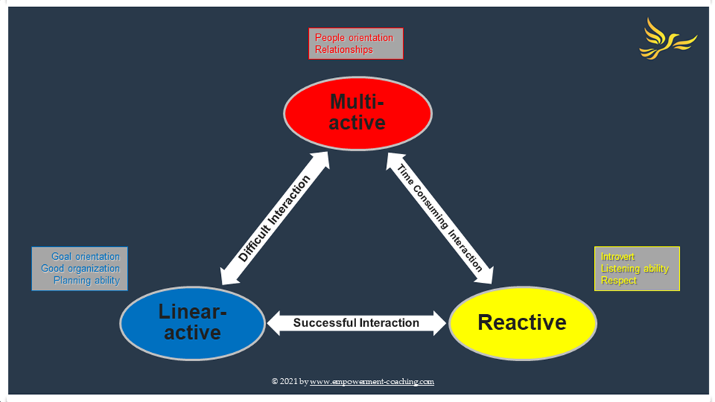
Figure 4 Interaction between linear and multi-active countries
Source: www.emporment-coaching.com

For example, UK employees may perceive UAE counterparts as vague or non-committal, while UAE employees may view their UK counterparts as overly blunt or confrontational. These misperceptions can hinder effective collaboration, decision-making, and problem-solving, ultimately impacting organizational performance and employee morale.
In terms of International Human Resource Management (IHRM) practices, addressing this cultural disparity requires a strategic approach (Schweiger & Weber,1992). Both countries need to recognize and respect each other's communication norms while also implementing strategies to bridge the gap and facilitate effective communication. To achieve this by using Lewin model (Odor, 2018), there are three steps that they need to follow.
In this model, the initial phase involves unfreezing. During this stage, managers must underscore the significance of the current strategy (acquisition) in ensuring the company's sustainability and its impacts on both company performance and employee well-being. It's crucial to emphasize that this strategy isn't optional but rather a necessary business decision. Effective communication with individuals from diverse cultures is essential throughout this process, and addressing any challenges that arise is imperative for the successful implementation of the strategy.
In the change stage there are some activities that must be implemented such as:
- Cross-cultural training: Providing employees with training and workshops on cultural awareness, communication styles, and feedback practices can help increase their understanding and appreciation of cultural differences (Mendenhall & Oddou, 1985). This can empower employees to adapt their communication strategies accordingly and navigate cross-cultural interactions more effectively.
- Cultural intelligence: Encouraging employees to develop cultural intelligence, or the ability to understand and adapt to different cultural contexts, can foster greater empathy, flexibility, and collaboration across diverse teams (Ang et al., 2006). This can involve incorporating cultural intelligence assessments into performance evaluations and providing resources for self-directed learning and development.
- Communication protocols: Establishing clear communication protocols and guidelines that accommodate both direct and indirect communication styles can help mitigate misunderstandings and promote effective communication (Ting-Toomey & Dorjee, 2019). This could include providing templates for written communication, clarifying expectations for feedback delivery, and encouraging regular check-ins to ensure alignment and understanding.
- Feedback mechanisms: Implementing feedback mechanisms that accommodate cultural preferences and sensitivities can help foster a culture of open communication and continuous improvement (MacDonald et al., 2013). This may involve offering multiple channels for feedback, such as anonymous surveys, one-on-one discussions, and group feedback sessions, to accommodate varying comfort levels and communication preferences.
In the final stage of refreezing, Energy Power can effectively manage cultural differences in communication and feedback methods, minimizing potential obstacles and capitalizing on the strengths of each culture to enhance success during the post-acquisition integration phase. This strategy promotes smoother collaboration and decision-making while cultivating a more inclusive and adaptable organizational culture, well-equipped to flourish in varied global settings. The diagram below outlines the primary objectives of this approach.

Figure 5 Application of Lewin model in IHRM issue
Source: created by the author

Cultural Implications
The Lewis Model provides a useful framework for understanding these cultural differences in feedback practices. In the context of the model, the UK's direct and goal-oriented feedback style aligns with the Linear-Active cultural profile, emphasizing efficiency and clarity in communication (Lewis, 2018). On the other hand, the UAE's more subtle and context-dependent approach reflects characteristics of Multi-Active cultures, prioritizing relationships and adaptability.
By recognizing and respecting these cultural traces, individuals and organizations can navigate cross-cultural feedback interactions more effectively. Cross-cultural training and intercultural competence development can equip individuals with the skills to understand and interpret feedback within different cultural contexts, fostering mutual understanding, trust, and collaboration.
In conclusion, understanding how cultural differences influence feedback practices between the UK and the UAE is essential for effective communication and relationship-building in international business contexts. By leveraging cultural insights and adopting a culturally sensitive approach to feedback, individuals and organizations can foster positive and productive interactions across cultural boundaries.

Conflict Resolution Approach
Based on the cultural differences outlined in the negotiation practices between the United Kingdom (UK) and the United Arab Emirates (UAE), a conflict resolution approach that integrates elements of both competitive and collaborative strategies would be most effective.
Integrating the change management model of Unfreeze, Change, and Freeze complements the proposed conflict resolution approach tailored to the cultural differences between the UK and the UAE in negotiation practices. By preparing negotiators for change, adapting negotiation strategies to accommodate cultural nuances, and institutionalizing cross-cultural competence, organizations can navigate cultural differences sensitively and effectively, fostering long-term partnerships grounded in mutual respect and understanding.
Given the assertive and direct negotiation style typically observed in the UK, a competitive approach that emphasizes clear objectives, logical argumentation, and the pursuit of evident outcomes could be beneficial. This approach aligns with the UK's preference for efficiency, clarity, and transparency in negotiations.
Therefore, a hybrid conflict resolution approach that blends elements of principled negotiation and integrative bargaining would be appropriate. This approach involves separating people from the problem, focusing on interests rather than positions, and generating options for mutual gain, as advocated by Fisher and Ury's (Fisher et al., 2011) concept of principled negotiation. Additionally, integrating elements of integrative bargaining, where parties aim to maximize joint advantages by finding common interests and encouraging collaboration, would help bridge cultural differences and foster mutual understanding.
Furthermore, utilizing cross-cultural negotiation frameworks, such as the Lewis Model, can provide valuable insights into the core motivations and communication patterns of each culture, allowing negotiators to adapt their approach accordingly. Cross-cultural training and intercultural competence development can also equip negotiators with the necessary skills and strategies to navigate cultural differences sensitively and effectively, fostering mutual understanding, trust, and respect across cultural boundaries.
However, offering a conflict resolution approach that combines competitive and collaborative strategies, tailored to the cultural differences of both the UK and the UAE, is essential for successful cross-cultural interactions and the achievement of mutually beneficial agreements.

Ethnocentric and Polycentric Model in People Management

The ethnocentric and polycentric models are two contrasting approaches in international human resource management (IHRM) (Taylor & Woodhams, 2022). The ethnocentric model involves the centralized control of key decision-making processes by headquarters, typically located in the home country. This model often results in standardized practices across global subsidiaries and places emphasis on the transfer of expatriate employees from the home country to overseas assignments. Conversely, the polycentric model advocates for decentralized decision-making, allowing subsidiaries in different countries to have greater autonomy in managing their human resources. This approach prioritizes local responsiveness and adaptation to diverse cultural and market contexts. Understanding the distinctions between these models is essential for effectively managing human resources across borders, especially during the acquisition process, where decisions regarding staffing, training, and compensation strategies must align with the organizational culture and objectives of both the acquiring and acquired entities.
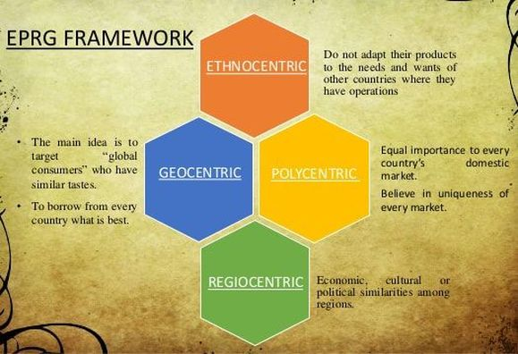
Figure 6 EPRG Model
Source: https://www.google.com/url?sa=i&url=https%3A%2F%2Fmyhrm.weebly.com%
In the circumstances of a UAE acquisition of a UK company, the applicability of the ethnocentric and polycentric models in people management during the takeover process is significant. Initially, an ethnocentric approach may be considered, where decision-making authority primarily resides with the UAE headquarters. This approach could involve the deployment of UAE expatriate managers to oversee critical functions and ensure alignment with the acquiring company's practices and objectives. However, due to the distinct cultural and operational differences between the UK and UAE, a polycentric model might prove more effective in managing the acquired workforce. Adopting a polycentric approach allows for decentralized decision-making, enabling the UK subsidiary to retain autonomy in managing its human resources while adapting practices to local norms and preferences. This approach fosters employee engagement and buy-in, essential for successful integration and alignment of organizational cultures. By carefully assessing the applicability of both models and integrating elements of each, the acquiring company can navigate cultural complexities and optimize people management strategies for long-term success in the post-acquisition phase.
When considering a scenario where a UAE company acquires a UK counterpart, it's essential to assess how ethnocentric and polycentric models apply to different aspects of people management. Different areas can be evaluated as follows:
- Recruitment
Under ethnocentric model, recruitment may heavily rely on expatriates from the UAE headquarters to fill key positions in the acquired company. This approach ensures alignment with the acquiring company's culture and standards but may limit local talent development.
Adopting a polycentric approach allows the UK subsidiary to have more autonomy in recruitment, leveraging local expertise and networks to attract top talent. This fosters a sense of ownership and local relevance but may lead to inconsistencies across global operations (Lakshman, 2013).
- Training
In ethnocentric model, training programs may be centralized and standardized, focusing on transferring UAE-specific knowledge and practices to the UK workforce. This ensures uniformity but may neglect the unique needs and competencies of local employees.
A polycentric approach enables customized training initiatives tailored to the UK context, incorporating local language, culture, and market dynamics. This enhances employee engagement and effectiveness but may result in duplication of efforts across subsidiaries (Michailova & Hollinshead, 2001).
- Performance Appraisal
Performance appraisal criteria may be aligned with UAE standards, emphasizing adherence to headquarters' goals and benchmarks. This facilitates consistency but may undervalue local contributions and achievements in ethnocentric model.
Embracing a polycentric perspective allows for the adaptation of performance appraisal metrics to suit the UK subsidiary's context and objectives. This promotes fairness and relevance but may create challenges in benchmarking performance across diverse locations (Mamman & Adeoye, 2007).
- Leadership Development:
Leadership development programs in ethnocentric model, may prioritize grooming UAE-based executives for leadership roles within the acquired company. This ensures continuity in leadership but may hinder the development of local talent.
A polycentric approach encourages the identification and development of local leaders within the UK subsidiary, fostering a pipeline of diverse leadership talent. This enhances organizational agility and adaptability but may require coordination and integration efforts across geographically dispersed teams.
Advantages and Disadvantages Ethnocentric Model
Navigating the complexities of people management requires an understanding of the advantages and disadvantages essential in both the ethnocentric and polycentric models. The ethnocentric model, characterized by its centralized control and alignment with headquarters' goals and standards, offers several benefits. Firstly, it facilitates coordination and control across the organization, ensuring that all subsidiaries operate in accordance with the overarching strategic direction set by the UAE headquarters. This centralized approach also fosters a sense of unity and common purpose among employees, as they are united by a shared organizational vision and values. Additionally, the ethnocentric model can expedite decision-making processes and implementation of initiatives, as there is a clear chain of command and reporting structure.
However, the ethnocentric model also comes with its set of challenges. By prioritizing headquarters' goals and standards, it may limit local autonomy and innovation within subsidiaries. This could lead to a lack of flexibility in responding to local market dynamics and customer needs, potentially hindering the organization's ability to adapt and thrive in diverse cultural contexts. Moreover, the imposition of uniform practices and standards across all subsidiaries may overlook the unique strengths and capabilities of each local market, resulting in missed opportunities for growth and development (Shah et al., 2012).
In contrast, the polycentric model embraces local responsiveness and adaptation, recognizing the importance of empowering subsidiaries to make decisions based on their unique contexts. This approach enhances employee engagement and motivation, as local teams feel empowered to take ownership of their work and contribute meaningfully to the organization's success. Furthermore, by fostering diversity of perspectives and encouraging experimentation, the polycentric model stimulates innovation and creativity within the organization. Employees are encouraged to think outside the box and explore new approaches to problem-solving, leading to the development of novel products, services, and business strategies.
However, the polycentric model is not without its challenges. Coordinating and aligning efforts across geographically dispersed subsidiaries can be complex, requiring effective communication channels and collaboration tools to facilitate information sharing and decision-making. Moreover, there is a risk of duplication of efforts and inconsistencies in practices and standards across different locations, which could undermine organizational efficiency and effectiveness (Shah et al., 2012).
In conclusion, while both the ethnocentric and polycentric models offer distinct advantages and disadvantages in people management areas, a balanced approach that integrates elements of both may be most effective. By combining centralized control with localized decision-making, organizations can leverage global synergies while respecting local nuances and fostering a culture of inclusivity and collaboration across diverse teams. This hybrid approach enables organizations to optimize performance, innovation, and agility in a post-acquisition context, ensuring long-term success and competitiveness in the global marketplace.

Interview Analysis on the Validity of the Lewis Model

Interview: Cultural Background
The interviewee identifies as a white, middle-aged female with a predominantly British background [appendix]. Growing up in a linear culture like the UK, their upbringing was heavily influenced by familial values, including a strong sense of right and wrong instilled by their parents and grandparents. The linear culture of the UK emphasizes direct communication, adherence to schedules, and a preference for structured and orderly ways of life. As a result, the interviewee was raised with a clear understanding of societal norms and expectations, shaped by the linear perspective of their cultural upbringing.
This cultural background has deeply influenced their approach to work and business, instilling values of punctuality, reliability, and accountability. In the linear culture of the UK, efficiency, clarity, and adherence to deadlines are highly prized attributes in professional settings. The interviewee's upbringing in such an environment has instilled in them a strong work ethic and a commitment to achieving goals in a systematic and organized manner.

Interview Findings on Cultural Differences
The interviewee adeptly navigates the intricacies of cultural disparities within business settings, drawing upon the foundational concepts outlined in the Lewis Model, particularly the distinction between linear-active and multi-active communication styles. They perceive subtle yet thoughtful differences in communication patterns, attitudes towards hierarchy, and decision-making protocols between their British upbringing and other cultural frameworks.
In examining communication styles, the interviewee underscores how the linear-active tendencies ingrained in their British background emphasize directness, clarity, and adherence to structured dialogue. In contrast, they acknowledge that cultures with multi-active communication styles may prioritize relationship-building, emotional expressiveness, and context-rich exchanges. This awareness illuminates the different complexities present in cross-cultural communication dynamics, underscoring the necessity for adaptability and sensitivity in navigating diverse business environments.
Furthermore, the interviewee delves into the varying attitudes towards hierarchy prevalent across cultures. In the linear-oriented culture of the UK, hierarchical structures often uphold a sense of authority and respect, delineating clear lines of command. Conversely, in cultures with multi-active inclinations, hierarchical frameworks may be more fluid, with an emphasis on collaborative decision-making and collective contributions. This recognition underscores the importance of understanding and respecting divergent organizational structures and power dynamics when engaging in cross-cultural collaborations.
Moreover, the interviewee sheds light on the differing approaches to decision-making processes across cultural contexts. In linear-oriented cultures like the UK, decision-making tends to follow a systematic and sequential path, often prioritizing objective criteria and rational deliberation. Conversely, cultures with multi-active tendencies may adopt a more holistic and intuitive approach to decision-making, emphasizing interpersonal relationships and consensus-building. This contrast underscores the need for adaptive strategies that accommodate diverse decision-making paradigms to foster effective cross-cultural collaborations.
In sum, the interviewee's astute observations elucidate the multifaceted nature of cultural differences within business settings, highlighting the significance of understanding and navigating the intricacies of communication styles, hierarchical dynamics, and decision-making processes across diverse cultural landscapes. By drawing upon insights from the Lewis Model and real-world experiences, they offer valuable perspectives on fostering cultural intelligence and enhancing intercultural competence in the realm of international business.

Communication
In line with the Lewis Model, the interviewee emphasizes the importance of open-mindedness, communication, and cultural sensitivity in successful cross-cultural communication. They recognize the benefits of cross-cultural teams in fostering creativity and innovation through diverse perspectives. The interviewee acknowledges the differences between linear-active and multi-active communication styles, where linear-active cultures prioritize direct and concise communication, while multi-active cultures value rapport-building and relationship development during conversations.
Negotiation
Cultural differences significantly impact negotiation styles and outcomes in business settings, echoing the concepts from the Lewis Model. The interviewee notes differences in communication norms, attitudes toward risk, and perceptions of time, which can affect the negotiation process. They provide an example of how Chinese business deals often involve relationship-building before formal negotiations, reflecting the multi-active approach.
Feedback Practices
The interviewee mentions a shift towards giving others opportunities to express their opinions in decision-making processes, indicating a growing awareness of the importance of feedback and inclusivity in the workplace. This aligns with the principles of adaptability and inclusivity emphasized in the Lewis Model.
Analysis of Interview Responses
Analysing the interview responses reveals a deep comprehension of how cultural disparities intricately influence diverse facets of business operations. By referencing the Lewis Model, the interviewee effectively contextualizes their observations, illustrating the interplay between cultural dynamics and business practices. Notably, they adeptly determine the need for adaptability, cultural sensitivity, and effective communication strategies to navigate the complexities of cross-cultural interactions.
The interviewee's recognition of the collaboration of both linear and multi-active communication styles underscores their understanding of diverse cultural concepts. This acknowledgment reflects an appreciation for the varying approaches to communication established across global business environments. Moreover, their emphasis on adaptability highlights a crucial aspect of cultural competence, emphasizing the importance of remaining flexible and receptive to cultural differences to foster effective collaboration and mutual understanding.
Furthermore, the interviewee's insights into the significance of cultural sensitivity resonate deeply with the challenges of navigating cross-cultural interactions. By acknowledging the diverse cultural norms and expectations that shape business dynamics, they advocate for a mindful approach that prioritizes respect, empathy, and inclusivity. This acknowledgment underscores the interviewee's commitment to fostering meaningful dialogue and bridging cultural divides in pursuit of mutually beneficial outcomes.
In summary, the interviewee's analysis reveals a holistic understanding of the complexities inherent in cross-cultural interactions within business contexts. Their emphasis on adaptability, cultural sensitivity, and effective communication highlights the importance of cultivating cultural competence to thrive in an increasingly interconnected and diverse global marketplace. By considering the notes of both linear and multi-active communication styles, they offer valuable insights into navigating cultural differences and fostering collaborative relationships across diverse cultural landscapes.
Comparison with Lewis Model
The interview findings align with the concepts presented in the Lewis Model, which categorizes cultures based on communication styles, attitudes towards hierarchy, and decision-making processes, including linear-active and multi-active approaches. The interview provides real-world examples that support the validity of the model in understanding and navigating cultural differences in business settings.
Discrepancies and Agreements
While the interviewee does not explicitly mention all aspects of the Lewis Model, such as attitudes towards time or workplace culture, there is general agreement regarding the influence of cultural differences on communication, negotiation, and feedback practices. The interview provides valuable insights into how these concepts manifest in real-world business scenarios.
Conclusion on Validity of the Lewis Model
The interview findings support the validity of the Lewis Model in understanding and navigating cultural differences in business settings. However, the model may benefit from further exploration of additional cultural dimensions, such as attitudes towards time and work-life balance, to provide a comprehensive framework for cross-cultural analysis. Overall, the interview provides valuable insights into the practical application of cultural theories in business contexts, enhancing our understanding of the complexities of cross-cultural interactions.

Conclusion and Recommendations

The analysis of cultural factors in change management within the context of the acquisition of Universal Elect Plc by Energy Power underlines the significance of understanding and addressing cultural differences in fostering a smooth transition and maximizing synergies between organizations. Cultural factors permeate various aspects of organizational dynamics, including communication, negotiation, feedback practices, and International Human Resource Management (IHRM) practices. By leveraging frameworks such as the Lewis Model and change management models like Lewin model (Unfreeze, Change, and Freeze), organizations can navigate cultural complexities sensitively and effectively, thereby enhancing the success of post-acquisition integration efforts.
Key Findings:
Cultural Sensitivity: Cultural sensitivity is essential for effective cross-cultural communication, negotiation, and feedback practices. Recognizing and respecting cultural nuances fosters mutual understanding, trust, and collaboration across diverse teams.
Cross-cultural Communication Training: Providing cross-cultural communication training and intercultural competence development equips employees with the skills and strategies to navigate cultural differences sensitively and effectively. This enhances communication effectiveness and fosters a more inclusive and adaptable organizational culture.
Flexible People Management Approaches: Adopting flexible people management approaches, such as a balanced integration of ethnocentric and polycentric models, enables organizations to leverage global synergies while respecting local nuances. This promotes employee engagement, innovation, and agility in diverse cultural contexts.
Recommendations:
Energy Power should invest in comprehensive cultural sensitivity training for employees involved in the acquisition process. This training should focus on raising awareness of cultural differences, promoting empathy, and providing strategies for effective cross-cultural communication and collaboration.
The company should implement cross-cultural communication training programs to equip employees with the necessary skills and knowledge to navigate diverse cultural contexts sensitively and effectively. These programs should cover topics such as cultural differences in communication styles, negotiation practices, and feedback exchanges.
Energy Power should adopt flexible people management approaches that integrate elements of both ethnocentric and polycentric models. This hybrid approach allows for centralized control while also empowering subsidiaries to make decisions based on their unique contexts, fostering employee engagement and innovation.
By prioritizing cultural sensitivity, investing in cross-cultural communication training, and adopting flexible people management approaches, Energy Power can effectively navigate cultural differences and maximize the success of the acquisition of Universal Elect Plc. These recommendations ensure that the organization is well-equipped to thrive in a diverse and interconnected global marketplace, driving long-term success and competitiveness.

Appendix
Interview with D. Shannon – Deputy HR Manager

1. Can you describe your cultural background?
I identify as a white, middle-aged female with predominantly British background. My mother was a self- employed payroll specialist and my father a Ministry of Defence policeman. My grandmother was religious and her values were carried down to my mother and so on to me. I feel I was raised with a strong sense of wrong and right, based upon their roles in society and upbringing.
2. Can you describe how your cultural background shapes your perspective on work and business? As above
3. In your experience, what factors do you believe contribute to successful cross-cultural communication in a business environment?
Key factors are open-minded consideration, communication and courtesy. In our multi-cultural society, it is also beneficial to not only have knowledge of another language, but also the ability to adapt in different cultural settings, sometimes now referred to a global mindset or cultural sensitivity. This can minimise misunderstandings and conflicts. Having cross-cultural teams can encourage creativity and innovation by approaching problems with different perspectives.
4. How do you think cultural differences impact negotiation styles and outcomes in business settings? Could you explain a specific experience in this regard?
Varied communication norms, attitudes toward risk, and perceptions of time can alter the negotiation process. In some cultures, indirect communication and relationship-building may take precedence, affecting the pace of negotiations for example when 90% of Chinese business deals were completed on the golf course before anyone ever set foot in the boardroom. Power dynamics and hierarchies differ across cultures changing the decision-making processes. Attitudes toward confrontation, compromise, and the importance of written agreements vary. I have understood even in the Japanese business practices, it is unlikely you will be told no, but the subject will not be raised a second time and no opportunity provided to re-present said information. Successful negotiation in cross-cultural contexts requires adaptability, cultural sensitivity, and a willingness to understand and integrate diverse ideas. Awareness of these differences fosters effective communication, trust-building, and ultimately contributes to mutually beneficial business outcomes.
5. Can you share an example of a cultural misunderstand or miscommunication you’ve experienced?
Can’t recall a specific incident
6. Have you had a colleague from China, Korea or Thailand? What are the key cultural similarities between you and your colleague in the workplace?
Although I have not had a Chinese colleague in a number of years, knowledge of their culture through friends means I am aware of their respect for elders / seniors – something taught to me at a young age.
7. Have you had a colleague from China, Korea or Thailand? What are the key cultural differences between you and your colleague in the workplace?
Again from what I know, the differences are often around communication (direct with British), punctuality and individualism. Chinese place more emphasis on working as a collective and the hierarchical respect.
9. How do you navigate cultural differences when working with colleagues or clients from diverse backgrounds?
Sometimes by reading up or learning about the business culture when I enter the workplace (I read about 5 different books when I started working for a Japanese company – but not so many when I previously worked for a Swiss company as the cultures are more similar)
10. What do you think or how do you behave in the following situations;
Time management and deadlines – culturally, I was brought up to believe that being late for something you are doing with others is disrespectful and impolite. In more recent years, I have had to take a more relaxed view of the behaviour of others. I do try to be on time to all things (even 2 out of 3 babies were born on their due dates!) and try to manage my workload – but have been known to misjudge how long an exercise might take. Hierarchy in the organisation – I try and take a healthy level of respect across all levels of hierarchy. Despite being in a managerial role for some years, I still sometimes find it difficult to challenge the decisions of higher management – as I was brought up to think senior managers will know best. These days, I try to ensure that I can justify my argument with theory-based evidence with additional data justification.
Making decisions – when completing my leadership qualification some years ago, it was pointed out that I did not allow others to give their opinions. That resonated with me and since then, I have always tried to give others enough opportunity to get their point of views across and what makes them think that way. I have tried over the years to give myself enough time to consider the outcomes from various perspectives and give the best decision to align with strategy or output requirements based on the level of decision.
11. In your opinion, how significant are cultural differences in determining the success or failure of international business ventures?
I believe that cultural differences play a significant role in determining the success or failure of business ventures. These differences can impact various aspects of business operations, including communication, decision-making, management styles, and stakeholder behaviour.
• Communication Styles: Varying communication styles may lead to misunderstandings or misinterpretations. Different preferences for direct or indirect communication can affect how messages are conveyed and received.
• Negotiation and Decision-Making: Different negotiation styles and expectations can impact deal-making processes. Varying approaches to decisions can affect the speed and efficiency of business decisions.
• Management Practices: Cultural differences may influence leadership styles and management practices.
• Varied attitudes towards hierarchy, authority, and teamwork can impact company dynamics.
• Consumer Behaviour: Cultural preferences and values influence consumer behaviours and purchasing decisions. Adapting marketing strategies to align with local culture is crucial for success.
• Legal and Regulatory Compliance: Legal and regulatory frameworks can differ significantly between countries, requiring businesses to navigate diverse legal environments and align where required through similar departments.
• Ethical Considerations: Ethical standards and expectations can vary, requiring businesses to consider cultural differences in business ethics.
• Workplace Culture: Differences in work hours, holidays, and attitudes towards work-life balance can affect employee satisfaction and productivity.
• Adaptability and Flexibility
Many companies invest in cross-cultural training for their employees, do market research and rely on strong local partnerships. Flexibility, cultural sensitivity, and the ability to adapt strategies to local requirements are crucial for overcoming the challenges posed by cultural differences.

References

Adler, N.J. and Aycan, Z. (2018) ‘Cross-cultural interaction: What we know and what we need to know’, Annual Review of Organizational Psychology and Organizational Behavior, 5(1), pp. 307–333. doi:10.1146/annurev-orgpsych-032117-104528.
Al-Rashidi, A. M. (2016). Communication styles in the UAE: A case study of student-teacher interaction in higher education. Journal of Educational and Developmental Psychology, 7(1), 1-17.
Ang, S., Van Dyne, L. and Koh, C. (2006) ‘Personality correlates of the four-factor model of Cultural Intelligence’, Group &amp; Organization Management, 31(1), pp. 100–123. doi:10.1177/1059601105275267.
Aroussi, R. A. ., Harguem, R. S. S. . and Chabani, Z. . (2024) “Women Leadership during Crisis: How the COVID-19 Pandemic Revealed Leadership Effectiveness of Women Leaders in the UAE”, Migration Letters. London, UK, 21(3), pp. 100–120. Available at: https://migrationletters.com/index.php/ml/article/view/6522 (Accessed: 28February2024).
Bennett, M.J. (2017) ‘Intercultural Communication Training, overview’, The International Encyclopedia of Intercultural Communication, pp. 1–11. doi:10.1002/9781118783665.ieicc0178.
Fells, R.E. and Sheer, N. (2020) Effective negotiation: From research to results. 4th edn. Cambridge, UK: Cambridge University Press. Available at: https://books.google.co.uk/?hl=bg&tab=pp (Accessed: 2024).
Fisher, R., Patton, B. and Ury, W. (2011) Getting to yes: Negotiating agreement without giving in. 3rd edn. New York, New York: Pinguin Books. Available at: https://d1wqtxts1xzle7.cloudfront.net/58834379/GETTING_TO_YES_Annotated_with_my_case_studies._.pdf?1554783708=&response-content-disposition=inline%3B+filename%3DGETTING_TO_YES_by_Fisher_and_Ury_free_pd.pdf&Expires= (Accessed: 2024).
Galbraith, J.R. (2012) ‘The Evolution of Enterprise Organization Designs’, Journal of Organization Design, 1(2). doi:10.7146/jod.1.2.6342.
Goby, V.P., Nickerson, C. and David, E. (2015) ‘Interpersonal Communication and diversity climate: Promoting workforce localization in the UAE’, International Journal of Organizational Analysis, 23(3), pp. 364–377. doi:10.1108/ijoa-09-2014-0796.
Guirdham, M. and Guirdham, O. (2017) Communicating across cultures at work. 4th edn. London: Red Globe Press.
Hu, Q. et al. (2012) ‘Managing employee compliance with information security policies: The critical role of Top Management and organizational culture*’, Decision Sciences, 43(4), pp. 615–660. doi:10.1111/j.1540-5915.2012.00361.x.
Lakshman, S. (2013) Multinational Companies Executive Selection Practices: challenge of Human Resource Management in International Business Management (Doctoral dissertation, Conservatoire national des arts et metiers-CNAM). [Preprint]. Available at: https://theses.hal.science/tel-01124252/file/2013CNAM0933.pdf (Accessed: 2024).
MacDonald, H.A. et al. (2013) ‘Cultural differences in the motivation to seek performance feedback: A comparative policy-capturing study’, Human Performance, 26(3), pp. 211–235. doi:10.1080/08959285.2013.795572.
Mamman, A., & Adeoye, B. (2007) ‘Development management’, PERFORMANCE MANAGEMENT IN MULTI NATIONAL COMPANIES IN AFRICA: IMPLICATIONS FOR TRANSFERABILITY OF HUMAN RESOURCE MANAGEMENT INNOVATION TO DEVELOPING COUNTRIES [Preprint]. doi:10.21511/dm.
Manville, G., Matthias, O. and Campbell, J. (2018) Management consultancy insights and real consultancy projects, Google books. Abingdon, Oxon: Routledge. Available at: https://books.google.co.uk/books?hl=bg&lr=&id=6GBQDwAAQBAJ&oi=fnd&pg=PA161&dq=lewis+model+framework+for+analysing+cultural+differences++and+business+practices&ots=A5RWtIe1Vz&sig=hiHAJvgwD8bqKpdd1ky9Srr5DPM&redir_esc=y#v=onepage&q&f=false (Accessed: 2024).
Mendenhall, M. and Oddou, G. (1985) ‘The dimensions of expatriate acculturation: A review’, Academy of Management Review, 10(1), pp. 39–47. doi:10.5465/amr.1985.4277340.
Michailova, S., & Hollinshead, G. (2001). Western management training in the ‘new’Europe beyond ethnocentric coherence and polycentric ambiguity. In Paper submitted to the Second International Conference on Critical Management Studies, University of Manchester, UK. (Accessed: 2024)
Moore, C.W. and Woodrow, P.J. (2010) Handbook of Global and Multicultural Negotiation, Google Books. San Francisco: Jossey-Bass. Available at: https://books.google.com/books?hl=bg&lr=&id=afW7VfMTTRcC&oi=fnd&pg=PR9&dq=To+effectively+manage+these+cultural+differences,+negotiators+should+embrace+a+nuanced+and+flexible+strategy+that+acknowledges+and+honours+the+values+and+preferences+&ots=pRdGrgnDjR&sig=9-pM9ceBVkWo8uSEWk4FXtUbKYw (Accessed: 2024).
Odor, O.H. (2018) ‘Organisational change and development. European Journal of Business and Management’, Organisational Change and Development, 10(7), pp. 58–66.
Rahim, A. (2002) ‘Toward a theory of managing organizational conflict’, International Journal of Conflict Management, 13(3), pp. 206–235. doi:10.1108/eb022874.
Sarala, R.M., Vaara, E. and Junni, P. (2019) ‘Beyond merger syndrome and Cultural Differences: New Avenues for research on the “human side” of global mergers and acquisitions (m&as)’, Journal of World Business, 54(4), pp. 307–321. doi:10.1016/j.jwb.2017.10.001.
Schweiger, D. M., & Weber, Y. (1992). Strategies for managing human resources during mergers and acquisitions: An empirical investigation. Human Resource Planning: Solutions to Key Business Issues Selected Articles, 101-118.
Shah, F.A., Yusaff, Dr.R. and Hussain, A. (2012) ‘A critical review of multinational companies, their structures and strategies and their link with International Human Resource Management’, IOSR Journal of Business and Management, 3(5), pp. 28–37. doi:10.9790/487x-0352837.
The Lewis Model: https://www.businessinsider.com/how-to-negotiate-around-the-world-2015-8
Ting-Toomey, S. and Dorjee, T. (2019) Communicating across cultures. 2nd edn. New York, US: Guilford Press. Available at: https://books.google.com/books?hl=bg&lr=&id=ysRUDwAAQBAJ&oi=fnd&pg=PP1&dq=communication+across+cultures&ots=wcw3mPMsTU&sig=xO8LPrNxMB9qYilX3rmEMZe0vfY (Accessed: 2024).

