BMIH5003 Foreign Languages and Cultural Awareness
Intercultural Competence Report

Student: IOANA ALEXANDRA VARLAN
Student ID: 2219850
Lecturer: Heidi Prosser

Executive Summary
The Inclusivity Hotel & Spa in London seeks Japanese employees. The organization's core ideals will shift drastically. The GLOBE Project's leadership and culture study informs this report's analysis of the two countries' considerable cultural, leadership, and business contrasts. Clear communication norms, English and Japanese leadership styles in leadership programmes, and cross-cultural training can solve these issues. Effectively integrating people from different cultures would improve the Inclusivity Hotel & Spa's organisational culture and create a welcome environment for guests and staff.

Table of Contents
Executive Summary 2
Introduction 4
Main Body 5
Conclusion 8
Recommendations 8
References 9

Introduction
In today's globalised hospitality sector, managing diverse teams is crucial to success. Being the new Assistant General Manager at the Inclusivity Hotel & Spa requires me to comprehend and master the challenges of leading people from diverse cultures. This report will also discuss the challenges these differences cause in the hotel industry and offer practical answers to the Hotel Management Team.

Main Body
Cultural Overview
England and Japan are two countries that have significant cultural contrasts. Cultures differ from country to country. Japan has a more varied workforce than the United Kingdom does. Utilise Hofstede's dimensions in order to compare different civilizations. Measures of socioeconomic disparity are referred to as power distance. Japan has difficulties in cultural intolerance due to the fact that it is a power gap behind the United Kingdom. Above all else, Japanese businesses and employees need to have faith in one another and put in a lot of effort (Trianasari, Butcher, and Sparks, 2018). Power distance is reduced when workers in the UK are directed regularly.
According to Hofstede, culture functions as a barrier between individuality and collectivism. Jobs are shown in the photo. The individuality of the United Kingdom's culture came in at number 89. In Japanese businesses, it is encouraged to have friendly teams that place a priority on working together. The Japanese place a higher emphasis on teams than they do on individuals (Ishikawa, M., 2019). The Brits place a high value on regulations, the management of people, and making skilled choices.
There is a high level of stress, aversion to risk, and uncertainty in Japan. The discipline is something that Japanese specialists advocate (Smith, 2018). Comparison between the long-term and the short-term viewpoint is the last step. Discipline, adaptability, and endurance are key values in Japanese culture. Japan, you need to find stability. Due of its low rating, the United Kingdom is considered short-term. The United Kingdom places a high importance on stability, tradition, and race.
Globe Project (Country Analysis)
The GLOBE Project's cultural leadership and behaviour study shows cultural differences. Japan scores 62 for Individualism. Japanese culture values individualism. Korea and China have extended families, while Japan has not (GLOBE project, no date). Japan values tradition, therefore the father gives the eldest son the family name and property. Younger children lived with relatives after leaving home. Japanese company devotion shows individualism. Context determines Japanese in-group. The Japanese are more reserved than most Asians.
Britain was Individualist with 76. British people like solitude. Children learn independence, purpose, and social impact early on. Britain has prospered in the past decade, pouring money north. The "ME" culture and overspending are noted. One of the most influential was Japan with 95 points. Civilizations without collectivism avoid aggressiveness and rivalry. Multiple factions clash violently. Kindergarteners learn sports combat. Japanese companies are inspired by winning teams. Japan is famous for its monodukuri workmanship, hotel and restaurant service, and food and gift presentation. Their notorious workaholism shows dedication. Long hours and hard work hinder Japanese women's career advancement.
The UK is vast and ambitious at 66. Foreigners sometimes misread British achievement-driven values and humble culture. Words might contradict intentions. British culture encourages success and hard work, unlike Scandinavian and consensus cultures. Average hierarchical Japanese culture score: 54. Japanese people behave according to their social rank. Asian hierarchy is absent. Visitors feel delayed company choices make Japan too hierarchical. Before Tokyo top management, all levels must approve proposals (Oey and Lim, 2022). Japan's lengthy decision-making process shows that no single person can make such decisions, unlike hierarchical nations. Japan is meritocratic and low Power Distance. Japanese schools believe everyone is equal and can achieve anything with hard work.
Britain ranks 35th in inequality reduction on the PDI. I find it intriguing that the British upper class has a lower PD index than the working class. Initial investigation shows the PDI score does not reflect British social segmentation. It also demonstrates a British paradox: birth order dictates social status while demanding equal job possibilities. Fair play matters to equal treatment advocates.
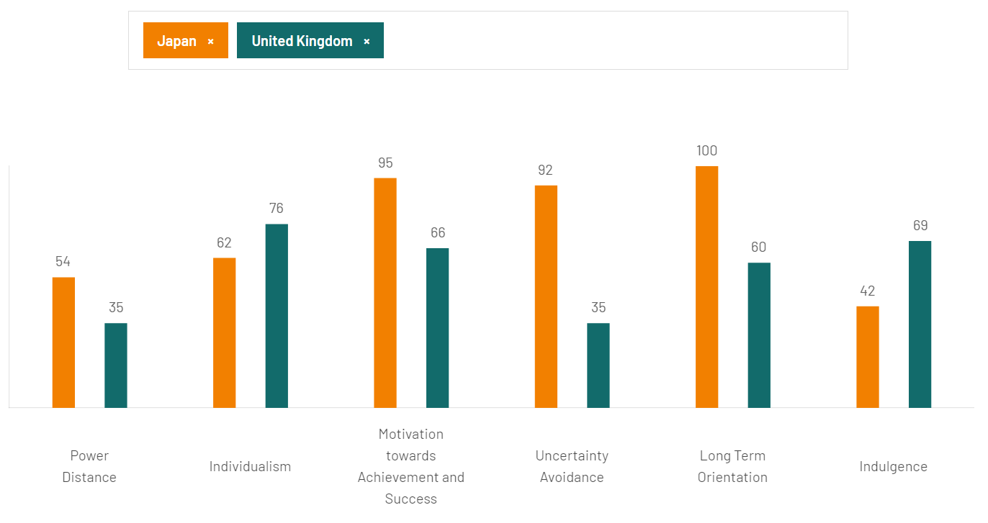
Figure: Comparison Scores between UK and Japan (Country comparison tool, 2024)
Cultural Practices and Values in Japan
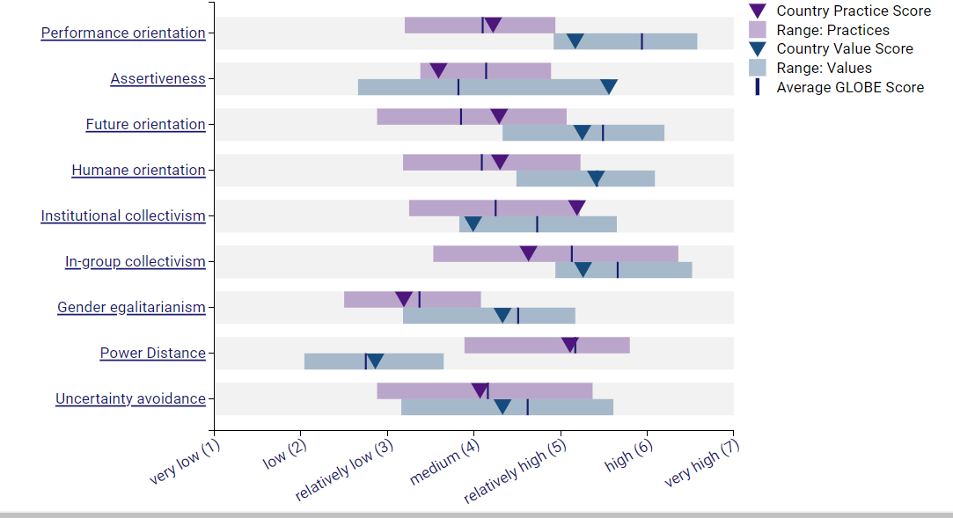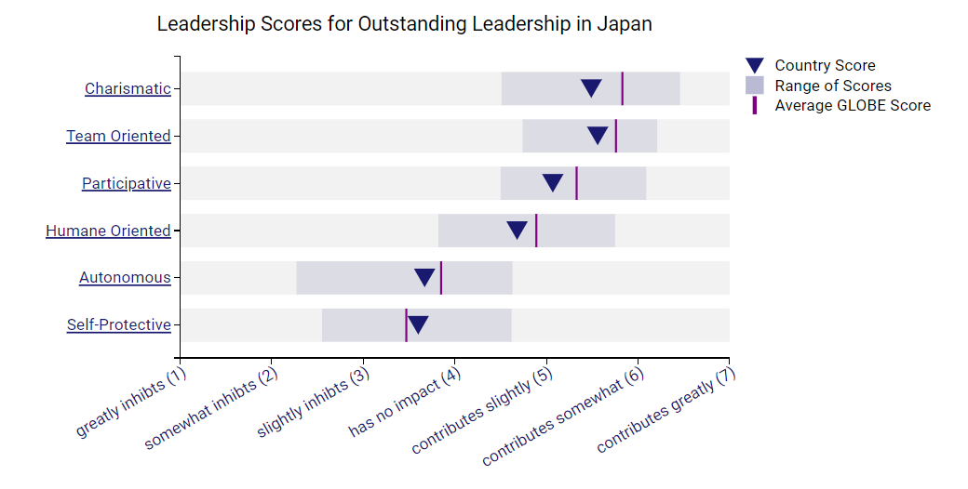
Cultural Practices and Values in England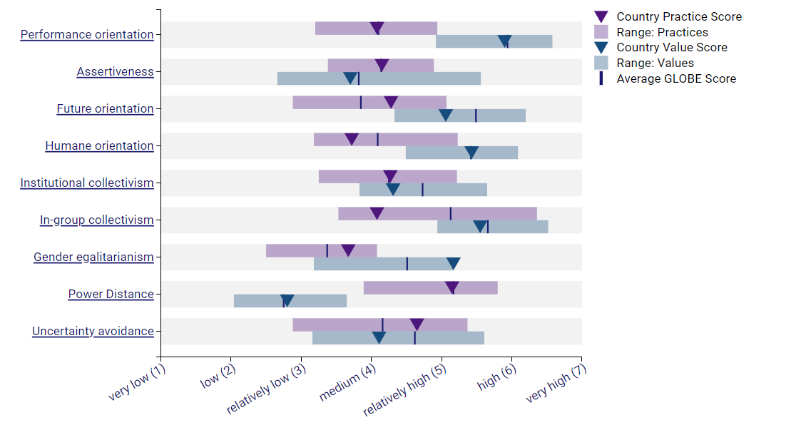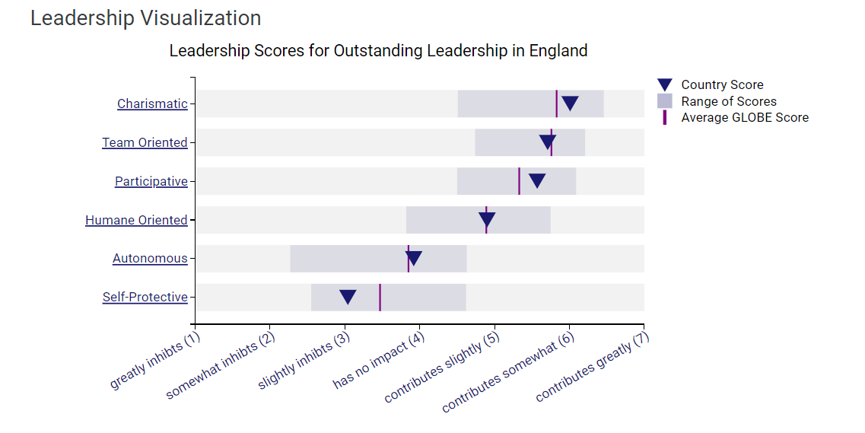Challenges in Intercultural Leadership in Hospitality
There is a possibility that individuals will have different speech patterns, which might lead to communication problems. As a result of the prevalence of implicit and indirect communication in Japan, direct engagement may be seen as being unpleasant. It has been observed that people in England have a predilection for engaging in direct connection with one another (Ayeh, Au, and Law, 2016). The act of deciding between several options: The more egalitarian way of life that is prevalent in England may be contrasted with the hierarchical structure that is prevalent in Japanese society. Finding a way to effectively manage this gap is very necessary in order to facilitate effective team interaction. In order to solve cultural issues, there are a variety of approaches that might result in complications. It is possible that England may have a bias for engaging in direct conflict, whereas Japan may have a tendency for using diplomatic and indirect measures in order to maintain peace (González-Rodríguez et al., 2019).

Conclusion
To create a happy and productive work environment, supervisors of a team that includes people from both England and Japan must understand and appreciate cultural differences (Nazarian, Atkinson, & Foroudi, 2017). These traits can be used by The Inclusivity Hotel & Spa to improve the experience for both its employees and visitors, ensuring an amazing and friendly environment.

Recommendations
Cross-Cultural Training
Training that spans many cultures: Team members with advanced English and Japanese must be rigorously trained. This method can improve reciprocity, cultural awareness, and conflict resolution (Driskill, G., 2018).
Establishing Clear Communication Protocol
Communication protocols should be transparent and culturally acceptable. Both nations need culturally appropriate and transparent communication procedures (Klyukanov, I.E., 2020). Materials should aid language learning and open discourse.
Leadership Development Programmes
Leadership development initiatives must mix Japanese and English leadership styles. This could create a leadership team that knows and uses the techniques.

References
GLOBE project (2024) Globeproject.com. Available at: https://globeproject.com/index.html (Accessed: 30 January 2024).
Country comparison tool (2024) Hofstede-insights.com. Available at: https://www.hofstede-insights.com/country-comparison-tool?countries=japan%2Cunited+kingdom (Accessed: 30 January 2024).
Driskill, G., 2018. Organizational culture in action: A cultural analysis workbook. Routledge.
Oey, E. and Lim, J. (2022) ‘Clustering Different Learning Behavior with Model of Culture’, in Proceedings of the 7th North American International Conference on Industrial Engineering and Operations Management, pp. 12–14.
Klyukanov, I.E., 2020. Principles of intercultural communication. Routledge.
Ayeh, J. K., Au, N. and Law, R. (2016) ‘Investigating cross-national heterogeneity in the adoption of online hotel reviews’, International journal of hospitality management, 55, pp. 142–153. doi: 10.1016/j.ijhm.2016.04.003
Trianasari, N., Butcher, K. and Sparks, B. (2018) ‘Understanding guest tolerance and the role of cultural familiarity in hotel service failures’, Journal of hospitality marketing & management, 27(1), pp. 21–40. doi: 10.1080/19368623.2017.1329677
González-Rodríguez, M.R., Martín-Samper, R.C., Köseoglu, M.A. and Okumus, F., 2019. Hotels’ corporate social responsibility practices, organizational culture, firm reputation, and performance. Journal of sustainable tourism, 27(3), pp.398-419.
Smith, P. B. (2018). When elephants fight, the grass gets trampled: Cultural psychology, globalization, and the generation of intercultural miscommunication. International Journal of Intercultural Relations, 34(3), 173-188.
Ishikawa, M. (2019). The Japanese Mind: Understanding Contemporary Japanese Culture. Tuttle Publishing.

