

Professional Reflection
Module: Foreign Languages
Module Code: BMIH5003
Lecturer: Giulia Chifari
Student name: Andreea Catalina Mecic
Student number: 2215573

Contents
1. Introduction 3
2. What Happened? 3
3. So What? 4
4. Now What? 4
5. References 5

Introduction
Delivering outstanding customer service places the utmost significance on understanding and respecting the cultural differences among visitors (Andriyani et al., 2019). This professional reflection will focus on my time working at a hotel, where I experienced a cultural misunderstanding that must be fixed for better future encounters. I will use the Driscoll Reflective Model for this reflective activity since it provides an organised framework for introspection (Driscoll et al., 2019). What, So What, and Now What are the three core questions that Driscoll's Reflective Model is built around.
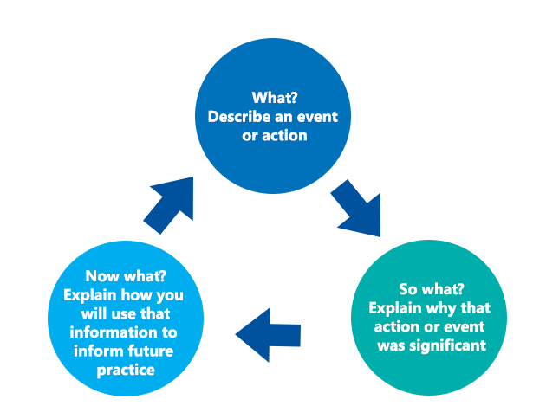
Figure 1: Driscoll Model of Reflection. Source: Driscoll et al. (2019).

What Happened?
I recently had an experience while working at a hotel's front desk that demonstrated the value of cultural understanding in the hospitality industry. When a party of Japanese tourists checked in, it became apparent that a cultural misunderstanding upset both the visitors and me. The communication gap was the main problem. My typical method of putting people at ease through warm conversation, light humour, and informal language did not work with these Japanese guests. It became clear that they did not respond favourably to this tactic.

So What?
As time passed, it became clearer that there was a cultural misunderstanding. Even though I tried to make the atmosphere friendly and welcoming, the Japanese visitors came off as restrained and apprehensive. I first thought that there could be a linguistic barrier. The visitors seemed to prefer more formal contact, and my attempts at informal chat were met with polite but reluctant reactions. In light of this experience, I realised that various difficulties may arise in the hotel industry, particularly in the culturally varied community. Understanding and gaining knowledge of different cultural contexts helps one understand why individuals act and behave the way they do (Yang et al., 2022). The need to adapt one's communication approach to satisfy the cultural tastes and expectations of visitors from various backgrounds was brought home by this experience.

Now What?
I must significantly alter my front desk staff's behaviour to avoid further cultural misunderstandings. I need to be more flexible in how I approach communication. I should evaluate the guest's comfort level and adjust instead of using my regular cheerful talk. To respect their desire for formality and politeness, I should, for instance, be more formal and restrained while hosting Japanese visitors. I fully understand the importance of paying great attention to nonverbal signs while interacting with people from different cultural backgrounds. It's critical to recognise that how body language is interpreted might vary greatly based on cultural standards (Bonvillain, 2019). What is considered polite or respectable in one culture could have quite different meanings in another. In addition, I have realised how crucial it is to comprehend how people around me interpret my body language. Even while my non-verbal cues may be intended to indicate friendliness and openness, others from different cultural backgrounds can mistakenly interpret them differently. The importance of asking questions is yet another priceless lesson I've learned. There shouldn't be any hesitancy while looking for understanding and clarification. People from different origins often feel respected and appreciated when others show real interest in their way of life. I now deliberately ask open-ended questions, inviting others to express their cultural viewpoints, customs, and beliefs.

References
Andriyani, A., Djatmika, D., Sumarlam, S. and Rahayu, E., 2019. Learning from face-threatening acts by tourism workers in Bali: The impacts of cross-cultural misunderstanding. Journal of Social Studies Education Research, 10(3), pp.64-81.
Yang, H., Cheung, C. and Li, W., 2022. Intercultural communication competency practices in the hotel industry. Journal of China Tourism Research, 18(1), pp.162-184.
Bonvillain, N., 2019. Language, culture, and communication: The meaning of messages. Rowman & Littlefield.
Driscoll, J., Stacey, G., Harrison Dening, K., Boyd, C. and Shaw, T., 2019. Enhancing the quality of clinical supervision in nursing practice. Nursing Standard, 34(5).

