Planning and Delivering an International Meeting/Event

Module Name: International Meetings Management BMIH6007
Tutor’s Name: Kathryn Flynn
Student Name: Elena-Petronela Ciubotariu
Student ID: 2219782

I confirm that I have not used any AI tools in the research and creation of this assignment. I confirm that I have not presented any AI generated materials as my own work. I confirm I have copies of my drafts, notes, and other resources I used, which I may be asked to provide in evidence.

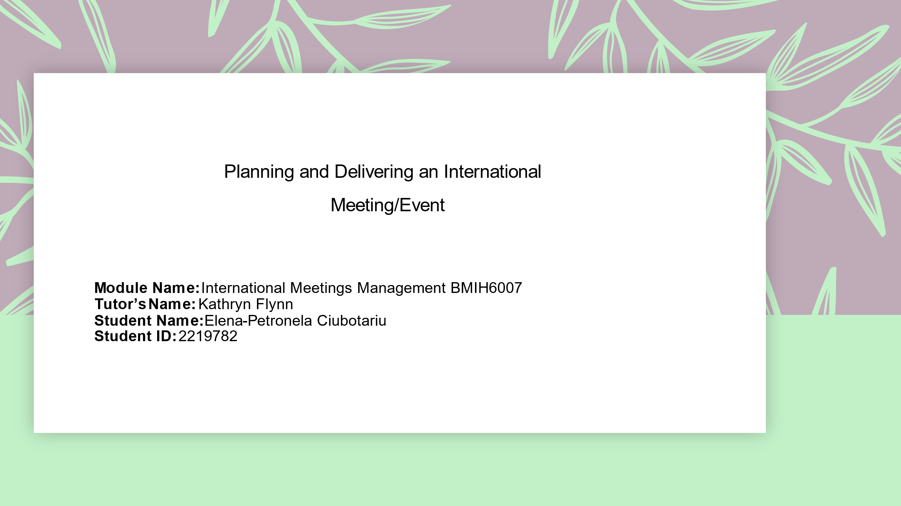

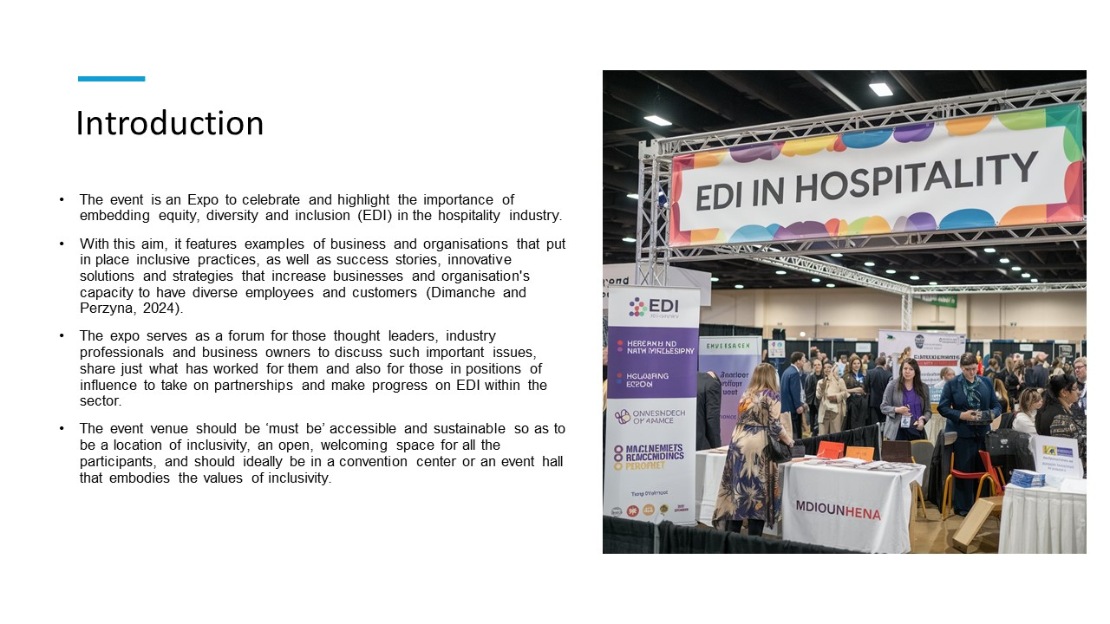
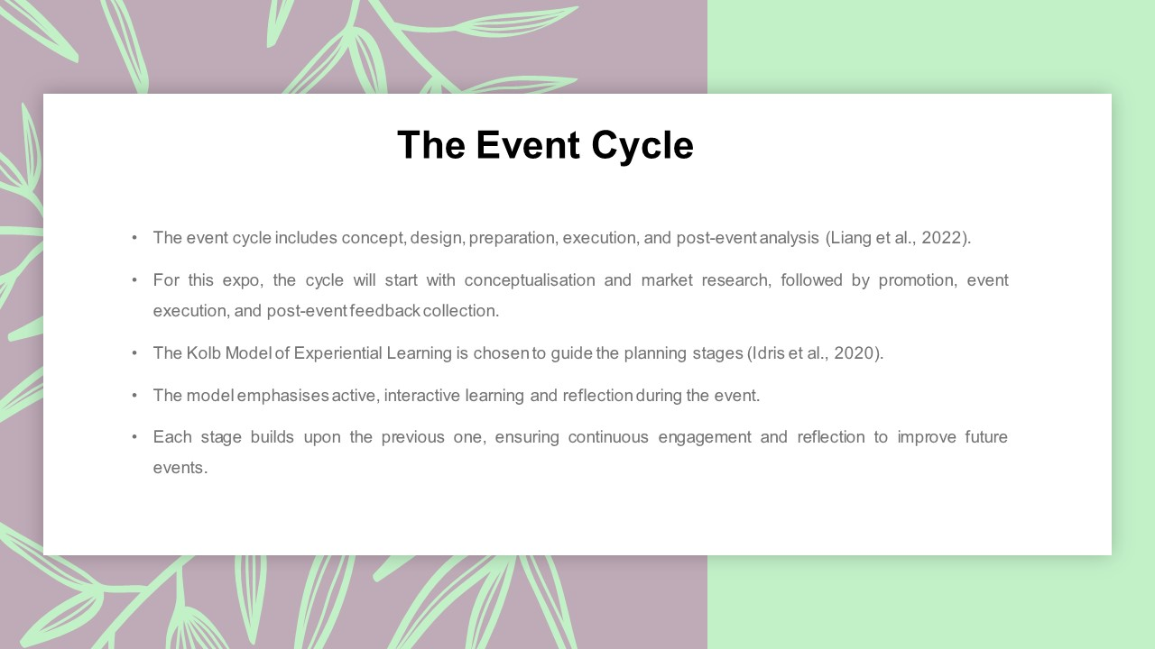
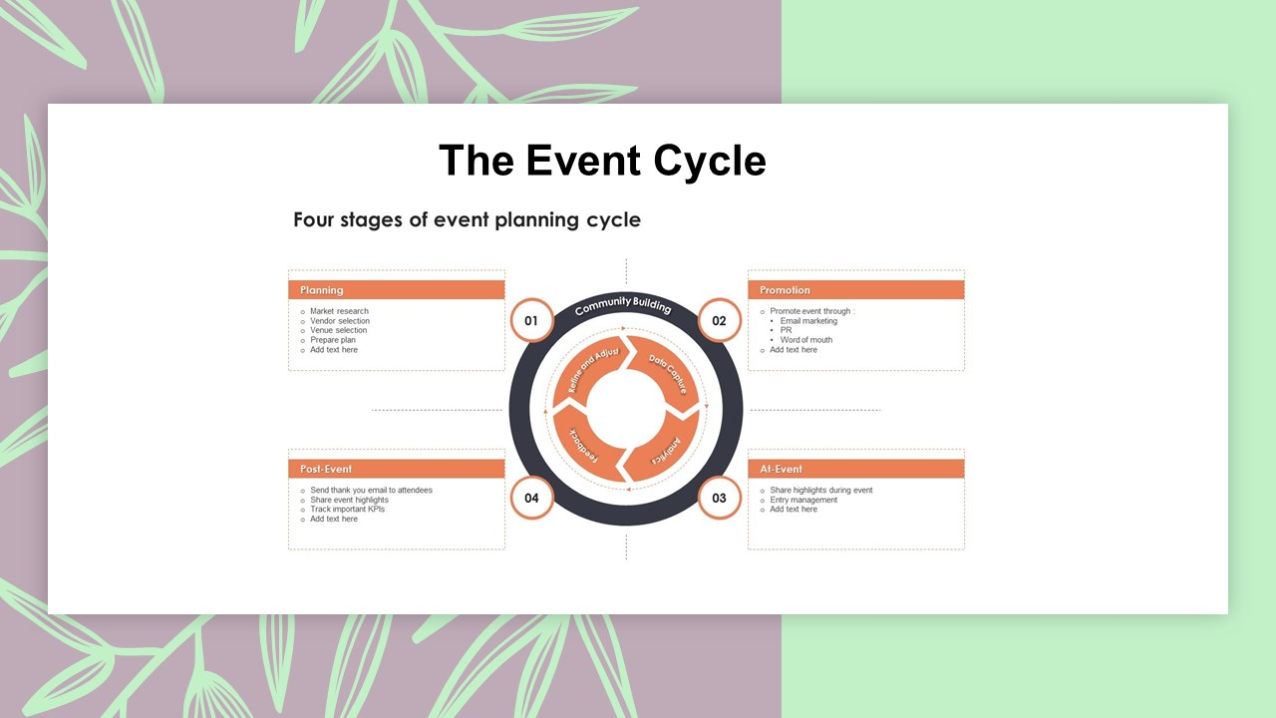
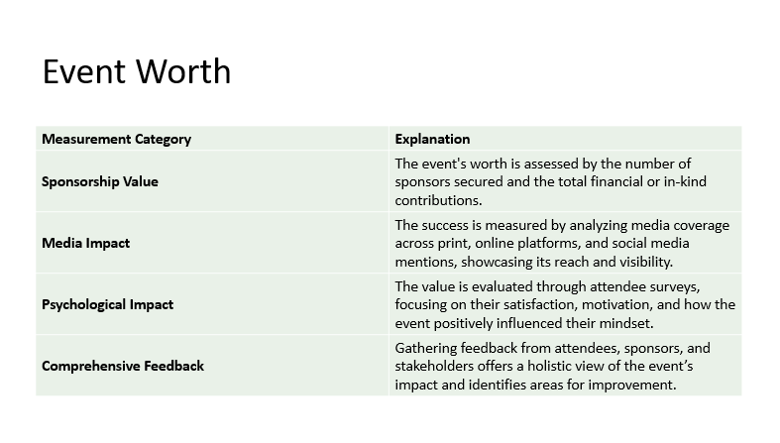

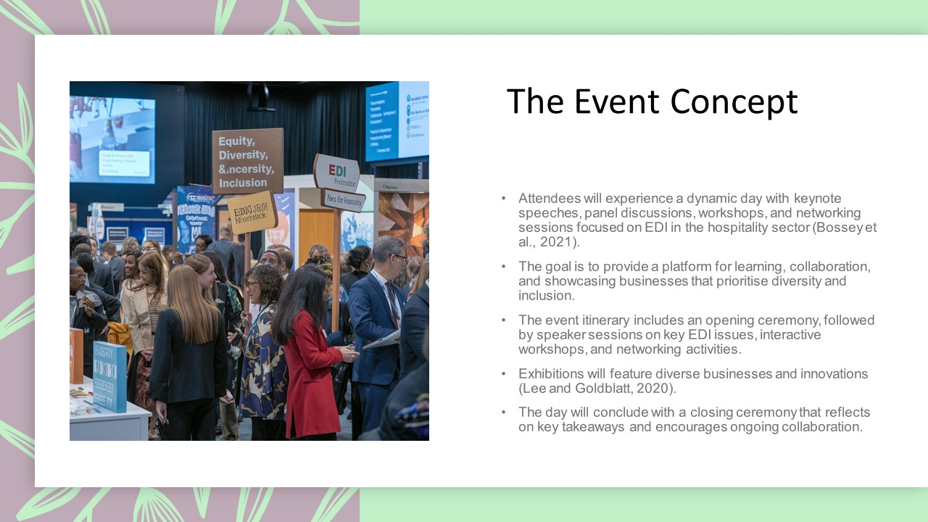

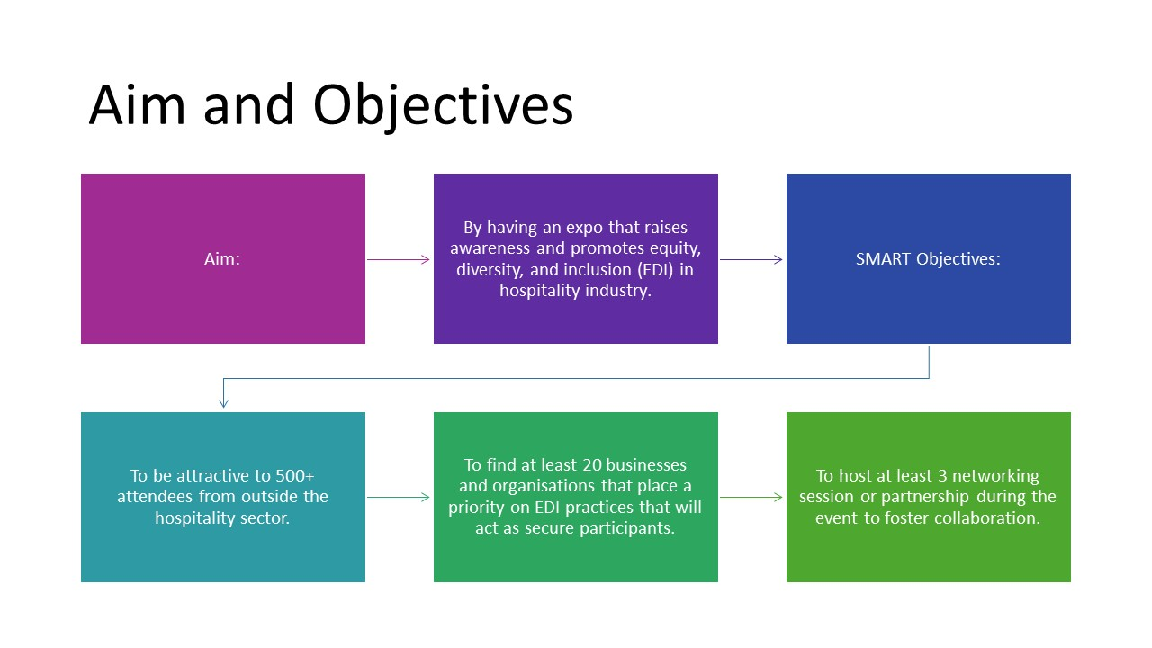

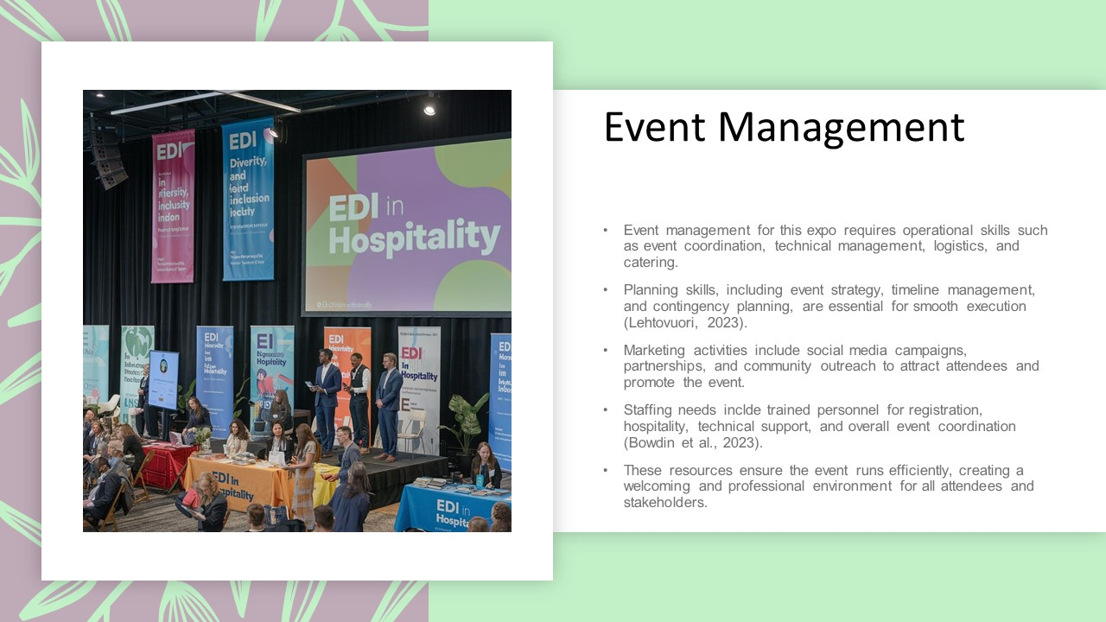

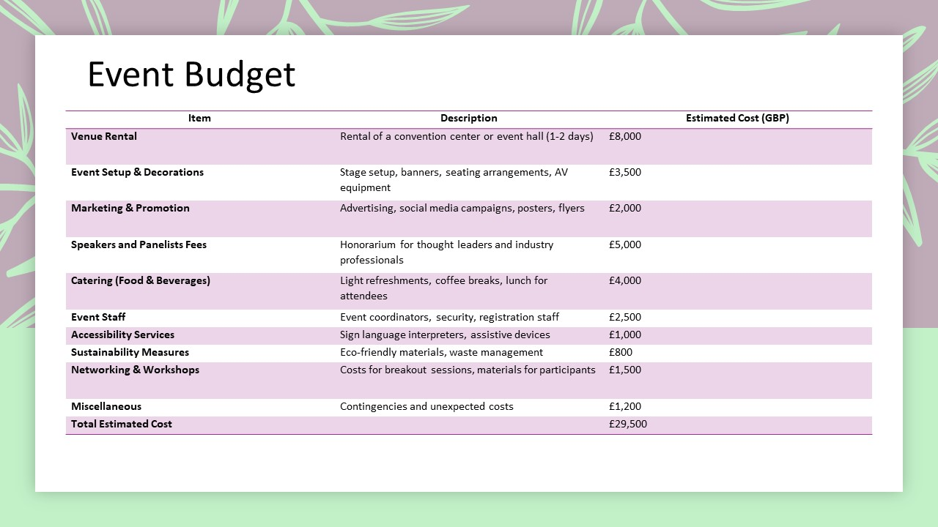
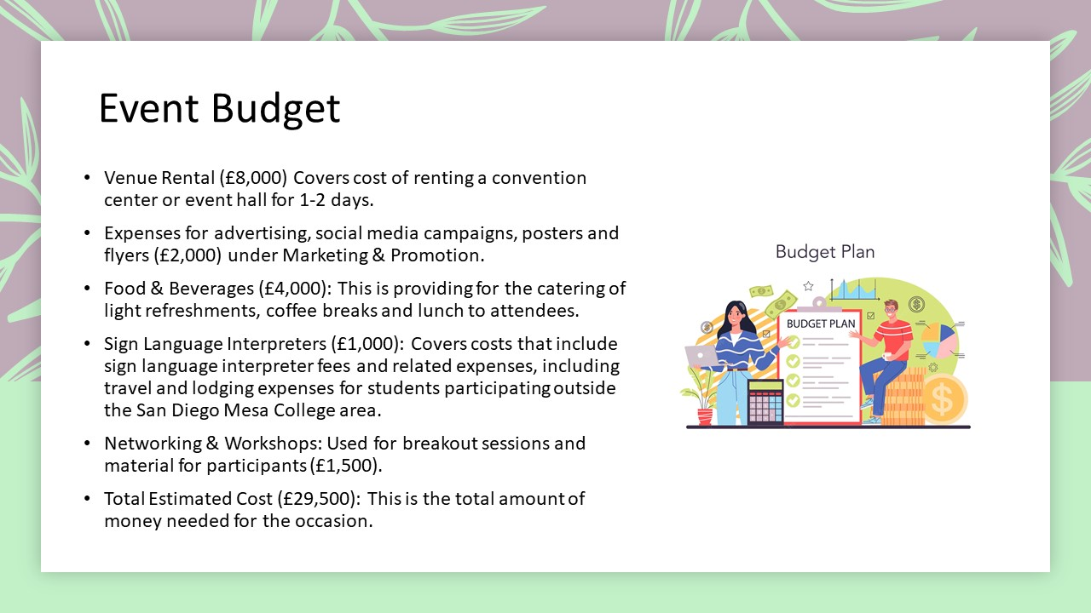
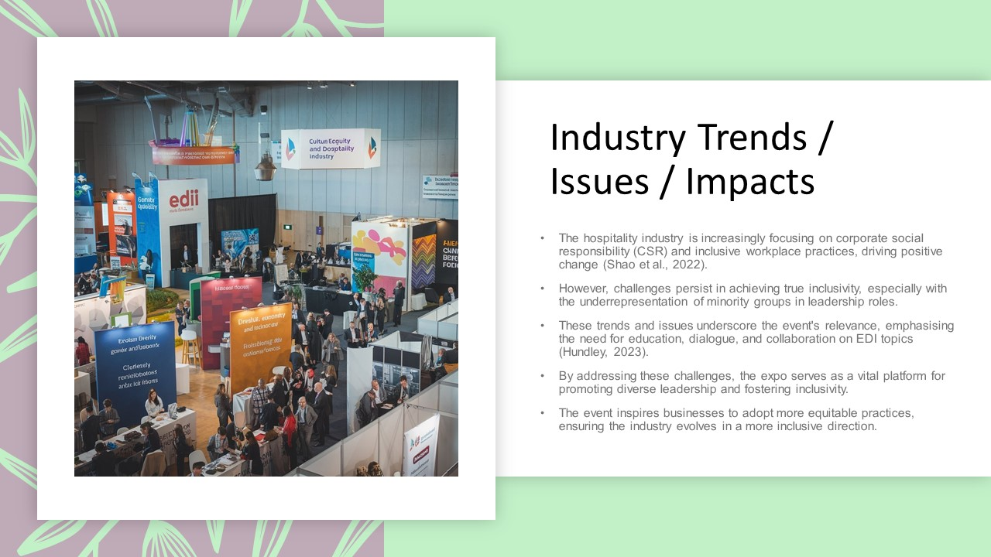

References:
- Bernauer, V. S., Bhati, A., and Thirumaran, K. (2023). Guest editorial:(In) equalities in hospitality and tourism–exploring diversity and equity issues. Equality, Diversity and Inclusion: An International Journal, 42(4), 465-468.
- Bossey, A., Curtis, M., Weeden, C., and Williams, M. (2021, July). The Association for Events Management Education (AEME) 17th Annual Forum 2021-Events Principles and Practices: a level playing field?.
- Bowdin, G. A., Allen, J., Harris, R., Jago, L., O'toole, W., and McDonnell, I. (2023). Events management. Routledge.
- Dimanche, F., and Perzyna, M. (2023). INCLUSION MANAGEMENT IN THE CANADIAN HOSPITALITY INDUSTRY. The Routledge Handbook of Diversity, Equity, and Inclusion Management in the Hospitality Industry, 271.
- Dimanche, F., and Perzyna, M. (2024). Diversity, equity, and inclusion management in the Canadian hospitality industry. In The Routledge Handbook of Diversity, Equity, and Inclusion Management in the Hospitality Industry (pp. 271-281). Routledge.
- Fresnoza, E. P., Balcombe, D., and Choo, L. (2024). Social justice in tourism recovery: examining equity, diversity, and inclusion in Canadian tourism restart policies. Tourism Critiques: Practice and Theory.
- German, L. A., Bonanno, A. M., Foster, L. C., and Cotula, L. (2020). “Inclusive business” in agriculture: Evidence from the evolution of agricultural value chains. World Development, 134, 105018.
- Groenewald, E. (2024). Assessing the Role of Leadership in Shaping EDI Policies and Initiatives in Hospitality Industries: A Systematic Review and Meta-analysis Review. International Multidisciplinary Journal of Research for Innovation, Sustainability, and Excellence (IMJRISE), 1(1), 13-19.
- Hundley, S. P., and Keith, C. J. (Eds.). (2023). Trends in assessment: Ideas, opportunities, and issues for higher education. Taylor and Francis.
- Idris, F., Din, W. M., and Tajuddin, M. (2020). Adapting Kolb’s Experiential Learning Cycle In Enhancing Attitude And Skills Among Undergraduates Through Volunteerism’. AJTLHE, 12(2), 122-39.
- Khatter, A. (2025). Challenges and Solutions for Corporate Social Responsibility in the Hospitality Industry. Challenges, 16(1), 9.
- Lee, S. S., and Goldblatt, J. (2020). Special events: The brave new world for bolder and better live events. John Wiley and Sons.
- Lehtovuori, I. (2023). Building an event-planning start-up: business plan for a small event planning start-up company.
- Liang, H., Zhang, J., Wang, Y., Li, S., Wang, X., and Yin, Z. (2022, November). Research on Energy Internet Demonstration Project Management Based on Pre-Event, during Event, and Post-Event Control. In 2022 5th International Conference on Power and Energy Applications (ICPEA) (pp. 548-553). IEEE.
- Lima Rabelo, F., Vieira Fernandes, A. M., and Perelygina, M. (2023). Handbook of Diversity and Intercultural Inclusivity for Hospitality at TU Dublin.
- Manohinclusionaran, A., Madera, J. M., and Singal, M. (Eds.). (2024). The Routledge handbook of diversity, equity, and management in the hospitality industry. Routledge.
- Mohammadi, Z., Bhati, A., and Ng, E. (2023). 20 years of workplace diversity research in hospitality and tourism: a bibliometric analysis. Equality, Diversity and Inclusion: An International Journal, 42(4), 551-571.
- Shao, J., Cherian, J., Xu, L., Zaheer, M., Samad, S., Comite, U., ... and Badulescu, D. (2022). A CSR perspective to drive employee creativity in the hospitality sector: a moderated mediation mechanism of inclusive leadership and polychronicity. Sustainability, 14(10), 6273.
- Velasco, M. (2019). Resistance to diversity and inclusion change initiatives: Strategies for transformational leaders. Organisation Development Journal, 37(3), 9-20.
- Wolbring, G., and Lillywhite, A. (2021). Equity/equality, diversity, and inclusion (EDI) in universities: the case of disabled people. Societies, 11(2), 49.

