A report focussing on:

Why I have chosen construction as a sector to work in

Prepared for:

Mr R Thomas (R.H.Thomas@uwtsd.ac.uk)

Created by:
Mr Cerith Edwards (2219938) – Trainee Quantity Surveyor for Premier Forecourt and Construction

Date completed:
01/11/2022

Word Count:1041 Module Code – ACBA4003

.
Table of Contents
Page Number
1.0 Executive Summary 3
2.0 Terms of reference 3
3.0 Procedure 3
4.0 Findings 4
5.0 Conclusion 7
6.0 References 8
7.0 Appendices 9

- Executive Summary
My decision to seek a career in the construction industry will be discussed in this report. Along with my inspiration, it will include my sources of work experience. There will be a summary that outlines the benefits and reasoning I chose to change my career path in the construction sector.

- Terms of Reference
  - My professional history and why the construction business will benefit from my experiences.
  - Why I decided on the Quantity Surveyor role.
  - The report submission deadline is 23:55 on the 3/11/22

- Procedure

  - All the sources used in the report, including websites and first-hand accounts, are listed in the references and bibliography.

- Findings

  - My background and construction-related transferrable abilities

For the past 20 years, I've been employed by the civil service, primarily responsible for ensuring road safety. My main duties included managing and supervising workers as a team leader and the latter as the head of the training team for my department. Managing between 10 and 100 employees at any given time.
Construction has always been an interest of mine. I began a construction management course in 2003, although I was unable to complete it due to working part-time for the Civil Service. The combined hours of working and attending college became unmanageable, I decided to pursue a career full time in the civil service.
The Civil service has allowed me to gain and develop many skills which are all essential to the construction sector. I conducted online study to ensure I possess the transferrable skills necessary to be successful. Knight, M. (2022), confirmed. “Teamwork, self-belief, self-management, communication,” alongside leadership are key skills that are attractive for employers within construction. After considering construction jobs and reigniting my passion for the sector combined with already having these key skills, I decided to move on from the civil service and seek a career as a quantity surveyor. I found that the commercial path was the most appropriate for my skill set.

  - Why the construction industry and in particular the Quantity Surveyor role

Despite my lack of construction knowledge, I recently made the decision to construct my own Garden shed. It took a lot of research to determine the best way to build this, using the most suitable and sustainable resources, while remaining within my budget. I made sure my plan to construct the project was achievable, keeping expenses minimal and ensuring the project could be finished without any additional unwanted cost. I had to make decisions throughout the build that I had little or no experience about. From designing the floorplans, personally digging the footings to sourcing and constructing the materials, I relished the manual labour. I enjoyed researching which materials to use, alongside the decisions involved in whether to erect a block build or timber frame, having a flat roof or a pitched roof etc, constantly weighing up the pros and cons to all my options. What, I enjoyed most about my construction project was managing the budget, working with the relevant subcontractors, and developing relationships with industry stakeholders while making sure the project would be completed on schedule. This was when I realised, I had a passion for a role in the construction industry. I spoke to friends who were in the construction industry about my build, highlighting what I enjoyed about completing the project. These conversations led to discussions about suitable construction roles. Through these conversations, I discovered what a quantity surveyor does. I knew immediately that I had to pursue a career as a quantity surveyor.
Ensuring I had the required skills for the role, I spent time researching the various roles and responsibilities of a Quantity surveyor. Each quantity surveyor’s role varies slightly within each company, however the fundamental of the role is to “project finances and maintain contractual relationships. A construction quantity surveyor will report on the financial aspect of a project, ensuring value for money and cost optimisation throughout the construction process.
Aside from focusing on cost, quantity surveyors also make sure that construction plans are of high quality, that all appropriate legislation is followed, and that the construction site doesn't have any safety violations.” (Randstad, no date). The above statement truly excites me, hence why I changed careers to become a Quantity Surveyor.

  - Benefits of being a quantity Surveyor and working in the construction sector
It was never going to be simple decision to leave a well-paying job, but the chance to pursue a career in a field I'm going to thrive in and have already become passionate about seemed too good to be true.
A quantity surveyor is a well-paid role. The website (totaljobs, no date) states “the average wage for a Quantity surveyor is 57,500. It also states that the average working hours are between 37 – 40 a week.” As a single dad, I find both very attractive, while allowing a good work/life balance.
There will always be a demand for construction workers with the ever-growing population and economy. I can only see the construction industry getting stronger year by year, (Time recruitment, no date) state “the construction industry is constantly growing and as it does so, it needs to recruit even more workers. There is an increasing demand for construction workers”. My decision to leave the public service was made easier after researching job securities in the construction sector. I'm even more certain now that deciding to train to be a quantity surveyor was the correct choice.

Construction qualifications along with experience are recognised world wide. (Maximumrecruitment, no date) state that “There are already 1000s of Quantity Surveyors working internationally in the Middle East (Dubai, Abu Dhabi, Qatar) and Asia regions (Hong Kong, Macau, Malaysia, Singapore) that have successfully made the transition overseas and are now seeing the benefits both financially and in their career progression.” Travelling the world has always been an interest of mine and another benefit that the quantity surveyor role offers.

5.0 Conclusion
5.1 The construction industry is an attractive sector to work in, offering job satisfaction in a secure industry. It offers a wide range of roles and responsibilities for individuals, with continuous opportunities for development and refining skills. Working within the construction industry allows you to gain many transferable skills that can be used from company to company or country to country. These skills can also be used to further your career or change career paths. It allows you to work individually or as part of a team. You interact with people from a variety of backgrounds, and frequently end up with colleagues who become lifelong friends. The construction sector is recognised globally and will always allow an opportunity to travel the world, experience different cultures and significant financial gain.
The report above outlines a few of the factors that assisted me in my decision of becoming a quantity surveyor and work in the construction industry. I am eager to discover what the future holds for me and where my career path will lead. I'm currently enjoying my position as a trainee quantity surveyor and my future aspirations are to become a commercial manager.

6.0 References
5 reasons why you should pursue a career in construction (2018) Time Recruitment. Available at: https://time-recruitment.com/5-reasons-pursue-career-construction/ (Accessed: October 23, 2022).
An international career in quantity surveying (no date) Maxim Recruitment. Available at: https://www.maximrecruitment.com/news/post/an-international-career-in-quantity-surveying/ (Accessed: October 23, 2022).
Knight, M. (2022) What skills do you need for construction careers?, Youth Employment UK. Available at: https://www.youthemployment.org.uk/skills-construction-careers/ (Accessed: October 23, 2022).
Quantity surveyor (no date) What does a quantity surveyor do? | QS Job responsibilities | Randstad UK. Available at: https://www.randstad.co.uk/career-advice/job-profiles/quantity-surveyor/ (Accessed: October 23, 2022).
Check average quantity surveyor salary - totaljobs (no date). Available at: https://www.totaljobs.com/salary-checker/average-quantity-surveyor-salary (Accessed: October 23, 2022).

7.0 Appendices

  - Appendix 1
The Shed I built mentioned in 3.2
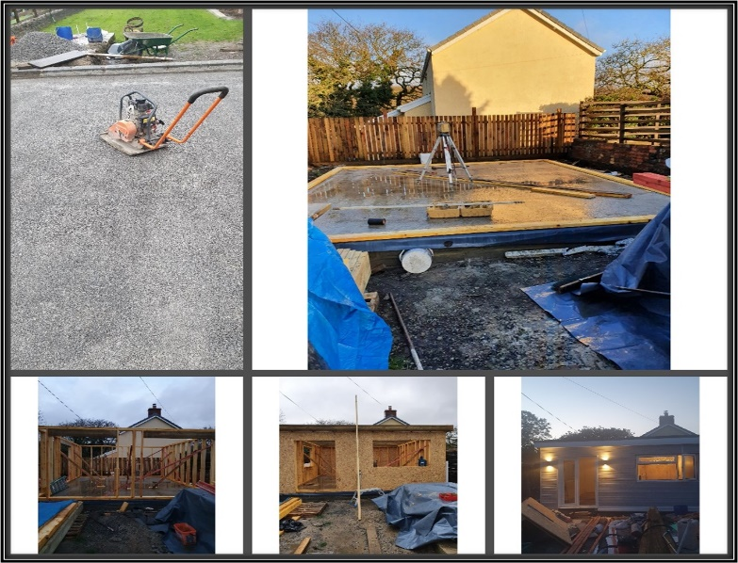
Source: (Cerith Edwards, Circa 2019)

  - Appendix 2

The below is where I recorded my costing for the garden shed
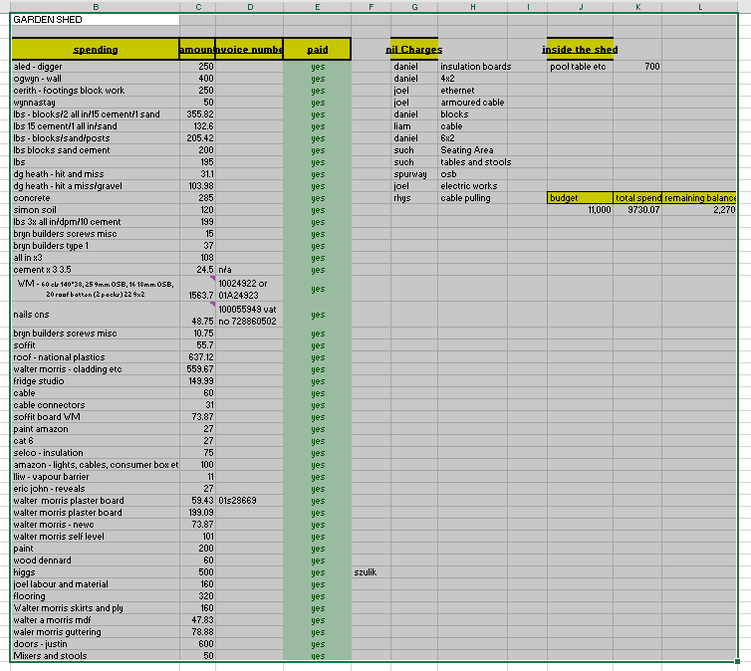
Source: (Cerith Edwards, Circa 2019)

  - Appendix 3

The following Screen shot shows job adverts on linkedin.com for Quantity surveyor roles in Dubai.

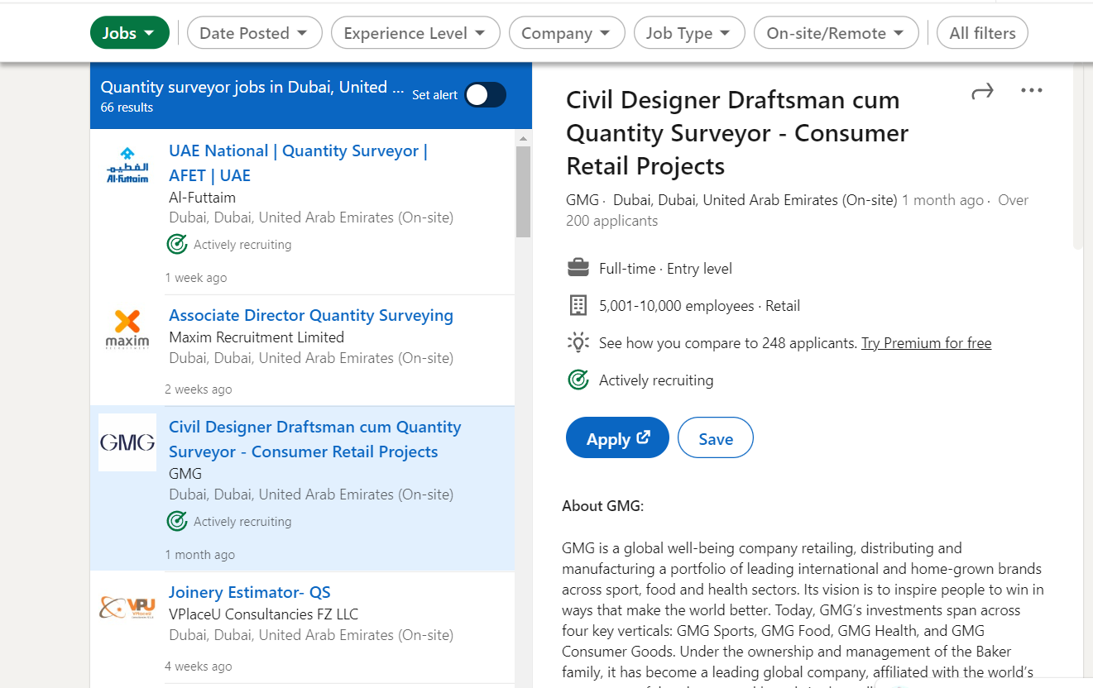

Source: 33 quantity surveyor jobs jobs in Dubai, United Arab Emirates (3 new) (no date) 33 Quantity Surveyor Jobs jobs in Dubai, United Arab Emirates (3 new). Available at: https://www.linkedin.com/jobs/search/?currentJobId=3304905977&geoId=106204383&keywords=quantity+surveyor+jobs&location=Dubai%2C+United+Arab+Emirates&refresh=true (Accessed: October 25, 2022).

