Organisational Behaviour and Strategic Management Analysis of Marriott
Hotels & Resorts
Student name: Nicoleta Aurelia Monafu
Student ID:2245344
Module code: BMIH5004
Module Title: Management & Organisational Behaviour

Declaration
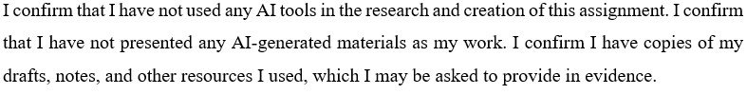

Executive Summary

This report aims to analyse the organizational behaviour and analyze Marriott International’s organizational structure, corporate culture, change management, creativity, and planned direction. The findings show that Marriott uses a divisional structure to manage its diverse brands and operations. Based on Hofstede’s dimensions, its corporate culture emphasizes individualism and uncertainty avoidance, which positively influences employee motivation and service quality. The company’s recent change efforts, such as technology integration and environmental sustainability initiatives, were implemented using Kotter’s 8-Step Change Model and have led to mixed reactions from staff, though they align with Marriott’s long-term goals. The strategic direction of Marriott is focused on market expansion, brand consistency, and technology adoption, with clear differentiation from its competitors like IHG. The report recommends further investment in technology to enhance customer experience and operational efficiency and suggests targeted employee training programs to improve adaptability during change initiatives. Furthermore, Marriott which should focus on maintaining its commitment to sustainability while expanding into developing markets.

Table of Contents
1 Introduction 4
2 Organisation Structure, Culture, and Goals 4
2.1 Structure 4
2.2 Culture 6
2.3 Goals 6
3 Recent Change Initiatives 7
3.1 Digital Transformation at Marriott 8
3.2 Sustainability Program at Marriott 9
4 Strategic Direction 9
5 Recommendations 12
5.1 Implementation plan 12
6 Conclusion 13
7 Reference List 15

1 Introduction
This report explores Marriott’s internal structure, employee culture, recent innovation and change programs, and its long-term strategic vision (Eschenbrenner et al., 2023). The report will begin with background information about the company, then explore its internal structure and culture. It will also look at how Marriott manages change and the strategies it uses to remain competitive in the hotel industry. Marriott is a well-known and respected global hotel group that was founded in 1927 and now operates in over 130 countries (Marriott, 2025). It is recognised for its excellent service, brand variety, and strong customer loyalty.

Organisation Structure, Culture, and Goals

Structure
Marriott follows a functional organisational structure, where the company is divided into departments including departments like marketing, finance, operations, and HR. Each unit focuses on its specific area, and employees report to managers in their department. This structure helps Marriott manage its many hotels around the world by making sure each part of the business runs smoothly (Giousmpasoglou and Marinakou, 2024). It also allows the company to keep high standards, control costs, and offer similar services in different locations. This structure works well for large companies like Marriott that need to handle many tasks at once.
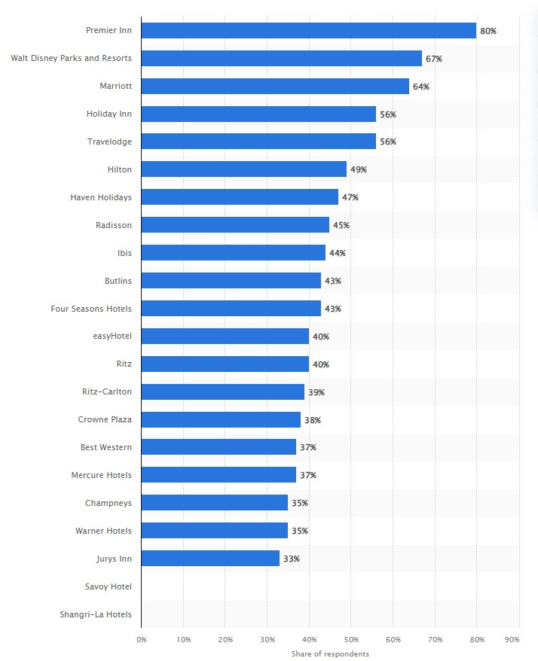
Figure 1: Leading hotel brands among millennials in the UK Q2 2024
Source: (Statista, 2024b)

(Figure 1) illustrates the popularity as one of the top hotel brands preferred by millennials in the UK as of Q2 2024. Marriott's strong position indicates its effective organisational structure and market appeal to younger demographics. Marriott’s structure also matches Mintzberg’s machine bureaucracy model. In this type of organisation, there are clear rules, strong control from the top, and a set way of doing things (Harris et al., 2022). Tasks are divided into small parts, and everyone has a clear role.
This helps Marriott maintain a high level of service across its global hotels. It also supports the company’s goal of offering a consistent guest experience while managing a large and complex international business.

Culture
Marriott has a strong and friendly company culture that focuses on teamwork, respect, and service. Using Hofstede’s cultural dimensions, Marriott shows low power distance, meaning managers and employees are treated equally and work together closely (Horozhankina et al., 2024). The company also has low uncertainty avoidance, which means it is open to new ideas and flexible ways of working. Marriott supports individual achievements but also values teamwork, which shows a balance between individualism and collectivism. This culture helps employees feel trusted, valued, and motivated in their roles.
Marriott’s culture has a big effect on employee motivation, service quality, and performance (Neupane and Khanal, 2022). When operate sense respected and supported, they are more likely to enjoy their jobs and do their best work. Marriott also gives training and rewards to help staff grow and stay motivated. Because of this positive culture, employees deliver better customer service, leading to happier guests and better performance overall. In the hotel industry, where service is very important, a strong and positive culture is key to success.

Goals
Marriott has clear goals across the organisation as a whole and within individual hotel properties (Sanvitale, 2020). At the corporate level, the main goal is to be the world’s favourite travel company by offering excellent service and growing its global presence. This supports Marriott’s with a mission to enrich customer lives through unforgettable experiences and a vision to become the most preferred hospitality brand globally. most loved travel company (Horozhankina et al., 2024).
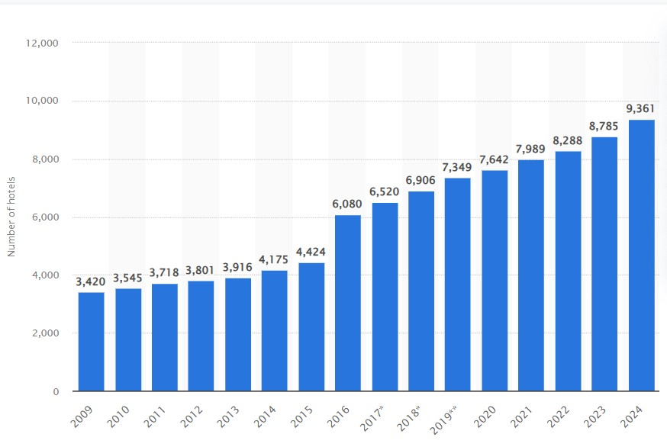
Figure 2: Marriott hotels worldwide 2009-2024
Source: (Statista, 2024c)

(Figure 2) illustrates the growth of Marriott hotels worldwide from 2009 to 2024, showcasing the company's strategic goal of expanding its global presence. This aligns with Marriott's long-term goal of market expansion. At the hotel level, goals often focus on improving guest satisfaction, increasing bookings, and keeping high service standards (Septa Intiar et al., 2024). These goals follow the SMART criteria. For example, a SMART goal for a hotel could be that tncrease guest satisfaction scores by 10% over the next six months through staff training and service improvements (Alharbi et al., 2025). This goal is defined goals that are specific, quantifiable, attainable, aligned with objectives, and set within a clear timeframe. This ensures objectives are well-structured and practical at both levels, Marriott makes sure that everyone in the company works towards the same direction and continues to grow and improve.

Recent Change Initiatives

Digital Transformation at Marriott
Marriott has recently made a major digital transformation to improve guest experiences and make operations smoother (Periasamy and Dinesh, 2024). This change included the launch of a new mobile app, contactless registration and till, and better digital booking systems. The reason for this change was to meet growing customer expectations for fast and easy service, especially after COVID-19 increased the demand for contactless services.
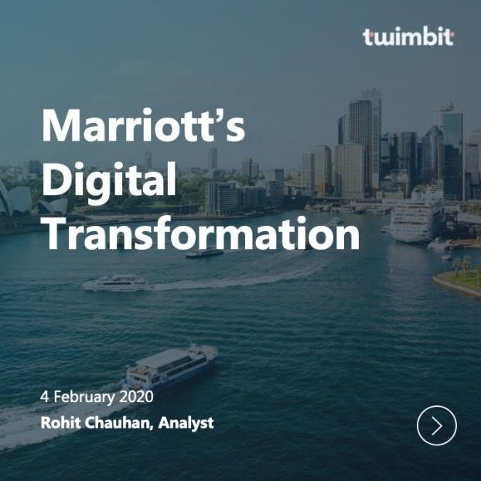
Figure 3: Digital Transformation at Marriott
Source: (Menon, 2020)

Marriott followed Kotter’s 8-Step Change Model to manage this transformation. They created a sense of urgency and built a team to lead the change. Then, they formed a clear vision, communicated the benefits, and gave staff the right tools and training. Staff reactions were mostly positive, especially among younger employees, who adapted quickly. Some older employees needed extra support and training.
The success of the digital transformation was seen in higher app downloads, faster check-in times, and improved guest satisfaction (Amirulloh Anwar et al., 2024). This shows the change was successful and helped Marriott stay modern and competitive.

Sustainability Program at Marriott
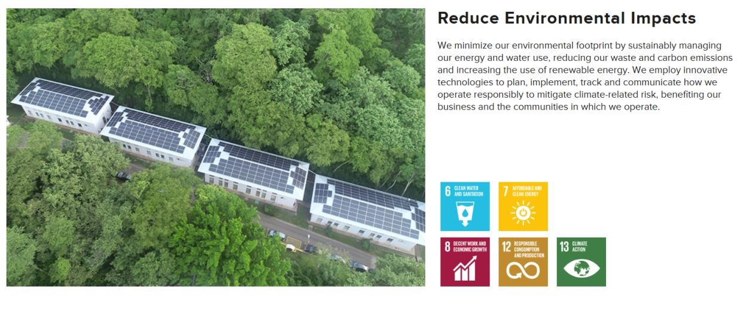
Figure 4: Sustainability Program at Marriott
Source: (csr-marriott, 2024)

Another important change initiative at Marriott is its move towards sustainability. Marriott introduced the Serve 360 which are liability decent in every course database. This change aims to reduce the hotel’s carbon footprint, cut energy and water use, and reduce plastic waste. The reason for this change was to protect the environment, follow new regulations, and meet customer expectations for eco-friendly travel. Marriott used Lewin’s Change Model to guide this process (Coulter, 2021). In the unfreeze stage, they raised awareness among employees about environmental problems. In the change stage, they introduced new practices like energy-saving systems, water-reducing taps, and removing plastic straws. In the refreeze stage, these changes were made part of everyday work routines. Staff reactions were mixed at first.
Some found it difficult to change old habits, but most accepted the new ideas after training. The success of the program was measured by lower utility bills, improved sustainability ratings, and positive customer feedback. This shows that Marriott’s sustainability program is working well.

Strategic Direction

Marriott International has developed a well-rounded strategy to sustain its growth in the competitive global hospitality market (Marriott, 2025). With the help of using Porter's Generic Strategies, Marriott primarily focuses on differentiation. The company offers distinct and exceptional experiences through a wide range of services across its various brands. From luxury accommodations under brands like Ritz-Carlton to budget friendly alternatives such as Courtyard by Marriott, the company tailors its services to align with the diverse needs of its customers. This differentiation strategy allows Marriott to command premium prices while delivering superior customer service. In addition, Marriott integrates some elements of cost leadership in it select-service properties like Fairfield Inn and Residence Inn, where it provides value for money without compromising the quality of service (Eschenbrenner et al., 2023).
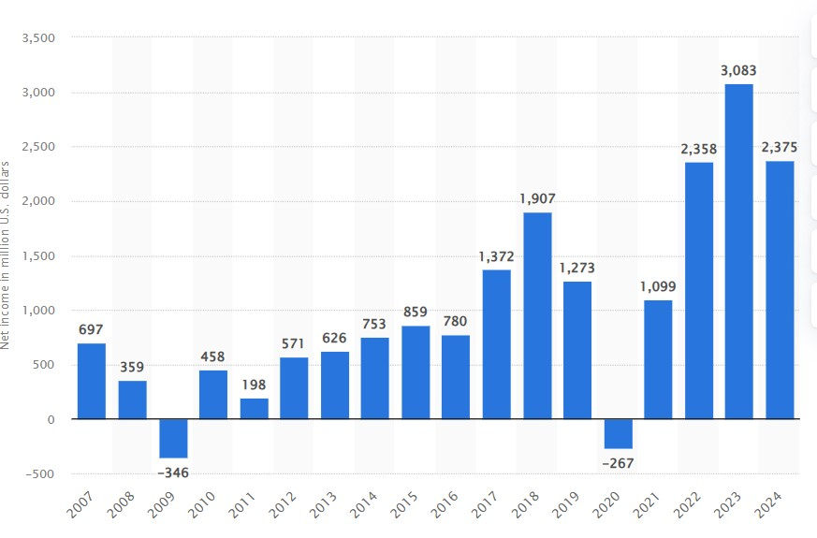
Figure 5: Marriott net income worldwide 2007-2024
Source: (Statista, 2024a)

(Figure 5) illustrates Marriott's net income worldwide from 2007 to 2024, highlighting the company's financial performance over time. This data supports the evaluation of Marriott's strategic direction, reflecting how its strategies have influenced profitability and long-term growth. One of Marriott's long-term goals is market expansion, with a particular focus on emerging markets like Asia-Pacific, Africa, and Latin America. The company aims to increase its global presence and tap into the growing demand for hospitality services in these regions. Marriott’s strategy also revolves around brand consistency, ensuring a seamless and high-quality guest experience across its various brands, which is essential for brand loyalty (Alharbi et al., 2025). By maintaining uniformity in service quality and amenities, Marriott strengthens its global recognition and encourages repeat business from travellers.

Additionally, Marriott plans to adopt more advanced technology to enhance the customer experience. The implementation of artificial intelligence (AI) to enable personalized services, mobile applications for seamless booking and check-in processes, and the incorporation of smart room technology are significant measures Marriott is adopting in order to stay competitive. These are directed towards enhancing operational effectiveness and customer experience. The company also has high-end sustainability targets aimed at lessening its impact on the environment by reducing energy use, conserving water, and minimizing waste generation within its hotels.

Table 1: Long Strategic Goals
Goal | Description
Market  Expansion | Marriott aims to expand its expansion into developing markets such as Asia-Pacific, Africa, and Latin America to increase its global footprint.
Brand  Consistency | The company focuses on maintaining a consistent brand experience across all its hotel brands to ensure loyalty and recognition.
Technology  Adoption | Marriott plans to further integrate technology, such as AI-driven customer service and mobile apps, to enhance guest satisfaction and streamline operations (Jogarao, 2024).
Sustainability | Marriott is committed to achieving significant sustainability targets, including reducing its carbon footprint and waste (Vlasceanu et al., 2020).
Source: (Author)

Comparing Marriott's strategy with its rival IHG, both players target growth and robust brand positioning. Nevertheless, Marriott's diversified brand portfolio appeals to a wide variety of market segments compared to IHG's strong emphasis on its midscale brands like Holiday Inn and Holiday Inn Express (Oskam and Tjeerd Zandberg, 2019).
Marriott also takes the lead in technology usage, especially in creating more memorable guest experiences, and is ahead of IHG in this respect. Though both chains are equally devoted to sustainability and growth, Marriott's diversification strategy and technological innovations place it at a competitive advantage in the market.

Recommendations

Marriott needs to keep upgrading its digital technology to simplify services and speed them up for guests. Enhancing more features of the mobile app, such as in-app room service requests or virtual concierge assistance, can boost guest satisfaction. Marriott also needs to invest in ongoing staff training to enable staff to adapt to new systems and ensure top-of-the-line service quality. At a cultural level, Marriott should continue encouraging diversity, equality, and inclusion (DEI) by means of workshops and recruitment processes. This will promote a positive working environment and encourage employees. Marriott can further enhance sustainability by incorporating more renewable sources of energy into its hotels and minimizing food wastage by improved planning and smart kitchen systems. Having set objectives with time frames will allow Marriott to monitor progress. Each hotel ought to be assigned small but precise objectives so that each location helps the company's overall purpose. Finally, communication ought to be enhanced between management and employees, so they all know their place and feel part of the company's future developments. These steps will help Marriott grow stronger, stay modern, and keep both guests and employees happy.

Implementation plan
Table 2: Implementation Plan
Action | Steps to Implement | Timeline | Responsible  Team
Improve mobile app features | Add options like room service orders and chatbot help. Test features with guests. | 3–6 months | Digital and IT  Team
Staff training on new technologies | Create simple training sessions and videos. Offer help desks in hotels. | 1–2 months  (ongoing) | HR and Training  Department
Expand DEI practices | Run workshops, include DEI in recruitment, and review promotion fairness. | 3–4 months | HR and Diversity  Team
Use more renewable energy | Install solar panels where possible and switch to green energy providers. | 6–12 months | Facilities and  Sustainability
Reduce food waste | Use smart inventory systems and donate extra food to local charities. | 3–5 months | Food &  Beverage  Department
Improve staff communication | Hold monthly meetings, introduce staff feedback tools, and clear notice boards. | 1–3 months  (ongoing) | Hotel Managers and HR Team
Source: (Author)

Conclusion
In summary, Marriott's organizational design, culture, and recent change efforts are central to its performance. The flexible organization of the company and emphasis on employee satisfaction through its DEI initiatives enhance service quality. Marriott's digital transformation and sustainability efforts are moves in the right direction. The success of these changes can be observed in enhanced guest experiences and operational efficiency. A strong organizational culture, clear goals, and continuous improvements in strategy are crucial for Marriott’s ongoing success and growth.

Reference List
Alharbi, R., Rahaf Alshreef, Raghad Alhashmi, Mais Alkhalaf and Elhaj, S. (2025). Improving the Quality of Services and Increasing Customer Satisfaction in the Hotel. [online] pp.1–6. doi:https://doi.org/10.1109/icaisc64594.2025.10959421.
Amirulloh Anwar, F., Deliana, D. and Suyamto, S. (2024). Digital Transformation in the
Hospitality Industry: Improving Efficiency and Guest Experience. International Journal of Management Science and Information Technology, [online] 4(2), pp.428–437. doi:https://doi.org/10.35870/ijmsit.v4i2.3201.
Coulter, D.T. (2021). Operationalizing Lewin’s 3-Step Change Model in the Outpatient Setting: A COVID-19 Case Study. [online] MEDICA. Available at: https://medicamusc.researchcommons.org/theses/563/ [Accessed 30 Apr. 2025]. csr-marriott. (2024). Sustain - csr-marriott. [online] Available at: https://serve360.marriott.com/sustain/ [Accessed 30 Apr. 2025].
Eschenbrenner, B., Zlatic, A., Bechtel, M., Collins, B., Straley, C. and Gubbels, G. (2023). Marriott International: A Managerial Strategic Audit. [online] DigitalCommons@University of Nebraska - Lincoln. Available at: https://digitalcommons.unl.edu/honorstheses/632/ [Accessed 30 Apr. 2025].
Giousmpasoglou, C. and Marinakou, E. (2024). Human Resources Management in Hotels. Palgrave Advances in Managing and Marketing Tourism, Hospitality, and Events, [online] pp.129–158. doi:https://doi.org/10.1007/978-3-031-52803-3_6.
Harris, J.D., Snell, S.A. and Harrison, K. (2022). Marriott International: Hospitality’s
Uncertain Future. SSRN Electronic Journal. [online] doi:https://doi.org/10.2139/ssrn.4248262.
Horozhankina, N., Korneyev, M. and Farzullaev, R. (2024). Marriott International’s place in international hotel chains. Umsf.dp.ua. [online] doi:https://doi.org/2706-9079.
Jogarao, M. (2024). AI in the Hospitality Industry. Technology and Luxury Hospitality, [online] pp.199–210. doi:https://doi.org/10.4324/9781003488248-14.
Marriott.com. (2025). About Marriott International | Corporate Information. [online] Available at: https://www.marriott.com/marriott/aboutmarriott.mi [Accessed 30 Apr. 2025].
Menon, M. (2020). Marriott’s digital transformation – personalized hospitality. [online] Twimbit.com. Available at: https://twimbit.com/insights/marriott-international [Accessed 30 Apr. 2025].
Neupane, R. and Khanal, T.R. (2022). EVALUATION OF THE IMPACTS OF TRAINING ON EMPLOYEE PERFORMANCE IN THE UK HOTEL INDUSTRY: AN ANALYSIS OF EMPLOYEES’ PERSPECTIVES AT MARRIOTT
INTERNATIONAL. International Journal of Research -GRANTHAALAYAH,
[online] 10(3), pp.57–85. doi:https://doi.org/10.29121/granthaalayah.v10.i3.2022.4534.
Oskam, J. and Tjeerd Zandberg (2019). The hospitality industry. Routledge eBooks, [online] pp.66–96. doi:https://doi.org/10.4324/9781003023814-3.
Periasamy, P. and Dinesh, N. (2024). Leveraging Digital Transformation Technologies in the Hospitality Industry. Revolutionizing the AI-Digital Landscape, [online] pp.151– 165. doi:https://doi.org/10.4324/9781032688305-11.
Sanvitale, A. (2020). Corporate Social Responsibility in the Hotel Industry: A Study of Marriott International and Odyssey Hotel Group _____________ In Partial Fulfilment of the Requirements for the Degree of Bachelor of Arts. [online] Available at: https://arno.uvt.nl/show.cgi?fid=151914.
Septa Intiar, Enik Rahayu, Bayu Ade Prabowo and Yuliamir, H. (2024). Maximizing Guest Satisfaction and Financial Benefits: An Integrated Approach in Wimarion Hotel Management. Indonesian Journal of Economics and Management, [online] 5(1), pp.30–38. doi:https://doi.org/10.35313/ijem.v5i1.5729.
Statista. (2024a). Marriott net income worldwide 2024| Statista. [online] Available at:
https://www.statista.com/statistics/256252/net-income-of-marriott-international/ [Accessed 30 Apr. 2025].
Statista. (2024b). Top hotel brands among UK millennials 2024| Statista. [online] Available at: https://www.statista.com/statistics/951264/most-popular-hotelbrands-millennials-uk/ [Accessed 30 Apr. 2025].
Statista. (2024c). Marriott hotels worldwide 2024| Statista. [online] Available at:
https://www.stcatista.com/statistics/247285/number-of-marriott-internationalhotels-worldwide/ [Accessed 30 Apr. 2025].
Vlasceanu, C., Tenie, I. and Crismariu, O. (2020). Global sustainability and responsibility in hotels and cruising industry. Proceedings of the International Conference on
Business Excellence, [online] 14(1), pp.306–315. doi:https://doi.org/10.2478/picbe-2020-0029.

