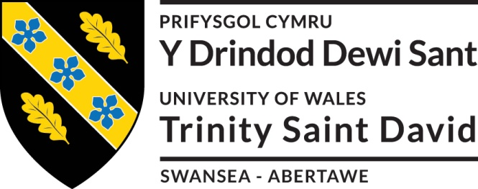
Critically evaluate modern theories of leadership in the context of working within the QinetiQ Test Range operation.
Appraise the effects of the established culture on implementing change within the work environment.

By Jake Tyrrell
P148324

Engineering Management and Law Assignment

2017-2018

Contents
1 Introduction 2
2 Modern theories of Leadership 2
2.1 Personality Traits 2
2.1.1 Myers-Briggs Type Indicator 2
2.1.2 The Big 5 3
2.2 Types of Leadership 5
2.2.1 Leadership as a service and leading by example 5
2.2.2 Inspirational Leaders 6
3 Organisational Change 8
3.1 Organisational Structure 8
3.2 Understanding Culture and Knowledge 8
3.3 Inclusion and Engagement 9
3.4 Current Change Management 9
4 Conclusion 10
5 Bibliography 11
6 References 11
Appendix A 13

1 Introduction

The author will critically evaluate modern theories of leadership in the context of working within the QinetiQ Test Range operation by delving into the background of modern leadership, personality traits and comparing them to the current QinetiQ leadership.
The author will also appraise the effects of the established culture on implementing change within the work environment. To carry this out the report will focus on the management structure, the cultures and knowledge at QinetiQ and look into the ideals of inclusion and engagement.

2 Modern theories of Leadership

Leadership can be defined as [1] ‘The ability to influence a group toward the achievement of a vision, or set of goals.’ It can be achieved by various different methods that can all be successful. This following section of the report delves into the theories of modern leadership.

2.1 Personality Traits

Personality is seen as a key role in leadership. Personality traits are specific to the person and tend not to change. [2] ‘In the course of thirty years, most adults will have undergone radical changes in their life situations. They may have married, divorced, remarried. They have probably moved their residence several times and yet, most will not have changed appreciably in their standing on any of the five dimensions’. McCrae & Costa are referring to The Big 5 which is covered in section 2.1.2 of this report.

Moreover, personality traits of an individual are seen to indicate whether, or not the person will be a good leader. This is identified through classifying behaviours in a multiple of real life situations. There have been many studies of personality traits of good leaders throughout history; Prime Ministers, Presidents, CEOs, Military Generals and even Sporting Team Managers.

2.1.1 Myers-Briggs Type Indicator
One of the most commonly used assessments of personality is the Myers-Briggs Type Indicator (MBTI). MBTI is [3] ‘the most widely used personality inventory in the world, with more than 3.5 million assessments administered each year’. MBTI classifies the answers producing a personality type out of 16 choices. The indicator usually involves a questionnaire of around 100 questions that queries the participants on how they would deal with, or feel in certain situations. The outcome of the questions determines whether the person is:

- Extraverted (E), or Introverted (I)
- Sensing (S), or Intuitive (N)
- Thinking (T), or Feeling (F)
- Judging (J), or Perceiving (P)

The resulting letters added together equate to the personality type shown in Figure 1.
[4]
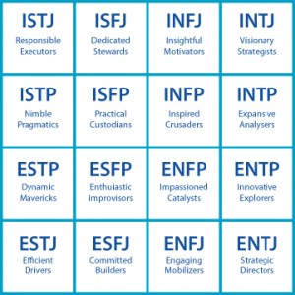
Figure 1

An example result of the MBTI test is shown in Appendix A this is the authors own result.

2.1.2 The Big 5
There has certainly been much focus on personality traits. Various studies throughout the 1900’s lead to a whole host of traits that great leadership was thought to derive from. The problem was, the multiple studies had little to nothing in common. In the early 90’s The Big 5 was fashioned. Its traits are alike and complimented by MBTI.

Studies into introversion and extroversion were part of the baseline that The Big 5 originated from as shown in Ewen R. B research into core traits (Figure 2).

[5]

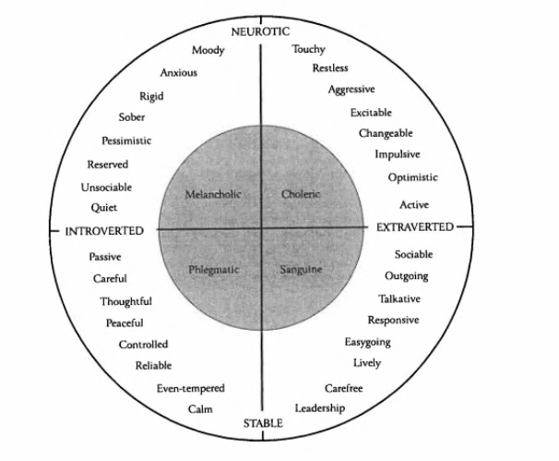
Figure 2

Figure 3 explains The Big 5 traits.
[6]

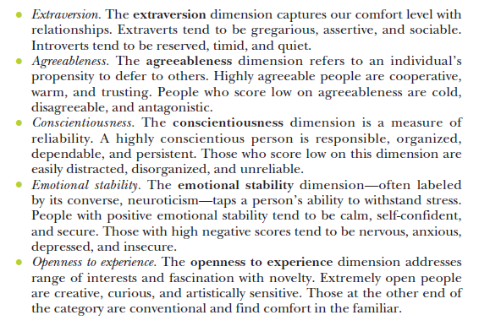
Figure 3
Whereas in MBTI, the person taking the test is identified as 1 of 16 personalities, The Big 5 works on a high and low score on each of the 5 traits, this is depicted below as depicted in Figure 4.
[7]
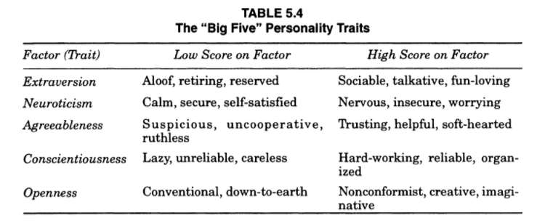
Figure 4

2.2 Types of Leadership

2.2.1 Leadership as a service and leading by example

Leadership as a service is the idea that a good leader serves his people. In the case of QinetiQ a Trials Team Leader serves his direct staff.
He/she accomplishes it by:

Looking at the needs of his team | What do they need to increase productivity?  - Support/Guidance  - Training  - Motivational chat
Removes inequalities | - Fair pay to all staff  - Bonus payments to the hardest working  - No favourites
Building trust | - Performing to the best of his ability  - Openness  - Easy to talk to  - Keeps his word

Leading by example can be difficult, it is a natural skillset to some, but is also something that can come with experience. The promotion of a positive self image whilst in the eyes and scrutiny of the company can be demanding. Phrases such as; “walk the walk, talk the talk” and “I wouldn’t ask someone to do something that I wouldn’t do myself “, are well known and used. Similarly, “do as I say and not as I do” is dictating and can be seen in a negative light to the leader’s image.
The belief in the company’s leader is reinforced by him taking the mantle and showing the correct behaviours, after all, leading by example the Leader should be an embodiment of the QinetiQ values. This is captured by D.Hock, cited in Leadershipnow [8] ’Control is not leadership; management is not leadership; leadership is leadership. If you seek to lead, invest at least 50% of your time in leading yourself—your own purpose, ethics, principles, motivation, conduct.’ Leadership starts from belief in yourself and how a leader portrays their beliefs to their followers. Leading by example means that in turn the followers – multiple layers of directors, management, team leaders and employees understand the values of QinetiQ and promote the values onto their direct staff.

2.2.2 Inspirational Leaders

To be classed as a modern inspirational leader like the major business CEO’s who’s company’s occupy the news, social media and advertisement (i.e. Facebook, Amazon, Google and Apple), the leadership should be visionary and the vision communicated in a way that grabs the attention of the company’s staff and gets them on board. Brian Krueger wrote about the Amazon CEO, [9] ‘Jeff is a visionary who deals with problems at a very high level. He has a vision of where he wants to take the company which is far beyond the view of most others, including the exec leadership team. There are plenty of “aha” moments where you finally get a glimpse of where he is going.’ Leading followers in a direction communicated through a vision requires inspirational leadership and passion like Jeff Bezos (Amazon CEO) showed. Although inspirational leaders need to inspire by communicating their vision to the company’s employees they can inspire an employee by just listening. Finding the time to listen to an employee will sometimes inspire them, as their Team Leader wants to listen to see what they have to say. Churchill captures this as; [10] ‘Courage is what it takes to stand up and speak. Courage is also what it takes to sit down and listen.’

Two modern theories of inspirational leadership are Charismatic Leadership and Transformational Leadership. Being charismatic is defined as [11] ‘exercising a compelling charm which inspires devotion in others.’ Charismatic leaders are appealing to the company, they are great articulators, enabling them to reach out with their vision and their goals they are able to influence people. This is a great asset to a company with employees that are not on script and need to be guided in a certain direction. Throughout the company QinetiQ needs charismatic leaders that can capture the imagination of their staff and boost their output. Though it is necessary to be cautious [12] ‘Charisma can produce great good or great evil—both Hitler and Ghandi were charismatic leaders.’ The benefits of a charismatic leadership is that it can create a willingness to participate in the end goal (vision).

Type in on the internet the “10 greatest leaders” and you will discover iconic names such as :

- Winston Churchill
- Mao Zedong
- Steve Jobs
- Mohandas Karamchand Ghandi

These are all seen as charismatic leaders, but did the situations that they found themselves in enhance their following? [13] ‘Charisma appears most successful when the follower’s task has
an ideological component, or the environment includes a high degree of stress and uncertainty. Even in laboratory studies, when people are psychologically aroused, they are more likely to respond to charismatic leaders. This may explain why, when charismatic leaders surface, it’s likely to be in politics or religion, or during wartime, or when a business is in its infancy or facing a life-threatening
crisis.’ Was it the foresight of impending doom in 1939 when only the English Channel stood between Great Britain and invasion by Nazi Germany that inspired trust and confidence in the populations new found leader (Winston Churchill) who wanted to fight back. This could be seen as a using the public sentiment.

QinetiQ’s previous leadership had a hard task of bringing the company back into the black [14] ‘QinetiQ, sank £19.1m into the red last year after booking £14.1m in sell-off fees and costs.’ QinetiQ for years wasn’t making money which was heavily publicised when the government tried to float it on the stock market. Leo Quinn was hired as the CEO of QinetiQ with a track record of turning around failing companies, [15] ‘Quinn's solution was to launch a 24-month self-help plan to cut debt and transform QinetiQ's culture from public sector organisation into private sector business. When the financial results of the programme were unveiled last month, the market liked what it saw. Net debt had been cut from £538m to £122m, costs slashed, and the pension deficit was down.’ Although heavily disliked at the start of his career, he turned the company around and is spoken of fondly. This is an example of situational leadership, where the sentiment of the staff changes through what has been perceived as the company’s success.

Whereas Charismatic leadership works particularly well with medium to large companies, Transformational Leadership performs better on medium to small companies. A Transformational Leader influences through a vision, but also a sense of purpose. QinetiQ’s current CEO is very vision based [16] ‘Our strategy is inherently outward looking... we have been building positive momentum with its implementation during the year.’ He seeks to grow the company and shares his vision and pride towards the company, not only with employees, but the industry as well. The author sees the current CEO as a Transformational Leader.

As well as the CEO, most Managers and Team Leaders at QinetiQ Test Ranges could be classed as Transformational Leaders. They tend to have high expectations of their staff, but spend a lot of time on each individual coaching and promoting best practice, therefore gaining the overall respect of their own staff and peers. They have the time and best ratio (of employees to leader) to be able to do this. [17] ‘According to Burns, the transforming approach creates significant change in the life of people and organizations. It redesigns perceptions and values, and changes expectations and aspirations of employees.’ The time spent on each individual inspires them to do their best and the Transformational Leader gets the best out of them.

3 Organisational Change

Organisational change, if transitioned efficiently and effectively, can greatly boost a company’s output. Although a transition not performed correctly and to plan, can create chaos, bad sentiment in the work force towards its leadership and, reduce the overall morale. To understand the baseline of this organisational transition, the management style of the company needs to be identified.

3.1 Organisational Structure

QinetiQ, once part of the MoD’s Defence Evaluation and Research Agency (DERA) has continuously evolved in management style. Typically, DERA was a mixture of Centralised and Product organisational structure. The main authority was needed from the top, but on sporadic occasions the local Superintendent (Head of Site) would make an important decision. The structure was hierarchical.
Whilst there is still a strong military connection in the company, it has a lot of specialised staff that have expertise in various advanced subject areas. So a military-esque structure with orders from the top down will not help as these staff need management that understands what they do.
QinetiQ has for some years adopted a Matrix structure and management system. Although it has an edge of Product structure as well. [18] ‘A matrix organizational structure is a company structure in which the reporting relationships are set up as a grid, or matrix, rather than in the traditional hierarchy. In other words, employees have dual reporting relationships - generally to both a functional manager and a product manager.’ One key benefit of this is excellent communication between subject matter experts and management, as their leadership, understands what they are saying. These conversations can be very complex and in specific fields of expertise. QinetiQ has a diverse skill set it is able to draw upon when there is a need. [19] ‘The ability to draw upon diverse skill sets from multiple disciplines strengthens the overall project team. Matrix approaches to projects and other initiatives are typically less expensive than establishing dedicated project teams and the diversity of the team members makes them superior to many purely functional teams.’ Moreover, Matrix management suits the company due to its diverse skill set. Whilst there as some hints of a Product structure as well in certain areas of the company as the company is spread over multiple locations across the UK and Globally. There is always a true risk of siloes developing, that weakens the professional relationships that the Matrix management structure incorporates.

3.2 Understanding Culture and Knowledge

It is crucial when changing the company to know the staff, or seek to understand what drives them, being conscious this it will differ from person to person, i.e. some thrive on public recognition, others on a simple pat on the back, some are driven by delivering good service and others by climbing the corporate ladder. Driving a company towards organisation change when the foundations and sentiment of the workface is not engaged with the ideals, is like driving a car without any fuel. The company isn’t a company without its staff. A vision is just words unless it has the support and commitment of the workforce.

Staff knowledge of the company is critical to creating a successful change. Individually managers know both the company processes and how to drive and motivate their teams. Although there are many formal written processes that the company is built on, there is also the “know how” to get the job done efficiently. The organisation in every level of QinetiQ comes down to two ideals. Explicit knowledge, where procedure and process are put in place to be followed and to guide and Tacit knowledge, where employees get things done in using the process, but mainly through their knowledge of how it is done in that specific department, a sort of informal underlying protocol. Engaging with employees and using their wealth of experience and “know how” in their relevant departments can aid the change. [20] ‘Interaction between tacit and explicit knowledge leads to the creation of new knowledge.’

3.3 Inclusion and Engagement

Everyone has to feel like they are doing something towards the end goal. Setting out clear milestones and inviting staff to advise on how to get to those milestones includes them in the process, it also utilises their tacit knowledge (as mentioned in the previous section) to get the best out of the process.
Communicating to the staff the success, or failure of each milestone that makes up the organisation change is vital. The work force must know how they are performing and progressing towards the target.

Inclusion of all staff, including those who do not necessarily have a direct effect on the change propositioned, can still assist with the end goal. [21] ‘During a visit to the NASA space centre in 1962, President John F. Kennedy noticed a janitor carrying a broom. He interrupted his tour, walked over to the man and said, “Hi, I’m Jack Kennedy. What are you doing?” “Well”, Mr. President, the janitor responded, “I’m helping put a man on the moon”.’ This is the idea that everyone must do their “bit” to help toward the goal.

3.4 Current Change Management

Upon reflection of this report, the current changes that are occurring throughout the company are positive. The leadership vision is clear and the company knows what direction it wants to head. Throughout the changes all employees have been empowered to make suggestions of positive changes, or quick wins that would benefit the company. In some areas of the company the matrix structure isn’t suitable, as those areas are reasonably isolated geographically and would be suited to a more Product style structure, although this could sabotage relationships with other sites. Within the lower levels of management, Transformational Leaders are working hard to utilise tacit knowledge represented in their teams and incorporate it into processes, creating multiple efficiencies. Whilst the author doesn’t believe the employee engagement and vision is as strong as suggested by the NASA janitor, the leadership have instilled confidence in its employees.

4 Conclusion

Overall this report details some of the key elements that are crucial and significant leadership techniques. All leaders are different and possess a percentage of each of the defining traits and factors mentioned in this report. Whilst charismatic leaders are well known, there is an argument that the situation that they find themselves in may help to enhance their success and recognition as leaders, through the use of public sentiment.

It is the opinion of the author that Transformational Leaders are more common at QinetiQ and are found in the smaller and closely knit teams that you find on the Test Ranges. Creating and communicating effectively a vision of the organisational change, will motivate employees to help change the company. Indications of success, or failure of the milestones, must be shared throughout the process. The inclusion of all staff in company organisational change, reduces the alienation of the work force

To be able to complete a successful organisational change, the employees must be focused and in the right mind set. Without the right organisational culture steered by the company’s leaders, the change will not have a driving force. Through the right leadership and correct application, organisation change can be accomplished.

5 Bibliography

The “Big Five”, Trait Theory, (Online), http://traittheory.weebly.com/big-five.html

J. Keshmiri, Leadership & Big 5 Personality Traits, Linkedin, (Online),
https://www.linkedin.com/pulse/leadership-big-5-personality-traits-joe-keshmiri/

The Myers-Brigs Foundation, (Online), http://www.myersbriggs.org/my-mbti-personality-type/mbti-basics/home.htm?bhcp=1

C. Yin, X Er-ming, “Communicating Explicit and Tacit Knowledge within and across Organizational Borders: Their Impact on Absorptive Capacity and Competitive Advantage”, 2010 International Conference on Management Science & Engineering, Melbourne, November 2010

R. C. Tucker, “The Theory of Charasmatic Leadership”, Daedalus, Vol 97, Issue 3, 1968

6 References

[1] S. P. Robbins, “Leadership”, Organizational Behaviour, 15th Edition, Pearson, 2013, Page 369

[2] R. R. McCrae & P. T. Costa, Personality in Adulthood, ‘A Five Factor Theory Perspective’, Guilford Publications, 1990, Page 87

[3] E. Bajic, How the MBTI can help you build a stronger company, Forbes, (Online),
https://www.forbes.com/sites/elenabajic/2015/09/28/how-the-mbti-can-help-you-build-a-stronger-company/#20bf213ad93c, Accessed 14/01/18

[4] Myers-Briggs type indicator, Career Research, (Online), http://career.iresearchnet.com/career-assessment/myers-briggs-type-indicator, Accessed 14/01/18

[5] R. B. Ewen, Personality: A Topical Approach, ‘Theories, Research, Major Conroversies and Emerging Findings’, Lawrence Erlbaum Associates, London 1998, Page 139

[6] S. P. Robbins, Organizational Behaviour, 15th Edition, Pearson, 2013, Page 136

[7] R. B. Ewen, Personality: A Topical Approach, ‘Theories, Research, Major Conroversies and Emerging Findings’, Lawrence Erlbaum Associates, London, 1998, Page 140

[8] Leading Thoughts, Quotes on Leadership, Leadershipnow, (Online),
www.leadershipnow.com/leadershipquotes.htm, Accessed 14/01/18

[9] What sets Amazon’s Jeff Bezos Apart as a Leader, Huffington Post, (Online)
https://www.huffingtonpost.com/entry/what-sets-amazons-jeff-bezos-apart-as-a-leader_us_59ee381be4b0f777352c86f7, Accessed 14/01/18

[10] Leadership Quotes that will Lead you to Success, (Online), http://www.motivateamazebegreat.com/2014/05/winston-churchill-quotes-will-lead-your.html, Accessed 14/01/18

[11] Google.co.uk definition

[12] G. P. Hansen, The Trickster and the Paranormal, Xlibris, Philidelphia, 2001, Page 103

[13] S. P. Robbins, Organizational Behaviour, 15th Edition, Pearson, 2013, Page 381

[14] P. Tyrrell, “QinetiQ in the red after rip off”, Evening Standard, 09/08/2002, (Online), https://www.standard.co.uk/news/qinetiq-in-the-red-after-rip-off-6341950.html, Accessed 13/01/18

[15] G. Ruddick, “QinetiQ chief Leo Quinn: ‘We tried to be something we weren’t”, Telegraph, 04/06/2012, (Online),
http://www.telegraph.co.uk/finance/newsbysector/industry/defence/9309177/Qinetiq-chief-Leo-Quinn-We-tried-to-be-something-we-werent.html, Accessed 13/01/18

[16] Investors, Summary Annual Report and Accounts 2017, (Online), https://www.qinetiq.com/en-gb/investors/2017-in-review, Accessed 13/01/18

[17] Anonymous, Transformational Leadership, Page 1, (Online),
https://www.langston.edu/sites/default/files/basic-content-files/TransformationalLeadership.pdf, Accessed 31/01/18

[18] Matrix Organisational Structure: Advantages Disadvantages & Examples, (Online),
https://study.com/academy/lesson/matrix-organizational-structure-advantages-disadvantages-examples.html, Accessed 16/02/18
[19] F. J. Reh, Challenges and Benefits of Matrix Management in the Workplace, The Balance, (Online) https://www.thebalance.com/matrix-management-2276122 , Accessed 14/01/18

[20] R. Halonen & E. Laukkanen, Managing tacit and explicit knowledge in organisational teams, Department of Information Processing Science, University of Oulu and Centre for Innovation & Structural Change, National University of Ireland, Galway, Page 293, (Online) http://ieeexplore.ieee.org.ezproxy.uwtsd.ac.uk/stamp/stamp.jsp?tp=&arnumber=4746707, Accessed 03/02/18

[21] B. Carn, Lessons on Innovation from President Kennedy’s challenge to place a man on the Moon, Huffington Post, (Online), https://www.huffingtonpost.com/billie-carn/lessons-on-innovation-fro_b_11071878.html, Accessed 04/02/18

[22] Type finder research edition, (Online survey),
https://www.truity.com/personality-test/3796/test-results/5547233, Accessed 14/02/18

Appendix A

[22]


