Deborah Ann Lloyd
1803701
An Academic Critique
ECPT 6002
Tutor – Mark Flagg
Submission Date – 24 May
Word Count - 1500

Introduction

Reflection itself is not a new concept (Ghaye, 2011; Bassot, 2016; Sellars 2017). However, what is evident from the following review is that it became more prevalent during the 1980s when Schon (1983) further developed the idea that reflection should encompass a continuous cycle of events. This was closely followed by similar theorists Kolb (1984) and Gibbs (1988).
The purpose of this paper is to critically review and analyse reflective practice in teaching and learning. The paper will begin with a critical review before concluding with an analysis of the benefits and values of this practice. The paper will be supported by theories and frameworks from key authors.

There are many similar definitions of reflection (Ghaye, 2011; Bassot, 2016; Sellars 2017). Due to limitations, the following have been chosen for this paper:
Reflection is the active, persistent and careful consideration of any belief or supposed form of knowledge in the light of the grounds that support it and the further conclusions to which it tends (Dewey, 1933, p. 9).
Reflection is clearly purposeful because it aims at a conclusion. The purpose of reflecting is to untangle a problem or to make more sense of a puzzling situation; reflection involves working towards a better understanding of the problem and ways of solving it (Loughran, 1996, p. 14).
The purpose of this paper is to critically evaluate reflective practice in teaching and learning. The concept of reflection in education was initially introduced by Dewey (1933) who believed that merely acquiring information about an issue is not knowledge. Knowledge comes from analysing and evaluating. The individual becomes an active inquirer, seeking a conclusion that could be open for further study. It is more of a creative than scientific venture. In addition, Stenhouse (1979) explains that reflective thinking is not about predictions, possibilities and disciplines it concerns itself with comparative education: “Thus we need to tutor our judgement, not simply to discipline it”. Locke (1690) as cited in Frazer (1959) asserts that it is not enough to simply understand something. We should be applying our own thoughts to enable us to effectively judge and grasp a deeper level of knowledge and understanding of a given situation. Moreover, Bourner (2003) states: “For reflection to lead to learning there needs to be an exploration of facts, feelings or emotions, behaviours and thoughts which is precipitated by interrogating some past experience by asking searching questions”.
Examples of ‘searching questions’ are shown in figure 1, Gibbs reflective cycle (1988). This was designed to encourage individuals to reflect and evaluate all the phases involved in an experience or activity. According to Gibbs: “It is not sufficient to have an experience in order to learn. Without reflecting on this experience, it may quickly be forgotten, or its learning potential lost.”
Figure 1: Gibbs Reflective Cycle (1988):
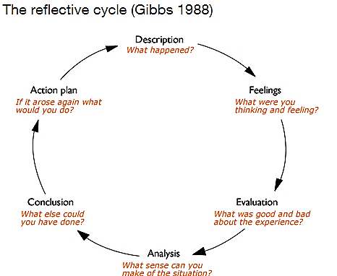
However, Roffey-Barentsen and Malthouse (2013) argue that, although this model was developed to encourage reflection by asking questions it is restrictive as it suggests to the individual that this is all they need to consider. In contrast, the CIPD (n.d.) suggest looking at the situation and expanding on the questions in more detail as shown in table 1:
Table 1 (Source: CIPD, n.d.)
Description | When and where did this happen?  Why were you there and who were you with?  What did you/they do – or not do?
Feelings | What were your feelings before, during and after the situation? What do you think the others in the situation were feeling?
Evaluation | What was positive/negative about the situation. How did you contribute? How did others contribute?
Analysis | What are your assumptions/insights?
Conclusion | What could you do differently? What skills do you need to develop?
Action Plan | How will you progress? Who will support you?

Schon (1983,1987) suggests that life is about trial and error. Therefore, reflection should encompass a continuous cycle of events to include past and present experiences refering to this as reflective practice:
- Reflection-in-action – Using past experiences to enable one to ‘think on their feet’
- Reflection-on-action – Thinking about the experience after the event took place and learning from it.
As Schon did not offer a model or diagram of his work (Roffey-Barentsen and Malthouse, 2013), Kolb’s learning cycle (1984) as shown in figure 2 is an example of how Schon’s continuous cycle could be perceived.
Figure 2: Kolb’s learning cycle (1984)
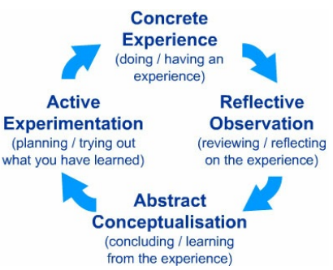

According to Kolb (1984, p. 38): “Learning is the process whereby knowledge is created through the transformation of experience”. Roffey-Barentsen and Malthouse (2013) describe Kolb’s learning cycle as “combining reflection with experience”, an ongoing process to improve continued professional development that can be applied to any activity. Table 2 is an example of how Kolb’s learning cycle could be used for teaching a lesson.
Table 2: Teaching a lesson (Source: Roffey-Barentsen and Malthouse, 2013).
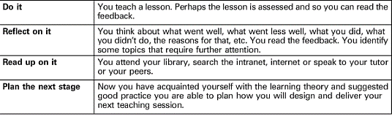

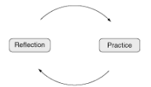
In addition to Gibbs and Kolb, Ghaye (2011) asserts that reflection and practice are linked as it is not just about self-improvement and how we develop ourselves in the workplace. Reflective practice is also about developing positive emotions to enable us to make sense of a situation. These new insights and understandings can then be put into practice to improve our actions allowing for higher quality teaching. Ghaye suggests asking oneself the following reflective questions:
- Awareness - What am I trying to do?
- Appreciation – How successful am I?
- Imagine – Is there a better way to achieve this?
- Design – What do I need to do to achieve this?
- Judgement – Should I be doing this?

(Source: Ghaye 2011)

However, Schon (1983) suggests that reflection is not always about the individual, it can also involve trying to understand the situation through the eyes of others, for example; a student, colleague or mentor. Schon refers to this as re-framing. Brookfield (2017) describes this as critically reflective teaching. Taking time to identify and analyse the assumptions that outline our teaching practice allows us to keep-up-to-date, leading to more effective teaching. According to Bolton and Delderfield (2018) reflective practice changes the way professionals think and relate to the wider society. This plays a key part in terms of employability as today’s professionals “face so many complex and unpredictable situations”. The ability to act reflectively and spontaneously not only improves the quality of their work it allows for unity, leading to a decrease in work-related stress and an increase in job satisfaction. Moreover, Sellars (2017) states that teaching is not an easy profession. Often there are no right or wrong answers to the strategies we use and there is not always time to liaise with colleagues. Therefore, teachers will often be required to “reflect critically on a number of interactions”. Teaching involves many different aspects. It is not just about formative and summative assessment criteria it is also about change in terms of keeping up with the key issues the profession is currently facing such as globalisation and emerging technology. As teachers we need to be well informed. Developing teaching strategies to accommodate diversity and integrating technology to support the learning is essential in today’s climate. In addition, Robins et al (2003) describe the classroom as a “fast moving environment” so taking the time to think about the skills we need to develop allows us to make “more informed judgements and professional decisions”.

Conclusion
The purpose of this paper was to critically review and analyse reflective practice in teaching and learning. Reflection itself is not a new concept as the theorists utilised in this paper date from 1690 to the present day. However, the evidence suggests that Schon was accurate in terms of life being about trial and error and that reflection should encompass a continuous cycle of events to include past and present experiences, particularly professionals as they are facing intricate and unpredictable situations. Also, the frameworks by Kolb and Gibbs complement Schon’s work in terms of the reflective process. In addition, the examples provided by Roffey-Barentsen and Malthouse, and the CIPD give an excellent insight to how Kolb’s and Gibbs’ work can be useful in teaching as it has been said that there is not always time to liaise with colleagues which results in having to think on one’s feet in a fast-moving environment.
Moreover, what is clear is that reflective practice is of significant benefit to teaching and learning; not just for self-improvement but the context in which teaching, and learning takes place, particularly in terms of diversity, integrated technology and globalisation. Ghaye’s reflective questions could be useful for this.

Recommendation
What is surprising is how reflective practice plays a key part in employability as it is linked to a higher quality of work, a decrease in work-related stress and an increase in job satisfaction (Bolton and Delderfield, 2018). This leads to the recommendation: if reflective practice plays a key part in employability, it must be worthy of further research in terms of human capital and sustained competitive advantage. “…the empires of the future will be empires of the mind.” (Churchill, 1943) as cited in The Economist (2006).

References

Bassot, B (2016) The reflective practice guide: An interdisciplinary approach to critical reflection. Routledge: Oxon.
Bolton, G and Delderfield, R (2018) Reflective practice: Writing and professional development. 5th edn. London: Sage Publications.
Bourner, T. (2003) ‘Assessing reflective learning’, Education and Training; London, 45 (4.5) pp.267-272. Proquest. [Online]. Available at: https://search-proquest-com.ezproxy.uwtsd.ac.uk/docview/237069318?accountid=130472&rfr_id=info%3Axri%2Fsid%3Aprimo (Accessed: 16 April 2019).
Brookfield, D. S. (2017) Becoming a critically reflective teacher. 2nd edn. Jossey-Bass: California.
CIPD (n.d.) Reflective practice guide. [Online] Available at: https://www.cipd.co.uk/Images/reflective-practice-guide_tcm18-12524.pdf (Accessed: 30 April 2019).
Dewey J (1933) How We Think: a restatement of the relation of reflective thinking to the educative process. Revised edn. Boston: D C Heath & Co.
The Economist (2006) ‘The battle for brainpower’, The Economist, 7 October [Online] Available at: https://www.economist.com/special-report/2006/10/07/the-battle-for-brainpower (Accessed: 2 May 2019).
Frazer, A. (ed.) (1959) Locke, J. [1690]: An essay concerning human understanding, two vols. New York: Dover.
Ghaye, T. (2011) Teaching and learning through reflective practice: A practical guide for positive action. 2nd edn. Oxon: Routledge.
Gibbs, G. (1988) Learning by doing: A guide to teaching and learning methods. Oxford: Oxford Brookes Further Education Unit.
Kolb, D. A. (1984). Experiential learning: Experience as the source of learning and development (Vol. 1). Englewood Cliffs, NJ: Prentice-Hall.
Loughran, J. J. (1996) Developing reflective practice: Learning about teaching and learning through modelling. London: Falmer Press.
Robins, A., Ashbaker, B., Enriquez, J. and Morgan, J. (2003) ‘Learning to reflect: professional practice for professionals and paraprofessionals’, International Journal of Learning, 10, pp. 2555–2565.
Roffey-Barentsen. J. and Malthouse, R. (2013) Reflective practice in education and training. 2nd edn. Sage Publications: London.
Schon, D (1983) The reflective practioner: How professionals think in action. New York: NY Basic Books.
Schon, D. (1987) Educating the reflective practitioner, London: Jossey Bass.
Sellars, M. (2017) Reflective practice for teachers. 2nd edn. London: Sage Publications.
Stenhouse, L. (1979). ‘Case study in comparative education: particularity and generalisation. Comparative Education, 15 (1), pp. 5-10. Taylor Francis [Online] Available at: http://www.jstor.org.ezproxy.uwtsd.ac.uk/stable/3098839 (Accessed: 24 April 2019).

