Student Name: Shazan Begum
Student ID: 1712823
Module Tittle: Marketing Management
Module Code: LCMB 7001
Assignment: 2

Daimler Group and Mercedes-Benz’s Environmental Marketing Analysis

Contents
Introduction 1
Daimler Group and Mercedes-Benz 2
PESTLE Analysis of Daimler Group and Mercedes-Benz 2
Political and Economic 3
Social and cultural 4
Technological 4
Legal 5
Environmental 5
Porters 5 Forces Model 6
Competitive/Industry Rivalry 6
Threats of new entrants 7
Bargaining power of buyer 7
Bargaining power of supplier 7
Threats of substitutes 7
SWOT Analysis 7
Strengths 8
Weaknesses 8
Opportunities 8
Threats 8
Advantages and limitation of SWOT Analysis. 9
Segmentation, Targeting, and Positioning 9
Marketing Mix strategies of the company. 11
Product 11
Price 12
Place 12
Promotion 12
Conclusion 12
Recommendation of future marketing strategies for Mercedes-Benz 12
Reference 14

Introduction
As a project team member employed by the external consultant/agent hired by Daimler and Mercedes-Benz, the task is to conduct an environmental marketing analysis taking into consideration the key external influencing drivers together with an analysis of the internal environment and the role that marketing plays within the organisation. To ensure all attributes of environmental marketing analysis is covered PESTLE analysis, Porter 5 Force model and SWOT analysis will be applied to the company. Critical analysis of one of the models will be carried and the advantages and disadvantages will be discussed. Segmentation, targeting and positioning and how they are interconnected will be discussed. Furthermore, the marketing mix decisions in the product life cycle stages will be considered. The report will include with a conclusion and a recommendation of future marketing strategies for the company with the aid of Ansoff Matrix model.
As businesses and organisations are shifting to globalization with the service and product the competition is also growing. Customers and consumers’ have the option to shop around for the best suited product or service that satisfy the needs and wants of individuals. Without appropriate marketing strategies businesses and organisation cannot get to the consumers and customers to satisfy their needs. According to The Chartered Institution of Marketing “Marketing is the management process responsible for identifying customer requirements profitability” (CIM Insight, 2009).

Daimler Group and Mercedes-Benz
Daimler AG in partnership with Mercedes-Benz is one of the world’s successful automotive companies with Mercedes-Benz luxury and premium cars and van, Daimler trucks, buses, and Daimler mobility divisions. The start of Mercedes-Benz was in year 1926 when DMG Daimler Company and Carls Benz Company merged to partnership (Mercedes-Benz, 2021). Covid-19 and the Brexit has impacted many manufacturing companies, sales in manufacturing of motor vehicles, semi-trailers and trailer division declined the most falling £13.1 billion percentage of 24,9 to £39.5 billion in 2020 (Office of National Statistics, 2021).

PESTLE Analysis of Daimler Group and Mercedes-Benz
Macro environment audit is the inspection of external environmental issues that may affect the organisation. The elements are Political, Economic, Social, Technological developments, Legal and Environmental is referred to as PESTLE analysis. The objective of the analysis is to identify the critical issues of the external environment that may affect the company at different level.
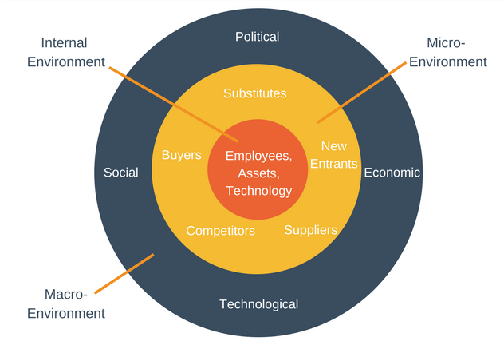
Figure 1. Environmental factors (Image taken from Expert Program Management 2021).

Political and Economic
There is a variety of differences between both political and economic environments, however they are both interlinked therefore it is difficult to acknowledge their individual impacts. For example, a political measure can create an economic effect elsewhere and this could in-turn lead to political action being carried out.
The political decision on Brexit will leave Daimler and Mercedes-Benz at a loss of hundreds of millions in euros according to the CEO Ola Kallenius. Although the company does not have a car plant in the country it is estimated to see a financial impact in the low three-digit million-euro scale. Daimler group will not build a car plant factory in the UK due to sales volumes being small and speculate following from Brexit the UK auto plants are at risk.
Daimler and Mercedes-Benz operate worldwide therefor the impact on the economy by covid-19 has affected them significantly specially the countries that are industrialised countries. Although China was the first country to be affected by the pandemic it was also one of the first country to recovery with the growth of the economy which expanded to 2.3% in a year. With India being the highest number of infected worldwide with economic downturn, the gross domestic product dropped by 7.5%. The demand for heavy duty trucks by Daimler has decreased by 28% in the EU30 region. Bus market demand in EU30 was significantly below the previous year level (Daimler, 2021).
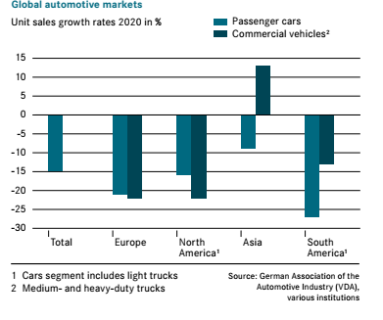
Figure 2. Global Automotive Markets (Daimler, 2021).
There are other economic factors that has had an impact on the purchase power of consumers, these include income, price, saving and credit available. Due to the pandemic and covid-19 many people have lost their jobs and therefore some people have had to go into their saving to survive. People saw some price rise in necessities because of the effect on supply chain.
After scanning and analysing the external environment using the PESTLE analysis, it is transparent that some element of the external environment is unfavourable to Daimler Group. Political and economic has had a huge impact on the company’s profit. The Brexit and Covid-19 are the main cause. Due to the economic power in cites and increase in cost of living in addition with stagnant wage growth, cars are increasingly becoming a luxury and surplus purchase (Advantage-MarketLine, 2021).

Social and cultural
Customers are becoming increasing demanding of the product and services they buy. They demand it to be of quality, durable and at reasonable cost furthermore purchase decision are becoming more based on brand value of the product/service. One in four people in the UK believe that brands value is just as important as the product itself (Hooley et al. 2020). Mercedes-Benz is well known for its luxury premium cars and vans and as the slogan says, “the best or nothing”, they take customers safety and comfort to a high level when manufacturing their products. The social culture of having the very best has become a trend among young people and these cultural and trends needs are becoming very easily accessible through the multiple choice available to consumers. Consumers have variety of options available for finance and leasing cars and other high-end products.
Social and cultural aspect can be seen as favourable as more younger people are wanting to drive specially after Covid-19, some older people do not feel safe going on public transport therefore coming back to driving and looking for ownership of vehicle. Finance options are becoming more favourable among younger buyers, The Bank of England estimated the annual growth rate of around 20 percent in dealership finance between 2012 and 2016 furthermore, the US auto loan balance have been increased for six years (Advantage-MarketLine, 2021).

Technological
Due to digitalization and technological changes organisations and companies face many challenges to stay competitive in the market. Digitalization has instigated an increase in the use of digital systems to support the processes in the business and in marketing.
The German Institute für Automobilwirtschaft (IFA) carried out a study on behalf of the DEKRA Automobile GmbH to find out how intensively digital media was being used in the automotive retail. The survey was answered by 175 industry members, and they were the representative for the authorised dealer in Germany in 2017. Automotive Dealers have identified the importance of being fundable on the internet. The result shows 73,3 percent use SEO to place themselves in search engines, while only 19,1 percent use a professional data management tool (Bauer, 2018). Although at the time Virtual dealership tours (13,4 percent) and virtual reality (1,9 percent) are mostly seen as not important back then, looking into the future this maybe the way forward with any future pandemic crisis.
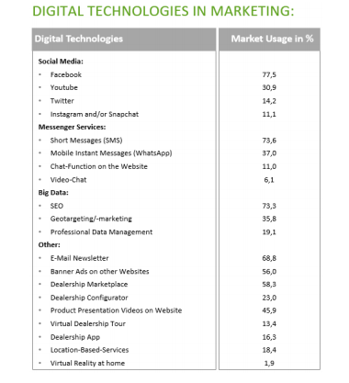
Figure 3. Digital technologies in Marketing of Automotive Industry (Bauer, 2018).
Technology is favourable as less manpower is needed and machine are replacing human. In terms of advertising, they are reaching more consumers through Facebook and Instagram (Digital Agency Network. 2021). Consumers can design their own car using thousands of images.

Legal
Germany’s law on the equal participation of women and men in executive positions (Koch. 2015) has meant some strategic change in the board of director level in Daimler Group. As of December 2020, the company has 30% of women in executive position. The Brexit also has had an impact on Daimler with a lower profit margin due to the extra taxation. Legal aspects have not been favourable to the company.

Environmental
Consumers want more than a brand; they want to know their choice of brand are performing and maintaining sustainability and are environmentally friendly. Environmental pressure groups are impacting organisations and companies and large amounts are spent on corporate advertising each year to demonstrate the care and concern for the environment (Hooley, et al 2020). Daimler and Mercedes CEO Ola have announced the plan to have all their factories worldwide obtain electric from renewable source by 2022. Climate change and air quality plans are under way with Daimler Group with plans to have all new vehicle fleet to be Co2-neutral by 2039, the result of this move will mean there will no longer be any relevant impact on air quality in the inner cities. In working towards sustainability Daimler Group has ceased printing annual and interim reports (Daimler, 2021).
Environment is favourable in the long term however in the short term it may seem very costly. For example, to change to renewable energy can be costly to set up but in the future the company will save on fuel cost.

Porters 5 Forces Model
Porters 5 Force model is used to scan the external forces of the company or industry. By using this framework companies can get an idea of the factors that can affect the profitability and of its competitors by asking five direct questions (AUTHOR,2019).
Porters Five Force Model

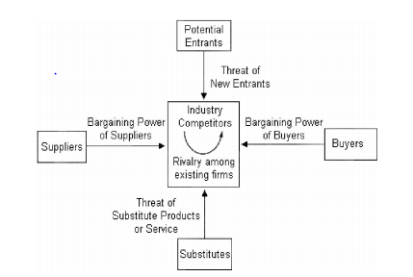
Figure 4: Porters Five Force Model (MalekShirabadi, et al. 2013).

Competitive/Industry Rivalry
Competitive Industry Rivalry is medium due to the joint venture with BMW. For decades Daimler Group and BMW have been direct rivals but due to the high cost associated with manufacturing and the challenges faced by both companies they have decided to go into joint venture in mobility sector. The Ex-CEO Dieter Zetsche of Daimler Group stated growth is compulsory (Scherer, 2020). However, there are other big automotive companies for example: Tessler, Toyota and Fiesta who are rival companies.

Threats of new entrants
The threat of new entrance is predominantly low for the automotive industry due to the high cost of entrance and the risk associated with it. Daimler Group and Mercedes-Benz has a strong brand with rich history built over cades therefore it would be very difficult for new entrant to this industry. According to research to successfully entry into automotive manufacturing it is estimated the investments would be around $70bn for individual company. Therefore, the traditional automotive manufacturers are increasingly engaging in joint ventures to cover the immense investments and risk associated with the established mobility markets (Möller et al. 2019).

Bargaining power of buyer
Bargaining power of buyer is high for Daimler Group and Mercedes-Benz consumers. Over time other rivals have improve their service and product it is becoming difficult for Daimler Group and Mercedes-Benz to maintain its growth. For example, while the automotive industry was growing in providing electric and hybrid cars, Daimler Group took longer to take appropriate action in the change and to be innovate therefore other rivals took advantage.

Bargaining power of supplier
Bargaining power of supplier is medium. Most of Daimler Group’s plants are based in China and the highest sale is also in China. As China is a developing country, they want all the business they can acquire from manufacturing sector however, China is growing fast and they have plans to be the leader in vehicle deployment and cultivation of domestic companies therefore, foreign investors may see some change in future (Schwabe, 2020).

Threats of substitutes
Threats of substitute is low. Although there is alternative transport for example public transport, car sharing, and leasing options majority of the public are hesitant and uncomfortable to opt to these options since the start of the pandemic and Covid-19. Although the cost of owning a vehicle is becoming very costly with congestion zone, Ulez and parking issues in UK for example.

SWOT Analysis
SWOT analysis is used to understand the business environment which is central to a strategic planning and decision-making process. SWOT helps companies and organisations to gain a better insight into their internal and external business environment by analysing the positioning of the organizations/company’s resource and environment in four categories: Strengths, Weaknesses, Opportunities and Threats. SWOT analysis has been in use since 1960s and has been acclaimed for its simplicity (Phadermrod, 2019).

Strengths
Daimler Group and Mercedes-Benz has a worldwide famous brand and known for its increase interest in ensuring safety and comfort. Daimler Group and Mercedes-Benz holds its patent and copyright protection. The company’s focus is in satisfying the customers’ needs and went made possible by the large amount of financial resource available. The product value is validated by increase customer confidence (Daimler India, 2021). Daimler Group operate worldwide with its efficient distribution channels and economies of scale and experience. They are innovative in initiating design details. They are expanding their market segments to reach out and appeal to more consumers.

Weaknesses
Daimler Group has a narrow market segment compared to their rivals and competitors. They have a strong competitor BMW who are very popular among younger population with lower price. Daimler Group also has a high production cost. The delay reaction to the demand of electric vehicle has been a weakness. The pandemic and covid-19 have seen a reduction in sale and their main plant factory is based in China, one of the first country affected by the pandemic.

Opportunities
Sustained technology advance is an opportunity for the company. Government policies support the automotive and automate industry to support innovation and growth (Canada. 2019). For sustainability and growth more vehicle manufacturing companies are open to the option of Joint Venture. BMW and Mercedes-Benz are in the process of Joint Venture with the mobility vehicle sector. Opportunities to expand on market segment and market penetration further.

Threats
Cost increase of manufacturing vehicles and increase in fuel price. Mergers among competitors in turn increase competition. Substitute and new entry also can be a threat to Daimler Group.
Global economic crisis leads to decrease financial resource allocated for luxury goods. Brexit had an affect on Daimler Group and Mercedes-Benz trading with UK, according to the CEO Ola of Daimler Group and Mercedes-Benz the profit has dropped by three digits since Brexit (Daimler, 2021) therefore, new rules and regulation is a threat. Customers’ needs and wants are changing away from the company’s product and services.

Advantages and limitation of SWOT Analysis.
Companies use SWOT analysis to help with strategic planning and decision making although it has been used by many firms over several years, there are some advantages and limitation of the model. The advantages are it is a source of information and builds on company’s strengths. Weaknesses can be minimising as well as maximising its response to opportunities. Threats can also be identified and minimised. Core competency of the company can be identified and help to set objectives for strategic plan. SWOT also helps in knowing the past, present and future, using these data future plans can be made (SWOT Analysis, 2021).
The limitation of SWOT analysis is not in control of management. Limitations include price increase of raw materials are not anticipated. Government guidelines and the i=environment is not considered. Searching for new market for the product and having no overseas market due to the import restrictions. Other limitation may include insufficient R&D facilities and lack of skill and efficient workforce. Faulty product and quality control. Industry relation maybe poor.

Segmentation, Targeting, and Positioning
Segmentation, targeting, and position are interconnected. Market segmentation is dividing the dis-similar consumers into smaller similar groups therefore equipping the company with the knowledge of who their consumers are. The company can then target these specific groups for positioning their brand and image in the minds of the consumer. Every market has market segment, and it will vary from company to company. For example, at Daimler Group the consumers who want a bigger car and most comfortable regardless of price make up one market segment. While another group may have high priority for the safety features in the vehicle regardless of price is another market segment.
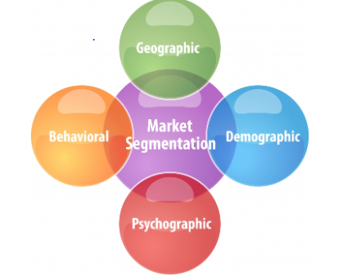
Figure 5: Market Segmentation (Proctor, 2021).
Consumer or customer segmentation can be divided into four different sectors: Behavioural, Geographical, Demographical and Psychographic. Majority of the companies use combination of these in their consumer segmentation process. The company should target segments in which it can generate most profit and customer value.
At Daimler Group and Mercedes-Benz, the old marketing strategies was safety, luxury, and precision engineering. Behavioural segmentation was used by the company, they targeted the high-end clients, are middle to older generation. They created an image of safety and luxury in the minds of the consumer comparative to the competition.
Due to the competition in the luxury car industry and changing consumer attitudes the marketing strategies has changed. Marketing strategy now is based on consumer life-style oriented, focused on more fun loving approachable and energetic side.
Mercedes-Benz marketing strategies has changed due to the expansion of its target market which includes twenty-five to forty-five years old in addition to the baby boomers. To enhance customer value to the target market Mercedes-Benz has identified it to be imperative to expand the product, increase communications with the target market, allow more competitive prices as well as continuing its excellence customer service. Company’s marketing strategies are not too dissimilar to BMW, both companies spend a large amount in advertising campaigns. For new SUV all electric vehicle targeting young audience, the campaign to promote it they are featuring Grammy Award singer The Weekend. Mercedes-Benz is tugging with emotions, they revealed transphobia mural in Toronto pride in June the Pride month for LGBTQ. Daimler Group and Mercedes-Benz uses differentiated marketing where they focus on one marketing mix for one segment group and a separate marketing mix for another segment group. The company also does concentrated marketing for rich and high-end client groups.
Mercedes-Benz physical retail are the Mercedes me Stores where they offer visitors an interactive brand and product experience in exclusive city-centre locations. The modern architecture and the inviting catering and event concept, the Mercedes me Stores has increasingly appealing to young and new target groups. The company is modernising the brand identity in interior and exterior of the retail stories. The objective is creating a mesmerizing customer experience at the Point of Experience and position themselves well in a customer’s mind.

Marketing Mix strategies of the company.
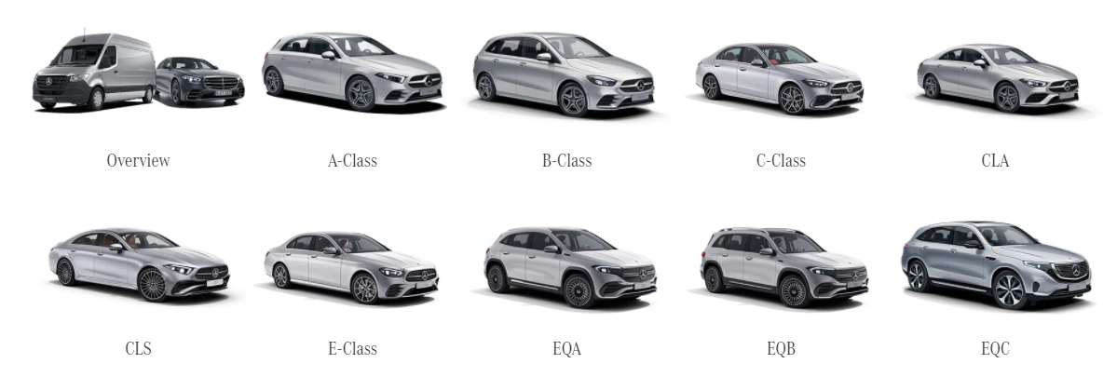

Product
Line extension is one of the strategies used by Daimler Group and Mercedes-Benz a downward vertical line extension within the same product category with different price and quality levels. Extending a brand to a lower level of quality and price leads to the prerequisite of managing contradictions of the quality level, that must remain in line with the brand’s standards at a reduced cost and must correspond to the market segment under consideration (TOURNOIS, L. and CHANARON, J., 2018).
Line stretching is one of the branding strategies used by Daimler Group and Mercedes-Benz, Smart cars is a subsidiary of Mercedes-Benz and parent company Daimler (Car and Driver, 2021). The joint venture with Geely Global Engineering will cost 5.5 billion RMB to transform smart into a leading player in premium and intelligent electrified vehicle, both parties are making equal contribution however Mercedes-Benz AG share will be covered by the contribution of the smart brand and the vehicle will be designed by the worldwide Mercedes-Benz network. It will be developed by Geely global engineering network (News Report, 2021).

Price
For pricing the company uses price skimming strategy where they initially charge high price that customers will pay and then lower it over time as the demand is satisfied and competition enters the market. The price is reduced to attract more price sensitive segment of the population.
Psychological pricing is used by Mercedes-Benz as it is a well-known brand of luxury cars with high safety features and high-tech functions. They also use odd pricing or lower than a whole number. They also give discount for repeat purchase.

Place
Daimler Group and Mercedes-Benz sell their product through direct channel. They have their own retail dealer stores.

Promotion
To promote their brand they advertise, use sales promotion, direct marketing, and digital marketing. They also promote the brand through public relations with namouras greener projects as mentioned above. Celebrity endorsement is also used for promotion and different model of the car is used in action movies.

Conclusion
The report consisted of an environmental marketing analysis taking into consideration the key external factors together with an analysis of the internal environment and the role marketing plays within the company. An introduction to the report and Daimler Group and Mercedes-Benz was offered. External environmental analysis was conducted using PESTLE and favourable and unfavourable for each section was discussed. Porters 5 Force Model was used to scan the external forces of the company. SWOT analysis was performed to identify the businesses internal environment furthermore the models’ advantages and disadvantages was considered. Segmentation, targeting and positioning of the company was identified. The companies market mix: product, price, place, and promotion were identified. Further recommendation was made.

Recommendation of future marketing strategies for Mercedes-Benz
Mercedes-Benz has reached growth and maturity stage with their cars in the product life cycle, the company is one of the mature and successful company in the automotive industry.
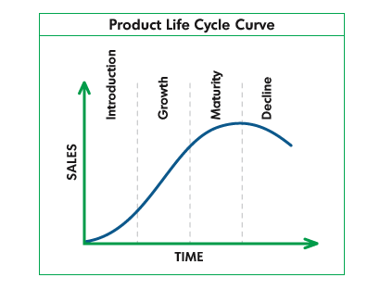
Figure 6. Product Life Cycle curve (Spencer, 2021).
Ansoff Metrix is a very effective model used by businesses to analyse and plan their strategies for increase sales revenue and profitability. As illustrated on the image below the focus of the model is on products and markets. There are four strategies in Ansoff Matrix. For existing market and existing product, the strategy will be market penetration. For existing product and new market, the strategy will be market development. New product and existing market the market strategy will be product development. New product and new market the strategy will be diversification, this strategy has high risk. A business can completely fail when diversification strategy is used, as the company may not have enough knowledge and experience in the product or the market the product is being launched to. The diversification strategy would not be the appropriate strategy to use at Mercedes-Benz at present due to the external environmental factors and the uncertainty in the automotive industry.

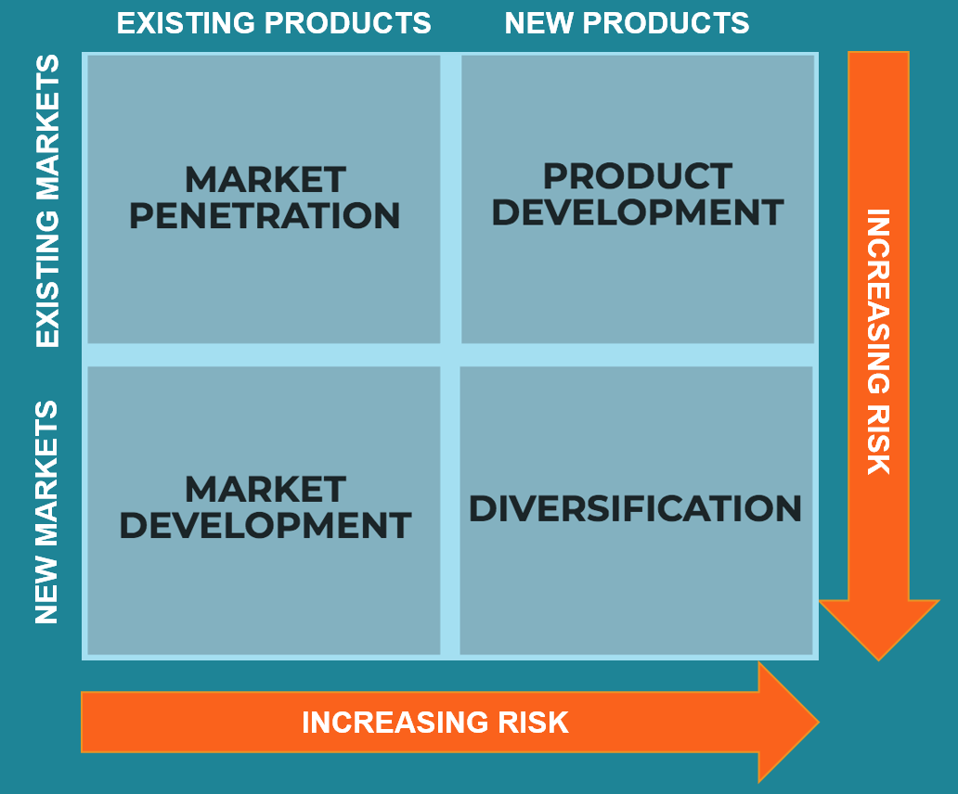
Figure 7: The Ansoff Matrix (Corporate Finance Institute, 2021).
After critically analysing Daimler Group and Mercedes-Benz it can be said for growth, they should use product development strategy. Their competitors have gone a step ahead by introducing and manufacturing all electric cars. Mercedes-Benz can produce better version of the all-electric car with additional features and correct version of existing ones in the market.
The company can further increase sales revenue and profitability by adopting market development strategy. This can be achieved by launching the product in new country and targeting new market.

Reference
Advantage-marketline-com.ezproxy.uwtsd.ac.uk. (2021) [online] Available at: <https://advantage-marketline-com.ezproxy.uwtsd.ac.uk/Search?industry=2800003> [Accessed 22 August 2021].
AUTHOR, STAFF. (2019). Analyzing Porter's 5 Forces on Coca-Cola (KO). New York: Newstex.
Bauer, H. (2018) The Digital Customer Journey in the Automobile Industry-A Quick-Check for the Retail Environment.
Bloomberg.com (2021). Bloomberg - Are you a robot?. [online] Available at: https://www.bloomberg.com/news/articles/2020-10-20/daimler-warns-hard-brexit-would-hurt-even-without-a-u-k-plant [Accessed 23 July 2021].
Canada (2019). Ontario Government Supports Innovation and Growth in Automated Vehicle Industry. MENA Report.
Car and Driver. (2021) The Smart Car Is Officially Dead in the U.S.. [online] Available at: <https://www.caranddriver.com/news/a27310639/smart-fortwo-discontinued-usa/> [Accessed 22 August 2021].
CIM Insight (2009). The Chartered Institute of Marketing. www.cim.co.uk/marketingresources
Corman, S.R., Trethewey, A. and Goodall, B. (2007) A 21st century model for communication in the global war of ideas. Consortium for Strategic Communication, Report, 701.
Corporate Finance Institute. (2021) Ansoff Matrix. [online] Available at: <https://corporatefinanceinstitute.com/resources/knowledge/strategy/ansoff-matrix/> [Accessed 24 August 2021].
Daimler Annual Reports (2021). Annual report & full year results 2020 | Daimler. [online] Daimler. Available at: https://www.daimler.com/investors/reports-news/annual-reports/2020 (Accessed 4 July 2021).
Daimler India (2021). Commercial Vehicles Outpaces Industry, Reports Market Share Gain in 2020. Contify Automotive News.
Digital Agency Network. (2021) Mercedes-Benz Car Builder On Instagram. [online] Available at: <https://digitalagencynetwork.com/mercedes-benz-car-builder-instagram/> [Accessed 6 August 2021].
Expert Program Management. (2021) Expert Program Management. [online] Available at: <https://expertprogrammanagement.com/2018/05/pest-analysis/> [Accessed 29 July 2021].
Hooley, G. et al (2020). Marketing strategy and competitive positioning. 7th edition. Pearson Education. Harlow, England; New York.
Kotler, P, & Armstrong, G. (2017) Principles of Marketing, EBook, Global Edition : Principles of Marketing, Pearson Education, Limited, Harlow. Available from: ProQuest Ebook Central. [9 August 2021].
MalekShirabadi, F., Hamidizadeh, M.R. and Jaberi, G.K., (2013). Studying the Role of Porter’s Competitive Force in the Formation of Car Industry’s Value Chain (Case Study: Iran Khodro Company). Life Science Journal, 10(6), pp.674-683.
Managementstudyguide.com. (2021). SWOT Analysis - Definition, Advantages and Limitations. [online] Available at: <https://www.managementstudyguide.com/swot-analysis.htm> [Accessed 8 August 2021].
Mercedes-Benz (2021). Corporate history. Available at: https://www.mercedes-benz.com/en/classic/history/corporate-history (accessed: 04 July 2021).
Möller, T., Padhi, A., Pinner, D., & Tschiesner, A. (2019, 12). The future of mobility is
at our doorstep. Retrieved from McKinsey - Our Insights on 04.05.2020:
https://www.mckinsey.com/industries/automotive-and-assembly/our-insights/thefuture-of-mobility-is-at-our-doorstep
News Report. (2021) Mercedes-Benz and Geely Holding establish smart brand as a global joint venture | Daimler. [online] Daimler. Available at: <https://www.daimler.com/investors/reports-news/financial-news/20200108-geely-jv-smart-automobile.html> [Accessed 22 August 2021].
Ons.gov.uk. (2021) UK manufacturers' sales by product - Office for National Statistics. [online] Available at: <https://www.ons.gov.uk/businessindustryandtrade/manufacturingandproductionindustry/bulletins/ukmanufacturerssalesbyproductprodcom/2020results> [Accessed 22 August 2021].
Phadermrod, B, et al, (2019). Importance-Performance Analysis based SWOT analysis. International journal of information management, 44, pp.194–203.
Proctor, R. (2021) Customer Segmentation: The Gold Is In The Data. [online] Opportunity Marketing. Available at: <https://opportunitymarketing.co.uk/blog/customer-segmentation-the-gold-is-in-the-data> [Accessed 9 August 2021].
Scherer, L.M. (2020) Your Now: Daimler´ s and BMW´ s joint road towards new mobility? (Doctoral dissertation).
Spencer, T. (2021) Product Life Cycle Model. [online] Spencertom.com. Available at: https://www.spencertom.com/2009/01/25/product-life-cycle-model/ (Accessed 22 July).
Schwabe, J., (2020). From “obligated embeddedness” to “obligated Chineseness”? Bargaining processes and evolution of international automotive firms in China's New Energy Vehicle sector. Growth and Change, 51(3), pp.1102-1123.
TOURNOIS, L. and CHANARON, J. (2018) Car crisis and renewal: how Mercedes succeeded with the A-Class. The Journal of business strategy, 39(1), pp. 3-14.

