Component 2 - Research Report
Student Name: Florentina Manolache
Student Number:2119958
Lecturer Name: Ngozi Ibeji
BMSW4003_BIRM
Digital Skills and Research Methods.

Table of Contents
1. Introduction 3
2. Research design 3
2.1 Research Question 4
2.2 Method 4
2.3 Ethical Considerations 5
3. Results 5
4. Discussion 9
5. Conclusion 11
6. Reference List 12

Introduction
The growing need for mobility requires adaptations throughout a university’s operation. This is because, with students working in different departments, ways to connect all ends efficiently became necessary (Schubert and Williams, 2022). Thus, it was in this context that digital communication and collaboration tools gained prominence. Used on a large scale even before the health crisis, such solutions have become part of the daily routine of many tasks with greater frequency (Weigel et al. 2021). Currently, it is not easy to imagine teams that do not use this type of resource for different purposes, such as meetings and videoconferences, publishing launches and project management, in addition to exchanging messages between employees, distributing tasks, and producing content, amongst others (Almodaires et al. 2021).
The main aim of this report is to analyse collaboration tools that are commonly used by UWTSD. To reach at the subject of the research has use the primary research method. Due to the spread of technology across industries, digital literacy will soon be required for the success of all businesses. In today’s environment, data entry, computer literacy, web-based communication, social networking, research, email and chat, word processing, secure information processing, and a multitude of other basic digital skills are required. Programming, digital business analysis, web business analysis, app development, digital marketing, design, and data visualisation are examples of more advanced digital talents.

Research design
A research design is a gathered body of work that takes into account numerous different research methodologies to guarantee that all essential data is incorporated (Nguyen, and Duong, 2021). This helps to ensure that the research design is effective. A data set is a collection of information or data that has been analysed in order to test a hypothesis and draw conclusions (Popescu et al. 2022).
This analysis can be performed in order to draw a conclusion or to test a hypothesis. There is potential for a research topic to be approached from both an academic and a scientific perspective. In order to reach the target population for the study, the researchers relied on a quantitative methodology.

Research Question
R1. Why collaboration tools are important in universities?
R2. Which collaboration tools is commonly used by UWTSD?
R3. Is the MS-Team is beneficial, and how it is beneficial in UWTSD as a collaboration tool?

Method
According to Almodaires et al. (2021), primary research can be carried out in a variety of ways; however, the most common techniques include conducting interviews with individuals or small groups, conducting surveys in which participants are asked about their attitudes and actions, and conducting observations of phenomena that occur in the real world (Schubert, and Williams, 2022). Additional types of research methodologies include “case studies, focus groups, data and text analysis, and clinical trials”. The primary investigation was carried out by means of a questionnaire that was developed using MS forms and was specific to the topic of the study.
Both the development of the questionnaire and the use of primary research in general have a number of benefits, including the following: the capability to adapt the research to the specific requirements of a company; the generation of more specific questions on the topic of interest; the generation of more definitive results; ownership of the data; and improvements in accuracy and utility (Tran, 2021). Due to the fact that those who participated in the survey are TSD faculty members and students, we may be able to use their replies to develop and execute curricula that will assist students and faculty members in acquiring the skills and information that they are lacking.
The use of one’s own network, whether professional or personal, as well as advertising strategies such as flyers, emails, letters, and in-person meetings are all efficient approaches to discover and contact individuals who could be interested in taking part in the study (Hubbard et al. 2021). College students and professors were asked to fill out the questionnaire. These individuals were chosen because they fell within the age ranges specified (18-30, 31-40, and 41-50), and it was anticipated that they would provide an accurate response to the subject that was addressed. The survey was sent out via direct email and WhatsApp, and the data that was received was placed into an Excel spreadsheet from which graphs and tables were created.

Ethical Considerations
First, we made it a point to ensure that each and every responder was taking an active role in the study. This was done since we are aware that when individuals show interest in something, they have a greater emotional investment in the results. They were given an explanation of the thinking behind the probe, and they agreed with it before it was carried out. It has been established that valid sources and previous commitments from audits have been honoured. A good piece of research will always be objective and forthcoming about both its methods and its findings (Ha, and Ngo, 2021). In conclusion, it is essential to emphasise that any and all precautions that were required to maintain the confidentiality of the respondents during the examination were taken.

Results
Majority of respondents expressed a high degree of assurance in using the MS Team in the questionnaire responses. Everyone involved thinks the faculty and students have adequate technological competence to effectively work together. According to the surveys, individuals have sufficient self-assurance to use Microsoft Team on at least a fundamental level; nevertheless, the survey will require additional participants and additional questions in order to accurately evaluate the amount of self-assurance required to use the Office suite. Additional questions are required to determine if the level of confidence is limited to fundamental skills, if a larger percentage of college students share the same sentiments regarding technological collaboration, and what can be done to encourage people to improve their current digital skills for future.
Yes | 5
No | 0

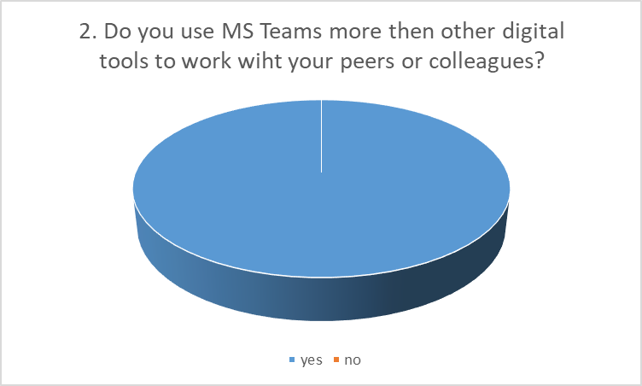
According to the results of using MS team more than other digital tool to work, 5 out of 5 respondent replied Yes. The results shows that most of the students at UWTSD uses MS Team to work with their peers and colleagues.
Daily | 2
Weekly | 3
Monthly | 0
Sometimes | 0
Rarely | 0

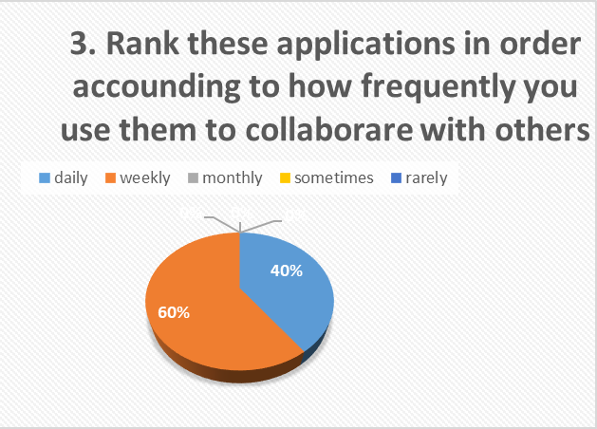
According to the results of how often the students uses MS Team as a collaboration tool in university, out of 5 respondent the results shows that the students uses MS Team weekly to collaborate with others.
Strong Agree | 5
Agree | 0
Disagree | 0
Strongly Disagree | 0
Neutral | 0

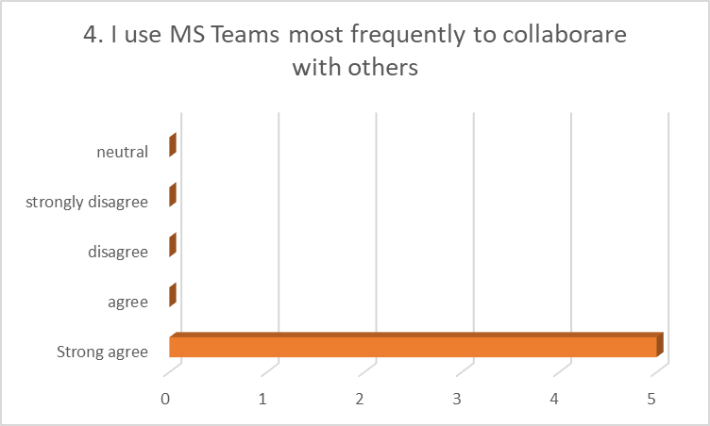
From the above findings of the question 5 out of 5 respondents responded that they all use MS Team most frequently to collaborate with others.
Happy | 4
Very happy | 0
Somewhat happy | 1
Somewhat unhappy | 0
Neither happy nor unhappy | 0
Very unhappy | 0
Sad | 0
Angry | 0

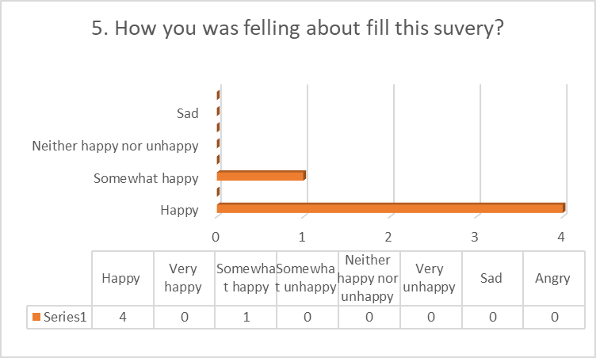
According to the finding of the survey that respondents find themselves Happy, that mean the respondents were happy to share with views as well as they find the research topic satisfactory.
Yes | 5
No | 0
Maybe | 0

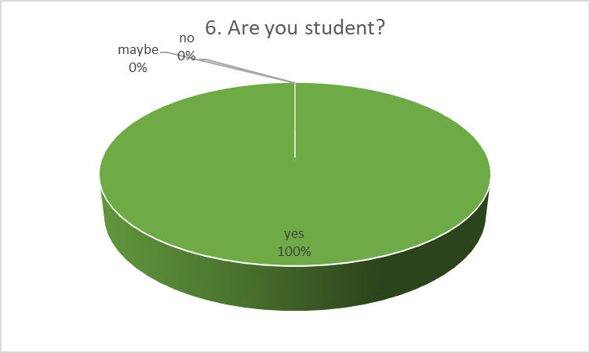
The result of the survey shows that all of the respondents were students as they all use MS Team more frequently in order to deal with others and to complete their tasks with others.

Discussion
These are digital resources that allow for the utilisation of technologies in order to promote communication and access to information through the use of electronic devices such as computers, tablets, and smartphones (Hubbard et al. 2021). The terms “programmes,” “applications,” “virtual platforms,” “games,” “hardware,” and “software,” as well as “portals” and “websites,” “cameras,” and “overhead projectors,” are all examples of digital products. They have applications in a variety of fields and can be put to a variety of uses, including in the fields of administration, advertising, health, science, education, and even personal or corporate use.
MS team in UWTSD’s education can be considered support materials and complementary resources for the teaching and learning process because they help teachers and students, contributing to a greater repertoire of possibilities for activities and interactions. This is because they serve as a support system for both the teaching and learning process as well as the teaching and learning process itself (Marion, and Fixson, 2021).
Students are assisted by the MS team in the development of useful digital skills that are applicable to a variety of day-to-day activities, both in and outside of the classroom, and are given the opportunity to discover the world through various forms of communication and information. They make it possible for pupils to conduct research that is both more extensive and engaging, as well as to gain more information on any topic, so assisting students in developing into critical and independent thinkers and explorers (Hubbard et al. 2021). It has been shown that using digital technology in education can increase students’ interest in the material being taught, leading to improved academic performance and increased student involvement in the educational process. This is because the technology brings the material being taught closer to the real world in a way that is both dynamic and practical. It also makes it possible to democratise access to education and to include students who have impairments because there are a number of resources that make learning easier and assist students overcome their limits.
The MS team is an excellent choice for remote teaching, particularly during the epidemic, because it is the mode of instruction that is now being used the most and because it ensures the continuity of learning (Almodaires et al. 2021). They are portable, so they can be used virtually anywhere, and they give students more freedom whilst also making it easier for teachers to do their jobs by providing them with complementing materials.
Main benefits of MS-Team:
- Future skills development.
- Adaptation to BNCC.
- Practicality.
- Dynamism.
- Democratisation.
- Inclusion.
- Interactivity.
- Creativity.
- Social interaction.
- Greater student engagement.
- Higher performance in learning.
- Autonomy.
- Ease.
- Bringing the school closer to the students’ reality.
- Allows remote teaching.
The MS Team package plans are scalable and stand out amongst the best known and used in the world (Marion, and Fixson, 2021). It is a set of solutions that cover different needs of universities, such as:
Storage space: the plans have cloud environments to store files with the necessary security.
Programs: Microsoft software is the most used in the job market, meeting different expectations of companies. In addition, as they are located in clouds, they are updated in real time and do not take up space on machines (Ha, and Ngo, 2021). We are talking about tools capable of contributing to the creation, sharing and management of projects.
OneNote: aimed at activities such as writing, sharing, and editing notes.
Access: allows building a database.
OneDrive and SharePoint: Ensures teams save, access, and share documents.
Sway: create and share reports and interactive presentations.
Microsoft Teams: work environment that allows the exchange of files, messages, and videoconferences.
Booking: tool that makes online appointments for companies.
Planner: aimed at managing activities and work teams (Marion, and Fixson, 2021).
Corporate email: creation of personalised addresses, with volume that may vary according to the contract.

Conclusion
It is concluded that the use of technology like MS Team in the classroom and digital tools through digital resources came to help in a practical way the teaching and learning process, inside and outside the classroom, as the acquisition of digital skills improves student performance in a general. With the advent of technology, all sectors of society suffered significant impacts, as it transformed the way students live, relate, communicate and, consequently, the way they teach and learn. Therefore, education technology came to meet the needs of the modern world like MS Team, bringing innovation to the classrooms of UWTSD and breaking with the traditional teaching model with education.

Reference List
Almodaires, A.A., Almutairi, F.M. and Almsaud, T.E., 2021. Pre-Service Teachers’ Perceptions of the Effectiveness of Microsoft Teams for Remote Learning. International Education Studies, 14(9), pp.108-121.
Ha, G.L. and Ngo, T.C.T., 2021. Challenges in learning listening comprehension via Microsoft Teams amongst English majors at Van Lang University. International Journal of TESOL & Education, 1(3), pp.142-175.
Hubbard, M., Bailey, M.J., Hess, D. and Hellebro, M., 2021. Mastering microsoft teams (pp. 57-74). Apress.
Kornytska, Y. and Kolisnyk, M., 2022. Cloud-based collaboration tools in the ESP class.
Leonardi, P., 2021. Picking the right approach to digital collaboration. How Work Will Work in the New Normal, p.13.
Marion, T.J. and Fixson, S.K., 2021. The transformation of the innovation process: How digital tools are changing work, collaboration, and organisations in new product development. Journal of Product Innovation Management, 38(1), pp.192-215.
Popescu, G.H., Ciurlău, C.F. and Stan, C.I., 2022. Virtual Workplaces in the Metaverse: Immersive Remote Collaboration Tools, Behavioral Predictive Analytics, and Extended Reality Technologies. Psychosociological Issues in Human Resource Management, 10(1).
Schubert, P. and Williams, S.P., 2022. Enterprise collaboration platforms: An empirical study of technology support for collaborative work. Procedia Computer Science, 196, pp.305-313.
Tran, M.T.T., 2021. Microsoft Teams in the context of freshmen ELF learning. AsiaCALL Online Journal, 12(2), pp.12-23.
- Weigel, A., Zeuge, A., Baumgart, T.L. and Niehaves, B., 2021. Bittersweet Virtual Reality Collaboration: Necessary and Sufficient Conditions.

7. Appendices: Questionnaire


