Machine Learning Activity: Feature Selection and Model Comparison
Train a Random Forest classifier on the Diabetes and/or Titanic dataset.
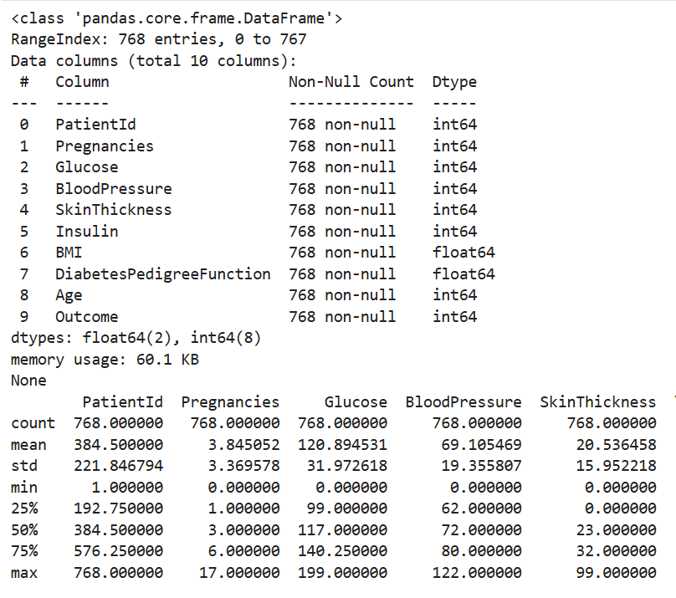
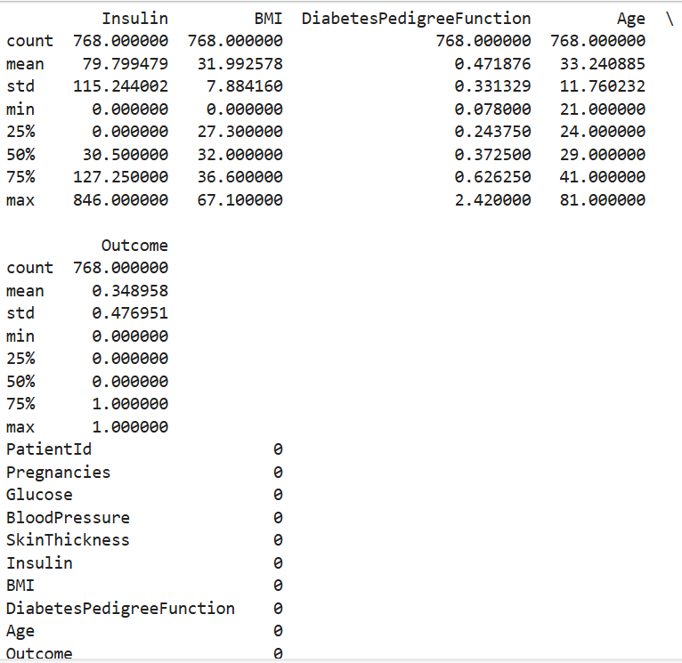
1- Investigate feature selection through:
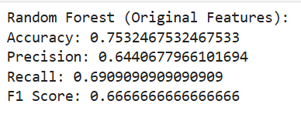
1a - Manually selecting important features and retraining the model.
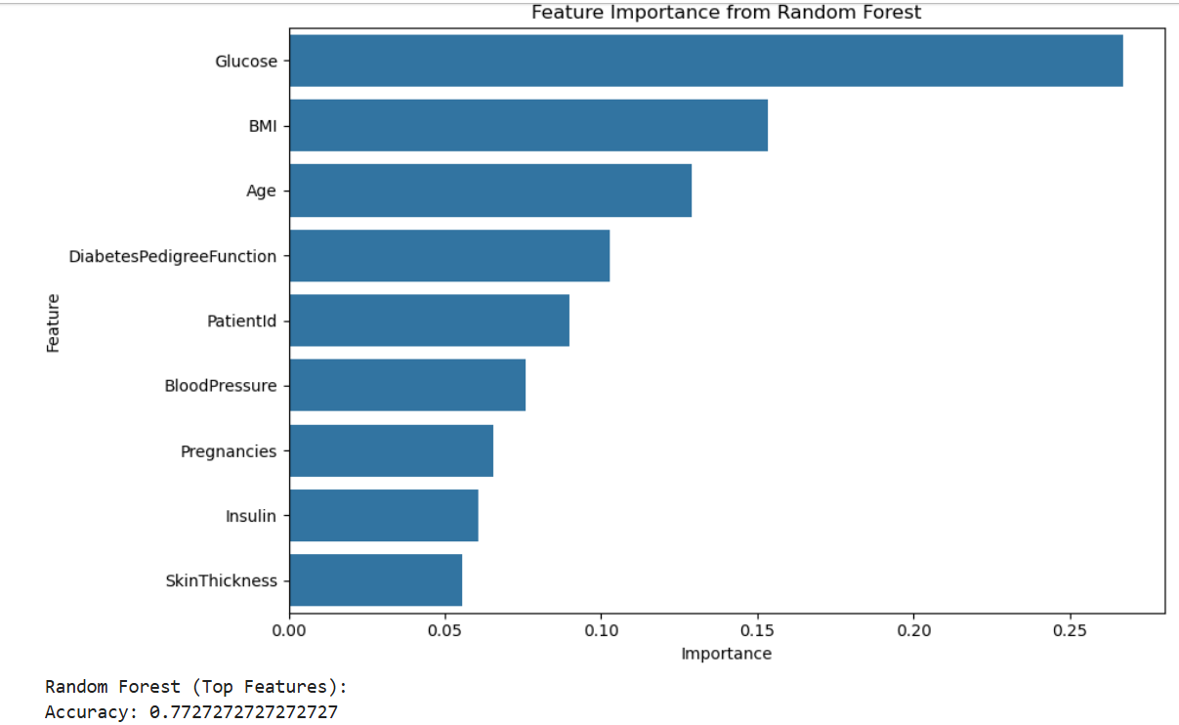
1b - Using Principal Component Analysis (PCA) for dimensionality reduction.
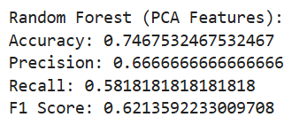
2- Train Logistic Regression and Naïve Bayes classifiers for comparison.
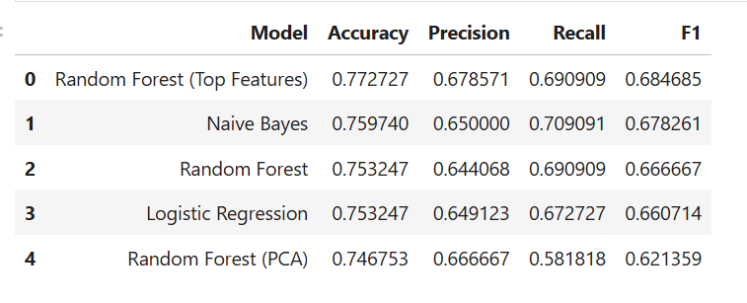
3- Evaluate model performance using accuracy, precision, recall, and F1-score.
Random Forest (Original) performed best overall.
Top Feature Selection simplified the model with minimal performance drop.
PCA reduced dimensionality effectively but slightly reduced interpretability.
Logistic Regression and Naïve Bayes were competitive but less accurate.

