3/26/2026
Afshana Begum (2337226)
University of Wales Trinity Saint David
Website Redesign for Online Business Presence

Table of Contents
Task 1 – Report 2
Introduction 2
MealSwift Website Redesign 2
Responsive Design Implementation 3
Implementation Section 3
Conclusion 4
References 4
References 4
Task 2 – UI/UX Web Design Phases 5
Wireframe Design 5
Mood Board Creation 6
Interactive Prototype 6
The screenshots of the Wireframe 7
The screenshots of Mood Board 15
The Screenshots of Prototype 26

Task 1 – Report

Introduction
The redesign of the MealSwift website begins with a structured set of UI/UX design phases that ensure the final product is visually coherent, intuitive, and aligned with the brand’s identity. This process starts with the creation of a mood board, which establishes the overall visual direction by defining the colour palette, typography, imagery style, and interface inspirations. By incorporating warm, appetising colours, clean sans-serif fonts, and high-quality food photography, the mood board communicates MealSwift’s core values of speed, freshness, reliability, and convenience. It acts as a visual foundation that guides all subsequent design decisions.
Building on this foundation, wireframes are developed to map out the structure and functionality of the website. These grayscale layouts focus on navigation, content hierarchy, and user flow across key pages such as the homepage, restaurant listings, menu pages, checkout, and real-time order tracking. Wireframes help identify and resolve usability issues early, ensuring that the redesigned interface supports a smooth and efficient user journey.
The final phase involves transforming these wireframes into a high-fidelity interactive prototype using Inkscape. This prototype incorporates the visual elements defined in the mood board and demonstrates realistic interactions, including navigation between pages, add-to-cart behaviour, and order tracking. Together, these phases create a cohesive and user-centred design process that supports MealSwift’s goal of delivering a modern, engaging, and efficient digital experience.

MealSwift Website Redesign
The current MealSwift website presents several usability, visual, and functional issues that negatively affect customer satisfaction and overall business performance. One of the most significant problems is the confusing navigation structure, which makes it difficult for users to locate restaurants, browse menus, or complete orders efficiently. This is compounded by an outdated visual design that lacks a clear hierarchy, modern aesthetics, and consistent branding, reducing user trust and engagement. The absence of mobile responsiveness further limits accessibility, as many customers rely on mobile devices for food ordering. Limited restaurant and menu information, combined with low quality images, prevents users from making informed choices and reduces the appeal of listed dishes. The ordering and checkout process is inefficient, with unnecessary steps and no progress indicators, contributing to abandoned carts. Additionally, the lack of personalised recommendations, customer reviews, and strong call-to-action elements weakens user motivation and reduces conversions. Slow loading times and the absence of real‑time order tracking further diminish the overall experience.
To address these issues, the redesign will introduce streamlined navigation, a modern visual identity, mobile-first layouts, enhanced menu details, high‑quality imagery, and an optimised checkout flow. Personalisation features, accessibility improvements, integrated reviews, stronger CTAs, and real-time tracking will create a more intuitive, engaging, and trustworthy platform. [1]

Responsive Design Implementation
Responsive design has become essential in e-commerce because it directly influences how users experience a website across different devices, particularly mobile phones, which now account for a significant proportion of online purchases. Implementing responsive design ensures that layouts, images, and interactive elements automatically adapt to various screen sizes, creating a seamless and consistent experience whether users browse on a smartphone, tablet, or desktop. This adaptability improves usability by enhancing readability, simplifying navigation, and ensuring that buttons, menus, and forms remain accessible and easy to interact with on smaller screens. A smoother browsing experience reduces frustration, increases engagement, and encourages users to continue exploring products or services. [1]
From a commercial perspective, responsive design has a strong impact on mobile sales. A mobile-optimised interface reduces friction at key stages of the purchasing journey, such as browsing menus, adding items to the cart, and completing checkout. Faster loading times, simplified forms, and touch‑friendly controls help lower cart abandonment rates, which are typically higher on mobile devices. Responsive design also improves search engine visibility, attracting more potential customers and increasing organic traffic. MealSwift, where users frequently order food on the go, a responsive design enhances convenience, supports quick decision‑making, and encourages repeat purchases. Overall, responsive design strengthens user satisfaction, boosts conversions, and helps e-commerce platforms remain competitive in a mobile-driven market. [2]

Implementation Section
The mood board and wireframes played a central role in shaping the final MealSwift website prototype, providing both visual direction and structural foundation. The mood board established the overall aesthetic identity of the platform, ensuring that every visual element aligned with MealSwift’s brand values of freshness, speed, reliability, and convenience. The chosen warm, appetising colours guided the appearance of buttons, highlights, and promotional sections, while the clean sans‑serif typography informed the hierarchy of headings and body text across all pages. High‑quality food imagery and UI inspiration from leading delivery apps influenced the modern, card‑based layouts and rounded interface components used in the prototype. As a result, the mood board ensured visual consistency and cohesive brand experience throughout the design. [3]
The wireframes provided the structural blueprint for each page, determining the placement of key elements such as search bars, restaurant cards, menu categories, checkout forms, and order‑tracking components. By focusing on layout, navigation flow, and content hierarchy without the distraction of colour or imagery, the wireframes helped identify usability issues early and ensured that the final design supported intuitive user interactions. When combined, the mood board and wireframes created a clear pathway from conceptual direction to functional layout, resulting in a prototype that is both visually engaging and user-centred. [4]

Conclusion
The project provided a valuable opportunity to apply a structured UI/UX design process to redesign the MealSwift website and address the usability challenges identified in the initial analysis. Working through the different design phases highlighted the importance of beginning with a clear visual direction, as the mood board helped establish a cohesive brand identity that guided all later design decisions. By defining colours, typography, imagery, and interface inspiration early, the project ensured that the final prototype remained visually consistent and aligned with MealSwift’s values of speed, freshness, and reliability.
Developing wireframes further demonstrated the significance of planning layout and functionality before introducing visual elements. This phase made it possible to focus on navigation flow, content hierarchy, and user pathways, helping to resolve structural issues and create an intuitive foundation for the redesigned interface. The wireframes ensured that each page supported a smooth ordering journey, from browsing restaurants to tracking deliveries.
Transforming these wireframes into a high-fidelity interactive prototype reinforced how visual and structural decisions come together to create a realistic user experience. The prototype showcased improved usability, clearer navigation, and a more engaging interface. Overall, the project emphasised how a thoughtful, step‑by‑step design process is essential for producing a high‑quality website that meets user expectations and supports MealSwift’s business goals.

References

References

[1] | D. Norman, Design for a Better World: Meaningful, Inclusive, and Humane, vol. 34, https://mitpress.mit.edu/9780262548304/design-for-a-better-world/, 2025, pp. 294-299.
[2] | E. M. A. Hussain, "The role of responsive web design in enhancing user experience and engagement," International Journal of Interactive Mobile Technologies, vol. 15, no. 8, pp. 4-18, 2021.
[3] | S. Althunibat, "The impact of mobile-friendly design on online purchase intention in e-commerce," Journal of Theoretical and Applied Electronic Commerce Research, vol. 17, no. 2, p. 548–563, 2022.
[4] | S. W. M. R. Islam, "User interface design factors affecting customer satisfaction in online food delivery services," International Journal of Data and Network Science, vol. 6, no. 4, p. 1231–1240, 2022.
[5] | S. S. N. Singh, "Optimising checkout design to reduce cart abandonment in mobile commerce," International Journal of Human–Computer Interaction, vol. 38, no. 12, p. 1100–1114, 2022.
[6] | A. R. Irene Pereyra, Universal Principles of UX, Rockport Publishers, 2020, p. 216.

Task 2 – UI/UX Web Design Phases

Wireframe Design
Wireframe design establishes the structural foundation of the MealSwift website by defining the layout and organisation of each page before any visual styling is applied. This phase focuses on functionality, navigation, and content hierarchy, ensuring that users can move through the platform smoothly and intuitively. The purpose of wireframing is to map out the user journey, resolve navigation and usability issues early, and plan page layouts logically without the distraction of colour, imagery, or detailed graphics. Five essential pages are included in the wireframing process: the homepage, which features a search bar, restaurant categories, promotional banners, and clear call‑to‑action buttons the restaurant listing page, which incorporates filters, sorting options, and restaurant cards displaying images, ratings, delivery times, and cuisine types the restaurant menu page, which presents the restaurant header, menu categories, and dish cards with descriptions, prices, and add‑to‑cart buttons the cart and checkout page, which includes an order summary, delivery address form, payment options, and a progress indicator; and the real‑time order tracking page, which displays an order status timeline, driver location, and estimated arrival time. Wireframes are created in black‑and‑white or grayscale using simple shapes such as rectangles and lines, keeping the focus on layout and structure. [5]

Mood Board Creation
A mood board serves as the foundation for the redesigned MealSwift website by establishing the overall visual direction and communicating the brand’s personality, emotional tone, and aesthetic style. It brings together key design elements such as warm, appetising colours like red, orange, and yellow to stimulate appetite, supported by neutral tones such as white, grey, and charcoal to maintain balance. Accent colours, including bright red or green, are used to highlight call‑to‑action buttons and important interface elements. The typography choices feature clean, modern sans‑serif fonts such as Poppins, Inter, or Montserrat, with bold weights for headings and lighter weights for body text to ensure clarity and readability. Imagery focuses on high‑quality food photography, visuals of delivery riders, local restaurants, and happy customers, all set against clean, bright backgrounds to reinforce freshness and trust. UI inspiration is drawn from modern food delivery platforms like Uber Eats, Deliveroo, and DoorDash, incorporating rounded buttons, card‑based layouts, and soft shadows to create a contemporary and user‑friendly interface. Brand keywords such as fast, reliable, fresh, local, and convenient help anchor the design direction. These elements are combined into a single A4 or landscape board containing colour swatches, font samples, imagery, UI inspiration, and keywords. [3] [5]

Interactive Prototype
The interactive prototype created in Inkscape transforms the earlier wireframes into high‑fidelity, fully designed screens that closely simulate real user interactions on the MealSwift website. Its purpose is to demonstrate how the redesigned platform will look, feel, and behave once developed, providing a realistic preview of the final product. The prototype visually represents the complete navigation flow, showing how users move between pages and interact with key elements. Five high‑fidelity screens are produced to match the wireframes: the Homepage, Restaurant Listing Page, Restaurant Menu Page, Cart and Checkout Page, and the Order Tracking Page. Each screen incorporates the final colour palette defined in the mood board, along with consistent typography, high‑quality food imagery, and polished UI components such as buttons, icons, and cards. Interactive elements, including hover states and clickable links, help simulate real behaviour for example, selecting a restaurant card opens the menu page, adding an item updates the cart icon, proceeding to checkout loads the payment page, and tracking an order displays a progress bar. By combining visual design with functional interaction, the prototype provides a comprehensive representation of the user experience and ensures that the final website aligns with both user expectations and MealSwift’s business goals. [6]
https://www.figma.com/make/l1R706Mk6cpWjp952lse8r/Create-Interactive-Prototype?t=D1ozaMmh16tbg68O-1

The screenshots of the Wireframe

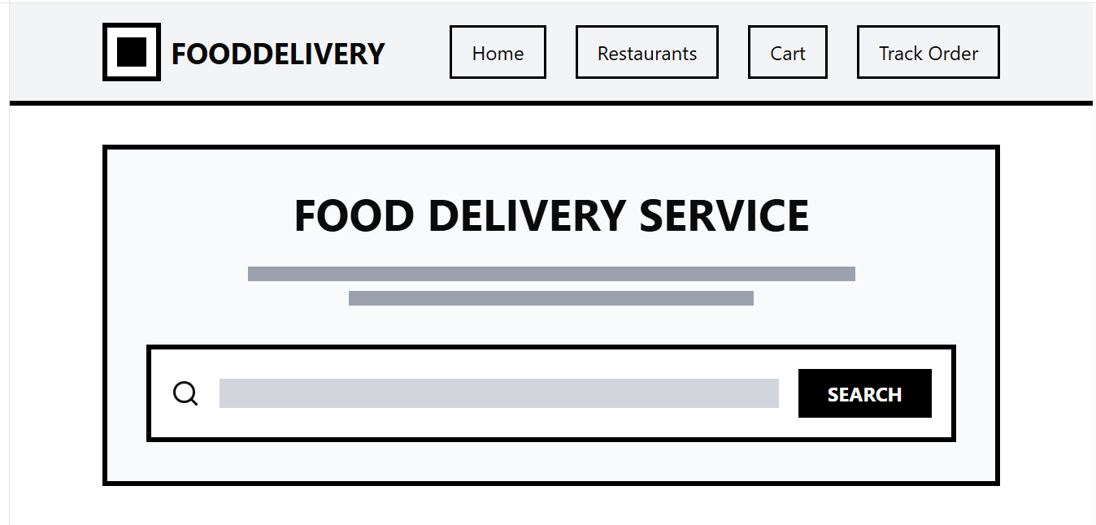
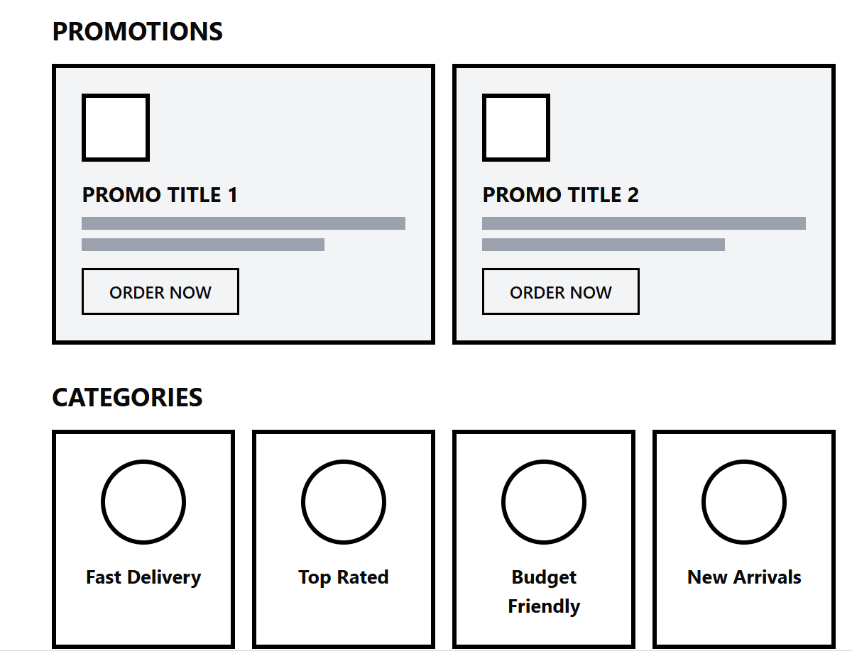
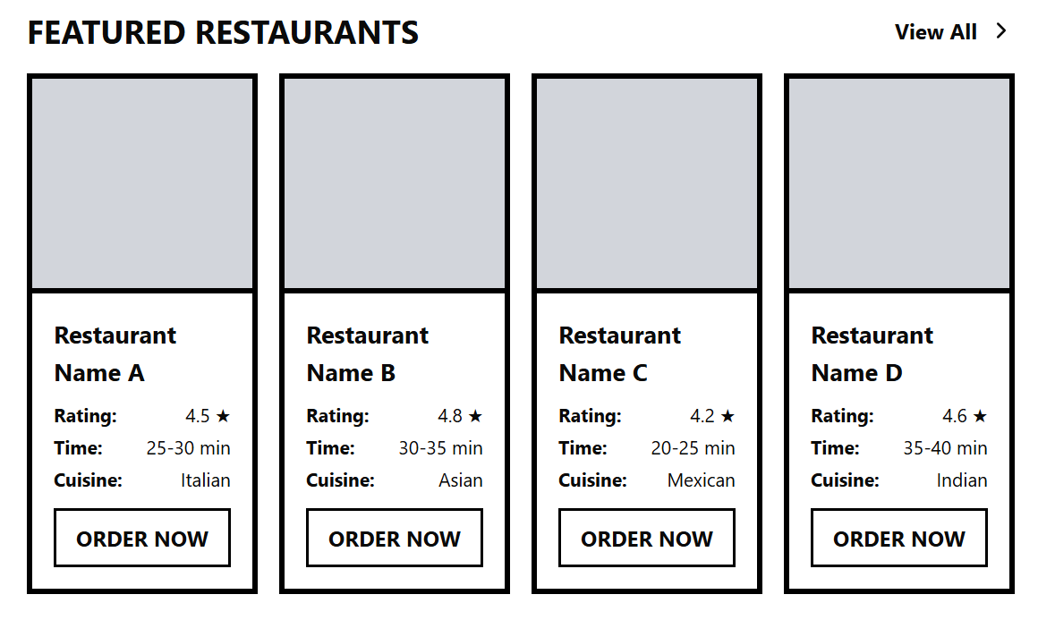
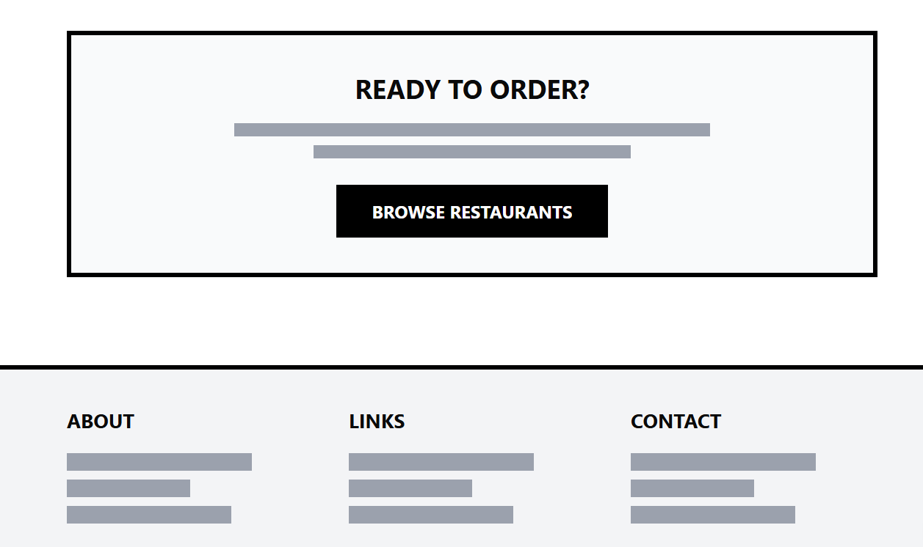
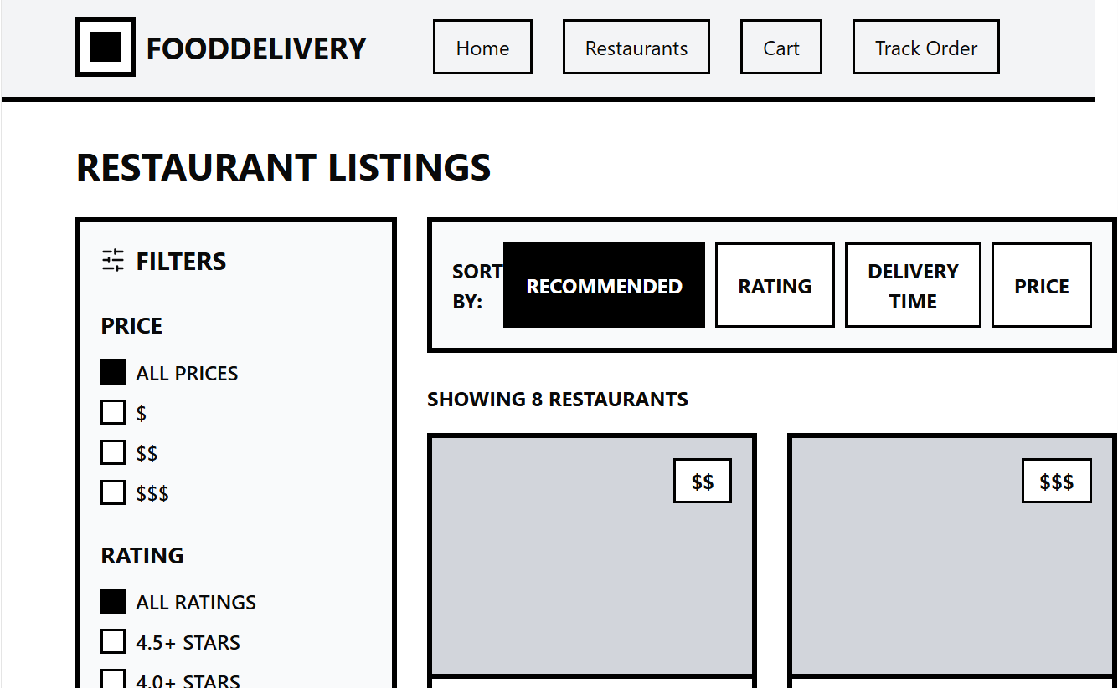
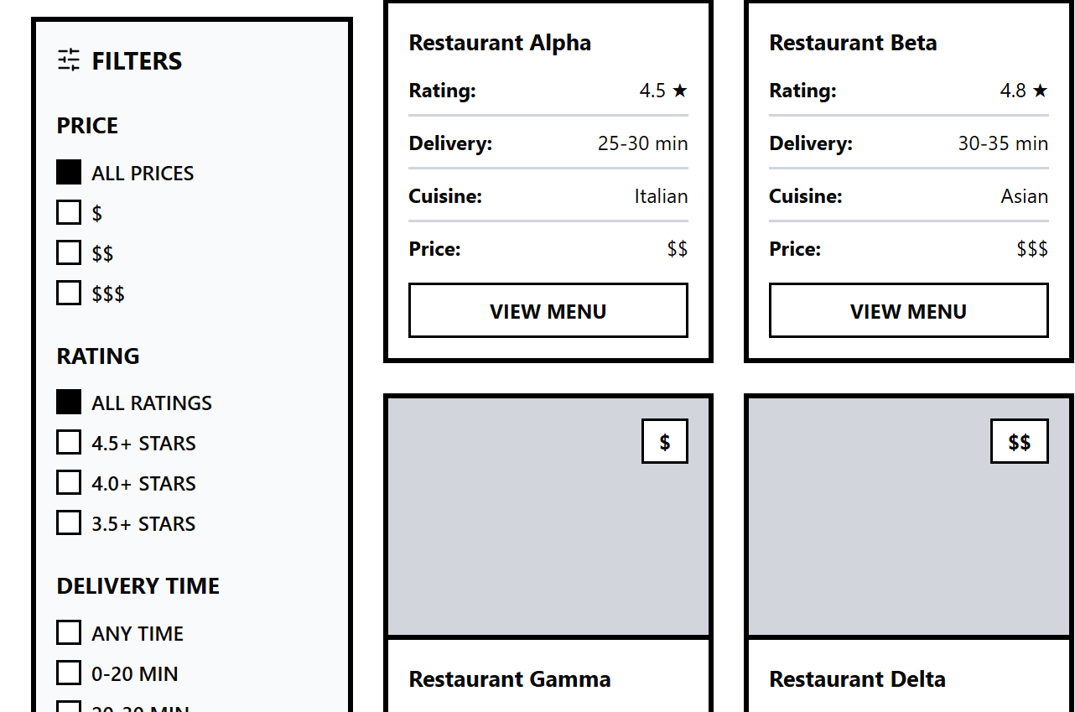
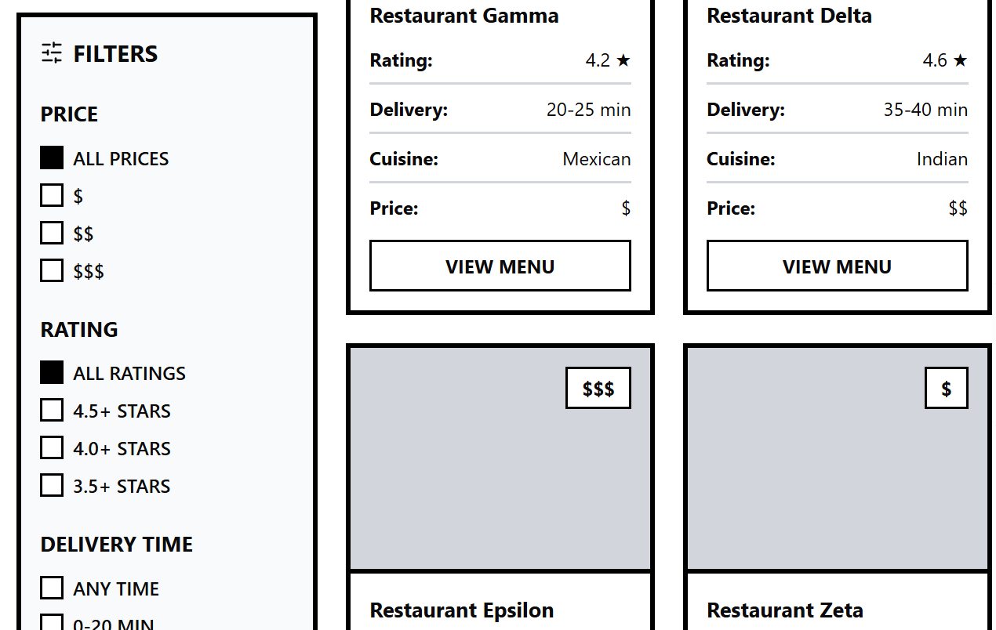
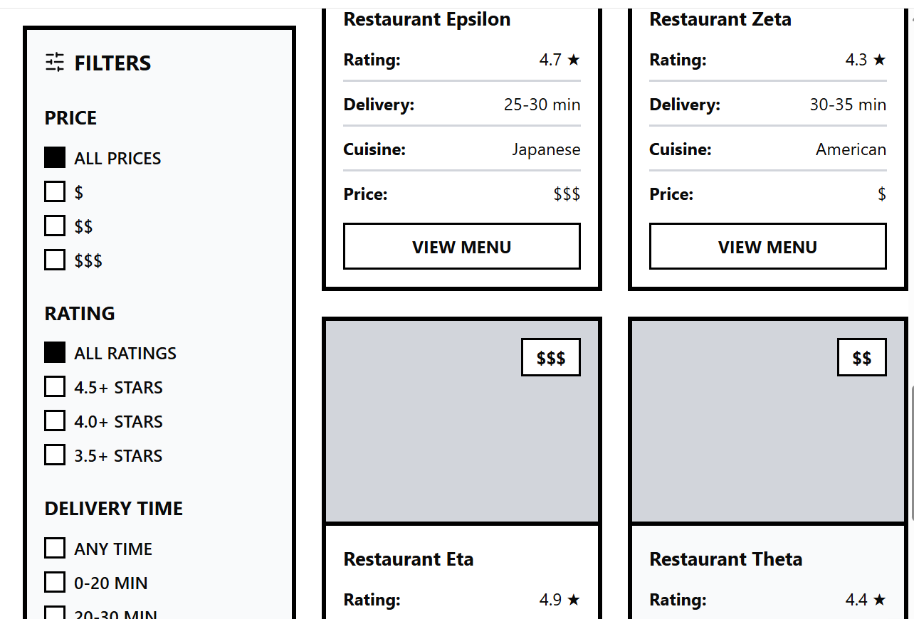
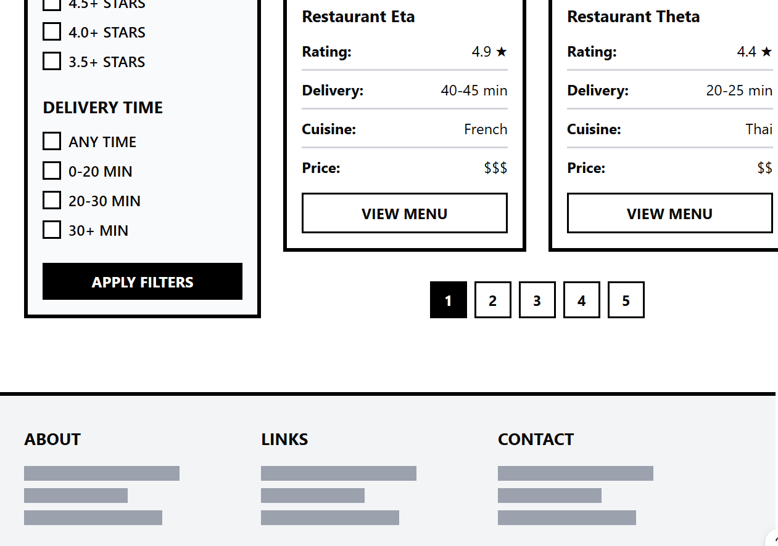
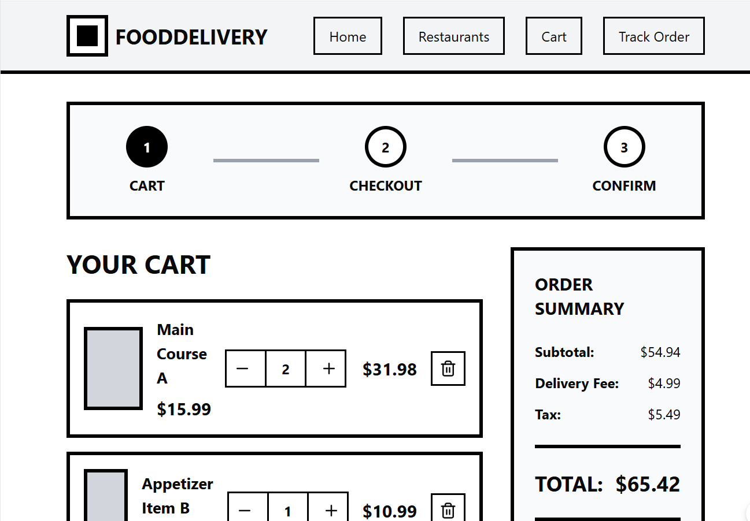
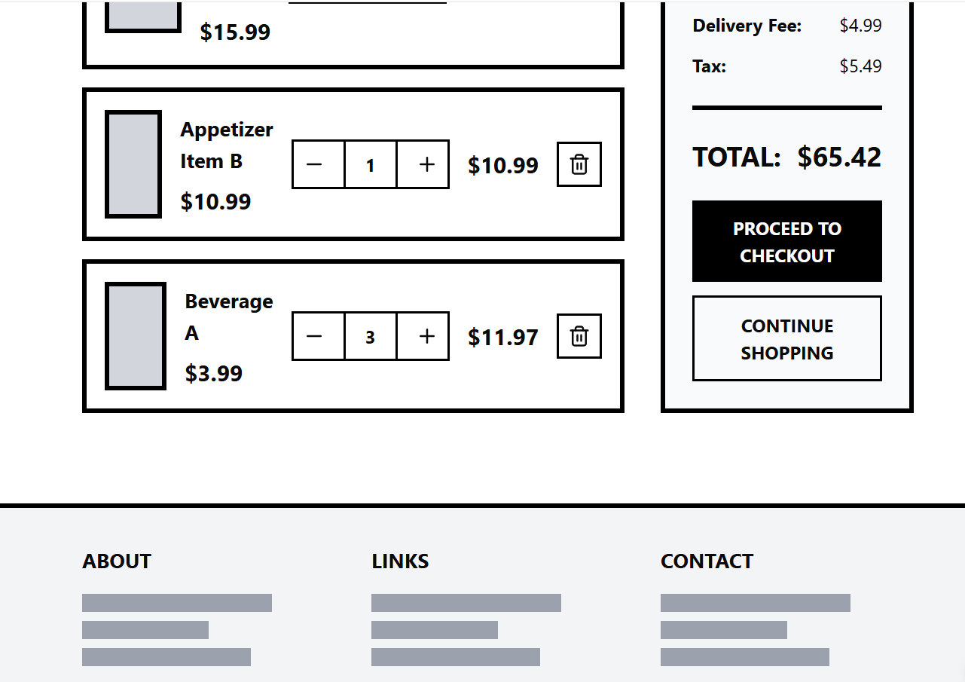
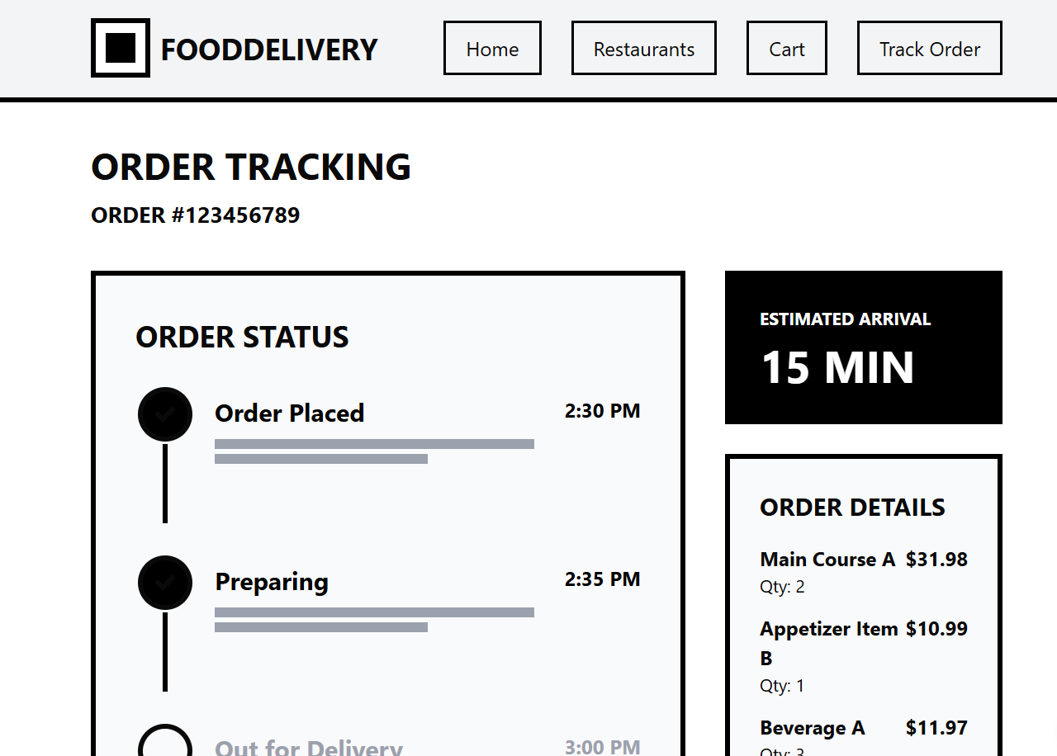
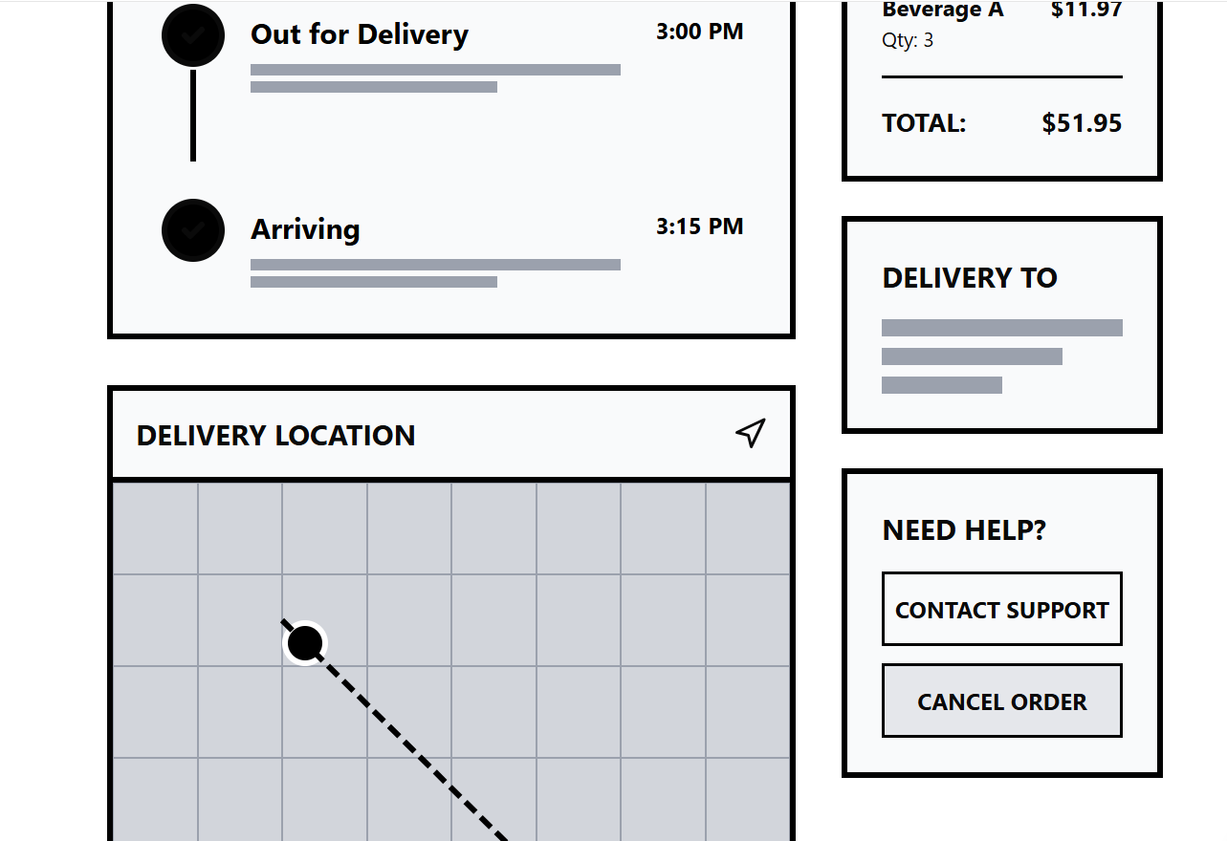
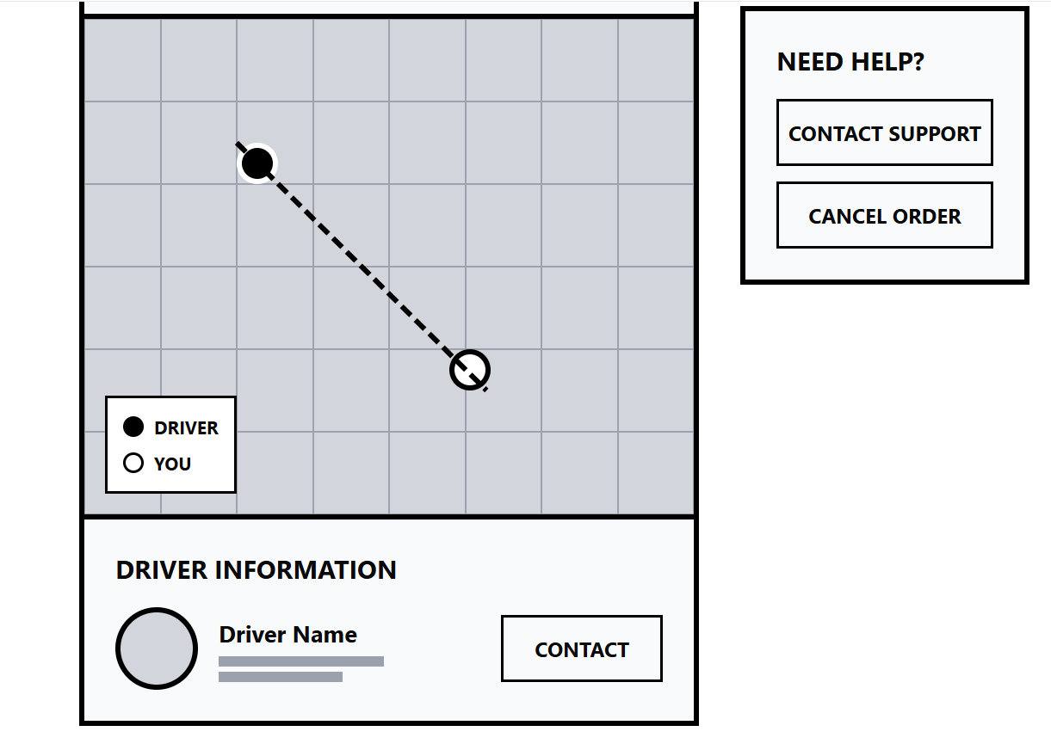
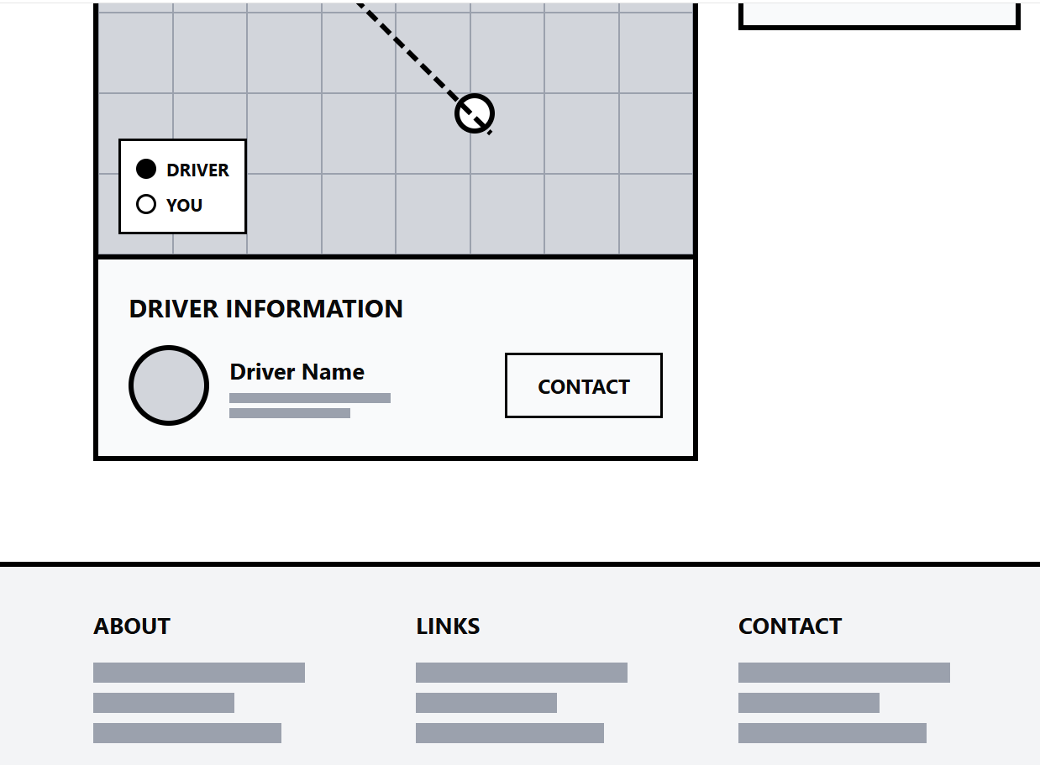
https://www.figma.com/make/zOL6ANTKXNczjOpiuxop4M/Moodboard-and-Wireframe-Creation?t=MHeqb97bfd5EmgFi-1

The screenshots of Mood Board
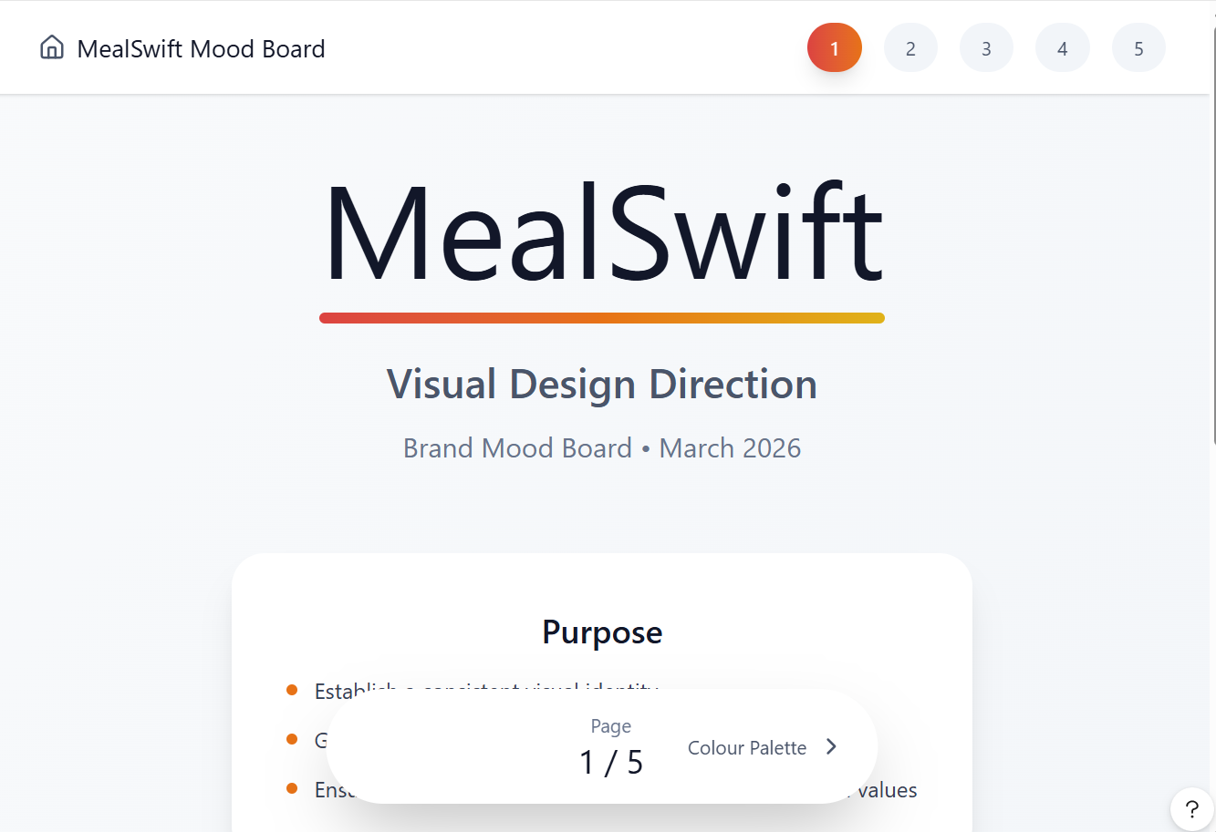
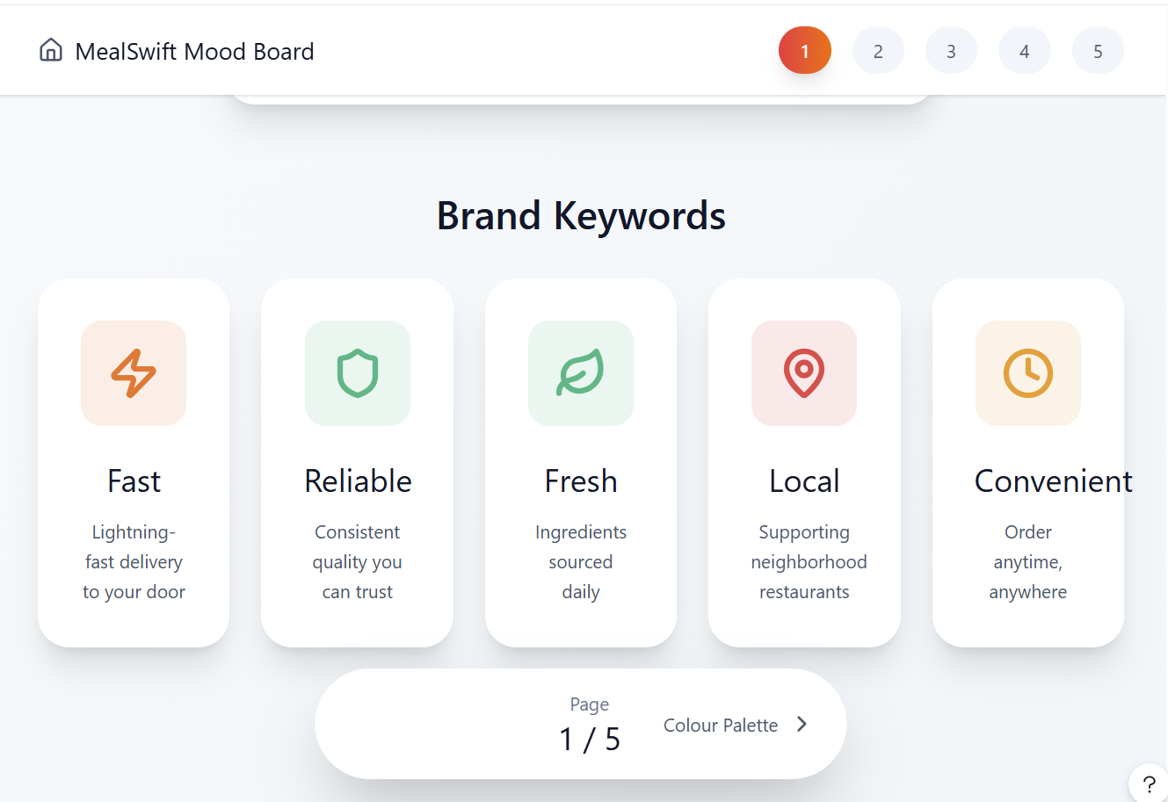
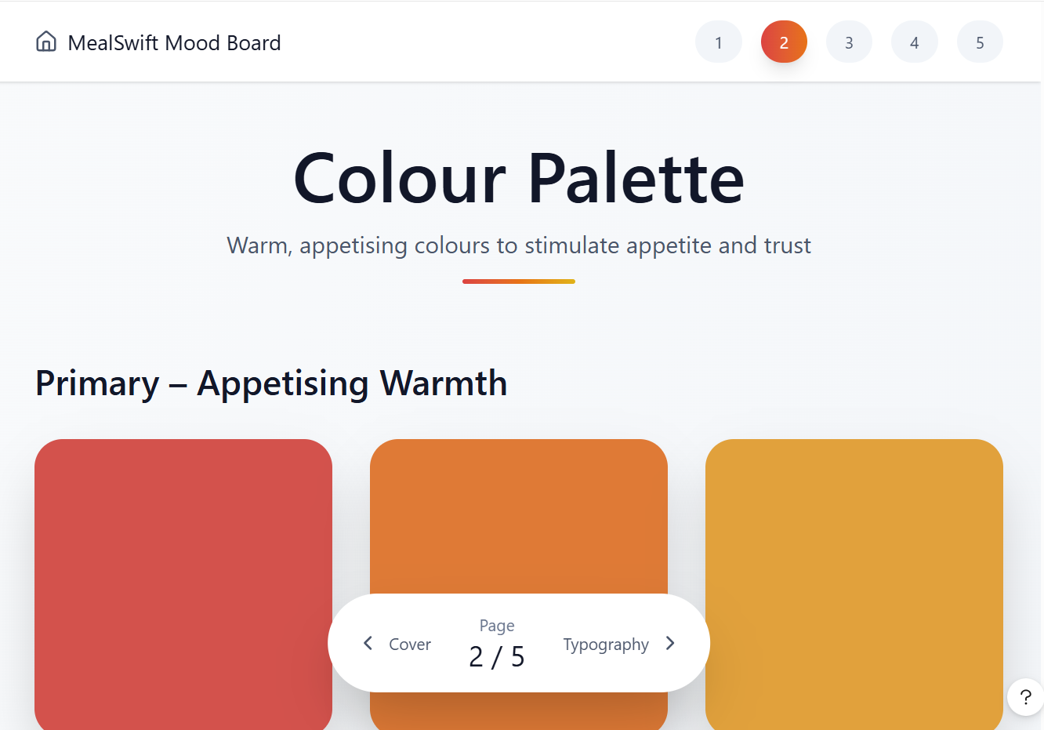
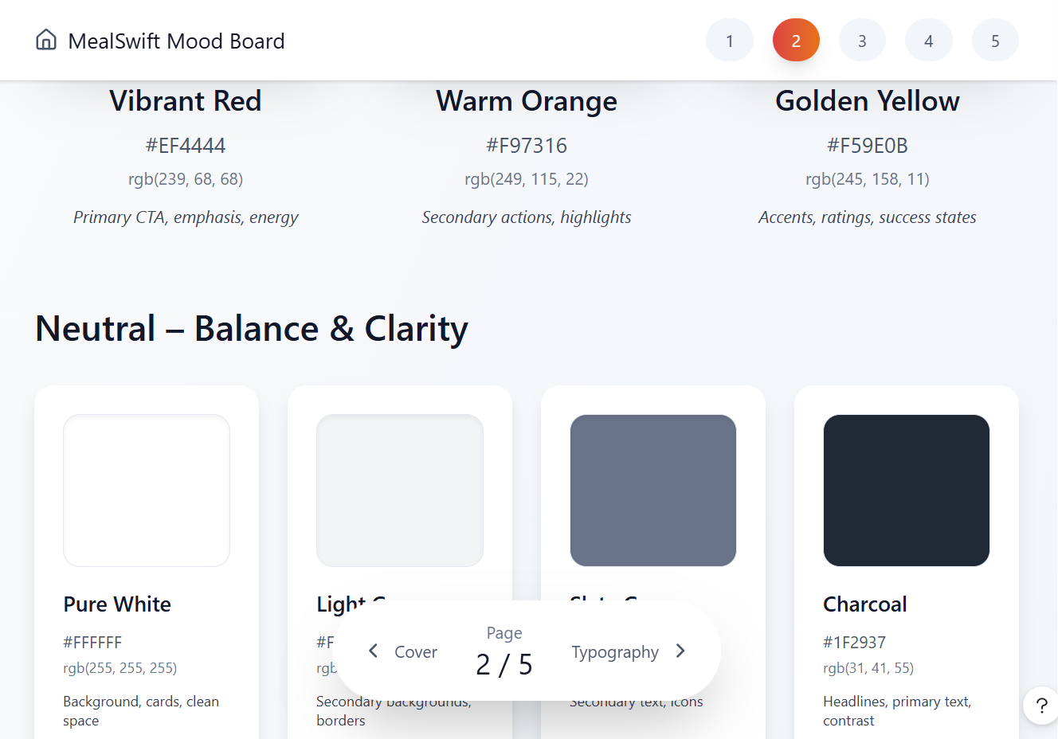
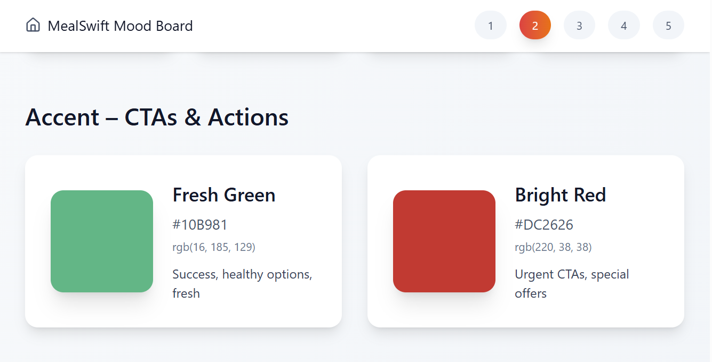
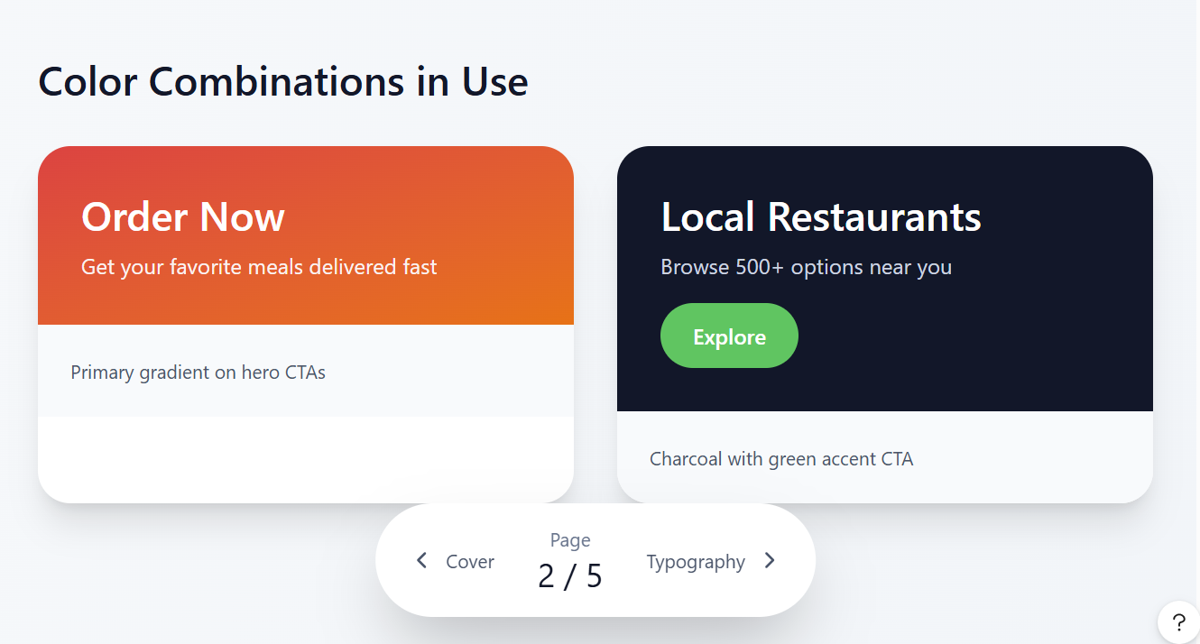
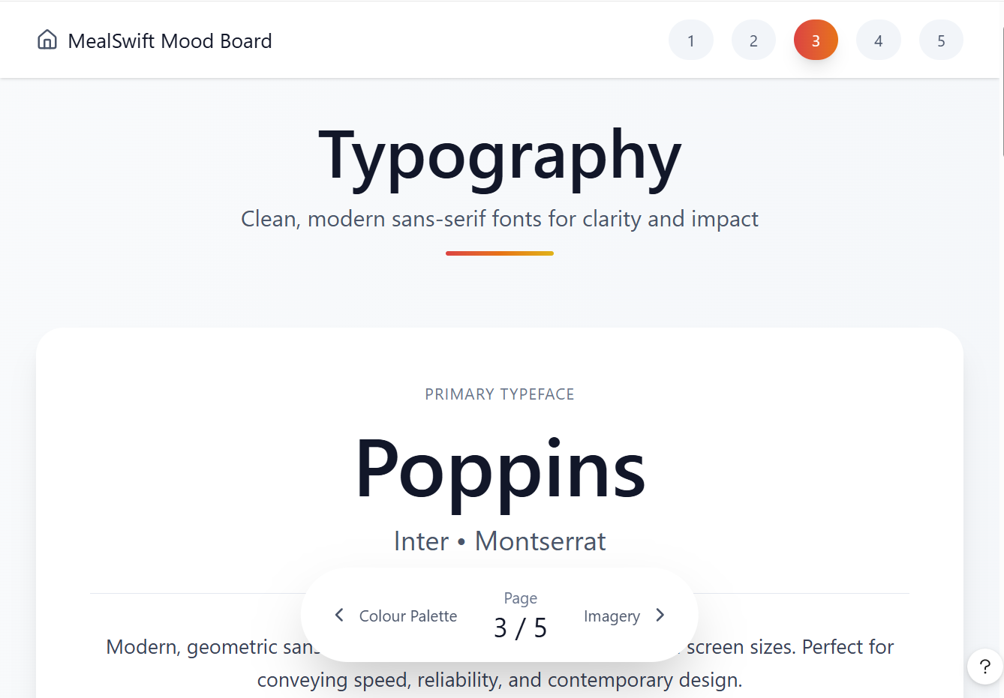
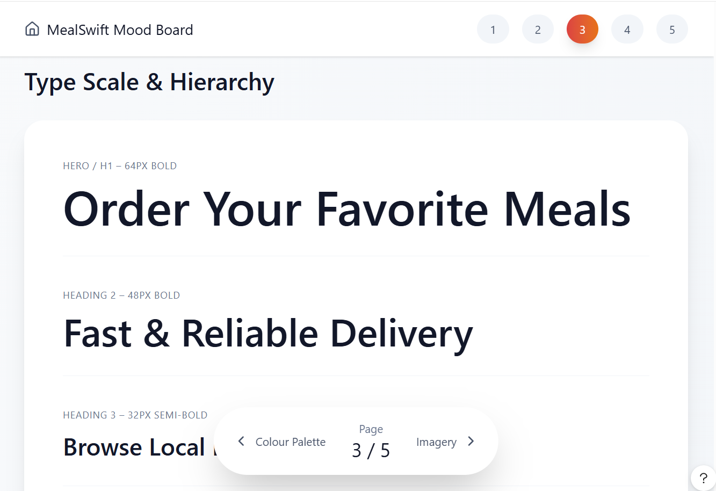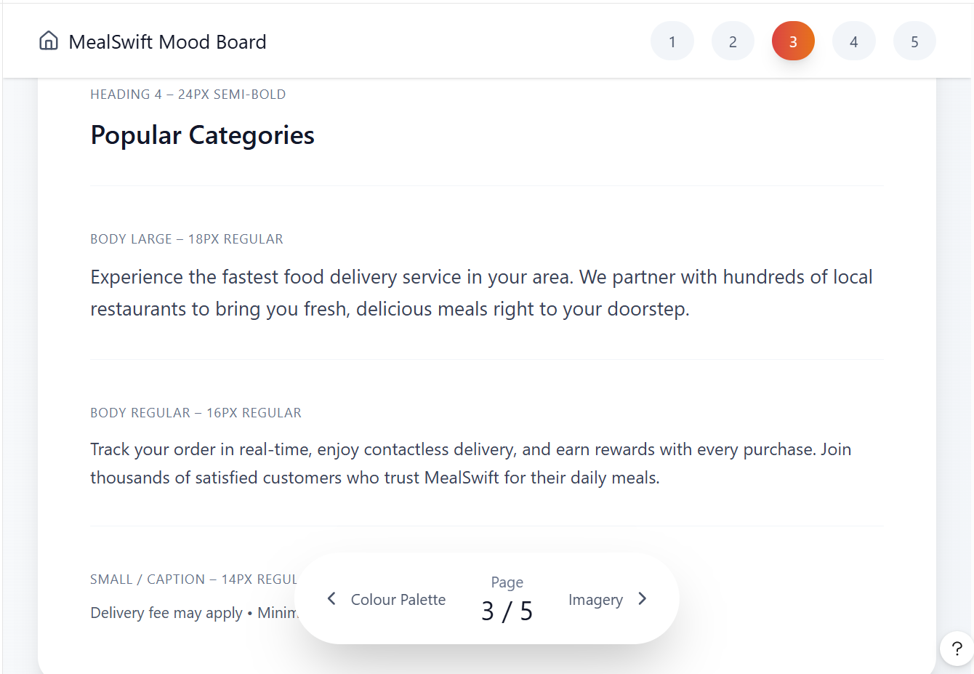
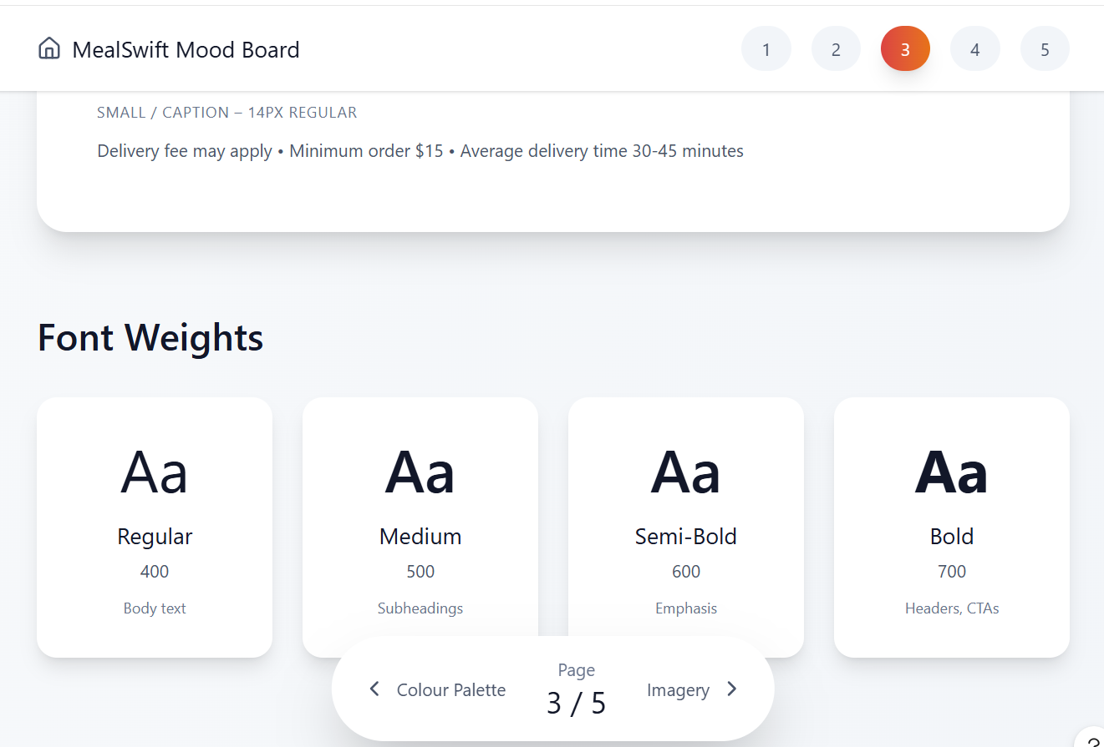
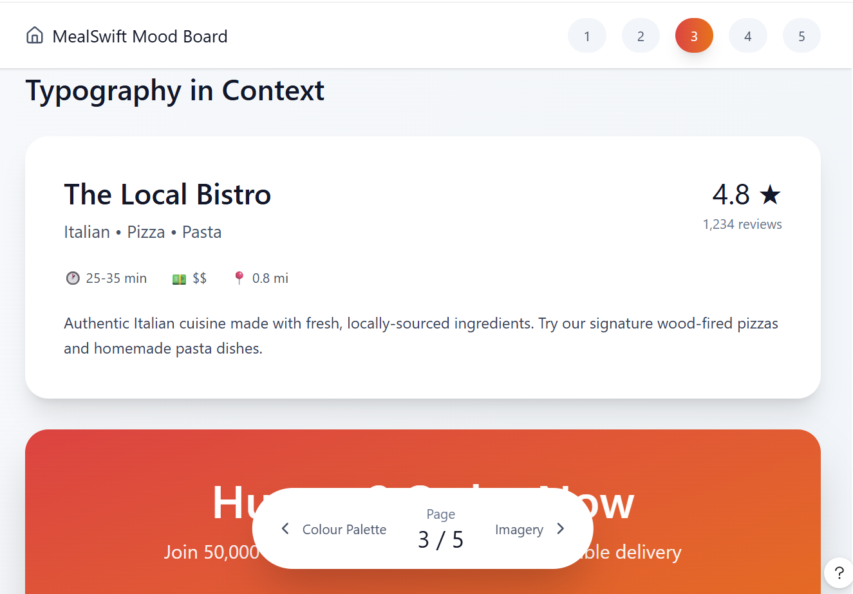
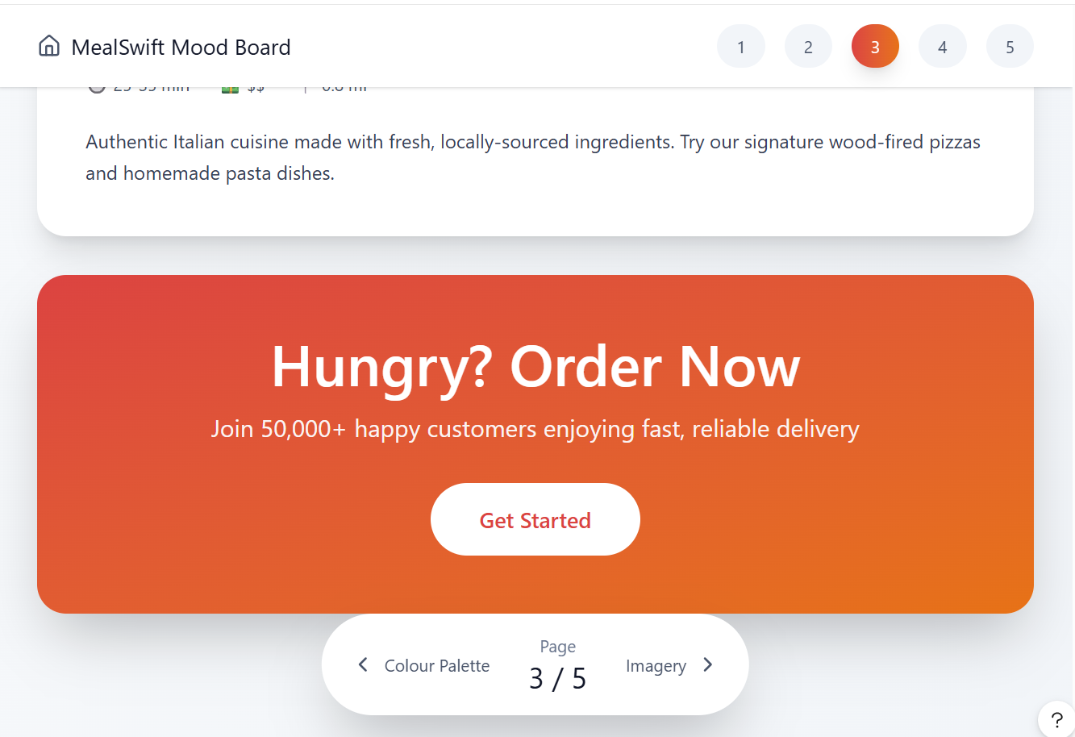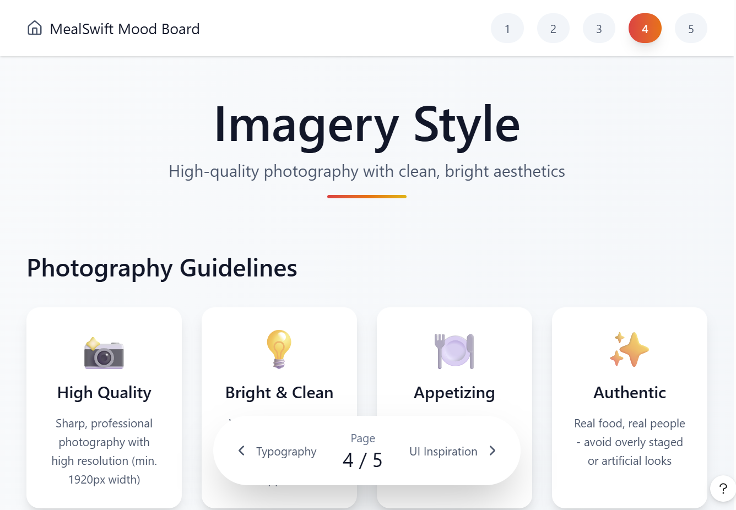
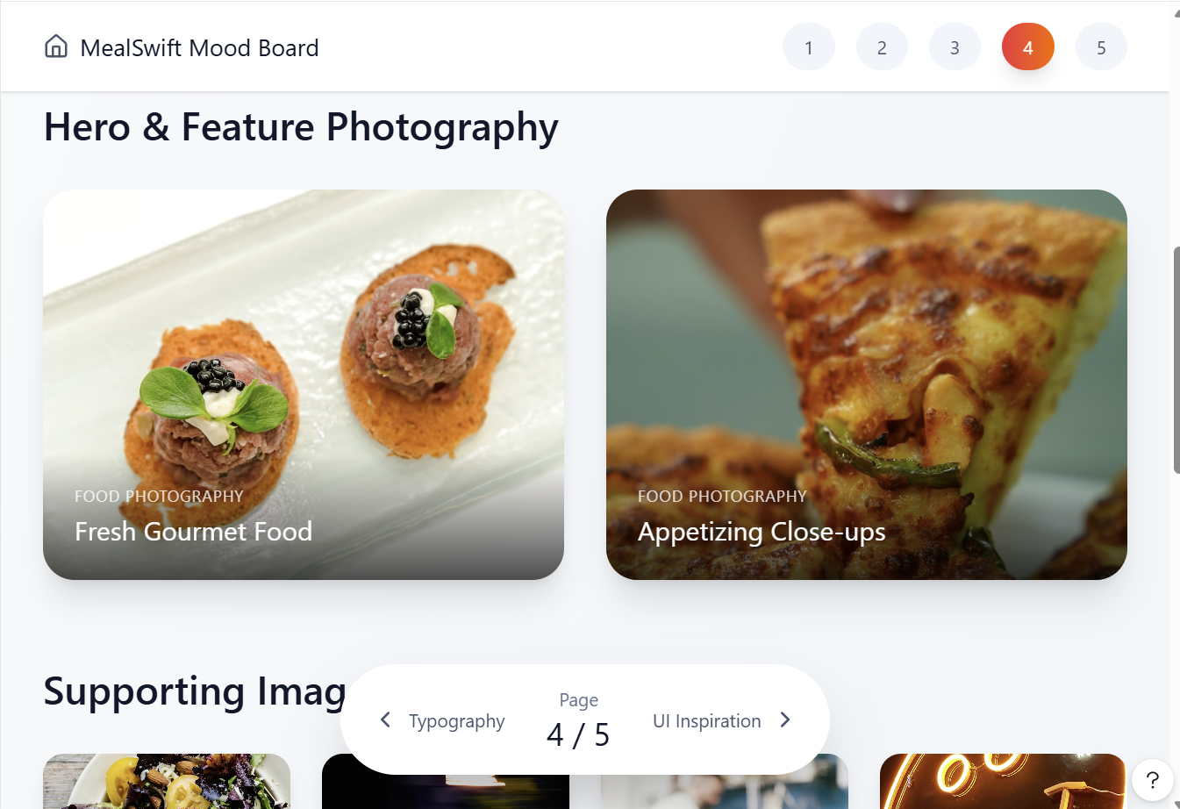
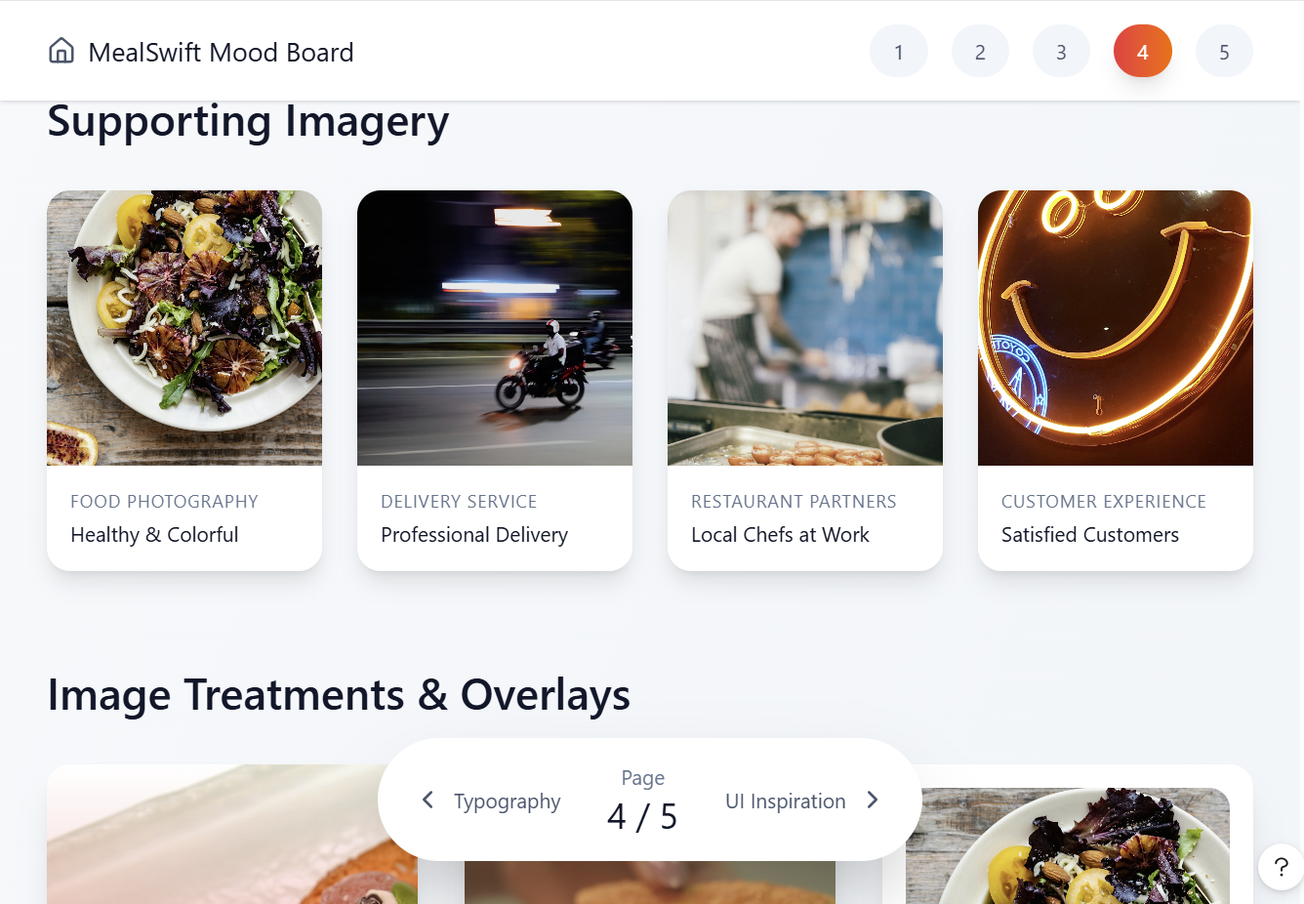
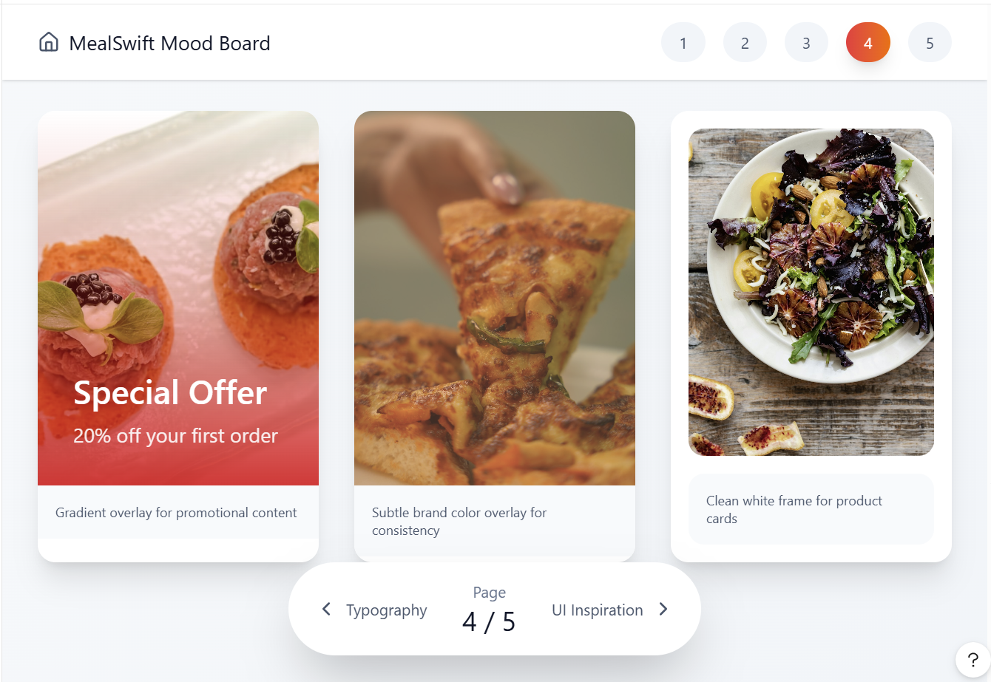
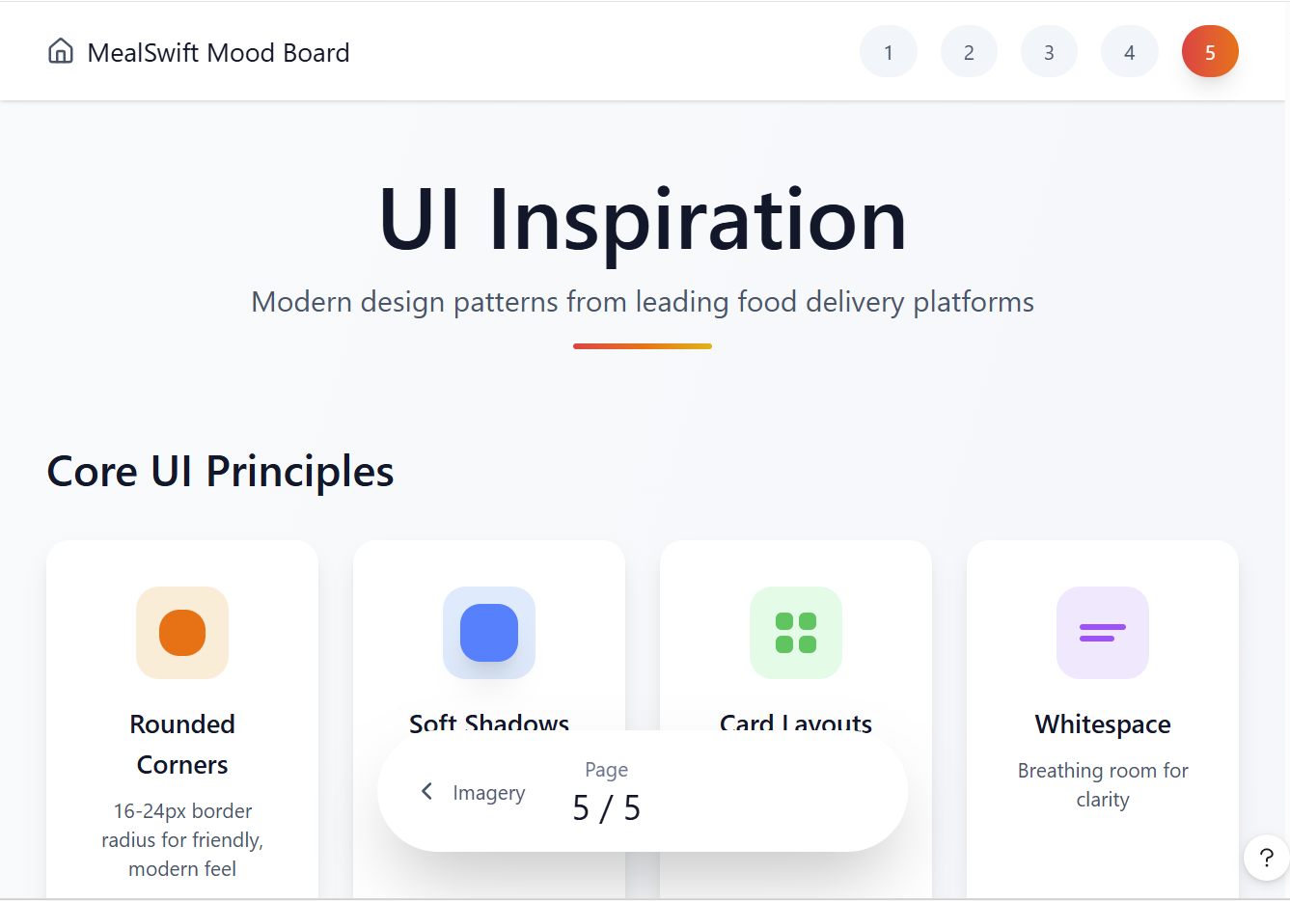
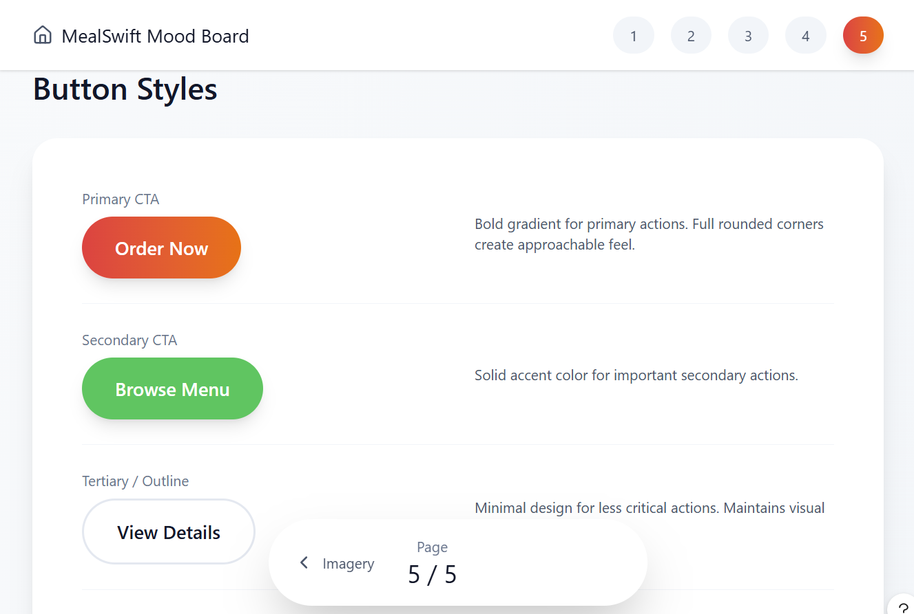
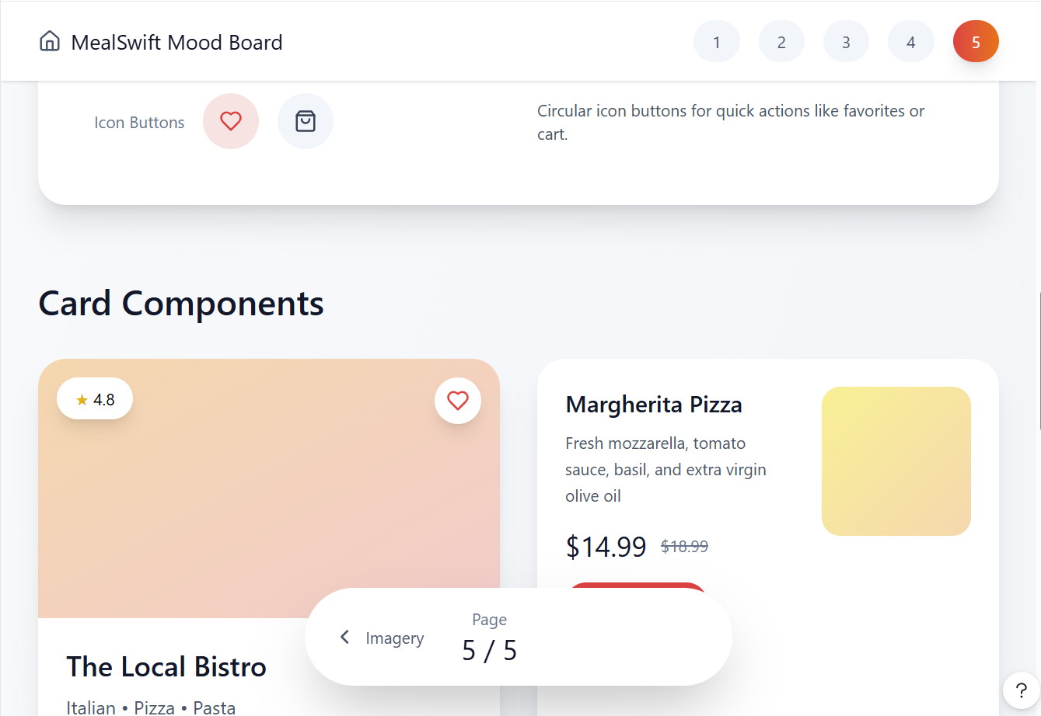
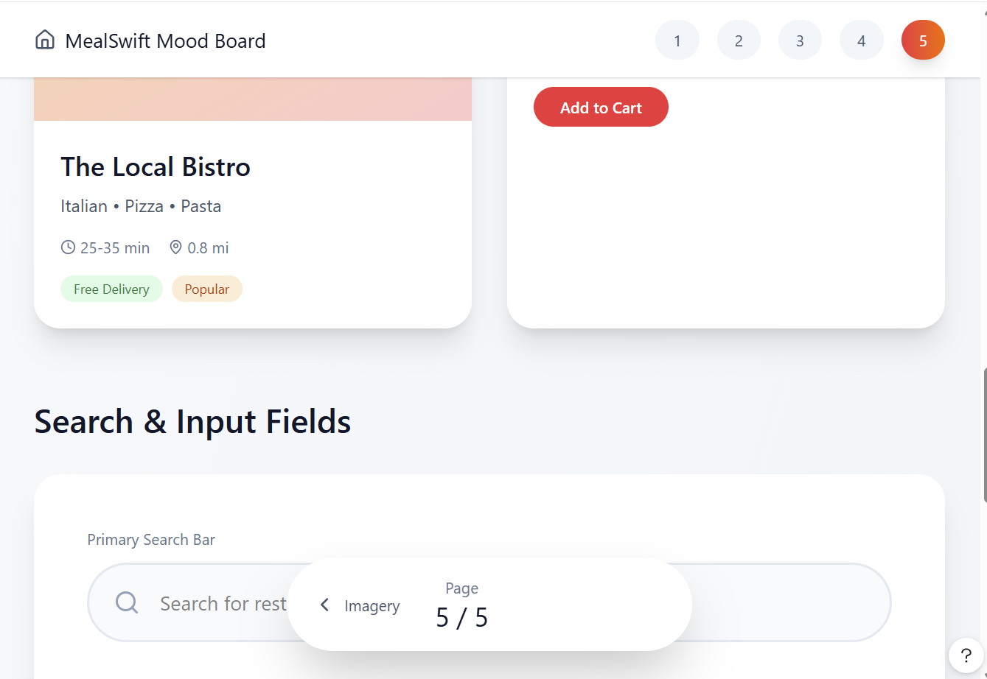
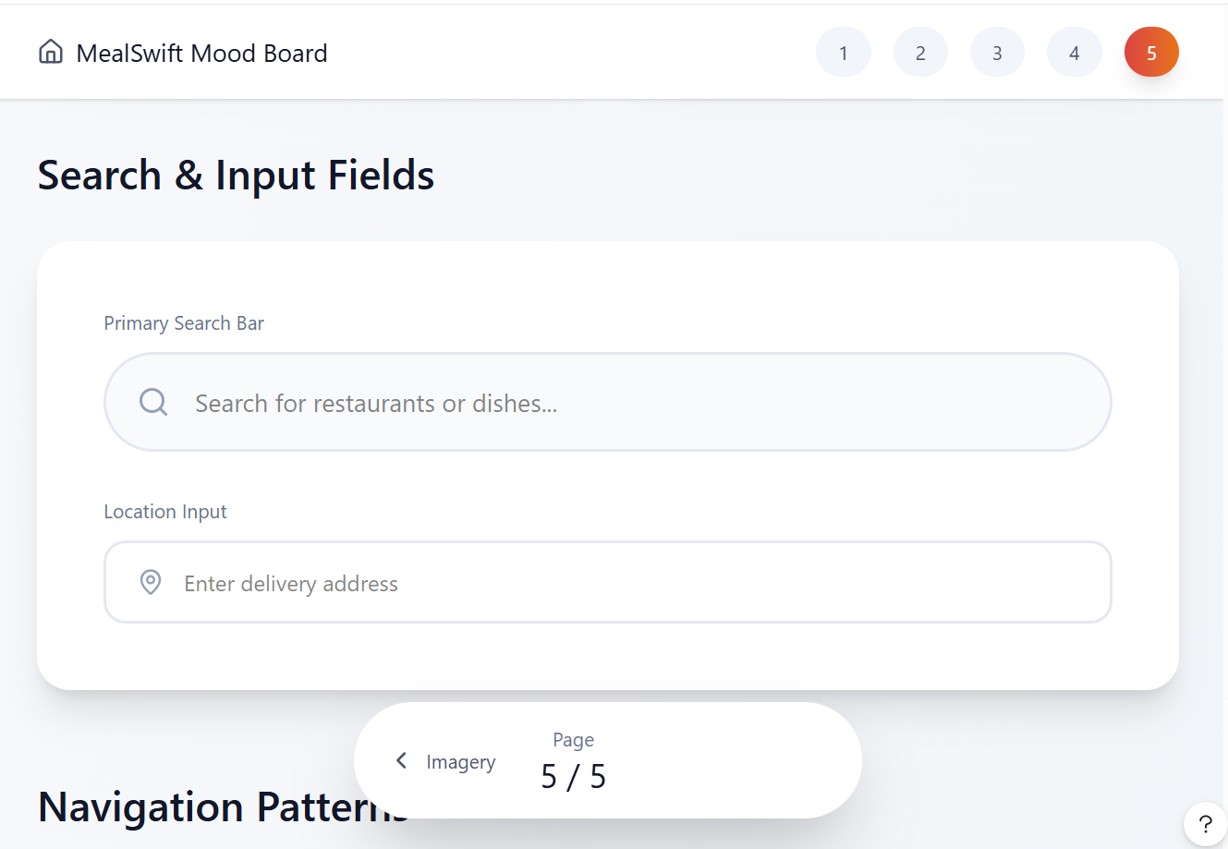
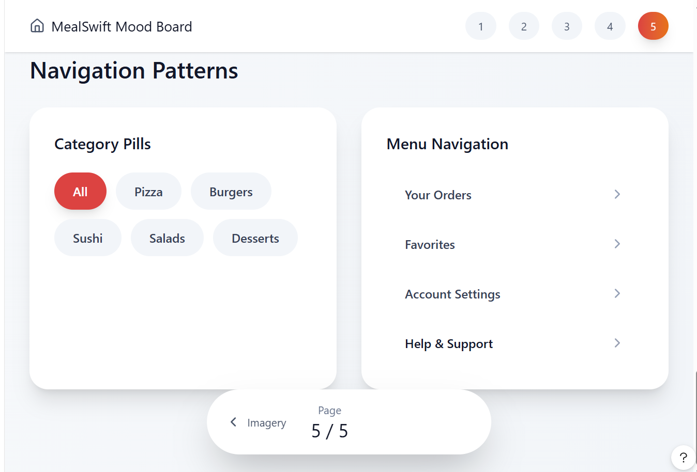
https://www.figma.com/make/l1R706Mk6cpWjp952lse8r/Create-Interactive-Prototype?t=uQ2XsJlZZfEDYo7i-1&preview-route=%2Frestaurants

The Screenshots of Prototype




