Electrical & Electronic Engineering

Analysis of an rlc network
Electrical Engineering
Rebecca Coles
2218001
Table of Contents
Abstract 2
Introduction 2
Method 2
Results 4
Discussion 6
Conclusion 8
References 9

Abstract
Within this report we were required to build an RLC circuit in Proteus. After building this circuit we would then be able to see phase difference before and after power factor correction (PFC) once plotting the data onto a graph. We could also calculate active, reactive and apparent power, Power factor, along with a capacitor value to correct the power factor of the load to $≥0.95$.
Additional graphs were plotted to see both power factor and phase angle against the capacitor value.

Introduction
This report displays the process of how PFC works on a load. It aims to decrease the power wasted.
An ideal power factor of 1 or close to 1 means when there is little to no power wasted. This would include the voltage and current being in phase. The capacitor would be the resistive component along with the inductor being the reactive component.
The difference between apparent, real and reactive power are.
Apparent Power – Power delivered to a circuit. This combines real and reactive power, this is measured in Volts-amperes.[1]
Real Power – Actual power consumed by a load, measured in Watts.[1]
Reactive Power – Power between the source and the load, not converted into useful work. The reactive components. This is also measured in Volts-amperes.[1]

There are many ways of correcting PFC, these include adding capacitors across the load, balancing the loads across the phases, reducing harmonics and many more. In this concept a RLC circuit is being used with a capacitor connected to improve the PFC. Capacitors can store and release electrical energy. When added into a circuit a capacitor helps balance out any lagging within the load.
However, in some cases the use of capacitors can cause an over correction and resonance issues within the circuit.
If the load was purely resistive then both voltage and current would be in phase and the power factor would be the best, it can. However, any inductive or capacitive pure loads would either be leading or lagging dependant on which one, making the power factor correction lower and resulting in power wastage.
The Graphs below give a clear demonstration of this explanation.

Method
Below a RLC circuit is built in Proteus. An analogue graph was then plotted with voltage of the load to the current of the circuit, before any PFC was added. Refer to Fig.1 below.

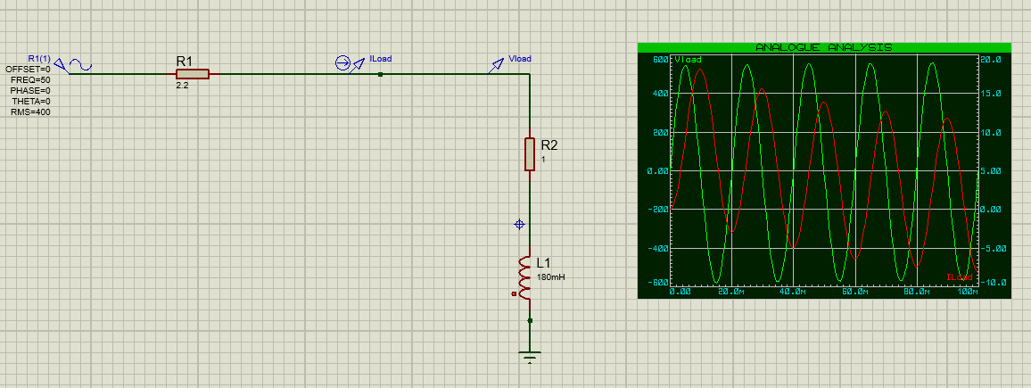
Fig.1

As you can see from the figure, the source resistor is 2.2Ω, load resistor is 1Ω and inductor has a value of 0.180mH. Connected to a 300Vrms, 50Hz sinusoidal source.

The first task in the assignment was to find the Active, Reactive and Apparent power. Below are they equations to each of these powers.

$$Apparant Power=V_{RMS} x I_{RMS}$$

$$Active Power=I^{2} x R$$

$$Reactive Power= I^{2} x X_{L}$$

Next, we had to calculate power factor. This is done by dividing the active and apparent power. Equation shown below.

$$PF= \frac{Active Power}{Apparent Power}$$

Then, we were required to find a suitable capacitor to correct the power factor of the load to $≥0.95$. They equation below was used.

$$C=\frac{1}{2πFX_{c}}$$

A Graph was also plotted showing the power factor against the capacitor value. As shown by the graph it is clear to see how using different size capacitors can affect the power factor on the load.
Additionally, another graph was illustrated showing phase angle against capacitor value.

When Power factors close to one, the energy stored within the capacitor and inductor are oscillated. By equal transfers of energy this causes the circuit to be purely resistive and little to no energy is dissipated. Both components work together in this circuit. The capacitor by storing electrostatic energy and then the inductor by magnetic energy.[3]

Results
The results obtained from the equations above are as follows.

Apparent Power = 1350.410VA
Active Power = 832.781W
Reactive Power = -1063.054VAr

We were then able to calculate the Power factor.
Power Factor = 0.616

Finally, the capacitor value could be calculated to correct the power factor of the load to $≥0.95$.
Capacitor value = 27.9$μF$

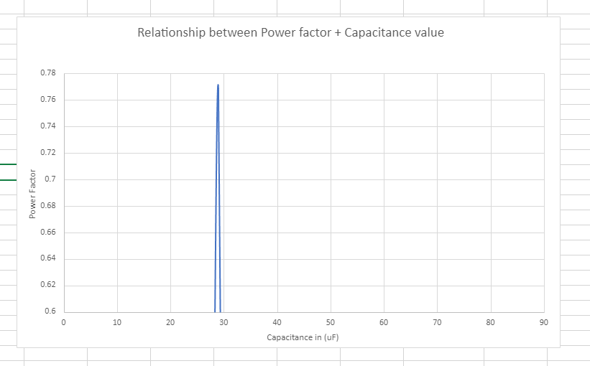

Fig.2

Above in Fig.2 is a graph plotted of Power factor against Capacitor value. This graph shows how different size capacitors can affect the power factor within the RLC circuit.

In the second part to the task, we were required to demonstrate phasor diagrams. This shows the circuit at different frequency points. Each one displaying a different resonance. Firstly Resonance, then 25Hz below resonance, 25Hz above resonance and 50Hz.
The value that was calculated for resonance was 71.02Hz.
Below are phasor diagrams for each of these frequencies.
Resonant (Fig.3), 25Hz below resonance (Fig.4), 25Hz above resonance (Fig.5) and finally 50Hz (Fig.6).

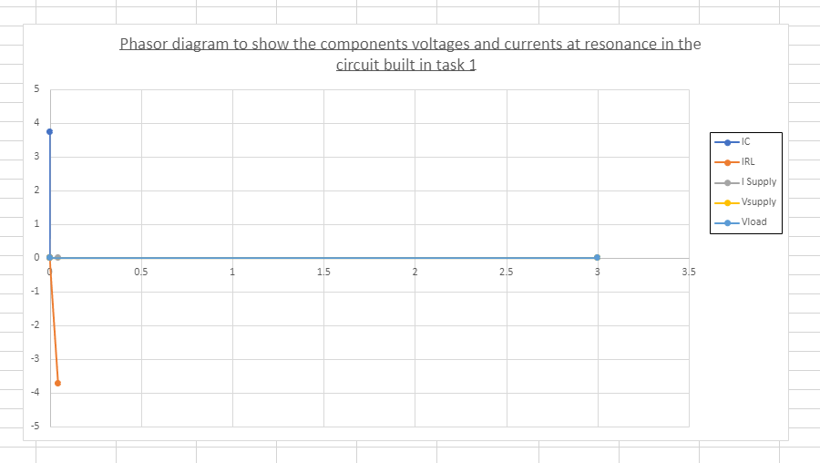

Fig.3
Diagram above shows the circuit at resonance.

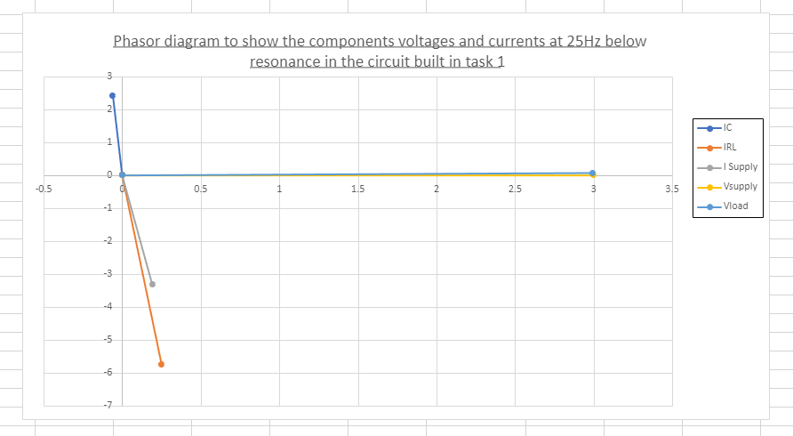

Fig.4
Diagram above shows the circuit 25Hz below resonance.
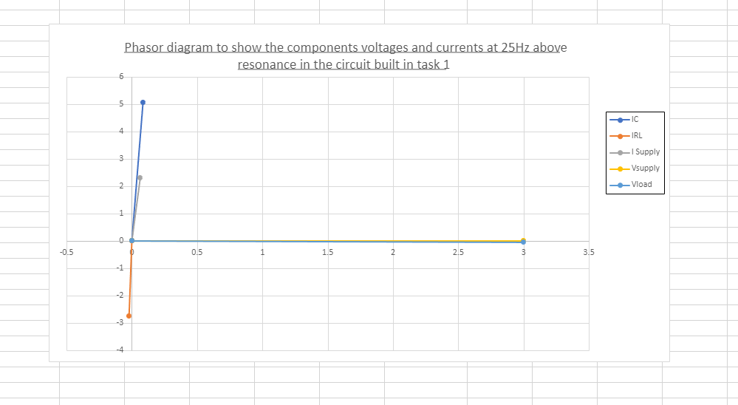
Fig.5
Diagram above shows the circuit 25Hz above resonance.

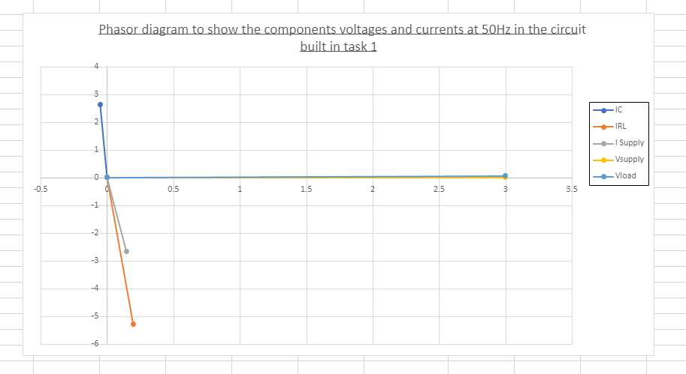
Fig.6
Diagram above shows the circuit at 50Hz.

Discussion
As shown from the first diagram (Fig.1) the voltage is leading the current. This shows this circuit is purely capacitive. It was leading by a considerate amount, -51.92°. We additionally know this is a capacitive circuit as the reactive power calculated would be in the negative values, this indicates the current lagging. We also know this circuit is a capacitive reactance circuit. Capacitive reactance is effectively a negative reactance, this can be used to counteract an inductive load. As shown this is clear to see throughout the graphs and diagrams.
After working out the phase angle of the circuit not including the capacitor the old angle was -51.92°, we then added a capacitor value of 27.9$μF$, to receive a new phase angle of 18.19°.
By doing this it would make the reactive power a smaller value, which gave the circuit a new power factor of $≥0.95$.
As shown in Fig.2 the positive effect the capacitor has on the circuit. Also as shown in the Figure below (Fig.7) the waveforms are closer together which overall improves the power factor of the circuit.
Furthermore, all phasor diagrams shown above with different frequency inputs, whether above or below resonance effect the capacitive reactance in the circuit. When the current within the circuit increases the resonance will increase, however the circuit reaches a point where it is resonant, this is where it drops back off and changes from and inductive to a capacitive circuit. Figure.8 shows a clear example of this happening within the circuit.

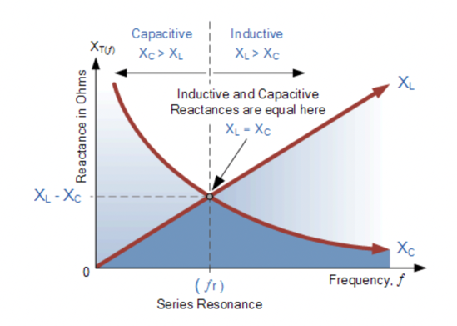

Fig.8

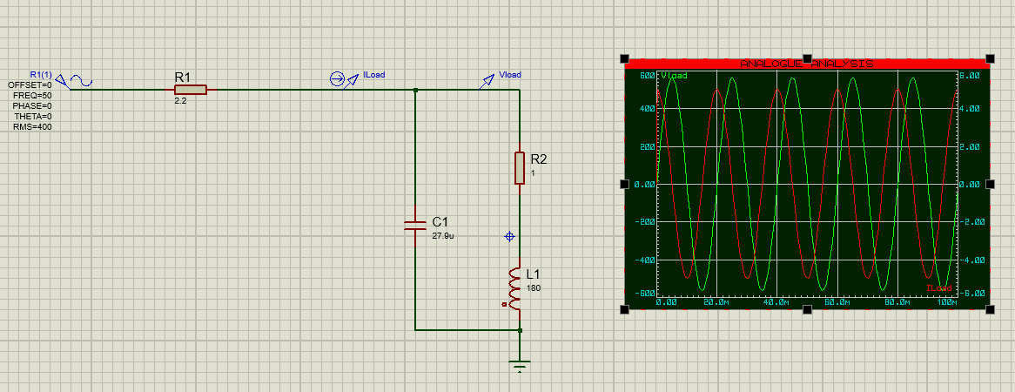
Fig.7

The value calculated to correct the power factor to $≥0.95$ will affect resonance and max power transfer within the circuit.
Power factor and resonance are interrelated in a circuit. A power factor at resonance will cause a purely resistive circuit. However, if the power factor is low at resonance, which in theory would be lagging, this can result in increased current. The importance of power factor in the circuit would avoid any resonant issues.
To add to this if the capacitor value was calculated too high it would affect the max power transferred. This would make the circuit a pure capacitive circuit, making the reactive power high. The max power transferred is when the impedance of the source and load are equal to one another. Calculating too low of a capacitor would make the resistance not equal to one another, leading to a low max power transfer within the circuit.

Conclusion
On completion of this task, it is now clear to see choosing the correct size capacitor for a RLC circuit is important. It not only has an effect of correcting the power factor, but it also plays a role in how a circuit would react and what output of power is given.
On the other hand, it has also given an insight into the importance of using a capacitor within the circuit. By doing this it has given a power factor of $≥0.95$ which in theory gives little to no waste on power output.
Next time an inductor could be added into the circuit, this could help change the circuit from a purely capacitive circuit which is ensuring the maximum power is transferred.

With all factors taken into consideration and correct components used it is possible to have a circuit with an efficient power factor and the maximum power transferred. This project along with evidence, graphs and diagrams clearly backs this evidence.

References
[1] S.Jacob, Power Factor Correction - 2022
[2] https://www.omega.com/en-us/resources/thermocouple-hub
[3] J. K. a. I. S. E.Hughes, “Oscillation of energy at resonance,” in Hughes electrical & electronic technology, Harlow: Pearson, 2016, p. 309.

