Task 1a: IEEE Referencing and Academic & Employability skills

A few of the many Academic skills include, Planning (Organisation & Time management), Communication, Self-discipline, and self-motivation. Being effective with time management means prioritising tasks to get a better understanding of which ones are more important or need completing first. This helps with the organisation by creating a to-do list in priority order. [1]

Effective communication skills give someone the ability to clearly explain a message in a way that fully explains the meaning of what is being said. This allows the people involved to feel understood and heard. When people are stressed, this may cause the communication to become skewed in a way that the other person may take the meaning in the wrong way or feel negative about the situation. [2]

Motivation is often explained as the ‘why’ behind the goal at hand. Motivation can be the initial kick start in the inspiration and goes hand in hand with discipline. When you may feel like procrastinating, self-discipline keeps you in check and puts you on the right path to continue doing what you should be and complete the goat set out. [3]

Employability skills include things such as Reliability, Teamwork, flexibility, agility, and change.
Reliability plays a huge part in employment. This shows the employer that you can consistently complete tasks on time at a high quality with minimal mistakes. Combined with good teamwork skills, this helps harmonise with colleagues to achieve a shared goal. This is also desirable as it contributes to overall company performance. [4]
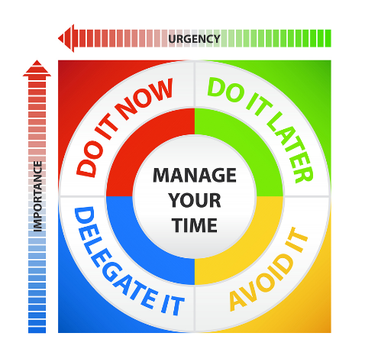

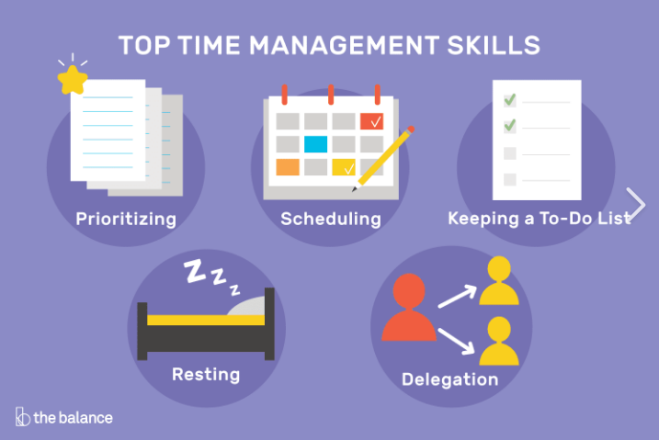

References
[1] Anonymous (). 7 Essential Time Management Skills. Available: https://www.coursera.org/articles/time-management-skills [Accessed Jun 13, 2023].
[2] Anonymous (). Effective Communication - HelpGuide.org. Available: https://www.helpguide.org/articles/relationships-communication/effective-communication.htm [Accessed Jun 13, 2023].
[3] Anonymous "Discipline vs. Motivation," Available: https://sourcesofinsight.com/discipline-vs-motivation/.
[4] Anonymous (). Employability Skills: 10 Examples of Skills Companies Value | Indeed.com. Available: https://www.indeed.com/career-advice/finding-a-job/employability-skills [Accessed Jun 13, 2023].

