Name of student
Student id
Name of professor
Name of course
Course code
Date

Scenario: (DS2 – BrightTech Repairs)

Table of Contents
Decision & Iteration Log (DS2 – BrightTech Repairs) 3
1. Why I chose my tool 3
2. What information I used 3
3. How I created my artefact 3
4. What changes I made 4
5. Feedback I used 4
6. Final explanation 4
References 5

Decision & Iteration Log (DS2 – BrightTech Repairs)

1. Why I chose my tool
I opted for Microsoft EXCEL as it is simple and an effective tool to work with numbers and to organise data. On BrightTech Repairs I was provided with details about various repairs including screen replacement, battery replacement and water damage repair.
The reason I like excel is being able to enter data into table format, and having it calculate automatically and being able to easily compare the different categories. This allows the manager the quickest look at the repair data, without having to read raw data.
In actual companies, too, Excel is used to record work and take decisions regarding data. Microsoft claims that Excel is meant for users to clear up data, analyse it and visualize it in a logical manner (Microsoft, 2024). Excel is a popular tool for businesses to analyse data, produce reports, and even visualise trends through charts (Chandoo, 2023). This goes towards my selection of tool in this task.

2. What information I used
I used the repair data from BrightTech Repairs. This included three main types of repairs:
- Screen replacements
- Battery changes
- Water damage fixes
This data was put in a table to enable me to total up the number of each type of repair. This allowed me to make comparisons on the frequency of different types of repair that occurred and was able to see trends in the information.

3. How I created my artefact
First, I began to put all the repair information into an excel spreadsheet, and set things up into a nice neat table.
Then I simply employed some basic Excel formulas to give me the number of each type of repair. This helped to speed up the process and minimize errors.
Thereafter I made a bar chart to ensure a visual comparison of the types of repair. This allowed one to easily determine which repair type occurred the most frequently.
According to Microsoft, creating charts in Excel can assist the user to comprehend the data rapidly and 'visually' (Microsoft, 2023). This is why I worked using an outline graph in my work.
Lastly, I verified all of the calculations and formatting that it was correct and easy to read.

4. What changes I made
Initially my spreadsheet was not well structured and I now added some headings and structuring to it.
I also changed formatting throughout to be consistent; using the same formatting for each repair type. This allowed the data to be more easily understood.
Not very clear, so I changed my first chart to a bar chart so that it's easier to make comparisons.
I also created a Totals column for each repair type to be able to easily view the total number of repairs made of each type.

5. Feedback I used
Feedback was given about the table and how it could be improved – it was said that the table was not well organised and was not well formatted. I tweaked the spacing and layout of it making it easier to read.
I was also told that my chart labels were not clear, so that was changed too with a larger font size for all labels so that they are more clear.
This feedback enabled me to improve my final artefact to be more professional and understandable about a business user.

6. Final explanation
This artefact illustrates the way Excel can be utilised in an easy-to-understand manner to organise and analyse business data. It's useful for BrightTech Repairs to learn about their repair activity for each month.
Of the repairs I did, changing screens was the most frequent repair. Its clear this is what customers care about the most, issues with damage to the screen.
Working with excel, I was able to compile information from the raw data overall. It gave me tools to sum up totals, compare the categories and to display the results visually, thus aiding in better business decisions.

References
Chandoo (2023) Why Excel is used in business data analysis. Available at: https://chandoo.org
Microsoft (2023) Create a chart in Excel. Available at: https://support.microsoft.com/en-us/excel/get-started/create-a-chart-from-start-to-finish
Microsoft (2024) What is Excel? Overview and features. Available at: https://support.microsoft.com/excel

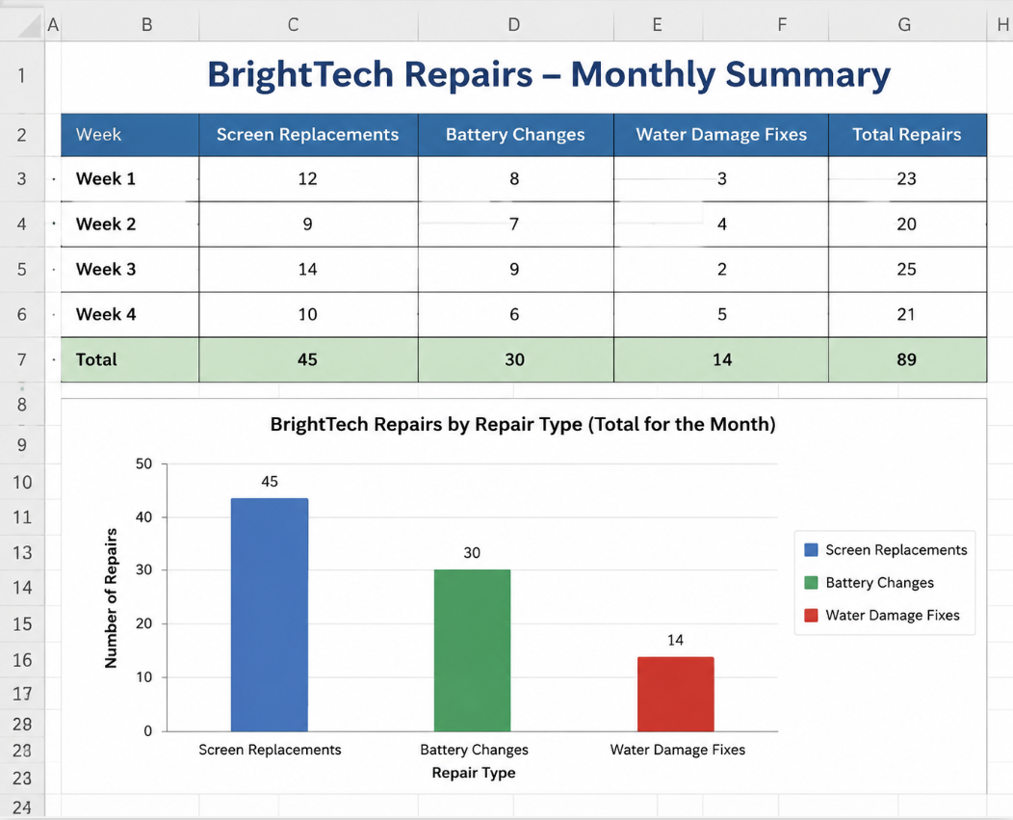
Source: Created by me (Screenshot from Excel)

