Student name: Ivascu Ana
Student number:2239390
Module code: BMIH5006
Lecturer: Kathryn Roberts
Assessment Component 2
Assignment Title: Report

I confirm that I have not used any AI tools in the research and creation of this
assignment. I confirm that I have not presented any AI generated materials as my own
work. I confirm I have copies of my drafts, notes, and other resources I used, which I may be asked to provide in evidence.

Table of Contents

Component 2: Report 3
Summary 3
Introduction 4
Solar-Powered Vehicles as Transportation in the Hospitality Sector 5
Solar-Powered Vehicles in the UK Hospitality Sector 6
Impacts of Solar-Powered Vehicles on Environment and Community 7
Further Development Strategies of Solar-Powered Vehicles in the UK Hospitality Sector 8
Cost Effectiveness and Realistic Approaches of Solar-Powered Vehicles 9
How the Improvements Will Benefit the Environment 9
Conclusion and Recommendations 10
Recommendations 10
References 11

Summary
Solar vehicles have increased their acceptance among users in different fields. Just like other sectors, the travelling and hospitality sector is also sensitive to sustainability concerns. With different initiatives and practices, solar vehicles can easily overcome societal as well as environmental issues and obtain long-term benefits accordingly. This study identified solar vehicles as the most effective and worthwhile plan for conducting sustainable approaches in the tourism sector. This study utilised different perspectives and scholarly opinions to understand the impact of solar vehicles in industrial areas and the possible benefits accordingly.

Introduction
The service offered to make it easier for visitors to travel to different areas in hospitality areas is identified as Hospitality Transport (Deloitte et al. 2021). Due to the development of sustainability practices in hospitality areas, transportation in this sector becoming eco-friendly. Different types of transportation modes are popular in the hospitality sector like rail services, road transportation, marine transportation, air transportation, hybrid transportation and others. Most of these transport systems emit CO2 which causes environmental pollution. Instead of traditional fuel-based transportation, hospitality companies, governments and visitors are showing their interest in sustainable transportation systems. Though electric vehicles are very costly, many hospitality services are leaning towards sustainability practrices by considering solar-powered vehicles. Moreover, it has been also identified that solar-powered vehicles can offer seamless services which are equally eligible to traditional, fuel-based vehicles (Kanwal et al. 2024). The energy consumption levels of solar-powered vehicles are comparatively lower than conventional vehicles and they emit zero carbon in the environment. In the UK, in the last 10 years, the popularity of solar-powered vehicles has increased significantly. It denotes the transition of transportation modes towards sustainability in the hospitality sector. This study will identify the concept of solar-empowered transportation services, its benefit in the hospitality sector and its impacts on the community landscape accordingly. Moreover, this study will also demonstrate further improvement strategies for this transportation mode and cost-effectiveness with realistic approaches accordingly.
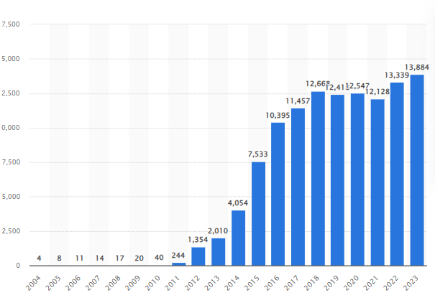
Generation of the Solar Power in the UK
(Source: Statista, 2024)

Solar-Powered Vehicles as Transportation in the Hospitality Sector
According to the research work of Kanwal et al. (2024), it has been identified that solar-powered vehicle is considered an emerging sustainable transportation mode in the hospitality sector to meet the environmental responsibilities of the industry. Instead of conventional fuel-based vehicles, these emerging vehicles are increasing their acceptance in the market by promoting several sustainable approaches like carbon-free running, minimal waste production and also energy-efficient services. Based on the report of Market US, it is expected that by 2032, the global solar-power vehicles market will reach $ 2543 million (Market.us, 2023). On the other side, it has been also identified that due to a large volume of sustainability benefits, companies in the hospitality sector highly adopt solar-powered vehicles for their customer-service operations. In comparison to electric vehicles, solar vehicles are more accepted because of their lower installation and maintenance costs. Currently, different hospitality companies in the UK collaborate with transportation services to provide eco-friendly solar-powered transportation to maintain their sustainability approaches.
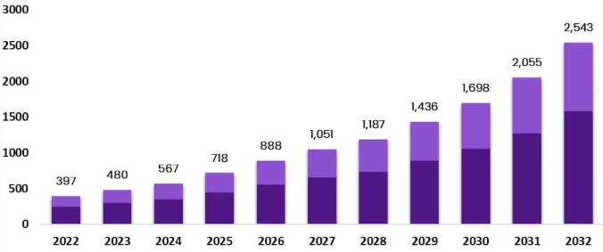
Increase of Global Solar-Empowered Vehicles
(Source: Market.us, 2023)

Solar-Powered Vehicles in the UK Hospitality Sector
In the hospitality sector of the UK economy, the operations of solar-powered automobiles incorporate sustainable transportation systems without harming environmental balance and conduct zero carbon emissions. These vehicles are generated by photovoltaic panels that are mounted on cars and charging stations. Based on the perspective of Arafa and Eltobgy (2021), it can be said that by using solar power to generate electricity for engines, these vehicles obsolete their need for fossil-based fuels and reduce greenhouse gas emissions to zero. From the same study, it has been also identified that in the hotel sector, this might entail the proper employment of eco-friendly golf cars and even safari cars for long runs. According to the perspective of Dhar et al. (2024), it has been seen that in current days, many individual vehicle companies develop buses also which are utilised for hospitality and tourism transportation purposes across the UK market.

Impacts of Solar-Powered Vehicles on Environment and Community
According to the research work of Dhar et al. (2024), it can be said that solar-empowered vehicles have a revolutionary impact on social and environmental advantages that support the UK’s sustainable development objectives. It has been also identified that by using sustainable solar energy, these vehicle users do not need to use fossil-based fuels. As a result, the possibility of generating carbon-based emissions is zero. The UK government aims to achieve net-zero goals on carbon emissions by 2050 (Smith et al. 2023). Using solar-based vehicles can help to support this goal from the end of hospitality sectors. On the societal ground, the usage of solar-empowered vehicles can help to achieve sustainable goals for society by considering SDGs. Additionally, based on the research work of Arafa and Eltobgy (2021), it can be said that solar-powered cars have the potential to improve social well-being from the local to national levels. Healthier populations as well as lower healthcare expenses might happen due to fewer cardiovascular and respiratory issues as a result of clear and healthy air. Moreover, it can be also mentioned that the expansion of the popularity of solar vehicles creates job opportunities in manufacturing firms, infrastructural construction areas and maintenance departments which can bring economic opportunities. Solar-powered vehicles will also be beneficial for developing smart tourism projects and green circular economy approaches.
Apart from community-based benefits, solar vehicles are also essential for environmental purposes because these vehicles are totally sustainable and have a deeper impact on eco-friendly approaches. Based on the perspective of Sagaria et al. (2022), due to the possibility of generating 0% carbon-based pollution in the air, these vehicles are highly acceptable in multiple sectors including the tourism sector. The UK government aims to make the country ‘Carbon Free’ by 2050, where the contribution of solar-empowered cars is appreciable (Smith et al. 2023). Especially in the hospitality sector, every year a huge volume of pollution is generated. To overcome these issues and ensure effective support in developing a pollution-free ecosystem, the utilisation of solar cars becomes necessary for the hospitality sector. On the other side, according to the perspective of Stauch (2021), it can be said that just like electric cars, solar vehicles also produce minimal industrial waste every year which is less harmful to the environment. Compared to electric cars, it can be also mentioned that the overall rate of population is lower in solar vehicles because after disposal, lithium-based batteries of electric cars might create soil pollution but solar vehicles have no such possibilities or elements which can create harmful threats for the environment.

Further Development Strategies of Solar-Powered Vehicles in the UK Hospitality Sector
Based on the research work of Stauch (2021), it has been identified that to enhance the benefits of solar-powered vehicles in the UK hospitality sector, companies in this field need to consider several strategies and conduct in-depth analysis accordingly.
- Integrating AI-based Smart Technologies: Due to the enhancement of technologies, companies in different fields increase their performance with smart technologies. To get more intense results, solar-powered vehicles need to integrate AI-based technologies to conduct regular supervision, analysis and operations to maintain the sustainable goals of the industry. Based on the perspective of Krim et al. (2021), it can be said that AI-based smart technologies can help solar vehicles give timely indications before every charge and assist users in maintaining their activities properly.
- Strategic Partnership with Third Parties: Instead of operating solely, tourism companies in the UK economy can make strategic partnerships with third-party service providers in the market. As a result, the overall operations and activities might be supportive and more developed for the entire hospitality sector.
- Expanding Promotional Activities: Enhancing public interest is essential for companies to get more benefits from a new launch. Based on the perspective of Sagaria et al. (2022), it can be said that the hospitality sector of the UK needs to enhance public awareness of solar vehicles through advanced promotional activities. In both digital and conventional platforms, these promotional activities can be conducted for public interest.

Cost Effectiveness and Realistic Approaches of Solar-Powered Vehicles
Solar-powered cars make a strong impact on both societal and environmental areas with a cost-effective approach. Based on the perspective of Arafa and Eltobgy (2021), it can be said that the capacity to capture renewable energy, and solar cars lessens the dependency on costly fuels which eventually lessens the overall operational cost. Due to advanced internal mechanisms, these cars require minimal internal parts in their engine which actually lessens the maintenance cost of these cars. However, the initial costs of these cars are comparatively higher than conventional cars but in the hospitality and tourism sector, these cars are treated as cost-effective and beneficial transportation modes.
Realistic of these cars in the market needs some infrastructural developments. However, the UK government proposes various support to solar vehicle companies to operate their activities in the market. Though the usage of solar vehicles is still limited, it needs to enhance public awareness and competitive cost strategies to attract more customers. So, the implementation of solar cars in the UK hospitality sector is realistic and supportive accordingly.

How the Improvements Will Benefit the Environment
The proposed improvements to that of the solar-powered vehicles, such as that of the process of integrating AI-based technologies, forming strategic partnerships, and improving sustainability metrics, will considerably gain the environment by way of reducing greenhouse fuel emissions, holding assets, and selling easy electricity. AI technologies can optimize electricity intake and routes, lowering unnecessary strength waste and making transportation more efficient. For example, Tesla’s AI-based structures in electric automobiles may be tailored for sun-powered fashions to gain comparable electricity optimization (Dhar et al., 2021). Strategic partnerships, like the collaboration among Mercedes-Benz and Canadian solar panel manufacturers for sun-powered buses, can advance the adoption of these automobiles in the hospitality sector. Enhanced promotional sports will create awareness approximately the environmental benefits, encouraging broader public and industry adoption. For instance, the partnership among Hilton Hotels and solar-powered vehicle companies has established how sustainability tasks can align with hospitality offerings, lowering the sector's carbon footprint. Maintaining sustainability metrics ensures non-stop tracking and improvement of automobile overall performance, reducing waste and improving performance (Leyva et al., 2021) . These advancements now not simplest align with international climate desires, just like the UK’s Net Zero Strategy, but additionally inspire sustainable tourism by means of supplying eco-friendly tour options, keeping herbal habitats, and decreasing air pollutants in traveller-heavy areas.

Conclusion and Recommendations
Solar-powered vehicles are a very much transformative solution for that of the sustainable transportation in the hospitality sector, addressing the urgent want to lessen carbon emissions and energy consumption. Their integration in hospitality offerings no longer most effective blessings the environment but additionally aligns with the developing call for for eco-friendly tour options among purchasers. While demanding situations along with infrastructure limitations persist, non-stop technological improvements and strategic collaborations can overcome these obstacles.

Recommendations
Hospitality companies should invest in that of the AI-based technologies to teh process of optimize energy efficiency as well as the operational costs
Form partnerships with renewable strength vendors to decrease set up fees and extend infrastructure.
Launch centered promotional campaigns to growth cognizance and adoption of sun-powered cars among travelers and stakeholders.
Monitor sustainability metrics to degree and enhance vehicle performance and environmental effect.

References
Market.us, 2023, ‘Global Solar Power Vehicles Market’, available at: https://market.us/report/solar-powered-vehicles-market/ available at: 25-01-2025.
Kanwal, N., Meng, C.S., Watabe, M., Zainal, N. and Siew, J.K.K., 2024. Carbon Footprint of Tourism Activities Including Transportation, Accommodation, and Infrastructure: A Critical Analysis. In The Need for Sustainable Tourism in an Era of Global Climate Change: Pathway to a Greener Future (pp. 95-120). Emerald Publishing Limited.
Arafa, H.F. and Eltobgy, A.E., 2021. The opportunities and challenges of adopting electric and hybrid vehicles in tourism road transportation in Egypt. International Journal of Heritage, Tourism and Hospitality, 15(1), pp.201-212.
Dhar, S., Sadhu, P.K., Chaudhuri, S.R. and Das, S., 2024. Enhancing energy efficiency and cost redemption through solar-powered electric vehicles with induction cooking system for mobile hospitality in India. Clean Technologies and Environmental Policy, pp.1-33.
Smith, A.C., Harrison, P.A., Leach, N.J., Godfray, H.C.J., Hall, J.W., Jones, S.M., Gall, S.S. and Obersteiner, M., 2023. Sustainable pathways towards climate and biodiversity goals in the UK: the importance of managing land-use synergies and trade-offs. Sustainability Science, 18(1), pp.521-538.
Sagaria, S., Duarte, G., Neves, D. and Baptista, P., 2022. Photovoltaic integrated electric vehicles: Assessment of synergies between solar energy, vehicle types and usage patterns. Journal of Cleaner Production, 348, p.131402.
Stauch, A., 2021. Does solar power add value to electric vehicles? An investigation of car-buyers’ willingness to buy product-bundles in Germany. Energy Research & Social Science, 75, p.102006.
Krim, Y., Sechilariu, M. and Locment, F., 2021. PV benefits assessment for PV-powered charging stations for electric vehicles. Applied Sciences, 11(9), p.4127.

