royal mail – change management

Verginica Caracas (1906795)
Leading and Implementing Workplace Change (BMSW6103_SWAN)

Table of Contents
1.0 Introduction 1
2.0 Finding 2
2.1 Royal Mail Background/ Area of Change 2
2.2 Change Models 2
2.3 Leadership- Management of Complex Area 2
2.4 Change Agents 2
2.5 Culture 2
3.0 Conclusion 3
4.0 Recommendations 4
5.0 Appendices 5
6.0 References List 6

1.0 Introduction
Change has become a constant in our lives, being present in our homes and communities, as well as in the workplace. This report was requested by The CEO of Royal Mail GLS. It was written by HRM department, the deadline to be submitted is 18 March 2022.
This factsheet looks at Change Models like Lewin three steps Change Theory (1947), Kotter eight steps Model (1996), and ADKAR, developed by Jeff Hiatt in the 1990s, as well as contemporary trends like Catalyst Initiative`s Theory of Change (2017), an unusual model which starts from the change in Nature, using Nature's strategies.
The report also analyses and evaluates the change management process that happened unexpectedly, in the middle of the pandemic within the Royal Mail, when Rico Back has suddenly resigned from CEO of Royal Mail, and how he was leading the company in Covid-19 crisis, as well as dealing with CWU Union. It describes how Keith Williams, the executive chairman, took responsibilities of a change agent in preparing and engaging Royal Mail employees for the change process.
A variety of resources like articles, blogs, books, and journals are presented in order to support this report.

2.0 Finding

2.1 Royal Mail Background/ Area of Change
Royal Mail is one of the oldest organizations in the world, being established in 1516 as a postal network operating only for the King and the Court until 1635 when the postal service was opened to the general public by Carol I. The name Royal Mail was given by the correspondence coaches in 1784. Royal Mail Group plc is a British multinational company in the transport and logistics sector with the object of activity: postal service and courier. The Royal Mail group has two important segments namely the Royal Mail & Parcelforce Worldwide and the General Logistics Systems (GLS).
Royal Mail Group plc has a total of 158,600 employees, of which 137,300 represent the staff working at Royal Mail & Parcelforce.
Economically, Royal Mail has a positive trend. The results for a full year ended March 28, 2021, show a 16.6% increase in revenue due to a 38.7% increase in parcel revenue which offset the 12.5% decrease in letters. (London Stock Exchange, 2021)
In recent years, Royal Mail has faced major changes from privatization, modernization of communications technology to a strike by the CWU Postal Workers' Union, and a change in leadership in the midst of the Covid pandemic.
A first tool that can help in the process of change is Pestle Analysis because it helps to understand the context for change (CIPD, 2021) and can indicate the direction of change in the business environment. (Appendices, p14)
The COVID-19 pandemic has created a rapidly changing and disruptive situation for organizations and a continuing need to adapt. In addition to the significant impact of the covid pandemic on organizations, other factors of change such as Brexit are creating uncertainty, and technology is leading to a fundamental change in the way businesses operate. It can be seen that the changes listed above which organizations face are due to external factors. Due to the influence of these external factors described in the Pestle analysis, there was a change of management at Royal Mail.
Rico Back was named CEO of Royal Mail after Moya Green in 2018. He has been with the GLS Group for three decades, and resigned in May 2020, after less than two years. Back proposed a transformation plan that would cost Royal Mail £1.8 billion, with the aim of expanding the parcel delivery service due to the increase in online shopping. The unions opposed the threat of a strike on job security, working and employment conditions, and pensions. Rico Back led the company for less than two years, with the results of his term of office failing. Under Back's leadership, Royal Mail's stock has fallen to its lowest level since the business was privatized in 2013. (Sweney, 2020)
It has also been criticized for taking benefits from Royal Mail: £ 6 million "golden salute" when he moved from the European branch to Royal Mail. Employees and the union criticized Back's stay in Switzerland, his country of residence, during the coronavirus outbreak. (Sweney, 2020)
Some managers see the change in organization as having a negative impact on the company, while others see organizational change as the source of success in the organization taking change as an opportunity, not a threat.
Rico Back the CEO of Royal Mail saw the change as a threat, not an opportunity. He decided to resign.
He was replaced in the meantime by the company's chairman, Keith Williams.
The change of management at Royal Mail began with the resignation of Rico Back and the arrival of Keith Williams to lead the company. Williams applied Lewin's Theory of Change.

2.2 Change Models
Change is a movement out of a current state, through a transition state, and to a future state. (Creasey, 2021) In business that means “the act of moving the company from where it is now to where it wants to be.” (Thompson, 2018)
Kurt Lewin was the first researcher to focus on studying change as an essential factor in any organization. Lewin is considered the father of change in management and organizational development highlighting the human aspect of change In 1947 he initiated The three-step change model, these being: Unfreezing, Change and Refreezing.
Over time, in an organization, activities, work environments, products, services naturally become habits and routine.
Unfreezing is an essential stage that seeks to prepare people for change, which means to gain perspective on their daily work and to open up their minds to new possibilities, to understand and follow the change. Understanding the need for change is a way to get people out of their comfort zone and determined them to overcome inertia, as well as to learn new things. At this stage, the leaders of the organizations face the resistance to change of the employees manifested by transfer requests, the decrease of the performance, sometimes even strikes.
Keith Williams' strategy at Royal Mail was focused on people to put an end to the two-year conflict between employees and management, and to normalize the company's business. Williams had a series of meetings with the CWU union representing the interests of postal workers and listening to them what complaints, wishes and expectations do employees have from the management. Approaching an open and honest communication, he managed in less than a year to conclude an agreement with the CWU that paves the way for the focus on parcel deliveries of the postal service to be an urgency and a priority, as well as the technological improvement of the company. (Oliver, 2020) Through the agreement, the employees received salary benefits and a shorter work schedule in appreciation and recognition of their fantastic efforts to keep the country connected during the pandemic. This action has managed to prepare employees for change. The CWU-backed management will explain the change needed for Royal Mail to withstand the fierce competition in the postal service industry and is, according to Lewin's theory, the first step in the change process. As CWU Secretary General Dave Ward said, the agreement was a success, which means that even in challenging times, it is possible to plan for a future that will continue to benefit workers, customers and the company.
In the case of Royal Mail, the strike of the postal workers represented by the CWU union showed resistance to the existing management led by Rico Back, determining the change and becoming a driver for the change of management. The locus of the change imperative was internal, bottom-up due to pressure from the CWU. It can be said that the CWU was a driving force behind Back's resignation.
Change (Transition) step involves a dynamic and time-consuming process and sometimes a transition period. In this time people could feel confusion and uncertainty, everything is new, and the end goal unclear. (Smith, 2019) Change can begin after people are ready and open-minded, ready to take on new tasks. In order to achieve the desired performance after the change, it must be seen from the beginning as an investment not a cost. Implementing change requires time and real support for people such as coaching and training. There must also be a continuous two-way communication that must be direct, simple, and clear.
Refreezing
This stage comes after the change process has been implemented and aims to perpetuate the change. This means monitoring for a set period of compliance with the new rules implemented by change. At this stage, people begin to feel comfortable with the new routines due to the change.
The benefits that Lewin Change Theory has demonstrated are:
- The model is simple and powerful.
- Represents the foundations of later developed theories of change. Even though it has been criticized for its simplicity, this model is still extremely relevant today and is a starting point for other theories of change that have been developed since. (Connelly, 2020)
- Lewin's ideas are based on psychology and the study of teams.
- The model is easy to understand and is successfully applied in change processes.
Because it was criticized as being too simple, other theories were developed that took Lewin's ideas and detailed the three steps. Two such theories are Kotter and ADKAR.
Kotter's model is a model of change in 8 steps:
Creating a sense of urgency to increase attention.
Formation of a guidance team.
Establishing a strategic vision
Attracting volunteers to support the change process.
Identifying barriers and removing them.
Generating short-term benefits.
Supports acceleration.
Permanence of change, no more returns to old routines.
This model is useful by providing a framework to follow and being like a road map becomes easier to apply.
This theory was designed for change management and organizational change.
ADKAR Model of Change
Like Kotter`s Model of change, ADKAR is a change management theory developed in 5 steps:
- Awareness of the need to change
- Desire to support change
- Knowing how to change
- Ability to demonstrate skills and behaviour.
- Reinforcement to make the change sticks.

Catalyst Initiative`s Theory of Change
“Catalyst Initiative`s Theory of Change is less logic model and more DNA; fewer smart goals and more poetry: less return-on-investment calculations and more an act of love.” Catalyst Initiative, 2022) It “is based on a living system framework and uses Nature`s strategies to create a deeper and more meaningful impact.” (Allen, 2022)

2.3 Leadership- Management of Complex Area
As a leader, Keith Williams embraced change, saw it as an improvement in his business, and his appointment as CEO at Royal Mail gave him the opportunity to participate as an agent of change in this process.
The change strategy used by Keith Williams to solve the management problems at Royal Mail was the support of personal and organizational development based on internal consulting, respectively the management team and the specialists within the group. (Moodle UWTSD, 2022) In his brief time as CEO of Royal Mail, Williams managed to end the postal workers' strike by concluding an agreement with the CWU, which provides certain benefits for employees such as a 3.7% pay rise in two years and reduced working hours. one hour a week. The CWU also accepted the technology improvement plan, which opens a window to modernize and focus on parcel deliveries. Thanks to the confidence and efficient leadership of Keith Williams, the price of a Royal Mail share began to see positive results, increasing by 1.1%.
Resolving the issue of conflict with employees, the change process had to be continued with the appointment of a CEO for the next period who could continue the change process. Less than a month after his success with the CWU Postal Workers' Union, Keith Williams named Simon Thompson CEO of Royal Mail, who has been Non-Executive Director of the Group since 2017. (Dawson, 2021) Williams said that Royal Mail needs to get through this transition period quickly and that Thompson has the required experience in both digital transformation and customer experience, and Royal Mail needs to put the customer at the centre. (Makortoff, 2021) Simon Thompson's previous experience recommends him for this position. He has held senior positions at Ocado, Apple, HSBC, Morrisons and Honda Europe. Thompson had the mission to continue Williams' work to implement the change. He had the task of implementing a recovery and modernization program in the organization that will ensure the future of the service by renewing Royal Mail to focus more on parcels than on letters. He presented a plan to reduce costs by reducing 2,000 management positions in various fields: IT, finance, marketing and sales, keeping postal workers and using temporary work. Royal Mail's willingness to take over the temporary workforce proves the group's desire to innovate and reshape itself.

Good leaders in change use tools, infrastructure, and rewards for an energized environment aligned with change.

2.4 Change Agents
A change agent is “someone who promotes and enables change within any group or organisation,” (Pratt, 2018) and has the responsibility to ensure that the change is successful. According to Swan (2018), a change agent “is a movement that is slowly gathering pace; role that has surfaced through the flux of changing organisational culture and seems to be the solution to bridging the gaps within changing organisational hierarchies.”
The main purpose of a change agent is to work actively to build a culture of acceptance of change among employees.
A first step is to identify people`s reactions to the change if is positive people are supporters they do not resist to the change, and if is negative people are gatekeepers and they manifest resistance to the change. For that, a useful tool is Kubler-Ross Change Curve. (1969)
Kubler-Ross Change Curve describes the 5 stages of grief in any dramatic change in each individual's life that are denial, anger, bargaining, depression, and acceptance. This model began to be used successfully in management change in the 1980s to identify employee emotions and reactions in a simplified three-step setting: shock and denial, anger and depression, and acceptance and integration. (University of Exeter, 2022)
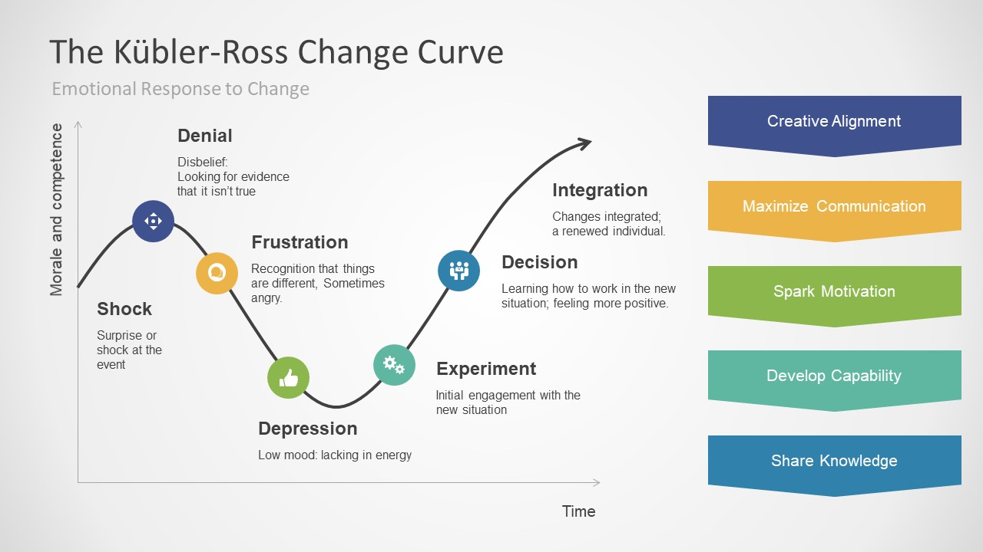
The first reaction to change is usually the shock due mainly to the lack of information and the fear of the unknown or of making mistakes. Immediately after the shock, people tend to deny it. In this first stage, communication is essential. People need to be informed so that they feel safe and aware of the changes that are taking place.
In the second stage, people generally show anger and depression. After the shock and denial, they feel the need to release their fear and point the blame at someone else, a scapegoat. When the anger has passed, depression occurs, representing the lowest point of the curve, at which point morale is low and doubt is high. At this point in the change process, performance is at its lowest level.
In stage 3, people accept that change is inevitable, becoming more confident and optimistic. They become curious about the new, how is working, they learn interesting new things that make them get involved and so the integration begins. At this stage, performance and productivity are timidly beginning to improve. Slowly a new work environment is being created.
It can happen that during the change process there is a return to an earlier stage if no real support is given, and each individual reacts differently to the change.
Kubler-Ross Change Curve helps leaders or change agents in grouping individuals according to their reactions and behaviours in
- Apathetic are disconnected from change.
- Incubators are still thinking about how to approach change.
- Advocates are not the first change, they have experience and become enthusiastic.
People interact with each other in the workplace, and it depends on how many Advocates, Incubators and Apathetic are on the team, because there is a risk that Advocates will slip back to the Apathetic side.
As stated above in the Royal Mail case, Keith Williams took responsibility for being a change agent for change management process. Being from inside the Williams Group, he observed the reactions of the people throughout the strike, knowing their dissatisfaction and conditions accumulated during the time they were led by Back. Thus, he prepared the strategy of rewarding the employees in order to motivate them, being able to conclude an agreement with the CWU union to end the strike. After discussions with Williams and the CWU, the union supports the change because they understand that the change will bring progress, so he became an agent of change, putting his shoulder to the management team to persuade employees to accept the change

2.5 Culture
Understanding an organization's culture is important because:
- ensures a competitive advantage in the business environment.
- determines all employees to share a common goal aligned with the purpose of the organization.
- helps to identify possible gaps between real and desired culture.
- can be a strategic tool for understanding change showing how employees relate to the culture of the organization.
Various models have been developed to describe an organization's culture, such as the Handy Model of Organizational Culture, Hofstede's Six Dimensions of Culture.
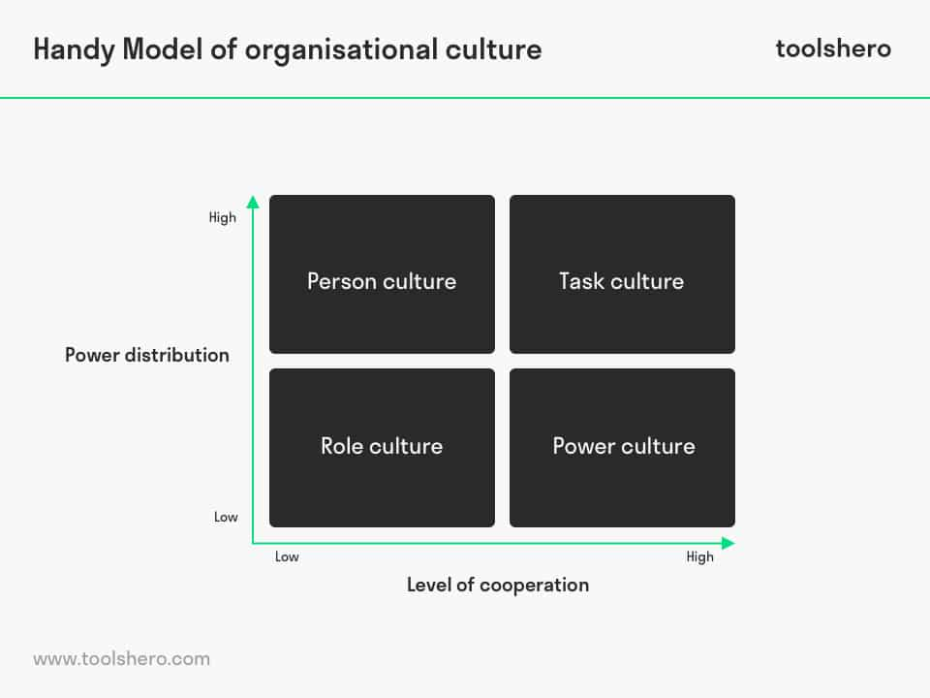
Charles Handy and Roger Harrison identified four types of organizational culture depending on the distribution of power and the level of collaboration in the organization: Role, Power, Person, Task. (Mulder, 2018)
Role Culture it is characterized by a low degree of cooperation as well as a low distribution of power within the organization. There is a clear hierarchy, status is more important than performance and rules and procedures are strict. This type of culture is not the most flexible type in the model. The key words of Role Culture are conservatism, predictability and stability.
Power Culture is characterized by high levels of collaboration and a low distribution of power in the organization. Individual performance is just as important as mutual collaboration. This type of culture is very flexible specific to entrepreneurial organizations led by a charismatic leader.
Person Culture is a culture with a high distribution of power but a low level of cooperation and is representative of professional organizations.
Task Culture is a culture with a high level of cooperation and a large distribution of power in the organization. Employees are professional and problem-solving, and the power is spread throughout the organization. Results are more important than personal needs or strict rules. It is an ideal and change-oriented culture for an organization.
According to Indeed (2022) Organizational Culture at Royal Mail received a rating of 3.8 on a scale of 1 to 5. This rating is given by the organization's employees through reviews, they are: "great place to work", "Royal Mail has an excellent culture "or at the opposite pole:" a culture of couldn`t care less "," favouritism culture ". This means that there are issues that need to be reviewed in the company's culture.
According to the Hardy Model, Royal Mail's culture is of the Role type with a well-established hierarchy and a bureaucratic structure, with strict and clear rules. Employees are accustomed to stability and security as demonstrated by the postal workers' strike. The status of the organization is more important than performance. Royal Mail received 1 million complaints from customers for delays, as well as about 77 postal districts that did not receive regular mail. (Ashcroft, 2022)
At Royal Mail, culture no longer fits the environment of today's postal services industry, with competition requiring a change in culture. In this sense, there are signals such as a customer focus stated by Simon Thompson: "looking to the future, we need to stay focused on the pace of change, to be brilliant for our customers." The restructuring program for 2,000 management positions announced by Thompson is intended to control costs, which has been welcomed by the stock market. It is a signal that Royal Mail is looking for its hierarchy.

3.0 Conclusion
In conclusion, the change of management at Royal Mail was not an easy process, requiring several successive changes in the executive management of the company. The change of leadership with Rico Back proved a failure, and Keith Williams' interim leadership (which also involved the CWU) was more cooperative and paved the way for a new leadership by appointing Simon Thompson. This change seems to be positive, with Thompson implementing a program to reorient the company's culture and a more humane approach to leadership. Models and theories of change, such as Lewin Change Management Model, Kubler-Ross Curve, Hardy`s Culture Model helped to identify deficiencies in the organization allowing management to take appropriate action.

4.0 Recommendations

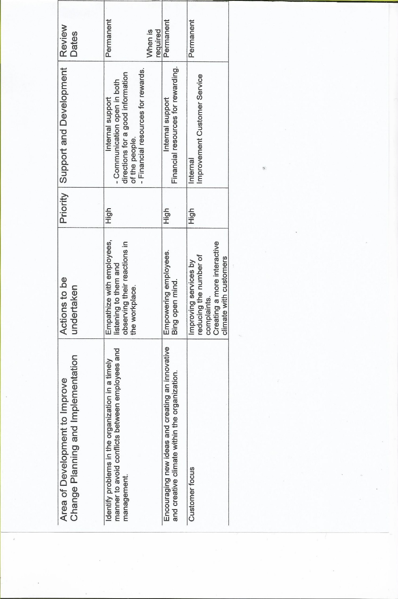

5.0 Appendices

6.0 References List
- Allen, K., (2022) New Theories of Change. Available at: http://www.kathleenallen.net. (Accessed: 8 March 2022)
- Ashcroft, J., (2022) What does Royal Mail`s profit downgrade mean for investors? Available at: http://www.proactiveinvestors.co.uk (Accessed: 15 March 2022)
- Catalyst Initiative, (2022) Evaluation Report 2014-2022. Available at: http://www.catalystnorth.org (Accessed: 9 March 2022)
- CIPD, (2021) PESTLE analysis. Available at:// http://www.cipd.co.uk (Accessed: 9 March 2022)
- Connelly, M., (2020) Kubler-Ross Five Stage Model. Available at: http://www.change-management-coach.com (Accessed: (March 2022)
- Connelly, M., (2020) The Kurt Lewin Change Management Model. Available at: http://www.change-management-coach.com (Accessed: 8 March 2022)
- Creasey, T., (2021) Change vs. Change Management. Available at: http://www.blog.prosci.com (Accessed: 6 March 2022)
- Dawson, C., (2021) Simon Thompson CEO Royal Mail appointed today. Available at: http://www.tamebay.com (Accessed: 9 March 2022)
- Indeed, (2022) Working at Royal Mail Culture. Available at: http://uk.indeed.com (Accessed: 15 March 2022)
- London Stock Exchange, (2021) Full Year Results 2020-21 Royal Mail plc. Available at: http://www.londonstockexchange.com (Accessed: 9 March 2022)
- Markortoff, K., (2021) Royal Mail appoints Simon Thompson as chief executive. Available at: http://www.theguardian.com (Accessed: 12 March 2022)
- Moodle UWTSD, (2022) Leading and Implementing Workplace Change-Change Agents. Available at: http://www.moodle.uwtsd.ac.uk (Accessed: & March 2022)
- Mulder, P., (2018) Handy Model of Organisational Culture. Available at: http://ww.toolshero.com )Accessed: 16 March 2022)
- Oliver, M., (2020) Royal Mail and unions reach an agreement to end two-year dispute over pay and conditions. Available at: http://ww.thisismoney.co.uk (Accessed: 15 January 2022)
- Pratt, M., K., (2018) Change agent (agent of change). Available at: http://www.techtarget.com (Accessed: 7 March 2022)
- Royal Mail Group, (2021) Full Year Results 2020-21. Available at: http://www.royalmailgroup.com (Accessed: 20 January 2022)
- Smith, C., (2019) These are the 3 Best Theories of Change Management. Available at: http://www.change.walkme.com (Accessed: 8 March 2022)
- S&P, (2021) Royal Mail Pls Pestle Analysis. Available at: http://www.swotandpestle.com (Accessed: 9 March 20220
- Swan, S. (2018) What are “change agents” and why are they the future of organisational culture? Available at: http://www.econsultantcy.com (Accessed: 7 March 2022)
- Thompson, J., (2018) The Definition for a Business Change. Available at: http://www.bizfluent.com (Accessed: 6 March 2022)
- University of Exeter, (2022) The Change Curve. Available at: http://www.exeter.ac.uk (Accessed: 10 March 2022)

