

Student Name: VEDANT PATEL

Student ID:2437457

Module Name: International Business Concepts

Module Code: LCMB7034

Lecturer’s Name: Akshay Narayanan (London)

Work Count: 5346

Term 2

Table of Content
1. Introduction 6
2. Benefits and challenges of international operations 7
a. Why Bharat Petroleum (BPCL) can be designated an MNC/TNC 7
b. Nature of BPCL’s global operations across the value chain 9
Research and development (R&D) 10
Sourcing and international trade 11
Production and process capabilities 13
Sales, branding and customer-facing operations 14
Financing and investment trajectory 15
c. Entry modes used across markets (home country, Mexico, and two other countries) 16
Home country (India): predominantly wholly-owned/PSU domestic operations plus network-based distribution 16
Mexico: arm’s-length sourcing/contracting (trade-based entry) and relationship-based engagement 18
United States: tender-based procurement/term contracting (non-equity entry) 19
United Kingdom: strategic relationship/long-term supply partnership (aviation channel) 20
Dominant entry mode (overall): non-equity contractual modes 22
d. Key benefits from BPCL’s international operations 22
3. OLI framework and BPCL’s international market entry into Mexico 25
3.1 Ownership advantages (O) 25
3.2 Location advantages of Mexico (L) 27
3.3 Internalisation advantages and governance choice (I) 29
3.4 Interaction of OLI factors and resulting entry mode 31
4. Cultural Differences and Their Impact on BPCL’s Entry Strategy and Success in Mexico 32
4.1 Hofstede-based cultural distance: India vs Mexico and why it matters 32
4.2 Implications for BPCL’s market entry strategy in Mexico 33
4.2.1 Governance, decision rights and partner selection 33
4.2.2 Entry mode choice: why “low-asset” entry may dominate initially 34
4.2.3 Process discipline and SOP transfer as a success condition 35
4.3 Implications for BPCL’s potential for success after entry 36
4.3.1 Relationship-building vs time horizon mismatch 36
4.3.2 Marketing communication and stakeholder legitimacy 37
4.3.3 Sustainability, social expectations and reputational risk 37
4.3.4 Bottom line: culture shapes “fit” between control and flexibility 39
5. Strategic SOP Adjustments Required for BPCL’s Success in Mexico 39
5.1 SOP Adjustment 1: Risk, compliance, and decision-clarity SOPs aligned with Mexico’s high uncertainty avoidance 39
5.2 SOP Adjustment 2: Relationship-embedded governance and partner-interface SOPs 42
5.3 SOP Adjustment 3: Human, safety, and sustainability SOPs sensitive to cultural and social expectations 44
5.4 Strategic coherence of SOP adjustments with OLI and cultural analysis 48
6. Conclusion 48
References 49

List of Figures
Figure 1: Bharat Petroleum Corporation Limited 6
Figure 2: BPCL Logo 7
Figure 3: BPCL Global Upstream Presence 8
Figure 4: BPCL Corporate R&D Capability 10
Figure 5: BPCL International Trade Operations 11
Figure 6: BPCL U.S. Crude Sourcing 12
Figure 7: BPCL Refinery Value Chain 13
Figure 8: BPCL Value-Added Lubricants 14
Figure 9: BPCL Sustainability and Legitimacy 14
Figure 10: Bharat Petroleum | BPCL - Sales Revenues 15
Figure 11: Wholly-owned/PSU domestic operations 16
Figure 12: BPCL Internal Refining Platform 17
Figure 13: Mexico Maya Crude Exports 18
Figure 14: BPCL Mexico Crude Sourcing 18
Figure 15: Non-Equity Market Entry 19
Figure 16: Strategic Partnership Entry Mode 20
Figure 17: BPCL–British Airways Partnership 21
Figure 18: Supply Cost Optimization 22
Figure 19: International Trade Risk Mitigation 23
Figure 20: Benefits of Strategic Partnerships 23
Figure 21: Sustainable Innovation Orientation 24
Figure 22: OLI framework 25
Figure 23: BPCL Integrated Technology Capabilities 26
Figure 24: BPCL Institutional Ownership Structure 27
Figure 25: Mexico Crude Oil Production 27
Figure 26: Mexico Regional Energy Integration 28
Figure 27: Internalisation vs Market Governance 29
Figure 28: U.S.–Mexico Energy Trade 30
Figure 29: Interaction of OLI factors and resulting entry mode 31
Figure 30: OLI-Based Entry Decision 31
Figure 31: Hofstede Model India and Mexico 32
Figure 32: BPCL Hierarchical Governance Structure 33
Figure 33: Mexico Energy Trade Balance 35
Figure 34: BPCL’s refinery operations 35
Figure 35: Relationship-building vs time horizon mismatch 36
Figure 36: Marketing communication and stakeholder legitimacy 37
Figure 37: Sustainability, social expectations and reputational risk 38
Figure 38: MNC Compliance and Legitimacy 38
Figure 39: Bottom line: culture shapes “fit” between control and flexibility 39
Figure 40: SOP 39
Figure 41: Risk Assessment and Control 40
Figure 42: Escalation Matrix for Risk Control 41
Figure 43: Internalisation Advantages in OLI 42
Figure 44: Mexican Business Culture and Practices 42
Figure 45: Benefits of Partner Relationship Management 43
Figure 46: Benefits Of Trade Agreements 44
Figure 47: Human Sustainability 45
Figure 48: Benefits of Employee Training 46
Figure 49: Ownership advantages 47
Figure 50: Strategic coherence of SOP adjustments with OLI and cultural analysis 48
Figure 51: BPCL Station 48

1. Introduction
Bharat Petroleum Corporation Limited (BPCL) is a leading Indian energy company, increasingly involved in international activities in the form of procurement of crude oil, establishing of trade partnerships and formation of strategic collaborations. The present report takes a close look at the international operations of Bharat Petroleum Corporation Limited (BPCL) with a focus on its interaction with Mexico, a representative emerging economy. This report critically evaluates the benefits and drawbacks of cross-border operations undertaken by BPCL using the Ownership-Location-Internalisation (OLI) framework alongside cultural analysis tools and explains the implications of cultural distance. Especially, the present analysis looks at the way that organisational practice and SoPs influence BPCL's chances of sustainable success in the Mexican context.
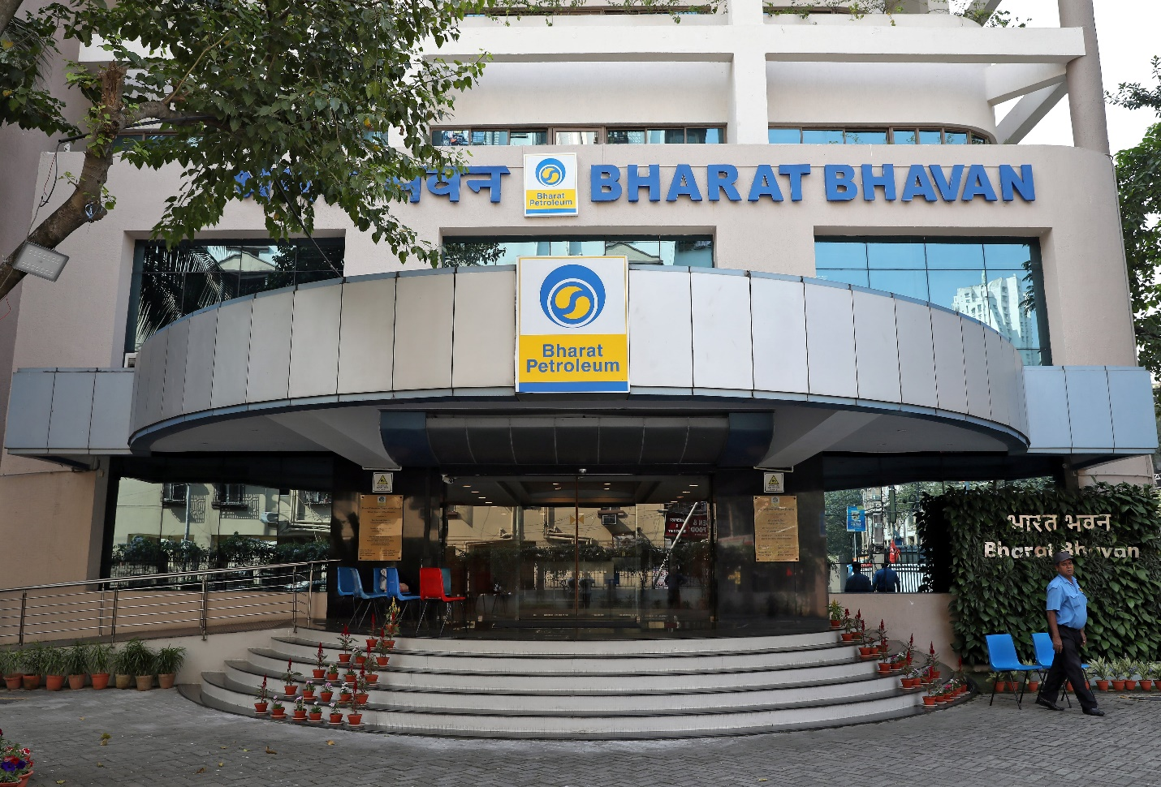
Figure 1: Bharat Petroleum Corporation Limited

2. Benefits and challenges of international operations

a. Why Bharat Petroleum (BPCL) can be designated an MNC/TNC
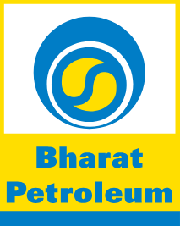
Figure 2: BPCL Logo
The ability of BPCL to engage in cross-border value chain activities not only domestic sales but also international trade linkages, global sourcing and persistent relations with foreign counterparties, which influence its competitiveness and strategic positioning, outside India makes it an MNC/TNC (Bharat Petroleum Corporation Limited, 2025). From a conceptual point of view, multinational corporations (MNCs) and transnational corporations (TNCs) can be distinguished by their contrived operations that cut across several national boundaries and hence giving them the ability to shape and react to the international economic conditions, governance expectations, and stakeholder pressures (Uddin 2025; Muhammed 2021).
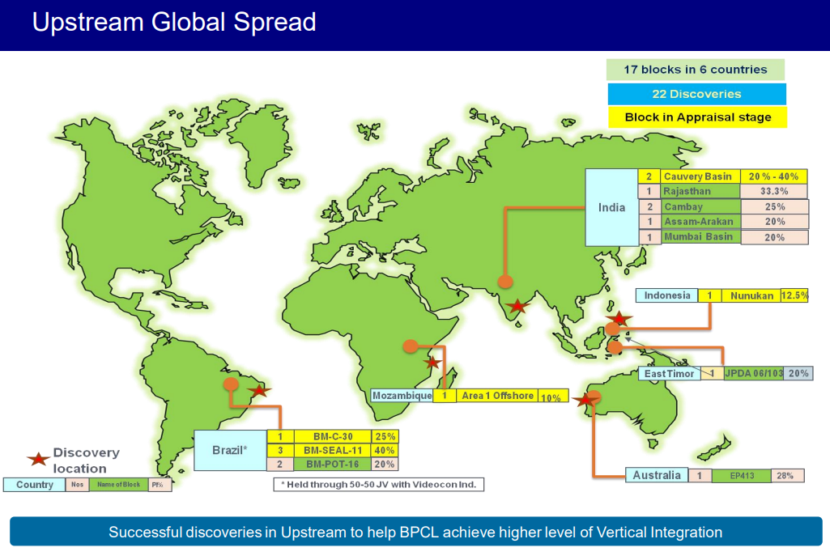
Figure 3: BPCL Global Upstream Presence
The international procurement practices of BPCL, including the organized tender of United States of America crude, as well as participation in the global energy projects along the aviation sector, represent the decision-making process in operation that is sensitive to the changes in the conditions of the International market and the global politics (Verma, 2025; Indian Masterminds, 2025). Furthermore, BPCL's commitments related to National Climate Change Plan and Innovative Approach to Sustainability are grounded in the wider transnational logic of upholding its legitimacy and competitiveness due to the global environmental and governance pressures (Bharat Petroleum Corporation Limited, 2025; Nosova, 2025).

b. Nature of BPCL’s global operations across the value chain
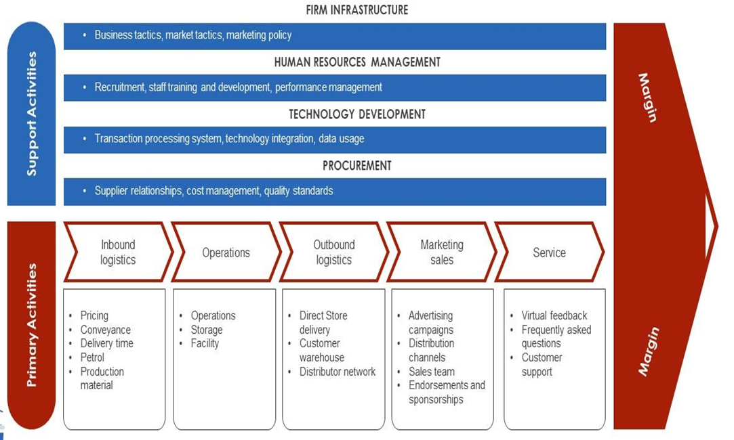
Figure 4:The value chain analysis

Research and development (R&D)
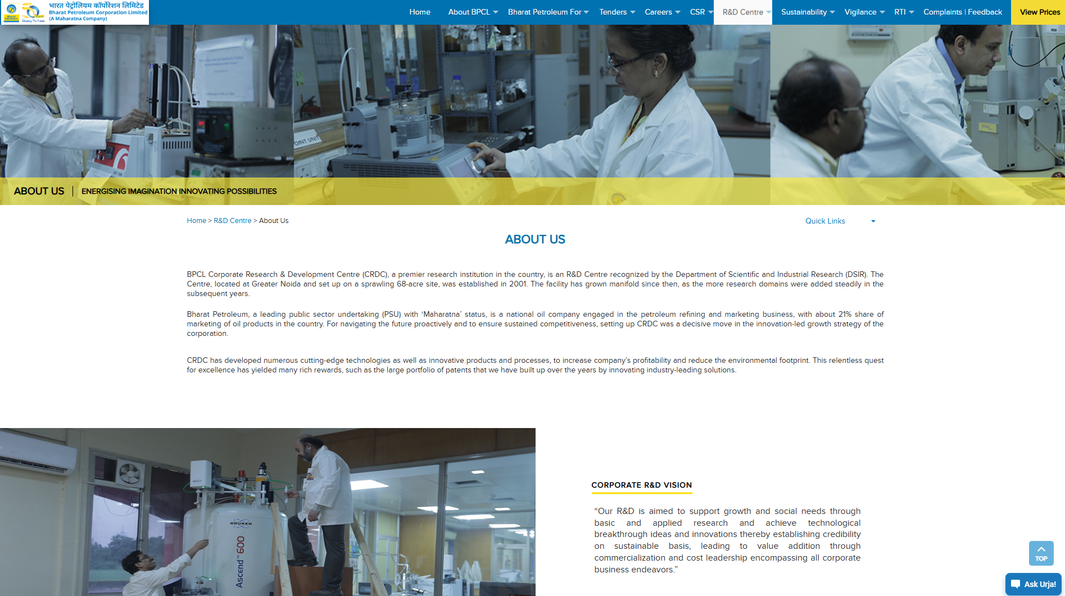
Figure 5: BPCL Corporate R&D Capability
The BPCL Corporation Research and Development Centre (CRDC) is strategically placed as a competitiveness enhancer by the way of applied refining and energy-related research, including alternative energy production, greening hydrogen, and mitigation of carbon dioxide, in addition to the traditional refining operations (Bharat Petroleum Limited, 2025; GlobalData, 2025). The firm represents R&D as the basis of "growth and social needs" along with commercialization and cost leadership, thereby indicating a desire to develop firm specific advantages that can be mobilized in increasingly internationalized energy markets (Bharat Petroleum Corporation Limited, 2025; Kocúrek, 2024).

Sourcing and international trade
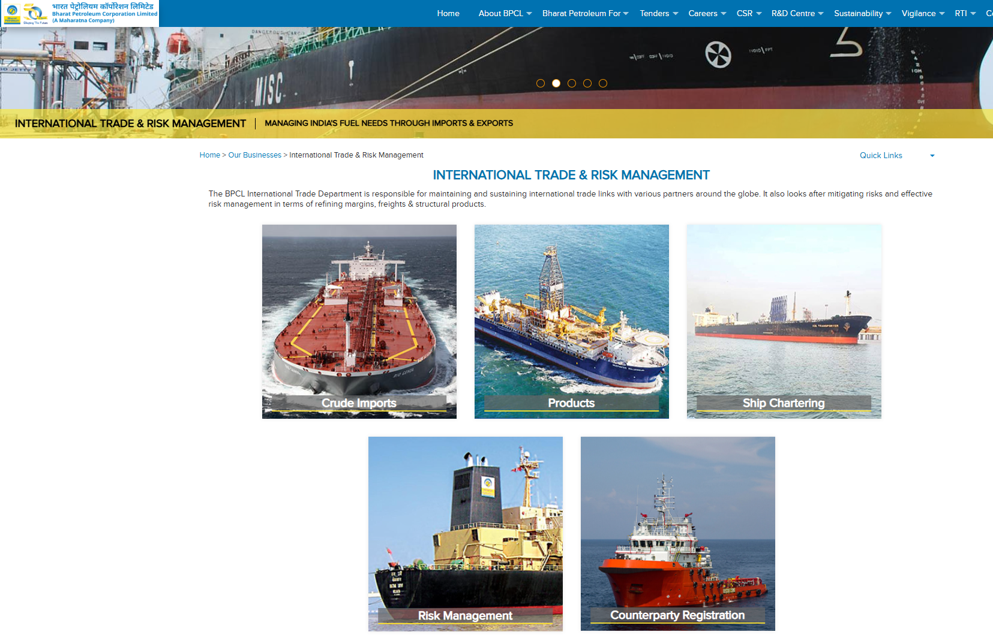
Figure 6: BPCL International Trade Operations
The International Trade and Risk Management division of BPCL directly handles the linkages of an international trade and eliminates the tendency to exposure to risk factors on refining margins, freight, and product transactions of the structure, which exemplifies a specific architecture of cross-country procurement and market-risk governance (Bharat Petroleum Corporation Limited, 2025).
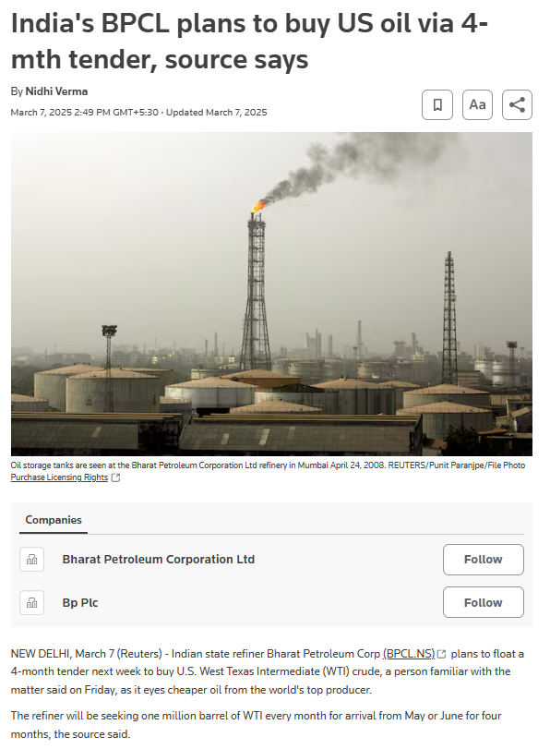
Figure 7: BPCL U.S. Crude Sourcing
As per Reuters report, BPCL is using tender mechanism for purchasing of US West Texas Intermediate (WTI) crude oil specifically one million barrels out of four month on continuous period and these procurement decisions are based on the relative price differentials and changing sanctions and geopolitical factors that limit supply options (Verma, 2025). According to the previous reports, BPCL has been exploring the use of the Maya crude of Mexico as one of its crude sources in its crude sourcing effort and this further highlights the policy of supplier diversification (Reuters, 2018).

Production and process capabilities
Bharat Petroleum Corporation Limited (BPCL) bases its primary downstream system in India on the basis of a network of refineries and process technology units that convert crude oil into a wide range of fractions and fuels (Bharat Petroleum Corporation Limited, 2025; GlobalData, 2025).
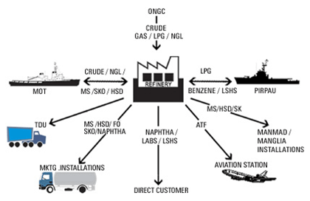
Figure 8: BPCL Refinery Value Chain
The targeted production base interacts with the external environment largely via imported crude supply chains and international product and technology benchmarking as opposed to taking up a wide global manufacturing footprint (Bharat Petroleum Corporation Limited, 2025; GlobalData, 2025).

Sales, branding and customer-facing operations
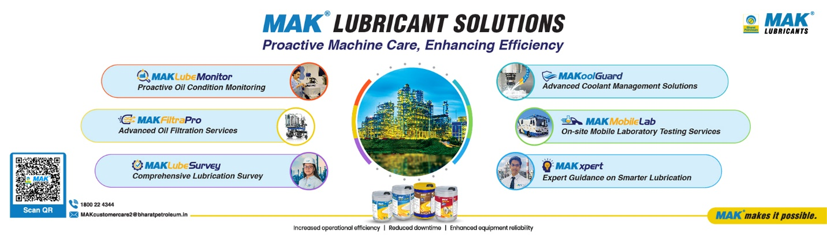
Figure 9: BPCL Value-Added Lubricants
Though the major retail operations of BPCL were concentrated in the domestic market, its commercial operations are linked up with international partners, most importantly in the sphere of provisioning of aviation fuel (GlobalData, 2025). As an example, the long-term relationship with British Airways brings BPCL, to connect the services of the aviation fuel to a recognizable foreign airline and major global aviation conventions, and thus strengthen reputational and relational capital which enhances the positioning internationally (Indian Masterminds, 2025).
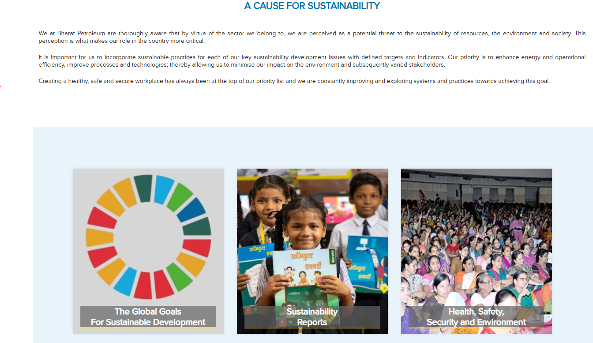
Figure 10: BPCL Sustainability and Legitimacy
BPCL also fits its brand legitimacy within sustainability narratives and reporting which increasingly become enablers of market access in globally scrutinized energy sectors (Bharat Petroleum Corporation Limited, 2025e; Muhammed, 2021).

Financing and investment trajectory
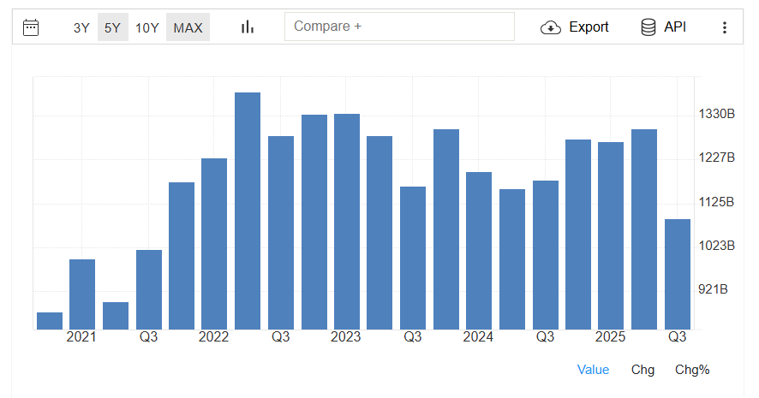
Figure 11: Bharat Petroleum | BPCL - Sales Revenues
The magnitude and investment stance of BPCL, which is manifested through the disclosure of its capital expenditure within the company profile, indicates the ability to mobilise funding to either infrastructure or transition-related investments, whereas the development of international sourcing and risk-management strategies serves to cushion profit margins and stabilises cash flows in the face of changes in the global oil market (GlobalData, 2025; Bharat Petroleum Corporation Limited, 2025). Such coordination is a reflection of an internalization logic, which includes the coordination in the management of cross-border contracting and implementation of risk controls within the firm, thus mitigating uncertainty and reducing transaction costs (Kocúrek, 2024; Schellenberg, Harker, & Jafari, 2017).

c. Entry modes used across markets (home country, Mexico, and two other countries)

Home country (India): predominantly wholly-owned/PSU domestic operations plus network-based distribution
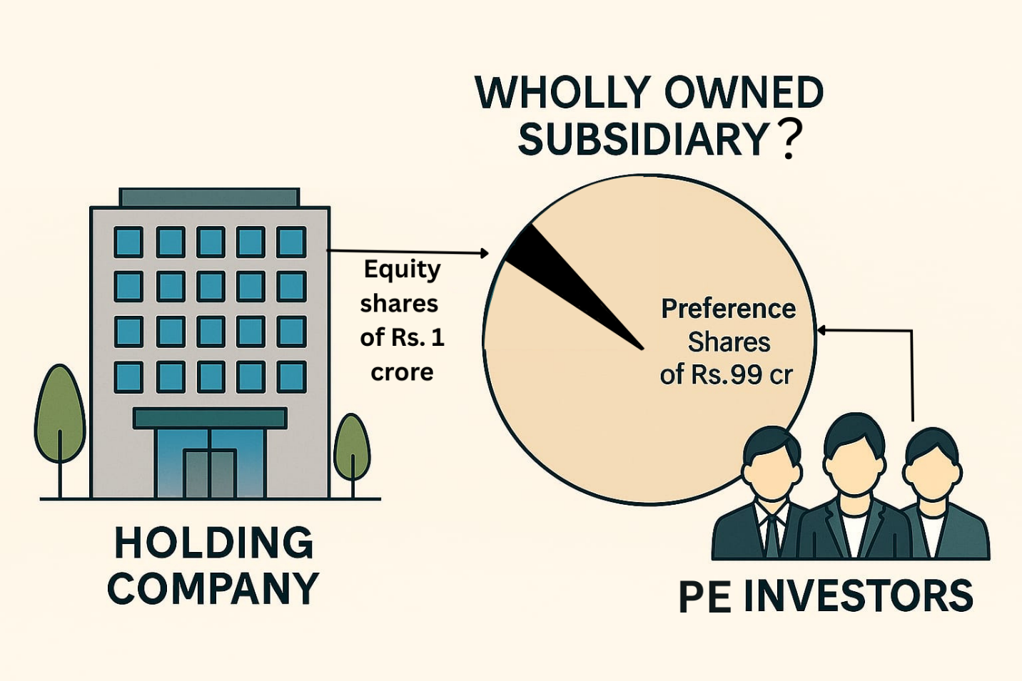
Figure 12: Wholly-owned/PSU domestic operations
In India, BPCL manages its core competencies, that is, the refineries, pipelines, depots, and retail outlets, via a wholly owned and centrally managed downstream channel network, therefore, reflecting the internalization benefits that place more emphasis on reliability, compliance, and scalability (GlobalData, 2025; Kocuk, 2024).
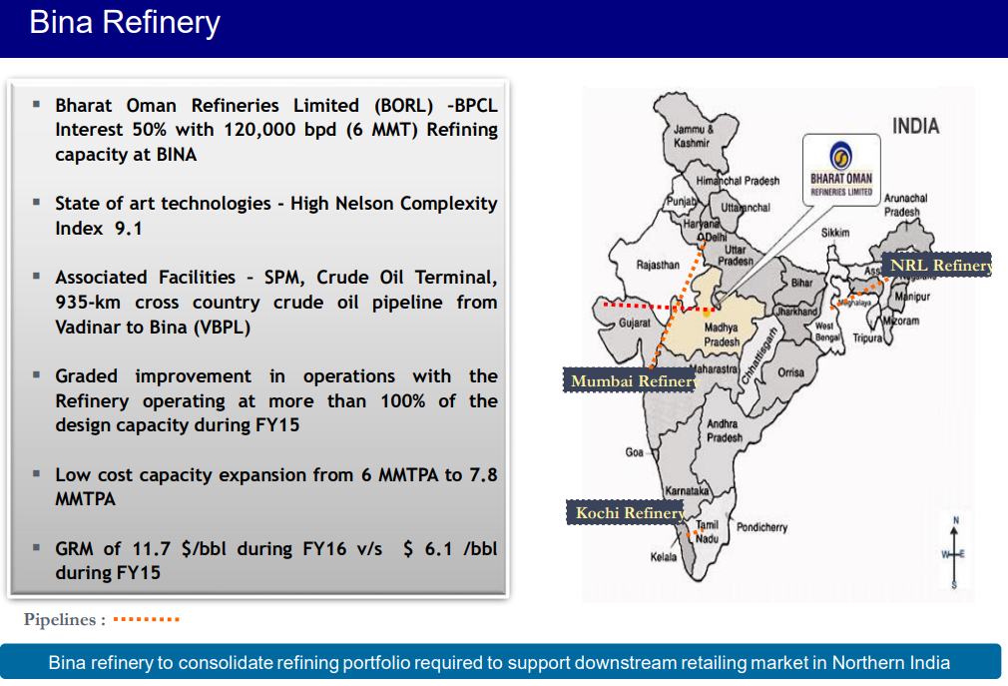
Figure 13: BPCL Internal Refining Platform
This internal mode forms a basic element in quality assurance, operational control systems and this compatibility with the national objects of energy security (Bharat Petroleum Corporation Limited, 2025). Though it is not an entry mode but a foreign country, it operates as a platform that facilitates international interconnection by creating refining capacity and creating demand that leads to import demand of the crude product (Verma, 2025).

Mexico: arm’s-length sourcing/contracting (trade-based entry) and relationship-based engagement
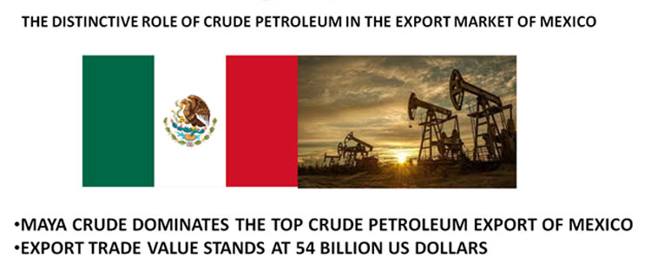
Figure 14: Mexico Maya Crude Exports
BPCL's engagement with Mexico is documented through exploration of sourcing Mexican crude grades (e.g. Maya crude) through commercial procurement discussions as it comprises an arm’s length non-equity contractual market entry into Mexico's upstream supply chain rather than a physical establishment (Reuters, 2018; Divrik, 2023).
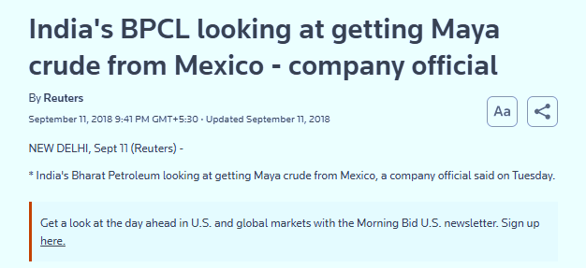
Figure 15: BPCL Mexico Crude Sourcing
Mexico related engagement can also be witnessed in terms of international aviation energy forums held in Mexico, where BPCL has recognised long-term aviation fuel relationships thus emphasizing relationship-building and reputation signaling in global business networks (Indian Masterminds‛25). In the light of market-entry strategy, these modalities are defined by low asset commitment, thus allowing flexibility facing price volatility and policy uncertainty (Wasik 2025; Schellenberg et al., 2017).

United States: tender-based procurement/term contracting (non-equity entry)
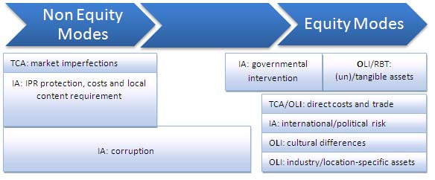
Figure 16: Non-Equity Market Entry
The exposition of the United States by BPCL is in large part done via organized tenders to get crude oil (WTI), which is a classic type of contractual entry into the market by acquisition of ownership interest in the United States supply chains (Verma, 2025). According to Reuters, BPCL plans to buy 1 million barrels per month over four months, which is similar to previous equivalent tenders and shows a pattern of repetition and procedural routine in BPCL's purchasing strategy (Verma, 2025). The observation is consistent with entry-mode theory that suggests that companies can choose a contract relationship when the main goals involve gaining supply access and price benefits, rather than market-serving foreign direct investment (Schellenberg et al., 2017; Divrik, 2023).

United Kingdom: strategic relationship/long-term supply partnership (aviation channel)
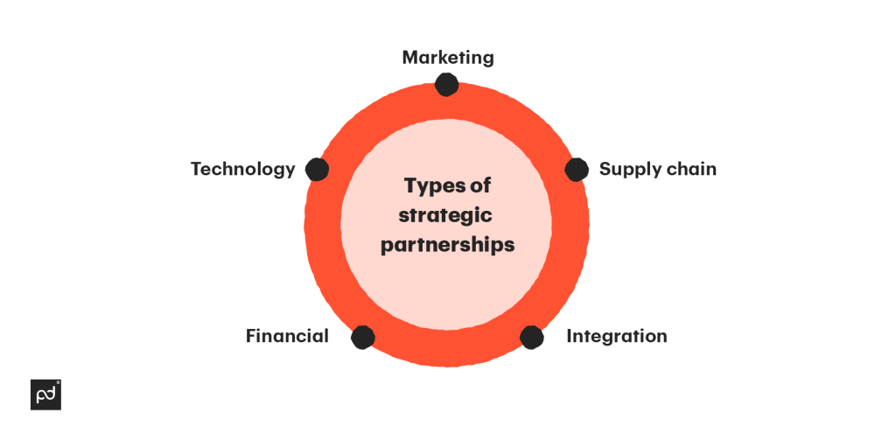
Figure 17: Strategic Partnership Entry Mode
BPCL's link with the United Kingdom is reaffirmed by the long-term relationship with British Airways, the United Kingdom's national flag carrier, in the area of aviation fuel services. This relationship has been made public at an international forum (Indian Masterminds event., 2025). It reflects a relational or strategic partnership paradigm- which guarantees an institutional relationship with customers across national borders- as opposed to the creation of BPCL-owned operations in the United Kingdom (Indian Masterminds, 2025; Herlitah, 2025).
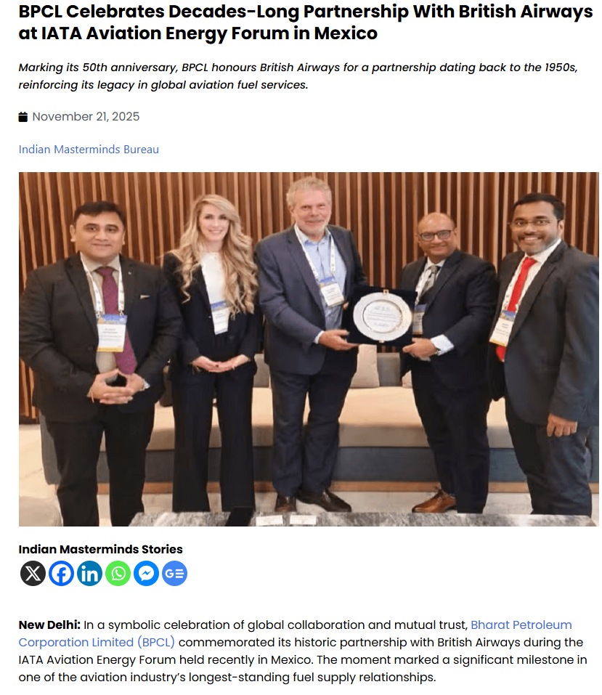
Figure 18: BPCL–British Airways Partnership

Dominant entry mode (overall): non-equity contractual modes
Across Mexico and the United States, and indirectly, via the UK-linked aviation, the international expansion of Bharat Petroleum Corporation Limited (BPCL) can be seen as being mainly composed of non-equity modes, including tenders, contracts and long-term supply arrangements, not to mentions the equity-based foreign direct investment. This pattern is consistent with the risk management priorities and the need for flexibility in the commodity markets (Bharat Petroleum Corporation Limited, 2025; Verma, 2025; Schellenberg et al., 2017).

d. Key benefits from BPCL’s international operations
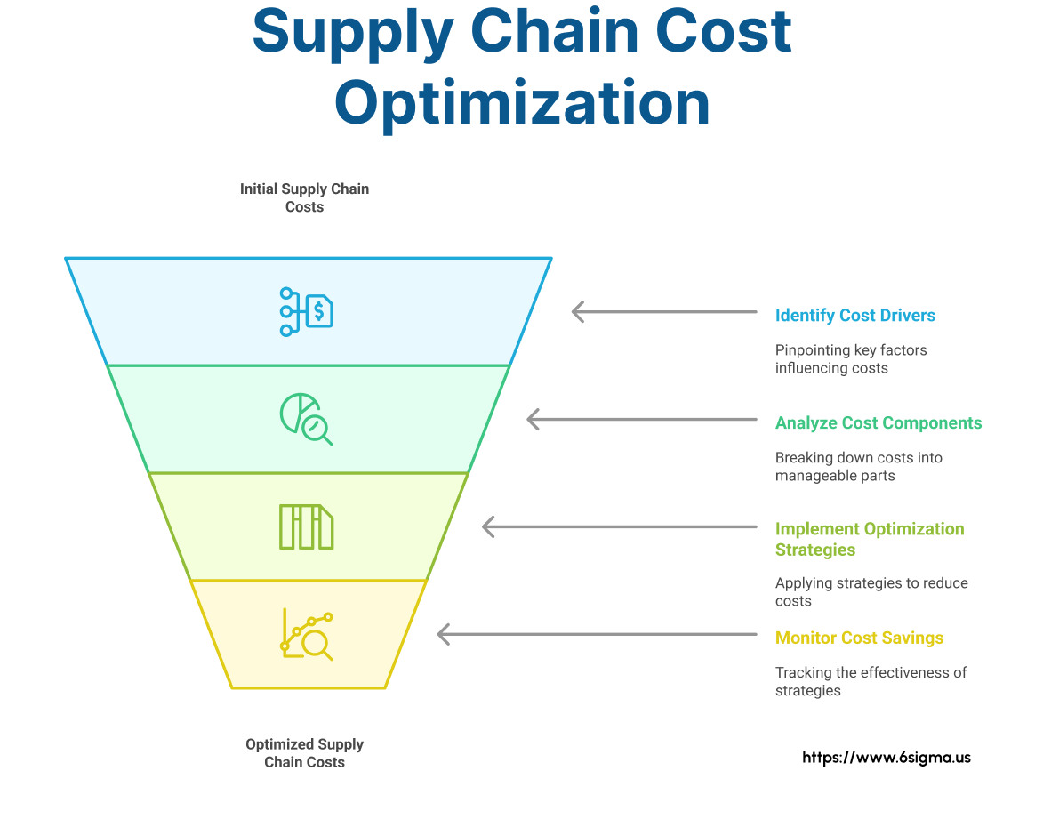
Figure 19: Supply Cost Optimization
Diversifying global sourcing has the benefit of minimizing supply chain and cost optimization, which may help minimize feedstock expenses and minimize dependence on a particular geopolitical route. An example of the ability to take advantage of the global market arbitrage is tender-based procurement of U.S. crude where the situation is favorable (Verma 2025; Bharat Petroleum Corporation Limited 2025).
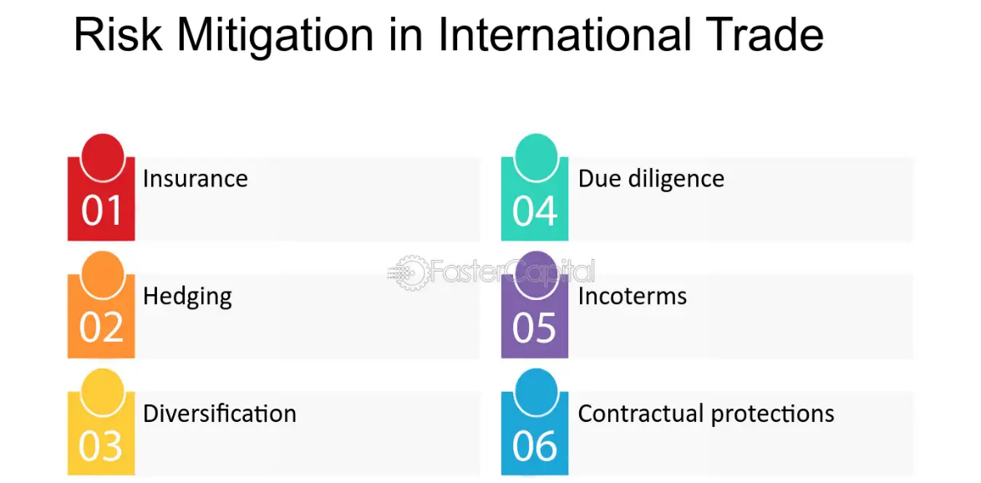
Figure 20: International Trade Risk Mitigation
Second, BPCL successfully risk mitigation by formalization of international trade and risk management procedure involving freight consideration, refining margin and structure product consideration complements resilience against fluctuations of oil prices and supply shocks (Bharat Petroleum Corporation Limited, 2025; Kocuarek 2024).
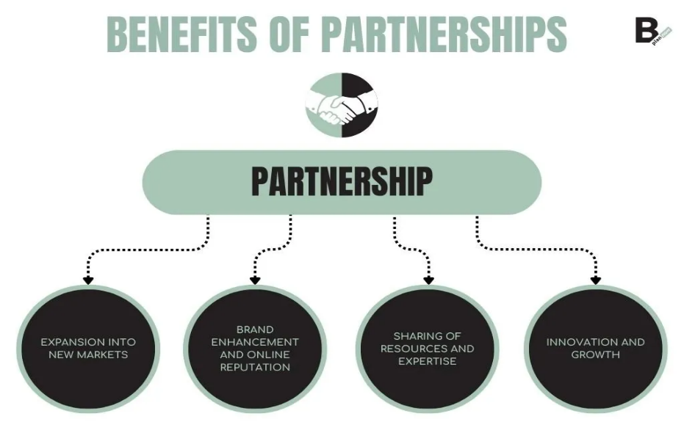
Figure 21: Benefits of Strategic Partnerships
Third, the reputational and relational benefits are created as a result of international relations, especially in the sector of aviation, and this contributes to the increased credibility of BPCL among the global partners and the establishment of long-term demand routes in niche markets, including aviation fuel (Indian Masterminds, 2025; Muhammed, 2021).
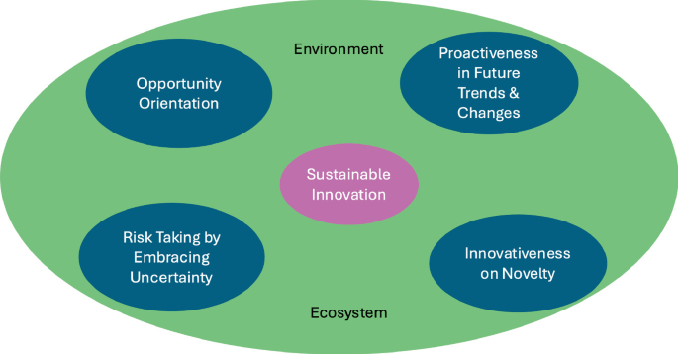
Figure 22: Sustainable Innovation Orientation
Finally, the firm's innovation and sustainability orientation embodied in its CRDC focus areas and sustainability framework are part of the construction of own long-term legitimacy and the building of capabilities in concert with global transition pressures to effectively compete as energy systems change (Bharat Petroleum Corporation Limited, 2025; Nosova, 2025).

3. OLI framework and BPCL’s international market entry into Mexico
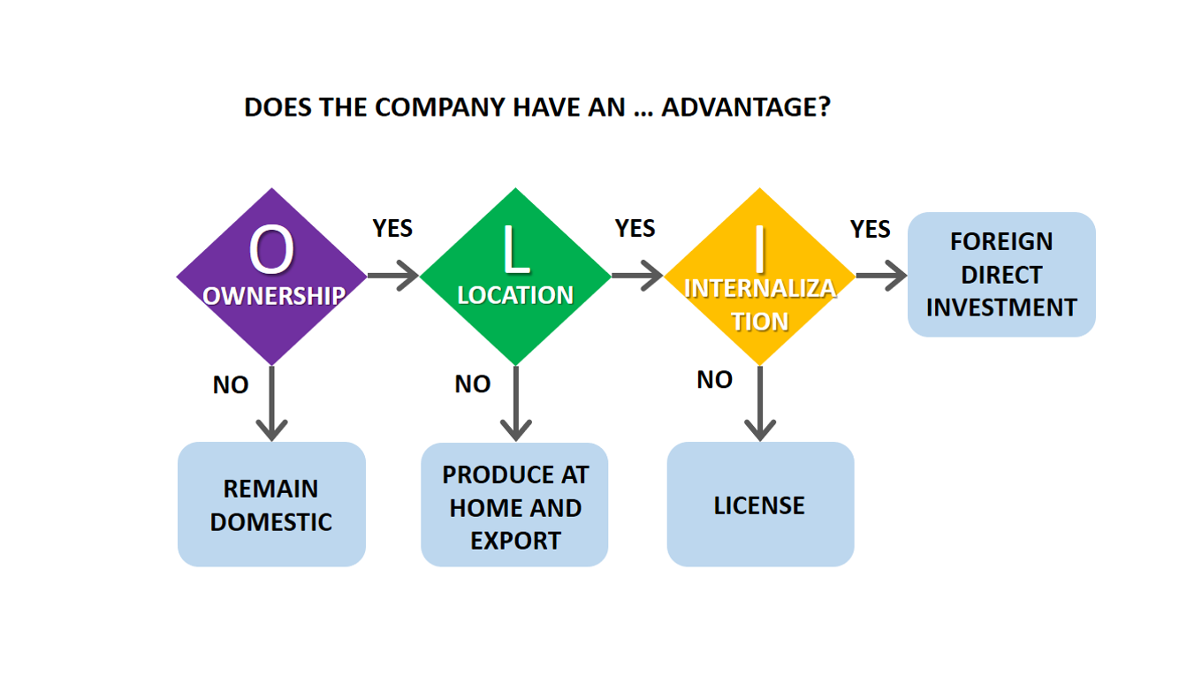
Figure 23: OLI framework

3.1 Ownership advantages (O)
The benefits of ownership of BPCL emerge mainly due to the existence of firm-specific advantages that are developed in the context of the home country and then selectively applied to international activities. As a Maharatna public sector enterprise having decades of experience in refining & marketing BPCL provides advanced expertise in both process and technological refinement, logistics & quality control which is supported by its Corporate Research and Development Centre (CRDC) (Bharat Petroleum Corporation Limited, 2025).
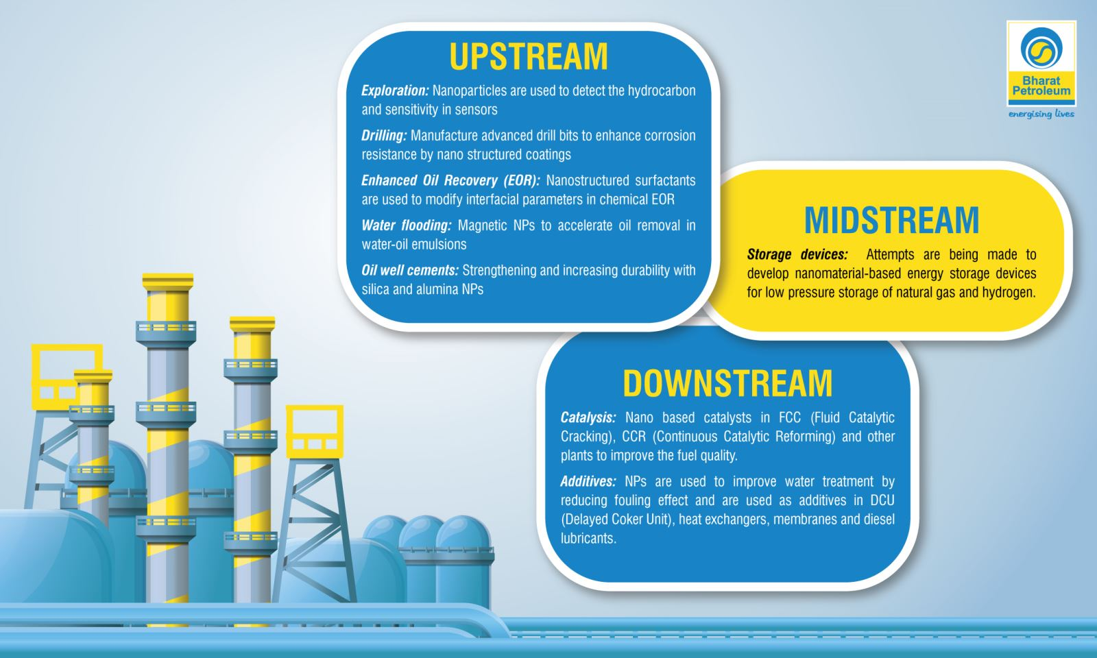
Figure 24: BPCL Integrated Technology Capabilities
The above capabilities grant BPCL the ability to refine a range of crude grades in an efficient manner, which is of critical significance in case of dealing with different suppliers like those located in Mexico producing heavy and sour crudes such as it is with Maya (Reuters, 2018).
Moreover, BPCL's institutional ownership provides advantages such as scale, support from the government and the established credibility in international contracting, which subsequently reduce the counterparty risk of cross-border trade (Uddin, 2025; GlobalData, 2025).
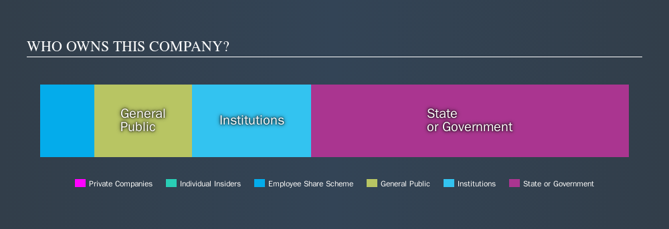
Figure 25: BPCL Institutional Ownership Structure
Its international trade and risk management framework also contributes to the ability of the firm to the turbulent commodity market without the need of major, long-term capital investments in foreign markets (Bharat Petroleum Corporation Limited, 2025). Nevertheless, these ownership advantages are very much focused on operational and transactional measures, and less on brand and consumer focalization, consequently discouraging incentives for market-seeking FDI in Mexico and promoting more trade-based engagement (Nosova, 2025).

3.2 Location advantages of Mexico (L)
Mexico has been granting BPCL intense location-specific benefits especially when analyzed through the resource selection perspective. The country forms an important producer of crude oil where established offshore tank reserves in the country and the ongoing relevance in the global oil and gas market (Trading Economics, 2025; Technavio, 2025). The Mexican crude grades such as the Mayas grade are well suited to the refining setup at BPCL, and hence makes Mexico through the crude more attractive as a source of crude and less attractive as a consumer market (Reuters, 2018).
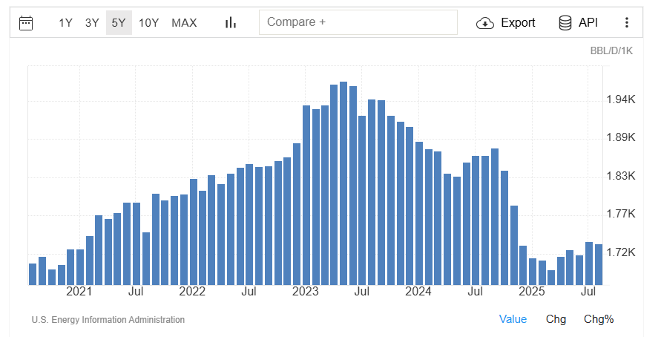
Figure 26: Mexico Crude Oil Production

From the geographical point of view, Mexico gains a lot from its location, being part of the important shipping routes and part of the North American energy trading networks, which increases both the reliability of the supply and the effectiveness of logistics (Technavio, 2025). Institutionally, oil and gas in Mexico has been liberated progressively and allows foreign buyers to sign commercial contracts without the need to develop local subsidiaries (Technavio, 2025).
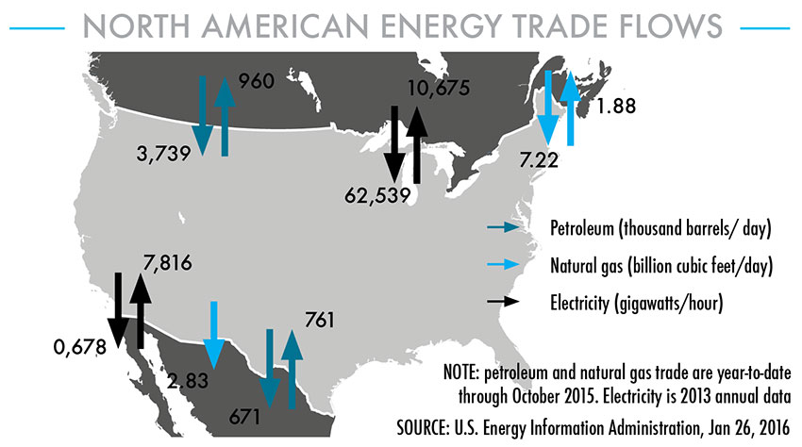
Figure 27: Mexico Regional Energy Integration
Nonetheless, in Mexico there are also disadvantages at a locational level that hinder entrance through equity-based approaches. The perceived risks of policy and expropriation of foreign state-owned businesses are an intensified effect of the regulatory intricacy, the political sensitivity of the hydrocarbon segment, and the prevalence of the national oil enterprise PEMEX (Kocúrek, 2024). The identified determinants reduce the appeal of Mexico in BPCL's ownership intensive such as refineries and upstream assets, thereby reinforcing a predilection for arm's length procurement instead of in house production.

3.3 Internalisation advantages and governance choice (I)
The benefits related to internalisation are associated with the question of whether BPCL is more likely to benefit by keeping control of its affairs within its ranks or through the involvement of the external market systems. Within the Mexican context, BPCL's internationalisation strategy focuses on market-based contracting and not on seeking full internalisation by adopting a foreign direct investment model.
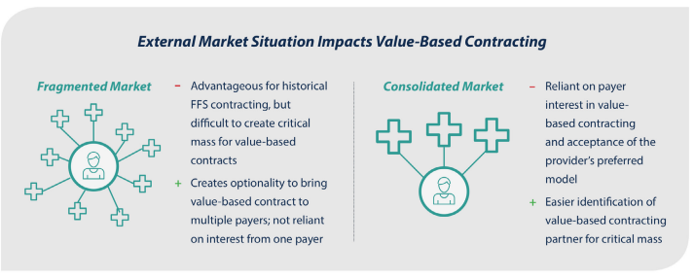
Figure 28: Internalisation vs Market Governance
An approach to procurement based on tenders and spot contracting or term contracting will allow internalising key decision-making related to volume, timing, and crude slate optimization and leave the upstream activities that require significant capital levels and occasional politicization to outsourcing organisations (Bharat Petroleum Corporation Limited, 2025; Schellenberg et al., 2017).
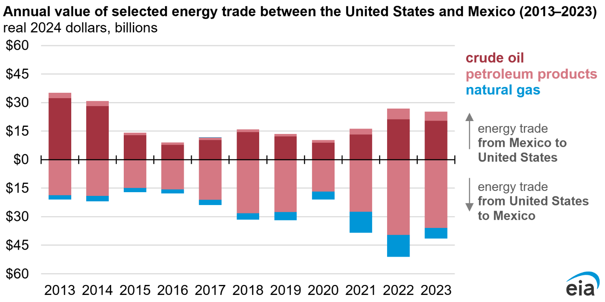
Figure 29: U.S.–Mexico Energy Trade
The reuse by BPCL of international tenders -or US crude and earlier Mexican crude exploration - shows organisational routines that lower transaction cost and reduce information asymmetry without requiring ownership (Verma, 2025; Reuters, 2018). This conclusion is in line with internalisation theory which states that companies will avoid foreign direct investment when the availability of sufficient contractual protection and governance institutions is sufficient to guard company-specific benefits (Mat Isa et al., 2017).
Internalizing operations in Mexico would subject BPCL to scrutiny in terms of compliance with labour, environmental and human rights standards in a foreign jurisdiction, which would increase compliance and reputational risks (Muhammed, 2021). On the other hand, contractual sourcing dilutes the direct responsibility of BPCL in the local operations practices whilst at the same time enabling the access of locational benefits.

3.4 Interaction of OLI factors and resulting entry mode
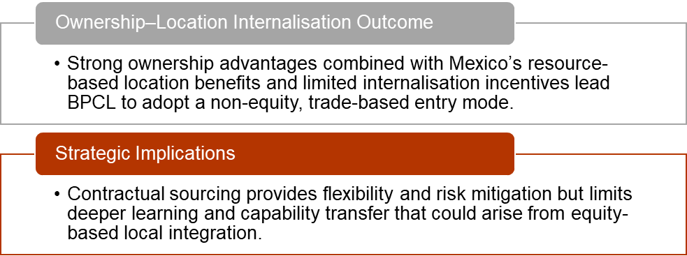
Figure 30: Interaction of OLI factors and resulting entry mode
The combination of BPCL's ownership structure, the geographical characteristics of Mexico and the aspects that relate to internalisation culminates in a mode of entry based on trade but not considered equity. The ownership benefits of both BPCL refining and procurement knowhow enables it to extract value of Mexico crude without the capital localisation requirements. The locational advantages have made Mexico attractive as a supplier but not considered to be a favorable destination for investment in downstream or upstream assets. Internalisation motivation is achieved by organisation based procurement processes instead of hierarchical growth.
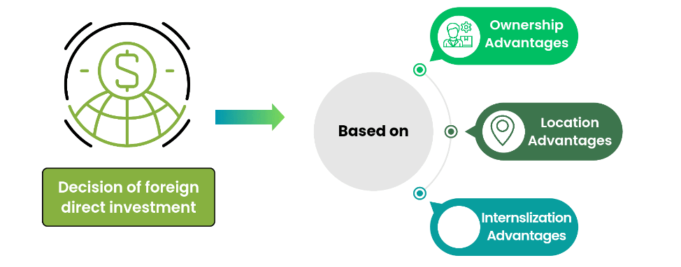
Figure 31: OLI-Based Entry Decision
The finding is consistent with the OLI framework that predicts that in situations where the benefits of ownership are high, but risks of location are high and the benefits of internalisation are limited, firms are likely to prefer export and import activities or contractual arrangements over foreign direct investment (Kocúrek 2024; Divrik 2023). The case of BPCL becoming one of the two companies in Mexico, with its involvement in sourcing negotiations and its involvement in the global aviation energy conferences held in Mexico, can represent either network-based or transactional internationalisation, though not deep embeddedness (Indian Masterminds, 2025).
Although this modality does provide flexibility and reduce the risk associated with the learning process, it simultaneously places constraints on learning and the transfer of capabilities achievable through deeper integration at the local level. The structure of BPCL OLI can shift in response to the growth of the momentum of energy transition, and the development of the regulatory framework in Mexico, however, in the current situation, the predominant mode of entering contracts is rational convergence of ownership benefits, locational benefits, and internalization constraints (Wasik, 2025; Technavio, 2025).

4. Cultural Differences and Their Impact on BPCL’s Entry Strategy and Success in Mexico

4.1 Hofstede-based cultural distance: India vs Mexico and why it matters
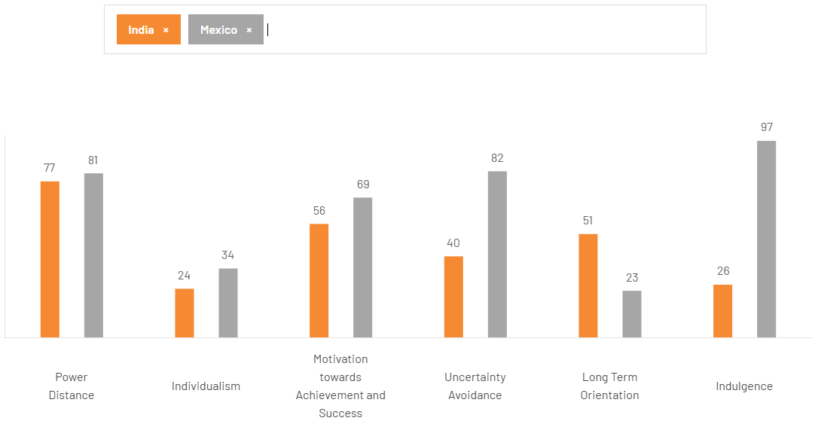
Figure 32: Hofstede Model India and Mexico
The Hofstede profile given shows both India and Mexico having a strong acceptance of hierarchical structures, but there are some striking differences in various dimensions characterized by uncertainty avoidance, temporal orientation and lifestyle orientation. Specifically, the dimension of Power Distance is high in both settings where scores stand at 77 and 81 for India and Mexico respectively. Furthermore, Individualism dimension also registers low values (24 for India and 34 for Mexico). Nevertheless, Mexico is an example of a much higher Uncertainty Avoidance score (82) compared with India (40) and a significantly larger Indulgence dimension (97 vs. 26). On the other hand, India is the better country at being Long-Term oriented than Mexico, with a score of 51 vs 23. The above dissimilarities can greatly impact the way BPCL designs its market-entry strategies and its future post-entry behavior since cultural consonance influences the perceptions of control, trust, contractual relationships, and service promises of partners (Yang, 2025; Felix and Kruger Neto, 2025).

4.2 Implications for BPCL’s market entry strategy in Mexico

4.2.1 Governance, decision rights and partner selection
High Power Distance in both markets can support BPCL’s preference for formal decision chains and escalation-based governance when dealing with Mexican counterparties (e.g., state-linked entities, ports, suppliers), because hierarchy is culturally legible on both sides.
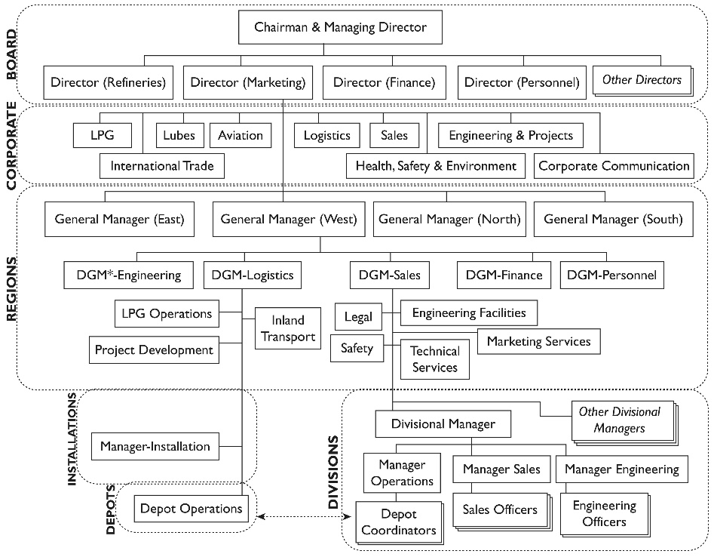
Figure 33: BPCL Hierarchical Governance Structure
Mexico's high Uncertainty Avoidance results in a deep inclination toward exhaustive contracts, unambiguous risk assignment, and predictable delivery protocols, which will place severe demands upon BPCL regarding documentation, compliance substantiation and dispute resolution frameworks (Yang, 2025; Schellenberg, Harker et al., 2017). This strategy makes contractual alliances, long-term procurement deals, and narrowly specified tenders the culturally appropriate entry mode relative to the entry mode in which only informal relationships are the basis of establishing entry (Divrik, 2023; Wasik, 2025). BPCL showcases a high degree of bringing the structured international trade linkages and risk management functions closer, thus strengthening the 'control-through-process' approach (Bharat Petroleum Corporation Limited, 2025).

4.2.2 Entry mode choice: why “low-asset” entry may dominate initially
In the case of BPCLMexico, sourcing and energy trade logic (e.g. an interest in Mexican Maya crude) is more substantiated as an interaction instead of a direct downstream retail roll-out, so trade-based entry modes, including tenders, contracts and strategic supply alliances, are more feasible in early development stages (Reuters, 2018; Bharat Petroleum Corporation Limited, 2025).
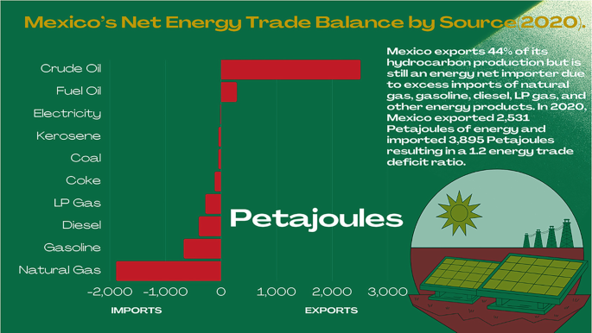
Figure 34: Mexico Energy Trade Balance
Mexico's high Uncertainty Avoidance may present another obstacle to early, fullowned expansion needs due to perceptions of excessive concerns for native legitimacy, both regulations and operational risks unless offset by working with experienced local partners (Mat Isa et al., 2017; Schellenberg et al. 2017). Practically, BPCL can still keep within itself interior control over delicate capabilities, such as pricing models, risk analytics, and quality standard operating procedures, but subcontract location-specific execution to Mexican counterparties on closely supervised contracts (Divrik, 2023; Wasik, 2025).

4.2.3 Process discipline and SOP transfer as a success condition
Mexico's extreme preference for low uncertainty avoidance means that stakeholders in Mexico are likely to punish or reward BPCL when the organization has robust procedures in place for safety, quality and continuity, and conversely are inclined to reward the firm if the procedures appear to be transparent and consistent or penalize the firm if they do not.

Figure 35: BPCL’s refinery operations
The refinery business of the BPCL is a source of the establishment of standardized processes and technological systems that may be reflected as credibility asset of the company in Mexico provided it translates it into locally understandable SOPs in terms of trading, terminal handling, aviation fuelling, and risk management interfaces (Bharat Petroleum Corporation Limited, 2025; Dettling, 2024). The transfer of standard operating procedures (SOPs) is not neutral: empirical evidence about the effectiveness of SOP shows that results about their use depend on understanding and reinforcement by leadership and on employees' acceptance at the local level. Accordingly, BPCL needs to make necessary adaptations to training language, accountability norms, and incident response expectations to the local context instead of merely copying-pasting Indian routines (Shaban et al., 2021; Nwulu et al., 2024).

4.3 Implications for BPCL’s potential for success after entry

4.3.1 Relationship-building vs time horizon mismatch
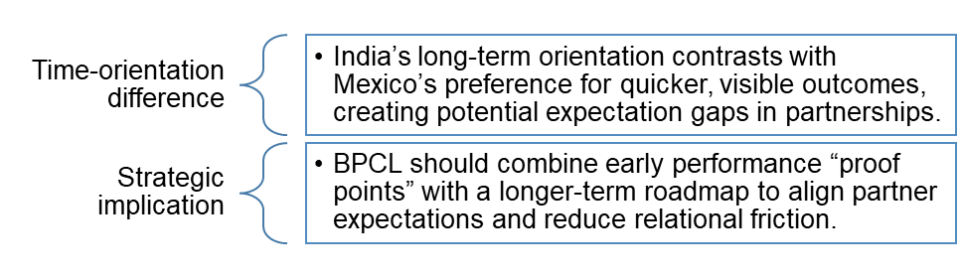
Figure 36: Relationship-building vs time horizon mismatch
The fact that India scores rather higher on the Long-Term Orientation dimension (51 points) describes a tendency toward long-term development of relationships and wait-and-see tendencies, whereas the relatively lower score of Mexico (23 points) indicates a preference toward more immediate and visible outcomes. This mismatch may impede success if BPCL chooses to conceptualize value solely in terms of long-term efficiency gains; whereas Mexican partners foresee higher levels of service improvements, faster issue resolution and proximal commercial gains (Yang, 2025; Felix et al., 2025). To reduce friction, BPCL can design contracts, which include early proof points, such as high-speed pilot volumes and base-performance KPIs, and, at the same time, a long-term roadmap. The approach is consistent with the research on the entry mode that emphasizes a gradual commitment in the case of uncertainty (Schellenberg, Harker, and Jafari, 2017; Divrik, 2023).

4.3.2 Marketing communication and stakeholder legitimacy
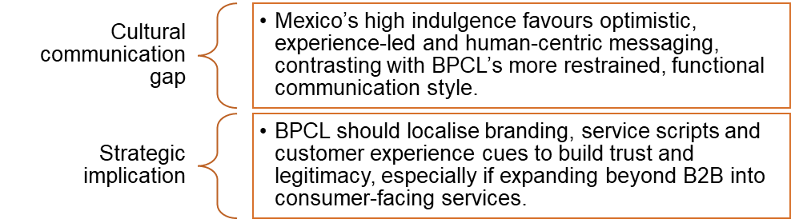
Figure 37: Marketing communication and stakeholder legitimacy
The Indulgence gap (Mexico 97 vs India 26) implies Mexican may appreciate optimistic, experiential led communication and human-centric brand communication more than BPCL's home country may have a more restrained, functions led communication tendency. When BPCL goes wider than B2B trade to services like aviation, lubricants, and retail format, the tone of the campaigns, customer experience indicators, and service scripts should be adjusted to the local emotional sampler to prevent the perceptions of being impersonate or bureaucratic (Yang, 2025; Naik et al., 2021). This is significant because cultural misalignment can lead to a breakdown of trust in the product brand and a decrease of conversion rate, even if the quality of the product is high (Felix et al., 2025).

4.3.3 Sustainability, social expectations and reputational risk
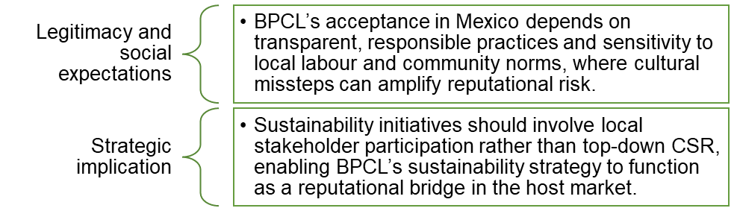
Figure 38: Sustainability, social expectations and reputational risk
It is as a multinational corporation that is working across border that the innovation of BPCL into an emerging economy is subject to its perceived responsibility, transparency and treatment of stakeholders. Scholarship points to the association of the operations of multinational corporations leading to an increased level of scrutiny of rights, labor practices, community impacts and this indicates the potential for cultural misinterpretations in community engagement, which may exacerbate the risks of legitimacy (Muhammed, 2021; Uddin, 2025).
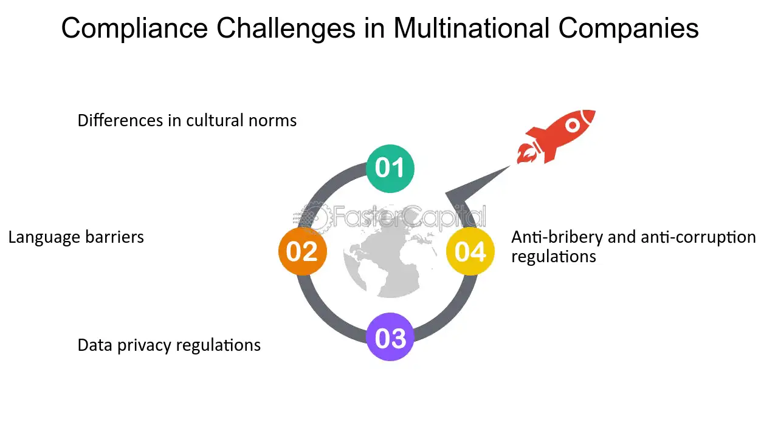
Figure 39: MNC Compliance and Legitimacy
The sustainability positioning of BPCL can also act as a reputational bridging mechanism by communicating and implementing the strategy of sustainability with involvement of local stakeholders instead of top-down signalling of CSR (Bharat Petroleum Corporation Limited, 2025e; Kibtiah and Kamal, 2025).

4.3.4 Bottom line: culture shapes “fit” between control and flexibility
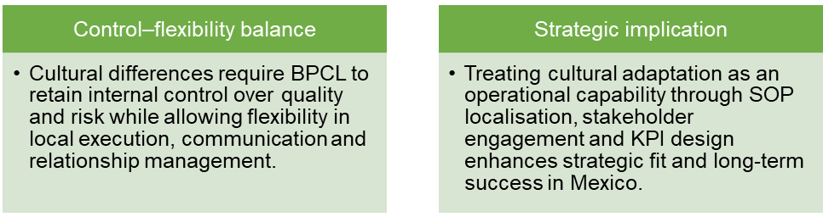
Figure 40: Bottom line: culture shapes “fit” between control and flexibility

5. Strategic SOP Adjustments Required for BPCL’s Success in Mexico
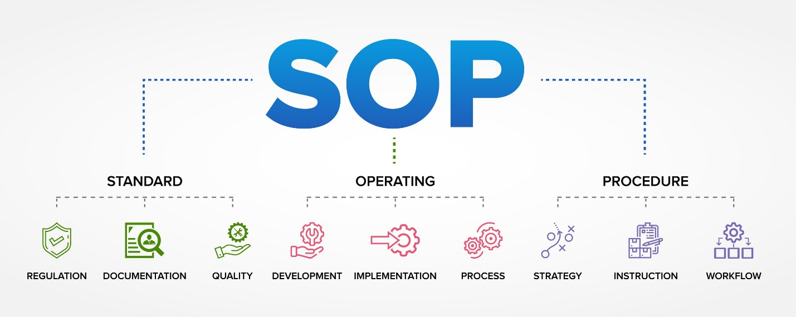
Figure 41: SOP

5.1 SOP Adjustment 1: Risk, compliance, and decision-clarity SOPs aligned with Mexico’s high uncertainty avoidance
The significantly higher score for uncertainty avoidance in Mexico in comparison with India indicates a very strong cultural bias towards predictability, formalized regulations, and explicit delineations of risk in commercial dealings. Following the BPCL ownership benefits, entrenched in process discipline, refinery technology, and systematic risk handling, the current cultural environment dictates the proliferation and localisation of risk-management and compliance standard operating procedures, as opposed to relying on the implicit organisational norms inherent in the Indian context (Kocúrek, 2024; Bharat Petroleum Corporation Limited, 2025).
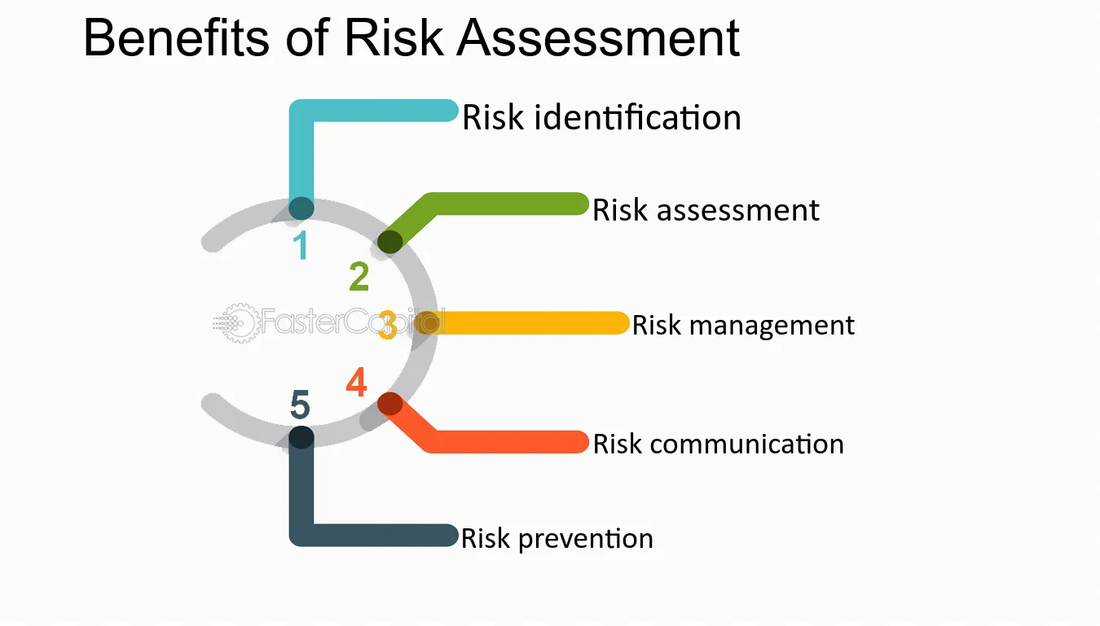
Figure 42: Risk Assessment and Control
Bharat Petroleum Corporation Limited international trade standard operating procedures currently in place emphasize on hedging, procurement on the basis of tenders, freight risk management and quality assurance (Bharat Petroleum Corporation Limited, 2025). However, within the context of Mexico, these Standard Operating Procedures have to be optimized to integrate the explicit escalation matrices, contractrendezvous playbooks, and regulatoryfacing documentation regimes, which would help to ensure that the Mexican associates would perceive BPCL activities as a de-ambiguation process, instead of a de-familiarizational process (Yang, 2025; Schellenberg et al., 2017). And research on the effectiveness of Standard Operating Procedures shows that employees and partners working with high uncertainty organizational cultures value clarity over flexibility, making explicit decision thresholds and approval times of utmost importance to encourage operational trust (Shaban et al 2021; Dettling 2024).
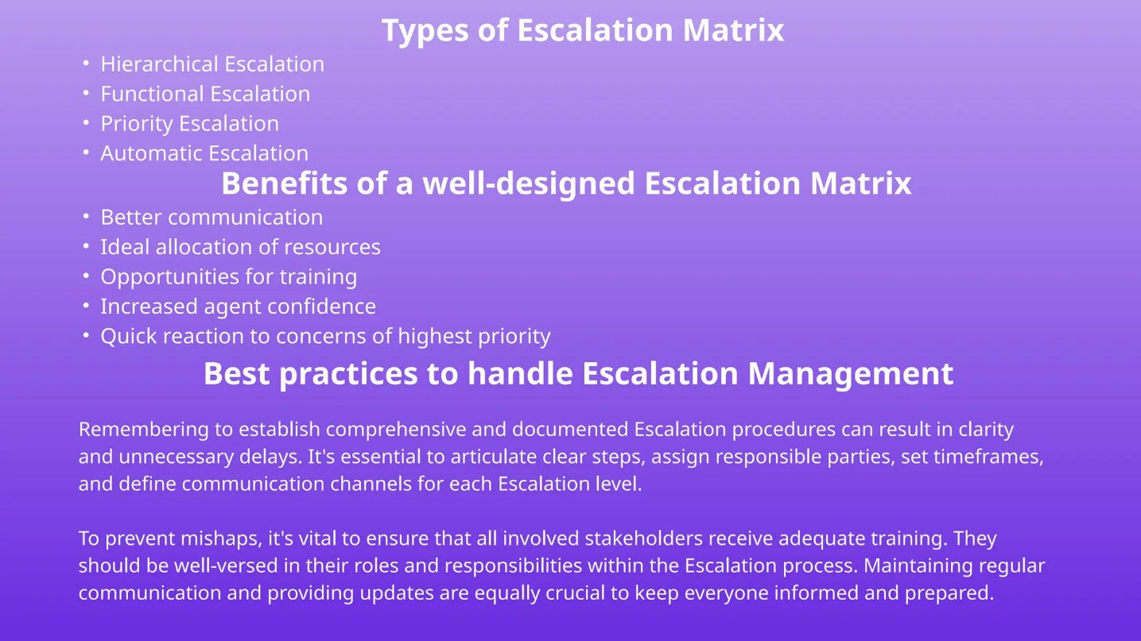
Figure 43: Escalation Matrix for Risk Control
According to the OLI analytical perspective, this change strengthens the internalisation benefit of BPCL because it allows the firm to preserve its internal risk analytics, pricing logic, and quality control, allowing external actors to work under the explicitly outlined procedural constraints (Mat Isa et al., 2017). The inability to localise risk standard operating procedures (SOPs) may undermine BPCL's ownership advantages by encouraging perceptions of opacity or delayed responsiveness in a socio-cultural market where the cost of uncertainty is considered highly expensive (Felix & Kruger Neto, 2025).

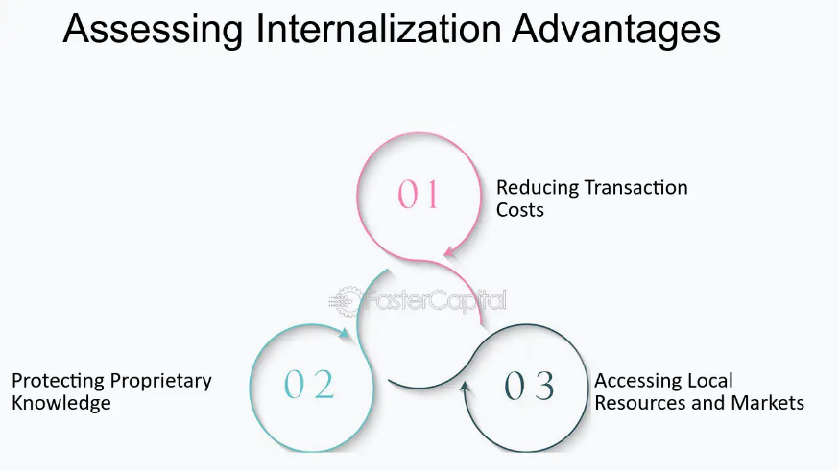
Figure 44: Internalisation Advantages in OLI

5.2 SOP Adjustment 2: Relationship-embedded governance and partner-interface SOPs
India and Mexico are both rated high on power distance and low on individualism thus showing that they tolerate hierarchies and relational decisions. Nonetheless, the current prevailing Mexican commercial ethos portrays a profound emphasis on personal trust, demonstrable authority and continuity of relationships, especially within sectors such as energy, infrastructure and aviation-linked industries, sectors where BPCL is most likely to operate (Indian Masterminds, 2025; Yang, 2025).
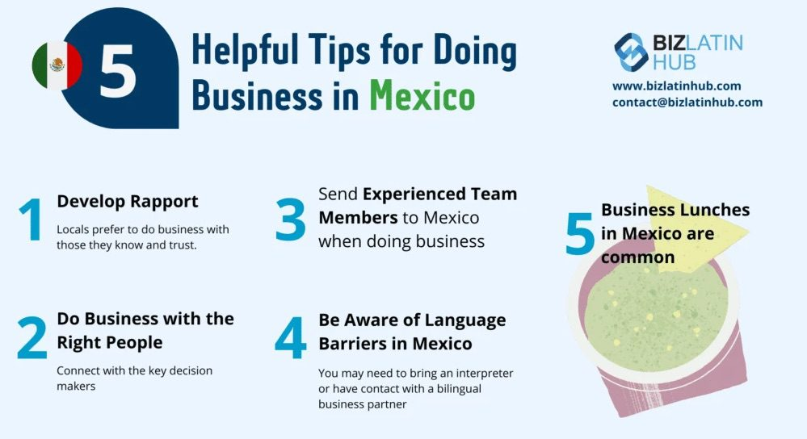
Figure 45: Mexican Business Culture and Practices
The traditional SOPs of BPCL are predetermined by the traditions of the public sector that prioritize formal approvals, paper-based communication, and process compliance (Bharat Petroleum Corporation Limited, 2025; GlobalData, 2025). Although these SOPs are effective in the domestic context, they require adaptation to incorporate relationship management practices, such as assigning senior relationship custodians, developing negotiation protocols, which include appropriate cultural considerations and establishing cycles of structured in-person engagement with Mexican counterparts. According to empirical results of internationalisation, in the emerging economies, relational governance is likely to complement, not to replace formal contracts (Divrik, 2023; Wasik, 2025).
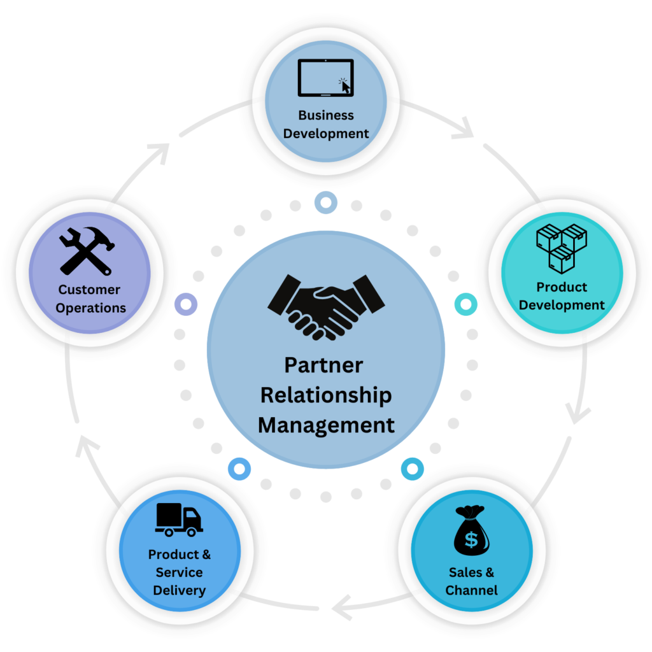
Figure 46: Benefits of Partner Relationship Management
This adjustment is quite important in the context of BPCL's predicted methods of market penetration in Mexico, which are mainly determined by trade-based agreements, long-term supply contracts, and strategic partnerships rather than creation of wholly owned subsidiaries (Reuters 2018; Verma 2025). SOPs should, hence, formalize the process of grabbing relationship intelligence, willingness of commitments in an informal way in such a way that trust is maintained and hints authorization should the top-level leadership be implicated. Such a format of SOPs is in line with empirical data that shows that partner-to routines have a pronounced effect on performance after entry into culturally distant markets (Herlitah, 2025; Schellenberg, Harker, and Jafari, 2017).
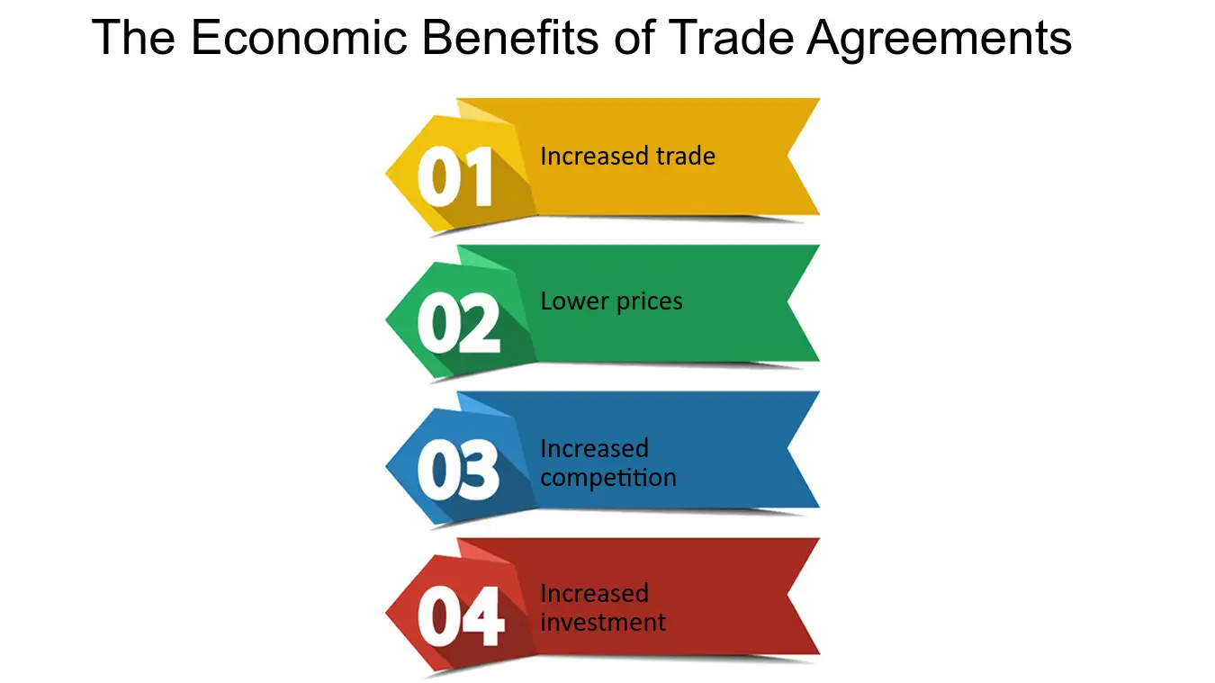
Figure 47: Benefits Of Trade Agreements
From an OLI perspective, this type of adjustment is about increasing the abilities of BPCL in terms of utilizing its location advantages, thus allowing the firm to navigate the institutional and cultural context of Mexico efficiently without having to make excessive capital commitments, while ensuring its ownership advantages at the same time through the implementation of controlled interfaces (Kocurek, 2024).

5.3 SOP Adjustment 3: Human, safety, and sustainability SOPs sensitive to cultural and social expectations
A third fundamental change of Standard Operating Procedures relates to human, safety, and sustainability practices which are fundamental aspects of BPCL in its role as a multinational actor and are facing growing criticism in the emerging economies. Cultural research has shown that differences in labour practices, communication of safety measures, and engagement in the community may dissipate stakeholder acceptance in spite of good technical performance (Muhammed, 2021; Uddin, 2025).
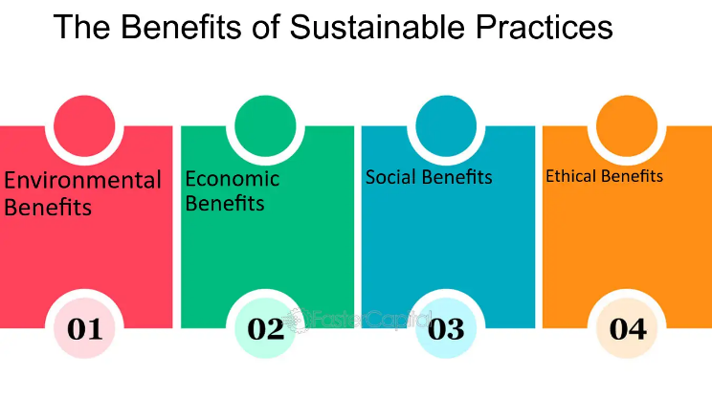
Figure 48: Human Sustainability
BPCL also uses exceptionally standardised safety and process SOPs in its refiners and foreign locations, which is supported by technological systems and constant drive to improve processes (Bharat Petroleum Corporation Limited, 2025f; Nwulu et al., 2024). In Mexico, however, these Standard Operating Procedures (SOPs) need to be recalibrated to deal with the norms of communication style, training delivery, and worker-participation, especially the culture of high indulgence and high social orientation. Those safety and sustainability communications that are too procedural or abstract are unlikely to have any resonance without being explicitly linked to visible well-being or communal effects (Felix et al., 2025; Naik et al., 2021).
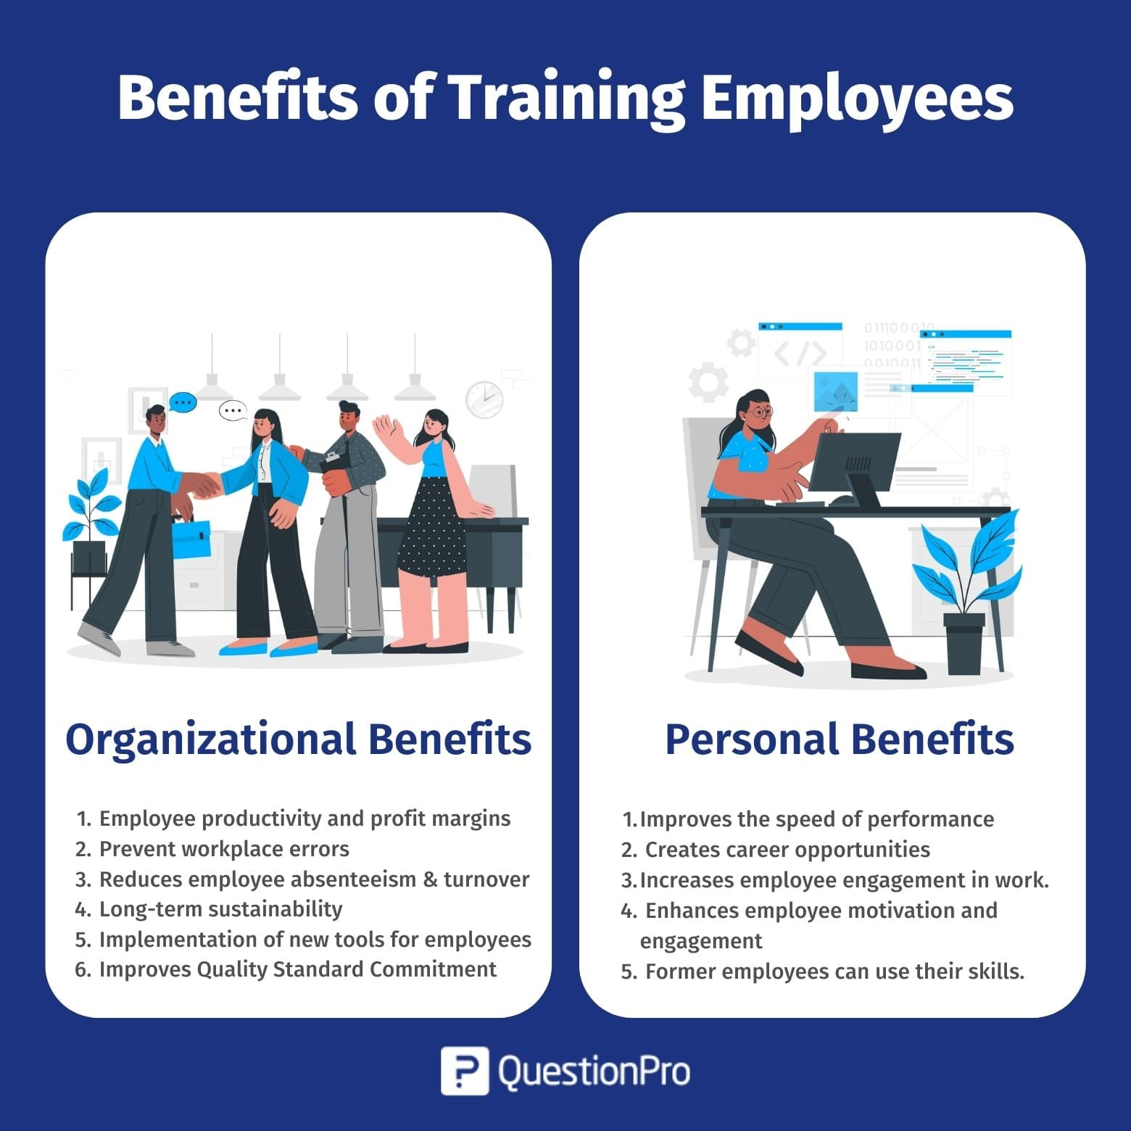
Figure 49: Benefits of Employee Training
For example, empirical evidence shows that the success of Standard Operating Procedures (SOPs) in industrial settings depends not only on the technical design of these procedures but also on cultural acceptance, leadership reinforcement and fairness (Shaban et al. 2021). In turn, BPCL should reform its standard operating procedures by including bilingual teaching and instructional resources, participatory and participatory safety briefings, and context-specific sustainability indicators, which would be in line with the current trend in Mexico towards environmental and social expectations (Technavio, 2025; Trading Economics, 2025). The implementation of this strategy further helps BPCL in building its sustainability position, a position that is increasingly determined by the long-term access to operations, and the accrual of reputational capital (Bharat Petroleum Corporation Limited, 2025; Kibtiah et al., 2025).
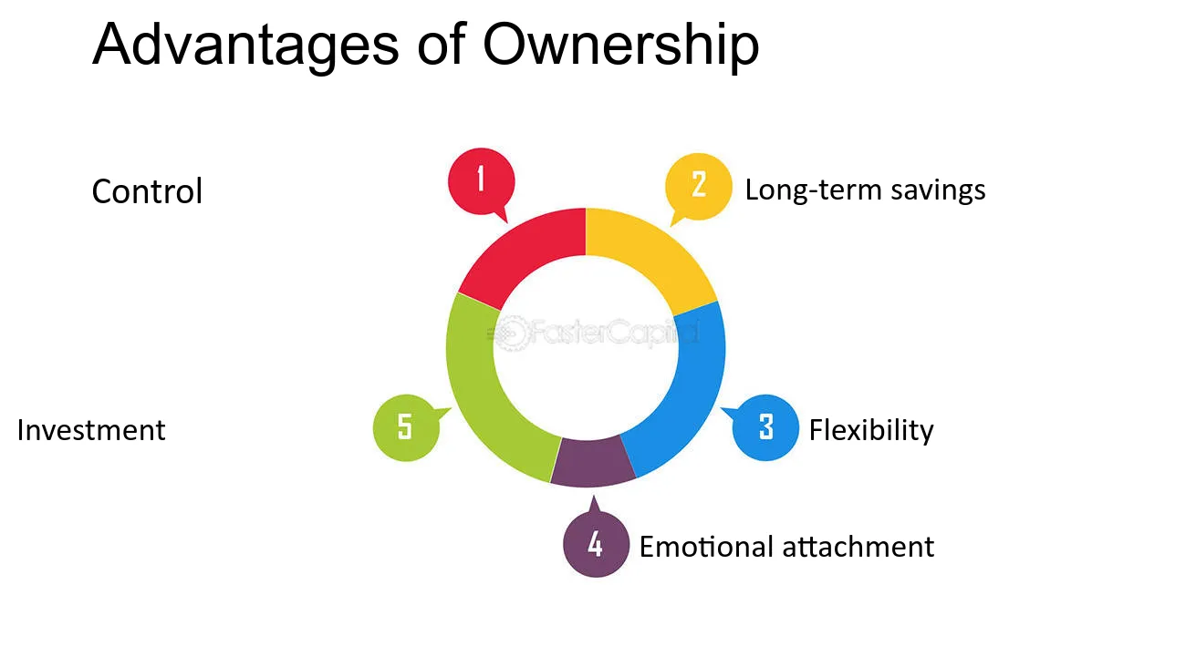
Figure 50: Ownership advantages
According to the OLI view, the localisation of the standard operating procedures protects ownership benefits of BPCL in the safety systems and environmental management, assuring that the said benefits are not seen as externally imposed standards in the host location (Kocúrek, 2024; Mat Isa et al., 2017).

5.4 Strategic coherence of SOP adjustments with OLI and cultural analysis
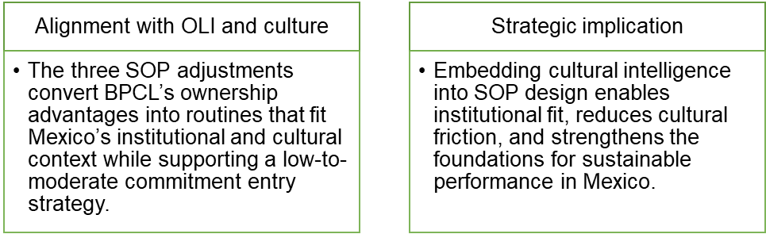
Figure 51: Strategic coherence of SOP adjustments with OLI and cultural analysis

6. Conclusion
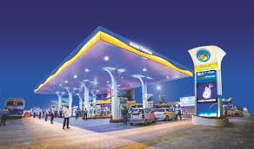
Figure 52: BPCL Station
The analysis shows that the internationalization undertaken by Bharat Petroleum into Mexico is dependent on a complex interaction that involves ownership benefits, location factors and internalization policies which are substantially influenced by cultural differences. BPCL's significant advantages in process discipline, technological capability, and risk management are the basis of significant ownership advantages for BPCL in leading cross-border operations; but the full implementation of these advantages relies on their compatibility with the institutional and cultural context of Mexico. The OLI assessment explains why BPCL has given specific preference to trade-based and partnership-based entry modes instead of high-asset commitment, hence the consideration of both of these factors along with the need to deal with uncertainty effectively. A more subtle cultural analysis shows that differences between India and Mexico in their level of uncertainty avoidance, temporal orientation, and indulgence have a direct impact on the form of governance, inter partner relations, and operational expectations. The proposed changes to the SOP, therefore, which include improved risk visibility, embedded relationship governance and culturally sensitive practices in relation to human and sustainability concerns act as some fundamental facilitators of strategic congruence. Overall, the report highlights the fact that success of BPCL in Mexico is not due to the success of the company in its home country but rather due to its ability to adapt the internal systems to the local cultural and institutional context while preserving the core competitive advantages.

References
Bharat Petroleum Corporation Limited (2025) Bharat Petroleum Corporation Limited. Available at: https://www.bharatpetroleum.in/index
Bharat Petroleum Corporation Limited (2025) International trade. Available at: https://www.bharatpetroleum.in/our-businesses/international-trade
Bharat Petroleum Corporation Limited (2025) Our Journey. Available at: https://www.bharatpetroleum.in/about-bpcl/our-journey
Bharat Petroleum Corporation Limited (2025) Process and technology – Mumbai refinery (MR). Available at: https://www.bharatpetroleum.in/bharat-petroleum-for/refineries/mumbai-refinery(mr)/process-and-technology
Bharat Petroleum Corporation Limited (2025) R&D centre. Available at: https://www.bharatpetroleum.in/r-and-d-centre/r-and-d-centre
Bharat Petroleum Corporation Limited (2025) Sustainability. Available at: https://www.bharatpetroleum.in/sustainability/sustainability
Dettling, R.N. (2024) Writing effective standard operating procedures (SOPs). December. University of Phoenix.
Divrik, B. (2023) ‘International market entry strategies’, in Origin and branding in international market entry processes. Hershey, PA: IGI Global, pp. 1–10. DOI: https://doi.org/10.4018/978-1-6684-6613-1.ch001
Felix, L. and Kruger Neto, L.F. (2025) Corporate positioning and the impact of cultural differences on global markets. February. DOI: https://doi.org/10.5281/zenodo.15455645
GlobalData (2025) Bharat Petroleum Corp Ltd – company profile and segment analysis. Available at: https://www.globaldata.com/company-profile/bharat-petroleum-corp-ltd/analysis/
GlobalData (2025) Bharat Petroleum Corp Ltd – overview. Available at: https://www.globaldata.com/company-profile/bharat-petroleum-corp-ltd/
H. R., S., Madhusudan, G. and Tadesse, N. (2024) Impact of cultural difference on international businesses. September.
Herlitah, H. (2025) ‘Internationalization strategy through market entry mode: A study of the restaurant business’, Corporate and Business Strategy Review, 6(4), p. 209. DOI: https://doi.org/10.22495/cbsrv6i4art19
Indian Masterminds (2025) ‘BPCL celebrates decades-long partnership with British Airways at IATA Aviation Energy Forum in Mexico’, Indian Masterminds, 21 November. Available at: https://indianmasterminds.com/news/bpcl-british-airways-50-year-aviation-fuel-partnership-iata-forum-162061/
Kibtiah, T.M. and Kamal, M.G. (2025) ‘The role of multinational corporations (MNCs) in renewable projects in Indonesia’, Intermestic: Journal of International Studies, 9(2), p. 376. DOI: https://doi.org/10.24198/intermestic.v9n2.6
Kocúrek, M. (2024) ‘Impact of ownership-location-internalization (OLI) paradigm and investment development path (IDP) on gravity model of foreign direct investments in Eastern Europe and Central Asia (EECA) region’, Ekonomické rozhľady – Economic Review, 53(2), pp. 109–130. DOI: https://doi.org/10.53465/ER.2644-7185.2024.2.109-130
Lawrence, J., Gopinath, G.V., Pius, A. and Vedhi, C. (2019) ‘Evaluation of standard of oil by observing standard operating procedures (SOP) of the fried food processing’, International Journal of Advanced Scientific Research and Management. April.
Mat Isa, C.M., Mohd Saman, H. and Preece, C.N. (2017) ‘Development of OLI+S entry decision model for construction firms in international markets’, Construction Economics and Building, 17(4), p. 66. DOI: https://doi.org/10.5130/AJCEB.v17i4.5573
Muhammed, M.H. (2021) ‘Transnational corporations and human rights’, Global Jurnal Politik Internasional, 23(2), p. 285. DOI: https://doi.org/10.7454/global.v23i2.542
Naik, A. and Sharma, A. (2021) ‘Impact of cultural differences in marketing on buying behaviour’, International Journal of Engineering and Management Research, 11(3). DOI: https://doi.org/10.31033/ijemr.11.3.37
Nosova, O. (2025) Strategies of transnational companies in the technological sector. Paper presented at the 15th London International Conference, Istanbul, 15–17 April. DOI: https://doi.org/10.31039/plic.2025.13.327
Nwulu, E.O., Elete, T., Aderamo, A.T. and Esiri, A. (2024) ‘Optimizing shutdown and startup procedures in oil facilities: A strategic review of industry best practices’, Engineering Science & Technology Journal, 5(11), pp. 3094–3126. DOI: https://doi.org/10.51594/estj.v5i11.1703
PESTLE Analysis (2025) What is sales and marketing strategy of Bharat Petroleum Company? 27 September. Available at: https://pestel-analysis.com/blogs/marketing-strategy/bharatpetroleum
Reuters (2018) ‘India’s BPCL looking at getting Maya crude from Mexico – company official’, Reuters, 11 September. Available at: https://www.reuters.com/article/markets/us/indias-bpcl-looking-at-getting-maya-crude-from-mexico-company-official-idUSL3N1VX4J2/
Reuters (2025) ‘BPCL, Oil India to build $11 billion refinery, petchem complex in southern state’, Reuters, 28 October. Available at: https://www.reuters.com/business/energy/bpcl-inks-deals-with-oil-india-numaligarh-refinery-fact-expand-operations-2025-10-28/
Schellenberg, M., Harker, M. and Jafari, A. (2017) ‘International market entry mode – a systematic literature review’, Journal of Strategic Marketing, 26(7), pp. 1–27. DOI: https://doi.org/10.1080/0965254X.2017.1339114
Shaban, I., Farshad, A.A., Yarahmadi, R. and Mansourian, M. (2021) ‘Exploring the viewpoint of oil industry employees about factors affecting the success of standard operating procedures’, Archives of Occupational Health, 5(3). DOI: https://doi.org/10.18502/aoh.v5i3.7162
Technavio (2025) Mexico oil and gas market analysis, size, and forecast 2025–2029. March. Available at: https://www.technavio.com/report/mexico-oil-and-gas-market-industry-analysis
Trading Economics (2025) Bharat Petroleum Corporation Limited (BPCL) – sales. Available at: https://tradingeconomics.com/bpcl:in:sales
Trading Economics (2025) Mexico crude oil production. Available at: https://tradingeconomics.com/mexico/crude-oil-production
Uddin, S.S. (2025) Analyzing the role of multinational corporations in shaping global economic policies. August. DOI: https://doi.org/10.5281/zenodo.16893282
Verma, N. (2025) ‘India BPCL buys 10 million barrels of US oil via five-month tender, sources say’, Reuters, 14 August. Available at: https://www.reuters.com/business/energy/india-bpcl-buys-10-million-barrels-us-oil-via-five-month-tender-sources-say-2025-08-14/
Verma, N. (2025) ‘India’s BPCL plans to buy US oil via 4-month tender, source says’, Reuters, 7 March. Available at: https://www.reuters.com/business/energy/indias-bpcl-plans-buy-us-oil-via-4-mth-tender-source-says-2025-03-07/
Wasik, W.-U.-R. (2025) Strategic internationalization: A comprehensive analysis of market entry modes for small businesses. December. DOI: https://doi.org/10.13140/RG.2.2.33843.90402
Yang, J. (2025) ‘The impact of cultural differences on the effectiveness of international marketing of brand’, SHS Web of Conferences, 220, 03013. DOI: https://doi.org/10.1051/shsconf/202522003013

