

Changemakers: Creativity and Value Creation
Professions (BMHP5014)

Component 1: Portfolio of set exercises

Student name: Marcelina Musteata
Student number: 2415793
Lecturer’s name: Laila Surani

Table of Contents
Task 1: Defining Key Concepts in Practice 2
Task 2: Mind Map 3
Task 3: Self-Reflection of Group Activity 4
Task 4: Case Study Analysis of a UK Innovation 5
Task 5: Research Task 5
Task 6: Digital Innovation in Health and Social Care 6
Benefit of Wearable Health Technologies 6
Electronic Health Records (EHRs) and Communication 7
Digital Technology Supporting Preventative Care 7
Task 7: Understanding the NHS Leadership Framework 8
Summary of the NHS Leadership Framework 8
Inspiring Shared Purpose 8
Task 8: Self-Reflective Journal Entry 8
Evidence 9
References 12

Task 1: Defining Key Concepts in Practice
Innovation refers to the presentation of new ideas, processes or technologies that enhance services and outcomes. Innovation in healthcare improves patient care, treatment, and digital technology to assist patients. The Diffusion of Innovation Theory, proposed by Rogers (2003), describes the process of the spread of innovation when people accept new ideas over time depending on their usefulness and convenience. The reason why innovation is essential in health and social care is that it leads to increased efficiency, addressing evolving patient needs and the quality of care. As an illustration, electronic health records have enhanced practitioner-practitioner communication and minimised medication errors, enhancing safer and patient-centred care (Flessa and Huebner, 2021).
Creativity is the capability to generate original and useful ideas to solve problems or enhance practice. According to the Componential Theory of Creativity developed by Amabile (1996), creativity relies on expertise, skills of thinking and motivation. Health and social care need creativity due to the complexity and unpredictability of situations professionals may have to deal with, which demand flexible thinking as solutions. As an example, occupational therapists can create customised treatment exercises to enhance patient recollection and interest. Creativity facilitates personalised interventions that enhance the wellbeing of service users (Paul and Phil, 2024).
Value creation entails delivering good patient outcomes and efficiently utilising resources. According to Porter (2010), there is the creation of healthcare value when there is an improvement in outcomes in relation to costs. This is significant in the context of health and social care since organisations are required to provide effective care in the face of financial strains. Preventive care programmes Preventive care programmes like vaccinations generate value in the form of better population health and lowering the cost of future treatment. This will make healthcare sustainable and patient-centred.
Change is the process of shifting the present practices to better practices in reaction to an internal or external force. The Change Management Model created by Lewin involves three steps: unfreezing, change implementation, and refreezing new behaviours (Burnes, 2007). Change is crucial in health and social care because organisations need to adjust to policy, technology, and demographic changes of patients. In the case of COVID-19, telehealth and remote consultations were quickly implemented as part of services, and they supported organisations to be more responsive, safe, and efficient (Barrow and Annamaraju, 2022).

Task 2: Mind Map
Prolonged waiting is a significant challenge in health and social care as it leads to delays in treatment, aggravated patient outcomes, and diminished satisfaction with services. It has been found that long waiting times result in worse clinical outcomes and more patient dissatisfaction (McIntyre and Chow, 2020). The causes of long waiting periods as depicted in the attached mind map are interrelated, and some of them are staff shortages, underfunding, increasing patient demand and delays in discharge processes. Such pressures have the potential to raise burnout among staff, potentially impacting patient safety and quality of care (Hall et al., 2016). Applying a systems thinking method, Meadows (2008) states that healthcare issues are caused by interconnected pressures throughout the entire system and not by a single factor. Otherwise, waiting times can keep on hurting vulnerable patients and overloading the services.
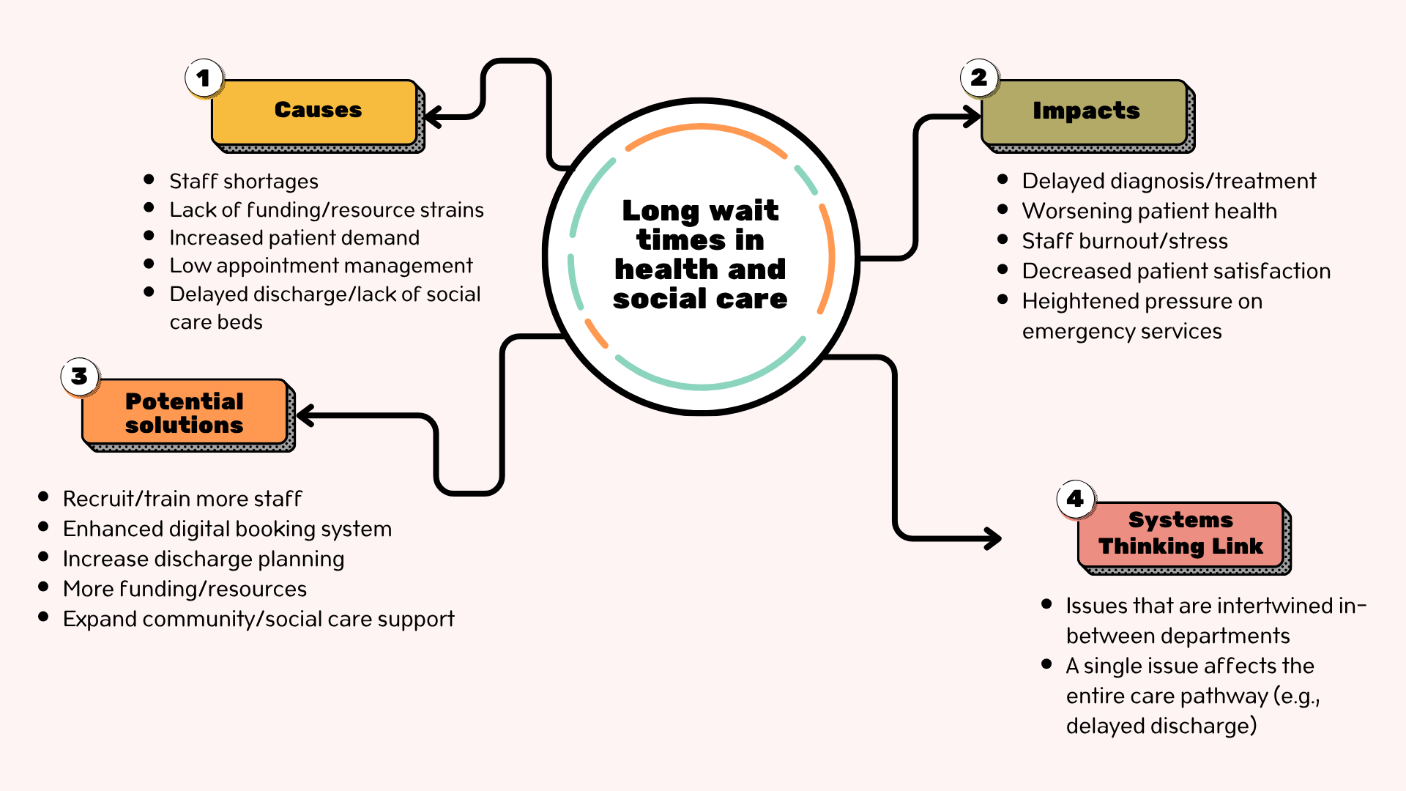

Task 3: Self-Reflection of Group Activity
I applied the Gibbs Reflective Cycle (1988) to my experience in my convergent and divergent thinking group activity. Divergent thinking entails the ability to come up with various creative thoughts and seek alternative possibilities, but convergent thinking is characterised by the reduction of ideas to the best solution (Rawlings et al., 2024). In the activity, my group initially employed divergent thinking, which involved brainstorming on a few solutions to the case study problem, and then convergent thinking was employed to select the most feasible solution.
I was comfortable with the idea-sharing process of brainstorming since divergent thinking is more comfortable to me since I like to explore the possibilities. But in the case where the group could not reach a final idea, I proposed that they make a list of pros and cons to contrast each idea. This assisted the group to arrange the ideas in a logical manner and decide in an efficient way. It is out of this experience that I came to learn that despite being at ease in being creative, my problem-solving capabilities are also good in aiding people to critique ideas.
The exercise helped me develop enhanced communication and teamwork skills since I learnt the need to listen to the views of others before making decisions. The importance of reflective practice is that it promotes lifelong learning through experience (Gibbs, 1988). In the future, I would be more assertive when bringing up my point at an earlier stage in the discussion and would urge the weaker group members to express their views to enhance teamwork even more.

Task 4: Case Study Analysis of a UK Innovation
One of the innovations that are being applied to the NHS to assist patients to get the best service is care navigation that will enable them to get the best service in the shortest time instead of automatically making a GP appointment. It was implemented due to the increasing strain on general practice, increased patient demand and excessive waiting times. According to NHS England (2025), care navigation assists in ensuring that patients obtain the proper care initially, enhancing efficiency in practices. This innovation was facilitated by creativity which involved a redesign of the traditional receptionist role into a more active system where the trained personnel evaluate the needs of patients and refer them to appropriate services like pharmacists, mental health teams or social prescribers.
The generated value consists of less GP workload, quicker access to care, and enhanced patient pathways. The advantages to many patients include being assisted by the most appropriate professional without undue delays. Tierney et al. discovered that care navigation has now become a common practice in primary care in England (Tierney et al., 2019). This is the case with Rogers' (2003) Diffusion of Innovation Theory, which argues that healthcare innovations are disseminated when they are seen to be useful and beneficial to the users.

Task 5: Research Task
Staff stress is an important health and social care problem, which impacts wellbeing, performance, and patient safety. In the study by Dall’Ora et al. (2020), it was observed that an intense workload and insufficient staffing are two of the primary triggers of staff stress, which is why professionals who work long hours with pressure tend to experience emotional exhaustion and burnout. This assists in showing how staff shortages in hospitals and care homes may put additional strain on the few remaining staff, leading to a decrease in the quality of care provided.
On the same note, Johnson et al. (2018) found that poor leadership, insufficient organisational support, and inadequate professional growth were the major stress factors among healthcare personnel. This brings to the fore the fact that workload is not the only cause of stress but also workplace culture and management practices.
The two studies agree that organisational pressures are factors that cause staff stress, but Dall’Ora et al. (2020) dwell more on workload, and Johnson et al. (2018) focus on management systems and support systems. These results are consistent with Maslach Burnout Theory, which postulates the occurrence of burnout due to emotional exhaustion, depersonalisation and diminished personal accomplishment when work stress is chronic.

Task 6: Digital Innovation in Health and Social Care

Benefit of Wearable Health Technologies
The key advantage of wearable health technologies, including smartwatches, is that they promote real-time monitoring of chronic health conditions. The wearable devices can monitor the heart rate, oxygenation, physical activity, and sleep patterns to enable the patient and healthcare providers to closely observe the symptoms and identify the changes in the early period. Studies indicate that wearable health devices enhance the management of chronic diseases through the provision of personalised monitoring and timely intervention in case the health status gets worse (Jafleh, E. A., et al., 2024). As an illustration, a heart disease patient can wear a smartwatch to measure irregular heartbeats and transmit the data to a doctor. This can minimise hospital admissions and facilitate self-management. According to the Technology Acceptance Model, individuals tend to embrace wearable health technology more when they believe it can be useful and convenient (Davis, 1989), which can be used to explain their increasing popularity in the medical field.

Electronic Health Records (EHRs) and Communication
Electronic Health Records (EHRs) enhance interdisciplinary teamwork and communication among healthcare workers by enabling the sharing of patient data in real-time across multidisciplinary teams. EHRs contain electronic documentation such as medical history, drugs, test findings, and treatment plans that may be accessed online by qualified professionals. Studies show that EHR systems can improve interprofessional communication and enhance coordination amongst patient-care staff (Robertson et al., 2022). To give an example, once a patient has been moved out of the accident and emergency to a hospital ward, the nurses, the doctors and the pharmacists will all be able to access the same up-to-date information, thereby preventing duplication and medication errors. This enhances continuity of care and decision-making. The Technology Acceptance Model argues that healthcare personnel will be more inclined to utilise EHR systems efficiently when they consider them helpful and easy to use (Davis, 1989).

Digital Technology Supporting Preventative Care
Digital technology aids in preventative care and health promotion because it assists people in keeping track of health risks and making healthier lifestyle decisions before becoming sick. Exercise, healthy diet, medicine reminders, and frequent health checkups can be motivated with the help of mobile health applications, wearable devices, and web resources. Studies indicate that digital technologies have the potential to enhance disease prevention and healthier behaviour among populations (De Santis et al., 2022). To illustrate, a mobile app can remind people to exercise daily, to keep track of calories, and to monitor blood pressure, thereby minimising the chances of obesity or heart disease. Practically, GP surgeries can prescribe digital apps to patients who are at risk of diabetes to help with weight control. The Technology Acceptance Model states that patients will be more willing to adopt preventative digital tools when they perceive them as easy, useful, and applicable to their needs (Davis, 1989).

Task 7: Understanding the NHS Leadership Framework

Summary of the NHS Leadership Framework
The NHS Leadership Framework provides an overview of the most important behaviours that effective leadership in a health and social care environment must possess. It consists of nine dimensions that are inspiring shared purpose, leading with care, evaluating information, connecting services, sharing the vision, engaging the team, holding people to account, developing capability, and influencing people for results. The framework is significant as it assists healthcare specialists to acquire leadership capabilities that enhance teamwork, decision-making, and patient outcomes (NHS England, 2025). Leadership in health and social care is important, as good leaders provide conducive environments, handle change effectively and ensure high quality of care (Singh et al., 2024). The framework encourages inclusive, compassionate, patient-centred leadership across the healthcare organisations (NHS England, 2025).

Inspiring Shared Purpose
Inspiring shared purpose can be employed by a leader who helps the staff to recognise the significance of their role and how their contribution to patient wellbeing works. Effective leaders are also able to inspire teams to work together to achieve a common goal, as they can communicate a clear vision (Saleh et al., 2025). As an illustration, a ward manager can invite the staff to come up with ideas on how to enhance the patient discharge process, which will make the staff feel appreciated and invested in service delivery. This may stimulate innovation and enhance patient care through enhanced motivation and collective responsibility.

Task 8: Self-Reflective Journal Entry
In this module, my perception of creativity and value creation in health and social care has been greatly enhanced. At first, I thought that creativity meant only to generate entirely new ideas, but now I understand that creativity can also be the process of enhancing the current processes and adjusting the practice better to the needs of patients. The education on the innovation model and activities like convergent and divergent thinking exercises made me realise that care settings can be structured to provide practical solutions to problems.
I also came to know that value creation does not solely entail cost reduction but also enhancing patient outcomes and quality of service. This shifted my thinking on the way healthcare organisations determine success. The examination of the leadership and innovation revealed to me how people with professionalism can impact change by promoting teamwork and fostering new ideas. Transformational Leadership Theory implies that leaders motivate employees by encouraging vision and innovation (Bass and Avolio, 1994) and supported my perception of the value of leadership in healthcare improvement. To use this learning in my future career, I will be open to innovation and actively contribute ideas that will improve patient care.

Evidence
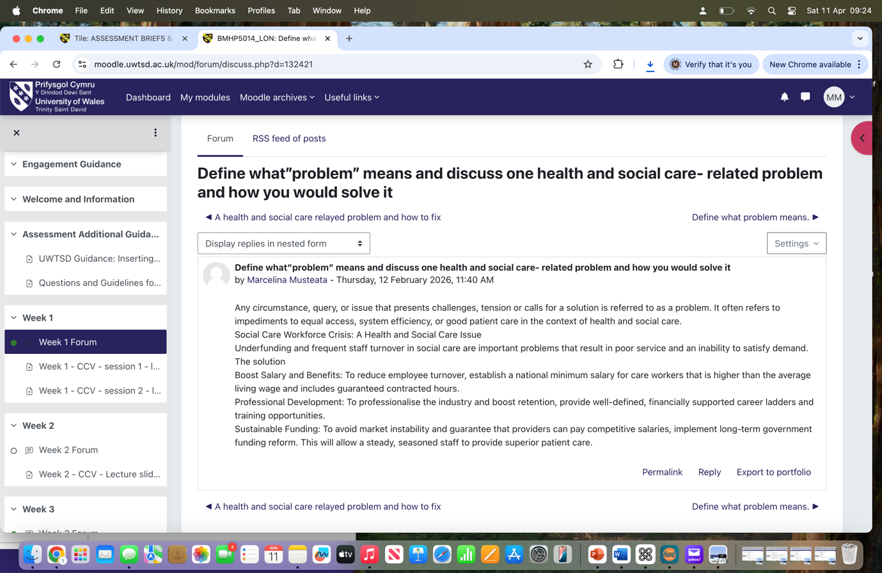


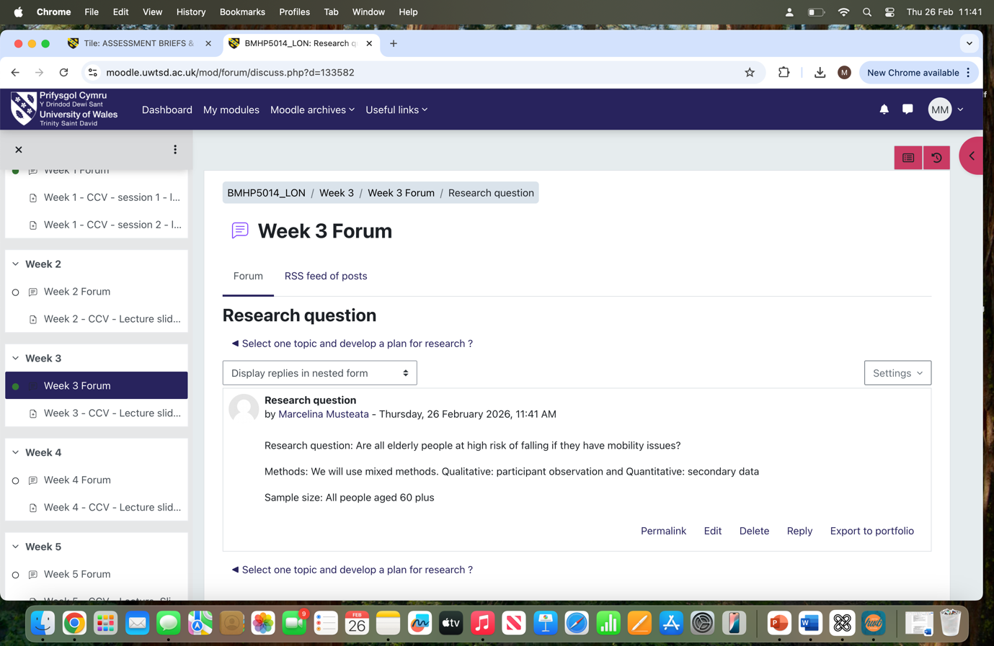



References
Amabile, T. (1996) Creativity in context. Boulder, Colorado: Westview Press
Barrow, J. M. and Annamaraju, P. (2022) ‘Change Management In Health Care’. StatPearls. 18 September. Available at https://www.ncbi.nlm.nih.gov/books/NBK459380 (Accessed date 18th March 2026)
Bass, B. M. and Avolio, B. J. (1994) Improving Organizational Effectiveness Through Transformational Leadership. Thousand Oaks, CA: Sage
Bernard, B. (2007) ‘Kurt Lewin and the Harwood Studies: The Foundations of OD’. Journal of Applied Behavioral Science; Vol. 43, Iss. 2: 213-224,227-231. Available at https://www.proquest.com/docview/236352406?sourcetype=Scholarly%20Journals (Accessed date 18th March 2026)
Dall’Ora, C., Ball, J., Reinius, M., and Griffiths, P. (2020) ‘Burnout in nursing: a theoretical review’. Human Resources for Health. 18:41. doi: 10.1186/s12960-020-00469-9. Available at https://pmc.ncbi.nlm.nih.gov/articles/PMC7273381 (Accessed date 19th March 2026)
Davis, F. D. (1989) ‘Perceived Usefulness, Perceived Ease of Use, and User Acceptance of Information Technology’. MIS Quarterly. Vol. 13, No. 3, pp. 319-340. Available at https://www.jstor.org/stable/249008 (Accessed date 20th March 2026)
De Santis, K. K., Mergenthal, L., Christianson, L., and Zeeb, H. (2022) ‘Digital Technologies for Health Promotion and Disease Prevention in Older People: Protocol for a Scoping Review’. JMIR Research Protocols. 11(7): e37729. doi: 10.2196/37729. Available at https://pmc.ncbi.nlm.nih.gov/articles/PMC9353678 (Accessed date 3th April 2026)
Flessa, S. and Huebner, C. (2021) 'Innovations in Health Care—A Conceptual Framework’. International Journal of Environmental Research and Public Health. 18(19):10026. doi: 10.3390/ijerph181910026. Available at https://pmc.ncbi.nlm.nih.gov/articles/PMC8508443 (Accessed date 3th April 2026)
Gibbs, G. (1988) Learning by doing: A guide to teaching and learning methods. Oxford Polytechnic, Oxford: Further Educational Unit
Hall, L. H., Johnson, J., Watt, I., Tsipa, A., and O’Connor, D. B. (2016) ‘Healthcare Staff Wellbeing, Burnout, and Patient Safety: A Systematic Review’. PloS One. Available at https://doi.org/10.1371/journal.pone.0159015 (Accessed date 3th April 2026)
Jafleh, E. A., Alnaqabi, F. A., Almaeeni, H. A., Faqeeh, S., Alzaabi, M. A., and Zhaman, K. A. (2024) ‘The Role of Wearable Devices in Chronic Disease Monitoring and Patient Care: A Comprehensive Review’. Cureus. 16(9):e68921. doi: 10.7759/cureus.68921. Available at https://pmc.ncbi.nlm.nih.gov/articles/PMC11461032 (Accessed date 3th April 2026)
Johnson, J., Hall, L. H., Berzins, K., Baker, J., Melling, K., and Thompson, C. (2018) ‘Mental healthcare staff well‐being and burnout: A narrative review of trends, causes, implications, and recommendations for future interventions’. International Journal of Mental Health Nursing, 27 (1). pp. 20-32. ISSN: 1445-8330. Available at https://doi.org/10.1111/inm.12416 (Accessed date 6th April 2026)
Maslach, C. and Jackson, S. E. (1981) ‘The measurement of experienced burnout’. JOURNAL OF OCCUPATIONAL BEHAVIOUR, Vol. 2, 99-113. Available at https://onlinelibrary.wiley.com/doi/epdf/10.1002/job.4030020205 (Accessed date 6th April 2026)
Meadows, D. H. (2008) Thinking in Systems: A Primer. London: Earthscan
McIntyre, D. and Chow, C. K. (2020) ‘Waiting Time as an Indicator for Health Services Under Strain: A Narrative Review’. Inquiry. 57:0046958020910305. doi: 10.1177/0046958020910305. Available at https://pmc.ncbi.nlm.nih.gov/articles/PMC7235968 (Accessed date 8th April 2026)
NHS England (2025) Draft Management & Leadership Framework. Available at https://www.england.nhs.uk/wp-content/uploads/2025/09/item-8i-appendix-a-mgmt-and-leadership-full-draft-standards.pdf#:~:text=The%20Management%20and%20Leadership%20Framework%20is%20being,managers%20and%20leaders%20across%20health%20and%20care (Accessed date 8th April 2026)
NHS England (2025) How to improve care navigation in general practice. 4 August. Available at https://www.england.nhs.uk/long-read/how-to-improve-care-navigation-in-general-practice-2/ (Accessed date 12th April 2026)
Paul, J. and Phil, M. (2024) ‘Healthcare Leadership: Leading for Creativity, Innovation, and Performance by Changing Organizational Culture in Healthcare’. European Society of Medicine. Issue 10, Vol.12. Available at https://esmed.org/MRA/mra/article/view/5909/99193548541 (Accessed date 6th April 2026)
Rawlings, B. S., Chetwynd-Talbot, D., Husband, E., Nuttall, A., Quinn, E., Taggart, R., Roome, H. E. (2024) ‘Divergent thinking is linked with convergent thinking; implications for models of creativity’. Thinking & Reasoning. Volume 31, Issue 4. Available at https://www.tandfonline.com/doi/full/10.1080/13546783.2025.2485059#abstract (Accessed date 3th April 2026)
Robertson, S. T., Rosbergen. I. C. M., Burton-Jones, A., Grimley, R. S., and Brauer, S. G. (2022) ‘The Effect of the Electronic Health Record on Interprofessional Practice: A Systematic Review’. Applied Clinical Informatics. 13(3):541–559. doi: 10.1055/s-0042-1748855. Available at https://pmc.ncbi.nlm.nih.gov/articles/PMC9179232 (Accessed date 3th April 2026)
Rogers, E. M. (2003) Diffusion of Innovations, 5th Edition. New York: Simon & Schuster
Saleh, M. S. M., Abdelwahid, A. E. A., Elsabahy, H. E., Eltahan, A. A., and Ata, A. A. (2025) ‘Visionary leadership: the mediating role of organizational support on nurse interns’ creativity and organizational effectiveness’. BMC Nursing. 24:400. doi: 10.1186/s12912-025-02951-y. Available at https://pmc.ncbi.nlm.nih.gov/articles/PMC11987171/#:~:text=Leading%20with%20vision%20necessitates%20creative,study%20proposed%20the%20following%20hypotheses: (Accessed date 6th April 2026)
Singh, P. K., Singh, S., Kumari, V., and Tiwari, M. (2024) ‘Navigating healthcare leadership: Theories, challenges, and practical insights for the future’. Journal of Postgraduate Medicine. 70(4):232–241. doi: 10.4103/jpgm.jpgm_533_24. Available at https://pmc.ncbi.nlm.nih.gov/articles/PMC11722716/#:~:text=Effective%20healthcare%20leaders%20must%20navigate,needs%2C%20and%20evolving%20healthcare%20policies.&text=Healthcare%20leaders%20are%20crucial%20for,ultimately%20improve%20patient%20care%20outcomes (Accessed date 12th April 2026)
Tierney, S., Wong, G., and Mahtani, K. R. (2019) ‘Current understanding and implementation of ‘care navigation’ across England: a cross-sectional study of NHS clinical commissioning groups’. British Journal of General Practice. 69 (687): e675-e681. Available at: https://doi.org/10.3399/bjgp19X705569 (Accessed date 12th April 2026)

