

Name: Brigitta Horváth
Student ID: 2213952
Module code: LCBB5001
Lecturer: Amer Kareem

Assignment 2
Evaluation report

Table of content

Introduction 3
Evaluate the business idea 3
Entrepreneurs skills 3
Personal SWOT analysis 5
PEST analysis 5
Conclusion 7
Reference list: 8

Introduction

The concept of SmartMeal, a personalised nutrition and meal planning app, comes from the personal need to effectively manage eating habits and fitness goals. Recognising a gap in the market for the use of existing meal tracking apps, SmartMeal aims to address this gap by providing personalised meal planning assistance. With a focus on user convenience and accurate tracking, the app aims to simplify the process of managing eating habits in today's fast-paced world. This comprehensive business proposal includes a business idea evaluation, an exploration of core entrepreneurial skills and a PEST analysis of the UK market environment, providing a view of SmartMeal's potential to meet the changing needs of health-conscious customers.

Evaluate the business idea

The idea for SmartMeal, a personalized nutrition and meal planning app, came from a personal need to track food intake and effectively manage fitness goals. The use of various meal tracking apps highlighted to me a gap in the market - the lack of personalized meal planning assistance. The app offers an opportunity to address this, based on the needs of the target audience. SmartMeal has the potential to become an integral part of individuals' daily routines. ’But the study shows people want to be able to tailor their diets to meet their particular health needs.’ – Broom (2022). By offering personalized meal plans, real-time tracking and a convenient shopping list function, SmartMeal aims to simplify the process of managing eating habits. The focus on user convenience and accurate meal tracking fits well with the growing demand for health and wellness solutions in today's fast-paced world. While I personally do not have specific skills in nutritional expertise, engaging dedicated nutrition experts to create the app ensures a commitment to providing users with reliable and authoritative advice. Leveraging the expertise of professionals can increase the credibility of the app and ensure the delivery of accurate nutritional advice. Researches show that health-conscious lifestyles are gaining ground and people are increasingly looking for convenient ways to manage their eating habits and achieve their fitness goals. Feedback from potential users also revealed that existing apps lack personalised meal planning functionality. This gap in the market offers a clear opportunity for SmartMeal to address unmet needs and gain traction with its target audience. Looking ahead, SmartMeal's long-term goals and potential growth strategy may include expanding the app's offering with additional features, such as integration with fitness trackers, partnering with health professionals, or scaling the operation to reach a broader user base.

Entrepreneurs skills

Entrepreneurship encompasses a diverse set of skills, traits, and behaviors that are essential for building and growing successful businesses. ’The entrepreneur always searches for change, responds to it, and exploits it as an opportunity.’ - Peter Drucker.
Creativity and innovation: entrepreneurs often face complex problems and need to develop creative solutions to overcome challenges and differentiate their products or services in the market. Creativity enables entrepreneurs to think outside the box, identify new opportunities and develop innovative approaches to meet customer needs. Whether it's inventing a breakthrough product, developing a unique marketing strategy or finding alternative ways to reduce costs. Creativity is the engine of entrepreneurial success, as it builds adaptability and resilience in a dynamic business environment.
Risk-taking and resilience: entrepreneurship by its very nature involves risk-taking, whether it's investing personal savings in a new business, entering unknown markets or pursuing unusual ideas. Successful entrepreneurs have the courage to embrace uncertainty and the ability to weather setbacks and failures. Risk-taking is essential to seize opportunities, drive growth and achieve long-term success. Morgan Housel said in his book (2020): ’Luck and risk are siblings. They are both the reality that every outcome in life is guided by forces other than individual effort.’ In addition, resilience is equally important as it allows entrepreneurs to learn from failure and persevere in the face of adversity, ultimately leading to personal and business growth.
Adaptability and resilience: in today's fast-changing business environment, adaptability is a critical skill for entrepreneurs to cope in the face of uncertainty and disruption. Successful entrepreneurs must be able to respond quickly to changing market dynamics, emerging trends and unforeseen challenges. Flexibility allows entrepreneurs to adapt their strategies, products and operations to changing consumer needs and stay ahead of the competition. By embracing change and maintaining flexibility, entrepreneurs can seize opportunities and achieve long-term success in dynamic markets.
Vision and strategic thinking: visionary entrepreneurs have a clear sense of purpose and direction, and are able to envision future opportunities and set ambitious goals for their business. Strategic thinking involves analysing market trends, assessing the competitive landscape and formulating long-term plans to achieve business goals. Entrepreneurs with a strong vision are able to inspire and motivate others, attract investors, and direct organisational efforts towards a common goal. Strategic thinking enables entrepreneurs to make informed decisions, allocate resources efficiently and take advantage of emerging opportunities, ensuring sustainable growth and profitability.
Persistence and determination: building a successful business requires unwavering commitment, persistence and determination to overcome obstacles and achieve the desired results. Entrepreneurial businesses often face many challenges, failures and setbacks along the way, from funding barriers and market swings to customer rejection and operational obstacles. However, resilient entrepreneurs are not discouraged by failure, stay focused on their goals and persist despite the difficulties. Persistence is essential to maintaining forward drive, learning from mistakes and ultimately achieving success, and is an essential trait for entrepreneurs to cultivate on their journey to building thriving businesses.

Personal SWOT analysis
Independence and persistence have always been among my strengths. If I believe in a goal or a vision, I will not give up and I am willing to follow it through, always adjusting and planning until I achieve the desired result. I have a creative mindset and am quick to find a solution to any problem, often quickly picking up on situations and reacting immediately. I am good at decision-making and tend to act quickly. I have difficulties in building relationships as starting conversations with strangers is a challenge. However, when it comes to discussing specific topics, it makes it easier for me to start a conversation and I have no problem initiating it. Also, my adaptability allows me to easily respond to change, which helps me to successfully navigate in a dynamic business environment. Furthermore, my previous leadership and communication experience allows me to effectively collaborate and contribute to teamwork in my future entrepreneurial pursuits.

PEST analysis

Political factors: the political environment in the UK can have a significant impact on business. Factors such as government policies, regulation and stability can affect the ease of doing business. For example, changes in tax policies related to health and nutrition can influence consumer purchasing patterns for personalised nutrition and meal planning apps such as SmartMeal. In addition, government initiatives to promote healthy eating habits or the regulation of food labelling standards can present opportunities or challenges for business, depending on the direction of change.
Economic factors: economic conditions, including GDP growth, inflation rates and customer spending, play a crucial role in shaping market demand and customer behaviour. In the UK, a stable economy and rising disposable incomes have contributed to increased spending on health and wellness products and services. However, an economic slowdown or fluctuation has the potential to affect customers' willingness to invest in premium services such as personalised nutrition applications. Understanding these economic trends is vital for pricing strategies and revenue projections.
Social factors: social trends and demographic factors influence customer preferences, lifestyle choices and market demand. In the UK, health and wellness is becoming more conscious and more people are prioritising healthy eating habits and fitness goals.
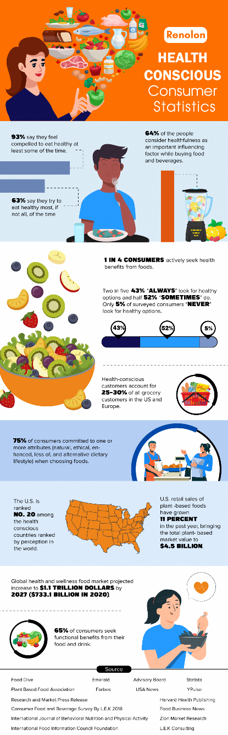(M, 2023).
In addition, an increasing health-consciousness of an ageing population and younger generations offers opportunities for businesses offering personalised nutrition solutions. Cultural factors, dietary preferences and lifestyle trends are also shaping customer behaviour and product acceptance.
Technological factors: technological progress is driving innovation and disrupting traditional business models. Based on Simon Kemp’s article (2023) at the beginning of 2023, the UK had a high level of digital penetration, with 97.8% internet penetration and 66.11 million users. Social media usage was also widespread, with 84.4 percent of the population, 57.10 million people, actively participating on various platforms. In addition, the number of mobile phone connections reached 87.66 million, exceeding the population. Therefor in the UK, high internet penetration rates, widespread smartphone penetration and the availability of cutting-edge technologies create a favourable environment for digital health solutions such as SmartMeal. Integration with wearables, AI-driven algorithms and data analytics capabilities enhance the functionality and user experience of the app. However, rapid technological change requires continued investment in research and development to remain competitive and meet changing customer expectations.

Conclusion
In conclusion, the business idea of SmartMeal, a personalised nutrition and meal planning app, shows great potential to meet the growing demand for convenient and efficient solutions to manage eating habits and achieve fitness goals. SmartMeal aims to provide users with valuable tools and resources for a healthier lifestyle by addressing a gap in the market for personalised meal planning assistance. With a focus on user convenience, accurate tracking and expert nutritional advice, SmartMeal is able to capitalise on the opportunities offered by societal trends towards health and wellness. With strategic planning and execution, SmartMeal can become a leading player in the digital health and wellness space.

Reference list:

Broom, D. (2022) 6 trends that define the future of health and wellness, World Economic Forum. Available at: https://www.weforum.org/agenda/2022/02/megatrends-future-health-wellness-covid19/ (Accessed: 15 February 2022).
Housel, M. (2020) ‘Luck & Risk’, in The Psychology of Money. Petersfield, Hampthire: Harriman House Ltd, pp. 25.
Kemp, S. (2023) Digital 2023: The United Kingdom - DataReportal – global digital insights, DataReportal. Available at: https://datareportal.com/reports/digital-2023-united-kingdom (Accessed: 20 March 2024).
M, Y. (2023) 18+ health conscious consumer statistics 2023: New data, BusinessDIT. Available at: https://www.businessdit.com/health-conscious-consumer-statistics/ (Accessed: 9 Aug 2023).

