Games Design and Critical Analysis

Painting an asset through substance painter and zbrushes poly paint.

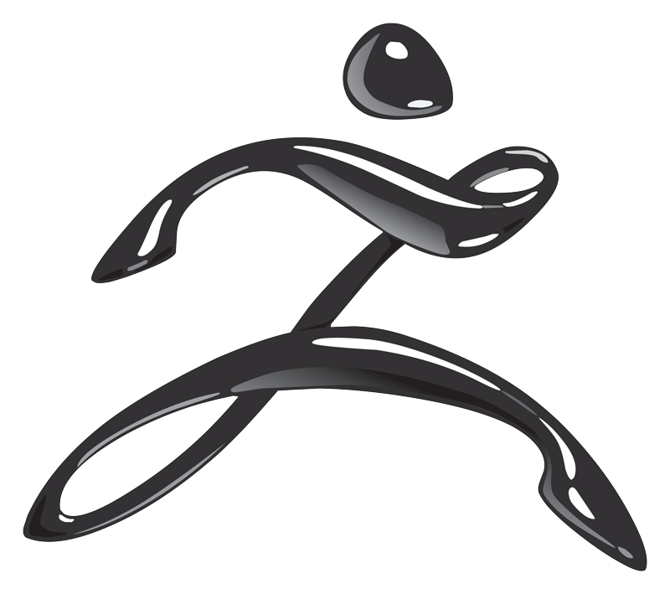
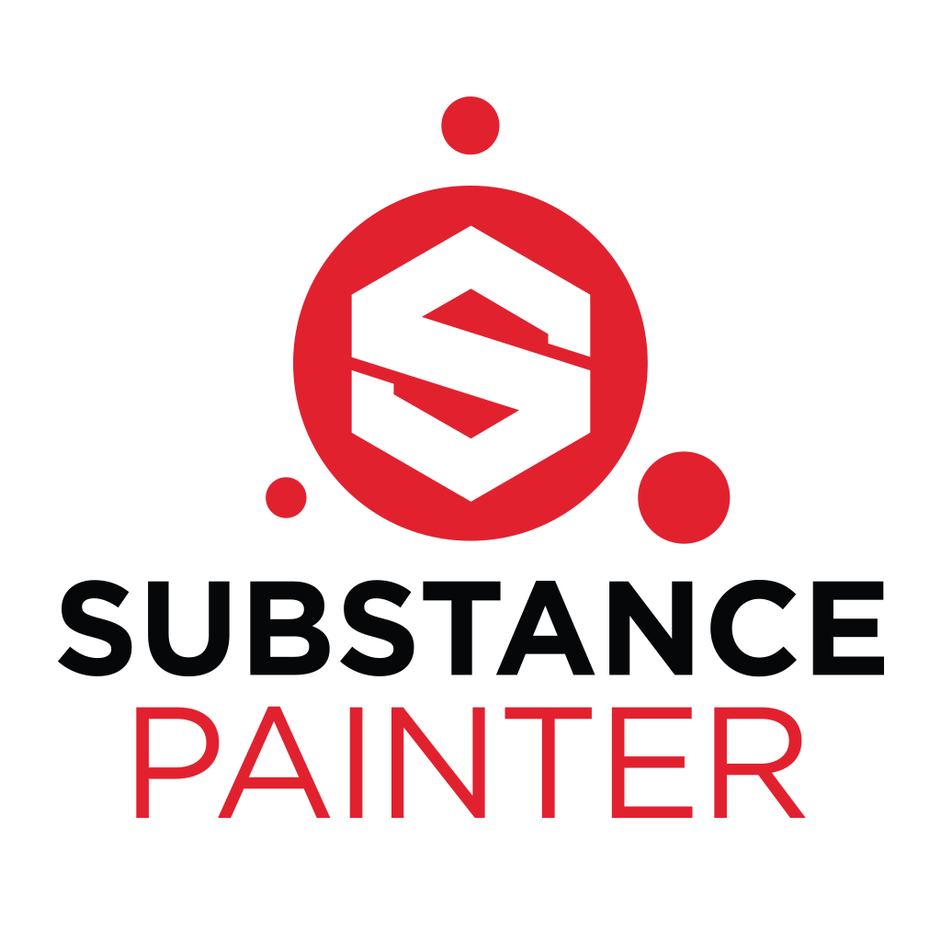


Declaration
This document and all data gathered from the test is all written by myself, any references used will be referenced in the correct Harvard format.

Abstract

The document will discuss the process of painting an asset created within Maya both in zbrush’s poly paint and substance painter. The main areas of discussion will be on the usability and the software’s tools. Discussion and debate on the capability of creating a high quality painted asset within the shortest time. Whilst throughout talking about the pros and cons of interface, quality and complexity of the software. All will be ended with a conclusion on which is best to be used for new users and for industry standard work.
This document will also list various places in which to learn and become aware of the capabilities of both substance painter and zbrush

Content page.

Page 5 – Introduction
Page 5 - 9 Literature Review + Research
Page 10 – Methodology
Page 11 – 15 – Data Gathering and Results
Page 16 – 17 – Conclusion
Page 18 – Further Work
Page 19 - References

Introduction

This document will discuss the process which was taken to see if Substance painter or zbrush has the more efficient software when it comes to texturing a model. There will be multiple different tools that will be looked at and possibly all tested to see which can give the best quality outcome in the shortest amount of time. Each of the separate programs will also be looked at for internal aid so if a user was confused on something to do, instead of going to YouTube to find the answer they could get help from the programme its self.
Before commencing with the test a video will be watched for each software just to have a brief understanding on how the software works. Once these have been watched the test will commence.
The key areas that will be tested, compared, contrasted and critiqued will be.
- Usability ( Navigation through software )
- Quality of brushes
- Unique tools
- Quality of colours
- Overall outcome of the artefact
- Problems encountered
These key points will hopefully structure the test to be more successful as these areas will be looked at much more in depth. Videos will be captured of each software to justify a conclusion based on time it took and the quality of the outcome.
Once every aspect is covered a personal conclusion based on the quality of the model without being biased.

Literature Review and Research
Substance Painter VS Zbrush ( Poly paint )
Substance Painer – ‘ Substance painter is a 3D painting software allowing you to texture and render your 3D meshes’ This is the first description of what substance painter is on Algorithmic’s website who are the owners and creators of substance painter.
The idea of substance painter is to give the user the tools in order to create the most lifelike assets or characters but also flip that and give the tools to create a very stylized texture.
With substance painter, it is designed so that any model that is uv unwrapped in whatever modelling programme being used you can ten import so you can directly paint onto the asset/characters , This is called painting UV’S this allows users to get a huge amount of detail into their artefact. Along with this programme comes a lot of more in depth elements that can help a user achieve a designated style and finished product. With additions such as smart materials which aren’t like general materials. Smart materials are as if a user mixes a load of simple and standard materials such as metal, wood and rust , compiles them into one texture which then allows the user to use as if it is one texture. Here are some examples.
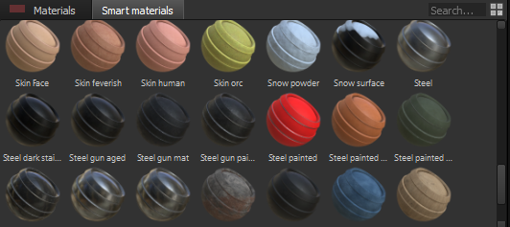

This is an example of just a few different Smart materials that can be used.
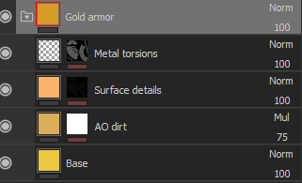

Take the ‘Gold armour’ smart material for example. This is the dropdown of that material What this is showing is that the material its self has built up different textures and then have been tweaked to fit the target material. Imagine it’s like painting a picture, the smart material acts like that in the sense of it works as a layering system. The base is the start point and then anything you add in addition will be on top of that base colour.
The algorithmic website displays the history of its company and the programmes created. The year 2002 ‘Marks the incubation phase for the allgorithmic corporation. From that year, the company has been forever growing, improving their invention and helping users become great texture artists.

Substace painter has been a very prominent tool used throughout the gaming industry. Gamers such as
- Uncharted 4
- Horizon zero dawn
- Watch dogs 2
- Tom Clancy’s Ghost Recon
And many more. Substace painter is known within the industry for being one of the best texturing software’s out in the market today. These don’t only offer the user the ability to import the textures into games. The software can be used as product design and automotive design if needed. As long as the model its self is sound and has the correct requirements too import into substance painter, then by all means the user has complete freedom to use it.

Zbrush ( Poly Paint )
Zbrush is prominently used to model characters and environment assets. This uses pre and custom made shapes that can be moves around by scale and shape. This then allows the user to begin modelling anything they choose so please. There is the fact that you can sculpt a human body specifically to represent an actual body is amazing. The key difference with exporting a model from Maya into substance painter and zbrush is that zbrush paints he vertices whereas as discussed before the uv’s get painted in substance painter. This can potentially have some problems that will need to be overcome when designing.
Painting within zbrush is called poly painting. This works by having a model and then using a type of process which is painting different colours on to the object to create a final artefact.
One key difference between these two pieces of software is that substance painter uses materials and the other doesn’t, just solid colour. This to some people may not be a big problem but the test will hopefully create an outcome as to which can create a game ready asset in the shortest amount of time, still have a high quality finish but also utilize many of the tools available.

Textures have come a long way since the first noticeable game textures in a 3D game such as the first Wolfinstein and Doom. Within the past 20 years games have evolved using as well as the software used to make games more ‘realistic’ and ‘lifelike’ and with games such as battlefield, forza and other games that have that realistic look comes great sales and a huge community following.
One thing that was found when conducting research about user’s time with the software. There is a lot more positive comments around the usability of Substance compared to zbrush’s poly paint. This is mainly because of the complexity and the depth of zbrush. As substance painter is purely a 3D painting software compared to zbrush having multiple different features. But for this test it was very interesting too see that substance was favoured just cause of the complexity of something that can easily be learned

What Games Use these?
Without a doubt a huge percentage of games use zbrush for modelling purposes but there is no evidence that companies use the poly paint feature from the research conducted although, the feature would probably be used by individuals that felt that there is no need to export to a separate soft wear that is specifically made for texturing.
Allegorithmic themselves list the games that have used substance painter for characters and environment. The list of games consist of
- Uncharted 4
- Horizon Zero Dawn
- Watch Dogs 2
And many more.
But games are not the only thing substance painter is used for, A section of the allegorithmic site shoes that substance painter is also used for film, architecture , design and education purposes. This programme can help a wide range of creators showcase their work in a high standard.

What is the difference between them both?
There are many significant differences between the both programmes , one primarily is used for painting the artefact and the other is too model but the key differences when it comes to the poly paint vs substance is that one lets you paint on the polys and the other lets you paint the vertices. This means that depending on the quality of the thing you wish to paint it will change the overall look.
Substance painter – Painting UV
Zbrush Poly Paint – Painting Vertices
There is ways to get around making it easier to paint. There is an option within zbrush called dynamesh. This reworks the topology on the artefact allowing the user to paint more fluidly across the artefact. The only problem with this is that it removes hard edges quite frequently if higher dynamesh is used. This is something through testing modellers would have to be cautious of.
Substance painter uses UV’s that modellers have previously made in their 3D modelling software. Maya for example gives you the option to split a model in half and creating a seam so it would be as if it has opened up flat. This makes it easier for textures to flow across the model.
Both substance painter and zbrush are used depending on the user’s preferences. From exploring various opinions through people. Many say that substance painter is the more efficient when trying to create an accurate copy off concept art, But with the modelling capabilities zbrush does have a more detailed system all around.

One video that in a lot of detail shows the process of creating a game ready model using both substance painter and zbrush. The forty-minute video discusses presents the made model in zbrush but the texture elements in both. It is a good example of the different process that must be taken in order to create the final game ready model. One thing that the video shows that could be used in the test is the use of different view ports of the asset, showing the different areas of material, roughness, metallic and things like ambient exclusion. This also gives a better understanding to new users who have not used things like this before as the user explains what specifically they are used for.

Methodology
Brief test description.
The test will involve creating an asset within maya ( In this case a nuclear missile ) Once the asset is complete it will be uv unwrapped ready for both substance painter and zbrush.
This asset will be imported into each programme and will be ready to paint. A walk through video will be watched for each software in the most basic software to show exactly how to prepare the asset to paint ( Both videos are approximately 5-7 minutes long )
Once completed, the painting of the asset will begin being timed and recorded for analysation and reference purposes for the conclusion to the test.
Once each item is complete, both recordings will stop and the painting from both software’s will be screen captured to use in this document.
Avoiding biasness was an issue that needed to be sorted. As there is more knowledge for substance painting then there was for poly paint. One made sure to have full knowledge of how the basic system worked and how to navigate to what was needed without effecting the test.
Once fully completed a check list will be filled out in order to see which has given the best outcomes regarding the areas that were planned to be concentrated on.

The conclusion of both tests will then go through a review stage where the videos will be looked at an analysed to see some things that could have possibly been avoided or even things that could have been done in order to save time. These will then go towards the decision of which software is the most efficient and which would most likely be best for new users to use.

Data Gathering And Results

Substance painter –
The Data gathered from substance painter was very much different to what was collected for zbrush. From the very beginning point of the test, substance painter allowed the user to jump right in and start painting. Once the asset was loaded into substance painter the user was given the option to paint, not with any colour but was as if you can shade in the asset.
One of the more ideal things about substance painter compared to zbrush , substance has more of a visible layering system. Almost identical to Photoshop.
Once the initial layer Is placed, you have the option to either place a normal material or what’s called a smart material. This asset had a mixture of both but predominantly smart materials. The effect that the smart materials gave to the whole asset was much better then building up many more normal smart materials. Adding a simple smart material adds depth too the asset. The main smart material used was one called ‘Mechanic’ This was a yellow background with dirt splatters surrounding the colour. Once applied to the asset. The ability to change the colour of the background and the splatter was used. There was a green colour scheme used throughout both substance and zbrush.
In this instance for substance painter. The very background which was the solid colour was changed to a swamp green and then the foreground splatter was more of a rusty brown rather than a dirt brown. Following this a black mask was created on that layer to allow the smart material to be basically invisible until painted on areas that you wanted that colour to show. This was a constant help throughout with substance painter. There was no need to worry about painting over something that wasn’t right as you could just utilize the layering system and it would work fine.
This was constantly used to build up the detail of the piece until needing to add some fore ground detail.
The main idea was to paint a start on the side of the asset to make it look more unique, too add some character too the piece. With trying to paint this the ultimate look to this didn’t look great. With this being the case. One found that there was an area on substance painter that said stencil. With this a picture of a star was found on google that could be used on an asset such as this. It was a simple case of clicking and dragging the image on to the stencil layer and painting on the stencil.
The most beneficial thing about being able to do this was the fact that you could then add another layer to blend the star in , as if it is in the background of the asset rather then right at the front.
Too add the final layer to the piece that would complete it was another smart material that was called ‘rust’ This was then placed on just like the other layers and added with a black

mask so I could pick and choose where I wanted the rust too go. As the rust was not a solid material there was something called the generator. This allowed the user to choose the layout of the shapes of the rust. This meant that there wasn’t repetitive shapes within the areas that had been chosen to paint with this specific material.
Problems encountered.
There was only one main problem that was encountered and it wasn’t to do with substance painting at all.
When modelling the asset. There were no separations for the uv around the wings of the asset. This meant when a colour was placed on that specific area, it would seem stretched.
It was quite tricky to overcome this problem but after playing with different materials and trying to figure out how to fix it, A simple change of the brush size was used to darken out areas of the material that appeared stretched. The results of this wasn’t what was expected when setting out the task, but for test purposes it was good to see that more detail and caution would need to be taken in the modelling process just as much as the substance painting process.
The brush that can be used within substance are very beneficial for all types of assets you might be modelling and texturing.
Substance also used particle effects to paint an asset. One example is rain drops. The rain drops can give the effect of corrosion or possibly streaks of water on glass. The use of the particles are very useful and easy to use.
Before completion of the piece. There was more understanding needed about the generators that can be used in the piece. After competition one found out that these can be used to really get a great effect on the asset. This could have been a very important thing to use to swerve the overall outcome of the piece to be much more detailed.

Zbrush –
The first initial stage of importing the image to zbrush was very problematic, trying to find the correct area within zbrush to import an already modelled asset was impossible at first. After searching for a few minutes, eventually the correct process in which to import was found.
The next step was to get the asset ready to be painted. Initially the process of this was simple until the painting process began.
When painting on the asset, there was no indication that any paint was being transferred on too the asset. There seemed to be broken streaks and not solid colour. There was complete

confusion as to why this was happening. The test was stopped purely to find this problem and try and fix it.
The way around this was too increase the dynamesh, what this did was increase the amount of faces that were on the asset. This has happened because of the modelling process was not utilised for zbrush specifically. But that is a problem that possibly wouldn’t be known by everyone so this is possibly a good area to focus on if planning to paint within zbrush.

Once the problems were overcome painting could begin.
The process of painting was initially simple. The first steps were to block out the asset with lighter colours and get an idea of what the colour pallet that would need to be used. One this is done painting began. The main colour scheme that was planned to use for both substance and zbrush was a swampy green with highlights of other colours. When picking the colours for painting in zbrush I found it was much easier to get the specific colour you wanted. It was just a case of scrolling through a colour chart until you liked whatever the colour may be.
With the problem of the mesh having to go through the process of dynamesh. The model changed shape ever so slightly, it lost most of its hard edges and somewhat blended all into one smooth piece, this didn’t affect the painting process and much as originally thought but it most defiantly made it more difficult to create the best possible piece.
When most of the asset was painted, one noticed that there was no real blending between the colours throughout the piece. The piece looked as if there were sections with solid colour. This didn’t look good or even within the guidelines initially set out. The way this was overcome was to get a colour that would match each of the colours, in this case it was an off white and a very dark blue. With these colours, there was no problem in removing that problems of the sectioned off colours.
Another problem that became quite a consistent pain was trying to navigate around the software. There are so many different areas of zbrush that means one thing but does another. For new users to pick this up and play around with it would be very confusing and difficult.
A few positives that was very noticeable was that zbrush could be used very efficiently for very detailed modelling changes. Although this was not a part of the test , you could change the asset to look as though it has extra layers , possibly mould, rust or even broken pieces. This could be very efficient for users if need be. This would absolutely need to be done within zbrush, bringing an asset from another modelling software to zbrush could drastically effect the final colour.

Final outcome ( Picture + Discription)
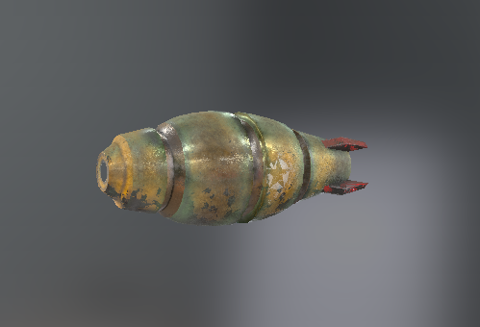

- Substance Painter –

This by far came out as the best texture. The whole texture its self was made using smart materials with a normal rust texture with a lowered intensity too mimic dirt and dust rather than rust. Being able to chance the colours of both materials and smart materials really helped with the overall process and outcome. As the idea was to create a game ready textured asset that could be used in different styles of games this does tick that box as depending on the in game shader. The colours would still show through and would still have the character it does without.
The one problem that was encountered when texturing this was the generator of the dirt located at the very bottom of the asset. This became a real pain to try and get right as when the generator was being moved manually there wasn’t much difference in the appearance of the colours. But it was decided to just be left as is and continue to finish the asset.
The final time to completion was just over an hour.

Final Outcome ( Picture + Discription )
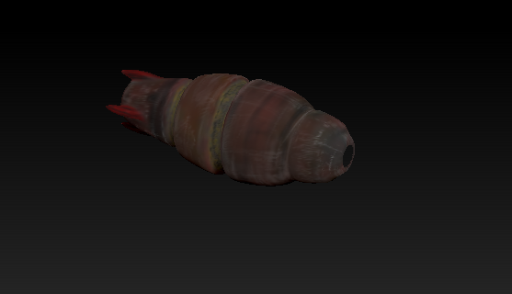
- Zbrush , Poly Paint

This final outcome wasn’t the best. The colours that were used in the beginning showed real hope of giving the asset real character and an overall good look. But as the problem of the painting not transferring to the asset correctly thus needing the dyna mesh process to happen it really then affected the final outcome. The colours turned out to be very dark and dull and there was no character at all throughout the whole of the texture process.
The initial challenge of trying to figure out how to even paint added another element of complication thus resulting in not being able to figure out how to transfer a stencil or even to gain access to more accurate colours.
With that being said the actual final outcome could still be used in a game. Unlike the substance painted version the colours are quite dull and not very detailed. So this could be used in a top down game or possibly as a killstreak type weapon in a fps game. Overall the outcome wasn’t exactly that was being aimed for but wasn’t the worse it could have been.
One of the most difficult things about creating this was the problem of gathering the correct colour palet prior too painting. As there was no specific materials like substance painter available to use this made the process much longer.
The final time of completion was just over an hour and a half.
Conclusion

Both Substance Painter and Zbrush have their own pros and cons, unfortunately one more then the other. The outcome for both were not by any means perfect, but one had much more of a pleasing outcome than the other.
Zbrush by all means has the potential to be used as a permanent painting software , but for new users to get straight into it would be somewhat difficult. Many videos would need to be watched to make sure everything was covered on the basics. This would then allow users to progress. Regardless of this one thinks that the process to complete a fully painted asset would take significantly longer than needed.
One positive is that the user has a very wide range of options when painting. The brushes that can be used can be changed in size very quickly using shortcut keys , or even on the scrolled at the very top of the zbrush page.
If considered before undertaking the test. Amendments would have been made to the process of the zbrush testing to
- Make sure that the model was properly ready for the texturing within zbrush.
- Possibly make the actual model in zbrush.
- Be more aware of other processes that can be taken to create the final painted artefact.

In all the final outcome for zbrush was not the best. For the intended outcome being a somewhat realistic looking nuclear missile, the painting process did not in ones opinion do the best job.
The outcome could be down to the lack of previous experience of the software, but there should be more detailed tutorials within zbrush to help users who may be confused or never used before a chance to learn quick and efficiently.

Substance painter was the better of the two software to use. If any designer has every had experience using substance painter then they would be able to use substance painter somewhat comfortably. There are some elements that are confusing to use such as stencilling, but this could be utilised by quite simply playing around in a layer and if something doesn’t look great , a simple delete of the layer can allow you to start again.
As Substance is a UV painting software, the outcome was a much more higher quality. As Substance painter has much more of a range of already made materials, it gave much more of an option to create the best-looking asset.

Once a layer was using the material, the user could change the details of that said material which made creating a finalised asset so much easier as you could inch for inch copy an idea or even a picture.
Although it doesn’t come with some problems. Just like zbrush it had a problem with the faces that get painted on, again this wasn’t a problem within substance painter, but with the modelling. Although it’s something still to look at carefully. The faces of the UV were stretched on 4 specific areas of the asset. The fins of the piece had a flat face that were complete quads that were not split up at all, meaning the faces when painted were stretched. This problem would need to be carefully looked at to allow better workflow.

When making this test, Substance painter 2017 was not available in the university as there was no licence available at that time. Now there is a possible second test could be conducted using Substance painter 2017 And Zbrush 4R8.
With this there could be more concertation on the areas that were not looked at in the first test. This could be other ways of texturing, possible external tools such as downloadable alphas that can affect the outcome of the piece.

Substance vs Zbrush Chart ( Most efficient )
KEY AREAS | Substance Painter | Zbrush
User interface | *
Quality of brushes | *
Uniqe tools |  | *
Quality of colours/Materials | *
Overall outcome of artefact | *
Most problems |  | *

The key areas that were planned to look at give an outcome that substance painter gives the best outcomes for most areas. This was purely based on the test that was created. Other key areas of zbrush or substance painter could be concentrated to do further work.

Overall the both tests really gave a good understanding as too which could be used more efficiently but also gave good further knowledge of both substance painter and zbrush’s poly paint feature.

Further Work
There are a few different tests that could be conducted in order to create possibly different outcome. An example of this would be to use Substance Painter 2017 vs Zbrush 4R8.
With these new and improved software applications, a similar test could be made in order to see again which can produce the best outcome. This test could specifically look at different elements of each piece of software such as generators and additional tools other than the conventional materials and smart materials. You could compare this to the areas in substance painter which allows you to get a image and somewhat paste the actual texture of the image onto an asset of the same dimensions and shape.
Some other further work could be to change the type of physical model you need to paint its self. For example a test could include having to texture a human character model with realistic scar tissue. This could then be done utilising many video tutorials and tutorials within the software themselves to try and help create the final outcome.
Another test could try and utilise the modelling aspect of zbrush more. The test could be to model a character in zbrush first then export the model to then be able to paint in zbrush and substance painter. This could then see if the procedure of modelling within zbrush first can actually give the better painted outcome later on.

There are possible areas that can be explored in much more detail when creating a test like this regarding specific tools. One test could be to explore a specific tool or process that are both available in substance painter and zbrush. From this a test could include the number of steps that need to be taken to get to the specific tool and how this could affect the process of the test.
There are many areas an individual can explore through testing as both substance painter and zbrush are so vast with the possibilities available. The results from many tests can be put together to see exactly which is the best software for texturing.

Refrences

youtube (2017). Create Quick 3D Game Model (Zbrush/Substance Painter). [video] Available at: https://www.youtube.com/watch?v=A1iO-bBn1XQ [Accessed 14 Nov. 2017].

youtube (2017). low poly from high poly in zbrush and substance painter. [video] Available at: https://www.youtube.com/watch?v=SiNl5-qm6QQ [Accessed 14 Nov. 2017].

Youtube (2017). Zbrush Polypaint Tutorial - An Introduction and Basics HD by 3dmotive. [video] Available at: https://www.youtube.com/watch?v=Pm2qq33nBp4&t=572s [Accessed 7 Nov. 2017].

Steamcommunity.com. (2017). Zbrush or this? :: Substance Designer 4 General Discussions. [online] Available at: https://steamcommunity.com/app/238710/discussions/0/540744934857292680/ [Accessed 29 Oct. 2017].

reddit. (2017). Do you prefer to texture paint in zbrush, or use 3rd party software, like Mari or 3D coat • r/ZBrush. [online] Available at: https://www.reddit.com/r/ZBrush/comments/2zkan0/do_you_prefer_to_texture_paint_in_zbrush_or_use/ [Accessed 24 Nov. 2017].

Forum.allegorithmic.com. (2017). Zbrush to Substance?. [online] Available at: https://forum.allegorithmic.com/index.php?topic=3173.0 [Accessed 24 Nov. 2017].

