Introduction.
  case study  Project planning, monitoring and control | Joshua Banfield  P143898  Juan A. Ferriz Papi

This assignment is to build four blocks of flats in the centre of Swansea town, the flats will be joined together to form an L shape building and each block will have a different number of levels. These range from 5-15 floors high. Block A will have 5 floors with two underground floors, block B will have 7 floors with two underground floors, block C will have 11 floors with two underground floors and the fourth flat will have 15 floors with two underground floors.
Where details are not specified the calculations will be worked from the assumption that the typical story height of 3.8metres and typical block perimeter 25mx20m. Work will commence the 1st January 2018.A working day will be considered as 8 hours.
The aim of this assignment is to make a schedule for the construction of this building. Starting from the substructure to the superstructure, Foundations, Basement, Top roof and the External walls. The paper will also include bar charts showing the work needed for each activity, the bar charts and Gantt charts will also show the number of workers it will take to complete each task, how long each task will take to complete and the cost of labour hours. In my Gantt chart and works schedule I will take into consideration of the float and bind. This should allow me to alter if there is to many labours onsite at any one time, also to manage the cash flow of the sight.

Site Layout

The first activity to commence before any site work begins is the site layout. Most construction sites that run into trouble do so for reasons related to managerial factors rather than because of technical problems. Site management, in general, involves many tasks, such as site investigation before construction process starts, material delivery and procurement management, keeping better site records and high level of information flow, monitoring performance regularly, establishing a good co-ordination system among different parts, and performing a good site layout planning.
Extensive time loss and cost overruns could result in large projects, where the number of manpower, subcontractors, and equipment involved are high, if there is no effective and systematic approach to site planning.

Substructure

Site clearance.
The second activity to commence is the earth works and the site clearance, this should take two labourers around five days. The next process of the earth works is to investigate the site for any existing services.
Production for 1 labourers with plant machinery 1m²=0.28 minutes.
With 2 labourers clearing the site of shrubs and bushes. 2m² in 0.56 minutes. 2.14m² hour clearance rate. 2000m²√2.14m² = 934.57 hours to clear site. This would take 23.35 days.

Cost for 1 labourers with plant machinery £4.33=1m²
With 2 labourers clearing the site would cost £8.66 2m².
2000m² x £4.33=£8,660
Coast per day £370.87

(SPON’S,2018)

Retaining wall contiguous pilling
Installing the contiguous piling will be the next activity.
Production for 1 labourers with plant machinery 900mm wide by 20m deep pile=4.44 hours.
With 4 labourer gangs can produce 3.8m in 8.88 hours. 247.5m√900mm bore=275piles for the perimeter of the building. 275√2=137.5 bores between two piling teams.
137.5x8.88hours=1,195working hours.
1,195 hours√8=74.5 days
(SPON’S,2018)

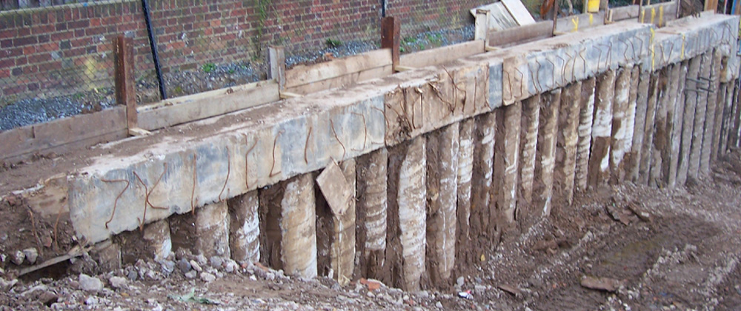

Excavation
After the piles, have been constructed the excavation can start for the 2 underground floors.
Production for 1 labourers with plant machinery 1m³=0.9 minutes.
With 3 labourers with plant machinery 3m³ in 0.9 minutes. 20m³ hour excavation rate. 2 floors with a total depth of 6 metres. 2000m² X 6m = 12,000m³ to excavate. This would take 15days.

Cost for 1 labourers with plant machinery £3.09=1m³
With 3 labourers with plant machinery £9.27 for 0.9 minutes. £61.8 hour excavation rate. 2 floors with a total depth of 6 metres. 2000m² X 6m = 12,000m³ to excavate. This would cost £7,416.
Coast per day £494.40
(SPON’S,2018)

Drainage/services
After the second floor of the basement has been excavated, the trenches for the drainage can be excavated and the drains can be laid. This is the last activity for the ground works, this process will take
Production for 1 labourers with plant machinery 1m=0.22 minutes.
With 2 labourers can produce 2m in0.44 minutes. 5.45m per hour.
5.45m a dayx8=43.6m per day
1000metres of drainage√43.6=22.5days.
(SPON’S,2018)

Foundation in situ, concrete reinforced raft foundation exceeding 300mm.

The complete floor area for this project is around 2000m2, each floor slab will there for be 500m2.

Production for 1 gang of contrite layers is 1m³=1.15hours .
With 2 labourers can produce 2m³ in 2.30 hours. 27.8m³ a day.
500m² per block √27.8m³=17.9 days per block.
2000m³ of foundation √27.8m³=71 days
(SPON’S,2018)

Basement walls.
The first activity to be done is to grout in between the contiguous piles, this will take two gangs of five labourers six days.
Production for 1 labour doing 1m³=2.4 hours of concrete wall.
With 2 labourers 2m³ an hour. 6.6m³ a day. The basement walls are 6m deep as excavation shows and a perimeter of 240m. 240mx6=1,440m². The walls for the basement do not need to be 1m thick so we will half the m² so the walls will only be 500mm thick.
720m² √ 6.6m³=109 days.
(SPON’S,2018)

Basement tanking

Production for 1 labourers with plant machinery 1m³=0.26 minutes.
With 2 labourers damp proofing at 2m² in 0.54 minutes. 4.61m² hour. The basement walls are 6m deep as excavation shows and an perimeter of 240m. 240mx6=1,440m²
1,440m² √ 4.61m² hour=312hours.
312√8 hiurs a day=39 days.
(SPON’S,2018)

Superstructure.
The main structural frame of the buildings will be constructed out of steel. The steel will again be constructed in different sequence, there will be two teams doing the steel skeleton of the building. The first team will start with block D the tallest building.

Steel frame
Production for 1 labourers fitting steel frame is 10m=0.30 minutes.
With 2 labourers 20m hour fitting steel beams. 1 block floor is 90m of steel. 90m √20m= 4.5 hours per block floor.
38 floor x 4.5 hours= 171hours√8hours in a day= 22 days

Cost for 1 steel fitting. £53.95=10m steel beam fitted.
With 2 labourers 20m hour is £107.90. 1 block floor is 120m. £107.90x6=£647.40 per block floor.
£647.40x38= £24,602.
£24,602√288=£85.42 per day
(SPON’S,2018)

Infill precast concrete beam and block floor.

Production for 1 gang fitting block and beam flooring. 1m²=0.45 minutes.
With 2 labourers they would produce 2.6m² an hour. 21.3m² a day.
Each single block floor area is 500m²
500m² √ 20.8m² a day= 24 days
4 labours doing 500m²=12 days
8 labours doing 500m²=6 days
2000m² √ 20.8m² a day= 96 days
(SPON’S,2018)

Roof covering
For this project, each block will have a fibre bitumen thermoplastic sheet covering.

Production for 1 gang fitting fibre bitumen roof covering. 1m2=0.23 minutes.
With 2 labourers they would produce 41.7m² an hour. 83.4m² a day.
Each single block floor area is 500m2
500m2 √ 83.4m² a day= 6 days
2000m2 √ 83.4m² a day= 24 days
(SPON’S,2018)

Infill walls with dry line plasterboard walls and partitions.

Production for 1 labourer dry lining is 600mm=0.23 minutes.
With 4 gangs labourers 2.4m hour fitting dry line. 1 block floor area is 90m perimeter. 90m √2.4m= 37.5hours per block floor. 4 days per block floor.
8 gangs would complete a block in 2 days.
38 floor x 37.5 hours= 1,425hours√8hours in a day= 178 days
(SPON’S,2018)

External wall
The envelope of the building will be made up using a curtain walling system. A curtain walling system is an aluminium frame that is attached to the steel skeleton of the building, large panels are then attached to the aluminium frame.

Production for 1 gang fitting metal wall cladding. 1.25m by 3.8m=0.30 minutes.
Assumption that the typical story height of 3.8metres and typical block perimeter 25mx20m.
With 2 labourers, can fit 5m hour. 1 block floor area is 90m perimeter. 90m √5m= 18 hours per block floor. 2.25 days per block floor.
38 floor x 18hours= 684hours√8hours in a day= 85.5 day
(SPON’S,2018)

Charts and Gantt charts.
Work schedule of duration and start dates and completion dates of each task.
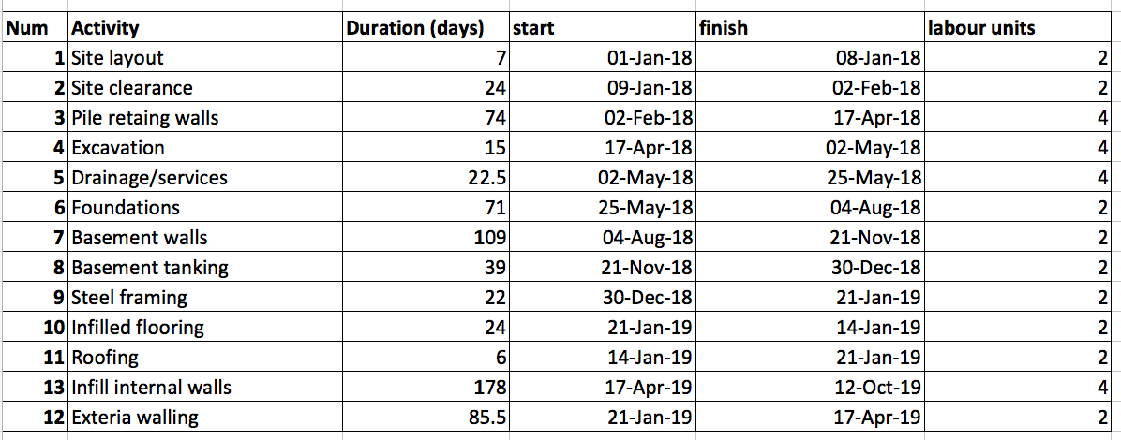
Critical path without any alteration to the labour or work flow. Such as pervious mention of working on block A and D to shorten the works of the project.
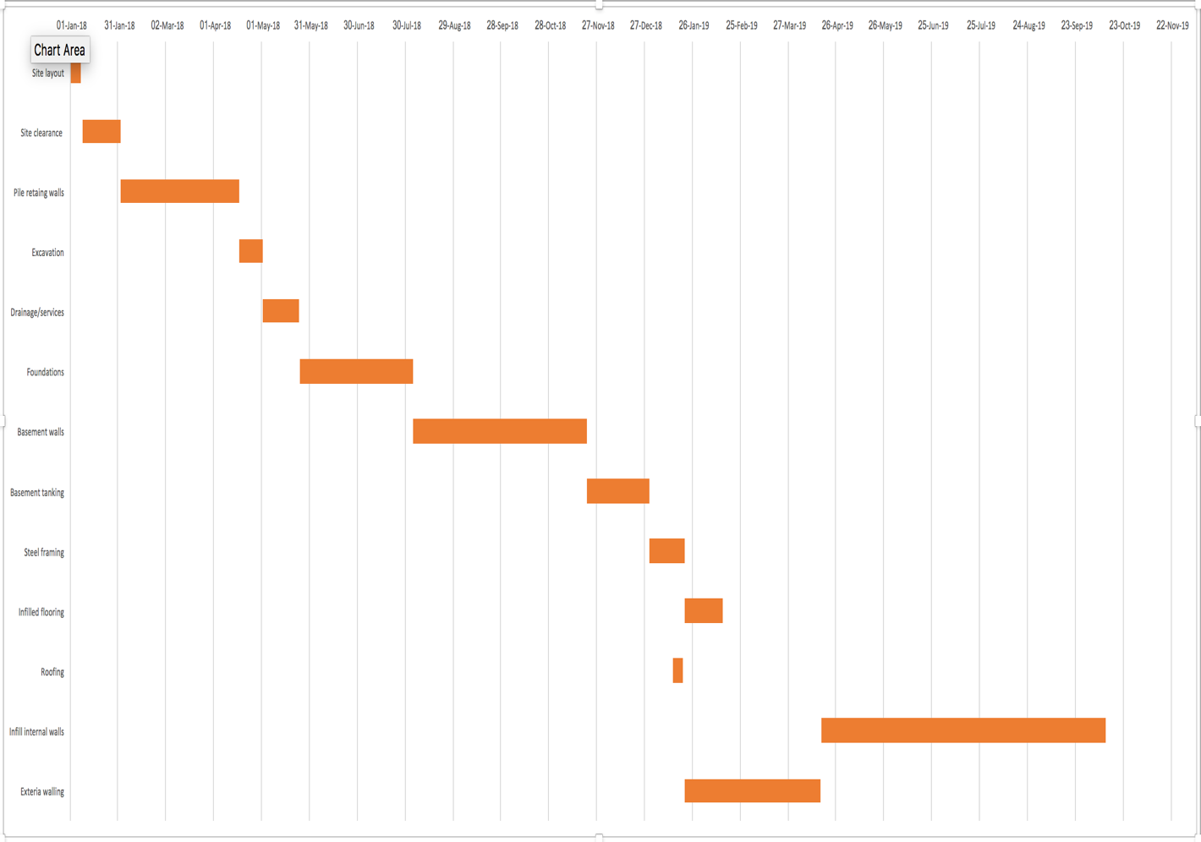
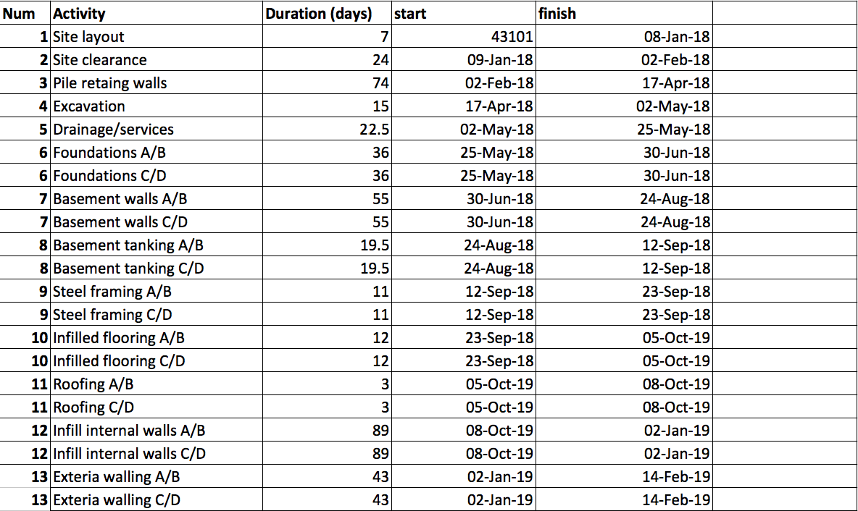

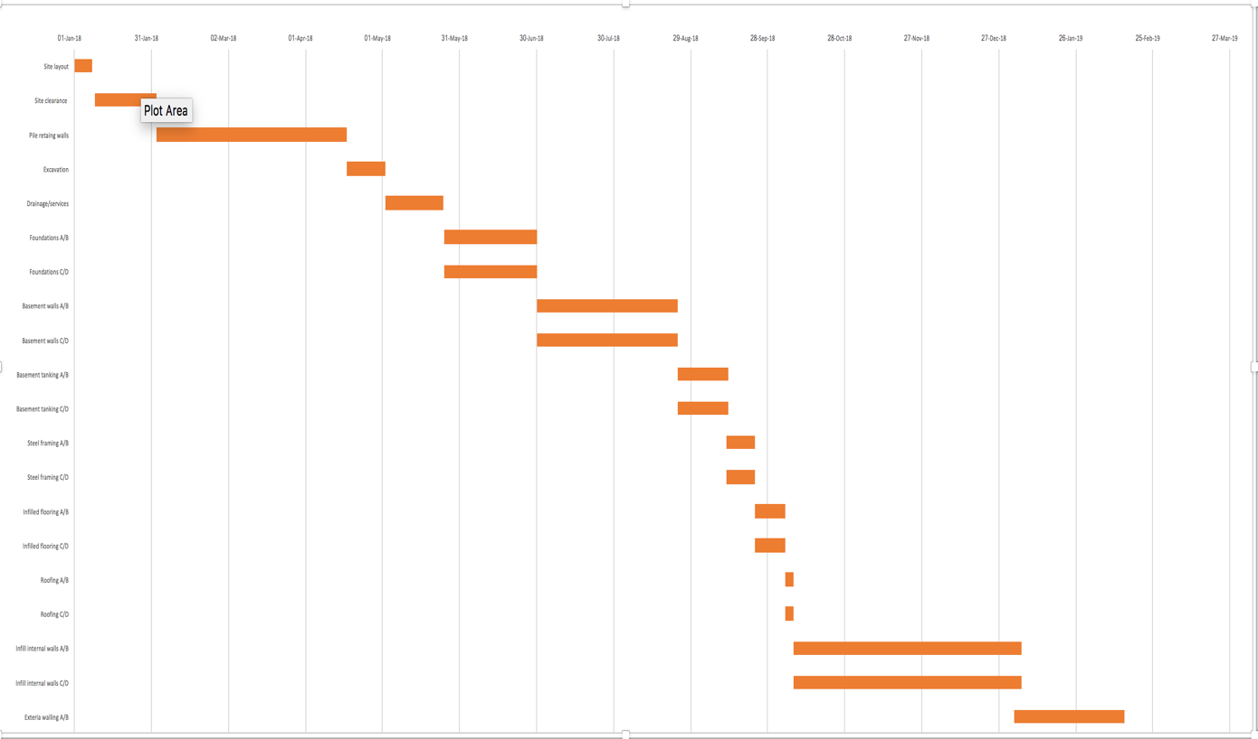
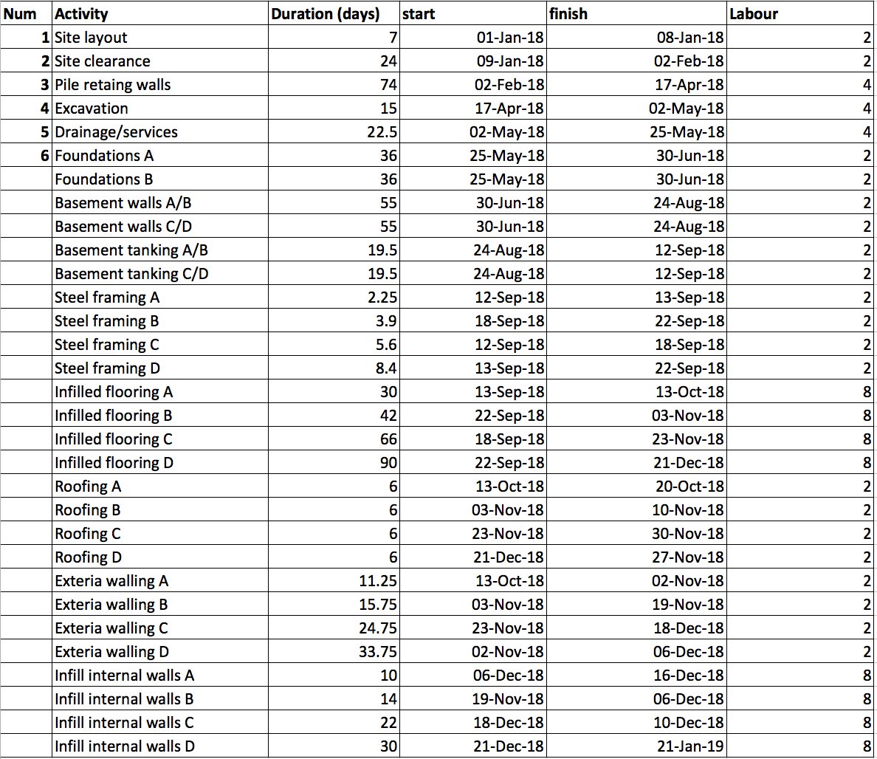

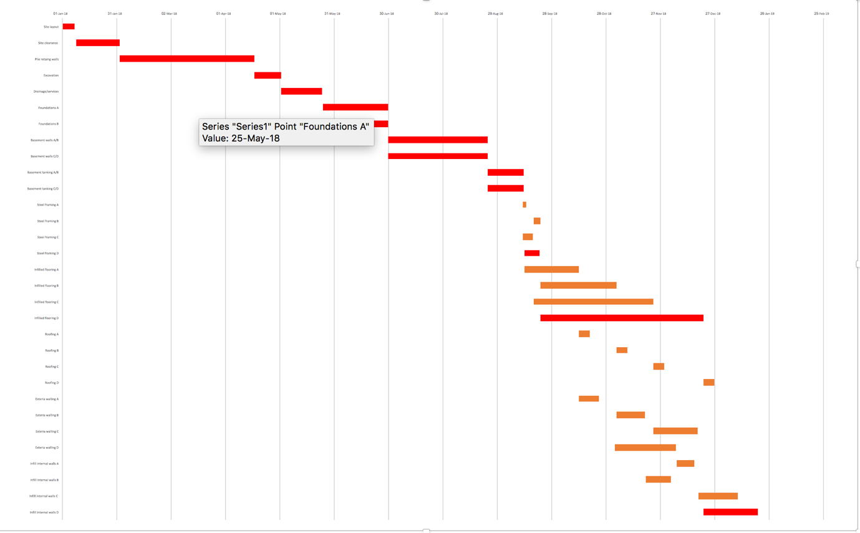(Red bar are the critical path.)
The final works schedule with labours on site with the smoothing technique used to minimise the number of people on the site at any time. The bar chart will also show the time scale that each activity is expected to take, and how many labourers that will be needed to complete the task with in this time. This can be worked out by using the SPON’s book.
The bar chats attached to this report will also show what is known as resource smoothing. When looking at a major project, looking at the cost of labour hours can be vital for the cash flow on a week to week basis. Resource smoothing can also be used to control how many labours are on site at any one time, for some the more labours on site the better as they think the job will get finished sooner. This isn’t always the case; a building site can get over crowded like anywhere else. Therefore, too many labours can slow the works down.
The amount of labours on site at any one time can be altered by using what is known as the float. The float is a noncritical activity within the program that can be brought forward or delayed within a specific time frame, this delay can happen without changing the critical path of the program.
By using the float to delay an activity or brining an activity forward. For example, if you have two activities going on at the same time of the program, both activity taking a week and both requiring ten labours to complete. If one activity can be brought forward or delayed a week without influencing the program, then there will be half the labours on site stopping overcrowding and keeping a steady cash flow within the project. (SPON’S,2018)

