Bethan Moyle
1707952@student.uwtsd.ac.uk
Design and implementation of a relational database system
Module Code: ACCA4023

Table of Contents
1 Introduction 2
2 Database Explanation 2
3 Scenario analysis 3
3.1 Entities and Relationships 3
4 Entity Relationship Diagram (ERD) Explanation 4
4.1 Entity-relationship Diagram (ERD) 5
5 Database Design 6
5.1 Rider 6
5.2 Bikes 7
5.3 Bookings 8
5.4 Employees 9
5.5 Maintenance 10
6 Testing 11
6.1 Query 1: Bikes Rented On The 19/01/2026 11
6.2 Query 2: Rentals By Specific Rider 11
6.3 Query 3: Bike Maintenance History Check 12
6.4 Query 4: Employee Maintenance Workload 12
6.5 Testing Summary 12
7 Conclusion 12
8 References 13

Introduction
Databases play a vital role in modern information systems by allowing organisations to store, manage and retrieve data efficiently and accurately. A well-designed database improves data consistency, reduces redundancy and supports effective decision making. This report explores the concept and purpose of databases, with focus on database normalization and relational design principles. Using EcoRide electric bike rental service as a case study, the report analyses the requirements of the system and demonstrates how structured database solutions can address operational challenges. Key aspects such as Entity identification, relationships, entity relationships diagrams (ERDs), table design and testing are examined to show how a reliable and scalable database can be developed to support business processes.

Database Explanation
A database is a structured system used to store, organise and manage data efficiently. It allows information to be easily accessed, updated and maintained. An important concept in database design is normalization [1], which is the process of organising data within a relational database to reduce redundancy and eliminate duplicate data [1]. This is achieved by splitting data into separate but related tables, which helps ensure that data is stored logically and consistently [1].
Normalization also provides several benefits that include improved data integrity, easier updates, more efficient storage, a clearer database structure, and a reduction in data anomalies such as insertion, update and deletion errors [1]. A commonly used level of normalization is Third Normal Form (3NF) [1], which ensures that all non-key attributes depend only on the primary key function improving consistency and reliability within the database [2].
In contrast to simple spreadsheet systems, databases are designed to support multiple users, enforce data validation rules, and maintain consistency across large volumes of data [3]. Spreadsheets are prone to duplication, accidental deletion, and inconsistent data entry, particularly when used by multiple people [3]. Databases address these issues by using structured tables, relationships, and constraints to control how data is stored and accessed [3]. Databases also support transaction processing, ensuring that changes to data are completed accurately and reliably [3]. This is particularly important in systems such as rental services, where incorrect or incomplete data could result in lost assets, billing errors, or poor customer experience [3]. By centralising data storage and applying normalization principles, organisations can improve operational efficiency, data security, and long-term scalability [3].

Scenario analysis
The EcoRide electric bike rental service requires a structured database system to improve the efficiency, reliability and accuracy of managing rider information, bike availability, rental transactions and maintenance records. The current reliance on manual forms and basic spreadsheets limits visibility across the system and increases the risk of errors such as unreturned bikes, and incomplete records. To resolve these issues, the database design must include defined tables for riders, employees, electric bikes and rental transactions, with each table using primary keys to uniquely identify records and foreign keys to establish relationships between related data. Clearly defining how tables connect will allow accurate tracking of bike usage, rental and return dates, staff involvement in maintenance, and overall bike condition. Selecting appropriate data types such as text, dates and numerical values, is essential to ensure data consistency and accuracy [3]. The use of constraints including fields and Not Null rules will help maintain data integrity by preventing invalid or missing data [4]. Implementing a relational database also improves accountability within the EcoRide service by clearly linking actions to specific riders and employees. For example, rental records identify who hired a bike and when, while maintenance records show which employee carried out servicing tasks. This reduces ambiguity and supports better operational oversight [3].
Furthermore, the use of validation rules and constraints such as primary keys, foreign keys, and NOT NULL fields ensures that critical information cannot be omitted or entered incorrectly [4]. These features help prevent common issues such as missing return dates, invalid rider records, or maintenance entries without assigned staff, improving overall system reliability. Additionally, a well-designed database will support scalability [3] as the EcoRide service grows and allows for effective reporting and analysis, such as maintenance frequency.

Entities and Relationships
The EcoRide database system is designed around several key entities that represent the main components of the electric bike rental service. These entities include Riders, Bikes, Rentals, Employees and Maintenance Records. Riders store information about individuals who use the service, while bikes store information about each electric bike, including its condition and location. The rental entity records each bike hire transaction and acts as a link between riders and bikes, allowing the system to track rental and return dates, duration and costs. Employees represent the staff members responsible for servicing and inspecting bikes, whereas Maintenance records store information about repairs and inspections of the bikes. The relationship between these two entities are primarily one-to-many, such as a rider having multiple rental records, a bike being associated with multiple rental and maintenance records, and employee carrying out multiple maintenance tasks. This structure ensures accurate tracking of bike usage, staff involvement, and maintenance history, while supporting data integrity and efficient database operation.

Entity Relationship Diagram (ERD) Explanation
An entity relationship Diagram (ERD) is a conceptual Model used in database design [5]. It is used to visually represent real-world entities, such as customers or products, and the relationship between them [5] (for example, A customer placing an order). ERDs use simple visual symbols such as rectangle to represent entities and lines to show the connections between them, making complex data structures easier to understand [6]. Entities represent real-world objects, while attributes are the properties that describe those entities [6], such as a customer’s name or order date. Relationships define how entities interact with one another, and cardinality specifies the number of instances in one entity that be associated with instances in another, such as one-to-one or one-to-many relationships [6]. By defining data, rules and connections before physical implantation, ERDs help ensure that database structures are logical, accurate, and well organised [5].
ERDs also play a critical role in supporting database normalization by clearly separating entities and their dependencies [1]. By visualising relationships and cardinality at an early stage, designers can identify potential redundancy and resolve many-to-many relationships through associative entities [1], such as bookings. This reduces the risk of anomalies and ensures that the final database structure aligns with Third Normal Form [1].
Additionally, ERDs improve communication between technical and non-technical stakeholders by providing a clear, visual representation of how data is organised. This ensures that system requirements are fully understood before implementation, reducing the likelihood of design errors and costly revisions later in the development process [5] [6].

Entity-relationship Diagram (ERD)
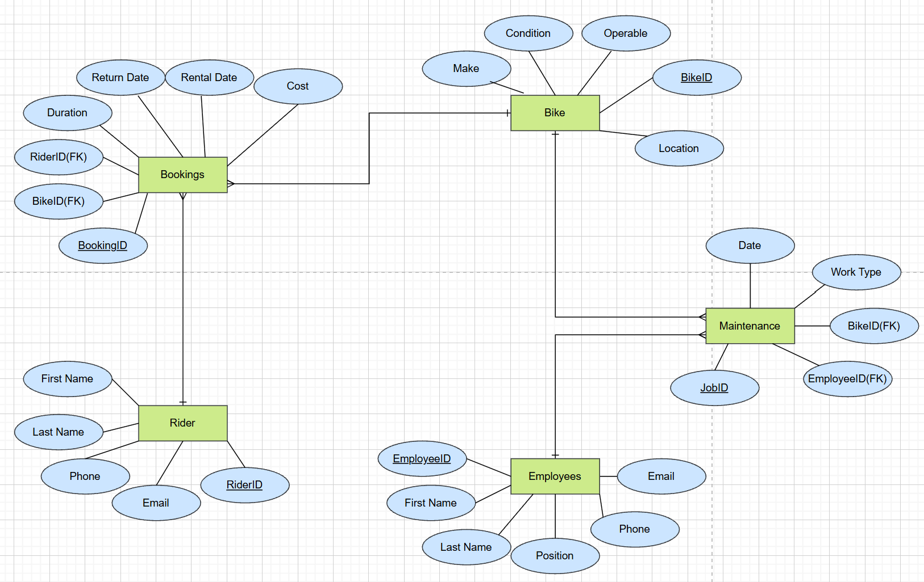

Figure 1- Entity Relationship Diagram

Database Design

Rider
The Rider entity was designed to store essential information about individuals using the EcoRide bike rental service. Attributes such as RiderID, First Name, Last Name, Email and Phone were included to support rider identification and communication, as outlined in the scenario requirements. RiderID is used as the primary key to uniquely identify each rider within the system.
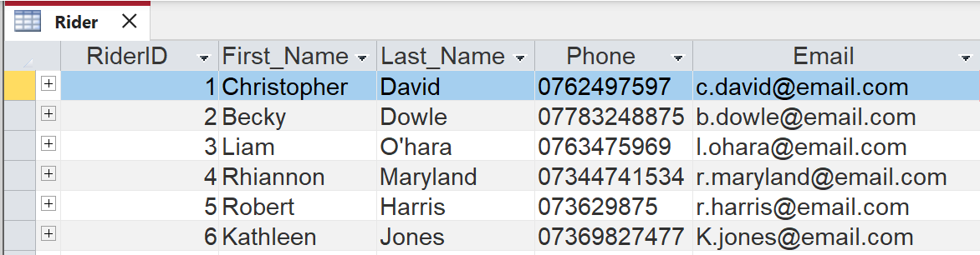
Figure 2 – Rider Table

The Rider entity is linked to the Bookings entity through a one-to-many relationship, as a single rider may make multiple bike rental bookings over time. This design ensures that the rider information is stored only once, reducing data redundancy and supporting data integrity using a foreign key in the Bookings table.
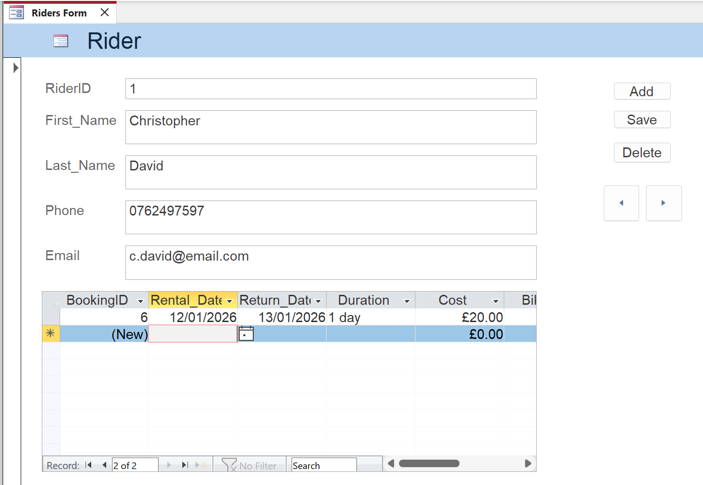

Figure 3 – Rider Table converted to a Form

Bikes
The Bikes entity was designed to store information about each electric bike available within the EcoRide rental scheme. Attributes such as BikeID, Make, Condition and Operable were included to allow staff to track the status and usability of each bike. BikeID acts as a primary key, uniquely identifying each bike in the system.
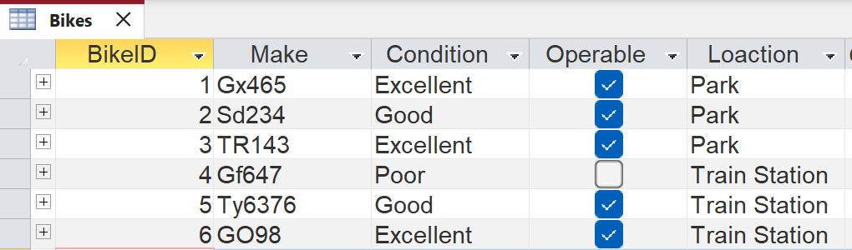
Figure 4 – Bikes Table

The Bike entity has a one-to-many relationship with the Bookings entity, as a single bike may be rented multiple times over its lifespan. It also has a one-to-many relationship with the Maintenance entity allowing maintenance history to be recorded for each bike. This structure supports efficient tracking of bike availability and servicing needs.
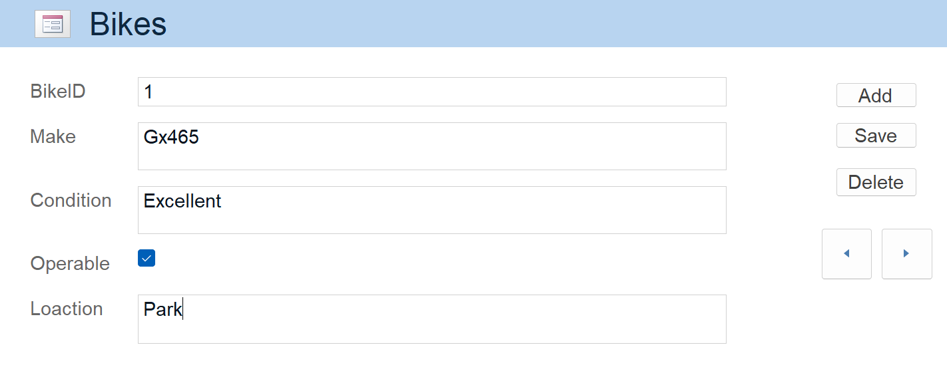
Figure 5 – Bikes Table converted into a Form

Bookings
the Bookings entity represents individual rental transactions within the EcoRide system. It was created to capture rental-specific details such as Rental Date, Return Date, Duration and Cost. BookingID is used as the primary key to uniquely identify each booking record.
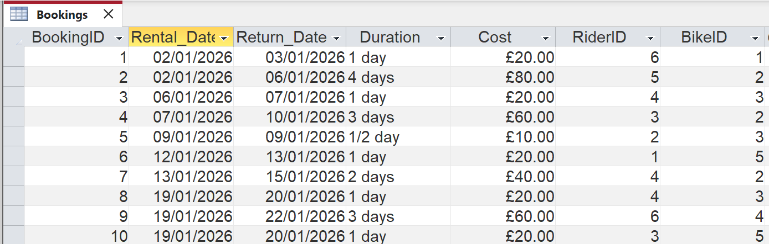
Figure 6 – Bookings Table

Bookings act as an associative entity between Rider and Bike, resolving many-to-many relationships between these entities. Foreign keys RiderID and BikeID are used to link each booking to specific rider and bike. This design allows accurate tracking of rental history while maintaining normalisation and preventing data redundancy.

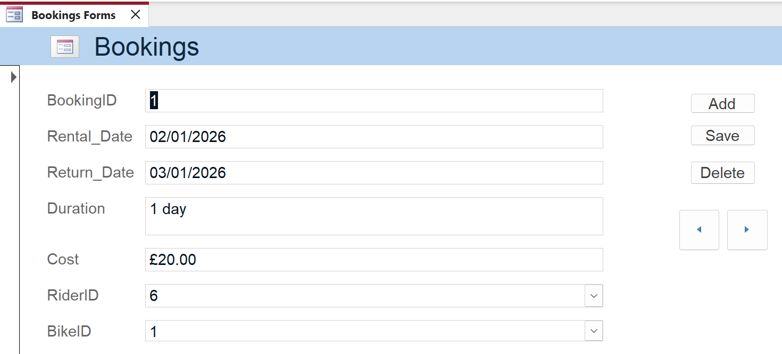
Figure 7 – Bookings table converted into a Form

Employees
The Employees entity stores information about staff members involved in maintaining and servicing bikes within the EcoRide scheme. Attributes including EmployeeID, First Name, Last Name, Email, Phone and Position were included to support staff identification and role tracking. EmployeeID serves as the primary key for the entity.
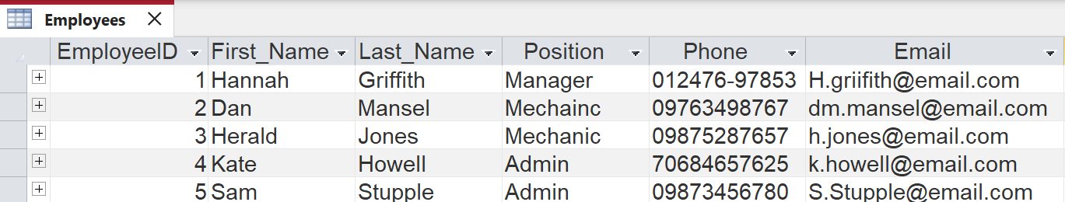
Figure 8 – Employees Table

A one-to-many relationship exists between Employees and Maintenance, as a single employee may carry out multiple maintenance tasks over time. This relationship enables the system to track staff involvement in bike servicing activities as required by the scenario.
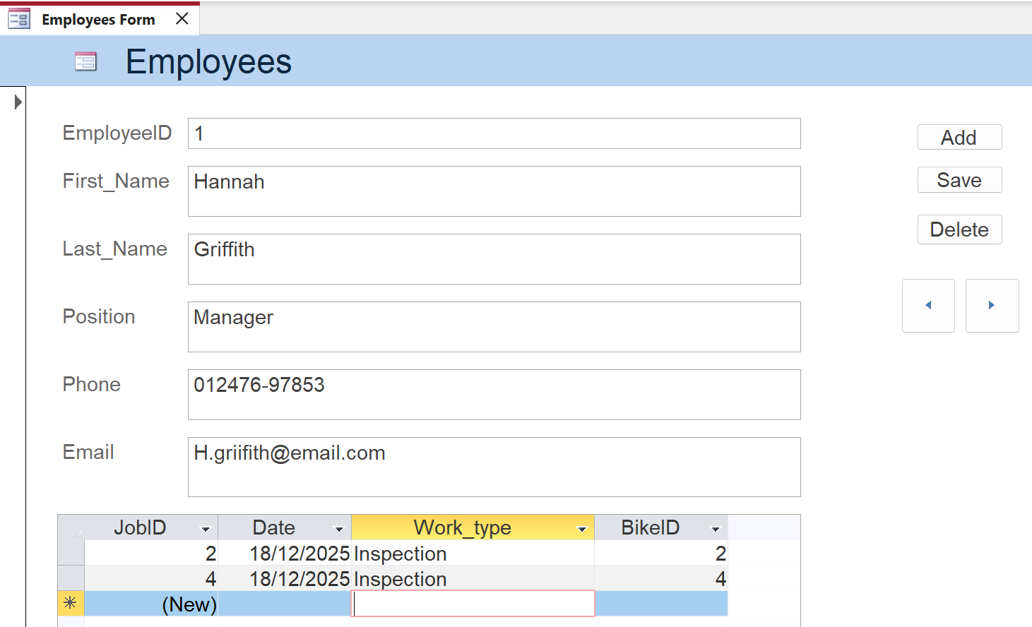

Figure 9 – Employees Table converted into a Form

Maintenance
The Maintenance entity was designed to record servicing and repair activities carried out on EcoRide bikes. Attributes such as JobID, Date and Work Type allow each maintenance task to be clearly documented. JobID is used as the primary key to uniquely identify each maintenance record.
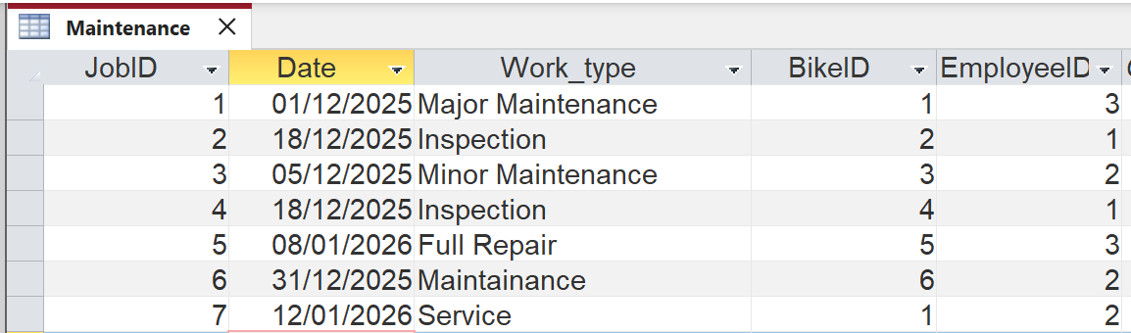
Figure 10 – Maintenance Table

The Maintenance entity includes foreign keys BikeID and EmployeeID linking each maintenance task to the bike being serviced and the employee responsible. This design supports the one-to-many relationship from both Bike and Employees ensuring maintenance history can be accurately tracked while maintaining data integrity and compliance with Third Normal Form.
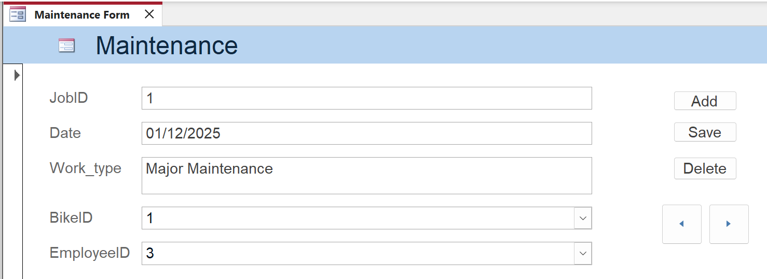
Figure 11 – Maintenance Table converted into a Form

Testing
Testing was carried out to ensure that the database meets the functional requirements of the EcoRide system. A series of queries were executed to validate relationships between entities, data integrity, and the system’s ability to support operational tasks such as tracking rentals, bike availability and maintenance history.

Query 1: Bikes Rented On The 19/01/2026
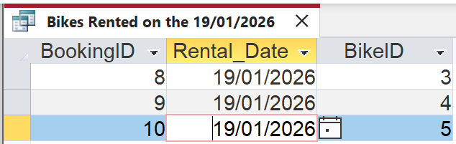
Figure 11 – Query 1 table

This query was used to test whether the system can correctly identify bikes that have been rented for a certain day by selecting bookings where the rental date is criteria is 19/01/2026.

Query 2: Rentals By Specific Rider
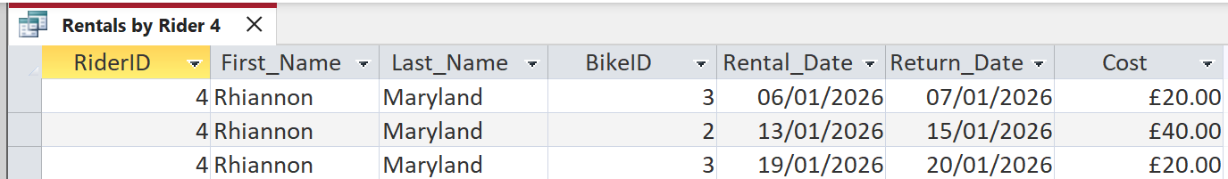
Figure 12 – Query 2 table

This query validated the one-to-many relationship between Rider and Bookings by retrieving all rentals associated with a specific rider.

Query 3: Bike Maintenance History Check
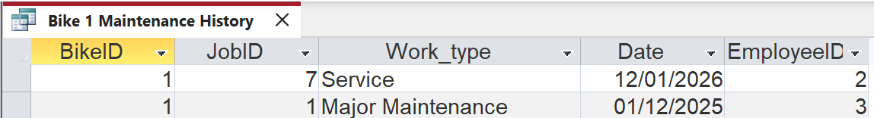
Figure 13 – Query 3 table

This query tests the ability of the system to track maintenance history for individual bikes, ensuring servicing records are correctly linked.

Query 4: Employee Maintenance Workload
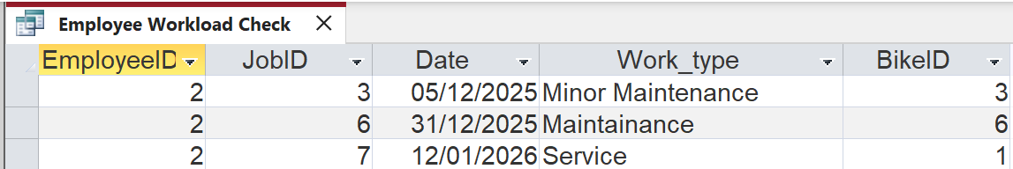
Figure 14 – Query 4 table

This query validates staff involvement by retrieving maintenance tasks carried out by a specific employee.

Testing Summary
Overall, the testing process confirms that the database structure functions as intended and supports key operational tasks. By validating relationships and ensuring accurate query results, testing helps identify potential issues early and demonstrates that the database meets the requirements of the EcoRide scenario. This process is essential in ensuring reliability, usability, and confidence in the system before deployment.

Conclusion
In conclusion, the design and implementation of the EcoRide database system demonstrates the importance of structured database design in supporting efficient and reliable operations. By applying normalisation principles and Third Normal Form, the database minimises redundancy while maintaining data integrity and consistency. The use of clearly defined entities, primary and foreign keys, and well-established relationships allows accurate tracking of Riders, Bikes, Bookings, Employees and Maintenance activities. The entity relationship diagram provided a clear visual representation of the system structure, supporting effective database planning and implementation. Finally, the testing queries confirmed that the database meets the functional requirements of the EcoRide service by successfully retrieving meaningful information related to rentals, availability and maintenance. Overall, the database design provides a scalable and robust solution that enhances operational efficiency and supports future growth of the EcoRide electric bike rental service.

References
[1] M. Fotache, M. I. Cluci, T. Taipalus, and G. Talaba, “The effects of database normalization on decision support system performance,” Inf. Syst., vol. 136, 2024, doi: 10.1016/j.is.2025.102636.
[2] M. J. Hernandez, “Keys,” in Database design for mere mortals : a hands-on guide to relational database design, 3rd ed., Addison-Wesley, 2013, ch. 8, pp. 243–270.
[3] J. L. Harrington, “Database Design Theory,” in Relational Database Design, 3rd ed., 2009, ch. Part 2, pp. 43–83. doi: 10.1016/b978-0-12-374730-3.00008-5.
[4] E. Bertino and R. Sandhu, “Database Security Concepts, Threats and Challenges,” IEEE Trans. Dependable Secur. Comput., vol. 2, no. 1, pp. 2–19, 2005, [Online]. Available: https://ieeexplore.ieee.org/abstract/document/1416861
[5] M. Genero, G. Poels, and M. Piattini, “Defining and validating metrics for assessing the understandability of entity-relationship diagrams,” Data Knowl. Eng., vol. 64, no. 3, pp. 534–557, 2008, doi: 10.1016/j.datak.2007.09.011.
[6] K. Kendall and J. Kendall, “Depicting Systems Graphically,” in System Analysis and Design, no. 2019, Pearson Education, limited, 2019, ch. 2, pp. 63–67.

