Vivian Presgrave (P151998)

3
A Report analysing Dragons Dataset

Contents
1. Executive Summary 3
2. Microsoft Excel functions analysing profitability 4
i. IF Function 4
ii. Look Up 6
iii. Pivot Tables, Charts and graphs 7
3. Strengths of spreadsheet software, such as Excel 10
4. Why should Dragons Office Supplier use Spreadsheet Software? 11
5. Data Mining Approaches 12
i. Association 12
ii. Classification 14
iii. Clustering 16
iv. Linear Regression Model 18
6. Conclusion and Recommendations 20
7. Bibliography 21
Bibliography 21

Executive Summary
The Dragon Office Supplies are an online stationery retailer operating in Wales. They are noticing a reduction in their profits and require a better understanding as to how they can overcome this issue. Through using the Excel records on sales which are provided by the office suppliers, it is possible to use decision-making software, such as Excel and Weka to critically analyse the areas where probability is lower and therefore find a solution on how to overcome the issue. The use of several functions, such as the IF, LOOKUP, PivotTables and Charts will all aid in finding patterns in the dataset. Specifically, PivotTables and Charts will allow the data to be summarised more easily and visualising the data will provide a better, more informative understanding of the data. Decision-making software, such as Weka will allow patterns in present in the data to become more prevalent, as its sophisticated decision-making software.

Microsoft Excel functions analysing profitability

IF Function
The IF function is used to execute a logical test and return one value for a “Profit” result, and another for a “Loss” result. For example, for a “Profit”, the profit value must exceed 0. For a “Loss”, it must be lower than 0: =IF(I2>0, “Profit”, “Loss”). The IF function is beneficial, as it allows for more than one condition to be tested by nesting the IF functions. The IF function is often combined with other logical functions like AND and OR. However, for the profit and loss column, only the IF function was used.
The purpose of the IF function was to evaluate which products are profitable for Dragon Office Supplies, whilst also seeing which products are causing a loss in the company. This was presented, in a separate column, labelled “Profit or Loss”. The screenshots showing the effectiveness’s of the IF Function are presented below.
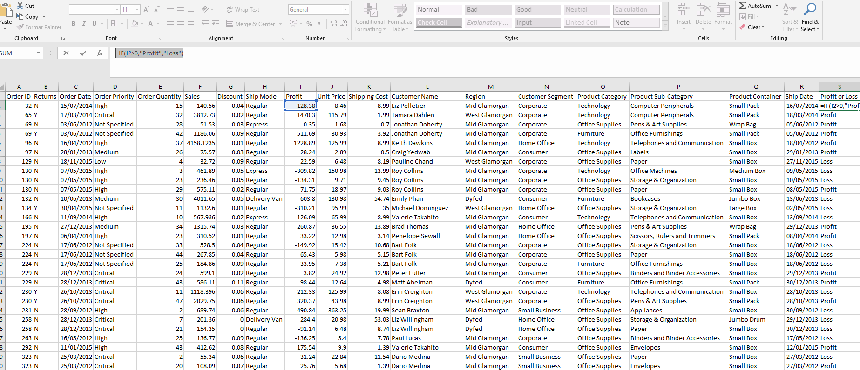

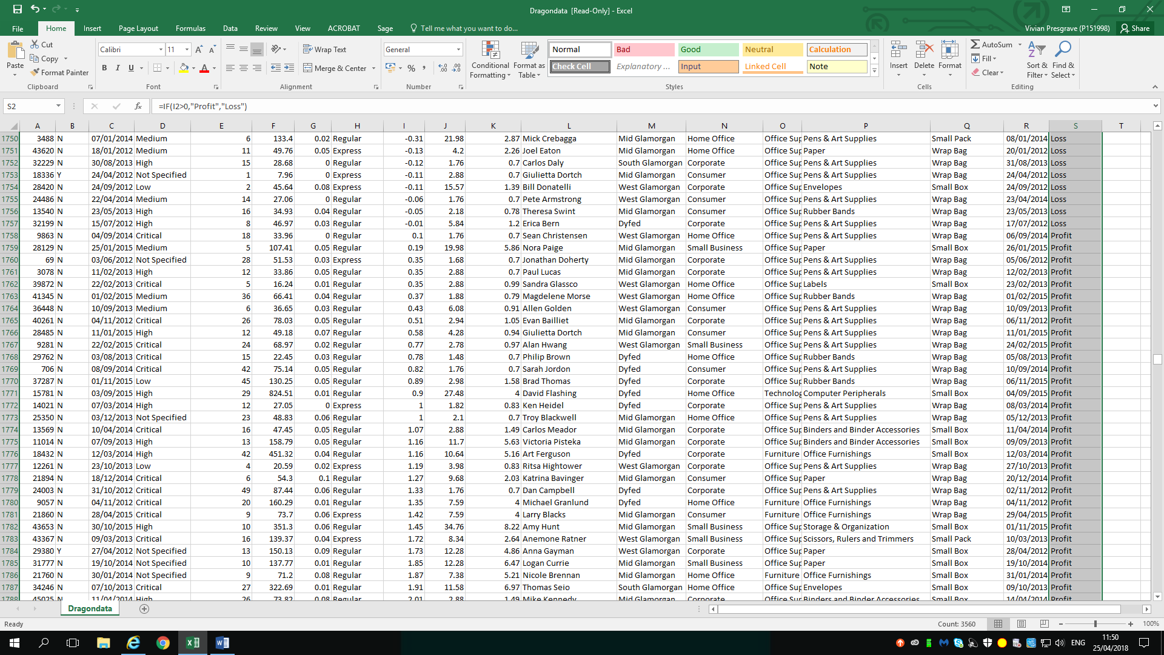

Look Up
The LOOKUP function, allows users to look in a single row or column and find a value from the same position in a second row or column. For example, if the Dragon Office Suppliers know the order ID for a product, but not the number of sales, they can use the LOOKUP function to successfully determine the sales for each Order ID. This would be beneficial, as it would provide the suppliers a greater understanding on which products sell more and which sell least, wilts also allowing them to evaluate the correlation between certain products and profitability.
The following LOOKUP function was used to find the number of sales for product number 32: =LOOKUP (A2,A:A,F: F).
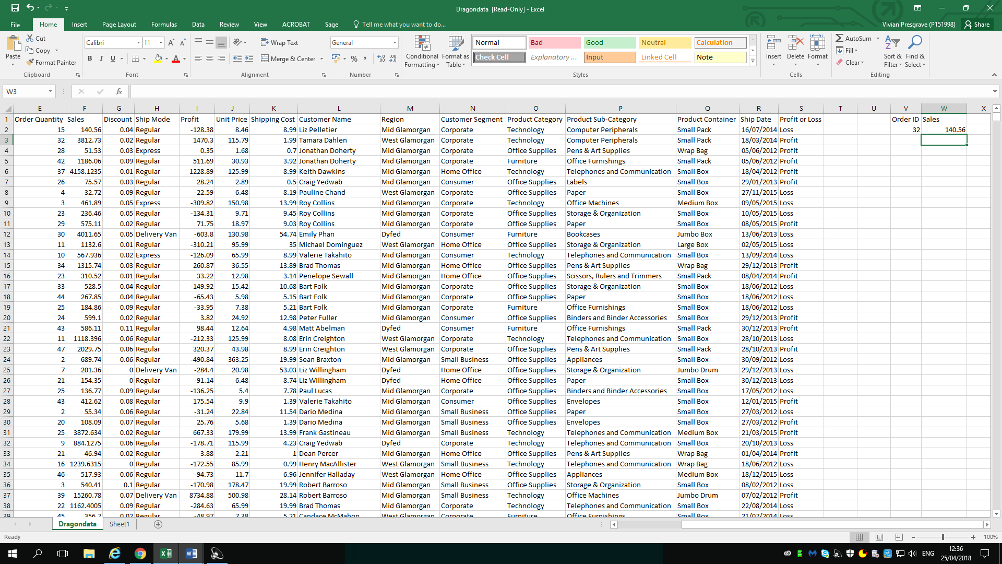
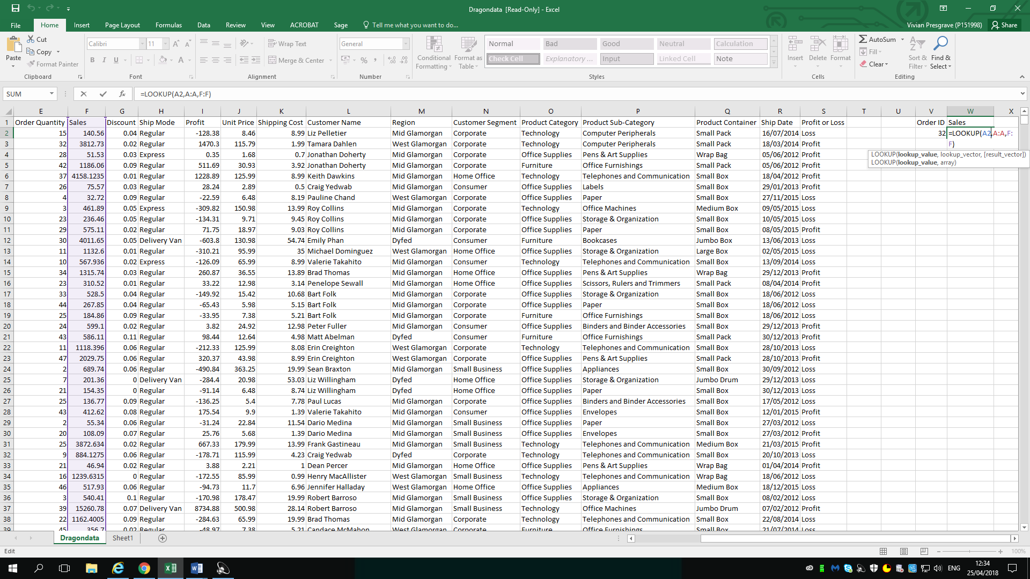

Pivot Tables, Charts and graphs
There is a lot of data presented on the Dragons Data spreadsheet, which does make it difficult to analyse. However, the use of PivotTables is beneficial in summarising, analysing and presenting the data more easily and effectively. Excel provides, a PivotTable option under the Insert Tab. As, PivotTables are adaptable they can be adjusted to display the results, between any variables. Pivot charts and graphs are based on the results from the PivotTable and can also be produced, by simply clicking on the PivotCharts tab, which falls under the insert tab. The following screenshots, show the analysis of the DragonsData spreadsheet using PivotTables and charts.

A Pivot Table showing the relationship, between order ID and priority and the number of sales.

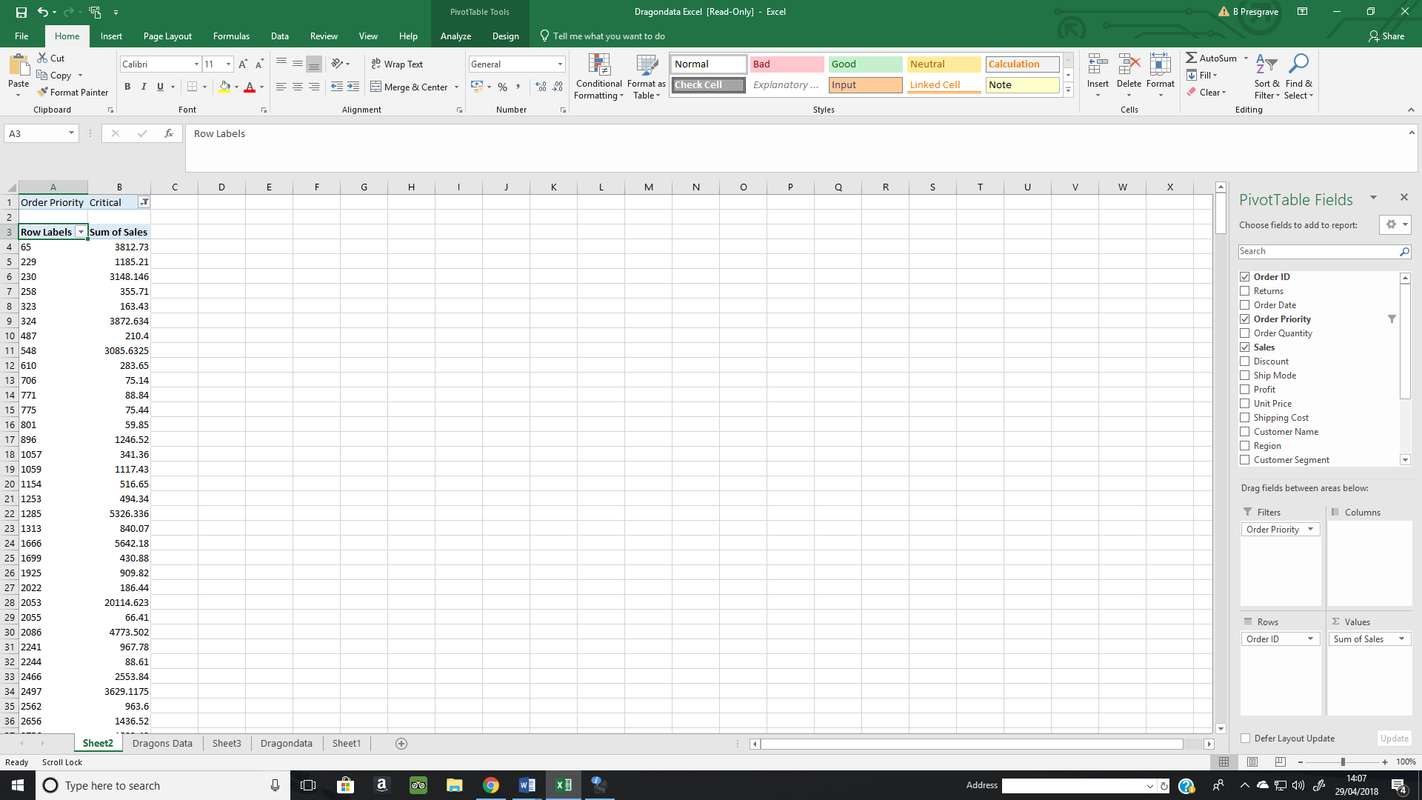

A Pivot Table to show the relationship between the sum of profit, in the different regions in Wales being served by the Dragon Office Suppliers. The graph produced from the data, clearly shows that Mid-Glamorgan is the most profitable region with almost £300,000 in profits. Whereas, South-Glamorgan is the least profitable, with profits being only slightly above £9,200. The Pivot Table comparing number of sales to the region, shows an identical correlation to the sum of profit and region. With sales in Mid-Glamorgan being the highest above 291,000 sales and the lowest sales in South Glamorgan at approximately 71,500. This indicates, that the number of sales, in the region does directly correlate the profit attained.
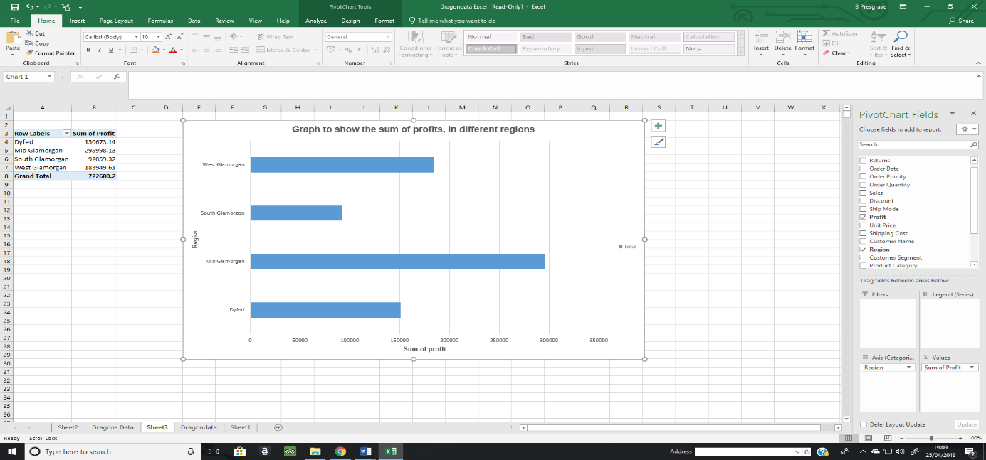

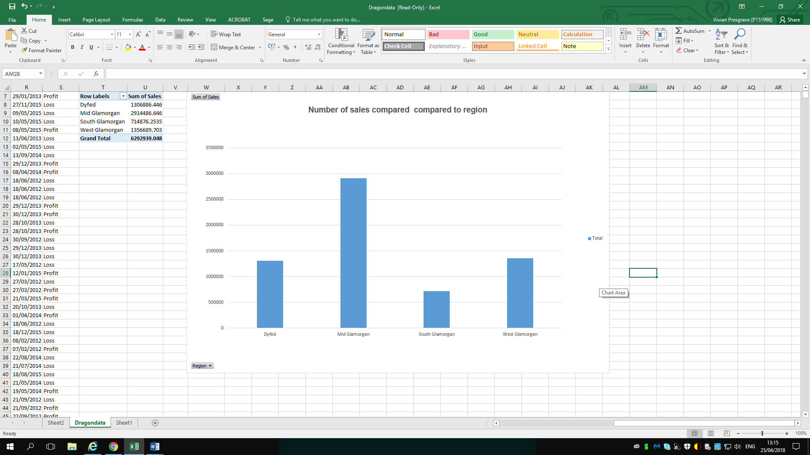
However, although this is true a pie chart analysing the relationship between profit and order priority shows there is no correlation between order priority and profit. For the “critical” order priority the sum of profit was only 16%, whereas for a “low” and “high” order priority the sum of profit is highest at 27%.
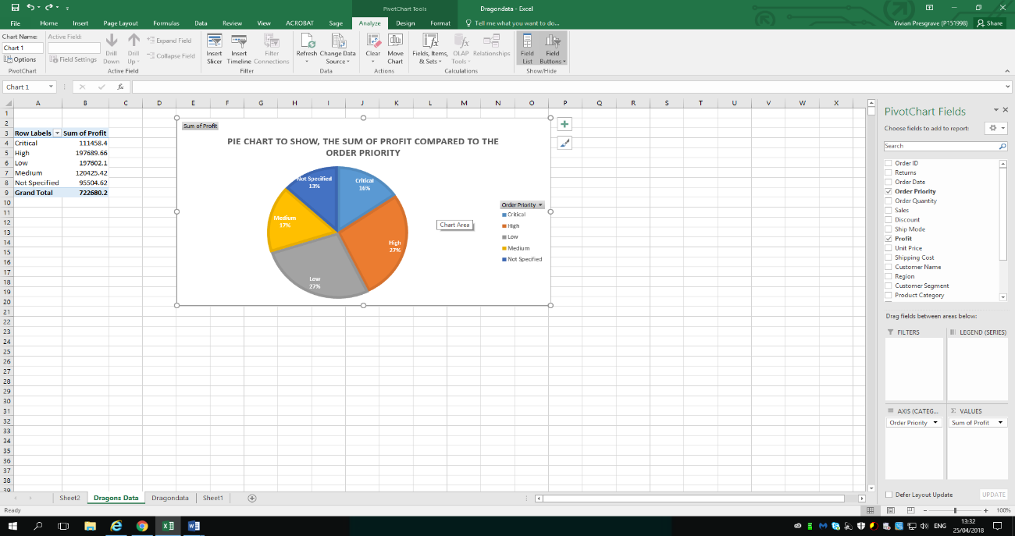

Strengths of spreadsheet software, such as Excel
Formula’s are some of the most beneficial elements of a spreadsheet, as it aids in pre-processing and analysing data. Excel, provides users with a vast range of pre-set functions that summarise common formulas. This allows users to apply functions without having to type them manually. The pre-set functions are available through buttons in spread program user interfaces. Functions include sorting and filtering data. They also, allow calculations, such as the mean, median, mode, sums and percentages to be calculated for vast quantity of data. Whilst, allowing variables to be compared more efficiently. An excel spread sheet saved as a CSV File can be imported to other applications, such as Weka (Antonovich, 2010 , p. 383). Which would further aid in the analysis and decision-making process.
Spreadsheet programs are also beneficial, as they allow data sets to be converted into graphical displays. Excel specifically, provides a ‘charts’ section that allows users to present their data visually through a chart or graph. Users can visually display and communicate their data sets, whilst presenting, through using pie or bar charts. According to (Smith, 2018, p. 1), visualising data will provide a greater, more informative understanding of the data and therefore effect future planning decisions. It can also help analyse data more effectively, as patterns and trends can be spotted more easily.

Why should Dragons Office Supplier use Spreadsheet Software?
Spreadsheet Software, such as Excel can help the Dragons Office Supplier in analysing and presenting data and will therefore affect the decision-making process when supplying to different regions. According to, (Parry, 2007, p. 195) Spreadsheets would allow the office supplier to carry out a performance measurement. For example, the company could use the data from the spread sheet and transform it into a PivotTable or Pivot Chart to see how profit varies from one region to another. This is presented, in the spreadsheet. The analysis of the Order ID, and number of sales can help the suppliers get a greater understanding into which products are the most profitable and should therefore be prioritised when purchasing stock for the company. The items, with the highest sales should be prioritised, as they are likely to produce the highest profit for the company. Whereas, the products with the lowest sales, should be bought in smaller supplies, so the company doesn’t spend excessively on supplies that don’t produce a vast profit.

Data Mining Approaches
Data mining is about processing data and identifying patterns or trends in the data, in order to come up with a conclusive decision. The principles of data mining have been prevalent for several years, however, with the advent of big data, it’s become even more established. There are several fundamental techniques that are utilised in data mining, to describe different mining and data recovery options.

Association
Association (or relation) is used to make a correlation between two or more categories, often of the same type to identify patterns. Weka can be used by the Dragons Office Suppliers, as it contains an implementation of the Alpriori algorithm for learning association rules. The association rule mining only works with categorical values. Which means, if a dataset contains numeric attributes, it needs to be converted into nominal attributes before applying the Alpori algorithm. The Alpori algorithm can identify statistical dependencies between groups of attributes, such as the ship mode and product category. Apoiri can also, compute all the rules that have given a minimum support and exceed a given confidence. The data set provided by the Dragons Office Suppliers, was analysed using Aloriori. The results are presented below.

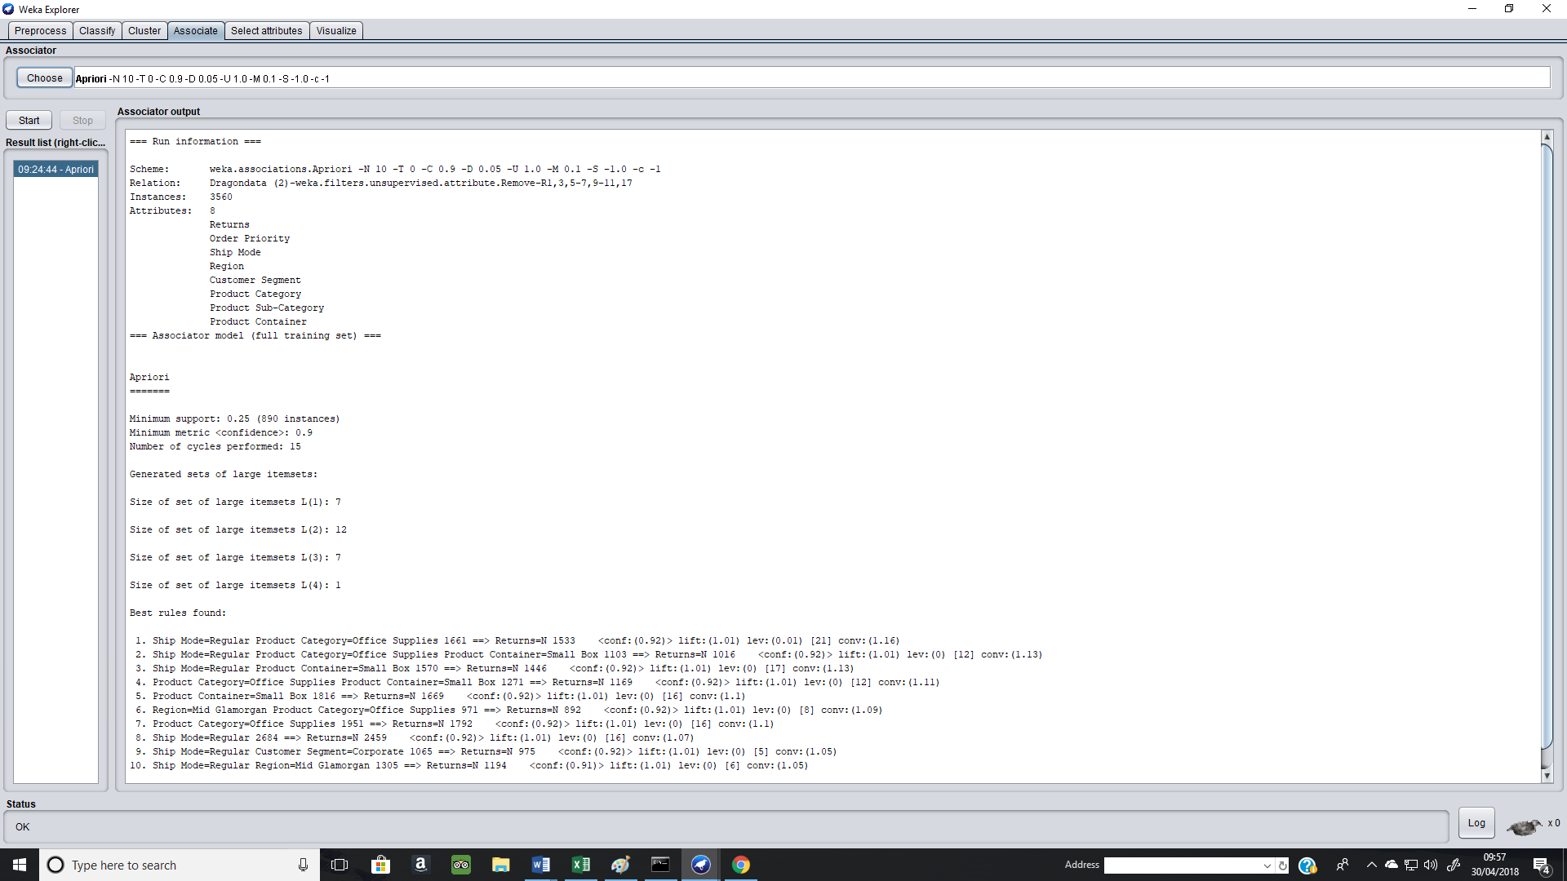
According to Apriori, there are 3560 instances and 8 attributes for the nominal data set. The minimum support value is, 0.25 and involves 890 instances. The metric is 0.9 and the number of cycles performed is 15. The L2 item set consists of the most instances (12). Whereas, the L4 item set contains the least instances (1). The Apriori algortithm, produces the 10 best rules for the nominal data. The first rule, states that there are 1661 office supplies that are shipped in a regular mode, with no returns on 1533 of those instances. Therefore, the confidence is very high 0.92 and suggests that office supplies should be shipped on a regular basis, as it will be beneficial for the suppliers because the chances of returns are very low (0.08).

Classification
Classification can be used to determine the type of customer, item or object by describing many attributes to identify a particular class.
Also, classification could be utilised as a feeder to, or the result of, other techniques (Brown, 2012, p. 1). One such example, is the use of decision trees to determine a classification. Clustering allows similar attributes in different classifications to identify clusters. The classification of the Dragons Data set is presented below, with a decision tree analysing the data.

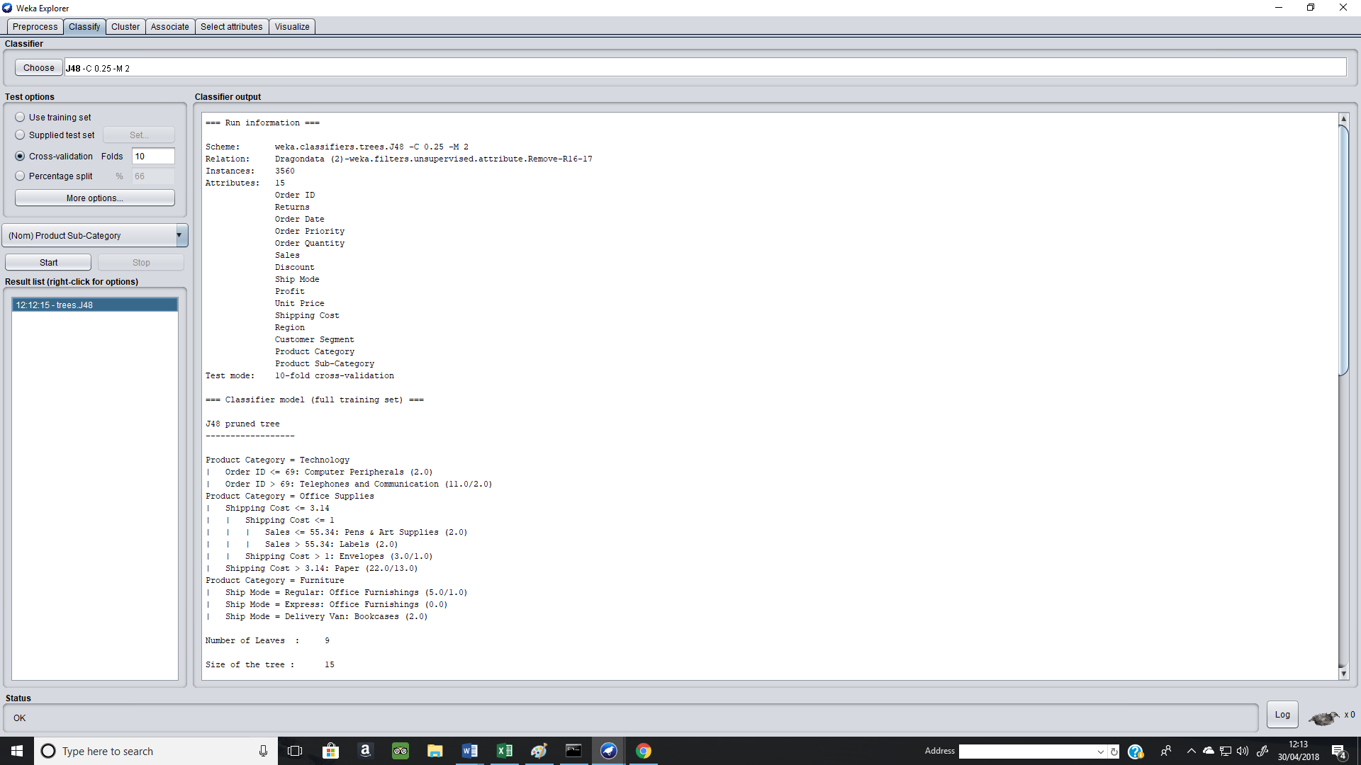

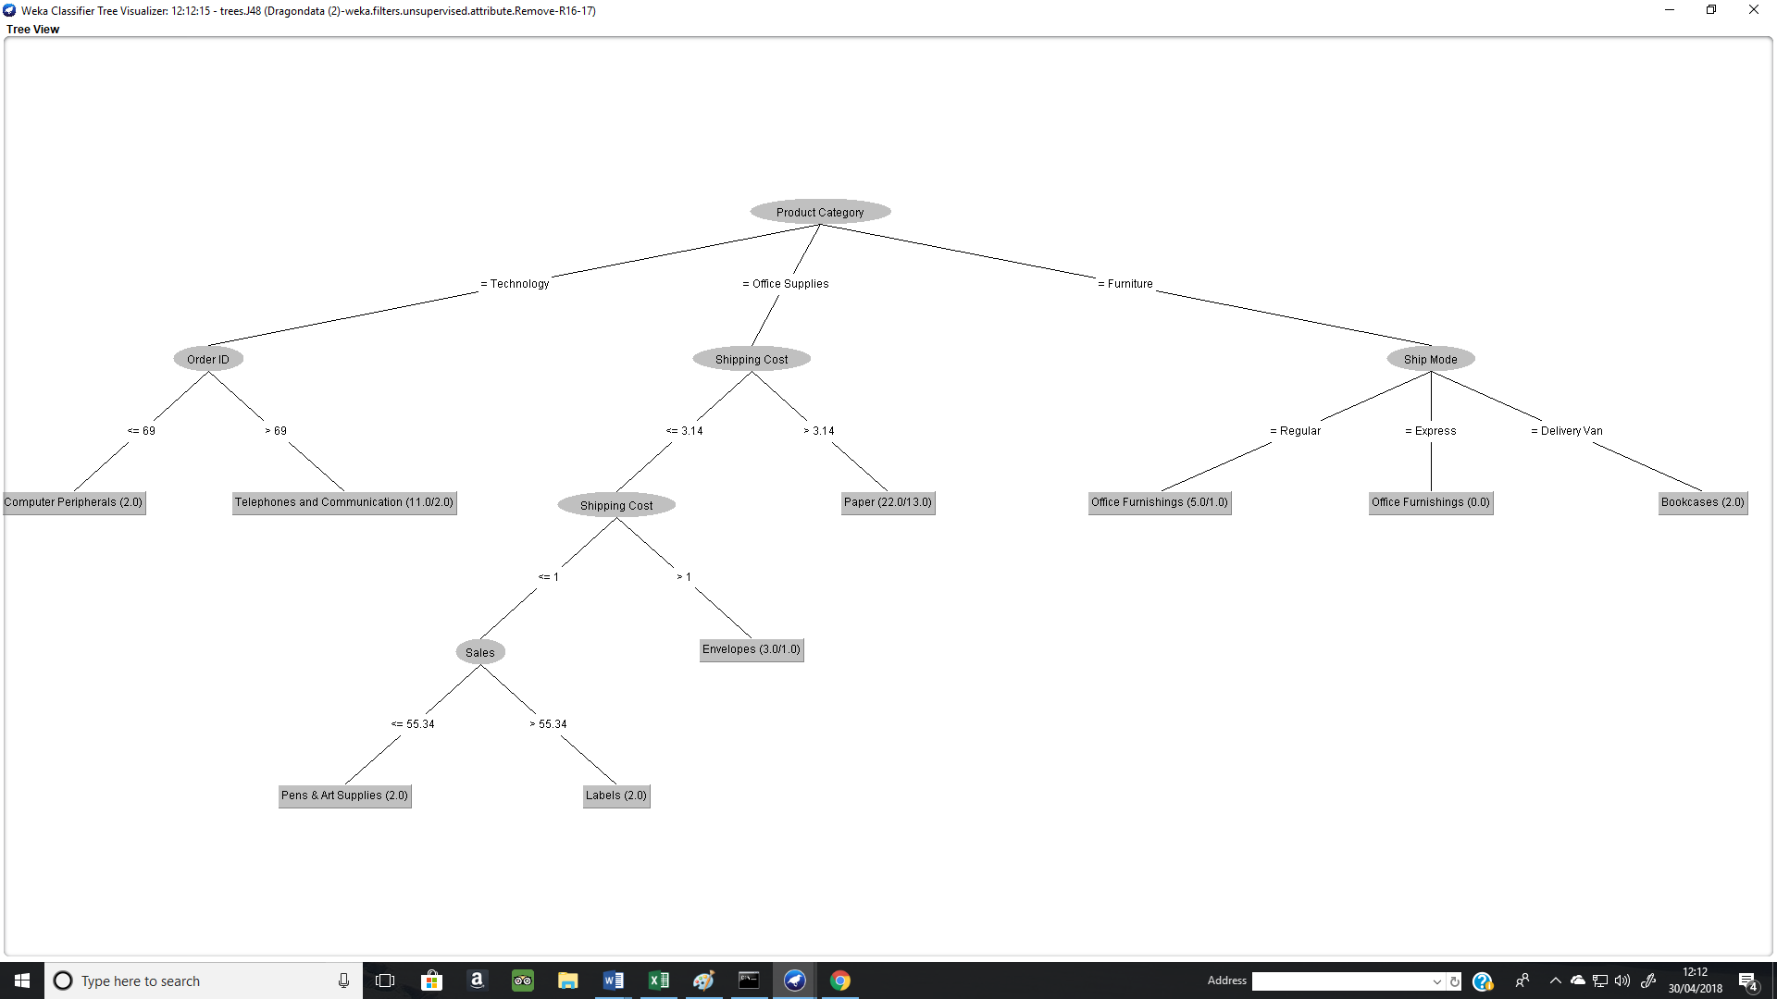
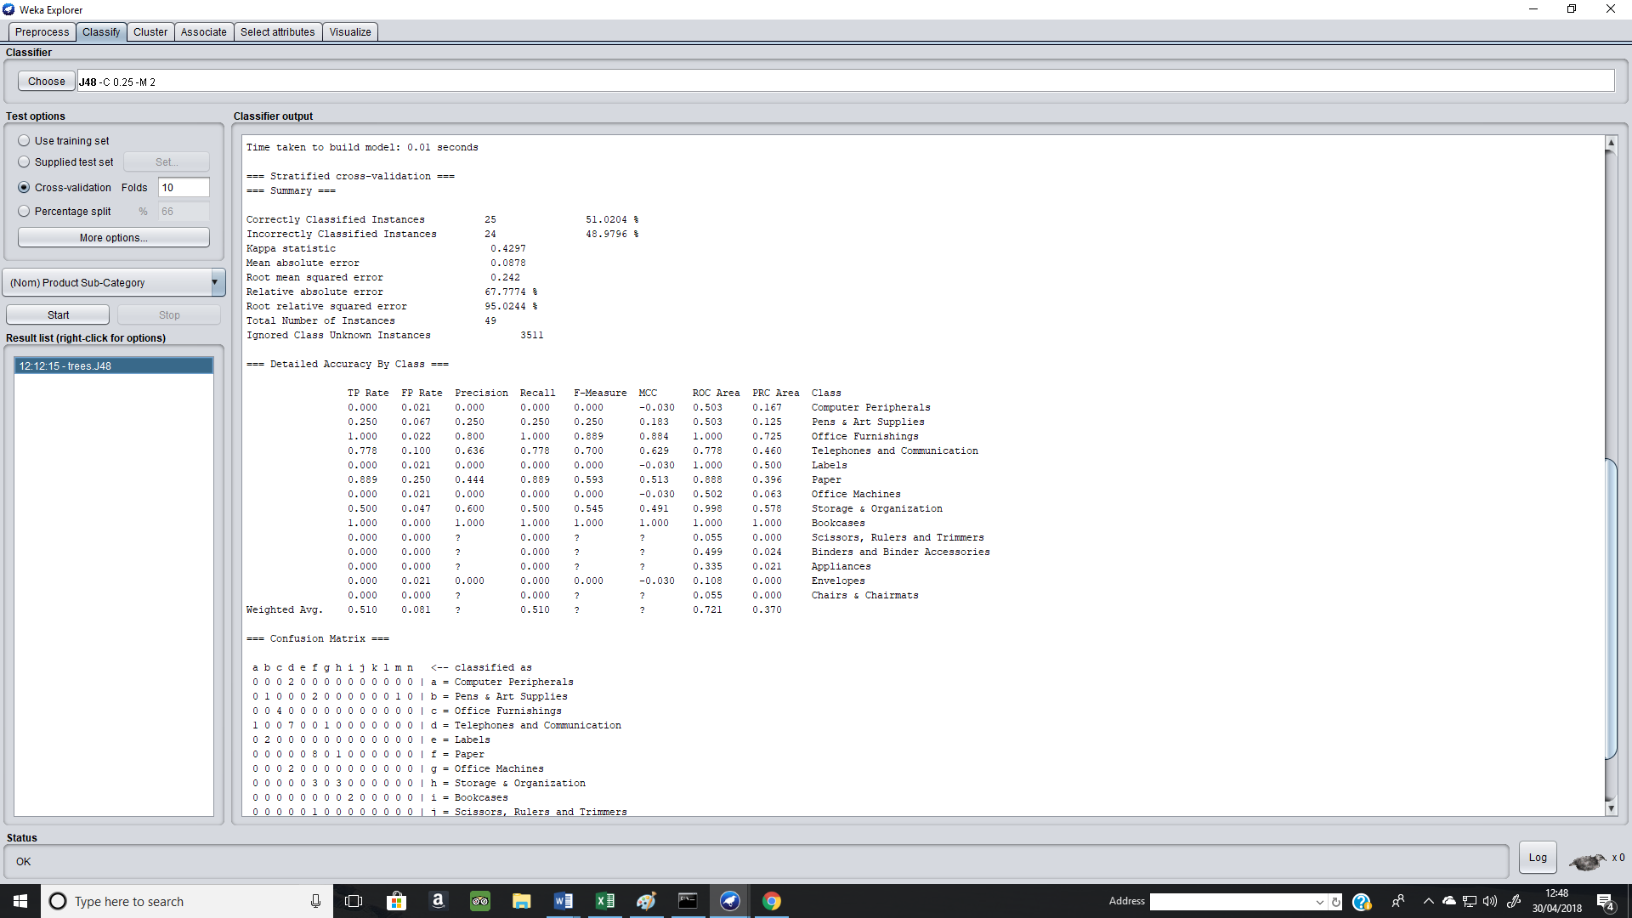

The results from the decision tree show that there are three product categories for products being sold by the office suppliers. The shipping cost for envelops, is very lowest as it is below 1. It also shows, that the sales are above 55.34 for pens and art supplies, which would inevitably mean these are the most profitable products and should be stocked in vast quantities. However, this model’s accuracy is only 51.02%, meaning it very reliable.

Clustering
Through analysing one or more attributes or classes, individual data can be grouped in order to form a structure opinion.
The algorithm used is Simple K-Means, it’s based on distance-based clustering (disjoint sets). Simple K-Means, minimises the total squared distance from instances to their cluster centres. The clustering analysis for the Dragon’s Data Set Is presented below.

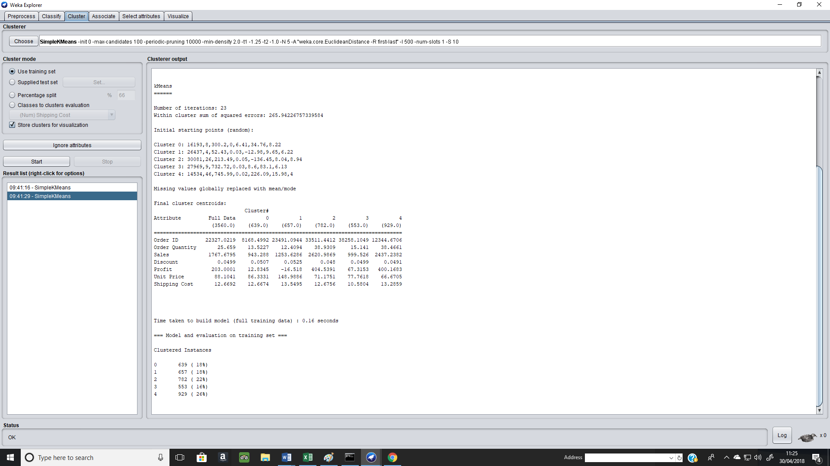
Clustering for 10 seeds

Clustering for 11 seeds
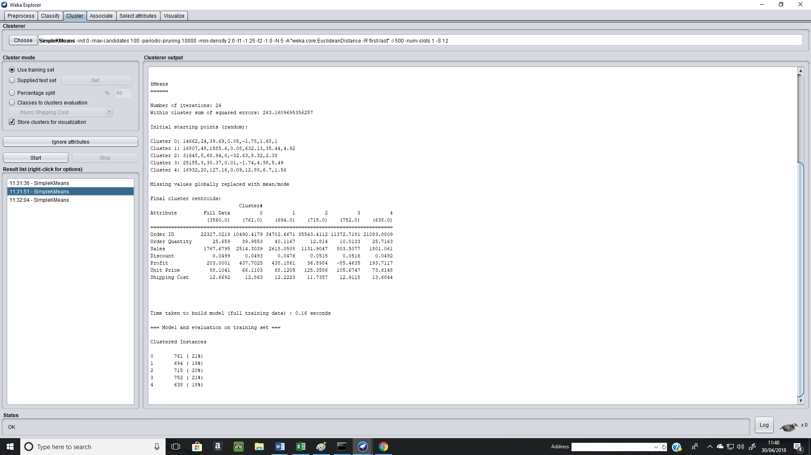

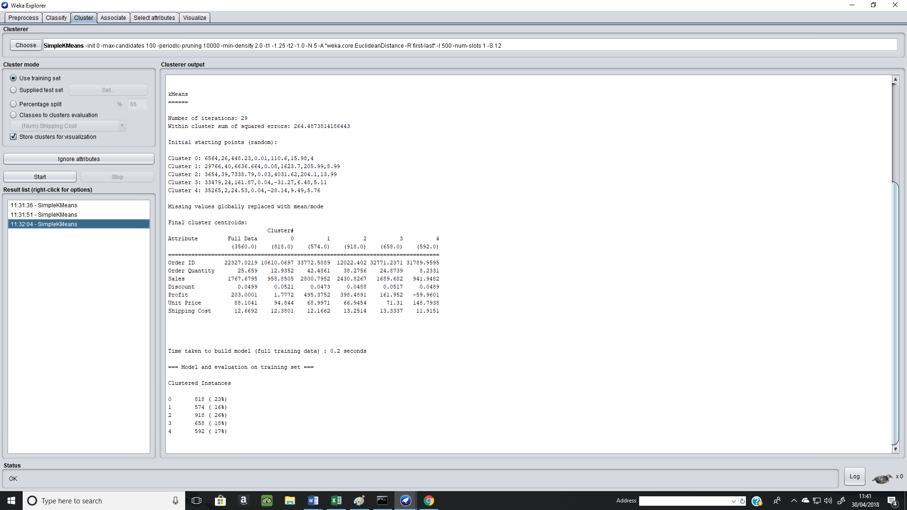
Clustering for 12 seeds
There are 5 clusters with the highest instances in cluster 4 (929) and the lowest in cluster 3 with 553. The total squared error is 265.94, at 10 seeds. The number of clusters remains the same, but the number of instances for each cluster and total squared errors changes as the seeds changes. For 11 seeds, the total squared error is 263.16 and for 12 seeds it’s 264.49 approximately. This suggests, that the data is accurate as there isn’t a vast difference in the total squared error at different seeds.

Linear Regression Model
Regression models are used to predict a target in a range. From the linear regression of the data provided, the shipping cost is dependent the profit for each product and the unit price. The co-efficient is 6.86.
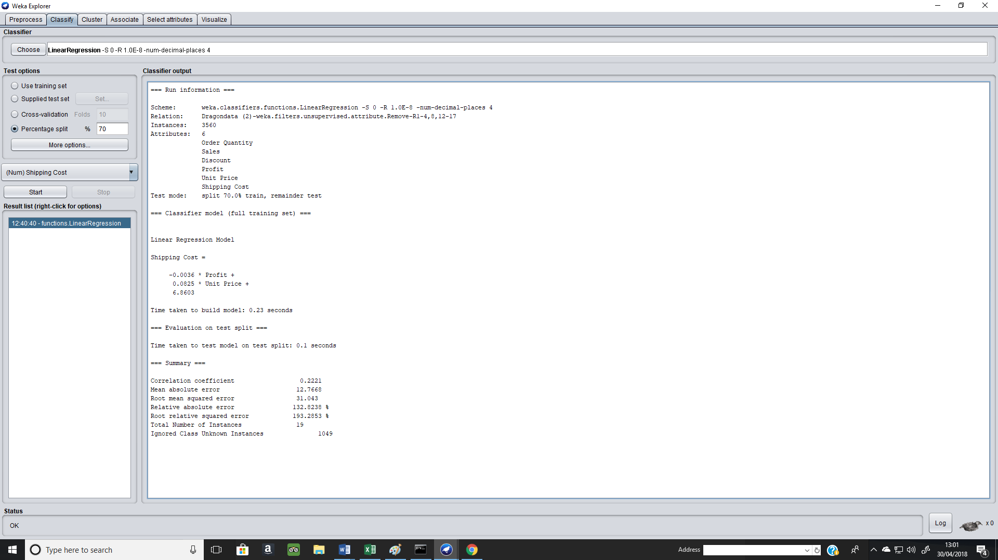

Conclusion and Recommendations
In conclusion, spread sheet software and data mining using software such as Excel and Weka would be beneficial for the Dragons Office Suppliers as it’s cost-effective and will not require vast funds to accurately operate effectively. Also, it allows trends to be discovered more easily, such as the profitability of products and the sales within different regions. (Weistroffer, 2016, p. 136) believes decision making software, such as Weka can aid in the decision-making process, by stating it can assist, “At various stages of the decision-making process, including problem exploration and formulation, identification of decision alternatives and solution constraints, structuring of preferences, and trade-off judgemets”. (Belton, 2002, p. 3) goes a step further and believes it is more than just a decision-making tool, by claiming it frees users “from the technical implementation details (of the decision-making method employed), allowing them to focus on the fundamental value judgements”. To get even more accurate results, monthly data should be analysed to see annual trends and give a greater insight into customer demands, profits and sales.

Bibliography

Bibliography
Antonovich, M. (2010 ). Office and SharePoint 2010 User's Guide: Integrating SharePoint with Excel, Outlook, Access and Word. New York City: Apress.
Belton, V. a. ( 2002). Multiple Criteria Decision Analysis: An Integrated Approach. Boston: Kluwer.
Brown, M. (2012, December December 11). Data mining techniques. Retrieved from IBM: https://www.ibm.com/developerworks/library/ba-data-mining-techniques/#fig2 Accessed on 25th April 2018
Ian H. Witten, E. F. (2011). Data Mining: Practical Machine Learning Tools and Techniques. Amsterdam: Elsevier.
Parry, J. H. (2007). College Accounting. Boston: Cengage Learning.
Smith, S. (2018, April 24). The Advantages of Using Spreadsheets. Retrieved from azcentral.com: https://yourbusiness.azcentral.com/advantages-using-spreadsheets-3647.html# Accessed on 25th April 2018

Trevor Hastie, R. T. (2001). The Elements of Statistical Learning: Data Mining, Inference, and Prediction. Berlin/Heidelberg: Springer Science & Business Media.
Weistroffer, H. a. (2016). Multiple Criteria Decision Analysis: State of the Art Surveys Series. New York: Springer.

