UNIVERSITY OF WALES
TRINITY SAINT DAVID

INTERNATIONAL BUSINESS COMMUNICATIONS (ASSIGNMENT 1)
LCBB6001
Catalina Alexandra Cobzaru
Student number: 1913403
Lecturer: Husam Alharahsheh
Executive summary
This report has conducted a comparative analysis of Brazil and the United Kingdom in the context of economic, cultural, religious and other factors using the Hofstede's cultural model. It has also discussed the communication barriers in Brazil that are needed to be considered by Sainsbury's while expanding business in this country. This assignment has suggested two potential recommendations that can be effective for Sainsbury's while expanding business in this country.

Table of Contents
1. Introduction 4
2. Introduction to Brazil 4
3. Cultural differences 7
4. Cultural sensitivity 9
5. Communication barriers and challenges (UK VS Brazil) 11
6. Communication strategies and recommendations 12
7. Conclusion 15
8. Reference list 16
9. Appendix: GDP rate of Brazil 19

1. Introduction
- The purpose of this report is to analyse the cultural differentiation between a developed country like the United Kingdom and a developing country like Brazil.
- A UK-based organisation Sainsbury’s is going to launch its business operation in Brazil.
- In this report, the cultural perspectives of Brazil in terms of population, culture, language, economy, workforce and technology are going to be analysed.
Differences in cultural perspectives in different countries have an effective influence on the purchasing behaviour of customers, which further triggers the positioning of organisational opportunities. In this context, diversified work culture inspires innovation and creativity within the organisation to gain a higher competitive advantage within the target market. Internationalisation of business not only involves the cross-border activities but also the consideration of cross-cultural influence. Culture is playing a critical role in making strategic decisions to set effective business policies.
This will be followed by the discussion on cultural differences between Brazil and the UK in order to develop effective business policies for successfully capturing the target market. Hofstede's cultural model will be analysed to understand the cultural differences among the people of the UK and Brazil based on power distance, masculinity, individualism, long-term orientation, uncertainty avoidance and indulgence. This will be followed by the evaluation of cultural sensitivity regarding language, gender, religion and practice. Barriers in the communication process and communication challenges are going to be identified for mitigating the risk of business in order to expand business in another country. Effective communication strategies will be suggested to Sainsbury’s along with other recommendations will be introduced at the end of the report.
During the business expansion, an organisation has to analyse the cultural differentiation to develop an effective relationship with the employees by gaining a better insight into the labour market.

2. Introduction to Brazil
Population
- Brazil is one of the leading developing countries in the world which contributes 2.85% of the world population (Trading economics, 2022).
- The annual population growth of Brazil was 0.713% in 2020, which is lower than the previous year (The World Bank, 2022a).
The continuous downfall of population growth indicates that the expanding organisation Sainsbury’s may face a threat of labour scarcity and a lower range of target population. Hence, Sainsbury’s has to analyse the target population for selecting efficient employees to gain successfully deliver the business operation. The lower population growth indicates that Sainsbury’s will face an issue to target a wider population and recruit potential candidates.
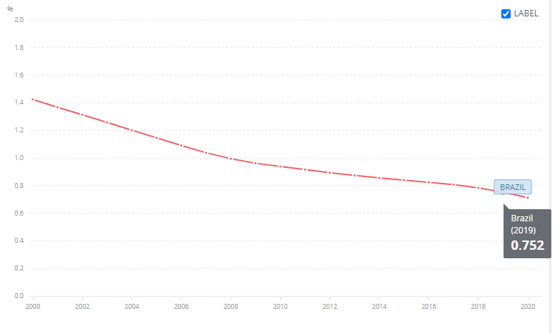
Figure 1: Population growth of Brazil
(Source: The World Bank, 2022a)
Culture
- Brazil is a world-famous celebrating country involving neighbourhood festivals.
- People of Brazil prefer spending time together by men are getting more freedom in comparison to women (AFS, 2022).
In Brazil, the household is generally considered the job of women, which indicates the prevalence of racial discrimination within the country.
Language
- Portuguese is the official language of Brazil and apart from these different indigenous languages are spoken by Brazilians (Original travel, 2022).
- Around 180 indigenous languages are spoken including the 200 tribal languages in Brazil but that is not recognised by the Brazilian authorities (Original travel, 2022).
Brazilian are capable of the use of English and Spanish language in tourist places and they occasionally say, French. As per the estimation of the “National Foundation of the Indian (FUNAI)”, many indigenous languages are practised by the people of Brazil.
Economy
- The rate of GDP fall in Brazil was -4.059% in 2020 which is lower than the previous year (The World Bank, 2022b).
- The inflation rate of Brazil in 2020 was 4.805%, which is higher in comparison with the previous year (The World Bank, 2022c).
The negative rate of GDP of Brazil indicates that the country is not an economically stable country, which can be a threat for Sainsbury’s. The inflation rate of Brazil indicates that this organisation will face an issue to set a pricing strategy for gaining a higher profit rate.
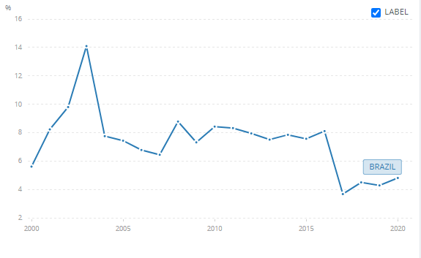
Figure 2: Inflation rate of Brazil
(Source: The World Bank, 2022c)
Technology
- In 2018, Brazil invested only 1.16% of the GDP in the research and development process (The World Bank, 2022d).
The lower investment in the R&D process indicates that the organisation will get less opportunity to make innovations in the business development process. Therefore, the scope of product improvement along with the implementation of advanced technologies is less after the expansion of business in Sainsbury’s.
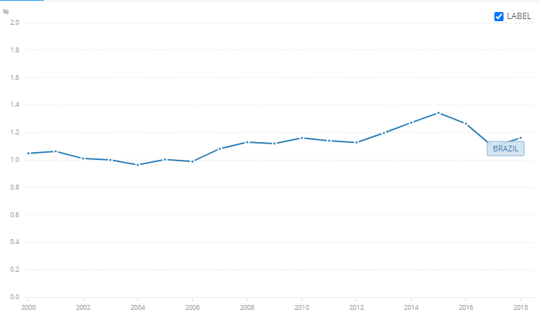
Figure 3: R&D expenditure of Brazil
(Source: The World Bank, 2022d)

Workforce
- As per the report of “The Brazilian Institute of Geography and Statistics (IBGE)” the strength of the Brazilian labour force was 107,249 as of February 2022, which is lower than the previous year (Economy, 2022).
The reduction of labour strength determines that Sainsbury’s will experience a threat of recruiting a potential customer base to deliver high-quality services and satisfy the needs of customers.

3. Cultural differences
- As opined by Minkov and Kaasa (2021), the application of Hofstede's cultural model is effective for understanding different cultural dimensions in order to gain better insight into cultural behaviour.
- The scores of Brazils and the UK are 69 and 35 respectively on the scale of power distance (Hofstede Insights, 2022).
- 89 and 38 are the scores of the UK and Brazil respectively in the context of individualism (Hofstede Insights, 2022).
The higher score of Brazil in power distance indicates that Brazilians accept inequalities and prefer hierarchical control. On the other hand, people of the UK prefer equal distribution of power within the organisational structure. The score of Brazil in the individualism index indicates that people are more comfortable working within a team whereas UK people prefer individual work. Therefore, Sainsbury's has to focus on the team development process with a higher authoritative hierarchical management process.
- The score of the UK in masculinity, uncertainty avoidance, long-term orientation and indulgence are 66, 35, 51 and 69 respectively (Hofstede Insights, 2022).
- Brazil has a score of 49, 59, 44 and 76 in masculinity, indulgence, long-term orientation and uncertainty avoidance respectively (Hofstede Insights, 2022).
- This evidence indicates a significant cultural differentiation between the two countries, which must be considered by Sainsbury’s to successfully manage the business operation within the target market.
The intermediate score of Brazil in the masculinity index indicates that this organisation will not face any issue of racial dominance. On the other hand, the high score of the UK in the masculinity index determines that UK people prefer the dominance of men employees within the organisation. A higher score for Brazil in the Uncertainty avoidance index indicates the higher need for an elaborate system of laws to maintain a structured life. In order to avoid the uncertain situation, Brazilians require strong legal compliances. On the other hand, the UK does not require excessive legal construction for avoiding unfavourable situations. Brazilian prefer relaxed and good experiences in their life along with the maintenance of good relationships with peers. In the long-term orientation scale, Brazil has an intermediate score and this rate indicates the deadline process for challenges to gain success in future. It can be identified that Brazil is an indulgent society in which people has a desire to control the impulse of others.
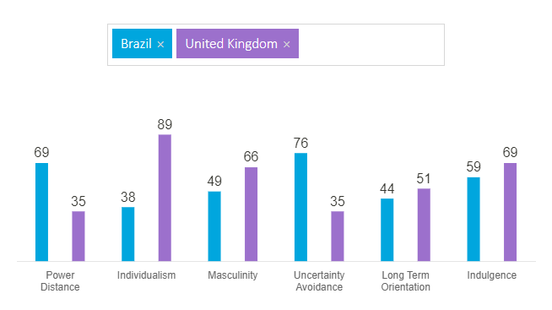
Figure 4: Cultural comparison between the UK and Brazil
(Source: Hofstede Insights, 2022)

4. Cultural sensitivity
- Language: The most used language in Brazil is Portuguese as 97.9 % of the Brazilian inhabitants speak this language as the primary language (Alphatrad, 2022).
- English is the most spoken language in the United Kingdom and most of the official paperwork is conducted using this language only (ONS, 2021a).
- Practice: Brazil is popular for its diverse cultural practice that displays a festive mood mostly (UNESCO, 2022).
- On the other hand, British inhabitants display a more formal, punctual, respectful and helpful cultural practice (studying-in-UK, 2022).
There are a total of 228 languages used in Brazil among which 11 are foreign languages and 217 are indigenous languages. It can be mentioned that Brazil is the only predominantly Portuguese speaking country in South America. Sainsbury’s needs to consider this and develop all business operations and official documents in Portuguese language on its most priority list while operating business in this country. German is the second most spoken language in this country though only 1.9% of people use this language in this land. On the other hand, English is the official language of the UK and Sainsbury’s has to adopt the Portuguese language before starting official activities in Brazil. In terms of practice, the UK is known for its formal and punctual cultural norms which emphasize following the queue instead of rushing, greeting people at the first meeting and showing respect to older people. Brazil, on the other hand, is popular for its diverse festive culture that mainly focuses on celebrating indigenous culture and respective rituals.
- Religion: Roman Catholic is the most practised religion in Brazil as 54.2% of Brazilian people belong to this religion (Statista, 2021a).
- In the United Kingdom, Christianity is the major used religion (ONS, 2021b). This indicates the necessity of considering the major religious practice of Brazil for the selected company while operating business in this land.
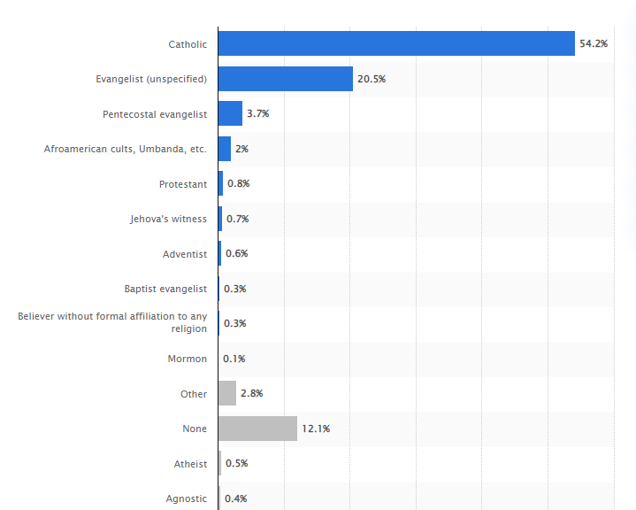
Figure 5: Most practised religion in Brazil
(Source: Statista, 2021a)
- Genders: Among 212 million inhabitants in Brazil, more than 108 million are women and 104 million men dwell in this country (Statista, 2021b).
- Among 67 million people who reside in the UK, 33.94 are female and 33.15 million are men (Statista, 2021c).
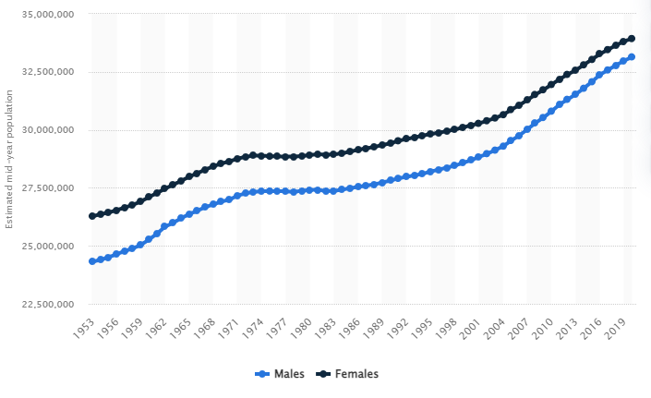
Figure 6: Population in the UK by gender
(Source: Statista, 2021c)
The statistical report reveals that there is an equality in the number of the male and female population in the UK as well as, in the nature of treating both genders equally as much as possible in various British organisations. There is no gender discrimination is found in this country which is a common issue in Brazil as male inhabitants of Brazil get extra freedom and opportunities than female ones in that country. Sainsbury's has to keep this under consideration while expanding business in Brazil and recruiting male and female employees in this organisation.

5. Communication barriers and challenges (UK VS Brazil)
- The main language of Brazil is Portuguese along with different indigenous languages (Original travel, 2022).
- The prevalence of the Portuguese language in Brazil can be identified as a major communication barrier, that can be experienced by Sainsbury’s.
- Racial discrimination is prevalent Brazil in where men are getting advantages of freedom compared to females (AFS, 2022).
In order to expand in the Brazilian market, Sainsbury’s has to give focus on communication with the local people for serving both the purpose of recruitment and the target customers. The language barrier can be a major barrier in this context in order to communicate the detail of business operations with the customers. The communication strategies of Sainsbury’s that are used in the UK cannot be appropriate to satisfy the different cultural needs of customers. The UK people prefer individualism whereas Brazilians feel comfort to work within a team. The power distribution scope can be another challenge for Sainsbury’s in order to set leadership and management styles within the organisation. Different management requirement of the Brazilian labour force triggers the communication barriers in terms of different perspectives and knowledge. Different mother tongues can be a major challenge, which may lead to misunderstandings and miscommunications during the decision-making process. In the UK equity is the basic target, Brazilians allow more freedom among males rather than females. Hence, a lack of knowledge about the local culture and needs of the local people can be a challenge for Sainsbury’s to capture the target market successfully. Moreover, different cultural viewpoints can be a major challenge or barrier for Sainsbury’s during the expansion of business in Brazil.

6. Communication strategies and recommendations
Communication strategies
- Communication strategies for developing countries such as Brazil can include focusing on a human-centred development paradigm in terms of reducing poverty, improving the living standards of the inhabitants and developing a sustainable society (SOAS, 2021).
- As illustrated by Bahrini and Qaffas (2019), the incorporation of information and communication technologies can help in improving the communication system in a developing country by focusing on increasing economic openness, developing the ICT infrastructure and prioritising the allocation of available resources.
Communication strategies for declining the communication gap in Brazil can be mentioned as focusing on the issue instead of concentrating on the person in terms of addressing the problem in information distribution and narrowing gaps in knowledge and skills. Social issues such as a gap in the knowledge of finding a job, getting a loan, legal regulations and government rules, and entering a new business market can be included in these information problems. These issues regarding communication gaps can be mitigated by incorporating new and advanced technologies such as Information and Communication Technology (ICT) and by ensuring that underdeveloped people get access to this technology.
Recommendations
Recommendation 1: Providing training on the use of advanced technologies
Specific | Providing training on the use of advanced technologies in the various business processes such as Robotics technology, Artificial Intelligence and ICT can be recommended for Sainsbury's.
Measurable | The success rate can be measured after the application of this recommendation in terms of evaluating the skills and knowledge improvement of Brazilian employees.
Attainable | This can be attained by appointing efficient trainers and competent employees in this first who can reskill the new workers by providing effective training.
Relevant | Training in advanced technologies also can enhance the competency levels and credentials of the new employees (Yang et al. 2020).
Time-bound | Six to nine months
Table 1: Recommendation one
(Source: self-developed)
This process of training on advanced technologies for the new employees can help Sainsbury's to decline the communication gap among the Brazilian inhabitants who are going to be appointed in this business firm.
CONTD…
Recommendation 2: Implementing an optimal pricing strategy
Specific | Implementing an optimal pricing strategy can be recommended for Sainsbury’s.
Measurable | The success rate can be measured after the application of this recommendation in the context of measuring the sales rate of Sainsbury’s products.
Attainable | A high-low pricing strategy is a ubiquitous one that is designed considering the buying behaviour of the consumers (Wu et al. 2022).
Relevant | Implementing technologies in determining optimal pricing strategy according to the affordability of the target consumers can help this firm for maintaining a stable sales rate of its products.
Time-bound | Three to six months
Table 2: Recommendation two
(Source: self-developed)
This slide presents the second recommendation of incorporating an optimal pricing strategy for effective sales of Sainsbury's products in Brazil.

7. Conclusion
- This assignment has been developed from the perspective of an international business communication consultant to analyse the scope of Sainsbury's for business expansion in Brazil.
- This report has conducted a comparative analysis of Brazil and the United Kingdom in the context of economic, cultural, religious and other factors using the Hofstede's cultural model.
- It has also discussed the communication barriers in Brazil that are needed to be considered by Sainsbury's while expanding business in this country.
This slide presents a recollection of the whole assignment which discusses what has been covered in this report. This assignment has suggested two potential recommendations that can be effective for Sainsbury's while expanding business in this country.

8. Reference list
AFS, 2022. Brazil: Explore Brazilian Culture | Learn more AFS-USA. [online] AFS-USA. Available at: <https://www.afsusa.org/countries/brazil/#afs-nav-people> [Accessed 20 April 2022].
Bahrini, R. and Qaffas, A.A., 2019. Impact of information and communication technology on economic growth: Evidence from developing countries. Economies, 7(1), p.21.
Hofstede Insights, 2022. Country Comparison - Hofstede Insights. [online] Hofstede Insights. Available at: <https://www.hofstede-insights.com/country-comparison/brazil,the-uk/> [Accessed 20 April 2022].
Minkov, M. and Kaasa, A., 2021. A test of the revised Minkov-Hofstede model of culture: Mirror images of subjective and objective culture across nations and the 50 US states. Cross-Cultural Research, 55(2-3), pp.230-281.
ONS, 2021a. Language - Office for National Statistics. [online] Ons.gov.uk. Available at: <https://www.ons.gov.uk/peoplepopulationandcommunity/culturalidentity/language> [Accessed 20 April 2022].
ONS, 2021b. Exploring religion in England and Wales - Office for National Statistics. [online] Ons.gov.uk. Available at: <https://www.ons.gov.uk/peoplepopulationandcommunity/culturalidentity/religion/articles/exploringreligioninenglandandwales/february2020> [Accessed 17 April 2022].
Original travel, 2022. Brazil Culture : Language, Religion, Food - Original Travel. [online] Originaltravel.co.uk. Available at: <https://www.originaltravel.co.uk/travel-guide/brazil/culture> [Accessed 18 April 2022].
SOAS, 2022. 2.1 Communication and knowledge for development. [online] Soas.ac.uk. Available at: <https://www.soas.ac.uk/cedep-demos/000_P523_MKD_K3637-Demo/unit1/page_17.htm> [Accessed 21 April 2022].
Statista, 2021a. Religion affiliations in Brazil 2020 | Statista. [online] Statista. Available at: <https://www.statista.com/statistics/1066928/religious-affiliation-in-brazil/> [Accessed 18 April 2022].
Statista, 2021b. Total population in Brazil by gender 2020 | Statista. [online] Statista. Available at: <https://www.statista.com/statistics/788353/population-total-gender-brazil/> [Accessed 16 April 2022].
Statista, 2021c. UK: Population women and men | Statista. [online] Statista. Available at: <https://www.statista.com/statistics/281240/population-of-the-united-kingdom-uk-by-gender/#:~:text=In%202020%20the%20population%20of,increased%20by%20approximately%207.67%20million.> [Accessed 17 April 2022].
studying-in-uk, 2022. British Culture and Social Norms. [online] Available at: <https://www.studying-in-uk.org/british-culture-and-social-norms/> [Accessed 17 April 2022].
The World Bank, 2022a. Population growth (annual %) - Brazil | Data. [online] Data.worldbank.org. Available at: <https://data.worldbank.org/indicator/SP.POP.GROW?locations=BR> [Accessed 22 April 2022].
The World Bank, 2022b. GDP growth (annual %) - Brazil | Data. [online] Data.worldbank.org. Available at: <https://data.worldbank.org/indicator/NY.GDP.MKTP.KD.ZG?locations=BR> [Accessed 18 April 2022].
The World Bank, 2022c. Inflation, GDP deflator (annual %) - Brazil | Data. [online] Data.worldbank.org. Available at: <https://data.worldbank.org/indicator/NY.GDP.DEFL.KD.ZG?locations=BR> [Accessed 17 April 2022].
The World Bank, 2022d. Research and development expenditure (% of GDP) – Brazil. [online] Data.worldbank.org. Available at: <https://data.worldbank.org/indicator/GB.XPD.RSDV.GD.ZS?locations=BR> [Accessed 17 April 2022].
Trading economics, 2022. Brazil Population - 2021 Data - 2022 Forecast - 1960-2020 Historical - Chart - News. [online] Tradingeconomics.com. Available at: <https://tradingeconomics.com/brazil/population> [Accessed 21 April 2022].
UNESCO, 2022. Diversity of Cultural Expressions in Brazil. [online] UNESCO. Available at: <https://en.unesco.org/fieldoffice/brasilia/expertise/diversity-cultural-expressions-brazil> [Accessed 19 April 2022].
Wu, M., Ran, Y. and Zhu, S.X., 2022. Optimal pricing strategy: How to sell to strategic consumers?. International Journal of Production Economics, 244, p.108367.
Yang, D., Wagh, M.S. and Draganov, P.V., 2020. The status of training in new technologies in advanced endoscopy: from defining competence to credentialing and privileging. Gastrointestinal Endoscopy, 92(5), pp.1016-1025.
Bibliography
Alphatrad, 2022. What are the most widely spoken languages in Brazil?. [online] Alphatrad.com. Available at: <https://www.alphatrad.com/news/the-most-widely-spoken-languages-in-brazil#:~:text=Portuguese%20is%20by%20far%20the,speaking%20country%20in%20South%20America.> [Accessed 19 April 2022].
Economy, 2022. Brazil Labor Force | Moody's Analytics. [online] Economy.com. Available at: <https://www.economy.com/brazil/labor-force/not-seasonally-adjusted> [Accessed 22 April 2022].

9. Appendix: GDP rate of Brazil
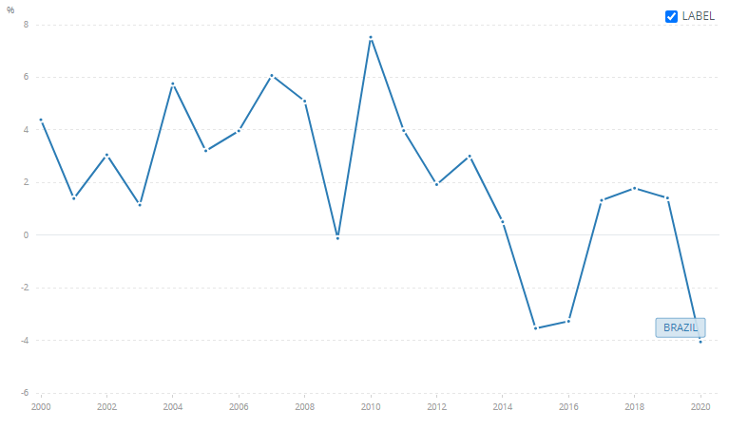
(Source: The World Bank, 2022b)

